Table 3. Distribution and comparison of final histology examination performance between the traditional and AI-assisted music-based intervention groups.
Score range |  | Excellent (17-20) | Good (15-16.99) | Moderate (12-14.99) | Poor (<12) | Overall examination score
Traditional Method | Score (Mean ± SD) | 17.96 ±  1.011 | 15.90 ±  0.4700 | 13.81 ± 0.5612 | 10.96 ± 0.9728 | 16.10 ±  2.341
Traditional Method | n  (%) | 65  (46.11%) | 43  (30.49%) | 20  (14.18%) | 13  (9.22%) | 141  100%
Intervention Method | Score (Mean ± SD) | 18.63 ±  1.010 | 15.87 ±  0.5911 | 13.58 ±  0.5898 | 11.21 ±  1.819 | 17.41 ±  2.263
Intervention Method | n  (%) | 97  (68.80%) | 28  (19.86%) | 10  (7.09%) | 6  (4.25%) | 141  100%
P-value |  | ****  P<0.0001 | ns  P=0.7769 | ns  P=0.2837 | ns  P=0.1276 | ****  P<0.0001
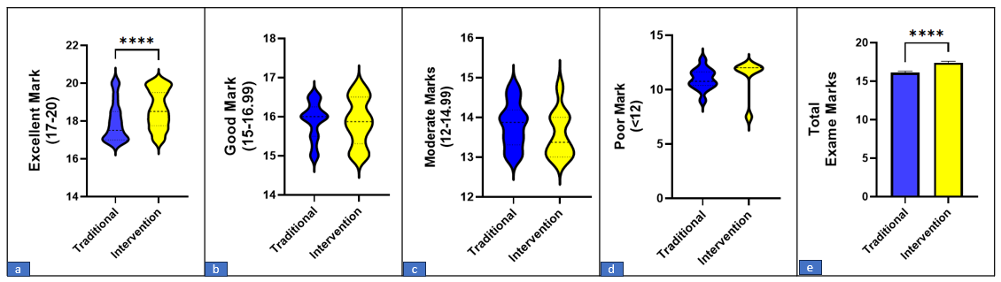

The upper panel shows the mean ± SD and the distribution of students across four achievement categories (Excellent, Good, Moderate, and Poor) based on the Iranian 0–20 grading system, together with the overall examination score. The lower panel presents violin plots of score distributions. The intervention group achieved significantly higher overall examination scores and a greater proportion of Excellent grades than the traditional group (****P < 0.0001), with no significant differences in the other achievement categories.

