Supplementary Information for:
Permafrost thaw slumps restructure Arctic stream microbial communities and transform biogeochemical regimes
Marina Taskovic¹, Brian D. Lanoil¹, Maria A. Cavaco², Maya P. Bhatia², Suzanne E. Tank¹
¹ Department of Biological Sciences, University of Alberta, Edmonton AB, Canada
² Department of Earth and Atmospheric Sciences, University of Alberta, Edmonton AB, Canada

Table S1. Location of thaw slump sites. Coordinates correspond to the location where rill water draining thaw slumps was collected. Sites were accessed from either the Dempster Highway or by helicopter. Sampling times captured periods of active thaw and stabilized slump activity, as well as seasonal dry spells and heavy rainfall. Due to such circumstances, on occasion, samples were not collected from every location at each site within a sampling year. If thawed materials created upstream impoundments (e.g., SE, 2023) or slump activity affected accessibility to downstream reaches (FM2.5 at FM3), sampling locations were adjusted to meet the study design.

Site | Latitude | Longitude | Elevation (m)
FM2 | 67.2557 | -135.2317 | 318
HE | 67.4049 | -135.4247 | 339
FM2.5 | 67.2516 | -135.2698 | 365
FM3 | 67.2559 | -135.2771 | 392
HG | 67.4375 | -135.6561 | 522
HA | 67.1492 | -135.6887 | 523
SE | 67.1473 | -135.7173 | 560
HC | 67.3276 | -135.8972 | 603
CB | 67.1829 | -135.7300 | 636
HB | 67.2393 | -135.8250 | 694
SF | 67.1833 | -135.8114 | 720

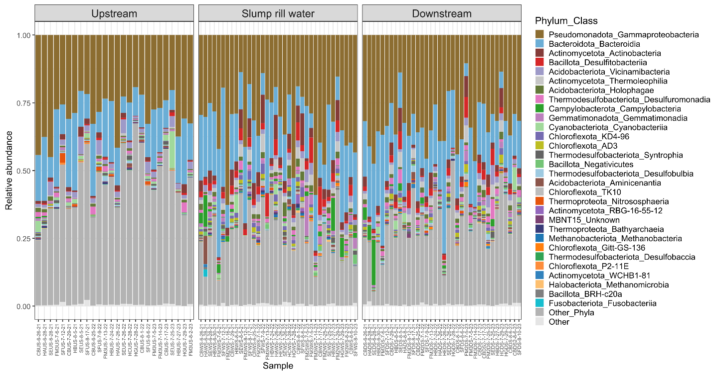

Figure S1. Highly represented taxonomic classes across samples by location. The ASVs with a phylum/class combination not represented in the top 30 most abundant are classified as “Other_Phyla”. All ASVs that do not have phylum-level classification are classified as “Other” in the legend.

Table S2. Linear mixed-effects model statistics for observed ASV richness. Marginal R² = 0.18, Conditional R² = 0.18 (site does not explain any variance). Pairwise comparisons are Tukey-adjusted.
Observed ~ location + (1 | site)
Fixed effects | Estimate | SE | df | t | p | p adj.
(Intercept) | 1389.5 | 95.8 | 69 | 14.51 | < 0.001
RW | -535.9 | 135.4 | 69 | -3.96 | < 0.001
DS | -316.9 | 135.4 | 69 | -2.34 | 0.022
Contrast
US – RW | 536 | 135 | 3.95 | 3.96 | < 0.001 | <0.001
US – DS | 317 | 135 | 2.34 | 2.34 | 0.024 | 0.057
RW – DS | -219 | 135 | -1.62 | -1.62 | 0.111 | 0.256
Random effects | Variance | SD
Site (intercept) | 0 | 0
Residual | 220019 | 469.1

Table S3. Linear mixed-effects model statistics for Shannon index. Marginal R² = 0.29; Conditional R² = 0.32. Pairwise comparisons are Tukey-adjusted.
Shannon ~ location + (1 | site)
Fixed effects | Estimate | SE | df | t | p | p adj.
(Intercept) | 6.4 | 0.126 | 24.9 | 50.3 | < 0.001
RW | -0.91 | 0.167 | 62.4 | -5.44 | < 0.001
DS | -0.62 | 0.167 | 62.4 | -3.72 | < 0.001
Contrast
US – RW | 0.91 | 0.167 | 63.3 | 5.44 | < 0.001 | < 0.001
US – DS | 0.62 | 0.167 | 63.3 | 3.72 | < 0.001 | 0.001
RW – DS | -0.29 | 0.167 | 63.3 | -1.72 | 0.091 | 0.206
Random effects (site) | Variance | SD
Site (intercept) | 0.013 | 0.116
Residual | 0.334 | 0.578

Table S4. Permutational analysis of variance (PERMANOVA) results of microbial Bray-Curtis dissimilarities. Pairwise p-values are adjusted using the Bonferroni method. Only sites with significant contrasts are included. Permutations = 999
Bray-Curtis ~ location * site + year
Variable | df | SS | R² | F | p | p adj.
Location | 2 | 3.57 | 0.16 | 7.73 | < 0.001
Site | 6 | 4.06 | 0.17 | 2.93 | <0.001
Year | 2 | 0.73 | 0.03 | 1.59 | 0.016
Location:Site | 12 | 4.77 | 0.19 | 1.72 | <0.001
Residual | 49 | 11.3 | 0.46
Total | 71 | 24.5 | 1
Group comparisons
Location
US – RW |  |  | 0.09 | 4.47 | < 0.001 | < 0.001
US – DS |  |  | 0.18 | 10.21 | < 0.001 | < 0.001
RW – DS |  |  | 0.06 | 3.09 | < 0.001 | < 0.001
Year
2021 – 2022 |  |  | 0.02 | 1.33 | 0.10 | 0.31
2021 – 2023 |  |  | 0.03 | 1.52 | 0.06 | 0.15
2022 – 2023 |  |  | 0.03 | 1.41 | 0.09 | 0.27
Site
FM3 – SE |  |  | 0.14 | 3.52 | < 0.001 | 0.011
FM3 – SF |  |  | 0.14 | 3.46 | < 0.001 | 0.004
HB – SE |  |  | 0.13 | 2.87 | < 0.001 | 0.011
HB – SF |  |  | 0.13 | 2.86 | < 0.001 | 0.008

Table S5. Distance-based redundancy analysis (dbRDA) of microbial community Bray-Curtis dissimilarities. Predictors were chosen via forward stepwise selection. Significant effects tested using a permutation-based ANOVA. Model R² = 0.33, adjusted R² = 0.20. Permutations = 999
Bray-Curtis ~ C:A + DOC + pH + DO + Water temperature + Alkalinity
Source | df | SS | Proportion | F | p | R²
Total |  | 13.0 | 1.0
Constrained | 6 | 4.34 | 0.33 | 2.58 | < 0.001
Unconstrained | 31 | 8.68 | 0.67
Predictors
Coble peak C:A | 1 | 1.23 |  | 4.42 | < 0.001 | 0.096
DOC | 1 | 1.11 |  | 3.97 | < 0.001 | 0.085
pH | 1 | 0.69 |  | 2.47 | < 0.001 | 0.053
DO | 1 | 0.46 |  | 1.64 | 0.022 | 0.035
Water temperature | 1 | 0.42 |  | 1.51 | 0.037 | 0.032
Alkalinity | 1 | 0.42 |  | 1.49 | 0.046 | 0.032
Residual | 31 | 8.69

Table S6. Significant Spearman correlations between Bray-Curtis dissimilatory scores and downstream physicochemical properties. The five variables with the highest absolute correlations (rho) are presented.
Downstream-Upstream (DS-US)
Variable | rho | p | p adj.
PP | 0.78 | < 0.001 | < 0.001
POC | 0.76 | < 0.001 | < 0.001
PN | 0.76 | < 0.001 | < 0.001
TSS | 0.75 | < 0.001 | < 0.001
P% | -0.65 | < 0.001 | 0.005
Downstream-Slump rill water (DS-RW)
POC | -0.78 | < 0.001 | < 0.001
TSS | -0.77 | < 0.001 | < 0.001
P% | 0.72 | < 0.001 | < 0.001
PN | -0.69 | < 0.001 | 0.002
PP | -0.63 | 0.001 | 0.007

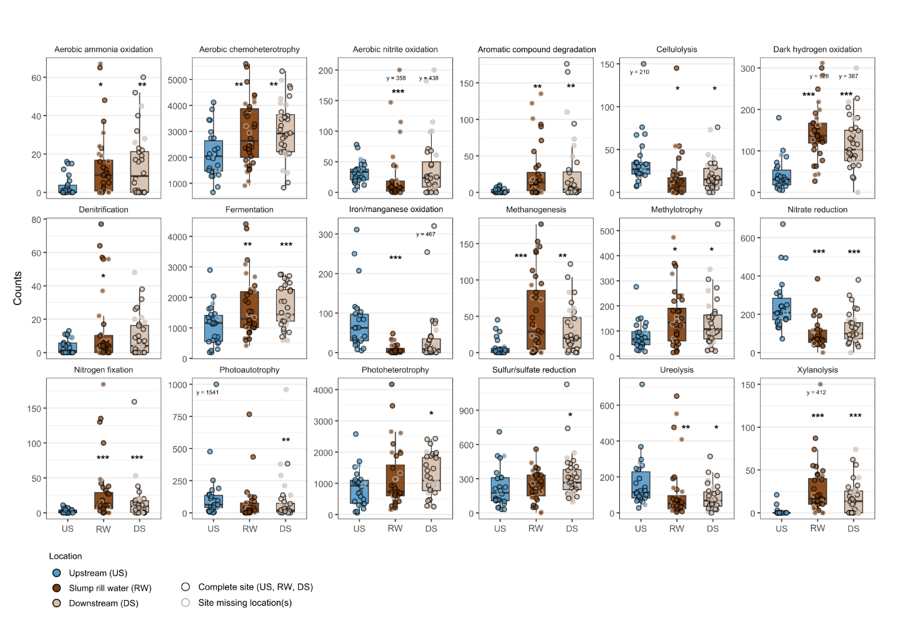

Figure S2. Microbial functional group abundance (ASV counts) between sampling locations. Asterisks above boxplots indicate significant levels of respective treatment groups (i.e., RW or DS) relative to upstream (US). * p < 0.05, ** p <0.01, *** p<0.001

Table S7. Additional details on the curation of functional groups used in analysis. Functional groups were annotated from ASVs using FAPROTAX¹, then groups were simplified using representative categories, or removed based on complete overlap with other groups. In some cases, sub-functions were consolidated into broader, more biogeochemically meaningful categories (e.g., Nitrate reduction). For each functional group, the table indicates whether groups were retained or removed, along with the rationale for removal. This step was performed to reduce redundancy and improve interpretability in downstream analyses.
Representative group(s) | Removed group(s) | Rationale
Denitrification | Nitrate denitrification  Nitrite denitrification | All ASVs assigned to groups removed were also assigned to the representative group, and vice versa.
Photoautotrophy | Oxygenic photoautotrophy  Photosynthetic cyanobacteria  Phototrophy
Methanogenesis | Hydrogenotrophic methanogenesis.  Methanogenesis by CO₂ reduction with H₂
Nitrate reduction | Nitrate respiration  Nitrogen respiration  Nitrite respiration | All ASVs assigned to groups removed were assigned as the representative group, and functional groups follow the same patterns between sampling locations.
Aerobic ammonia oxidation | Nitrification | Representative groups have diverging trends.
Aerobic nitrate reduction | Nitrification | Representative groups have diverging trends.
Sulfur/sulfate reduction  Originally named: Respiration of sulfur compounds | Sulfur respiration  Sulfate respiration | All ASVs assigned to groups removed were assigned to a representative group, and functional groups follow the same patterns between sampling locations.
Aerobic chemoheterotrophy | Chemoheterotrophy | Any ‘chemoheterotrophs’ that were not ‘aerobic chemoheterotrophs’ were represented by other functional groups (see Fig. 7).
Photoheterotrophy | Phototrophy | Grouping photoautotrophy and photoheterotrophy deemed not ecologically meaningful.

Table S8. Detection limits and methodological references for water chemistry parameters. All sample analysis was conducted at the Biogeochemical Analytical Service Laboratory at the University of Alberta, Edmonton AB, accredited to ISO/IEC 17025 for specific tests by the Canadian Association for Laboratory Accreditation.

Abbreviation | Parameter | Analytical detection limit | Reference | Method | Instrument
TP/TDP | Total phosphorus/total dissolved phosphorus | 1 µg L⁻¹ as P | APHA | 4500-P-G | Lachat QuickChem QC8500 FIA Automated Ion Analyzer
SRP | Soluble reactive phosphorus | 1 µg L⁻¹ as P | APHA | 4500-P-G | Lachat QuickChem QC8500 FIA Automated Ion Analyzer
TDN | Total dissolved nitrogen | 1 µg L⁻¹ as N | US EPA | 353.2 | Lachat QuickChem QC8500 FIA Automated Ion Analyzer
NH₄⁺ | Ammonium | 3 µg L⁻¹ as N | APHA | 4500-NH3-B,H | Lachat QuickChem QC8500 FIA Automated Ion Analyzer
NO₂⁻+NO₃⁻ | Nitrite/nitrate | 2 µg L⁻¹ as N | US EPA | 353.2 | Lachat QuickChem QC8500 FIA Automated Ion Analyzer
Alk. | Alkalinity | 1 mg L⁻¹ as CaCO₃ | APHA | 2320 B | Mantech PC-Titration Plus System
Mg²⁺ | Magnesium | 0.01 mg L⁻¹ | US EPA | 200.7 | Thermo ICAP-6300 Inductively Coupled Argon Plasma - Optical Emission Spectrometer (ICP-OES)
Na⁺ | Sodium | 0.02 mg L⁻¹ | US EPA | 200.7
Ca²⁺ | Calcium | 0.01 mg L⁻¹ | US EPA | 200.7
K⁺ | Potassium | 0.01 mg L⁻¹ | US EPA | 200.7
Cl⁻ | Chloride | 0.03 mg L⁻¹ | US EPA | 300.1 | Dionex DX-600 Ion Chromatography
SO₄²⁻ | Sulfate | 0.04 mg L⁻¹ | US EPA | 300.1 | Dionex DX-600 Ion Chromatography
APHA Standard Methods for the Examination of Water and Wastewater
US EPA US Environmental Protection Agency Test Methods
USGS US Geological Survey

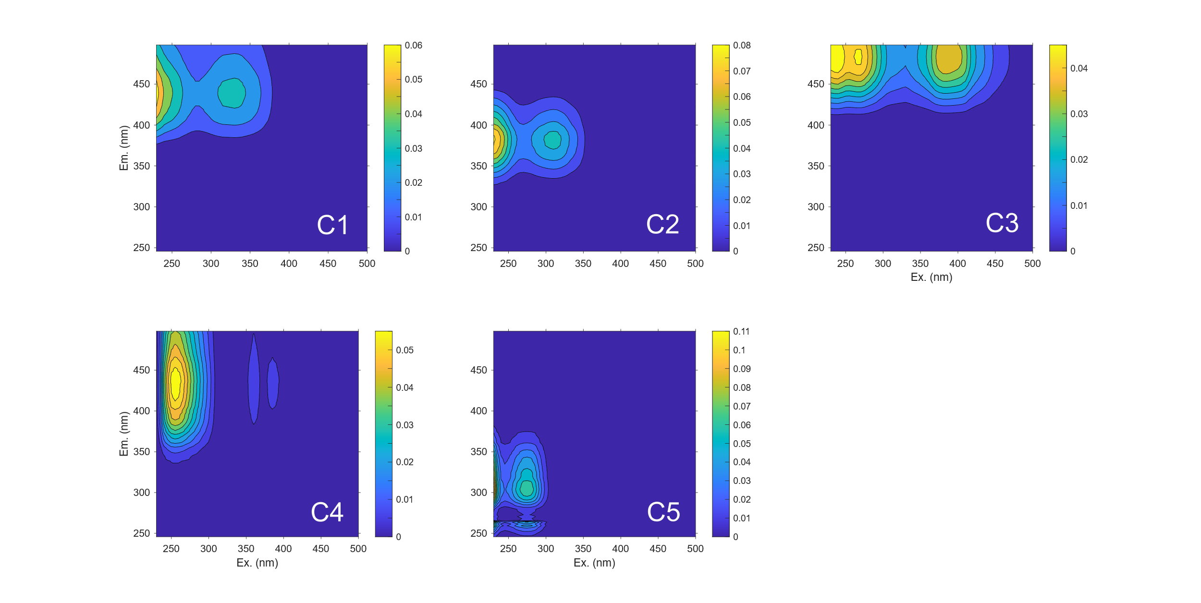

Figure S3.
Contour plots of spectra of the identified components from parallel factor analysis (PARAFAC). Colour scale bar represents fluorescence intensity in Raman units. Absorbance spectra and fluorescence excitation–emission matrices (EEMs) were measured with a Horiba Aqualog spectrometer at the University of Alberta. Absorbance was measured from 240 to 800 nm at 1 nm increments with a 0.1 s integration time using a 1 cm quartz cuvette. Excitation-emission matrices (EEMs) were constructed using fluorescence measurements with excitation ranging from 230 to 500 nm (5 nm increments) and emission ranging from 300 to 500 nm (2.33 nm increments). Emission intensities were normalized by integration time, which ranged from 1 to 3 s. A PARAFAC analysis was performed to decompose EEM data into independent fluorescent components that provide information on the molecular structure, source, and compositional properties of sample DOM². Sample EEMs were blank-subtracted from ultrapure water (Milli-Q, MilliporeSigma, 18.2 MΩ cm), corrected for inner-filter effects using absorbance measurements, and standardized to Raman Units (RU) using the area under the Raman scatter peak (350 nm excitation) of pure water³. To increase model robustness and allow for validation via split-half analysis, EEMs from slump sites (n = 97) and tributaries of the Peel River/Channel between 2021 and 2023 (n = 75) were included in the model. A five-component model was selected and explained 99.8% of the total variance in the dataset. The relative contribution of each PARAFAC component to the overall fluorescence signal of a sample was determined by normalizing the maximum fluorescence scores (F_{max}) of each component to the sum of all component intensities (%C = F_{max} / ∑F_{max}).

Table S9. Spectral composition of the five fluorescence components identified via PARAFAC analysis. The maximum excitation (Ex) and emission (Em) wavelengths (secondary peaks in brackets, where applicable), and descriptions of spectral properties to matched PARAFAC components from previous studies published on the OpenFluor database (>0.98 for Ex and Em). The model included three components representative of aromatic, humic-like compounds of terrestrial origin (C1, C3, C4). Component 2 (C2) represented humic-like compounds from microbial activity and processing of organic matter, similar to the Coble peak M⁴. Component 5 (C5) represented protein-like compounds (i.e., tryptophan and tyrosine). Corrected fluorescence data were also used to calculate fluorescence indices^{4–6}. Fluorescence indices with strong Pearson correlations to PARAFAC model components (r > 0.80) and similar interpretive molecular characteristics were excluded from analyses. This included: HIX, BIX, β:α, and Coble peak ratios C:T, C:M, and A:T.
Component | Peaks |  | Correlates (r > 0.80) | OpenFluor matches | Description and molecular characteristics | Matched studies with comparable results
Component | Ex (nm) | Em (nm)
C1 | 330 | 440 | pA:T, pC:M, pC:T, HIX | 27 | Humic-like; terrestrially derived material; common to aquatic environments; likely represents a myriad of highly aromatic, terrestrial organic matter degradation products. | C1⁷, C1⁸, C1⁹, C1¹⁰, C1¹¹
C2 | 310 | 382 | BIX, β:α | 13 | Similar to peak M fluorophores ⁴; humic-like DOM that is microbially processed from autochthonous/aquatic sources. | C4¹², C5¹³, C2¹⁴
C3 | 240 (265, 385) | 484 | Peak A:T, peak C:T, HIX | 8 | Humic-like of terrestrial origin; high molecular weight; recalcitrant molecules; associated with fulvic acid. | C5¹⁵, C3¹⁶, C3¹⁷, C3¹⁸
C4 | 255 | 437 |  | 3 | Humic-like of terrestrial origin; aromatic; similar to peak A; degraded⁴. | C3¹⁹, C3²⁰
C5 | 275 | 304 |  | 11 | Protein-like; mixture of tryptophan and tyrosine; associated with microbial activity and autochthonous origin; positively related to bioavailability. | C5²¹, C2²², C1²³, C5²⁴

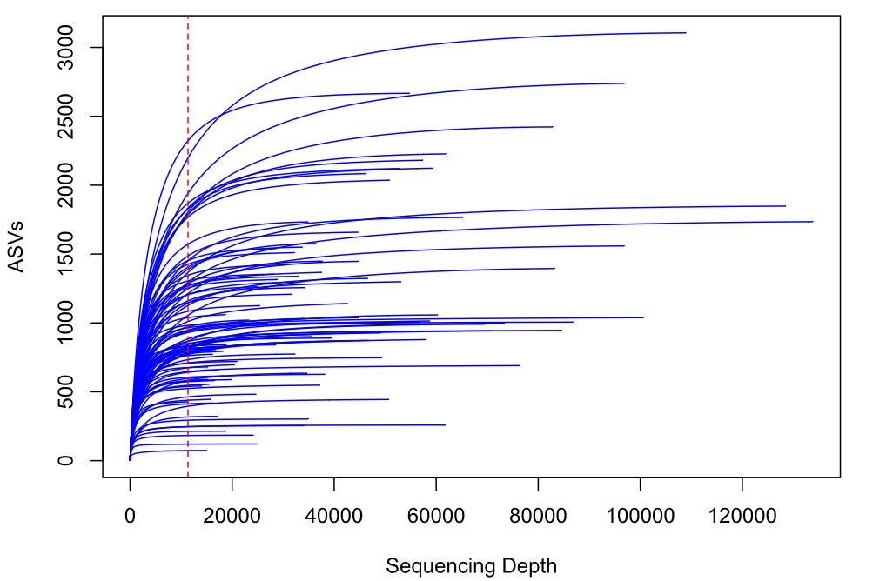

Figure S4. Rarefaction curve of microbial community data. Rarefaction depth illustrated with a dashed vertical line (FM2DS-7-5-23: 11,343 reads).
Additional information on microbial sample processing –
Sample water was collected in a 2 L or 4 L acid-washed polycarbonate bottle filled with minimal headspace and transported to the Western Arctic Research Centre (Inuvik, NT, Canada) on ice packs in coolers. Samples with low amounts of sediment were filtered first using a peristaltic pump. Sample water was filtered through 0.22 µm Sterivex filters (Millipore Sigma) until the filter reached capacity, and any settled suspended material was collected separately, without filtration, into 2 mL cryovials. Samples were processed in parallel to maximize sample collection and capture the entire stream community. All samples were transported from the Western Arctic Research Centre to the University of Alberta in a liquid-nitrogen dry shipper and stored at -80ºC until DNA extraction.
DNeasy PowerWater Sterivex and DNeasy PowerSoil Extraction Kits (Qiagen) were used to extract DNA. We implemented two modifications from the manufacturer's protocol to improve DNA yield and account for complications associated with large amounts of sediments in filter cartridges: (1) The filter was washed twice with ST1B solution (cell lysis enhancement buffer); the two washes were processed in parallel until the MB Spin Column filtering step, where the supernatants were combined. (2) A greater amount of material (0.65 g per sample) was extracted, following Winder et al.²⁵. Extracted DNA was quantified using a Qubit Fluorometer with a High Sensitivity dsDNA Assay Kit (ThermoFisher).
We targeted the V4-V5 hypervariable region of the 16S rRNA gene using the universal prokaryotic primer set 515F and 926R²⁶. PCR amplification and sample indexing were performed following Drapeau et al.²⁷. All primers were purchased from Integrated DNA Technologies (IA, USA). Sample DNA was amplified in a randomized order in a 25 µL reaction volume including: Q5 Reaction Buffer, 200 µM dNTPs, 0.02 U µL⁻¹ Q5 High-Fidelity DNA Polymerase (New England Biolabs, MA, USA), 0.1 µM of each primer, bovine serum albumin (samples < 0.2 ng µL⁻¹), and nuclease-free water. Each round of PCR included extraction blanks, a negative control, and a microbial community control (Zymo Research Corp., CA, USA). All extraction blanks and controls were sequenced to check for sequencing accuracy and identify potential contamination.
PCR product was size-selected using a 1:0.9 ratio of template to Sera-Mag Select magnetic beads (Cytiva, MA, USA), and samples were indexed during a second round of PCR (8 cycles) using Illumina i5 and i7 adaptors (0.5 µM; Illumina, Inc., Canada). The final PCR products were visualized on a 1% agarose gel to confirm successful amplification and pooled to roughly equimolar concentrations. Sample libraries were purified using the same magnetic beads (1:0.9 ratio) and quality checked on an Agilent 2100 Bioanalyzer at the Molecular Biology Service Unit (University of Alberta). The prepared libraries (4 nM) were spiked with 45% PhiX Control v3 and sequenced on an Illumina MiSeq using 2 x 300 bp paired-end chemistry at the Advanced Cell Exploration Core (University of Alberta).
Primers and adaptors were removed from reads using cutadapt and processed using the dada2²⁸ package in R. Taxonomy was assigned to amplicon sequence variants (ASVs) using the SILVA v138.2 trainset^{29,30}. Eukaryotes, mitochondria, chloroplasts, and global singleton ASVs were removed from the dataset. Following taxonomic assignment, the package decontam³¹ was used with the prevalence method to identify and remove ASVs flagged as contaminants (< 2% of total reads). Samples with fewer than 10,000 reads (8 of 106 initial samples) were removed before rarefaction because they had not reached an asymptote and lacked adequate sequencing coverage of richness. For sites with samples of filtered water and settled sediment, reads were combined prior to rarefaction to capture the whole-community microbial composition. All samples were rarefied 100 times to the lowest read count (11,343), and the average across iterations was used for all downstream analyses. R packages phyloseq, vegan, and ggplot2 were used for processing and visualization of sequence data. Rarefied ASV counts of microbial samples were used for all data analysis and visualization.

References
1. Louca, S., Parfrey, L. W. & Doebeli, M. Decoupling function and taxonomy in the global ocean microbiome. Science 353, 1272–1277 (2016).
2. Murphy, K. R., Stedmon, C. A., Graeber, D. & Bro, R. Fluorescence spectroscopy and multi-way techniques. PARAFAC. Anal. Methods 5, 6557 (2013).
3. Murphy, K. R. et al. Measurement of Dissolved Organic Matter Fluorescence in Aquatic Environments: An Interlaboratory Comparison. Environ. Sci. Technol. 44, 9405–9412 (2010).
4. Coble, P. G. Characterization of marine and terrestrial DOM in seawater using excitation-emission matrix spectroscopy. Marine Chemistry 51, 325–346 (1996).
5. Ohno, T. Fluorescence Inner-Filtering Correction for Determining the Humification Index of Dissolved Organic Matter. Environ. Sci. Technol. 36, 742–746 (2002).
6. Huguet, A. et al. Properties of fluorescent dissolved organic matter in the Gironde Estuary. Organic Geochemistry 40, 706–719 (2009).
7. Wauthy, M. et al. Increasing dominance of terrigenous organic matter in circumpolar freshwaters due to permafrost thaw. Limnol Oceanogr Lett 3, 186–198 (2018).
8. Grunert, B. K., Tzortziou, M., Neale, P., Menendez, A. & Hernes, P. DOM degradation by light and microbes along the Yukon River-coastal ocean continuum. Sci Rep 11, 10236 (2021).
9. Paradina-Fernández, L., Wünsch, U., Bro, R. & Murphy, K. Direct Measurement of Organic Micropollutants in Water and Wastewater Using Fluorescence Spectroscopy. ACS EST Water 3, 3905–3915 (2023).
10. Goranov, A. I. et al. Assessing the spatiotemporal variability of dissolved organic matter fluorescence composition in the Lake George, NY watershed. Biogeochemistry 167, 849–870 (2024).
11. Du, Y., Zhang, Y., Chen, F., Chang, Y. & Liu, Z. Photochemical reactivities of dissolved organic matter (DOM) in a sub-alpine lake revealed by EEM-PARAFAC: An insight into the fate of allochthonous DOM in alpine lakes affected by climate change. Science of The Total Environment 568, 216–225 (2016).
12. Menendez, A. & Tzortziou, M. Driving factors of colored dissolved organic matter dynamics across a complex urbanized estuary. Science of The Total Environment 921, 171083 (2024).
13. Kurek, M. R. et al. Trapped Under Ice: Spatial and Seasonal Dynamics of Dissolved Organic Matter Composition in Tundra Lakes. Journal of Geophysical Research: Biogeosciences 127, e2021JG006578 (2022).
14. Guéguen, C., Cuss, C. W., Cassels, C. J. & Carmack, E. C. Absorption and fluorescence of dissolved organic matter in the waters of the Canadian Arctic Archipelago, Baffin Bay, and the Labrador Sea. Journal of Geophysical Research: Oceans 119, 2034–2047 (2014).
15. Ouédraogo, F. et al. Changes over time in organic matter dynamics and copper solubility in a vineyard soil after incorporation of cover crop residues: Insights from a batch experiment. Chemosphere 350, 141137 (2024).
16. Calderó-Pascual, M. et al. The importance of allochthonous organic matter quality when investigating pulse disturbance events in freshwater lakes: a mesocosm experiment. Hydrobiologia 849, 3905–3929 (2022).
17. Thompson, L. M. et al. Controls on methylmercury concentrations in lakes and streams of peatland‐rich catchments along a 1700 km permafrost gradient. Limnology & Oceanography 68, 583–597 (2023).
18. Weigelhofer, G., Jirón, T. S., Yeh, T.-C., Steniczka, G. & Pucher, M. Dissolved Organic Matter Quality and Biofilm Composition Affect Microbial Organic Matter Uptake in Stream Flumes. Water 12, 3246 (2020).
19. Jutaporn, P., Muenphukhiaw, N., Phungsai, P., Leungprasert, S. & Musikavong, C. Characterization of DBP precursor removal by magnetic ion exchange resin using spectroscopy and high-resolution mass spectrometry. Water Research 217, 118435 (2022).
20. Osburn, C. L., Wigdahl, C. R., Fritz, S. C. & Saros, J. E. Dissolved organic matter composition and photoreactivity in prairie lakes of the U.S. Great Plains. Limnology and Oceanography 56, 2371–2390 (2011).
21. Walker, S. A., Amon, R. M. W., Stedmon, C., Duan, S. & Louchouarn, P. The use of PARAFAC modeling to trace terrestrial dissolved organic matter and fingerprint water masses in coastal Canadian Arctic surface waters. Journal of Geophysical Research: Biogeosciences 114, (2009).
22. Limberger, R. et al. Predator-induced changes in dissolved organic carbon dynamics. Oikos 128, 430–440 (2019).
23. Kida, M. et al. Origin, distributions, and environmental significance of ubiquitous humic-like fluorophores in Antarctic lakes and streams. Water Research 163, 114901 (2019).
24. Osburn, C. L. et al. Regional Groundwater and Storms Are Hydrologic Controls on the Quality and Export of Dissolved Organic Matter in Two Tropical Rainforest Streams, Costa Rica. Journal of Geophysical Research: Biogeosciences 123, 850–866 (2018).
25. Winder, J. C. et al. Climate warming has direct and indirect effects on microbes associated with carbon cycling in northern lakes. Global Change Biology 00, 1–15 (2022).
26. Parada, A. E., Needham, D. M. & Fuhrman, J. A. Every base matters: assessing small subunit rRNA primers for marine microbiomes with mock communities, time series and global field samples. Environmental Microbiology 18, 1403–1414 (2016).
27. Drapeau, H. F. et al. Shifts in organic matter character and microbial assemblages from glacial headwaters to downstream reaches in the Canadian Rocky Mountains. Biogeosciences 22, 1369–1391 (2025).
28. Callahan, B. J. et al. DADA2: High-resolution sample inference from Illumina amplicon data. Nat Methods 13, 581–583 (2016).
29. Quast, C. et al. The SILVA ribosomal RNA gene database project: improved data processing and web-based tools. Nucleic Acids Research 41, D590–D596 (2012).
30. Callahan, B. Silva taxonomic training data formatted for DADA2 (Silva version 138.2). Zenodo https://doi.org/10.5281/zenodo.14169026 (2024).
31. Davis, N. M., Proctor, D. M., Holmes, S. P., Relman, D. A. & Callahan, B. J. Simple statistical identification and removal of contaminant sequences in marker-gene and metagenomics data. Microbiome 6, 226 (2018).

