Supplementary material
Tailoring the Biological Activity of Oxorhenium(V) Complexes through Chrysin Ligand Functionalization

Luca Famlonga,¹‡ Lorenzo Chiaverini,¹‡ Jana Timotijević,² Ana Kandić,³ Stefan R. Nikolić,³ Antoine Dupé,⁴ Simona M. Sigona,¹ Elisabetta Barresi,¹ Chiara Giacomelli,¹ Ljiljana E. Mihajlović,³ Tiziano Marzo,^{1*} and Jelena Poljarević ^{3, *}

¹ Department of Pharmacy, University of Pisa, Via Bonanno Pisano 6, 56126, Pisa, Italy.
² University of Belgrade - Faculty of Chemistry, Belgrade, Studentski trg 12-16, 11158 Belgrade, Serbia.
³ Innovation Center of the Faculty of Chemistry, Belgrade, Studentski trg 12-16, 11158 Belgrade, Serbia
⁴ Institute of Chemistry, University of Graz, Schuberstr. 1, 8010 Graz, Austria

* Corresponding author(s)

Tiziano Marzo (tiziano.marzo@unipi.it)
Jelena Poljarević (jelenal@chem.bg.ac.rs)

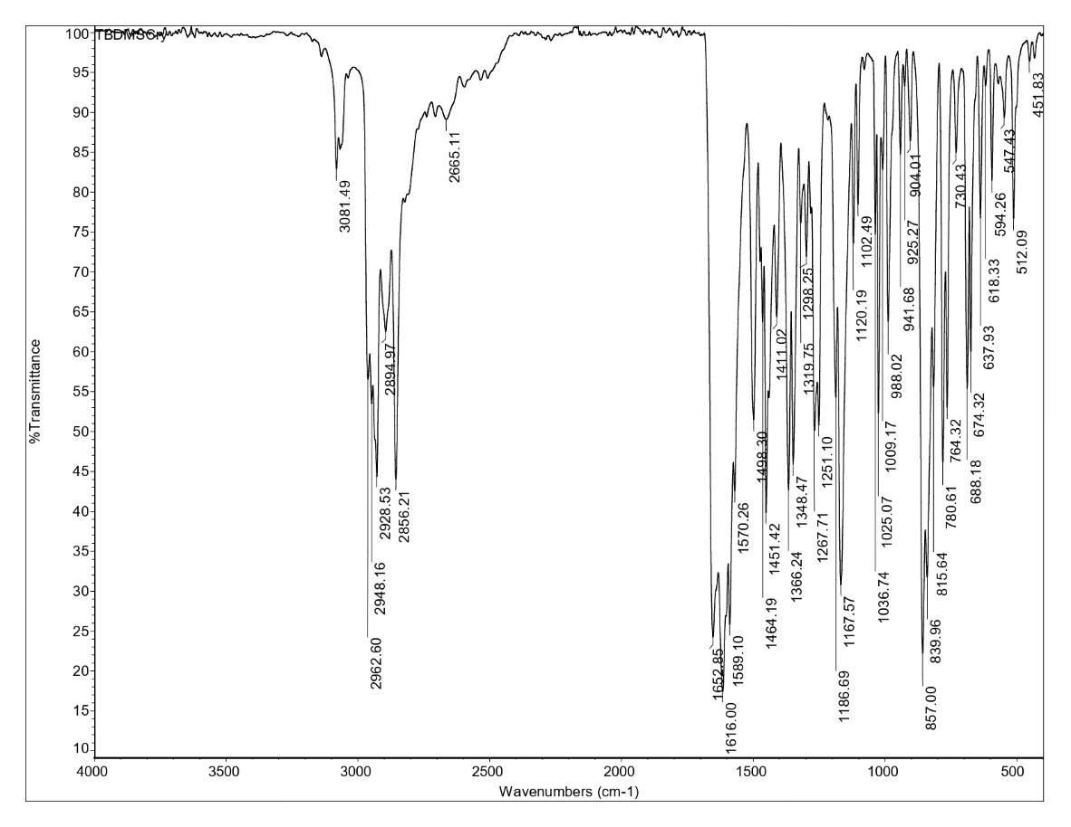
Figure S1. IR spectrum of HL5
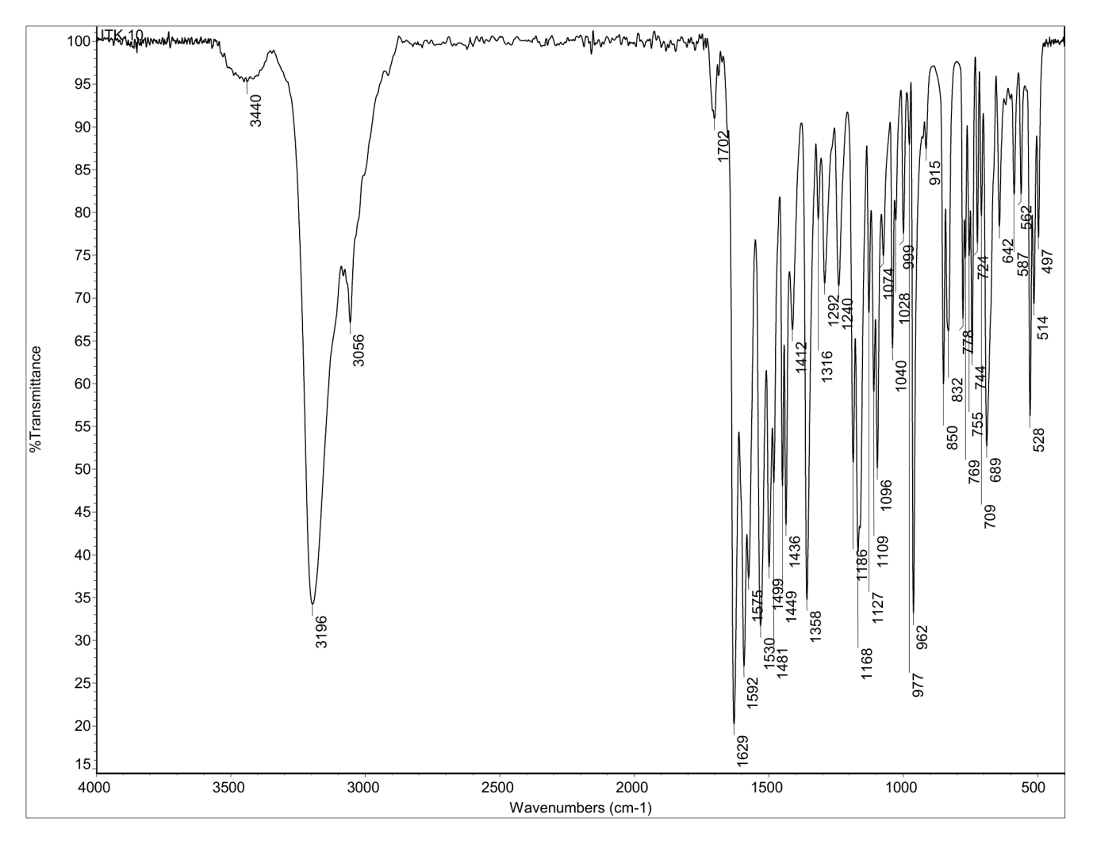
Figure S2. IR spectrum of 1.
Figure S3. IR spectrum of 2.
Figure S4. IR spectrum of 3
Figure S5. IR spectrum of 4.
Figure S6. IR spectrum of 5.

Figure S7. ¹H NMR spectrum of HL5 recorded in CDCl₃
Figure S8. ¹³C NMR spectrum of HL5 recorded in CDCl₃
Figure S9. ¹H NMR spectrum of 1 recorded in DMSO-d6
Figure S10. Overlapped HL1 (red) and 1 (blue) recorded in DMSO-d6.
Figure S11. ¹³C NMR spectra of 1 recorded in DMSO-d6.

Figure S12. ³¹P NMR spectra of 1 recorded in DMSO-d6.

Figure S13. ¹H NMR spectrum of 2 recorded in CDCl₃
Figure S14. Overlapped spectra of HL2 (blue) and 2(red)
Figure S15. ¹³C NMR spectrum of 2 recorded in CDCl₃.

Figure S16. ³¹P NMR spectrum of 2.

Figure S17. ¹H NMR spectrum of 3 recorded in CDCl₃.
Figure S18. ¹³C NMR spectrum of 3 recorded in CDCl₃
Figure S19. ³¹P NMR of 3 recorded in DMSO-d6
Figure S20. ¹H NMR spectrum of 4 recorded in CDCl₃
Figure S21. Overlapped ¹H NMR spectrum of HL4 (blue) and 4 (green).
Figure S22. ¹³C NMR spectrum of 4 recorded in CDCl₃
Figure S23. ³¹P NMR spectrum of 4 recorded in DMSO-d6.

Figure S24. ¹³C NMR spectrum of 4 recorded in CDCl₃
Figure S25. ¹H NMR spectrum of 5 recorded in CDCl₃.
Figure S26. Overlapped ¹H NMR spectra of HL5 (red) and 5 (blue) recorded in CDCl₃.
Figure S27. ¹³C NMR spectrum of 5 recorded in CDCl₃.
Figure S28. ³¹P NMR spectrum of 5 recorded in DMSO-d6.
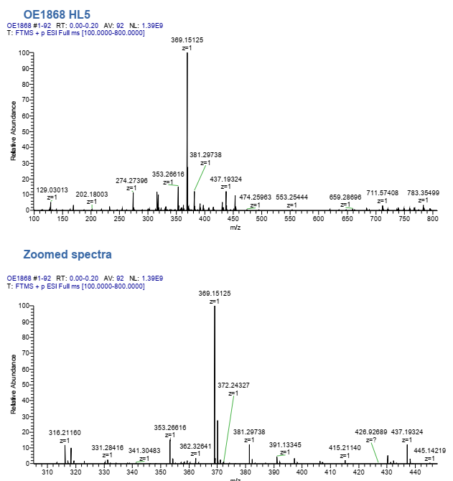
Figure S29. Mass spectrum of HL5 recorded in ACN.
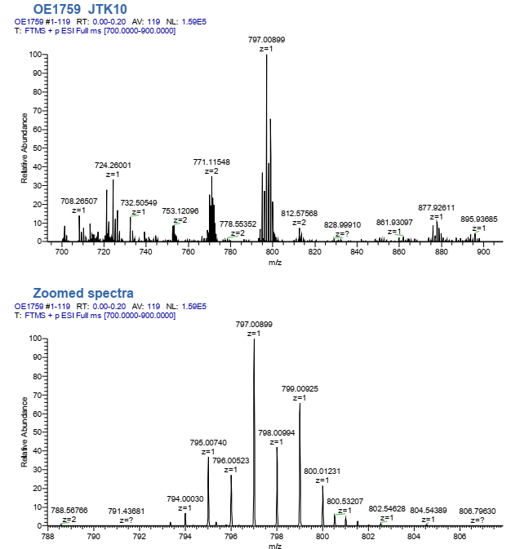
Figure S30. Mass spectrum of 1 recorded in CH₃CN.
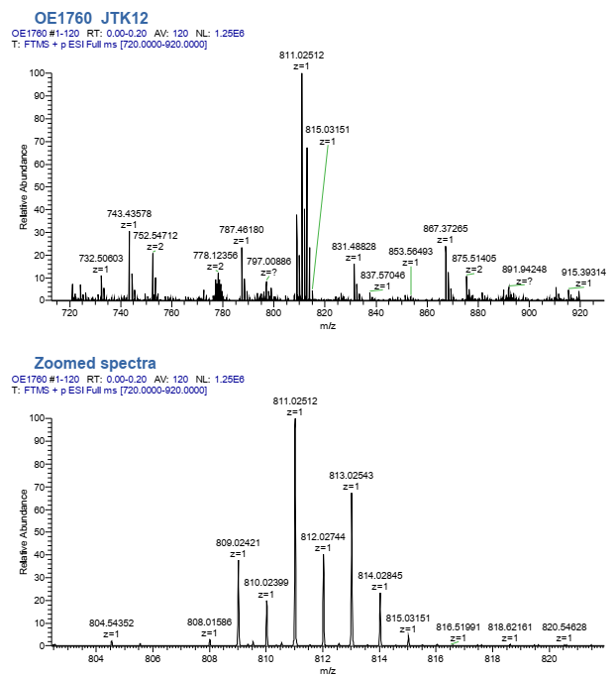
Figure S31. Mass spectrum of 2.
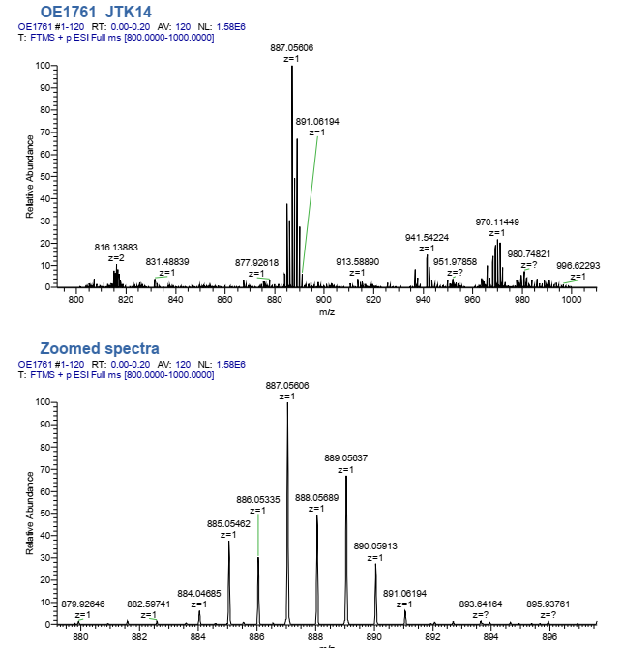
Figure S32. Mass spectrum of 3
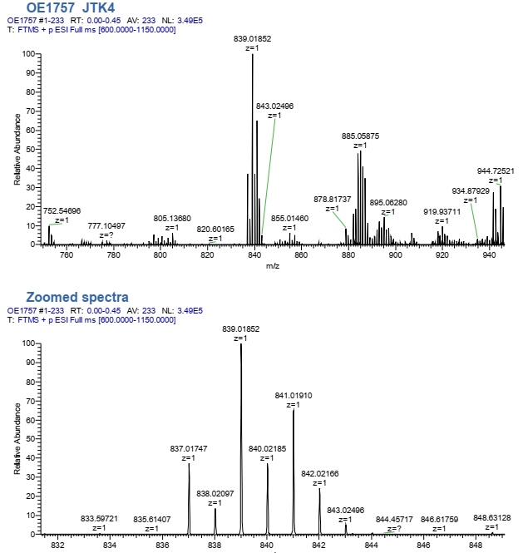
Figure S33. Mass spectrum of 4
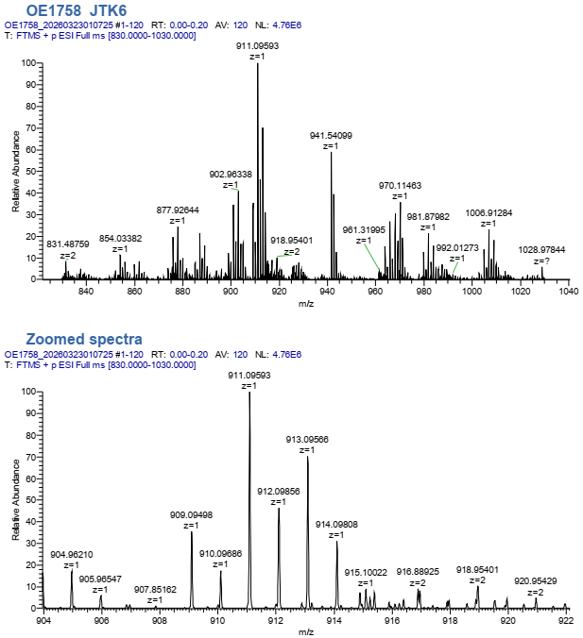
Figure S34. Mass spectra of 5 recorded in CH₃CN.

Figure S35. Effect of drugs on A2780, HCT116, and HEK293 cells after 24 h and 72 h of incubation. Dose–response curves fitted as log(inhibitor) vs. normalized response were reported (N=3).

Crystallographic Data

Crystal Structure Determination. The X-ray data collections for complexes 1-5 were performed on a Rigaku XtaLAB Synergy, Dualflex, HyPix-Arc 100 diffractometer. Reflection data were collected at T = 100 K using monochromatized Cu Kα radiation. Data reduction, scaling and absorption corrections were performed using the CrysAlisPro software.¹ For each structure, a numerical absorption correction based on Gaussian integration over a multifaceted crystal model and an empirical absorption correction using spherical harmonics, implemented in SCALE3 ABSPACK scaling algorithm, were performed. The structures were solved with the ShelXT² program using the intrinsic phasing solution method and by using Olex2³ as the graphical interface. The models were refined with the ShelXL⁴ program using full-matrix least-squares minimization techniques against F². CCDC 2573885 – 2573889 contain the supplementary crystallographic data for this paper. This data can be obtained free of charge via http://www.ccdc.cam.ac.uk/ or from Cambridge Crystallographic Data Centre, 12 Union Road, Cambridge, CB2 1EZ, UK.

Table S1. Crystal Data and Structure Refinement for 1 and 2.
Crystal data | [ReOBr₂PPh₃(L1)] 1 | [ReOBr₂PPh₃(L2)] 2
Empirical formula | C₃₃H₂₄Br₂O₅PRe | C₃₄H₂₆Br₂O₅PRe, C₃H₆O
Formula weight | 877.51 | 949.61
Temperature /K | 100.0(2) | 100.0(2)
Crystal system | triclinic | triclinic
Space group | P-1 | P-1
a /Å | 9.9361(2) | 9.2029(2)
b /Å | 11.2095(3) | 9.4257(2)
c /Å | 15.6183(3) | 20.5908(3)
α /° | 92.803(2) | 100.221(2)
β /° | 108.335(2) | 99.610(2)
γ /° | 114.038(2) | 90.428(2)
Volume /Å³ | 1476.25(6) | 1731.84(6)
Z | 2 | 2
ρ_{calc} g/cm³ | 1.974 | 1.821
μ /mm⁻¹ | 12.082 | 10.376
F(000) | 844.0 | 924.0
Crystal size /mm³ | 0.14 × 0.09 × 0.07 | 0.16 × 0.08 × 0.02
Radiation | Cu Kα (λ = 1.54184 Å) | Cu Kα (λ = 1.54184 Å)
2Θ range for data collection /° | 6.09 to 154.762 | 9.542 to 154.694
Index ranges | -12 ≤ h ≤ 12,  -14 ≤ k ≤ 14,  -18 ≤ l ≤ 19 | -11 ≤ h ≤ 11,  -10 ≤ k ≤ 11,  -26 ≤ l ≤ 25
Reflections collected | 31750 | 35050
Independent reflections | 6246 [R_{int} = 0.0437, R_{sigma} = 0.0322] | 7299 [R_{int} = 0.0580, R_{sigma} = 0.0408]
Data/restraints/parameters | 6246/0/383 | 7299/0/389
Goodness-of-fit on F2 | 1.034 | 1.044
Final R indexes [I≥ 2σ(I)] | R₁ = 0.0288, wR₂ = 0.0687 | R₁ = 0.0431, wR₂ = 0.1191
Final R indexes [all data] | R₁ = 0.0303, wR₂ = 0.0704 | R₁ = 0.0464, wR₂ = 0.1222
Largest diff. peak/hole / e.Å⁻³ | 0.86 / -1.07 | 1.47 / -2.45
CCDC no. | 2573885 | 2573886

Table S2. Crystal Data and Structure Refinement for 3 and 4.
Crystal data | [ReOBr₂PPh₃(L3)] 3 | [ReOBr₂PPh₃(L4)] 4
Empirical formula | C₄₀H₃₀Br₂O₅PRe, C₃H₆O | C₃₅H₂₆Br₂O₆PRe, C₃H₆O
Formula weight | 1025.71 | 977.62
Temperature /K | 100.0(2) | 100.00(12)
Crystal system | triclinic | monoclinic
Space group | P-1 | P2₁/c
a /Å | 9.90040(10) | 11.9576(2)
b /Å | 13.7680(2) | 13.7609(2)
c /Å | 14.5767(3) | 22.0069(3)
α /° | 86.526(2) | 90
β /° | 76.788(2) | 104.5540(10)
γ /° | 84.1720(10) | 90
Volume /Å³ | 1922.91(5) | 3504.98(9)
Z | 2 | 4
ρ_{calc} g/cm³ | 1.772 | 1.853
μ /mm⁻¹ | 9.402 | 10.299
F(000) | 1004.0 | 1904.0
Crystal size /mm³ | 0.22 × 0.19 × 0.13 | 0.15 × 0.12 × 0.12
Radiation | Cu Kα (λ = 1.54184 Å) | Cu Kα (λ = 1.54184 Å)
2Θ range for data collection /° | 6.232 to 154.758 | 7.638 to 154.76
Index ranges | -12 ≤ h ≤ 11,  -17 ≤ k ≤ 17,  -18 ≤ l ≤ 18 | -15 ≤ h ≤ 12,  -17 ≤ k ≤ 16,  -26 ≤ l ≤ 27
Reflections collected | 41461 | 38949
Independent reflections | 8146 [R_{int} = 0.0337, R_{sigma} = 0.0225] | 7431 [R_{int} = 0.0376, R_{sigma} = 0.0258]
Data/restraints/parameters | 8146/0/480 | 7431/0/445
Goodness-of-fit on F2 | 1.101 | 1.033
Final R indexes [I≥ 2σ(I)] | R₁ = 0.0245, wR₂ = 0.0640 | R₁ = 0.0300, wR₂ = 0.0721
Final R indexes [all data] | R₁ = 0.0247, wR₂ = 0.0642 | R₁ = 0.0333, wR₂ = 0.0738
Largest diff. peak/hole / e.Å⁻³ | 0.88 / -1.25 | 1.25 / -1.00
CCDC no. | 2573887 | 2573888

Table S3. Crystal Data and Structure Refinement for 5.
Crystal data | [ReOBr₂PPh₃(L5)] 5
Empirical formula | C₃₉H₃₈Br₂O₅PReSi
Formula weight | 991.77
Temperature /K | 100.0(3)
Crystal system | triclinic
Space group | P-1
a /Å | 11.08810(10)
b /Å | 11.8647(2)
c /Å | 15.17180(10)
α /° | 95.0780(10)
β /° | 90.0980(10)
γ /° | 109.3340(10)
Volume /Å³ | 1874.98(4)
Z | 2
ρ_{calc} g/cm³ | 1.757
μ /mm⁻¹ | 9.888
F(000) | 972.0
Crystal size /mm³ | 0.14 × 0.09 × 0.09
Radiation | Cu Kα (λ = 1.54184 Å)
2Θ range for data collection /° | 5.852 to 154.758
Index ranges | -13 ≤ h ≤ 11,  -15 ≤ k ≤ 15,  -19 ≤ l ≤ 19
Reflections collected | 47383
Independent reflections | 7914 [R_{int} = 0.0566, R_{sigma} = 0.0356]
Data/restraints/parameters | 7914/0/447
Goodness-of-fit on F2 | 1.036
Final R indexes [I≥ 2σ(I)] | R₁ = 0.0309, wR₂ = 0.0787
Final R indexes [all data] | R₁ = 0.0320, wR₂ = 0.0796
Largest diff. peak/hole / e.Å⁻³ | 1.74 / -1.84
CCDC no. | 2573889

Complex 1. All non-hydrogen atoms were refined anisotropically. Hydrogen atom positions were calculated geometrically and refined using the riding model, except the hydrogen of the hydroxy group which was found on a difference Fourier map and refined freely.
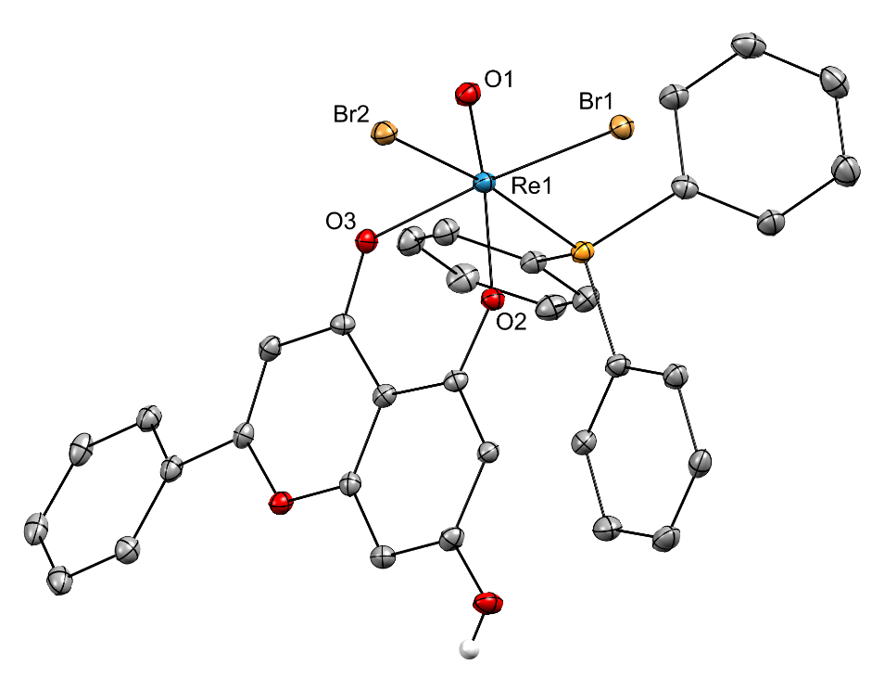
Figure S36. Molecular view of complex 1. Thermal ellipsoids are drawn at the 30% probability level. H atoms were omitted for clarity, except the hydrogen of the hydroxy group.
Table S4. Selected bond lengths (Å) and angles (°) for 1
Re1–Br1 | 2.4826(4) | Re1–O2 | 1.966(2)
Re1–Br2 | 2.5622(4) | Re1–O3 | 2.097(3)
Re1–P1 | 2.4599(10) | O2–C1 | 1.327(4)
Re1–O1 | 1.680(3) | O3–C7 | 1.278(4)
Br1–Re1–Br2 | 90.864(15) | O1–Re1–O2 | 169.07(12)
P1–Re1–Br1 | 89.03(2) | O1–Re1–O3 | 88.21(12)
P1–Re1–Br2 | 171.19(2) | O2–Re1–O3 | 82.48(10)
O1–Re1–Br1 | 98.97(9) | C1–O2–Re1 | 136.3(2)
O1–Re1–Br2 | 99.64(10) | C7–O3–Re1 | 130.4(2)
O1–Re1–P1 | 89.08(10)

Complex 2. All non-hydrogen atoms were refined anisotropically. Hydrogen atom positions were calculated geometrically and refined using the riding model. Since the acetone solvent molecule was disordered, the electron densities were removed from the electron density map by the SQUEEZE treatment using the OLEX2 solvent mask command. A solvent mask was calculated and 70 electrons were found in a volume of 280 Å³ in 1 void per unit cell. This is consistent with the presence of 1 acetone molecule per asymmetric unit which account for 64 electrons per unit cell.
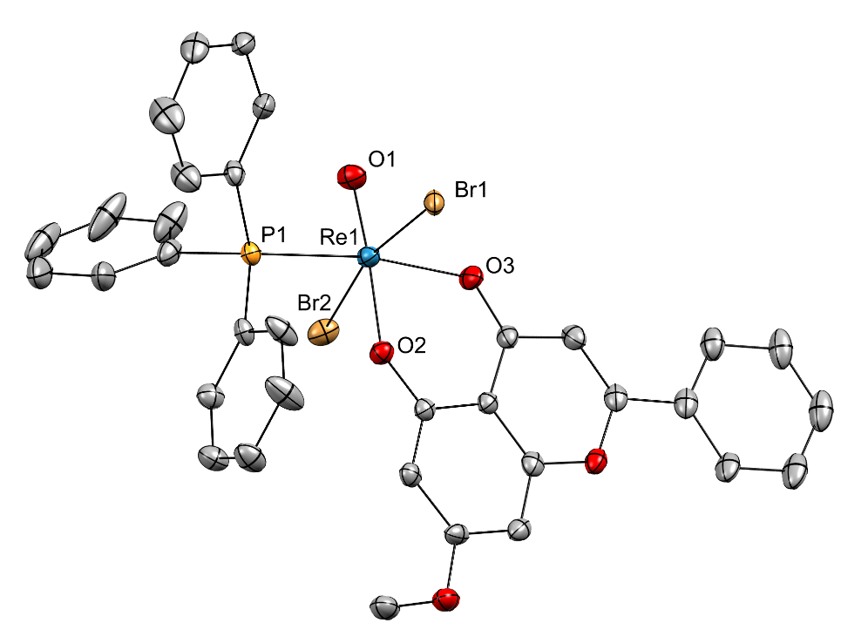
Figure S37. Molecular view of complex 2. Thermal ellipsoids are drawn at the 30% probability level. H atoms and the solvent molecule were omitted for clarity.
Table S5. Selected bond lengths (Å) and angles (°) for 2
Re1–Br1 | 2.5656(6) | Re1–O2 | 1.968(4)
Re1–Br2 | 2.5711(6) | Re1–O3 | 2.064(4)
Re1–P1 | 2.4381(13) | O2–C1 | 1.310(6)
Re1–O1 | 1.674(4) | O3–C7 | 1.272(7)
Br1–Re1–Br2 | 167.90(2) | O1–Re1–O2 | 176.08(19)
P1–Re1–Br1 | 91.69(3) | O1–Re1–O3 | 99.17(18)
P1–Re1–Br2 | 95.50(3) | O2–Re1–O3 | 83.18(16)
O1–Re1–Br1 | 96.43(16) | C1–O2–Re1 | 136.6(3)
O1–Re1–Br2 | 93.06(15) | C7–O3–Re1 | 130.5(3)
O1–Re1–P1 | 91.86(15)

Complex 3. All non-hydrogen atoms were refined anisotropically. Hydrogen atom positions were calculated geometrically and refined using the riding model.
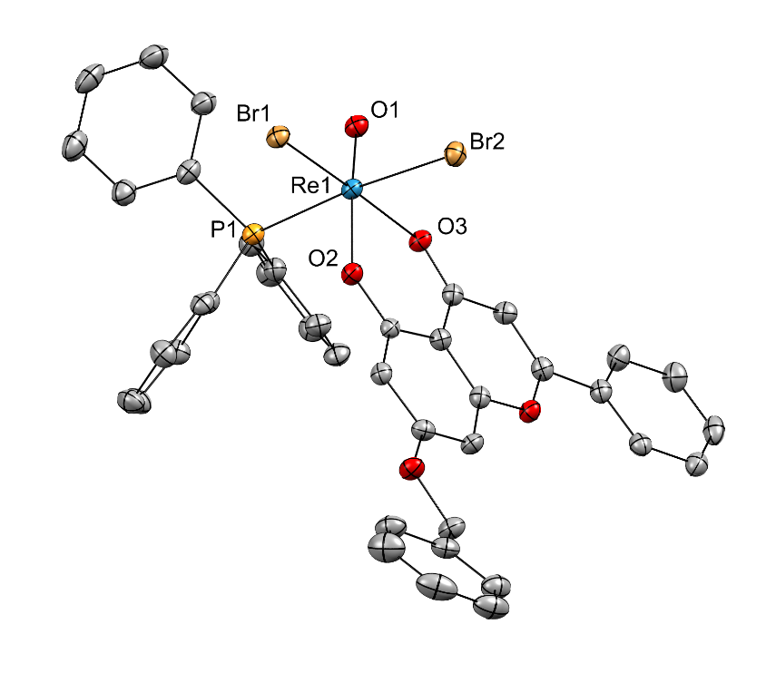
Figure S38. Molecular view of complex 3. Thermal ellipsoids are drawn at the 50% probability level. H atoms and the solvent molecule were omitted for clarity.
Table S6. Selected bond lengths (Å) and angles (°) for 3
Re1–Br1 | 2.4917(3) | Re1–O2 | 1.9751(19)
Re1–Br2 | 2.5589(3) | Re1–O3 | 2.0942(18)
Re1–P1 | 2.4734(7) | O2–C1 | 1.323(3)
Re1–O1 | 1.678(2) | O3–C7 | 1.268(3)
Br1–Re1–Br2 | 89.596(10) | O1–Re1–O2 | 168.90(8)
P1–Re1–Br1 | 91.090(17) | O1–Re1–O3 | 86.94(8)
P1–Re1–Br2 | 174.128(17) | O2–Re1–O3 | 82.92(7)
O1–Re1–Br1 | 100.42(7) | C1–O2–Re1 | 136.35(17)
O1–Re1–Br2 | 96.16(7) | C7–O3–Re1 | 130.76(17)
O1–Re1–P1 | 89.45(7)

Complex 4. All non-hydrogen atoms were refined anisotropically. Hydrogen atom positions were calculated geometrically and refined using the riding model.
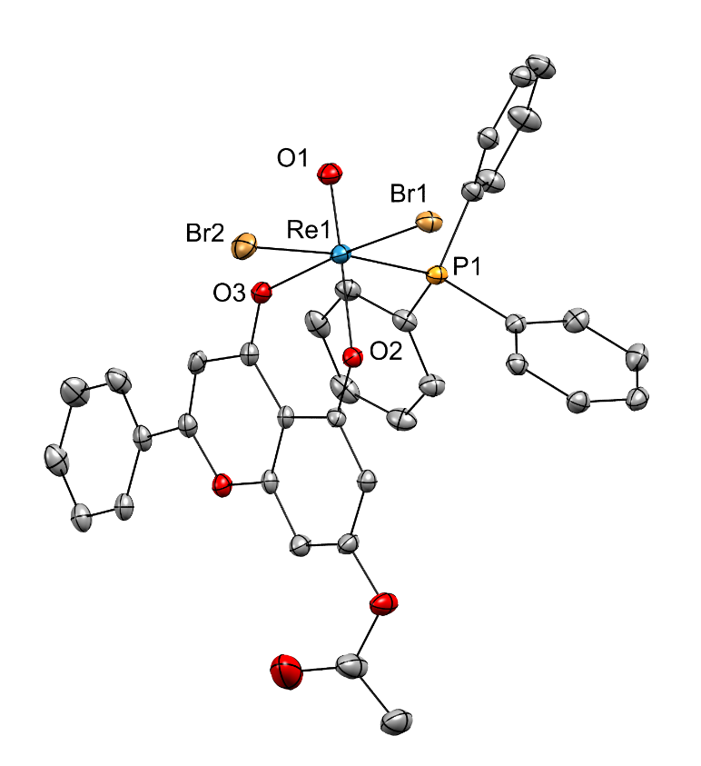
Figure S39. Molecular view of complex 4. Thermal ellipsoids are drawn at the 40% probability level. H atoms and the solvent molecule were omitted for clarity.
Table S7. Selected bond lengths (Å) and angles (°) for 4.
Re1–Br1 | 2.4864(4) | Re1–O2 | 1.996(2)
Re1–Br2 | 2.5388(4) | Re1–O3 | 2.088(2)
Re1–P1 | 2.4790(9) | O2–C1 | 1.330(4)
Re1–O1 | 1.682(2) | O3–C7 | 1.268(4)
Br1–Re1–Br2 | 88.755(14) | O1–Re1–O2 | 166.00(11)
P1–Re1–Br1 | 91.07(2) | O1–Re1–O3 | 88.08(10)
P1–Re1–Br2 | 173.92(2) | O2–Re1–O3 | 81.88(9)
O1–Re1–Br1 | 99.36(8) | C1–O2–Re1 | 135.4(2)
O1–Re1–Br2 | 98.86(9) | C7–O3–Re1 | 131.8(2)
O1–Re1–P1 | 87.17(9)
Complex 5. All non-hydrogen atoms were refined anisotropically. Hydrogen atom positions were calculated geometrically and refined using the riding model.
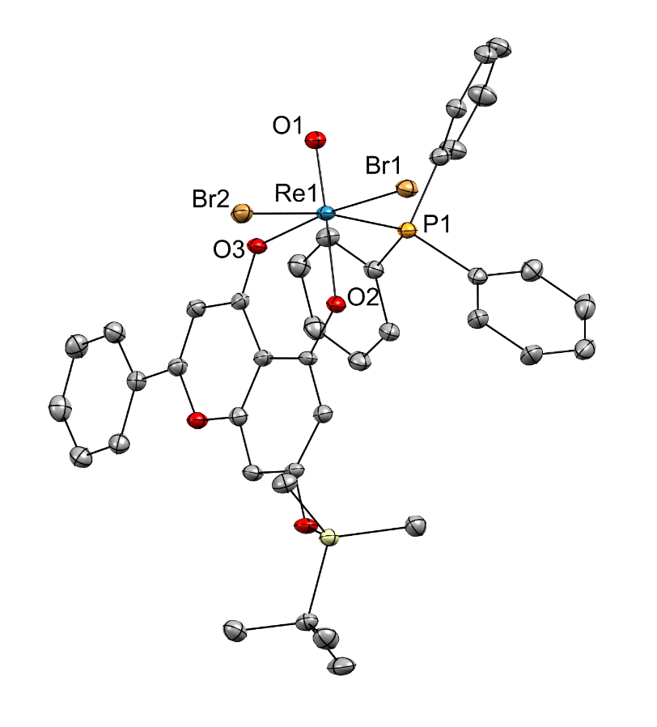
Figure S40. Molecular view of complex 5. The probability ellipsoids are drawn at the 50% probability level. H atoms were omitted for clarity.
Table S9. Selected bond lengths (Å) and angles (°) for 5.
Re1–Br1 | 2.4947(3) | Re1–O2 | 1.978(2)
Re1–Br2 | 2.5541(3) | Re1–O3 | 2.076(2)
Re1–P1 | 2.4703(8) | O2–C1 | 1.339(3)
Re1–O1 | 1.674(2) | O3–C7 | 1.270(4)
Br1–Re1–Br2 | 88.718(12) | O1–Re1–O2 | 169.81(10)
P1–Re1–Br1 | 92.141(19) | O1–Re1–O3 | 89.39(9)
P1–Re1–Br2 | 171.325(19) | O2–Re1–O3 | 82.67(8)
O1–Re1–Br1 | 98.66(7) | C1–O2–Re1 | 136.75(19)
O1–Re1–Br2 | 99.91(8) | C7–O3–Re1 | 132.82(19)
O1–Re1–P1 | 88.50(8)

References

(1) CrysalisPro, Rigaku Oxford Diffraction. 2024.
(2) Sheldrick, G. M. SHELXT - integrated space-group and crystal-structure determination. Acta Cryst. A 2015, 71 (Pt 1), 3–8.
(3) Dolomanov, O. V.; Bourhis, L. J.; Gildea, R. J.; Howard, J. A. K.; Puschmann, H. OLEX2 : a complete structure solution, refinement and analysis program. J. Appl. Crystallogr. 2009, 42, 339–341.
(4) Sheldrick, G. M. Crystal structure refinement with SHELXL. Acta Cryst. C 2015, 71 (Pt 1), 3–8.

