Appendix A. Causal loop diagrams of factors shaping Veteran health and safety
Diagram 1: Health consequences of service
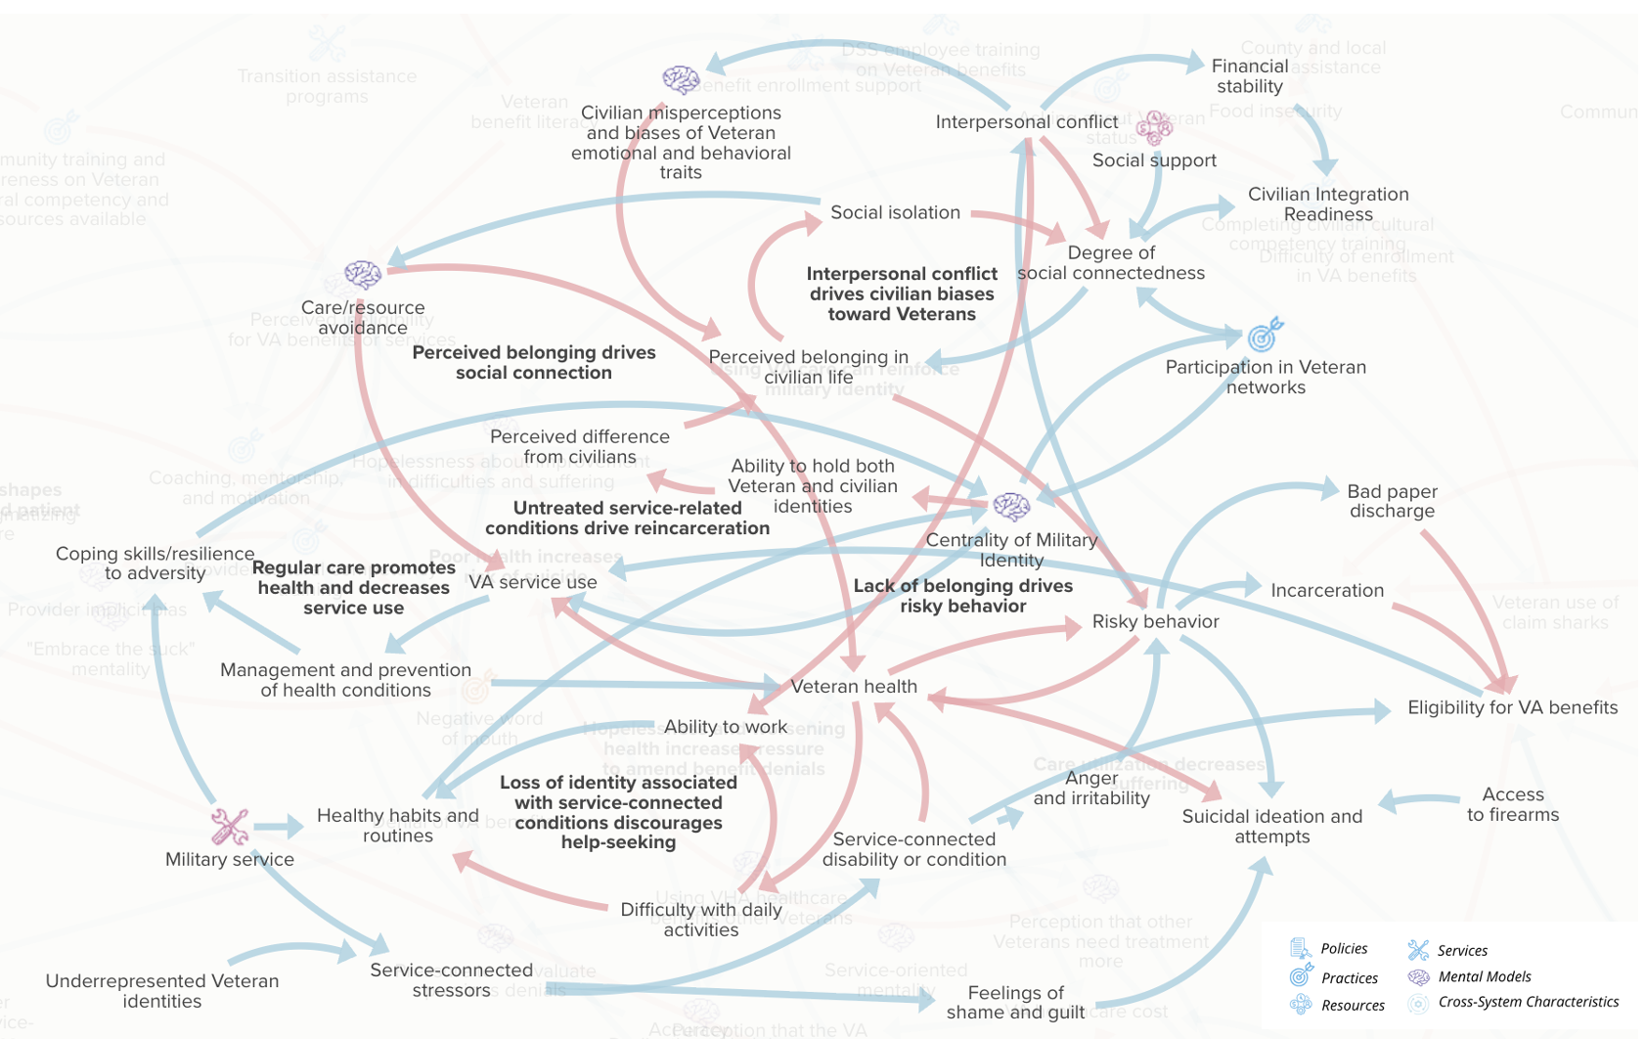
Diagram 2: Supporting a successful transition to civilian life
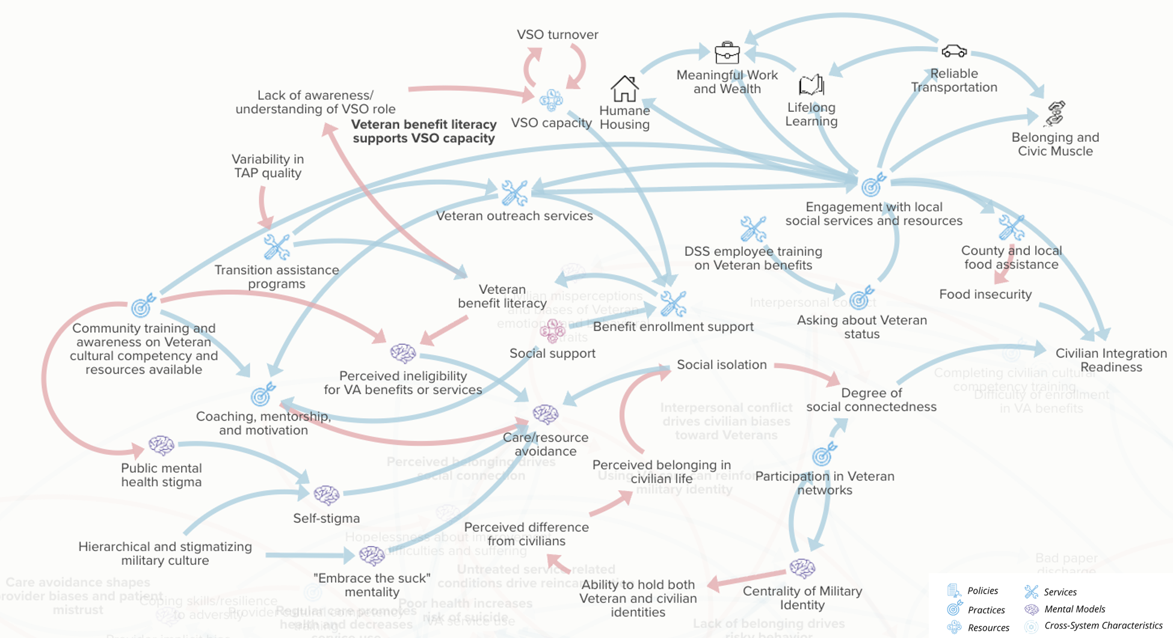
Diagram 3: Care-seeking behaviors and barriers to eligibility
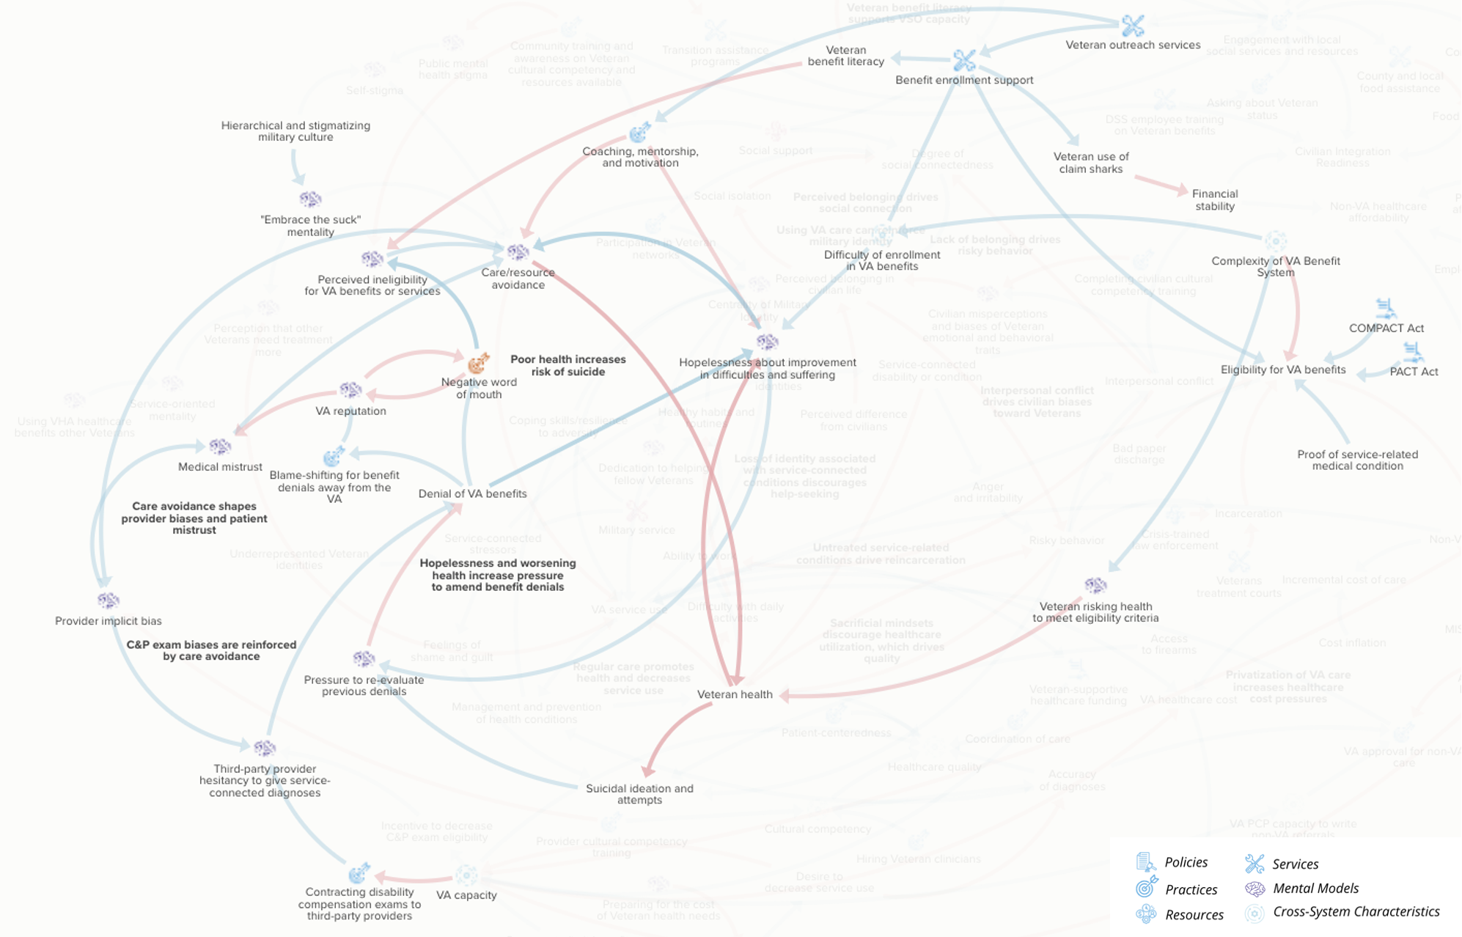
Diagram 4: Enrollment and utilization of health services
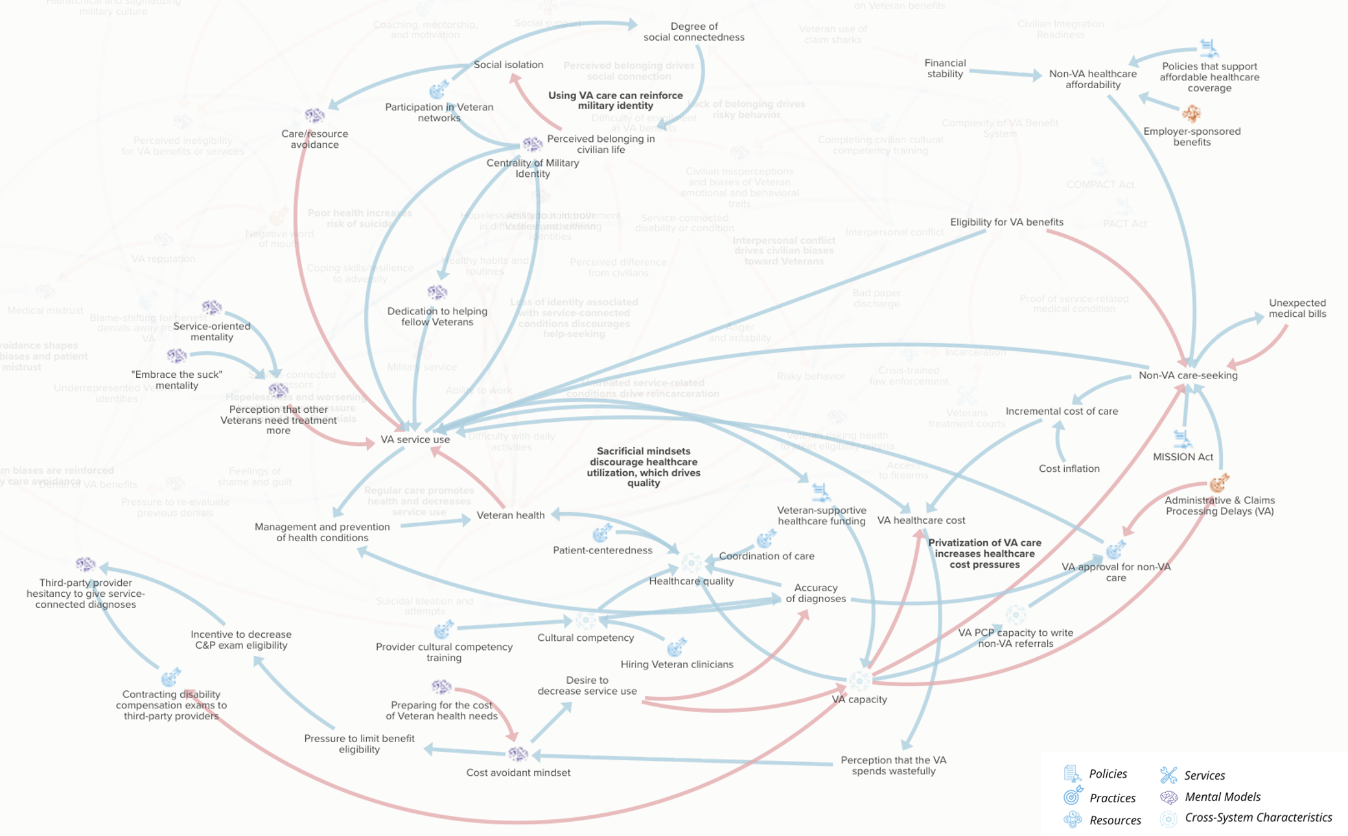
Legend: Casual loop diagrams depicting determinants of Veteran health and safety. Causal linkages were informed by a primary literature review and supplemented through feedback sessions with Veterans, community members supporting Veterans, and experts. Blue arrows demonstrate positive polarity; red arrows demonstrate negative polarity. A slideshow walkthrough of the diagram, with descriptions of variables and supporting evidence, is publicly available (48).

