Supplementary data
A Green Protocol for the Electrochemical Synthesis of a Fluorescent Dye with Antibacterial Activity from Imipramine Oxidation
Zahra Souri¹, Mahmood Masoudi Khoram², Davood Nematollahi^{*2}, Mohammad Mazloum-Ardakani¹, & Hojjat Alizadeh³
¹Department of Chemistry, Faculty of Science, Yazd University, Yazd, Iran. ²Faculty of Chemistry, Bu-Ali Sina University, Hamedan, Iran. Zip Code 65178-38683. ³Rooyana Veterinary Laboratory, Saqqez, Kurdistan, Iran. E-mail: nemat@basu.ac.ir. Fax: 0098 - 813- 8257407, Tel: 0098 - 813- 8282807

Table of contents
No. |  | Page
1 | IR spectrum of IMP | S3
2 | IR spectrum of DIMP | S4
3 | ¹H NMR spectrum of DIMP | S5
4 | Expanded ¹H NMR spectrum of DIMP | S6
5 | ¹³C NMR spectrum of DIMP | S7
6 | MS spectrum of DIMP | S8

FTIR spectrum of IMP
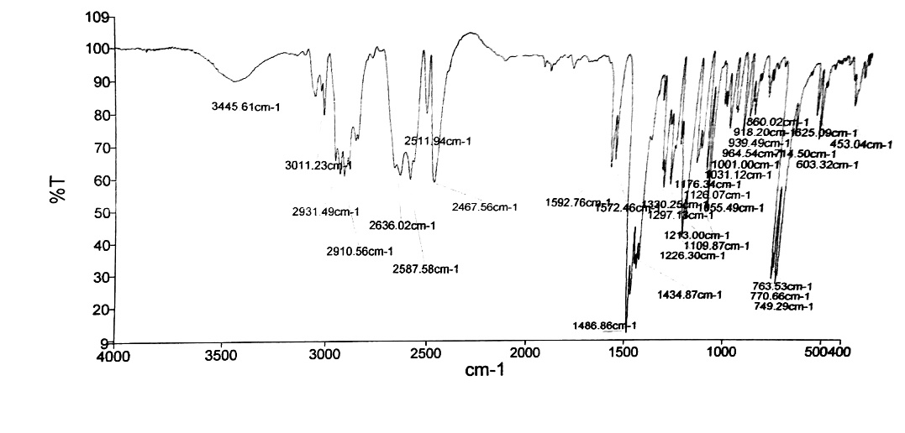
Figure S1. FTIR spectrum of IMP.

IR spectrum of DIMP
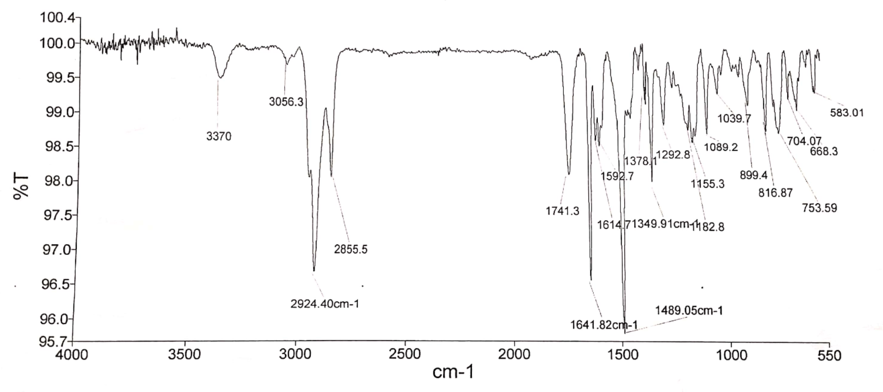
Figure S2. FTIR spectrum of DIMP.

¹H NMR spectrum of DIMP
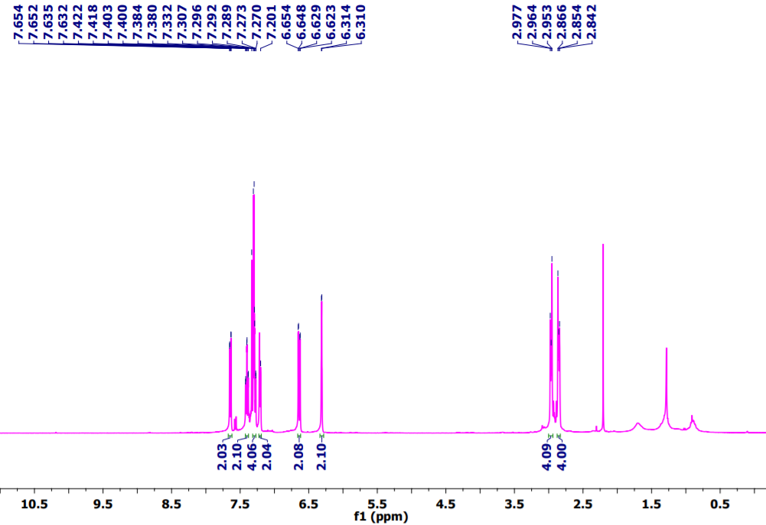
Figure S3. ¹H NMR spectrum of DIMP.

Expanded ¹H NMR spectrum of DIMP
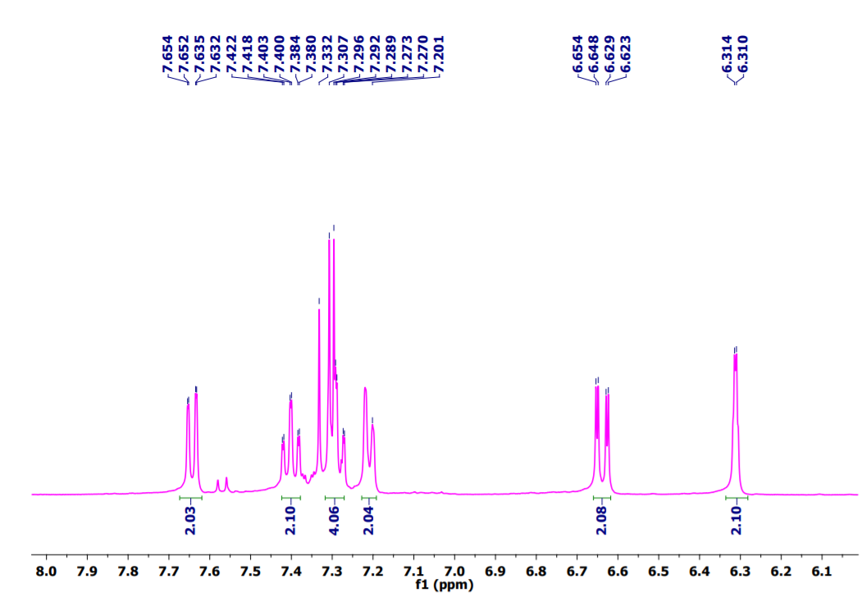
Figure S4. Expanded ¹H NMR spectrum of DIMP.

¹³C NMR spectrum of DIMP
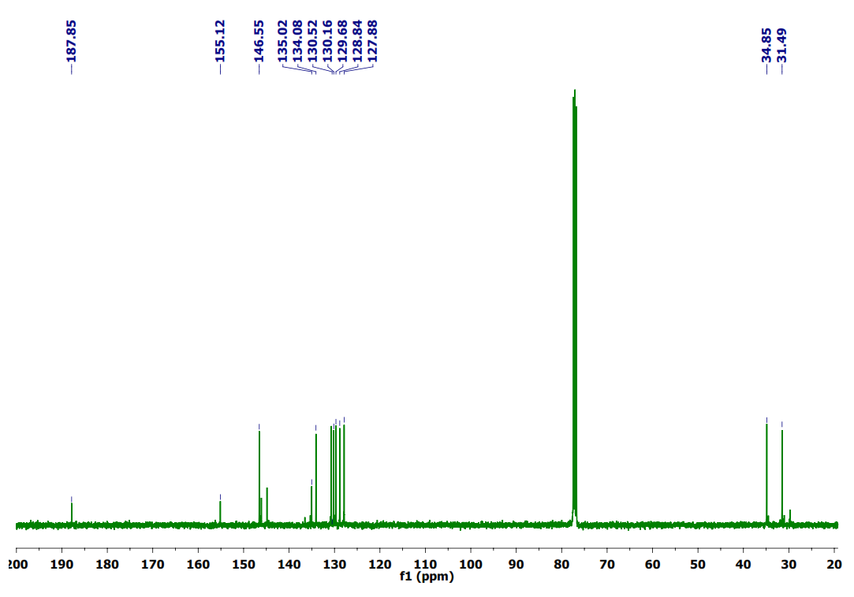
Figure S5. ¹³C NMR spectrum of DIMP.

MS spectrum of DIMP
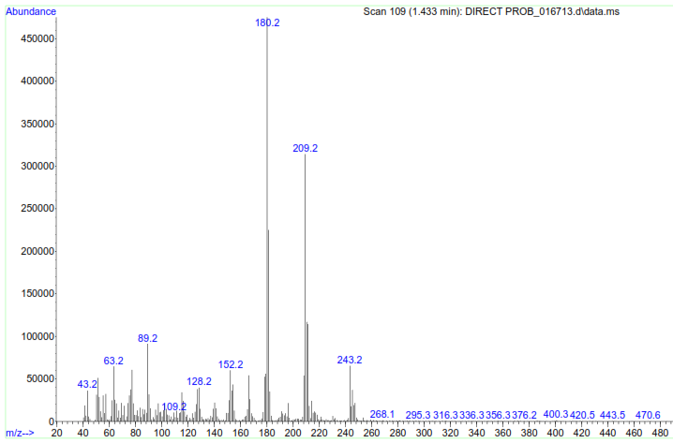
Figure S6. MS spectrum of DIMP.

