Supplementary Materials
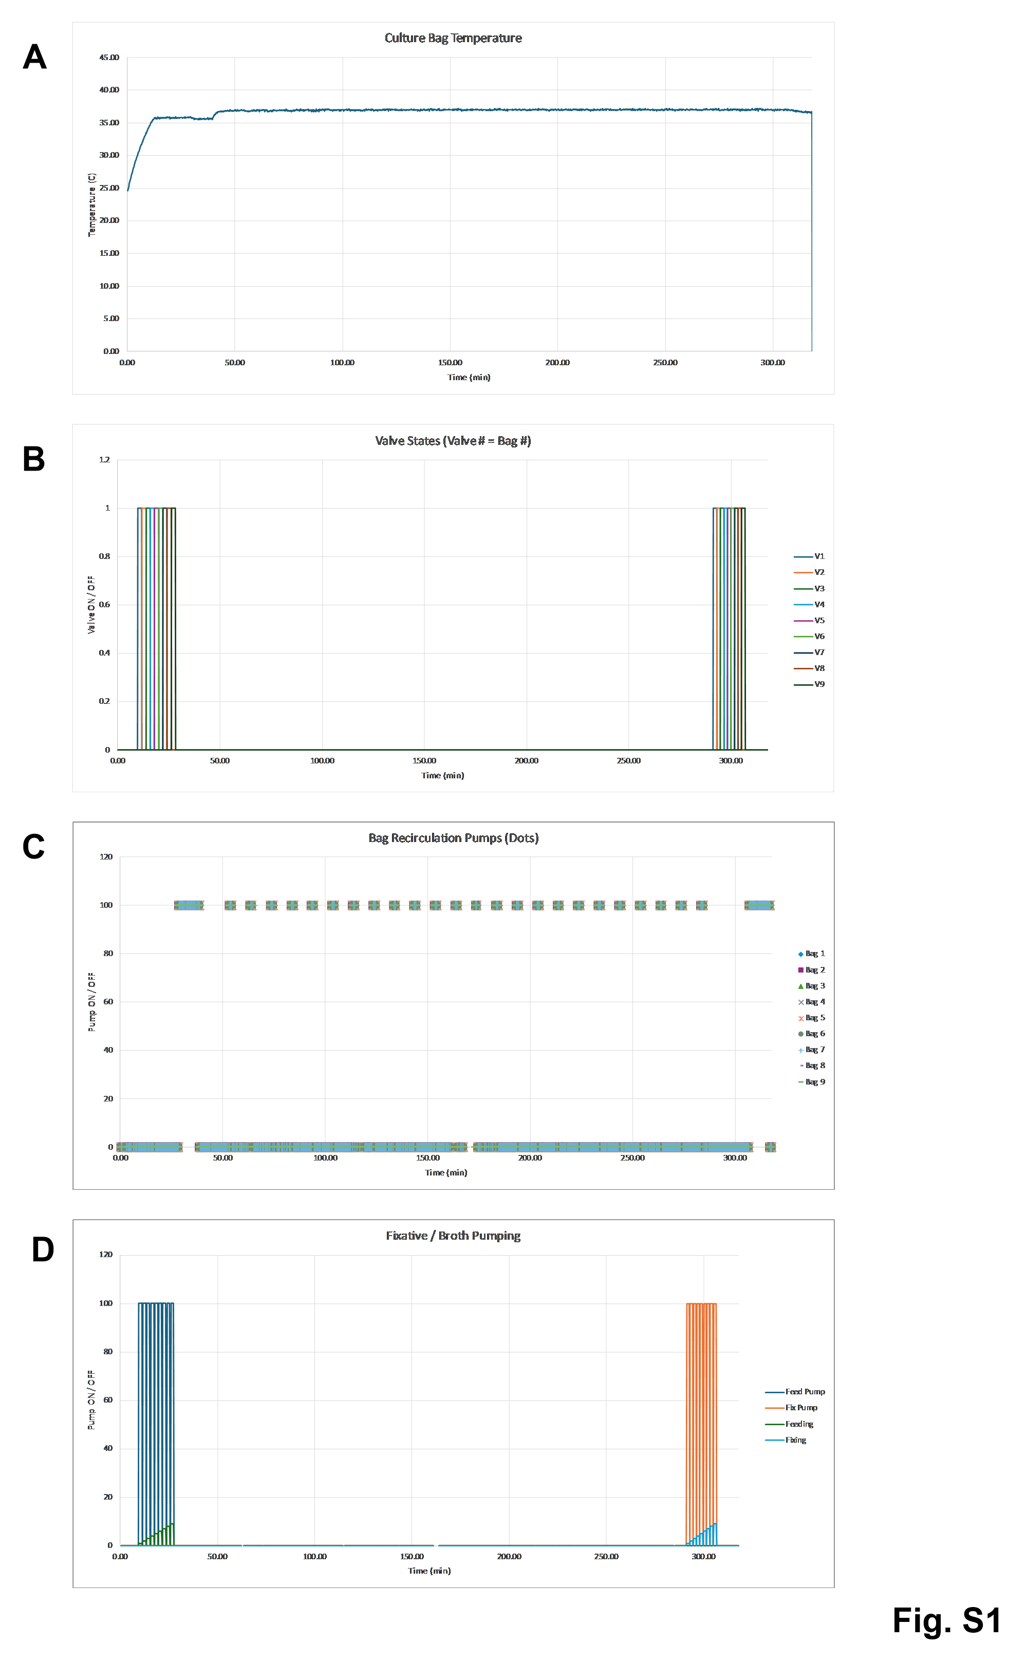
Supplementary Figure S1. The log of the temperature, pumps, and valves of the SpaceTango 6U CubeLab bioreactor during the spaceflight experiment. (A) The plot of the temperature of the incubation plate, which the culture bags were attached to over the duration of the flight experiment. (B) The sequential opening of valves to each culture bag at the start of the experiment to introduce LB broth and at the end to introduce the glycerol. (C) The duration and frequency of the recirculation pumps of bags 1 – 9 along spaceflight. (D) the media pump (#10) and fixative pump (#11) running at the start and end of the culture duration. The pump numbers refer to the flow diagram from Figure 1A.

Supplementary Table S1. Gene-specific primers used for RT-qPCR analysis.

Gene | Sequence (5’ to 3’) | Amplicon size
rpoD FW | GGTCTGACCATCGAACAGGTG | 185 bp
rpoD Rev | ATCAGACCGATGTTGCCTTC | 185 bp
hilA Fw | TACAGCAAGCGCTTAAATTGCT | 109 bp
hilA_Rev | ATCCCCATTTGCGCCATGCT | 109 bp
hilD_Fw | CCCACAGAGAAAGCGCAGA | 129 bp
hilD Rev | GTTGTTACAGTTACTGCAACCT | 129 bp
sopB Fw | GGGAAAGGGCGTATGCAGT | 123 bp
sopB Rev | CCATGACGTATCCCGCAAA | 123 bp
sopE2_Fw | CGAGCATAGGCCGGATCTTT | 124 bp
sopE2 Rev | ATCGTGGGAACGCTTCTGAG | 124 bp
invA_Fw | TCCGCTAATTTGATGGATCTCA | 132 bp
invA Rev | ATCCGGAAAACGACCTTCAATC | 132 bp
invC Fw | AAAAACGCGGCTTACGCTTT | 144 bp
invC Rev | CTGCTGGAAAGCGAGGAAGA | 144 bp
invF Fw | ACTCGCAGCGTTTACGATCT | 112 bp
invF Rev | GCATTTATCGATGGCGCAGG | 112 bp

Supplementary Table S2. E. coli DEGs (full DESeq2 results) between spaceflight and ground-control.

Supplementary Table S3. S. bongori DEGs (full DESeq2 results) between spaceflight and ground-control.

Supplementary Table S4. S. Typhimurium DEGs (full DESeq2 results) between spaceflight and ground-control.

