Would you like to talk?

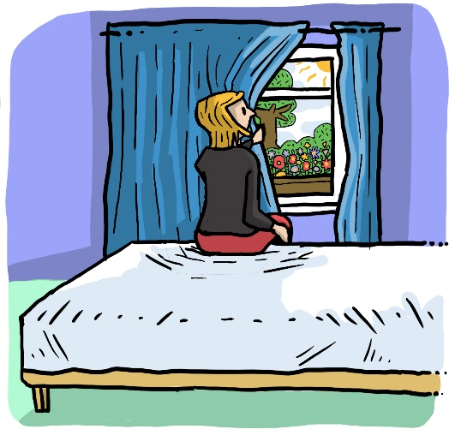

Sometimes we don’t want to talk because we feel too distressed or we don’t have the right words to say.

That is okay. Many people feel this way.

But it’s important to catch the moment if you feel like talking.

If that feeling comes, slide the card on the front of your door to green and a nurse will arrange some time to have a chat with you.



Room | Name of patient | Sign colour | Have you engaged? | 9 | 10 | 11 | 12 | 13 | 1330 | 14 | 15 | 16 | 17 | 18 | 19 | 20 | 21 | 22 | 23 | 00 | 01 | 02 | 03 | 04 | 05 | 06 | 07 | 0730
1
2
3
4
5
6
7
8
9
10
11
12
13
14
15
16
17
Sleep over
O/L
O/L
No. of patients off the ward
No. of patients on the ward
Initials of nurse

Codes to record patients’ whereabouts and therapeutic engagement needs
INT – interview room | CLR – clinical room | SEC – seclusion | AW – AWOL | SIC – sitting in chair | SICA – sitting in chair asleep
C – corridor | MDT – meeting/ ward round | STM – St. Marys | EL – escorted leave | SOB – sitting on bed | COM – male computer area
BAL – balcony | DR – dining room | GYM – gym | UL – unescorted leave | If lying or under covers:
GR – group room | OT – OT group | ADL – ADL kitchen | CL – community leave | LS – left side | RS – right side
TV – television lounge | L – laundry | B – bathroom | OL – overnight leave | BK – back | F – front
NO – nursing office | FL – female lounge | S – shower | IF NO MOVEMENT OR CHANGE ENTER ROOM AND CHECK ON PATIENT
DO – doctor’s office | FLB – female balcony | T – toilet
Colour of engagement sign: | G – Green | B – Blank
If sign is green: | Y – needs have been met | N – still requires therapeutic engagement | N/A – sign is blank | If unable to engage immediately, tell patient what you will do to address their needs

