Figure 2C
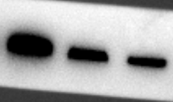
ShUSP8-USP8
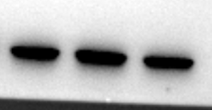
ShUSP8-GAP

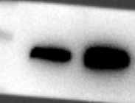
OEUSP8-USP8
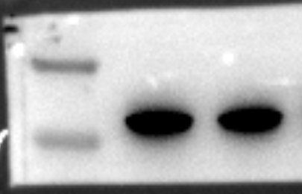
OEUSP8-GAP

Figure 5C
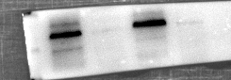
USP8
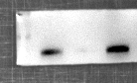
PRSS35

Figure 5D
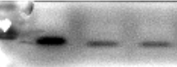
USP8
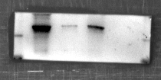
PRSS35

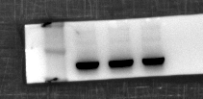
GAP

Figure 5F
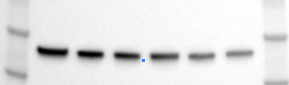
NC-PRSS35

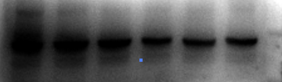
NC-USP8
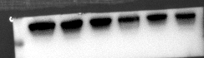
NC-GAP
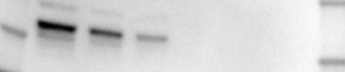
ShUSP8-PRSS35
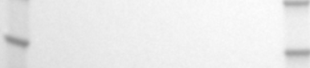
ShUSP8-USP8
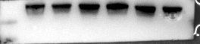
ShUSP8-GAP

Figure 5G
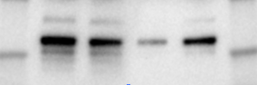
PRSS35
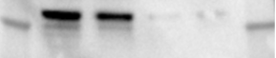
USP8

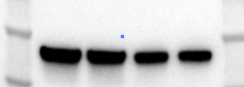
GAP

Figure 5H
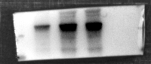
USP8
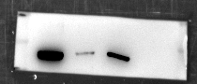
CXCL2

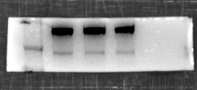
GAP

Figure S1 Raw image of WB

Gene name | Forward sequence (5' -> 3') | Reverse sequence (5' -> 3')
USP8 | TCAGCTCCGTCAACATCTGC | CGCGTGCTCTGGTCATAGA
CXCL2 | CCAACCACCAGGCTACAGG | GCGTCACACTCAAGCTCTG
PRSS35 | GGTGGACCCTCATTGATGGAT | CATTCGATGCCACACACTGTAT
CD8 | AAACTCGCATCTACTGGCAAA | GGTTCTTGTACTCGGGCCATA
GAPDH | GGAGCGAGATCCCTCCAAAAT | GGCTGTTGTCATACTTCTCATGG

Table S2 Details of used primers.

