Supplementary Information
Risk-service mismatches reveal conservation and restoration priorities in China's major urban agglomerations
Supplementary Fig. S1 Changes in ESV hotspots and coldspots in the three urban agglomerations from 2000 to 2020.
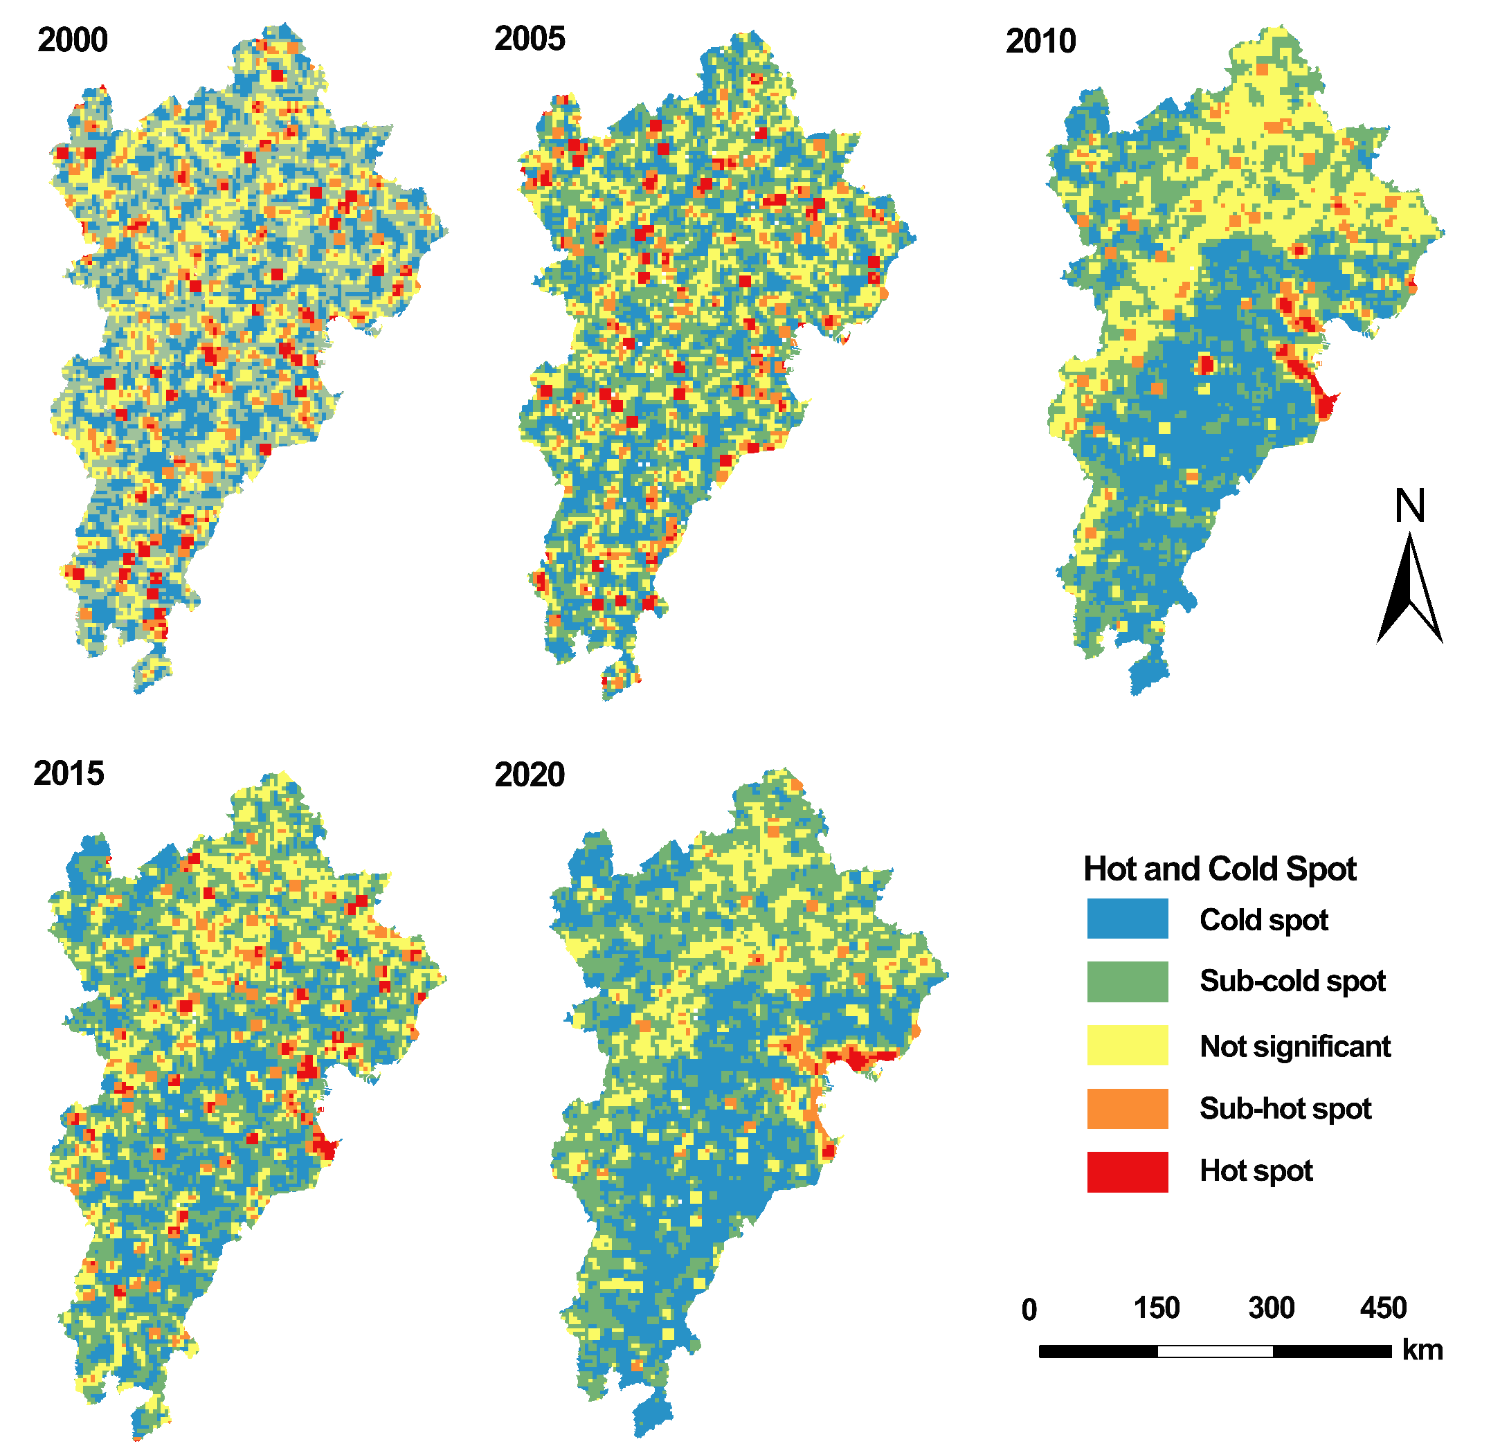
Beijing-Tianjin-Hebei region
(b)Yangtze River Delta
(c)Guangdong-Hong Kong-Macao Greater Bay Area

