eFigure 1. Subgroup analysis of the association between PEF and hip fracture risk.
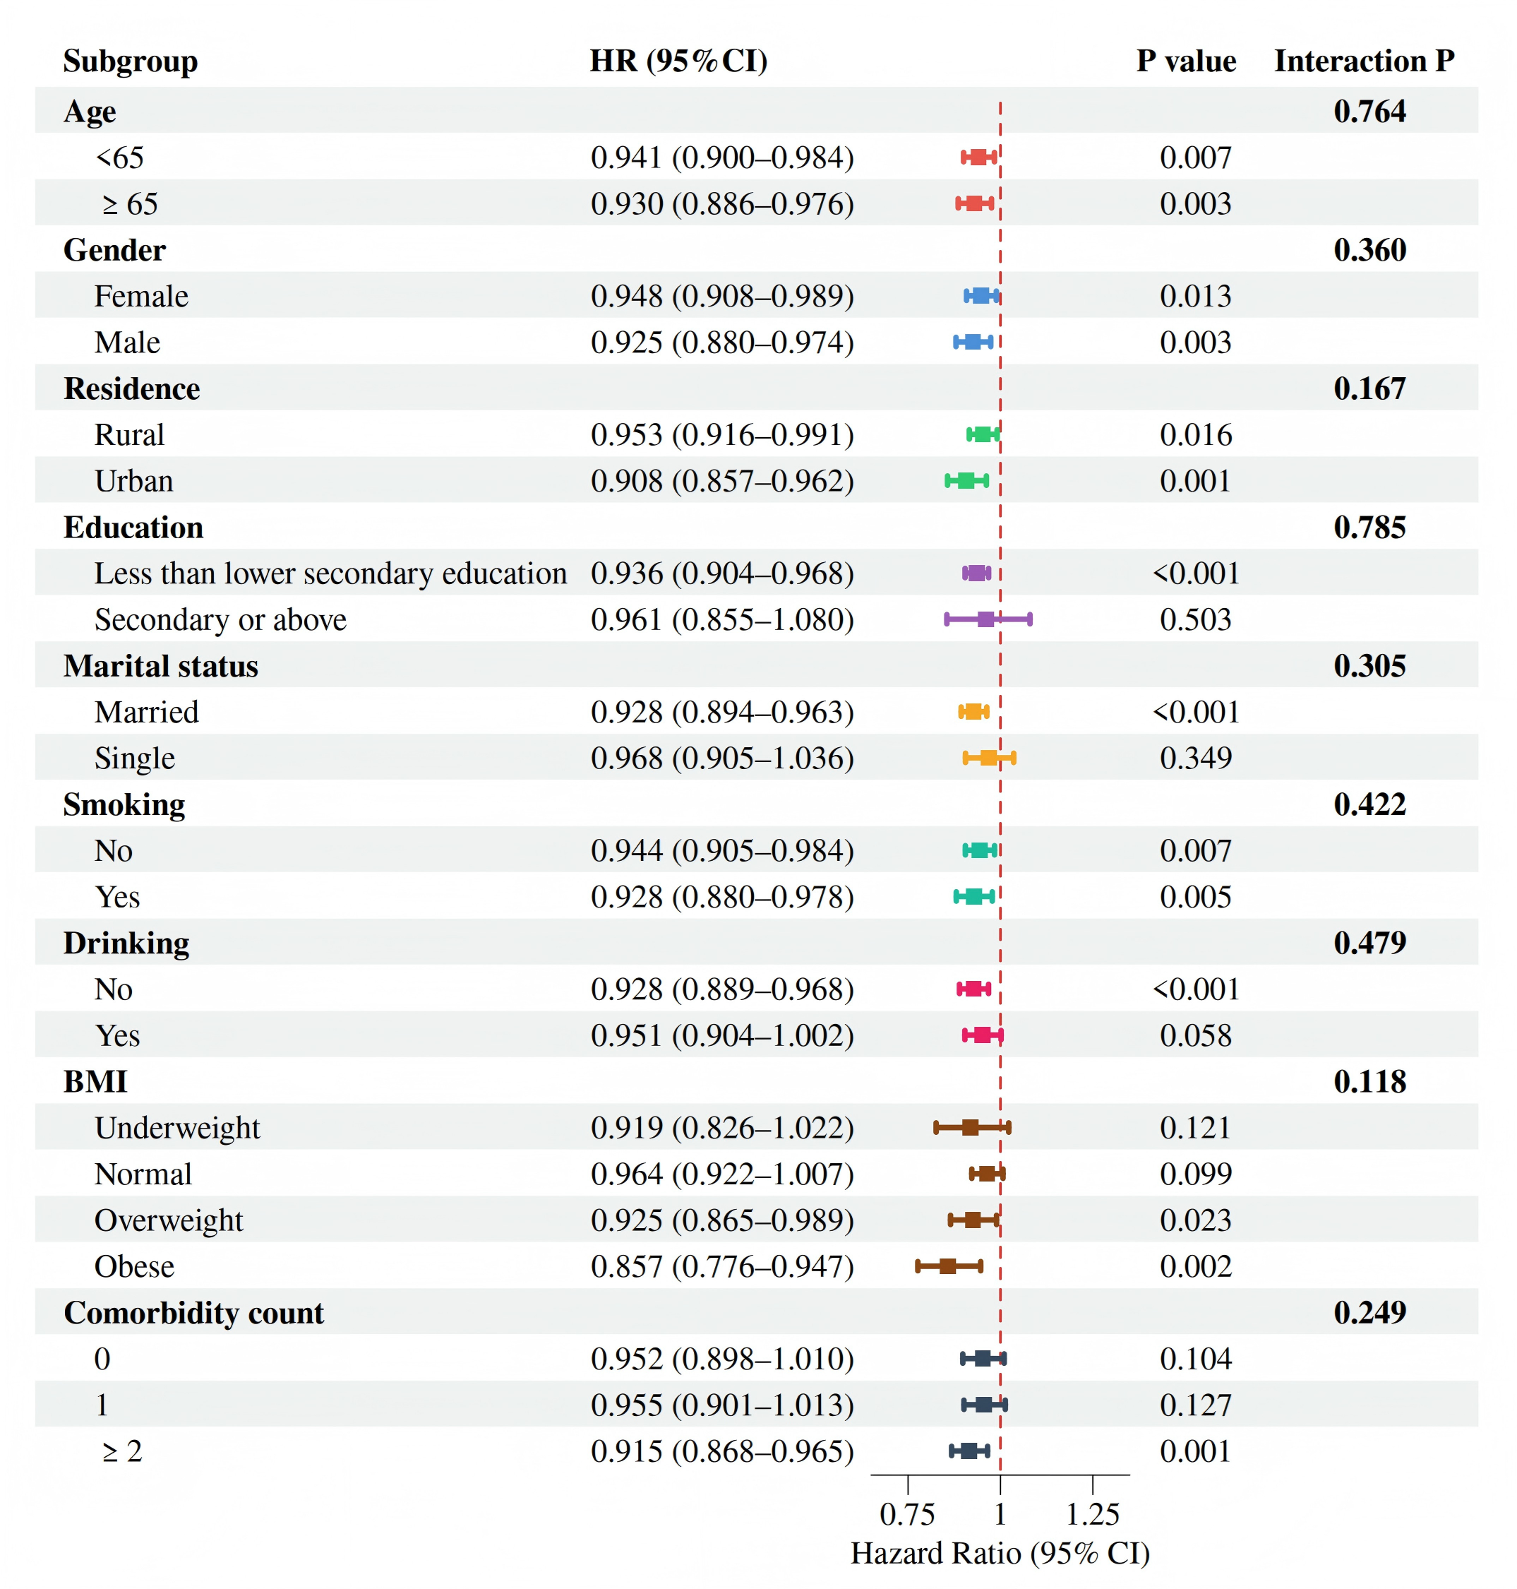
Forest plot depicting the association between baseline PEF (per 10% predicted) and incident hip fracture risk across nine prespecified subgroups. All estimates were derived from Model 3 (adjusted for age, gender, education level, marital status, residence, smoking, drinking, BMI category, and comorbidity count). Squares represent hazard ratios, horizontal lines indicate 95% confidence intervals. The dashed vertical line represents HR = 1. P values for interaction were derived from likelihood ratio tests comparing models with and without the interaction term.
eTable 1. Sensitivity analyses for the association between PEF and hip fracture risk.
Sensitivity analysis | HR (95% CI) | P value | E-value
E-value: Q2 vs Q1 | 0.868 (0.683–1.103) | 0.247 | 1.571 (—)
E-value: Q3 vs Q1 | 0.646 (0.495–0.842) | 0.001 | 2.469 (lower CI: 1.660)
E-value: Q4 vs Q1 | 0.695 (0.538–0.897) | 0.005 | 2.234 (lower CI: 1.473)
Excluding hip fractures at first follow-up wave
Q2 vs Q1 | 0.909 (0.702–1.178) | 0.471
Q3 vs Q1 | 0.629 (0.469–0.843) | 0.002
Q4 vs Q1 | 0.727 (0.551–0.958) | 0.023
60% clinical cutoff (<60% vs ≥60%) | 0.745 (0.615–0.902) | 0.003
All models were adjusted for age, gender, education level, marital status, residence, smoking, drinking, BMI category, and comorbidity count (Model 3).
E-value represents the minimum strength of association that an unmeasured confounder would need to have with both PEF and hip fracture to fully explain away the observed association. — indicates the CI crosses the null.
Excluding first 2 years removes participants with hip fracture within the first 2 years of follow-up to address potential reverse causation.
60% clinical cutoff: PEF <60% predicted vs ≥60% predicted, a clinical threshold indicating severe ventilatory impairment.
Abbreviations: PEF, peak expiratory flow; HR, hazard ratio; CI, confidence interval.

eTable 2. Baseline characteristics of the trajectory subcohort by PEF trajectory group.
Characteristic | Low-stable (n=1276) | Moderate-stable (n=3712) | High-stable (n=739) | P value
PEF Wave 1, median [IQR] | 50.582 [38.129, 63.737] | 81.945 [67.440, 94.713] | 112.358 [100.257, 123.397] | <0.001
Age, y (mean ± SD) | 59.757 (8.573) | 57.508 (8.126) | 60.118 (9.122) | <0.001
Gender, n (%) |  |  |  | 0.037
Female | 684 (53.605) | 2034 (54.784) | 367 (49.662)
Male | 592 (46.395) | 1678 (45.216) | 372 (50.338)
Residence, n (%) |  |  |  | <0.001
Rural | 910 (71.317) | 2560 (68.966) | 461 (62.382)
Urban | 366 (28.683) | 1152 (31.034) | 278 (37.618)
Education(n,%) |  |  |  | <0.001
Less than lower secondary education | 1216 (95.298) | 3318 (89.386) | 624 (84.438)
Secondary or above | 60 (4.702) | 394 (10.614) | 115 (15.562)
Marital status(n,%) |  |  |  | <0.001
Single | 188 (14.734) | 340 (9.159) | 70 (9.472)
Married | 1088 (85.266) | 3372 (90.841) | 669 (90.528)
Smoking, n (%) |  |  |  | 0.010
No | 742 (58.150) | 2333 (62.850) | 464 (62.788)
Yes | 534 (41.850) | 1379 (37.150) | 275 (37.212)
Drinking, n (%) |  |  |  | 0.503
No | 773 (60.580) | 2306 (62.123) | 447 (60.487)
Yes | 503 (39.420) | 1406 (37.877) | 292 (39.513)
BMI, n (%) |  |  |  | <0.001
Underweight | 149 (11.677) | 179 (4.822) | 21 (2.842)
Normal | 698 (54.687) | 1987 (53.539) | 331 (44.790)
Overweight | 318 (24.922) | 1097 (29.553) | 268 (36.265)
Obese | 111 (8.699) | 449 (12.090) | 119 (16.103)
Comorbidity count, n (%) |  |  |  | 0.017
0 | 410 (32.132) | 1380 (37.177) | 257 (34.777)
1 | 414 (32.445) | 1137 (30.633) | 245 (33.153)
≥2 | 452 (35.423) | 1195 (32.193) | 237 (32.070)
Hip fracture during follow-up, n (%) |  |  |  | 0.010
No | 1239 (97.100) | 3639 (98.033) | 732 (99.053)
Yes | 37 (2.900) | 73 (1.967) | 7 (0.947)
Data are presented as median [IQR], mean (SD), or n (%).
P values were derived from ANOVA, Kruskal-Wallis, or chi-square tests as appropriate.
PEF trajectory groups were identified using group-based trajectory modelling (GBTM) based on three waves of PEF measurements (2011, 2013, 2015).
Abbreviations: PEF, peak expiratory flow; BMI, body mass index.

eFigure 2. PEF trajectory patterns and group assignment.

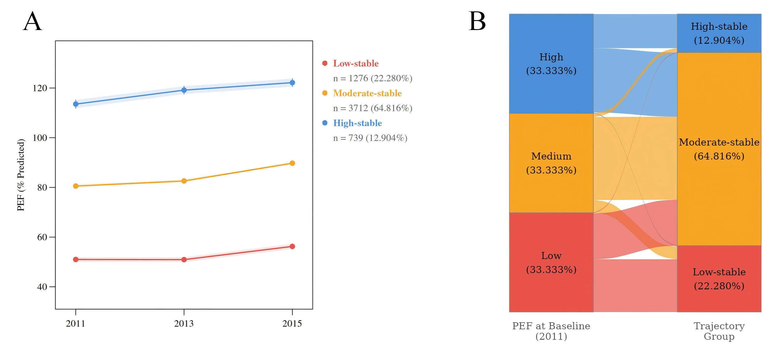
(A) Group-based trajectory modelling identified three distinct PEF trajectory patterns over the 2011-2015 waves: Low-stable (22.280%), Moderate-stable (64.815%), and High-stable (12.905%). Lines represent mean predicted PEF values, with shaded bands indicating 95% confidence intervals. (B) Alluvial diagram illustrating the transition from baseline PEF quartiles to trajectory group assignment.

eFigure 3. Cumulative incidence of hip fracture by PEF trajectory group.
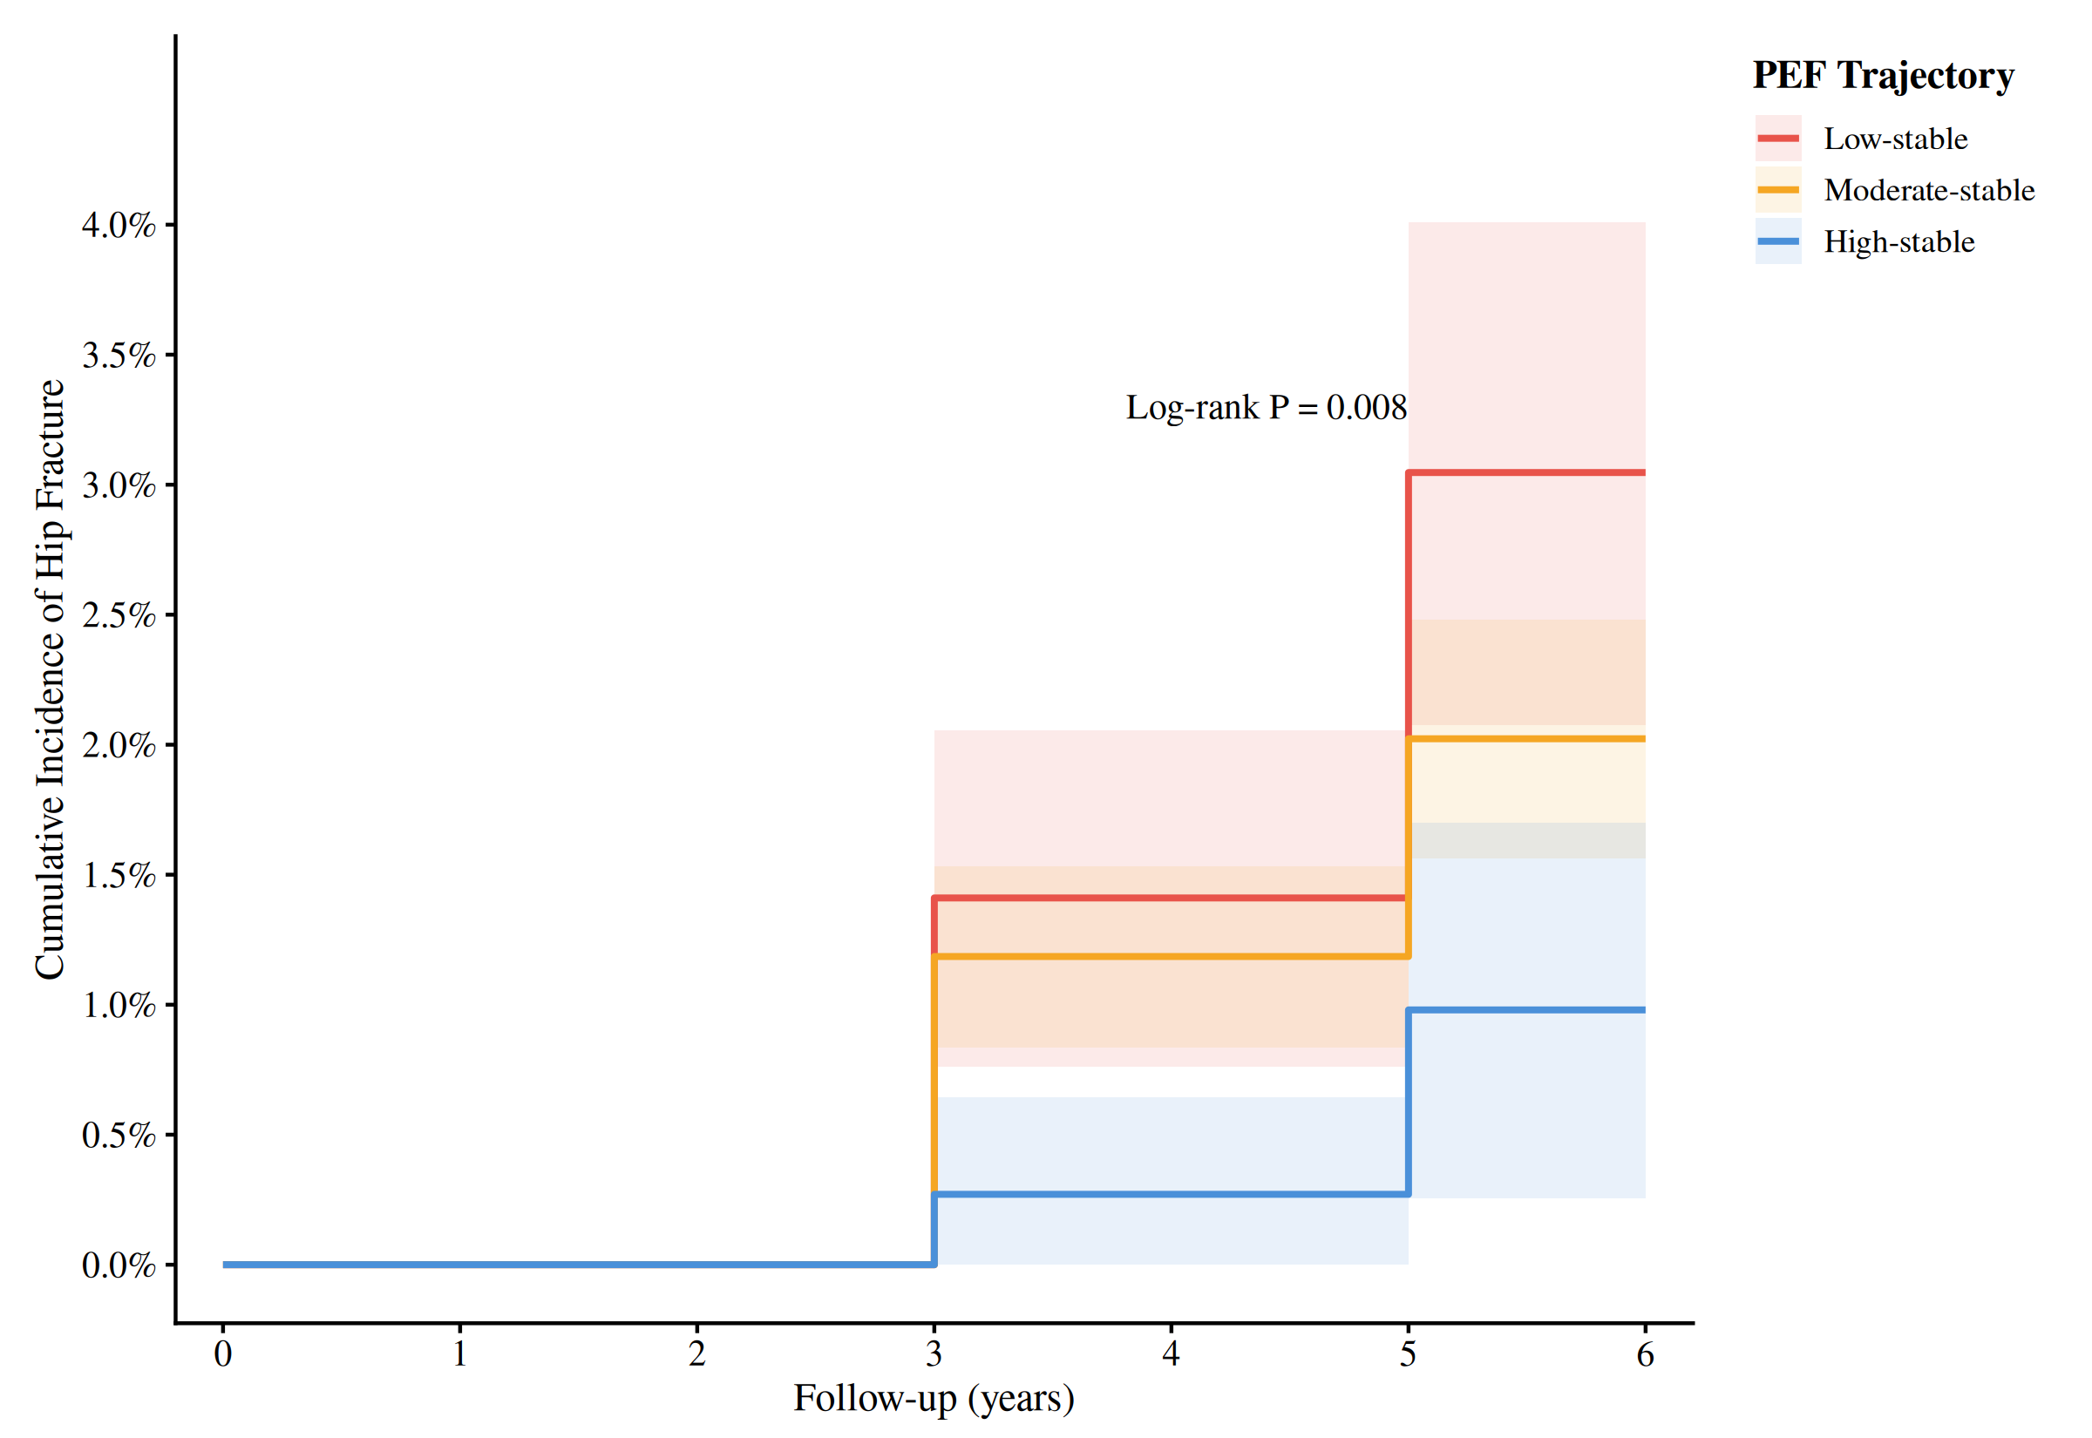Kaplan–Meier cumulative incidence curves for hip fracture according to PEF trajectory groups (Low-stable, n=1,276; Moderate-stable, n=3,712; High-stable, n=739). Trajectory groups were identified using group-based trajectory modelling (GBTM) based on three waves of PEF measurements (2011, 2013, 2015). Shaded bands represent 95% confidence intervals.
eTable 3. Baseline characteristics of the mediation subcohort by ADL status.
Characteristic | Non-ADL 2013 (n=8,191) | ADL 2013  (n=1,636) | P value
PEF, median [IQR] | 78.633 [58.593, 96.232] | 70.762 [52.087, 91.984] | <0.001
Age, y (mean ± SD) | 57.875 (8.673) | 62.276 (9.186) | <0.001
Gender, n (%) |  |  | <0.001
Female | 4168 (50.885) | 994 (60.758)
Male | 4023 (49.115) | 642 (39.242)
Residence, n (%) |  |  | <0.001
Rural | 5229 (63.838) | 1151 (70.355)
Urban | 2962 (36.162) | 485 (29.645)
Education(n,%) |  |  | <0.001
Less than lower secondary education | 7220 (88.146) | 1546 (94.499)
Secondary or above | 971 (11.854) | 90 (5.501)
Marital status(n,%) |  |  | <0.001
Single | 834 (10.182) | 295 (18.032)
Married | 7357 (89.818) | 1341 (81.968)
Smoking, n (%) |  |  | <0.001
No | 4880 (59.578) | 1061 (64.853)
Yes | 3311 (40.422) | 575 (35.147)
Drinking, n (%) |  |  | 0.004
No | 4911 (59.956) | 1044 (63.814)
Yes | 3280 (40.044) | 592 (36.186)
BMI, n (%) |  |  | <0.001
Underweight | 487 (5.946) | 149 (9.108)
Normal | 4396 (53.669) | 784 (47.922)
Overweight | 2387 (29.142) | 465 (28.423)
Obese | 921 (11.244) | 238 (14.548)
Comorbidity count, n (%) |  |  | <0.001
0 | 3135 (38.274) | 253 (15.465)
1 | 2598 (31.718) | 524 (32.029)
≥2 | 2458 (30.009) | 859 (52.506)
Hip fracture during follow-up, n (%) |  |  | <0.001
No | 7943 (96.972) | 1520 (92.910)
Yes | 248 (3.028) | 116 (7.090)
P values were derived from Wilcoxon rank-sum test (PEF), t-test (age), and chi-square tests (categorical variables).
Abbreviations: ADL, activities of daily living; PEF, peak expiratory flow; BMI, body mass index

