Supplementary information

Figure. S1. STEM images of AgCuCC catalyst and EDX mappings.

Figure S2. PXRD spectra acquired at room temperature for Ag₅₀Cu₅₀CC 150.4 heated at: 400 °C for 40 min (a), 300 °C for 40 min (b) and as-synthesized (c), Carbon cloth (d).

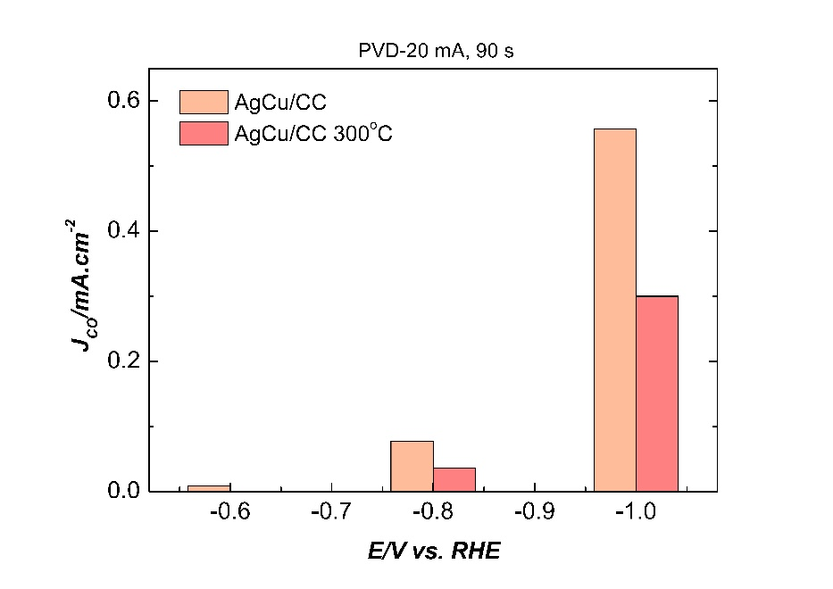
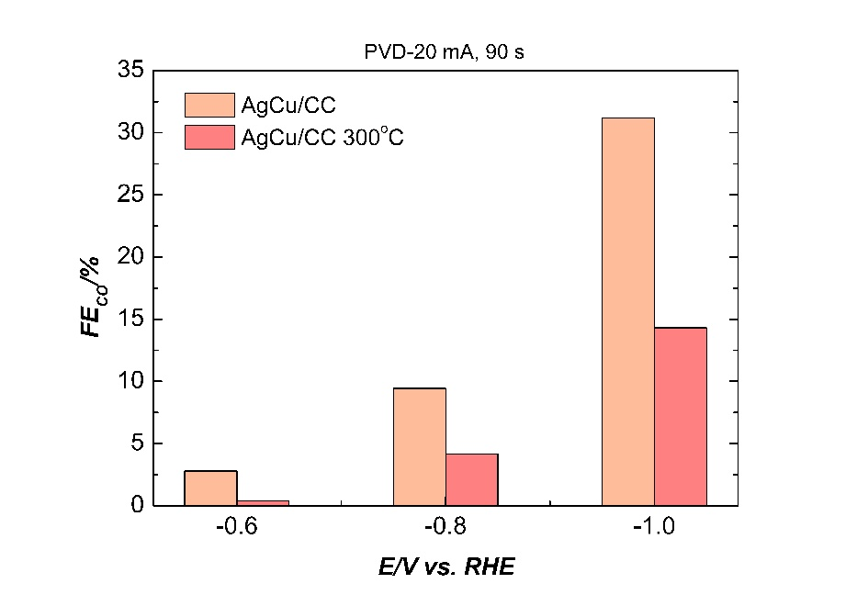
Figure S3. (a) Faradaic efficiency (FE%) of CO and (b) partial current density (J₍_{CO}₎) at various applied potentials vs. RHE of AgCu/CC and AgCu/CC annealed at 300 °C.

