Supporting Information for “Crustal electrical structure of the eastern segment of the collision-related porphyry copper-polymetallic metallogenic belt in South Tibet and its constraints on fluid migration”

Yue Sheng; Sheng Jin; Gaofeng Ye; Letian Zhang; Hao Dong; Yaotian Yin; Chengliang Xie; Jian’en Jing; Wenbo Wei

1. Inversion results:
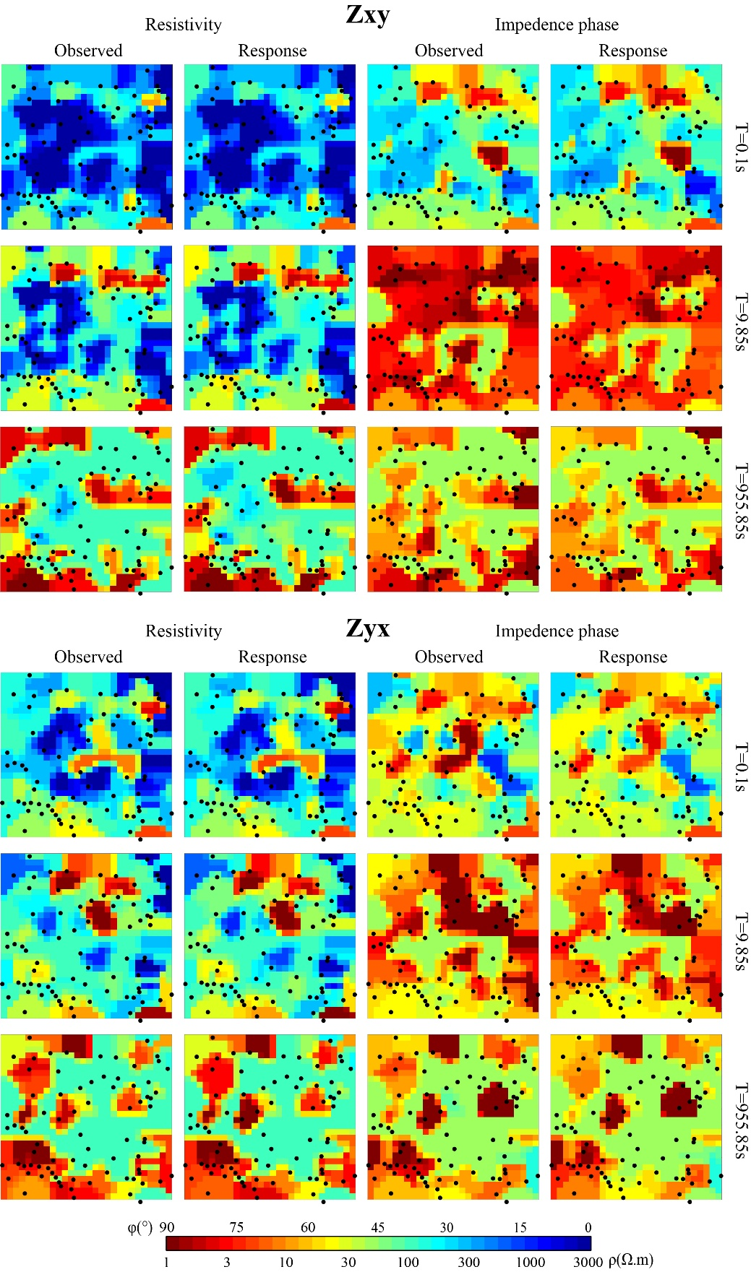
Figure S1. The observed apparent resistivity and phase (for Zxx, Zxy, Zyx, Zyy components) compared to the modelled apparent resistivity and phase, shown as horizontal pseudo-slices for periods of 0.1 s, 9.85 s and 955.85 s.

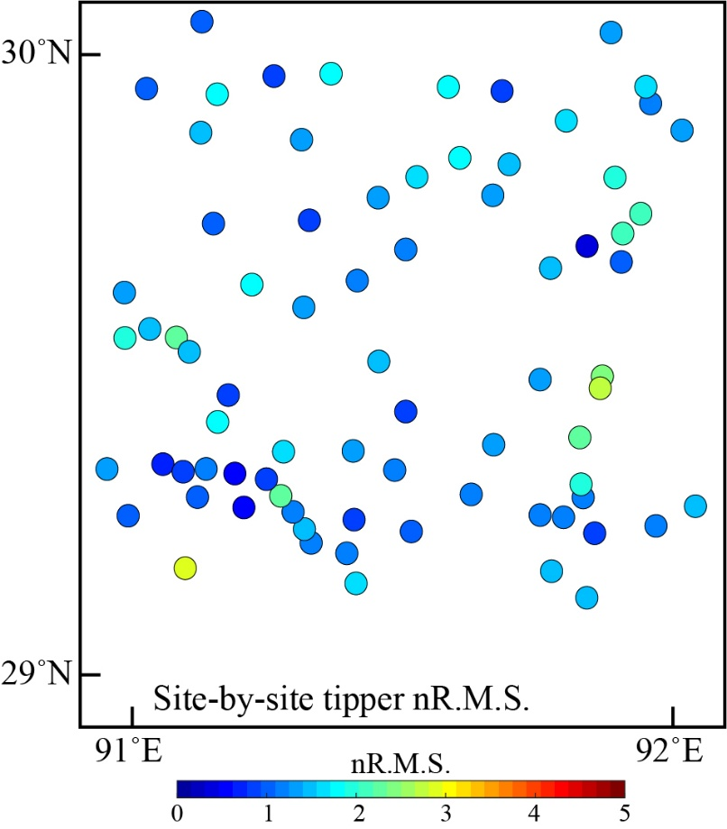
Figure S2. Site-by-site nR.M.S. of the tipper data of the 3-D inversion
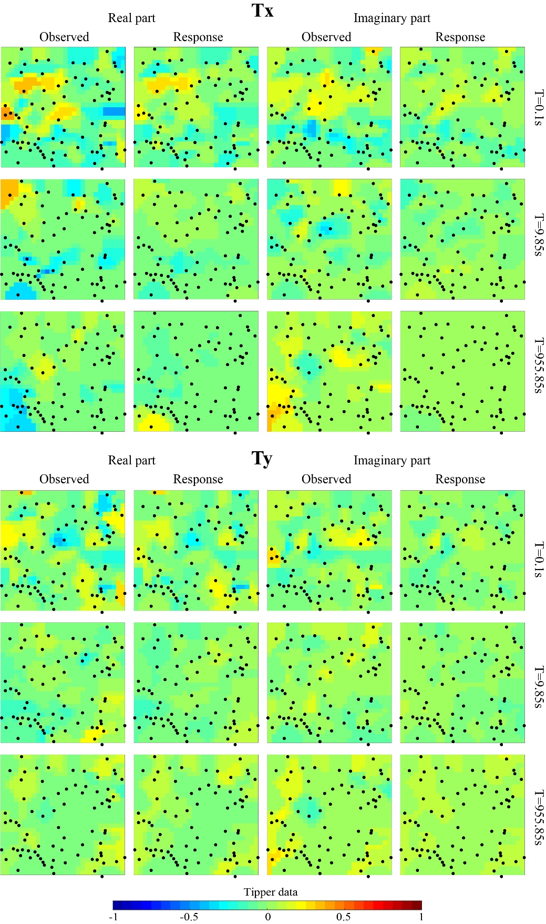

Figure S3. The observed value of the tipper data (for Tx, and Ty components) compared to the modelled value, shown as horizontal pseudo-slices for periods of 0.1 s, 9.85 s and 955.85 s.

2. Sensitivity tests:
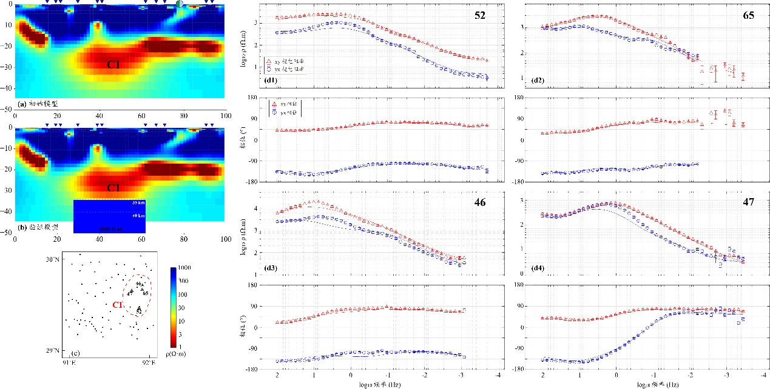
Figure S4. Resolution test for checking conductor C1. C1 is replaced with a 1,000 Ω·m block below depths of 35 km and 40 km. (a) Initial cross-section model of the 3-D inversion; (b) Verified model; (c) MT stations; (d1) - (f4) are the comparison of the curves of the apparent resistivity and phase between the verified model and 3-D model. Locations of 52, 46, 65 and 47 are in panel c.

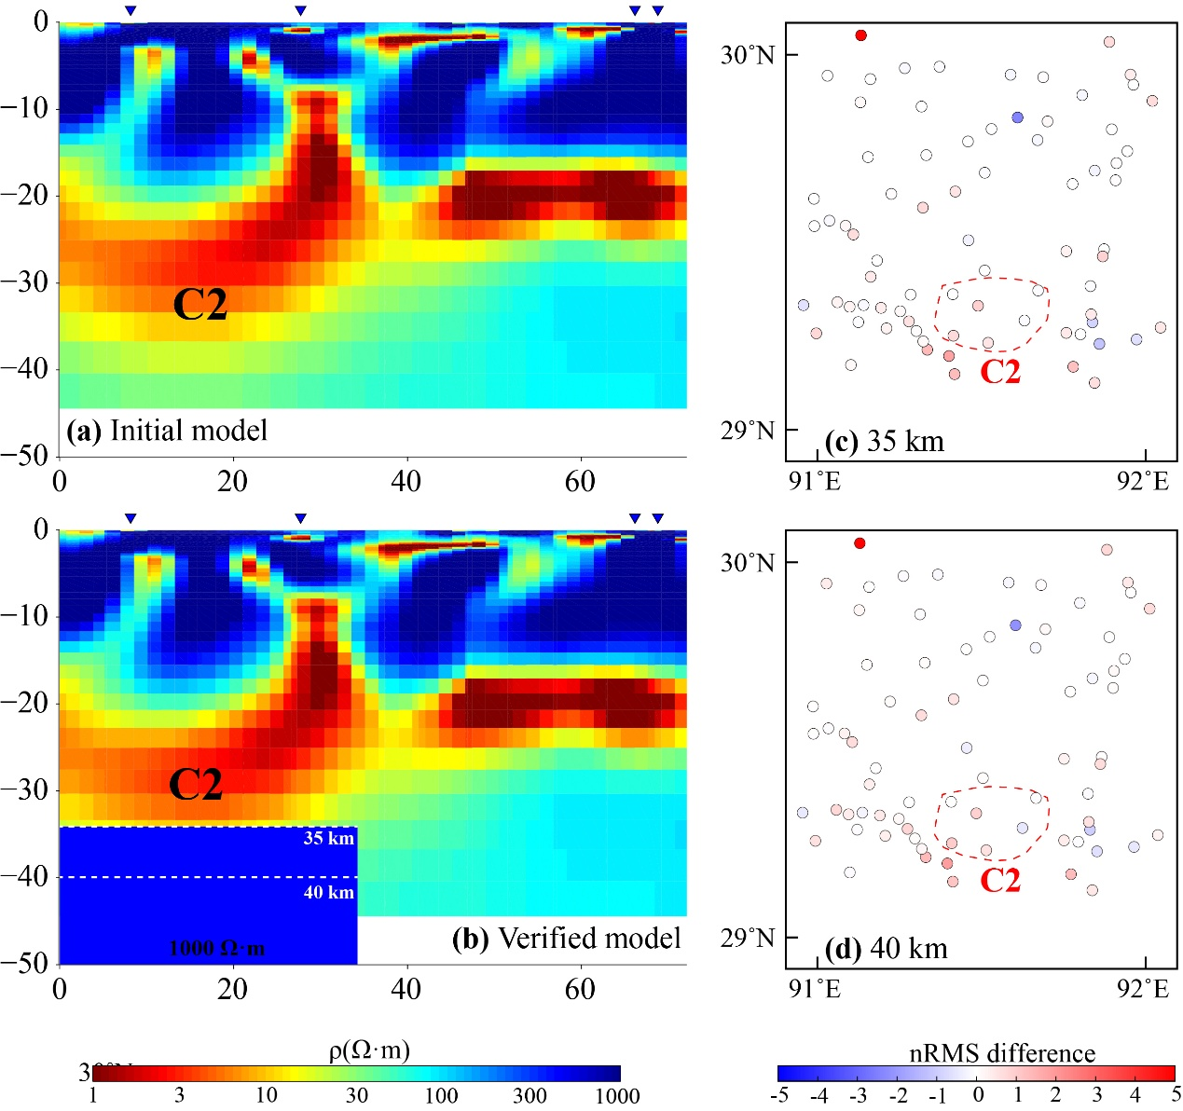
Figure S5. Resolution test for checking conductor C2. C2 is replaced with a 1,000 Ω·m block below depths of 35 km and 40 km. (a) Initial model. (b) Modified 3-D model. (c) and (d) Maps of the nR.M.S. (percent) difference between the preferred 3-D inversion model and the altered model at different depths.

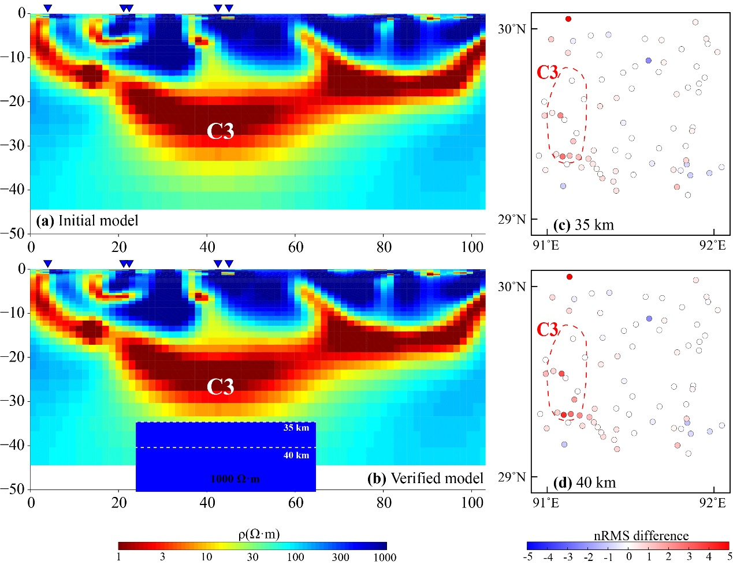
Figure S6. Resolution test for checking conductor C3. C3 is replaced with a 1,000 Ω·m block below depths of 35 km and 40 km. (a) Initial model. (b) Modified 3-D model. (c) and (d) Maps of the nR.M.S. (percent) difference between the preferred 3-D inversion model and the altered model at different depths.

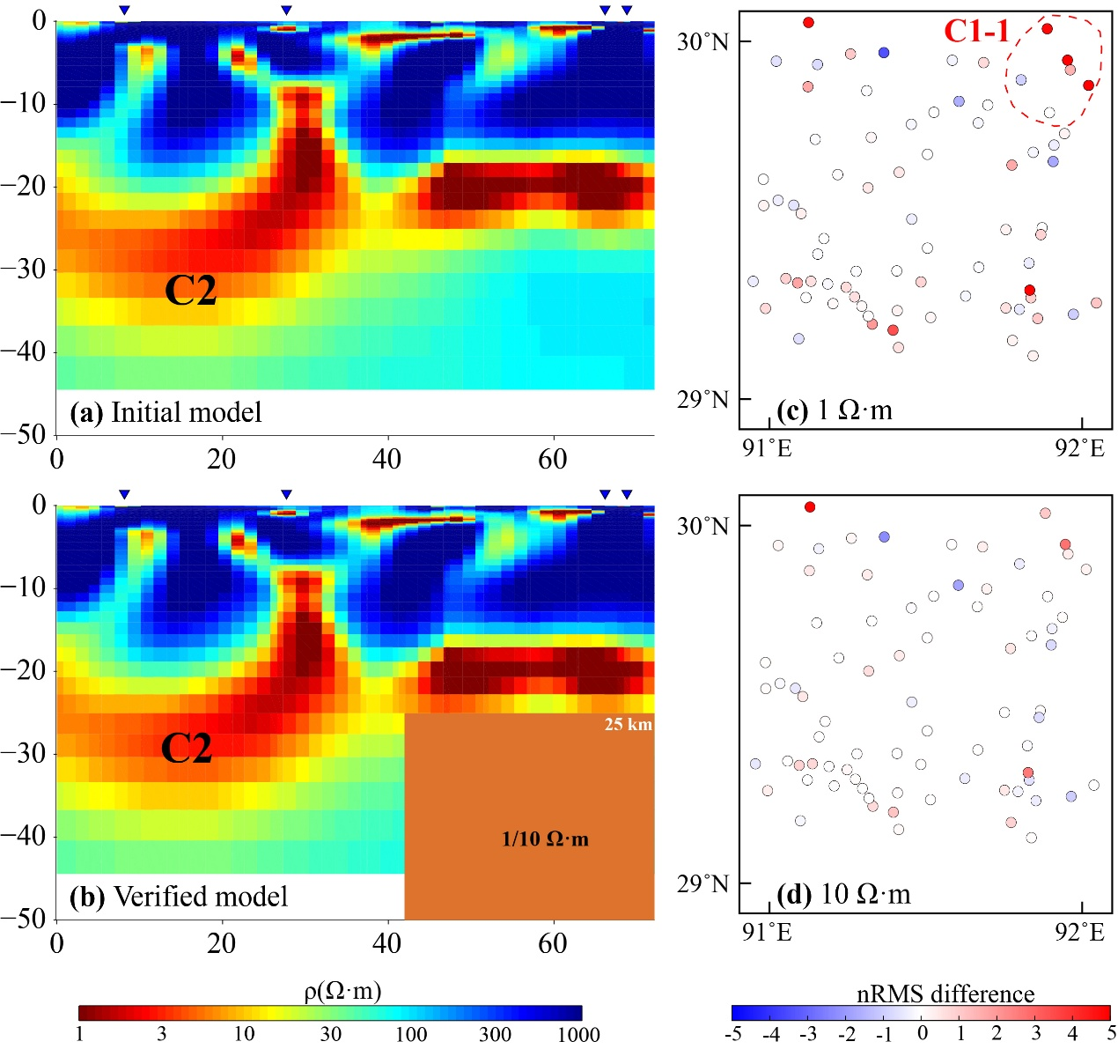
Figure S7. Resolution test for checking conductor C1-1. C1-1 is replaced with a 1 Ω·m and 10 Ω·m block at depths of more than 25 km. (a) Initial model. (b) Modified 3-D model. (c) and (d) Maps of the nR.M.S. (percent) difference between the preferred 3-D inversion model and the altered model with different resistivity (1 Ω·m and 10 Ω·m).

