Bridging dental and skeletal biology: dental tissue-derived mesenchymal stromal cells as models for studying physiological osteogenesis

Bibiána Baďurová¹, Romana Záhumenská^{1,#}, Tereza Pavlišová¹, Bronislava Gašperová^{1,2}, Veronika Kucháriková^{1,2}, Dana Dvorská¹, Lucia Kotúľová¹, Nela Žideková¹, Martin Kertys³, Sarah Kalmanová⁴, Rastislav Juríček⁴, Mária Janíčková⁴, Mária Kovalská⁵, Ján Strnádel¹, Zuzana Hatoková¹, Slavomíra Nováková¹, Erika Halašová¹, Henrieta Škovierová^{1*}

1 Comenius University in Bratislava, Jessenius Faculty of Medicine in Martin, Biomedical Centre Martin, Martin, Slovak Republic
2 Comenius University in Bratislava, Jessenius Faculty of Medicine in Martin, Department of Medical Biochemistry, Martin, Slovak Republic
3 Comenius University in Bratislava, Jessenius Faculty of Medicine in Martin, Department of Pharmacology, Martin, Slovak Republic
4 Comenius University in Bratislava, University Hospital in Martin and Jessenius Faculty of Medicine in Martin, Department of Stomatology and Maxillofacial Surgery, Martin, Slovak Republic
5 Comenius University in Bratislava, Jessenius Faculty of Medicine in Martin, Department of Histology and Embryology, Martin, Slovak Republic

# Present address: Comenius University in Bratislava, Jessenius Faculty of Medicine in Martin, Biobank for Cancer and Rare Diseases, Martin, Slovak Republic
* Corresponding Author; e-mail: henrieta.skovierova@uniba.sk

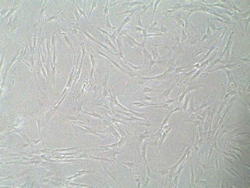
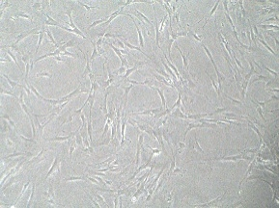
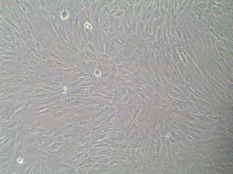
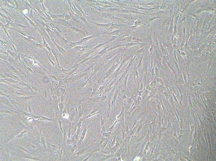
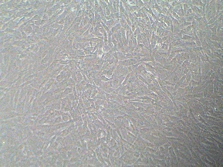
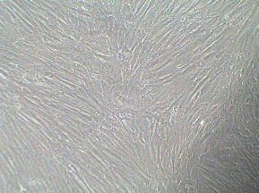
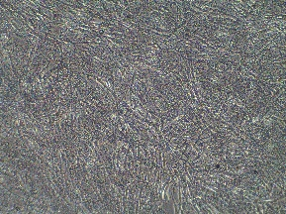
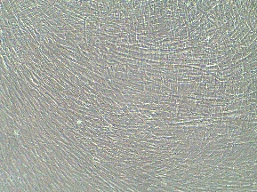
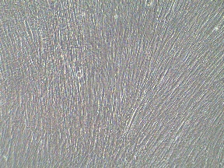
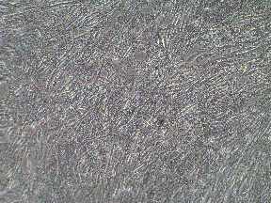
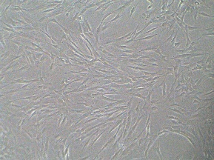
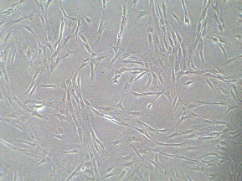
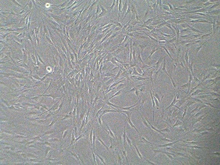
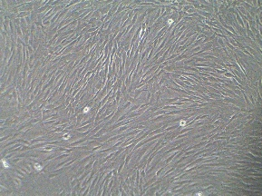
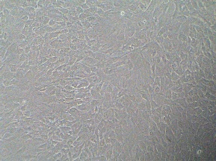

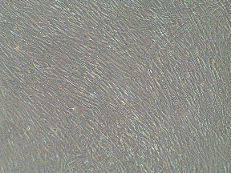
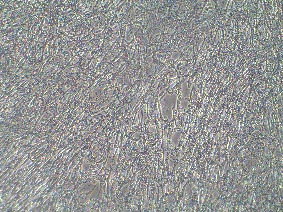
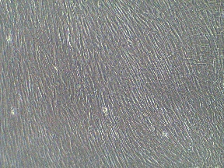
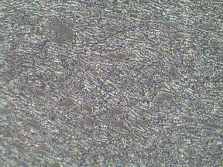
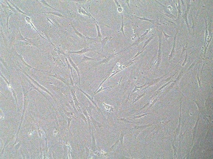
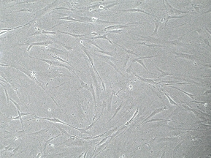
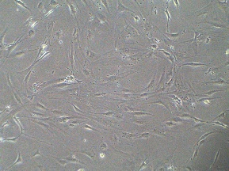
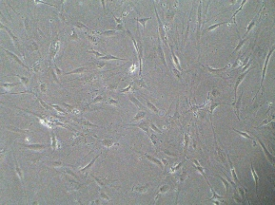
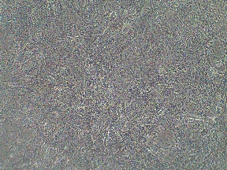
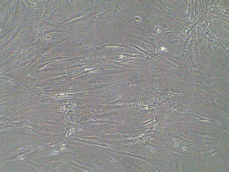
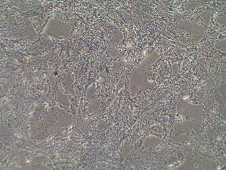
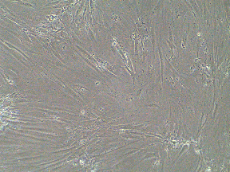
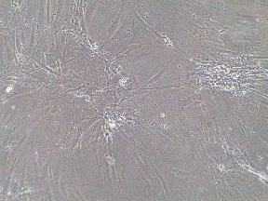
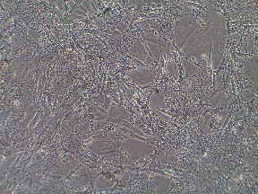
Figure S1 Morphology of DPSCs, SHEDs, and NHOst during 15 days of osteogenic differentiation. Control cells (CM) were cultured in standard medium, whereas differentiated cells (OM) were cultured in a commercial osteogenic differentiation medium. CM retained high proliferative activity and exhibited a typical fibroblast-like morphology. OM showed reduced proliferative capacity and produced calcium-containing deposits. Images were acquired using light microscopy at 100× magnification.
DPSCs
SHEDs
Day 0 Day 1 Day 5 Day 10 Day 15
CM OM
CM OM
CM OM
NHOst
100 µm

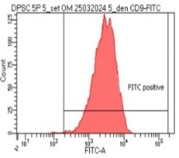
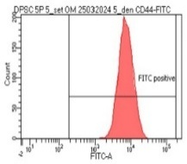
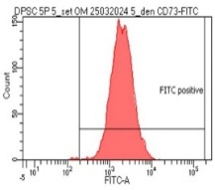
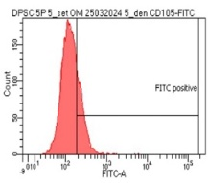
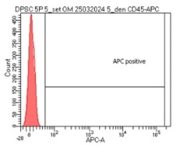
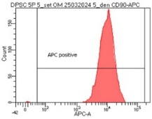
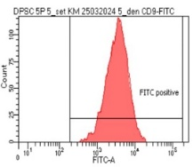
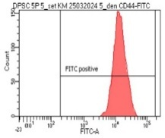
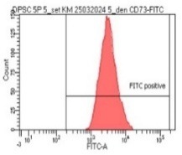
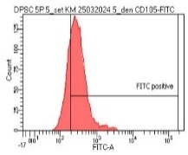
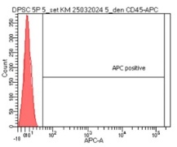
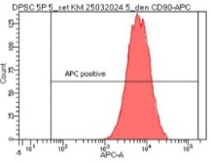
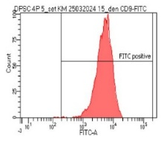
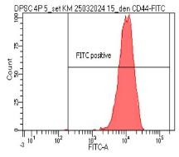
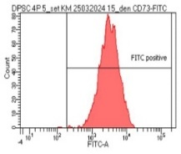
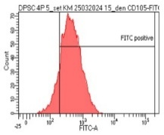
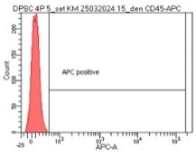
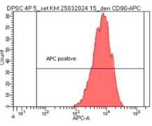
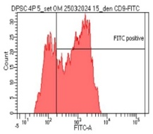
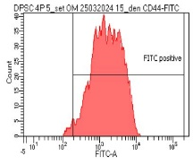
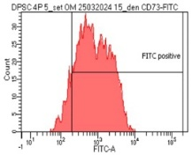
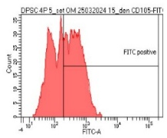
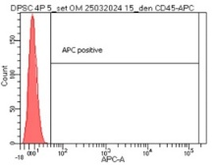
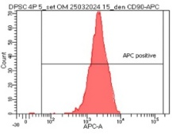
Figure S2 Expression of selected CD markers in DPSCs. The expression of individual CD markers was analyzed in control (CM) and osteogenically differentiated (OM) cells on Day 5 (D5) and Day 15 (D15) of differentiation. Data were acquired from 10,000 events per sample, and subpopulation gating was uniformly defined across all samples based on the respective isotype controls. Marker expression was determined by flow cytometry.
OM D5
CM D5
CM D15
OM D15
CD9
CD44
CD73
CD105
CD45
CD90

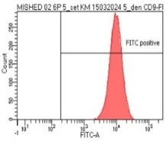
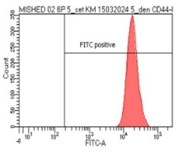
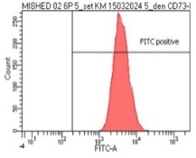
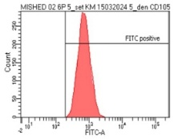
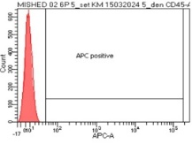
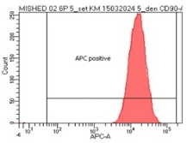
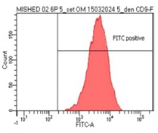
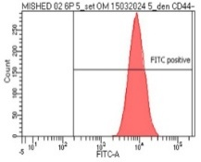
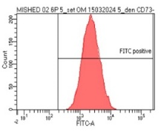
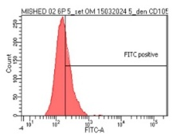
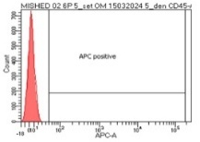
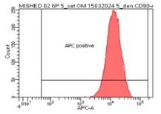
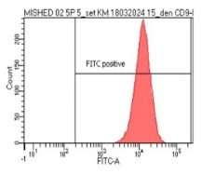
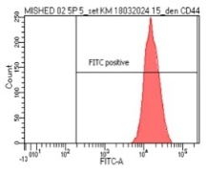
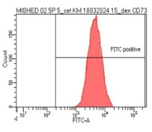
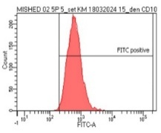
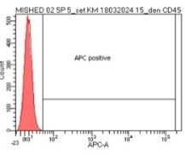
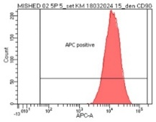
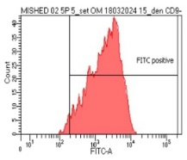
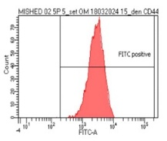
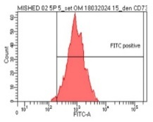
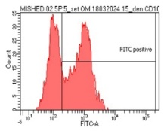
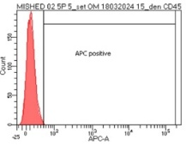
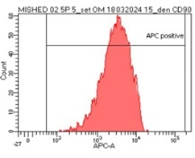
CD9
CD44
CD73
CD105
CD45
CD90
OM D5
CM D5
CM D15
OM D15
Figure S3 Expression of selected CD markers in SHEDs. The expression of individual CD markers was evaluated in control (CM) and osteogenically differentiated (OM) cells on Day 5 (D5) and Day 15 (D15) of differentiation. A total of 10,000 events were acquired per sample, and subpopulation gating was uniformly established across all samples based on the corresponding isotype controls. Marker expression was determined by flow cytometry.

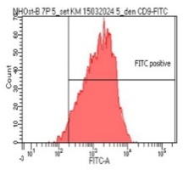
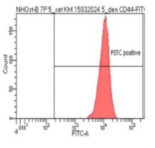
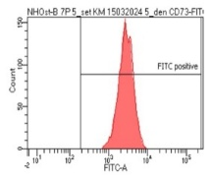
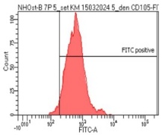
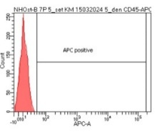
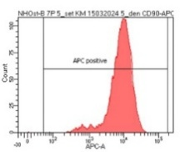
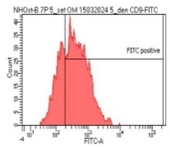
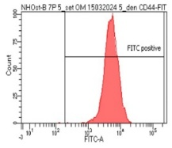
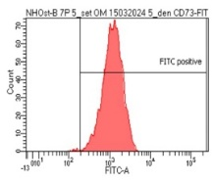
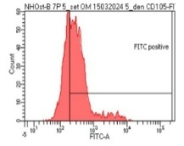
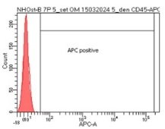
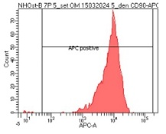
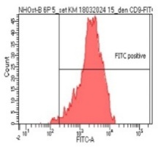
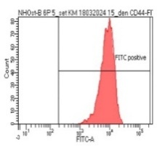
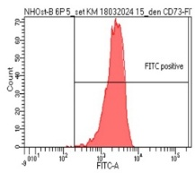
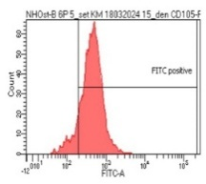
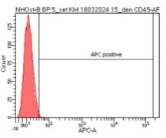
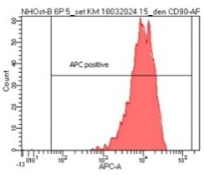
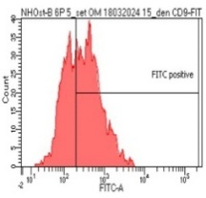
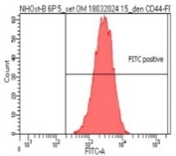
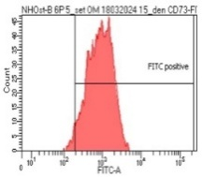
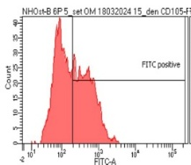
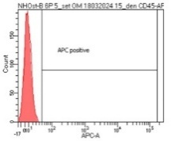
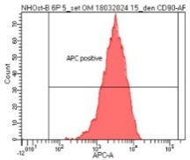
CD9
CD44
CD73
CD105
CD45
CD90
OM D5
CM D5
CM D15
OM D15
Figure S4 Expression of selected CD markers in NHOst. The expression of individual CD markers was analyzed in control (CM) and osteogenically differentiated (OM) cells on Day 5 (D5) and Day 15 (D15) of differentiation. A total of 10,000 events were acquired per sample, and subpopulation gating was consistently defined across all samples based on the respective isotype controls. Marker expression was determined by using flow cytometry.

Table S1 Gene expression changes were presented as log2FC (OM/CM) in DPSCs, SHEDs and NHOst cells during osteogenic differentiation, as determined by the RT2 Profiler PCR Array. The gene expression with substantial changes (|log2FC| ≥ 1) are shown.
DPSCs |  |  |  | SHEDs |  |  |  | NHOst
Day 5 |  | Day 15 |  | Day 5 |  | Day 15 |  | Day 5 |  | Day 15
Gene | log2FC | Gene | log2FC | Gene | log2FC | Gene | log2FC | Gene | log2FC | Gene l | log2FC
CSF3 | 8.8843 | CSF3 | 14.2327 | CSF3 | 7.9989 | CSF3 | 10.9125 | CSF3 | 9.7348 | CSF3 | 13.1347
ICAM1 | 6.3909 | MMP8 | 9.1471 | MMP8 | 6.3549 | CSF2 | 7.3826 | ALPL | 4.5059 | MMP9 | 7.8260
MMP8 | 4.8934 | CSF2 | 7.1193 | ALPL | 6.0032 | MMP8 | 6.2610 | ICAM1 | 4.1659 | MMP8 | 7.6991
COL10A1 | 4.7317 | COL10A1 | 6.7218 | ICAM1 | 5.7485 | ICAM1 | 3.8359 | MMP8 | 4.1060 | CSF2 | 6.7554
ALPL | 4.5515 | TNFSF11 | 3.9059 | CTSK | 4.4296 | ITGA3 | 3.1859 | IGF2 | 4.0626 | COL10A1 | 5.1022
COL3A1 | 3.8369 | SPP1 | 3.8339 | IGF1 | 3.9449 | ITGA2 | 1.7181 | FGFR2 | 3.1538 | TGFB2 | 2.9336
CSF1 | 3.3377 | ICAM1 | 2.9616 | TGFB3 | 3.4555 | COL10A1 | 1.5705 | CSF1 | 2.9449 | IGF2 | 2.6041
CTSK | 3.1953 | CTSK | 2.6531 | COL3A1 | 3.2675 | TNF | 1.4005 | NOG | 2.8197 | NOG | 2.3978
BMP2 | 2.1795 | ITGA2 | 2.4410 | TGFBR2 | 3.1953 | CTSK | 1.2570 | COL10A1 | 2.7845 | VEGFA | 2.0635
ITGA1 | 2.1506 | BMP2 | 2.3132 | CSF1 | 3.0807 | SP7 | 1.2203 | TGFB2 | 2.7355 | ALPL | 1.9745
CSF2 | 2.1375 | MMP10 | 2.1408 | PHEX | 2.8895 | BMPR1B | 1.1890 | COL3A1 | 2.0600 | ICAM1 | 1.5801
MMP10 | 1.9819 | ITGA3 | 1.7527 | BMP1 | 2.0072 | TNFSF11 | 1.0356 | COL15A1 | 1.9891 | ITGA2 | 1.2570
FN1 | 1.8032 | ALPL | 1.6826 | NFKB1 | 1.8875 | BMPR2 | -1.0893 | CSF2 | 1.9030 | BMPR2 | -1.0893
IGF1 | 1.7613 | COL2A1 | 1.6690 | EGFR | 1.8560 | IGF1R | -1.1203 | BMP2 | 1.4854 | FLT1 | -1.0893
COL2A1 | 1.6088 | CSF1 | 1.4005 | BMPR1B | 1.7908 | BMPR1A | -1.1844 | VEGFA | 1.4060 | BMPR1B | -1.1844
TGFBR2 | 1.6041 | BMP3 | -1.0893 | FN1 | 1.7908 | ITGB1 | -1.1844 | TGFBR2 | 1.2690 | TGFBR1 | -1.1844
SMAD1 | 1.5753 | FGFR1 | -1.0893 | RUNX2 | 1.6462 | COL2A1 | -1.4344 | FN1 | 1.1506 | TGFB3 | -1.4739
RUNX2 | 1.4647 | SP7 | -1.1520 | MMP9 | 1.4594 | RUNX2 | -1.5146 | BGN | -1.1844 | ITGB1 | -1.5564
BMP1 | 1.4489 | IGF2 | -1.2176 | ITGAM | 1.4168 | BMP1 | -1.5564 | PHEX | -1.2515 | MMP2 | -1.6439
TGFB2 | 1.4114 | TGFBR1 | -1.2515 | TGFB2 | 1.3896 | FLT1 | -1.6897 | DLX5 | -1.2863 | COL1A1 | -1.7859
ITGA2 | 1.3391 | TWIST1 | -1.3219 | MMP2 | 1.2265 | FGFR1 | -1.7859 | ANXA5 | -1.3219 | TGFB1 | -1.7859
NFKB1 | 1.2810 | ITGB1 | -1.5564 | TGFBR1 | 1.1177 | TGFBR1 | -1.8890 | BMP4 | -1.4344 | BMP3 | -1.8890
IGF2 | 1.2449 | CDH11 | -1.6439 | FGF2 | 1.0976 | PDGFA | -2.0000 | ITGA3 | -1.7859 | ANXA5 | -2.0589
SPP1 | 1.1827 | IGF1R | -1.6897 | COL5A1 | 1.0426 | CDH11 | -2.0589 | TGFB1 | -1.7859 | CTSK | -2.2515
COL5A1 | 1.1243 | DLX5 | -1.7370 | IGF2 | 1.0356 | COL5A1 | -2.1203 | TWIST1 | -1.9434 | COL1A2 | -2.3219
BMPR1B | 1.1110 | FGF1 | -1.9434 | SMAD1 | 1.0286 | MMP2 | -2.1203 | VEGFB | -2.0589 | SOX9 | -2.3219
BMP3 | 1.0635 | IGF1 | -2.0000 | COL10A1 | -1.0000 | TWIST1 | -2.1844 | TNF | -2.2515 | TWIST1 | -2.3959
MMP2 | 1.0072 | CD36 | -2.1844 | BMP6 | -1.0893 | EGF | -2.2515 | FLT1 | -2.3959 | FGFR2 | -2.4739
IGF1R | -1.0893 | CHRD | -2.2515 | TGFB1 | -1.2515 | DLX5 | -2.3959 | VCAM1 | -2.8365 | PHEX | -2.6439
BMP6 | -1.4739 | COL5A1 | -2.4739 | CD36 | -1.4739 | TGFB3 | -2.3959 | SOX9 | -2.9434 | CDH11 | -2.7370
SOX9 | -1.4739 | TGFB1 | -3.0589 | SMAD3 | -1.8365 | ANXA5 | -2.5564 | BMP6 | -3.0589 | BGN | -2.8365
COL14A1 | -1.5564 | BGN | -3.3219 | DLX5 | -2.0589 | COL3A1 | -2.5564 | SMAD3 | -3.3219 | VEGFB | -2.8365
TGFB1 | -1.8365 | COL1A2 | -3.3219 | SOX9 | -2.1203 | TGFB1 | -2.5564 | COL14A1 | -5.0589 | DLX5 | -3.6439
NOG | -2.3219 | BMP4 | -3.4739 | FLT1 | -2.6439 | CHRD | -2.8365 | CD36 | -5.6439 | COL15A1 | -3.8365
DLX5 | -3.0589 | SOX9 | -3.4739 | BGN | -2.7370 | SOX9 | -3.0589 |  |  | SMAD3 | -4.3219
SMAD3 | -3.8365 | BMP6 | -4.0589 | VCAM1 | -4.0589 | BGN | -3.4739 |  |  | VCAM1 | -5.0589
COL15A1 | -4.3219 | COL1A1 | -4.0589 | COL14A1 | -5.0589 | CD36 | -3.6439 |  |  | BMP4 | -5.6439
FLT1 | -4.3219 | SMAD3 | -5.0589 | COL15A1 | -6.6439 | COL1A2 | -3.8365 |  |  | BMP6 | -5.6439
 |  | FGFR2 | -5.6439 | COMP | -6.6439 | COL1A1 | -4.3219
 |  | COMP | -6.6439 |  |  | FGFR2 | -4.6439
 |  | VCAM1 | -6.6439 |  |  | BMP4 | -5.0589
 |  |  |  |  |  | SMAD3 | -5.6439
 |  |  |  |  |  | BMP6 | -6.6439
 |  |  |  |  |  | IGF1 | -6.6439

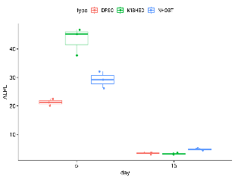
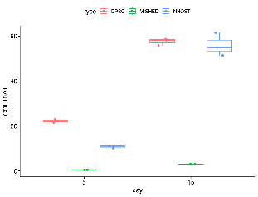
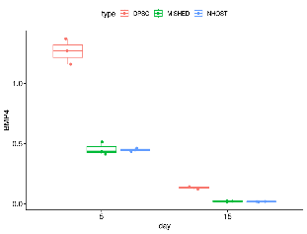
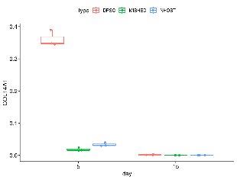
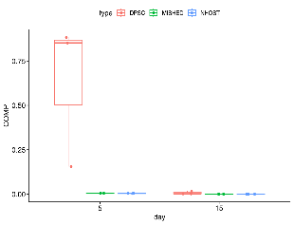
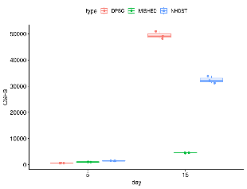
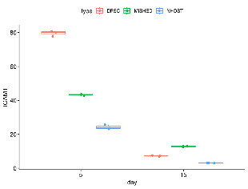
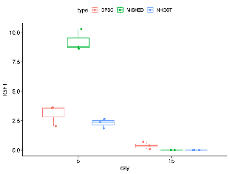
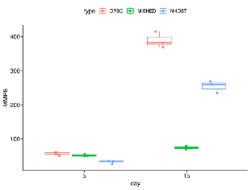
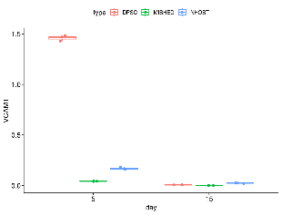
ALPL
COL10A1
BMP4
COL14A1
COMP
CSF3
ICAM1
IGF1
MMP8
VCAM1
Figure S5 Gene expression of selected genes during osteogenic differentiation. Gene expression levels of ten osteogenesis-related genes (ALPL, BMP4, COL10A1, COL14A1, COMP, CSF3, ICAM1, IGF1, MMP8, and VCAM1) were quantified by RT-qPCR in DPSCs, SHEDs, and NHOst cells at Day 5 (D5) and Day 15 (D15) of osteogenic differentiation. Boxplots illustrate the distribution of gene expression values at each time point, highlighting temporal changes in gene expression in each cell type represented by a single donor-derived cell population.

Table S2 Time-dependent changes in gene expression presented as log2FC (OM15/OM5) in DPSCs, SHEDs and NHOst cells during osteogenic differentiation, as determined by the RT2 Profiler PCR Array. The gene expression with substantial changes (|log2FC| ≥ 1) are shown.
DPSCs  OM D15/D5 |  | SHEDs  OM D15/D5 |  | NHOst  OM D15/D5
Gene | log2FC | Gene | log2FC | Gene | log2FC
CSF2 | 6.3789 | CSF2 | 7.8058 | MMP9 | 6.8311
CSF3 | 5.2102 | COL10A1 | 5.6299 | CSF2 | 4.7634
TNFSF11 | 4.6398 | CSF3 | 4.0081 | CSF3 | 4.6854
FLT1 | 3.8836 | ITGA3 | 3.9764 | COL10A1 | 4.6410
MMP8 | 3.2972 | MMP10 | 3.3291 | MMP8 | 3.8186
COL10A1 | 3.1110 | BMP2 | 3.0909 | TNF | 2.6668
SPP1 | 2.5008 | ITGA2 | 2.8797 | BMP2 | 2.2540
BMP2 | 1.5008 | FLT1 | 2.3306 | TNFSF11 | 2.2265
ITGA3 | 1.2987 | SP7 | 2.1110 | ITGA3 | 2.1110
FGF2 | -1.0893 | TNF | 1.5509 | SPP1 | 1.6645
BMPR2 | -1.1203 | TGFB2 | 1.4699 | EGFR | 1.3505
FN1 | -1.1203 | TNFSF11 | 1.4060 | CTSK | 1.2327
SMAD1 | -1.1844 | MMP8 | 1.2750 | NOG | -1.0291
TGFB2 | -1.1844 | COL15A1 | 1.0215 | BGN | -1.1203
SMAD3 | -1.2176 | BMP3 | -1.0291 | FGF2 | -1.2176
ALPL | -1.2863 | BMPR1B | -1.1520 | COL5A1 | -1.2515
MMP2 | -1.3585 | EGF | -1.2515 | SMAD3 | -1.2515
TGFBR1 | -1.4739 | FN1 | -1.2515 | VCAM1 | -1.4344
CDH11 | -1.5564 | RUNX2 | -1.4344 | BMP6 | -1.5564
COL15A1 | -1.6439 | CHRD | -1.5146 | CSF1 | -1.5564
TWIST1 | -1.7370 | MMP2 | -1.5564 | TGFBR1 | -1.5995
SERPINH1 | -1.7859 | ICAM1 | -1.6439 | COL1A2 | -1.9434
PDGFA | -1.8365 | TGFBR2 | -1.6439 | COL3A1 | -2.0589
BGN | -1.8890 | ANXA5 | -1.7859 | COL1A1 | -2.2515
RUNX2 | -1.8890 | TWIST1 | -1.7859 | DLX5 | -2.5564
ITGA1 | -2.0000 | PDGFA | -1.8890 | COL14A1 | -2.8365
BMP1 | -2.1203 | BMP4 | -2.0589 | COL15A1 | -3.0589
IGF1 | -2.2515 | TGFBR1 | -2.1203 | IGF1 | -3.3219
CSF1 | -2.3219 | CSF1 | -2.2515 | FGFR2 | -4.0589
IGF2 | -2.3219 | COL1A2 | -2.3219 | BMP4 | -4.3219
SOX9 | -2.5564 | BMP1 | -2.3959 | COMP | -4.6439
COL5A1 | -3.0589 | COL5A1 | -2.5564
ICAM1 | -3.0589 | BMP6 | -2.6439
COL1A2 | -3.3219 | COMP | -2.7370
COL1A1 | -3.6439 | SMAD3 | -2.9434
COL3A1 | -4.0589 | TGFB3 | -3.1844
BMP4 | -4.3219 | FGFR2 | -3.3219
FGFR2 | -5.0589 | COL1A1 | -3.8365
COL14A1 | -6.6439 | COL14A1 | -4.0589
VCAM1 | -6.6439 | COL3A1 | -4.6439
 |  | BGLAP | -6.6439
 |  | IGF1 | -6.6439
 |  | VCAM1 | -6.6439

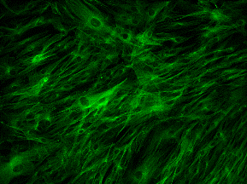
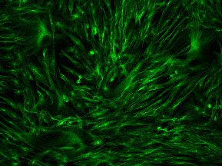
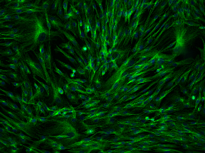
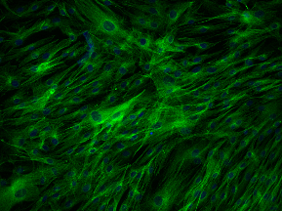
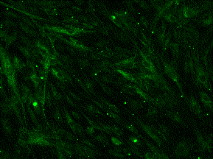
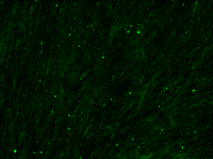
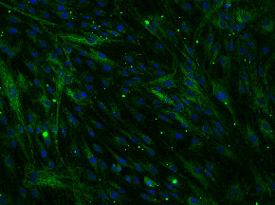
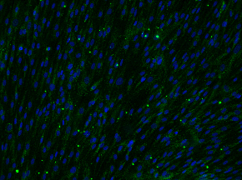
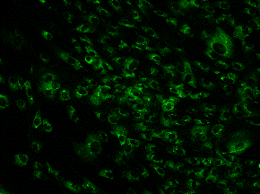
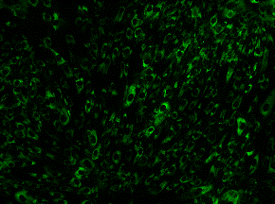
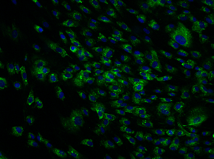
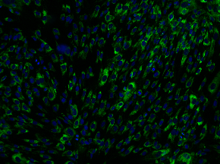
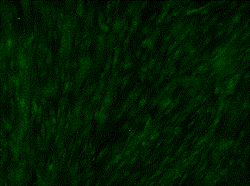
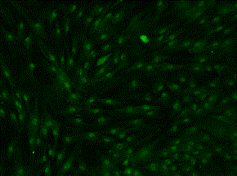
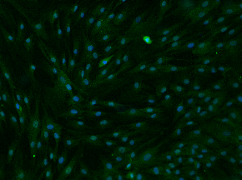
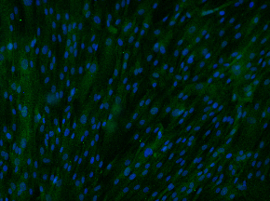
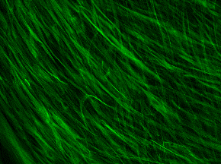
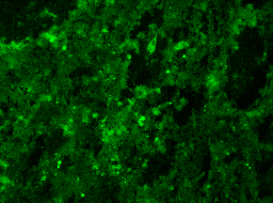
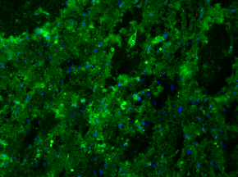
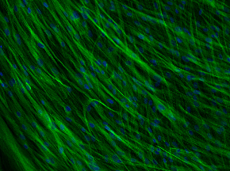
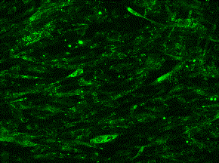
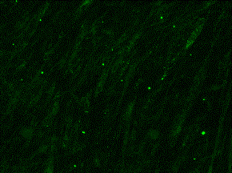
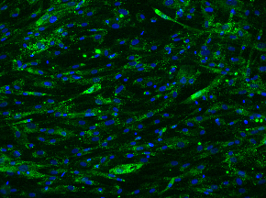
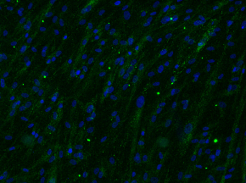
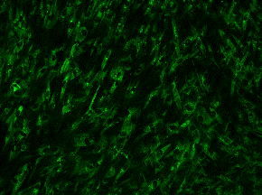
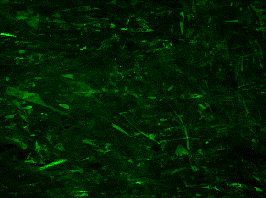
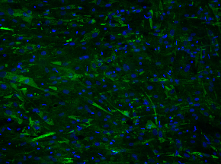
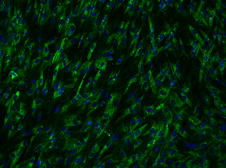
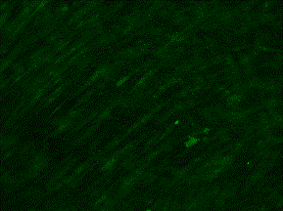
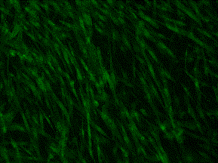
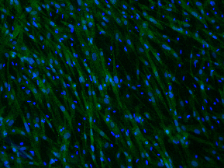
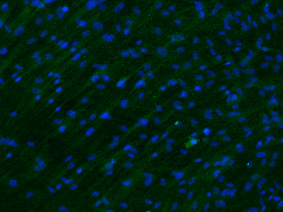
DPSCs Day 5
DPSCs Day 15
CM
OM
CM
OM
APOA2
APOA2 + DAPI
BSP2
BSP2 + DAPI
COL1A1
COL1A1 + DAPI
DMP1
DMP1 + DAPI
100 µm

Figure S6 cont.

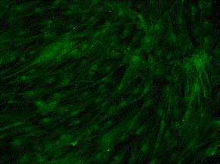
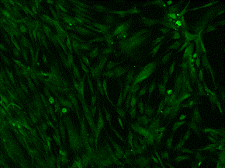
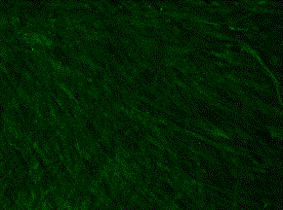
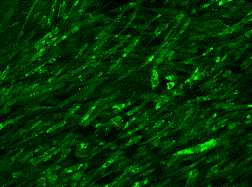
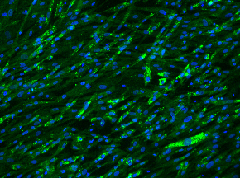
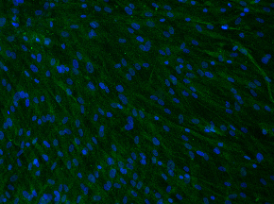
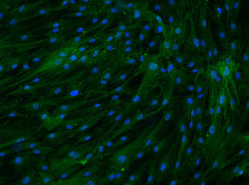
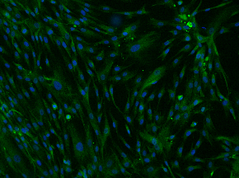
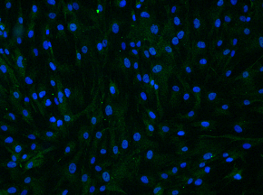
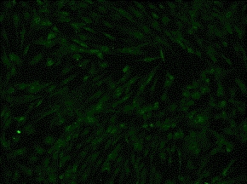
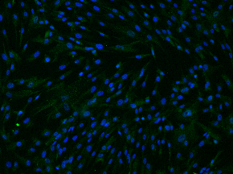
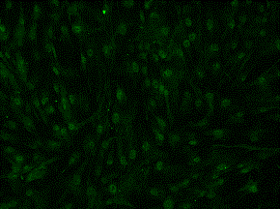
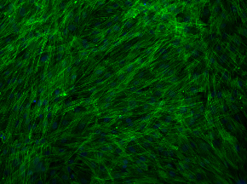
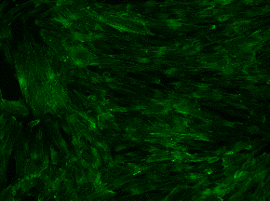
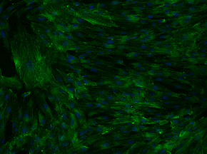
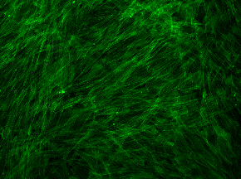
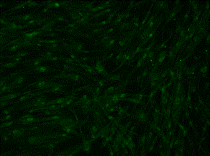
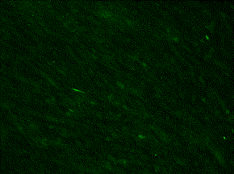
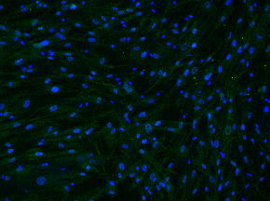
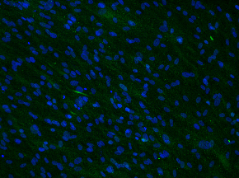
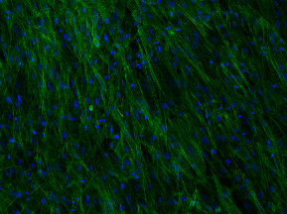
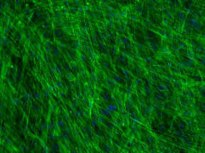
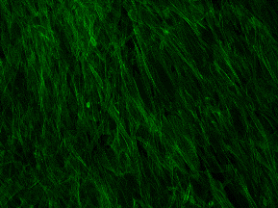
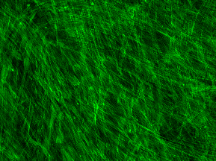
Figure S6 Immunocytochemical staining of osteogenic markers in DPSCs. Control (CM) and osteogenically differentiated (OM) cells were stained on Day 5 (D5) and Day 15 (D15) of osteogenic differentiation with fluorescent antibodies (green) against apolipoprotein A2 (APOA2), bone sialoprotein 2 (BSP2), collagen type I alpha 1 (COL1A1), dentin matrix protein 1 (DMP1), dentin sialophosphoprotein (DSPP), and osteopontin (OPN). Actin microfilaments of the cytoskeleton were visualized using phalloidin (PHAL), and cell nuclei were counterstained with DAPI (blue). For each marker, representative images are shown both with and without the blue nuclear channel to enhance visualization of the intensity and localization of the expressed proteins. Fluorescent signals were captured and analyzed using a fluorescence microscope (100× magnification).
DSPP
DSPP + DAPI
OPN
OPN + DAPI
PHAL
PHAL + DAPI
DPSCs Day 5
DPSCs Day 15
CM
OM
CM
OM
100 µm

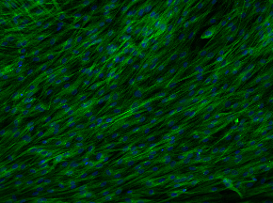
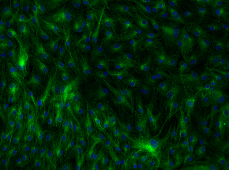
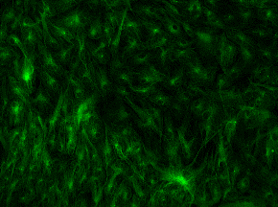
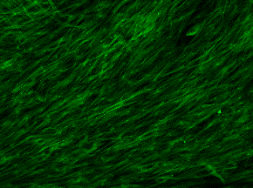
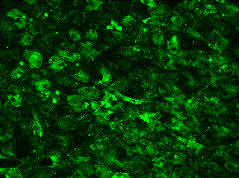
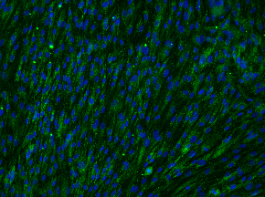
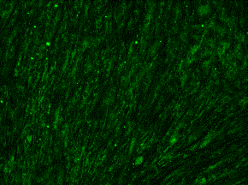
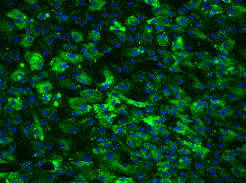
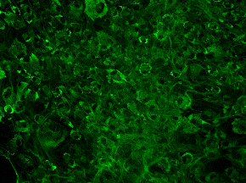
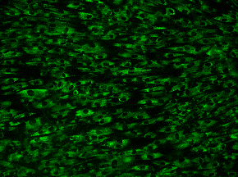
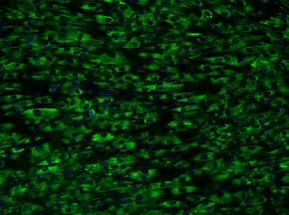
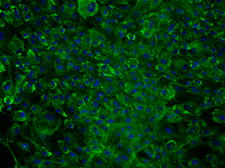
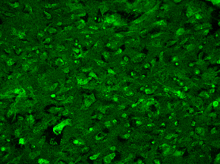
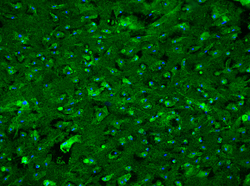
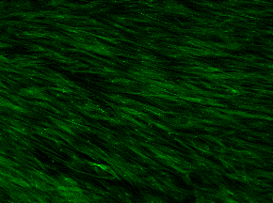
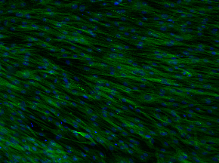
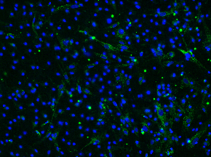
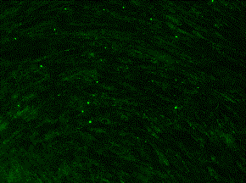
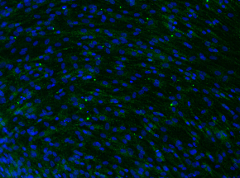
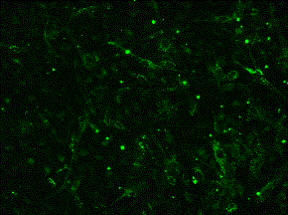
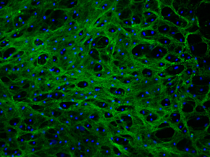
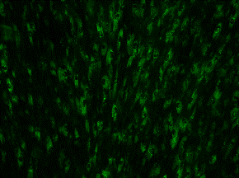
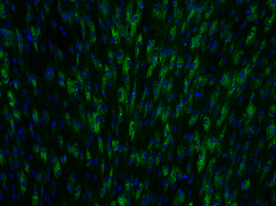
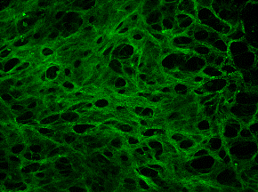
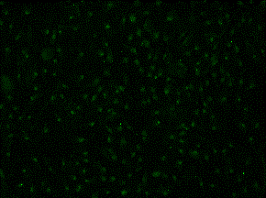
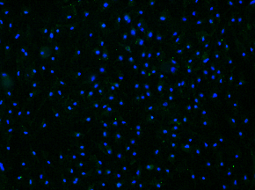
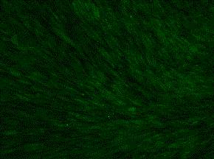
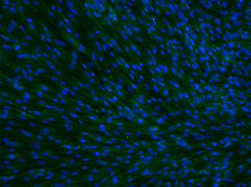
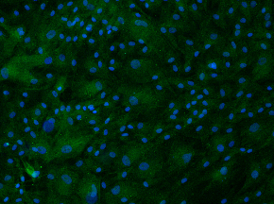
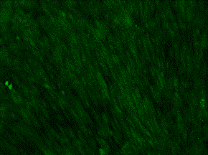
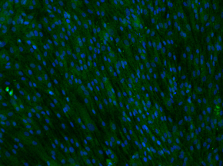
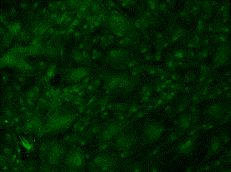
APOA2
APOA2 + DAPI
BSP2
BSP2 + DAPI
COL1A1
COL1A1 + DAPI
DMP1
DMP1 + DAPI
SHEDs Day 5
SHEDs Day 15
CM
OM
CM
OM
Figure S7 cont.
100 µm

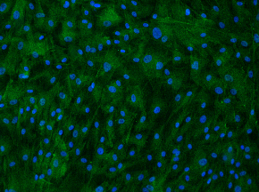
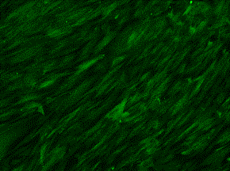
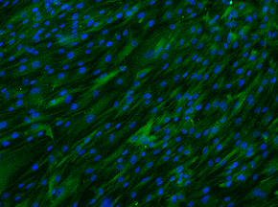
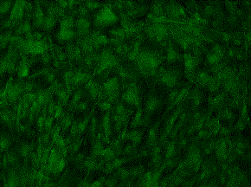
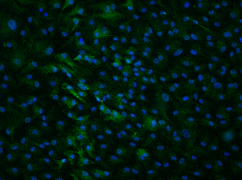
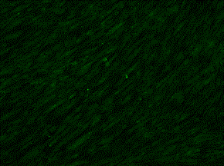
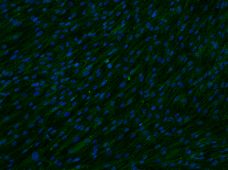
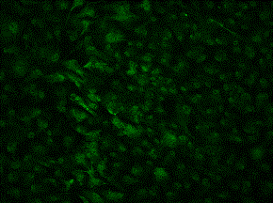
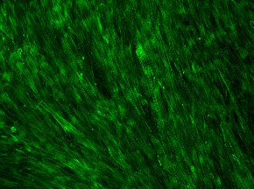
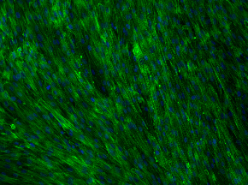
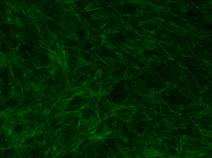
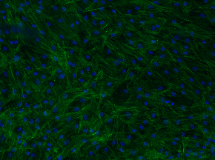
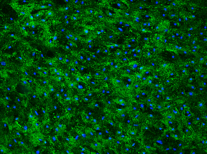
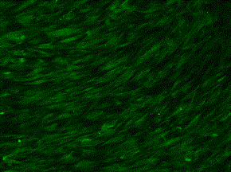
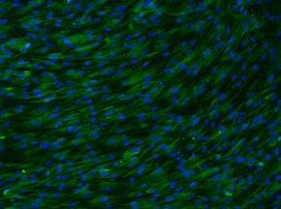
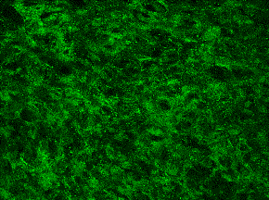
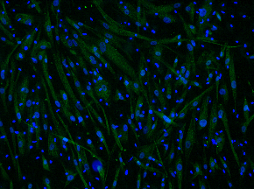
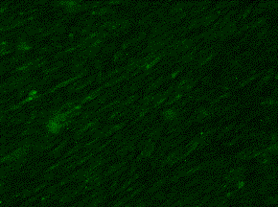
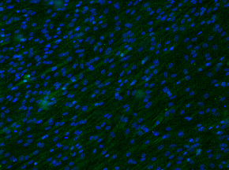
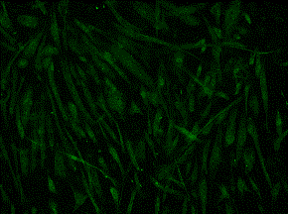
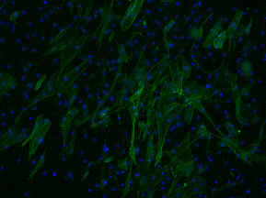
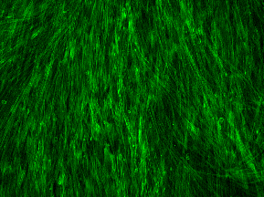
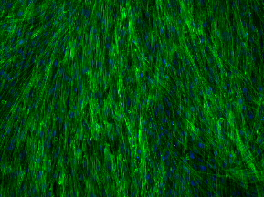
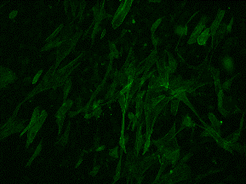
Figure S7 Immunocytochemical staining of osteogenic markers in SHEDs. Control (CM) and osteogenically differentiated (OM) cells were stained on Day 5 (D5) and Day 15 (D15) of osteogenic differentiation with fluorescent antibodies (green) against apolipoprotein A2 (APOA2), bone sialoprotein 2 (BSP2), collagen type I alpha 1 (COL1A1), dentin matrix protein 1 (DMP1), dentin sialophosphoprotein (DSPP), and osteopontin (OPN). Actin microfilaments of the cytoskeleton were visualized using phalloidin (PHAL), and cell nuclei were counterstained with DAPI (blue). For each marker, representative images are shown both with and without the blue nuclear channel to improve visualization of protein intensity and localization. Fluorescent signals were captured and analyzed using a fluorescence microscope (100× magnification).
DSPP
DSPP + DAPI
OPN
OPN + DAPI
PHAL
PHAL + DAPI
SHEDs Day 5
SHEDs Day 15
CM
OM
CM
OM
100 µm

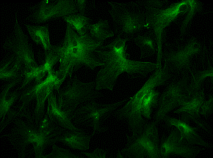
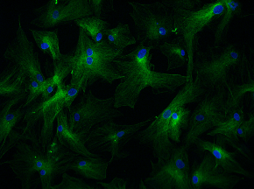
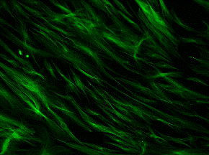
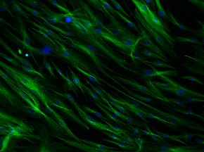
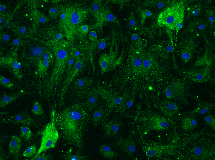
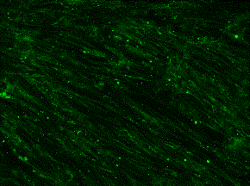
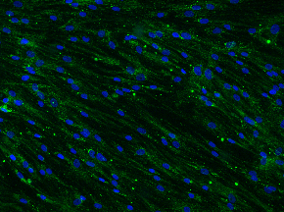
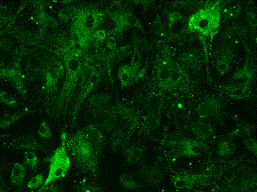
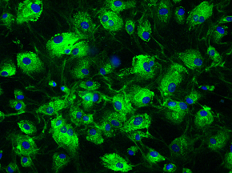
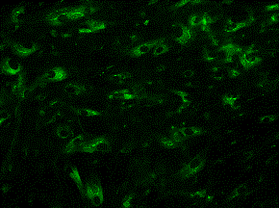
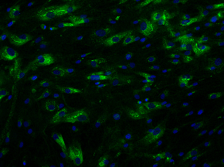
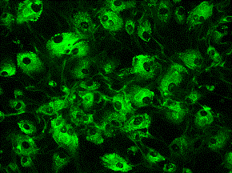
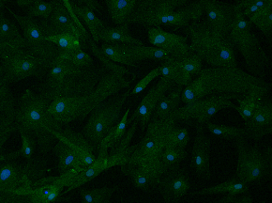
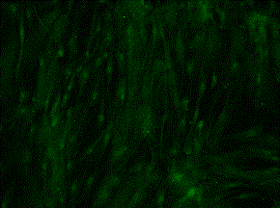
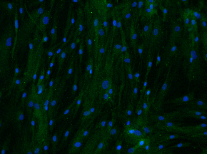
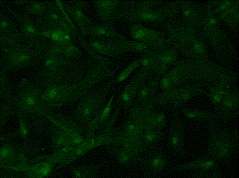
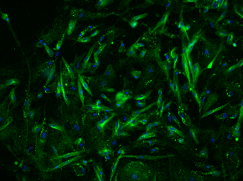
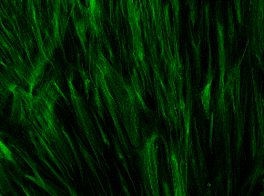
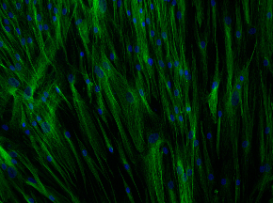
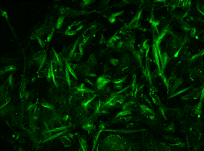
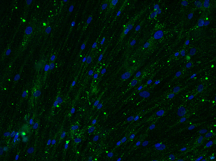
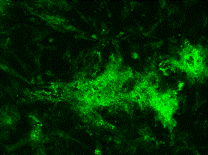
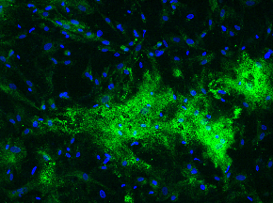
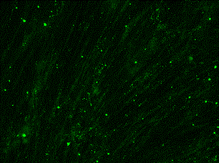
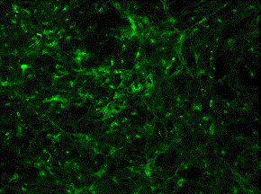
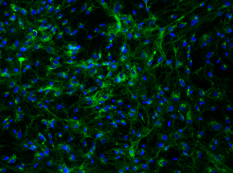
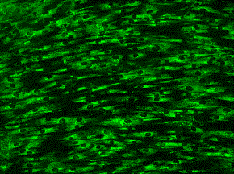
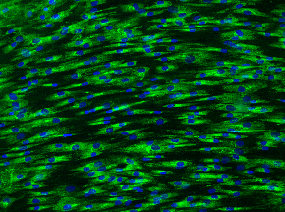
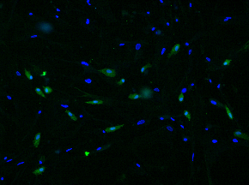

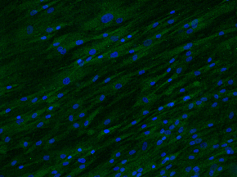
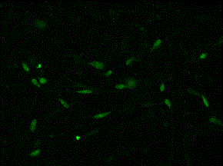
NHOst Day 5
NHOst Day 15
CM
OM
CM
OM
APOA2
APOA2 + DAPI
BSP2
BSP2 + DAPI
COL1A1
COL1A1 + DAPI
DMP1
DMP1 + DAPI
Figure S8 cont.
100 µm

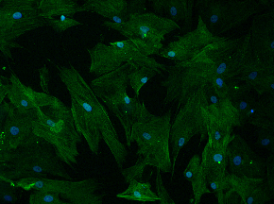
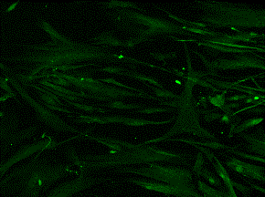
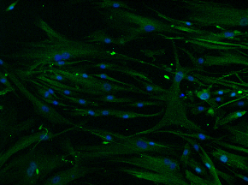
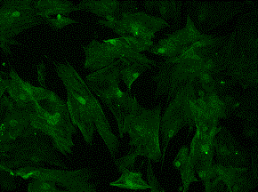
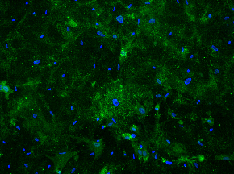
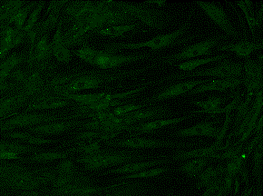
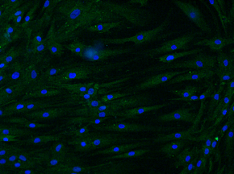
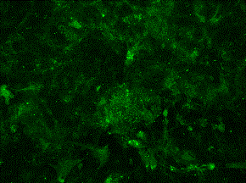
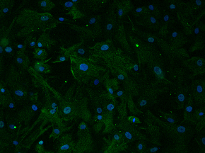
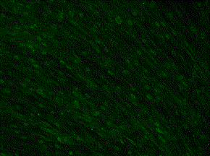
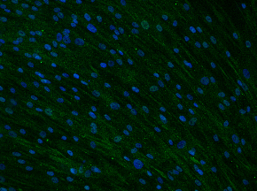
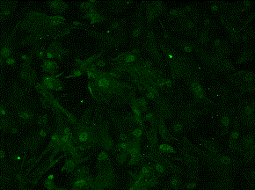
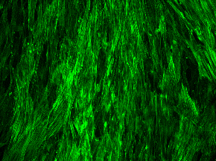
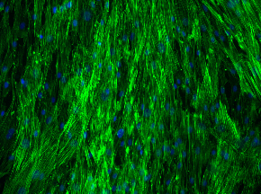
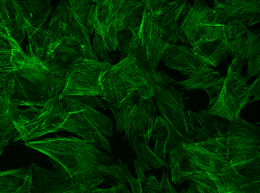
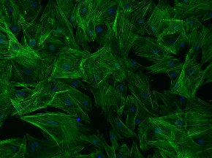
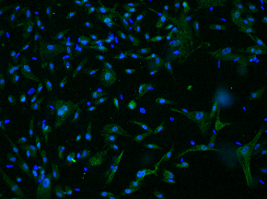
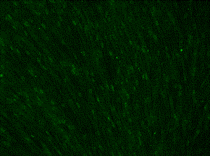
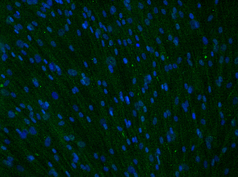
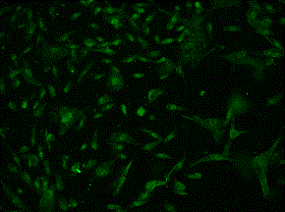
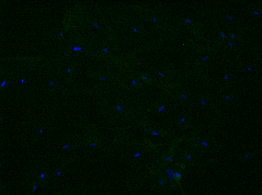
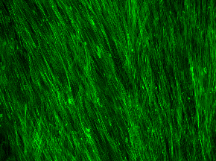
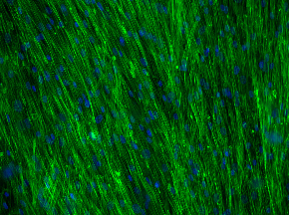
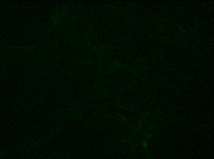
Figure S8 Immunocytochemical staining of osteogenic markers in NHOst. Control (CM) and osteogenically differentiated (OM) cells were stained on Day 5 (D5) and Day 15 (D15) of osteogenic differentiation with fluorescent antibodies (green) against apolipoprotein A2 (APOA2), bone sialoprotein 2 (BSP2), collagen type I alpha 1 (COL1A1), dentin matrix protein 1 (DMP1), dentin sialophosphoprotein (DSPP), and osteopontin (OPN). Actin microfilaments of the cytoskeleton were visualized using phalloidin (PHAL), and cell nuclei were counterstained with DAPI (blue). For each marker, representative images are presented both with and without the blue nuclear channel to enhance visualization of the intensity and localization of the expressed proteins. Fluorescent signals were captured and analyzed using a fluorescence microscope (100× magnification).
NHOst Day 5
NHOst Day 15
CM
OM
CM
OM
DSPP
DSPP + DAPI
OPN
OPN + DAPI
PHAL
PHAL + DAPI
100 µm

Table S3 Changes in intracellular metabolite abundances presented as log2FC (OM/CM) in DPSCs, SHEDs and NHOst cells during osteogenic differentiation, as determined by targeted metabolomic profiling using the AbsoluteIDQ® p180 kit. The metabolites with substantial changes (|log2FC| ≥ 1) are shown. Metabolites are designated using standard nomenclature. Standard abbreviations are used for amino acids and biogenic amines; LPC, lysophosphatidylcholines; PC, phosphatidylcholines; PC O, ether-linked phosphatidylcholines; SM, sphingomyelins.
DPSCs |  |  |  | SHEDs |  |  |  | NHOst
Day 5 |  | Day 15 |  | Day 5 |  | Day 15 |  | Day 5 |  | Day 15
Metabolite | log2FC | Metabolite | log2FC | Metabolite | log2FC | Metabolite | log2FC | Metabolite | log2FC | Metabolite | log2FC
Carnitine C0 | -1.6852 | Carnitine C0 | -2.7050 | Carnitine C0 | -2.1178 | Carnitine C0 | -2.8568 | Arg | 1.3389 | Carnitine C0 | -2.0739
Ala | -1.4719 | Ala | -2.1972 | Ala | -3.1061 | Ala | -2.6893 | Asn | 1.0327 | Arg | 2.2197
Asn | 1.8484 | Asp | 1.6487 | Cit | -1.5670 | Cit | -1.1518 | Asp | -2.1511 | Asp | -1.5984
Asp | 2.1909 | Cit | -2.3438 | Glu | -1.3898 | Gln | -1.9045 | Gln | -1.8653 | Gln | -1.9161
Cit | -2.3324 | Gln | -1.7878 | Ile | 1.7617 | Glu | -1.0799 | Glu | -1.6514 | Glu | -1.4138
His | 1.5578 | Glu | -0.9904 | Orn | -2.6036 | Ile | 1.9194 | Gly | 1.3284 | His | 1.7667
Ile | 2.4285 | Ile | 1.4001 | Phe | 1.2457 | Orn | -2.7199 | His | 1.4878 | Ile | 2.4158
Orn | -2.6588 | Leu | -1.0216 | Pro | 2.0963 | Phe | 1.2739 | Ile | 1.8745 | Leu | -1.0612
Phe | 2.0139 | Lys | -1.2713 | Thr | 1.6832 | Pro | 1.1470 | Leu | -1.5508 | Phe | 2.5966
Pro | 3.2215 | Orn | -4.4236 | Tyr | -1.3073 | Ser | 1.4276 | Lys | -1.1703 | Pro | 3.2314
Ser | 1.7625 | Phe | 1.0863 | Val | 2.3901 | Thr | 1.5852 | Phe | 2.1688 | Ser | 2.2345
Thr | 2.5085 | Ser | 2.3090 | Alpha-AAA | -3.6064 | Tyr | -1.3544 | Pro | 3.1168 | Thr | 5.4184
Trp | 1.8438 | Thr | 1.6370 | Creatinine | -1.8509 | Val | 2.3772 | Ser | 2.1551 | Trp | 3.3367
Val | 2.8736 | Tyr | -1.5730 | Kynurenine | 8.1236 | Alpha-AAA | -1.7959 | Thr | 5.1160 | Tyr | 1.1652
Alpha-AAA | -2.3205 | Val | 1.9418 | T4-OH-Pro | 1.9870 | Creatinine | -1.6112 | Trp | 2.9243 | Val | 1.2918
Creatinine | -2.1417 | Alpha-AAA | -2.0014 | Taurine | -3.1898 | Kynurenine | 6.6231 | Ac-Orn | 1.1550 | Ac-Orn | 1.8288
Kynurenine | 5.9333 | Carnosine | -5.3180 | LPC 16:0 | -1.6574 | Putrescine | 2.9256 | Creatinine | -1.5570 | Creatinine | -2.1918
T4-OH-Pro | 2.7491 | Creatinine | -2.3371 | LPC 18:0 | -2.0886 | Taurine | -6.8305 | Kynurenine | 7.1763 | Kynurenine | 6.4426
Taurine | -3.4655 | Kynurenine | 4.4288 | PC 28:1 | 1.6685 | LPC 16:0 | -1.3490 | Putrescine | -1.7196 | T4-OH-Pro | 2.4961
LPC 16:0 | -2.1996 | Putrescine | 2.8914 | PC 32:3 | 1.7680 | PC 30:0 | -3.5096 | Spermine | -1.2877 | Taurine | -6.7313
LPC 18:0 | -2.7256 | Spermidine | -1.2819 | PC 34:1 | -1.0764 | PC 32:0 | -5.3929 | T4-OH-Pro | 2.3810 | LPC 16:0 | -1.6445
LPC 18:1 | -1.3445 | Taurine | -6.5918 | PC 34:3 | 1.1390 | PC 32:1 | -4.5765 | Taurine | -7.9737 | LPC 18:0 | -2.4984
PC 28:1 | 1.3449 | LPC 16:0 | -2.5081 | PC 34:4 | 1.4709 | PC 32:2 | -2.8995 | LPC 16:0 | -1.7833 | LPC 18:1 | -1.2041
PC 32:3 | 1.2483 | LPC 18:0 | -3.4049 | PC 36:1 | -1.5051 | PC 34:1 | -6.4339 | LPC 18:0 | -2.3880 | PC 30:0 | -1.9225
PC 36:0 | -1.2955 | LPC 18:1 | -1.4732 | PC O-34:0 | -1.9262 | PC 34:2 | -5.1336 | LPC 18:1 | -1.0851 | PC 32:0 | -3.6209
PC 36:1 | -1.0465 | PC 30:0 | -1.4905 | PC O-34:1 | -2.0902 | PC 36:2 | -6.2412 | PC 28:1 | 1.0082 | PC 32:1 | -2.4753
PC 38:0 | -1.7447 | PC 32:0 | -2.9120 | PC O-34:2 | -1.1574 | PC 36:4 | -5.7359 | PC 34:4 | 1.0631 | PC 32:2 | -1.2098
PC 38:6 | -1.3257 | PC 32:1 | -3.1956 | PC O-36:1 | -2.0829 | PC 38:4 | -6.8279 | PC 38:6 | -1.2940 | PC 34:1 | -3.6330
PC O-34:0 | -2.3443 | PC 32:2 | -2.6382 | PC O-36:2 | -1.8988 | PC 38:5 | -5.3923 | PC 40:6 | -1.0120 | PC 34:2 | -3.0529
PC O-34:1 | -2.0811 | PC 34:1 | -3.9911 | PC O-36:3 | -1.4855 | SM 34:1 | -4.7387 | PC O-34:0 | -2.0032 | PC 34:3 | -1.9320
PC O-34:2 | -1.0081 | PC 34:2 | -4.2403 | PC O-36:4 | -1.8352 | SM 42:2 | -6.1465 | PC O-34:1 | -1.4528 | PC 36:1 | -3.8592
PC -O-36:0 | -1.1591 | PC 34:3 | -3.7025 | PC O-38:2 | -1.7475 | Hexose | -1.1778 | PC O-34:1 | -1.0534 | PC 36:2 | -3.5108
PC O-36:1 | -2.4043 | PC 36:1 | -4.7795 | PC O-38:3 | -1.6814 |  |  | PC O-36:1 | -1.8970 | PC 36:3 | -4.0014
PC O-36:2 | -2.3448 | PC 36:2 | -4.6484 | PC O-38:4 | -1.2401 |  |  | PC O-36:2 | -1.7616 | PC 36:4 | -3.2446
PC O-36:3 | -1.6334 | PC 36:3 | -5.1699 | PC O-38:5 | -1.4378 |  |  | PC O-36:3 | -1.3577 | PC 36:5 | -2.4487
PC O-36:4 | -2.1020 | PC 36:4 | -4.0773 | PC O-38:6 | -1.3277 |  |  | PC O-38:2 | -1.7814 | PC 38:3 | -3.9851
PC O-38:1 | -1.4770 | PC 36:5 | -3.8869 | PC O-40:4 | -1.1782 |  |  | PC O-38:4 | -1.5301 | PC 38:4 | -3.1139
PC O-38:2 | -1.9255 | PC 38:3 | -4.4708 | PC O-42:0 | 1.0505 |  |  | PC O-40:5 | -1.5071 | PC 38:5 | -2.8650
PC O-38:3 | -1.6767 | PC 38:4 | -4.7549 | SM 33:1 | -1.0602 |  |  | PC O-40:6 | -1.4978 | PC 38:6 | -3.8001
PC O-38:4 | -1.9092 | PC 38:5 | -4.3157 |  |  |  |  | SM 33:1 | -1.0341 | PC 40:5 | -3.7949
PC O-38:5 | -1.5191 | PC 40:5 | -4.4147 |  |  |  |  | SM 35:1 | -1.0187 | PC 40:6 | -3.8727
PC O-38:6 | -1.1501 | PC 40:6 | -5.0678 |  |  |  |  | SM 41:2 | -1.0260 | PC O-32:1 | -3.1086
PC O-40:4 | -1.2463 | PC O-32:1 | -2.9340 |  |  |  |  | SM 42:1 | -1.1136 | PC O-32:2 | -1.3110
PC O-40:5 | -1.3587 | PC O-32:2 | -1.5025 |  |  |  |  |  |  | PC O-34:1 | -4.6471
PC O-40:6 | -1.7851 | PC O-34:1 | -5.4604 |  |  |  |  |  |  | PC O-34:2 | -3.2100
SM 33:1 | -1.3176 | PC O-34:2 | -3.6383 |  |  |  |  |  |  | PC O-36:5 | -1.9039
SM 41:1 | -1.3659 | SM 33:1 | -3.5256 |  |  |  |  |  |  | PC O-38:5 | -3.5825
 |  | SM 34:1 | -1.9387 |  |  |  |  |  |  | PC O-38:6 | -2.5661
 |  | SM 34:2 | -2.0645 |  |  |  |  |  |  | SM 34:1 | -1.6459
 |  | SM 35:1 | -3.8659 |  |  |  |  |  |  | SM 36:1 | -2.3486
 |  | SM 36:1 | -2.1533 |  |  |  |  |  |  | SM 36:2 | -1.7582
 |  | SM 42:1 | -3.7882 |  |  |  |  |  |  | SM 42:1 | -4.4567
 |  | SM 42:2 | -2.6620 |  |  |  |  |  |  | SM 42:2 | -2.7888
 |  | Hexose | -2.6127

Table S4 Time-dependent differential intracellular metabolite abundances presented as log2FC (D15/D5) in osteogenic medium (OM) in DPSCs, SHEDs and NHOst cells during osteogenic differentiation, as determined by targeted metabolomic profiling using the AbsoluteIDQ® p180 kit. The metabolites with substantial changes (|log2FC| ≥ 1) are shown. Metabolites are designated using standard nomenclature. Standard abbreviations are used for amino acids and biogenic amines; LPC, lysophosphatidylcholines; PC, phosphatidylcholines; PC O, ether-linked phosphatidylcholines; SM, sphingomyelins.
DPSCs |  | SHEDs |  | NHOst
Metabolite | log2FC | Metabolite | log2FC | Metabolite | log2FC
Asn | -1.5371 | Asn | -1.0435 | Asp | -1.1005
Asp | -1.6746 | Asp | -1.5252 | Ser | -1.1222
Gln | -2.5689 | Gln | -2.4967 | Taurine | 1.4614
Glu | -2.3758 | Glu | -1.0997 | LPC 16:0 | -1.0861
Gly | -1.6835 | Gly | -1.5403 | LPC 18:1 | -1.0204
His | -1.1056 | Orn | -1.3410 | PC 30:0 | -2.3518
Ile | -1.2232 | Ser | -1.6634 | PC 32:0 | -2.4346
Leu | -1.0456 | Ac-Orn | -1.1120 | PC 32:1 | -2.4491
Phe | -1.1375 | Alpha-AAA | 1.4678 | PC 32:2 | -1.8840
Pro | -1.3110 | Kynurenine | -1.8838 | PC 32:3 | -1.5466
Ser | -2.0656 | Met-SO | -1.0944 | PC 34:1 | -2.8071
Thr | -1.3112 | Spermidine | -1.6653 | PC 34:2 | -2.6506
Trp | -1.2606 | Spermine | -1.5878 | PC 34:3 | -2.2026
Tyr | -1.1123 | T4-OH-Pro | -1.1792 | PC 34:4 | -1.9319
Val | -1.1883 | Taurine | -3.6761 | PC 36:1 | -2.3680
Ac-Orn | -1.2561 | LPC 16:0 | -1.5391 | PC 36:2 | -2.9740
Kynurenine | -1.0077 | PC 30:0 | -4.7526 | PC 36:3 | -3.3517
Met-SO | -1.3121 | PC 32:0 | -4.8462 | PC 36:4 | -2.8138
Spermidine | -1.7255 | PC 32:1 | -5.3223 | PC 36:5 | -2.1174
Spermine | -1.1712 | PC 32:2 | -5.1566 | PC 38:4 | -2.4512
T4-OH-Pro | -1.4375 | PC 32:3 | -4.5941 | PC 38:5 | -2.5312
Taurine | -1.8580 | PC 34:1 | -5.7939 | PC 38:6 | -2.5073
LPC 16:0 | -1.1603 | PC 34:2 | -5.6335 | PC 40:5 | -2.9904
LPC 18:0 | -1.1668 | PC 36:2 | -6.2260 | PC 40:6 | -3.0365
PC 28:1 | -1.6724 | PC 36:4 | -6.2496 | PC O-32:1 | -2.1651
PC 30:0 | -2.1865 | PC 38:4 | -6.7105 | PC O-34:1 | -2.9826
PC 32:0 | -2.0005 | PC 38:5 | -6.4975 | PC O-34:2 | -1.9538
PC 32:1 | -3.2941 | PC 34:1 | -4.9729 | PC O-36:5 | -1.4053
PC 32:2 | -3.5535 | SM 42:2 | -5.4295 | PC O-38:5 | -2.6027
PC 34:1 | -3.2119 | Hexose | -1.5454 | PC O-38:6 | -1.6923
PC 34:2 | -3.8095 |  |  | SM 34:1 | -1.7210
PC 34:3 | -3.8320 |  |  | SM 34:2 | -1.2160
PC 36:1 | -2.9560 |  |  | SM 35:1 | -2.1035
PC 36:2 | -3.5894 |  |  | SM 36:1 | -1.8394
PC 36:3 | -3.8810 |  |  | SM 36:2 | -1.6459
PC 36:4 | -3.9770 |  |  | SM 42:1 | -1.8502
PC 36:5 | -3.7789 |  |  | SM 42:2 | -2.2992
PC 38:3 | -3.4799 |  |  | Hexose | -1.1305
PC 38:4 | -4.1260
PC 38:5 | -4.2926
PC 40:5 | -4.0158
PC 40:6 | -3.7249
PC O-32:1 | -2.2637
PC O-32:2 | -2.0542
PC O-34:1 | -3.3594
PC O-34:2 | -2.4138
PC O-36:5 | -2.0351
SM 33:1 | -2.0595
SM 34:1 | -2.1088
SM 34:2 | -2.3173
SM 35:1 | -2.3418
SM 36:1 | -1.5209
SM 42:1 | -2.3005
SM 42:2 | -2.1988
Hexose | -1.5868

Table S5 Changes in extracellular metabolite abundances presented as log2FC (OM/CM) in DPSCs, SHEDs and NHOst cells during osteogenic differentiation, as determined by targeted metabolomic profiling using the AbsoluteIDQ® p180 kit. The metabolites with substantial changes (|log2FC| ≥ 1) are shown. Metabolites are designated using standard nomenclature. Standard abbreviations are used for amino acids and biogenic amines; PC, phosphatidylcholines; SM, sphingomyelins.
DPSCs |  |  |  | SHEDs |  |  |  | NHOst
Day 5 |  | Day 15 |  | Day 5 |  | Day 15 |  | Day 5 |  | Day 15
Metabolite | log2FC | Metabolite | log2FC | Metabolite | log2FC | Metabollite | log2FC | Metabolite | log2FC | Metabolite | log2FC
Ala | -1.1935 | Ala | -1.6244 | Ala | -2.6836 | Ala | -3.4026 | Ala | -1.3321 | Ala | -1.0250
Asp | 3.5741 | Asp | 1.6071 | Asp | 3.7908 | Arg | -1.1827 | Asp | 4.0758 | Asp | 1.4870
Glu | -1.6774 | Cit | -2.1351 | Gln | 1.5850 | Asp | 1.8901 | Gly | 1.9884 | Gln | -2.8628
Ser | 2.4339 | Gln | 1.7644 | His | 2.0238 | Met | 2.5850 | Ile | 1.1893 | Gly | 1.5396
Thr | 3.2451 | Gly | 1.3412 | Met | -1.1375 | Orn | -2.1527 | Ser | 2.3744 | Ser | 1.3549
Ac-Orn | 1.3959 | Orn | -4.2782 | Orn | 1.1669 | Ser | 1.6098 | Trp | 5.0768 | Trp | 3.3051
ADMA | 1.2839 | Ser | 1.4676 | Phe | 1.9329 | Trp | 4.7370 | Ac-Orn | 1.1834 | Ac-Orn | 2.6837
Kynurenine | 6.6644 | Trp | 2.1681 | Pro | 2.3248 | Tyr | 1.4525 | Kynurenine | 8.0693 | ADMA | 1.1155
Putrescine | -2.3708 | Ac-Orn | 1.9624 | Ser | 1.9866 | Kynurenine | 8.9449 | Putrescine | 2.9674 | Alpha-AAA | 2.7885
T4-OH-Pro | 1.3058 | Creatinine | -6.2789 | Thr | 2.5572 | Met-SO | 2.1321 | PC 34:1 | -1.6580 | Creatinine | -5.8927
Taurine | -0.7760 | Kynurenine | 6.8281 | Tyr | -1.8745 | PC 34:1 | -3.0838 |  |  | Kynurenine | 9.0005
PC 34:1 | -2.9311 | Met-SO | 4.1851 | Ac-Orn | 2.3219 | SM 34:1 | -1.6172 |  |  | T4-OH-Pro | 1.6457
SM 34:1 | -1.3172 | PC 34:1 | -2.5655 | Kynurenine | 10.7586 |  |  |  |  | PC 34:1 | -1.9165
 |  | SM 34:1 | -1.4854 | T4-OH-Pro | 2.6508 |  |  |  |  | Hexose | 1.5801
 |  | Hexose | -1.0851 | Taurine | -1.6332
 |  |  |  | PC 34:1 | -2.1131
 |  |  |  | Hexose | 1.0287

Table S6 Time-dependent differential extracellular metabolite abundances presented as log2FC (D15/D5) in osteogenic medium (OM) in DPSCs, SHEDs and NHOst cells during osteogenic differentiation, as determined by targeted metabolomic profiling using the AbsoluteIDQ® p180 kit. The metabolites with substantial changes (|log2FC| ≥ 1) are shown. Metabolites are designated using standard nomenclature. Standard abbreviations are used for amino acids and biogenic amines.
DPSCs |  | SHEDs |  | NHOst
Metabolite | log2FC | Metabolite | log2FC | Metabolite | log2FC
Asn | 2.1375 | Asn | 1.6245 | Ala | 1.6018
Gln | 1.1370 | Glu | 1.6366 | Asn | 1.6009
Glu | 1.9569 | Ile | -4.7944 | Leu | 1.1069
Ile | -1.7094 | Leu | 2.1944 | Tyr | 1.6189
Met | 1.2895 | Lys | 3.5607 | Val | 1.3047
Phe | -1.4475 | Orn | -1.0129 | ADMA | 1.1626
Trp | 1.7984 | Val | -1.4036 | Met-SO | 1.2644
Tyr | 1.1759 | Met-SO | 2.4639 | Putrescine | -1.2798
Alpha-AAA | 2.8313 | Putrescine | 1.3785 | Hexose | 1.2731
Met-SO | 1.6586
Sarcosine | 2.0000

