Gene–Radon Interaction Effects on Lung Cancer Risk: Validation of Susceptibility Loci Using Archived DNA from German Uranium Miners

Rosenberger Albert, Bonzheim Irina, Fend Falko, Hochstrat Beate, Johnen Georg, Brik Alexander, Rozynek Peter, Bickeböller Heike, Mörtl Simone, Gomolka Maria

Supplementary Information

Priority list of markers to be typed
Based on an extensive literature search, a list of 34 genes was compiled, evaluated and prioritised according to association, function and expression (1–4). These genes were either associated with radon-induced LC, known as lung-cancer risk-genes or considered relevant to the lung-cancer mechanism.
Prioritisation was based on the following score (simplified):
$$score = b_{typ of gene}b_{exposition} * (w_{1}b_{1}*func.+ w_{2}b_{2}*expr.+ {w_{3}b}_{3}*asso.)$$
where b_{type of gene} is a multiplier to distinguish lncRNA, miRNA, novel snoRNA, processed pseudogenes and protein-coding genes, b_{exposure} is a multiplier for exposure group (occupational, indoor-radon exposure) and w₁-w₃ are weights of the assessment categories ($\sum{w_{1}=1)}$, b₁-b₃ are scores of individual criteria of the assessment categories. All parameter values used are factually justified but to a certain extend subjective.
The gene function was categorised as either unknown, lung- or cancer-relevant, irrelevant or multiple/global. The gene expression was considered as unknown, moderately in the lung, primarily in other organs/tissues, multiplayer, primarily in the lung. The gene association was categorised as none, yes – detected by a GWAS, yes – detected not in a GWAS.

Examples figures of agarose gel of DNA samples
Representative agarose gel of DNA samples isolated from FFPE tissue. M denotes the molecular weight standard Lambda DNA/HindIII.
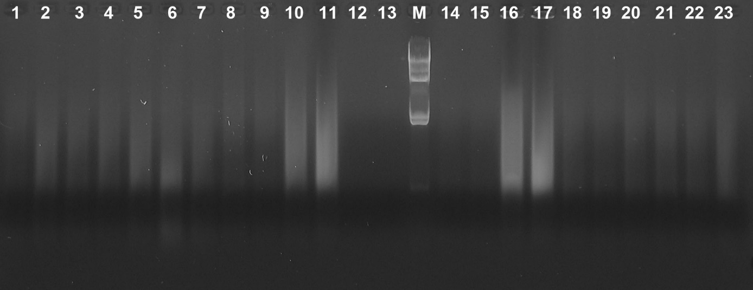
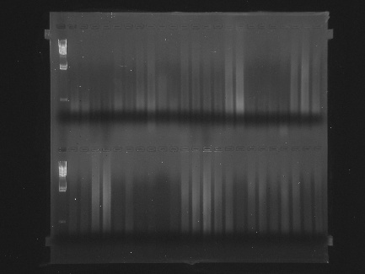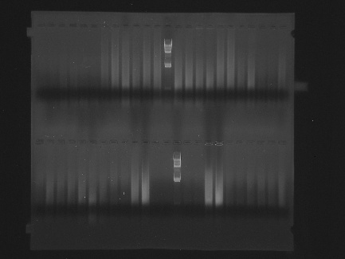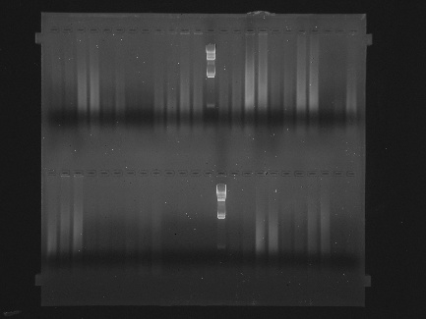

G model: genotypic relative risk (HWE distortion test)
The G model essentially describes the distribution of genotypes $\left[\begin{matrix}g_{0} & g_{1} & g_{2}\end{matrix}\right]$among "cases", taking into account the minor allele frequency f (MAF), the genetic relative risk (RR), with F also allowing a deviation from g₁ (excess heterozygosity). The distribution of genotypes in the source population is assumed to follow the HWE. It is given in S-Table 1 Genotype distribution among affected individuals (cases, patients) based on the HWE

We have taken uncertain genotypes into account by weighting them according to genotype probabilities (see Details to: Translation of the genotype doses into genotype probabilities).
S-Table 1 Genotype distribution among affected individuals (cases, patients) based on the HWE
genotypes g (minor allele count) | 0 | 1 | 2
Observed proportion of the genotype | $$g_{0}={n_{0}}/n$$ | $$g_{1={n_{1}}/n}$$ | $$g_{2={n_{1}}/n}$$
$P_{g,HWE}$: fraction of genotypes assuming HWE | $$(1-f)²$$ | $$2f(1-f)$$ | $$f²$$
relative penetrance* | $$1$$ | $$RR$$ | $$2*(RR-1)+1 = 2RR-1$$
risk of illness | $$p$$ | $$p∙RR$$ | $$p∙(2RR-1)$$
$P_{g,HWE,affected}$: fraction of those affected in the total population | $$p∙(1-f)²$$ | $$p∙RR∙2f(1-f)$$ | $$p∙\left(2RR-1\right).f²$$
$P_{HWE,affected}$Proportion of people with the disease in the total population | $$p\left\{\begin{aligned}{\left(1-f\right)}^{2}+ \\ RR∙2f\left(1-f\right)+ \\ \left(2RR-1\right)∙f²\end{aligned}\right\}$$
Proportion of g among those affected: $P_{g,HWE} | affected$ (in short $e_{g}$ | $$e_{0}=\frac{p∙(1-f)²}{p\left\{…\right\}}$$ | $$e_{1}=\frac{p∙RR∙2f(1-f)}{p\left\{…\right\}}$$ | $$e_{2}= \frac{p\left(2RR-1\right).f²}{p\left\{…\right\}}$$
$n_{0}, n_{1}, n_{2}$ are the numbers of individuals carrying 0, 1 or 2 copies of the rare allele. ${n=n}_{0}+ n_{1}+ n_{2}$is the sample size. In case of uncertain genotyping and $r_{0,i}, r_{1,i}, r_{2,i}$ indicating the genotype probabilities of individual i: $n_{0}=\sum_{i=1}^{n}{r_{0,i}}$. The same applies for $n_{1}$ and $n_{2}.$
* Penetrance $p$: fraction of individuals with a specific genotype g who express the expected phenotype (here: lung cancer). Across all genotypes, this is equivalent to incidence or risk of disease; $f$ minor allele frequency (MAF), $RR$ genetic relative risk
However, there are also mechanisms that can lead to a heterozygous or homozygous excess relative to HWE. Reasons for a heterozygote excess may include: e.g., a) hetero-positive selection (heterozygous individuals have a higher probability of survival or reproduction); b) Wahlund effect (mixing of genetically inhomogeneous subpopulations); c) negative assortative mating (individuals prefer to choose partners who are genetically different from themselves). Reasons for a homozygous excess may include: e.g., e) hidden relationships (hidden relationships or concealed population structures); f) inbreeding (consanguinity: the mating of individuals who are related in both the narrow and a broader sense); g) positive assortative mating (individuals preferentially choose partners with similar characteristics and consequently similar genotypes); h) homo-positive selection (when homozygous individuals have a higher probability of survival or reproduction).
Against the backdrop of possible inbreeding, a distribution of the genotype of a diallelic genomic marker with allele frequency $f$ (extended HWE) had to be defined as given in S-Table 2 (5). The proportion of g among those affected (${e_{g}=P}_{g,HWE} | affected$) changes accordingly.
S-Table 2 Extended HWE
genotypes g |  | 0 | 1 | 2
$P_{g,extHWE}$: fraction of genotypes assuming extended HWE |  | $${\left(1-f\right)}^{2}\left(1-F\right)+F(1-f)$$ | $$2f\left(1-f\right)\left(1-F\right)$$ | $$f²\left(1-F\right)+fF$$
$P_{HWE,affected}$Proportion of people with the disease in the total population |  | $$\left\{\begin{aligned}{\left(1-f\right)}^{2}\left(1-F\right)+F(1-f)+ \\ RR∙(2f\left(1-f\right)\left(1-F\right))+ \\ \left(2RR-1\right)∙(f²\left(1-F\right)+fF)\end{aligned}\right\}$$
$F$ excess homozygosity
The likelihood function L is used as the basis for the estimation. L is the probability of the observed sample occurring, calculated from the theoretical distribution of the three genotypes described above, given the parameters f, RR and F:
$$L\left(f,F,RR\right)=\sum_{g=0}^{2}{n_{g}∙e_{g}\left(f,F,RR\right)}$$
with $n_{g}$ the numbers of individuals carrying $g=0, 1 or 2$ copies of the rare allele.
The parameter RR is of central interest. It describes the disease risk of carriers of genotype $g_{1}$ (heterozygote) or $g_{2}$ (homozygote rarer allele) relative to that of carriers of genotype $g_{0}$ (homozygote more frequent allele). The last row of S-Table 1 shows that the “proportion of genotype g among those affected” is independent of risk of disease $p$.
The parameter RR can be estimated by maximising the likelihood of observed genotypes $\left[\begin{matrix}g_{0} & g_{1} & g_{2}\end{matrix}\right]$, given MAF and F as known. Since the likelihood function might not be unimodal (as shown in S-Table 3), the value of f (MAF) was set to the value given for persons of European descent in publicly accessible databases.
S-Table 3 Likelihood-function of two fictive autosomal markers
 | Log-Likelihood-function | saddle curve
MAF = 0,41 RR=0,75 | 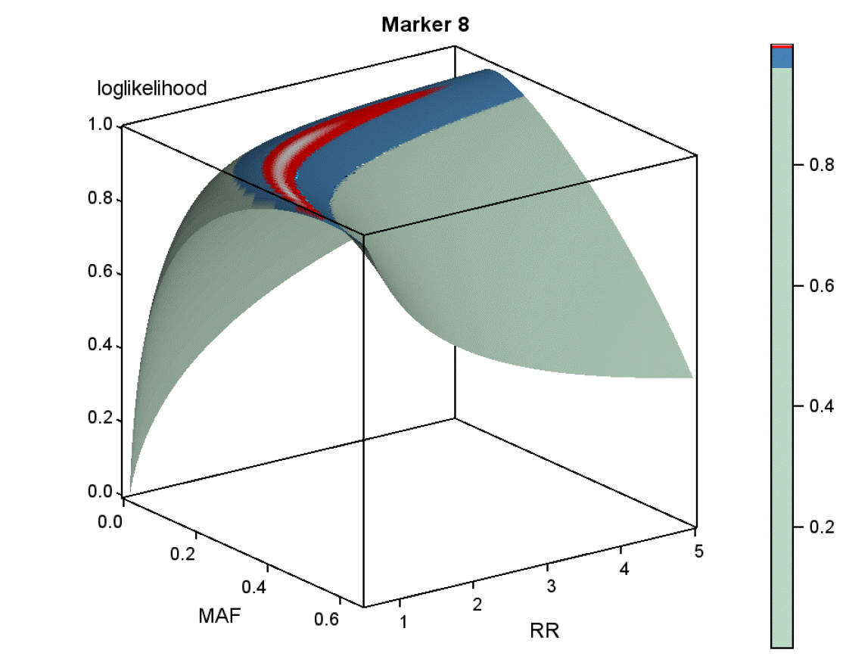 | 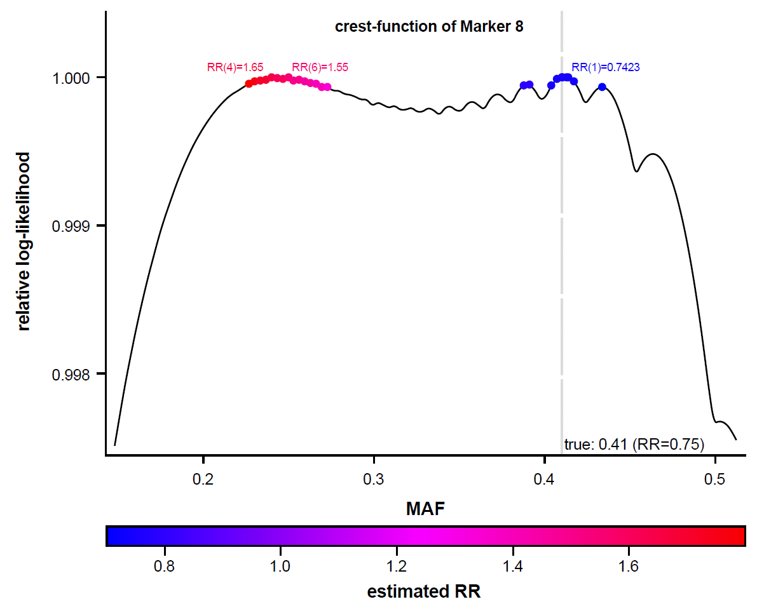
MAF=0,43 RR=1 | 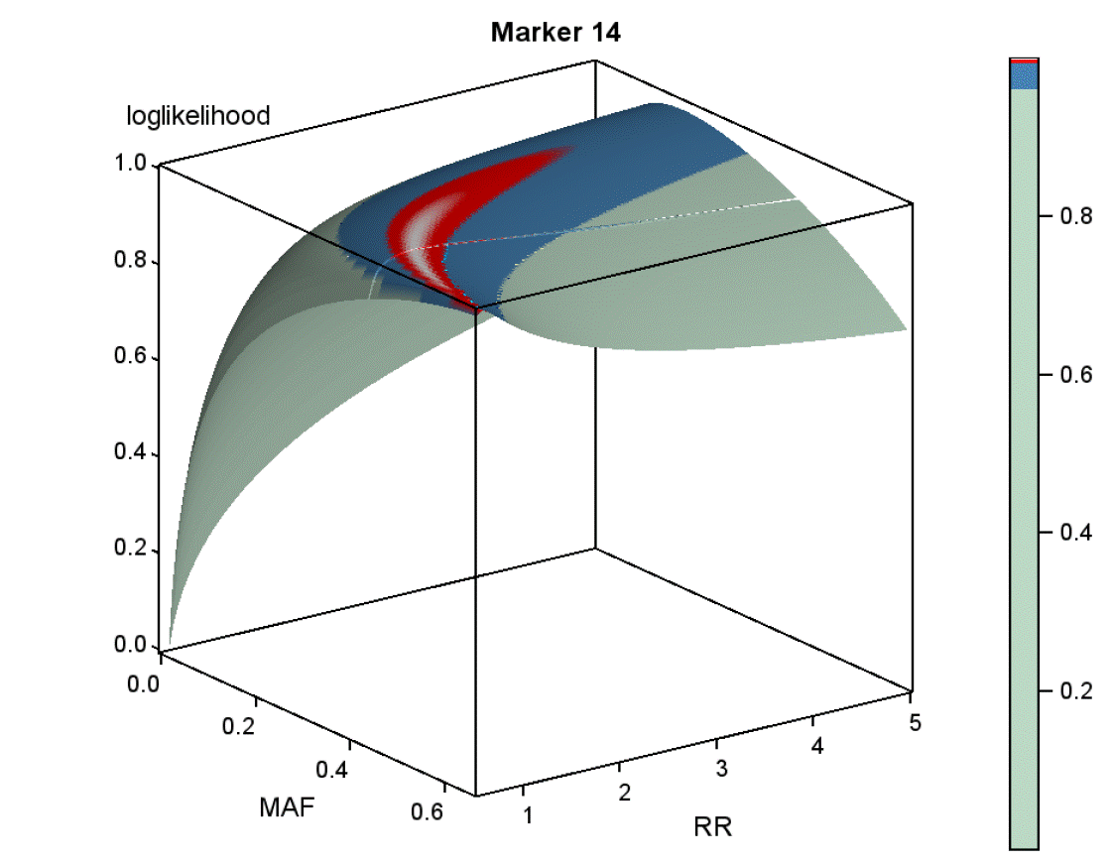 | 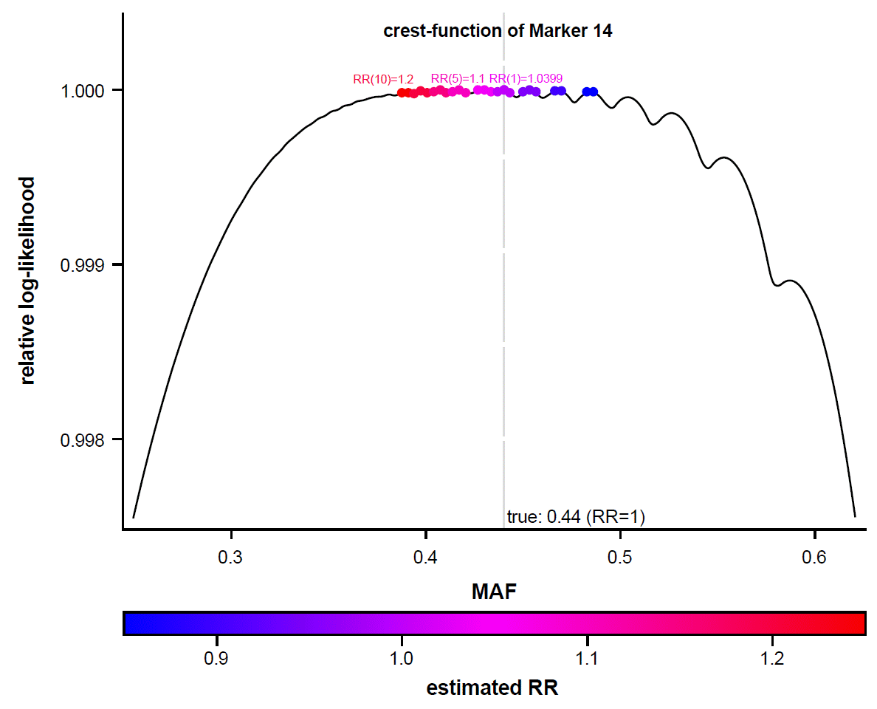

In case for MAF and F only an a-priori distribution can be assumed, the joint posterior distribution of parameters f, RR and F of the G model (likelihood x prior distributions of the parameters) can be mapped within the Bayesian MCMC framework. Since the likelihood function might not be unimodal, an informative a-posteriori distribution of f (MAF), around the value given for persons of European descent in publicly accessible databases, is required.
We used the following a-priori distribution:
f (MAF): informative: For a sample of k individuals (2*500=1,000 alleles), the number of risk alleles follows a binomial distribution: $x\sim binom(π=MAFpop,n=2k)$. The sample MAF is proportional by $MAF=x/2k$. The expected value of MAF is μ= MAF_{pop}, (population MAF for persons of European descent); the variance $σ_{μ}^{2}= μ\frac{1- μ}{n}.$
Hence, a beta distribution $B(α,β)$, i.e. the conjugate prior probability distribution of the binomial distribution, was used as the prior distribution of the MAF. Their parameters α and β were chosen so that μ and $σ_{μ}^{2}$remain unchanged.
RR: non-informative: log-normal distribution $logN\left(0,20\right)$,
restricting RR to positive values with an expected value of E(RR)=1
F: restrictive, non-information: uniform distribution $U(-0.1;+0,1)$

G model: genetic relative risk
S-Table 4 G Model: MCMC estimates from MAF and RR
Marker | Gen | MAF | 95%-HDI | RR | 95%-HDI | p_{direkt}†
rs7545208 | UBE2U | 0.34 | 0.31-0.36 | 1.25 | 1.02-1.46 | 0.0135
rs7526950 | UBE2U | 0.23 | 0.21-0.25 | 1.20 | 1.02-1.35 | 0.0325
rs10889478 | UBE2U | 0.48 | 0.46-0.51 | 0.95 | 0.82-1.08 | 0.5181
rs1908635 | UBE2U | 0.17 | 0.16-0.19 | 1.15 | 0.96-1.31 | 0.1152
rs7023680 | CDKN2A | 0.47 | 0.45-0.49 | 1.12 | 0.93-1.29 | 0.2289
rs3731217 | CDKN2A | 0.14 | 0.12-0.16 | 1.15 | 0.87-1.59 | 0.4889
rs10965227 | CDKN2A | 0.24 | 0.22-0.25 | 1.14 | 1.03-1.21 | 0.0276
rs73596224 | CUBN | 0.06 | 0.06-0.07 | 1.35 | 1.10-1.54 | 0.0073
rs60918373 | CUBN | 0.15 | 0.13-0.17 | 1.10 | 0.89-1.31 | 0.3133
rs7095324 | CUBN | 0.36 | 0.34-0.39 | 1.01 | 0.86-1.16 | 0.9439
rs10823112 | SIRT1 | 0.06 | 0.05-0.07 | 1.22 | 0.99-1.47 | 0.0597
rs10762183 | SIRT1 | 0.32 | 0.30-0.34 | 1.38 | 1.17-1.61 | <0.0001
rs7129281 | NAV2 | 0.27 | 0.25-0.29 | 0.95 | 0.74-1.13 | 0.549
rs11025138 | NAV2 | 0.30 | 0.28-0.32 | 0.92 | 0.75-1.07 | 0.3479
rs4756999 | NAV2 | 0.34 | 0.31-0.36 | 1.30 | 1.05-1.52 | 0.0056
rs7137426 | CD163L1 | 0.37 | 0.35-0.39 | 1.01 | 0.86-1.15 | 0.9482
rs7970379 | CD163L1 | 0.05 | 0.04-0.06 | 0.89 | 0.58-1.26 | 0.502
rs7302538 | CD163L1/ACSM4 | 0.06 | 0.04-0.07 | 1.18 | 0.86-1.65 | 0.517
rs1353793 | SOX5 | 0.45 | 0.43-0.47 | 1.34 | 1.14-1.54 | <0.0001
rs7978583 | SOX5 | 0.46 | 0.44-0.49 | 1.03 | 0.88-1.21 | 0.7345
rs4777965 | ST8SIA2 | 0.38 | 0.36-0.41 | 1.30 | 1.08-1.55 | 0.0083
rs1455777 | ST8SIA2 | 0.50 | 0.47-0.52 | 0.80 | 0.70-0.90 | 0.0063
rs3784722 | ST8SIA2 | 0.37 | 0.34-0.39 | 0.97 | 0.83-1.14 | 0.7011
rs8061518 | FTO | 0.34 | 0.32-0.36 | 1.27 | 1.07-1.50 | 0.01
rs6499657 | FTO | 0.16 | 0.14-0.17 | 1.22 | 1.00-1.55 | 0.091
rs1111483 | FTO | 0.48 | 0.46-0.51 | 1.02 | 0.89-1.18 | 0.9023
rs17886268 | TP53 | 0.04 | 0.03-0.05 | 1.14 | 0.93-1.35 | 0.3467
rs7141 | TP53 | 0.37 | 0.34-0.39 | 1.18 | 0.94-1.43 | 0.0726
rs7221056 | TP53 | 0.33 | 0.31-0.36 | 1.05 | 0.87-1.24 | 0.6576
† H₀: RR=1

Details to: Translation of the genotype doses into genotype probabilities
FLDSf is a highly flexible six-parametric function for isotonic transformation of a variable X of the value space [0-1] to a variable Y of the same value space [0-1] (6). We applied it to translate observed genotype doses (range 0 to 100) to genotype probabilities (range 0 to 1). The parameters of the FLDSf transformation per marker and per NGS setting were estimated during fitting the G model by maximizing the probability (ML method, with fixed MAF). The 87 FLDSf parameters sets (29 markers x 3 NGS-settings), grouped into 12 clusters with strong similarity (nearest centroid sorting via PROC FASTCLUS, SAS©). FLDSf parameter sets were created.
It is worth to note, that there was no marker and no NGS setting for which one and the same cluster could be assigned. No pattern whatsoever was identified for which NGS setting or which marker a particular FLDSf transformation was considered "optimal".
The genotype probability was then determined from the observed genotype doses (range 0 to 100) according to the related 12 FLDSf transformation clusters, depending on the marker and NGS setting (see S-Figure 1).

S-Figure 1 Twelve clusters of FLDSf transformations
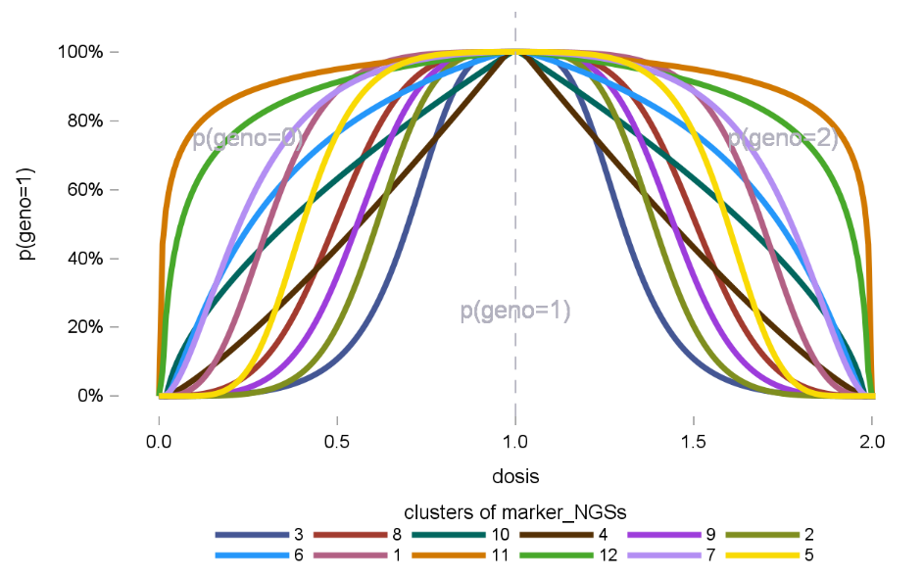
The numbering scheme of “clusters” is none-informative, as the assignment of markers/NGS-settings to clusters.

S-Table 5 Estimated parameters of the twelve clusters of FLDSf transformations
 | Function parameter |  |  |  |  |  | Probability of a heterozygosity at dose:
Cluster | a | b | c | d | u | o | 10 or 90 | 25 or 75 | 40 or 60 | F
3 | -2.00 | 2.50 | 1.25 | 1.25 | 0.02 | 0.97 | 1% | 15% | 96% | 0.0100
2 | 0.40 | 2.50 | 1.45 | 1.00 | 0.02 | 0.96 | 1% | 28% | 99% | 0.0333
9 | 0.00 | 2.50 | 1.25 | 1.08 | 0.02 | 0.97 | 3% | 42% | 99% | 0.0367
4 | 0.00 | 1.00 | 1.21 | 1.00 | 0.02 | 0.98 | 20% | 48% | 87% | 0.0271
10 | 0.00 | 1.00 | 0.93 | 1.43 | 0.02 | 0.99 | 41% | 66% | 92% | 0.0133
8 | -0.25 | 2.50 | 0.94 | 1.06 | 0.03 | 0.97 | 11% | 67% | 100% | 0.0375
6 | 1.46 | 1.00 | 1.00 | 0.77 | 0.02 | 0.97 | 52% | 79% | 96% | 0.0309
5 | 2.25 | 2.50 | 1.13 | 0.75 | 0.05 | 0.97 | 9% | 81% | 100% | 0.0375
1 | 1.67 | 2.50 | 0.92 | 1.00 | 0.02 | 0.97 | 38% | 91% | 100% | 0.0333
12 | 2.00 | 1.00 | 0.60 | 0.70 | 0.01 | 0.96 | 79% | 92% | 99% | 0.0240
7 | 2.00 | 1.60 | 1.00 | 1.00 | 0.01 | 0.97 | 73% | 93% | 99% | 0.0180
11 | 2.00 | 1.00 | 0.50 | 1.00 | 0.00 | 0.96 | 89% | 96% | 99% | 0.0240
sorted by dose; F estimated excess heterozygosity compared to HWE

MCMC estimation
The a posteriori distribution of a parameter is calculated using Bayesian methods (MCMC in this work). This reflects the probability of possible parameter values as a function of the observed data and a prior expectation (a priori distribution). Point estimates (here the mean value), interval estimates (here the 95% HDI) and significance measures (here based on the probability of direction) can be derived from the a posteriori distribution (7).
Highest Posterior Density Intervals (HDI)  The 95% HDI is a region with an a posteriori probability of 95%. The minimum density of any point within this region is equal to or greater than the density of any point outside this region. | 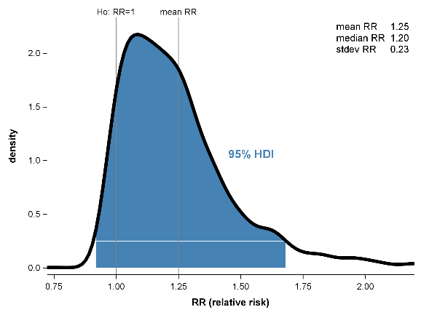
Probability of Direction (p_{d})  The probability of direction ($p_{d}$) can be defined as the probability that a parameter is smaller (or larger) than a value under the null hypothesis, whichever is the most probable. $(1- p_{d})$ is therefore the equivalent of the one-sided p-value but measured using the a posteriori distribution. | 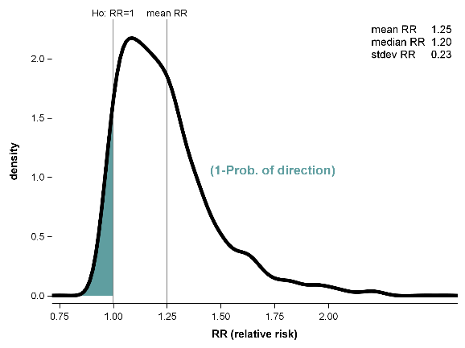

A parameter was labelled as significant in this work if p_{two−sided} = 2×(1−p_{d}) (p_{d}: “probability of direction”) was lower than 0.05. This corresponds approximately to the p-value of a 2-sided test of frequentist statistics.

References
1. Buniello A, MacArthur JAL, Cerezo M, Harris LW, Hayhurst J, Malangone C, u. a. The NHGRI-EBI GWAS Catalog of published genome-wide association studies, targeted arrays and summary statistics 2019. Nucleic Acids Res. 8. Januar 2019;47(D1):D1005–12. doi:10.1093/nar/gky1120 PubMed PMID: 30445434; PubMed Central PMCID: PMC6323933.
2. National Center for Biotechnology Information (NCBI)[Internet]. Bethesda (MD). dbGene [Internet]. Verfügbar unter: https://www.ncbi.nlm.nih.gov/gene
3. The Human Protein Atlas [Internet]. [zitiert 5. Februar 2021]. Verfügbar unter: https://www.proteinatlas.org/
4. Cunningham F, Amode MR, Barrell D, Beal K, Billis K, Brent S, u. a. Ensembl 2015. Nucleic acids research. Januar 2015;43(Database issue):D662-9. Located at: 25352552. doi:10.1093/nar/gku1010
5. Cavalli-Sforza LL, Bodmer WF. The Genetics of Human Populations. Mineola, New York: Dover Publications; 1999.
6. Rosenberger A. FLDS: A Flexible, Limited, Double-Sigmoid Transmission Function. Journal of Probability and Statistics. 2026;2026(1):6076741. doi:10.1155/jpas/6076741
7. Makowski D, Ben-Shachar MS, Chen SHA, Lüdecke D. Indices of Effect Existence and Significance in the Bayesian Framework. Frontiers in Psychology [Internet]. 2019 [zitiert 1. November 2022];10. Verfügbar unter: https://www.frontiersin.org/articles/10.3389/fpsyg.2019.02767

