Supplementary Material

Supplementary Methods

Western blot analysis

Spinal cord segments (L4–L6) were harvested immediately after euthanasia and frozen in liquid nitrogen. Tissues were homogenized in RIPA lysis buffer (Servicebio, China) supplemented with protease inhibitors (1:100, Servicebio). After incubation on ice for 30 min, lysates were centrifuged at 12,000 rpm for 10 min at 4°C. Protein concentrations were determined using a BCA protein assay kit (Servicebio, China). Samples were mixed with 5× SDS loading buffer (4:1 ratio) and boiled at 100°C for 15 min.

Equal amounts of protein (30 μg per lane) were separated by 10% SDS-PAGE and transferred onto PVDF membranes (0.45 μm, Millipore). Membranes were blocked with 5% non-fat milk in TBST for 30 min at room temperature, then incubated overnight at 4°C with primary antibodies: rabbit anti-PLA2G2A (1:1000, CUSABIO), rabbit anti-NTRK1 (1:1000, Proteintech), rabbit anti-BDKRB2 (1:1000, Proteintech), and mouse anti-β-actin (1:2000, Servicebio). After washing three times with TBST (5 min each), membranes were incubated with HRP-conjugated secondary antibodies (1:5000, Servicebio) for 30 min at room temperature. Protein bands were visualized using an ECL chemiluminescence kit (Servicebio) and imaged with a chemiluminescence imaging system (Servicebio SCG-W3000). Band intensities were quantified using AIWBwell™ software (Servicebio) and normalized to β-actin.

Supplementary Table S1

Table S1. Quantitative analysis of PLA2G2A, NTRK1, and BDKRB2 protein expression in the spinal dorsal horn.
Group | n | PLA2G2A | NTRK1 | BDKRB2
Control | 4 | 0.065 ± 0.008 | 0.158 ± 0.005 | 0.203 ± 0.005
Model | 3 | 1.017 ± 0.012**** | 1.020 ± 0.000**** | 1.203 ± 0.025****
US1 | 4 | 0.215 ± 0.019****#### | 0.418 ± 0.005****#### | 0.308 ± 0.005****####
Data are presented as mean ± SD. Statistical significance was determined by one-way ANOVA followed by Tukey's multiple comparisons test. ****p < 0.0001 vs. Control;####p < 0.0001 vs. Model.

Supplementary Figures

Figure S1. Design and realization of the custom rat treatment platform.
(A) 3D CAD rendering of the platform, showing the dual-transducer positioning arm and the adjustable rat fixation system.
(B) Photograph of the manufactured platform, demonstrating the actual structure and components.

Figure S2. Time course of (A) mechanical pain threshold and (B) thermal pain threshold in CFA-induced inflammatory pain rats (n = 8 per group). Data are presented as mean ± SD. The US1 group (shallow depth + low intensity) showed the most pronounced recovery over time.

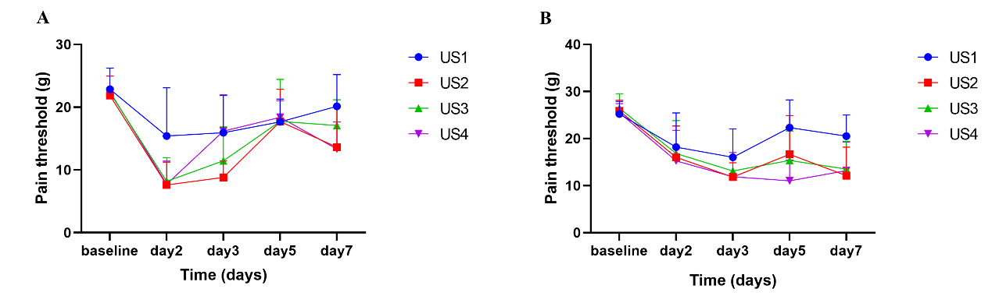
Figure S3. Representative heatmaps and trajectory maps of the open field test.
(A) Heatmaps of representative animals from US1 (3 mm + 0.03 W/cm²), US2 (5 mm + 0.03 W/cm²), US3 (3 mm + 1.0 W/cm²), and US4 (5 mm + 1.0 W/cm²) groups. The color scale represents time spent in different zones (0 s to ~8.0 s), with red indicating high duration and blue indicating low duration.
(B) Corresponding trajectory maps of the same animals.

Figure S4. Western blot analysis of pain-related protein expression in the spinal dorsal horn. (A) Representative blots of PLA2G2A (16.1 kDa). (B) Representative blots of BDKRB2 (44 kDa). (C) Representative blots of NTRK1 (140 kDa). (D) Representative blots of β-actin (42 kDa), used as an internal loading control. Molecular weight markers are indicated on the left (kDa). Lanes: C1–C4 (Control, naïve rats), M1–M3 (Model, CFA-induced inflammatory pain rats), US1.1–US1.4 (US1, UNFA treatment at 3 mm + 0.03 W/cm²).
