SUPPLEMENTARY MATERIAL

Clinical and economic assessments of a personalized support plan to improve adherence to positive airway pressure therapy in patients with obstructive sleep apnea: a randomized controlled trial in Portugal

Supplementary Methods
Personalized support program
The study personalized support program used in this study (VitalCare) comprised six distinct support plans tailored to the patient’s predicted positive airway pressure (PAP) adherence profile and digital literacy (Figure S1). High-adherence, digitally capable individuals received low-intensity educational and logistical support (primarily via a mobile application or phone calls). Conversely, low-to-intermediate adherence profiles were assigned to high-intensity pathways that combined frequent scheduled home visits, proactive telemonitoring alert management by trained HSP nurses, and hands-on mask and pressure adjustments.

FIGURE S1 Details of how the personalized support plan was determined for each patient
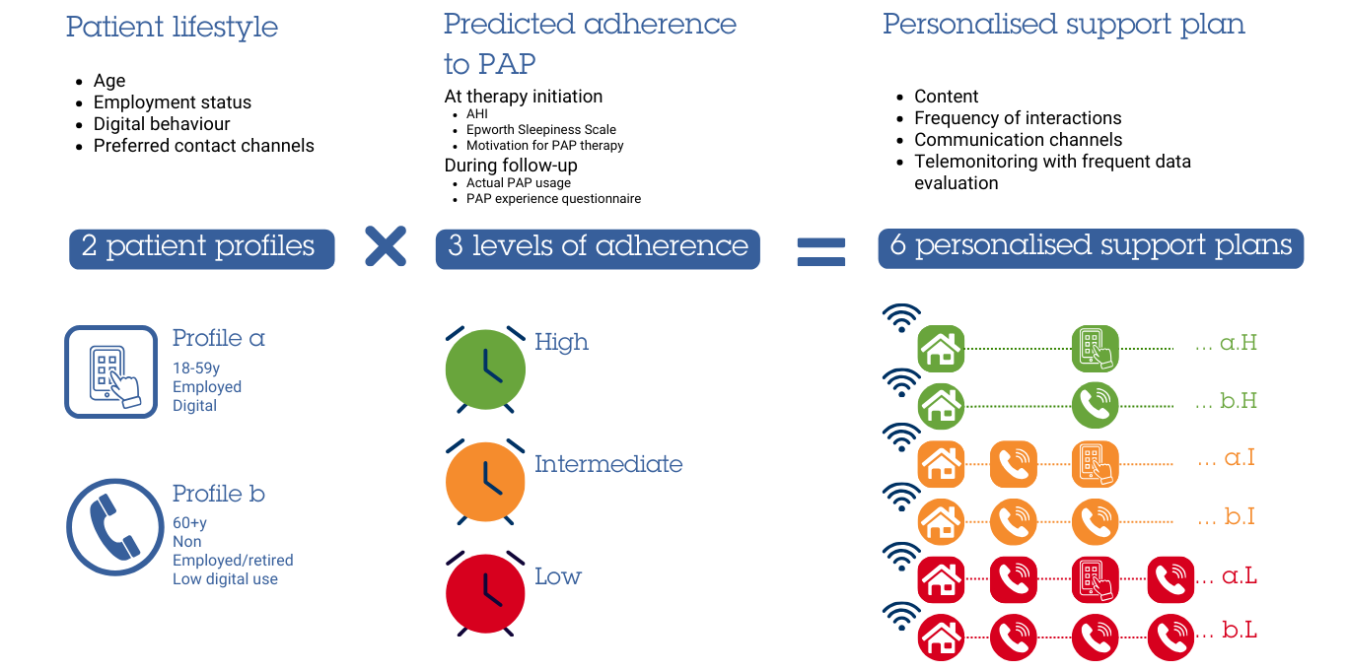

Health economic model
Costs for individuals who were adherent or non-adherent to positive airway pressure (PAP) therapy (device usage ≥4 h/day versus <4 h/day) over a 1-year time horizon from PAP therapy initiation were based on the Spanish cost-effectiveness study [1]. This study was performed in Spain and healthcare costs were those for the Catalan Health Service (CatSalut) in 2013.
Because healthcare costs in Portugal are lower than those in Spain, all costs were adapted to the Portuguese setting. For direct costs, a literature review was performed to compare unit costs for cardiovascular events, cancers and road accidents [2-4], and the average of the differences in these costs was applied in the model. To adapt indirect costs, the number of workdays missed was multiplied by the number of people in work in Portugal and the average salary (Table S1). Cost correction for inflation between 2013 [1] and 2023 was performed using the International Monetary Fund (IMF) database (CCEMG–EPPI Centre Cost Converter) (Table S1).

TABLE S1 Cost adaptation parameters and sources
Parameter | Data | Source used for cost adaptation
Inflation from 2013 to 2023 | +13% | https://eppi.ioe.ac.uk/costconversion/default.aspx
Direct medical costs (hospitalizations, visits for cardiovascular event, cancer, road traffic accident) | –25% | - Cardiovascular event: Luengo Fernandez et al, 2023 [3]  - Cancer: Luengo Fernandez et al, 2013 [2]  - Road traffic accident: Wijnen et al, 2017 [4]
Indirect costs | Mean salary per day at age 55–64 years (2021): €80  Employment rate of people aged 55–64 years (2023): 67.1% | https://www.ine.pt/xportal/xmain?xpid=INE&xpgid=ine_destaques&DESTAQUESdest_boui=606765498&DESTAQUESmodo=2  https://tradingeconomics.com/portugal/employment-rate-of-older-workers-age-group-55-64-eurostat-data.html

Supplementary Results
Adverse events
Specific details of the non-serious adverse events occurring during the study were discomfort (n=2), and nasal obstruction, nasal dryness, dry mouth and allergy to nasal mask (n=1 for each) in the standard follow-up group, and discomfort and nasal obstruction (n=2), and suffocation feeling, respiratory tract infection and nasal injury (n=1 each) in the personalized support plan group.

TABLE S2 Responses to the continuous positive airway pressure perception questionnaire in the personalized support plan group (n=53)
 | 1 month (n=47) | 3 months (n=45) | 12 months (n=43)
No/some difficulty tolerating PAP | 29 (61.7) | 27 (60.0) | 34 (79.1)
Not/somewhat uncomfortable mask | 30 (63.8) | 26 (57.8) | 35 (81.4)
Not/somewhat uncomfortable PAP pressure | 34 (72.3) | 27 (60.0) | 37 (86.0)
High likelihood/likelihood of wearing the equipment almost every night | 35 (74.5) | 34 (75.6) | 33 (76.7)
PAP very/somewhat beneficial for health and sleep | 30 (63.8) | 29 (64.4) | 37 (86.0)
Greatly/somewhat like PAP therapy | 23 (48.9) | 21 (46.7) | 24 (55.8)
Data are number of participants (%) who answered 1–4 on the 10-point Likert-type scale [from 1 (no difficulty/ no discomfort/positive attitude towards PAP) to 10 (significant difficulty/significant discomfort/negative attitude towards PAP)], where the denominator is the number of patients without missing data.
PAP, positive airway pressure.

TABLE S3 Adherence data for subgroups based on baseline apnea-hypopnea index
 | Mean PAP device usage, h/day |  | p-value | PAP device usage ≥4 h/day, n (%) |  | p-value
 | Standard follow-up (n=51) | Personalized support plan (n=56) | p-value | Standard follow-up (n=51) | Personalized support plan (n=56) | p-value
3 months
AHI <15/h (n=26) | 3.25±2.43 | 5.02±1.92 | 0.049ª | 6 (42.9) | 9 (75.0) | 0.13^{c}
AHI ≥15 to <30/h (n=39) | 2.73±2.34 | 4.85±1.97 | 0.005ª | 5 (27.8) | 14 (66.7) | 0.015^{d}
AHI ≥30/h (n=41) | 5.43±2.37 | 4.18±2.62 | 0.095^{b} | 14 (77.8) | 12 (52.2) | 0.11^{c}
6 months
AHI <15/h (n=26) | 3.00±2.56 | 5.07±1.67 | 0.022ª | 4 (28.6) | 9 (75.0) | 0.047^{c}
AHI ≥15 to <30/h (n=39) | 2.85±2.30 | 4.89±2.01 | 0.006ª | 4 (22.2) | 15 (71.4) | 0.004^{c}
AHI ≥30/h (n=42) | 5.44±2.46 | 4.16±2.52 | 0.077^{b} | 15 (78.9) | 12 (52.2) | 0.11^{c}
12 months
AHI <15/h (n=26) | 3.04±2.49 | 4.77±1.49 | 0.040ª | 4 (28.6) | 9 (75.0) | 0.047^{c}
AHI ≥15 to <30/h (n=39) | 2.84±2.36 | 4.82±1.85 | 0.007ª | 5 (27.8) | 17 (81.0) | 0.001^{c}
AHI ≥30/h (n=42) | 5.44±2.49 | 4.19±2.64 | 0.11^{b} | 16 (84.2) | 13 (56.5) | 0.09^{c}
Data are mean ± standard deviation, or number of participants (%) where the denominator is the number of patients without missing data.
ªStudent test.
^{b}Wilcoxon test.
^{c}Fisher’s exact test.
^{d}Chi-squared test.
AHI, apnea-hypopnea index; PAP, positive airway pressure.

References
1. Català R, Villoro R, Merino M, et al. Cost-effectiveness of continuous positive airway pressure treatment in moderate-severe obstructive sleep apnea syndrome. Arch Bronconeumol. 2016;52(9):461-9. https://www.doi.org/10.1016/j.arbres.2016.02.005.
2. Luengo-Fernandez R, Leal J, Gray A, Sullivan R. Economic burden of cancer across the European Union: a population-based cost analysis. Lancet Oncol. 2013;14(12):1165-74. https://www.doi.org/10.1016/s1470-2045(13)70442-x.
3. Luengo-Fernandez R, Walli-Attaei M, Gray A, et al. Economic burden of cardiovascular diseases in the European Union: a population-based cost study. Eur Heart J. 2023;44(45):4752-67. https://www.doi.org/10.1093/eurheartj/ehad583.
4. Wijnen W, Weijermars W, Vanden Berghe W, et al. Crash cost estimates for European countries, Deliverable 3.2 of the H2020 project SafetyCube (2017). Available at: https://www.safetycube-project.eu/wp-content/uploads/SafetyCube-D3.2-Crash-costs-estimates-for-European-countries.pdf. Accessed 18 Sep 2024.

