Supplement to: Limitations of the ARDS criteria during high-flow oxygen or non-invasive ventilation: Evidence from critically ill COVID-19 patients

Michael Hultström^{1,2}, Ola Hellkvist¹, Lucian Covaciu¹, Filip Fredén¹, Robert Frithiof¹, Miklós Lipcsey^{1,3}, Gaetano Perchiazzi^{1,3}, Mariangela Pellegrini^{1,3}

¹Anaesthesiology and Intensive Care Medicine, Department of Surgical Sciences, Uppsala University, Sweden
²Integrative Physiology, Department of Medical Cell Biology, Uppsala University, Sweden
³Hedenstierna Laboratory, Department of Surgical Sciences, Uppsala University, Sweden

Supplementary Table 1. Descriptive statistics of the six groups defined by changes in respiratory support. The possible changes of respiratory support defined six different groups of patients: 1) HFNC-to-NIV; 2) HFNC-to-MV; 3) NIV-to-HFNC; 4) NIV-to-MV; 5) MV-to-HFNC; 6) MV-to-NIV. BMI: body mass index, GCS: Glasgow coma scale.

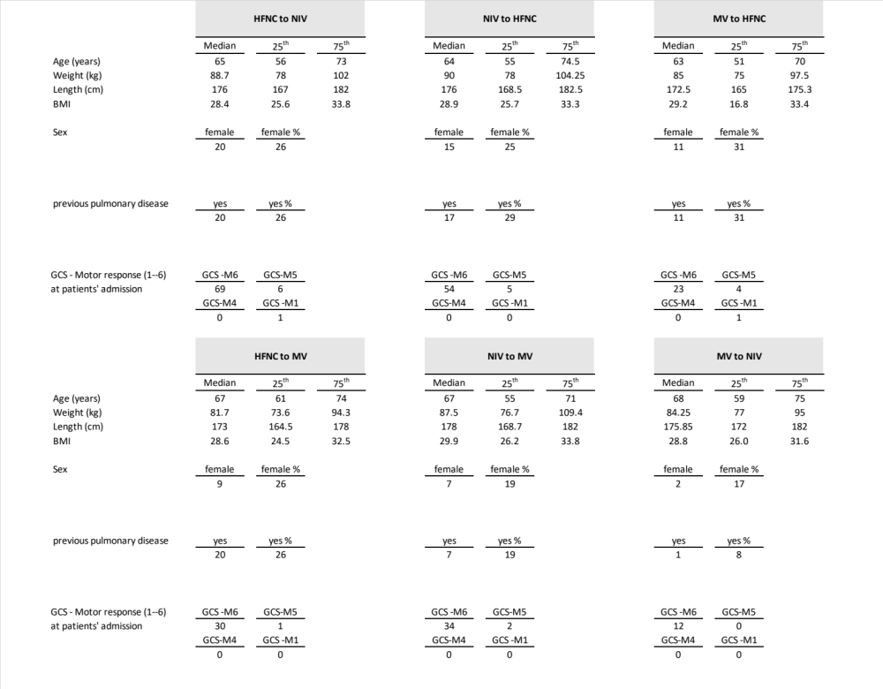
Supplementary Table 2. Descriptive statistics for correlation and Bland-Altman plot of PaO₂/F_{I}O₂ ratio analysis.
For correlation: r²: Pearson r-value squared; p: Pearson correlation p-value; rho: Spearman rho value; rhoP: Spearman rho value and p-value; SSE: sum of squared error; RMSE: root mean squared error;
For the Bland-Altman plot: SD: standard-deviation of the differences; rpc: reproducibility coefficient (1.96*SD); CV: coefficient of variation (SD of mean values in %); rcpPercent: reproducibility coefficient and % of values; IQR: interquartile range; 'RPCnp: RPC estimate based on IQR (non-parametric statistics), where RPCnp = 1.45*IQR ~ RPC (if distribution of differences is normal); ksp: Kolmogorov-Smirnov test that difference-data is Gaussian (p-value).

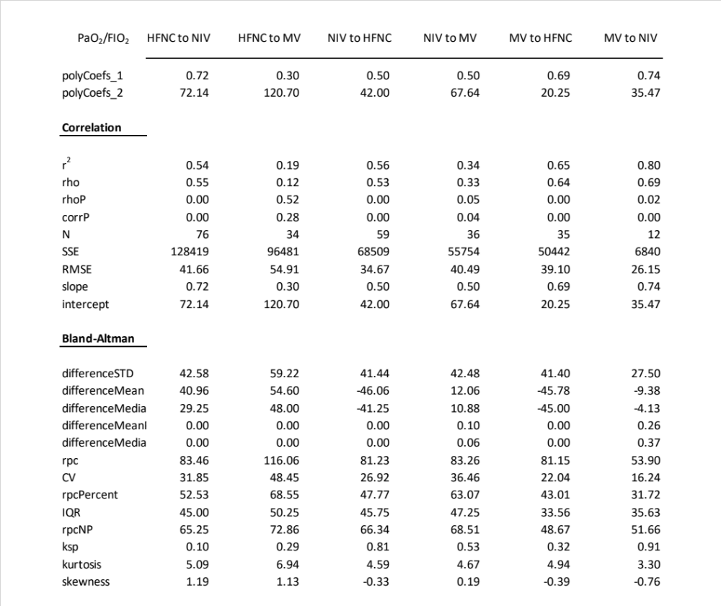
Supplementary Figure 1. Boxplot and scatter plot, PO₂/F_{I}O₂ ratio for each group including invasive mechanical ventilation (MV).
y-axis: PO₂/F_{I}O₂ ratio during HFNC (left graphs) and NIV (right graphs).
x-axis: ARDS severity during mechanical ventilation (MV) based on the Berlin definition.
Up left graph: subgroup HFNC-to-MV.
Down left graph: subgroup MV-to-HFNC.
Up right graph: subgroup NIV-to-MV.
Down right graph: subgroup MV-to-NIV.

Red circles for scatter plot of single data. For each boxplot median values and (interquartile range) have been reported. Two-sample Kolmogorov-Smirnov test (𝛼 = 0.05) was used to test statistical differences between MV and either HFNC or NIV. To compare, within the same level of ARDS severity, the two NIV and the two HFNC groups (four groups in total), the Kruskal-Wallis test (𝛼 = 0.05) followed by Bonferroni correction were used.
+: to indicate outliers, red line to indicate median values. *: labels statistical differences between HFNC (or NIV) and MV. #: labels statistical differences between HFNC-to-MV and MV-to-HFNC as well as between NIV-to-MV and MV-to-NIV.

