Online Supplemental Materials for

Treatment Response in a Randomized Controlled Trial on the Prevention of Mental Illness in the Offspring of Parents With Depression

Details on Imputed Data and Missingness
As a first step, it was examined whether missingness in youth-reported internalizing symptoms was systematically related to observed baseline variables. For both the intervention and control groups, children with missing values tended to be younger, more often female, and had parents with higher parental depressive symptoms. Within the intervention group, children with missing values also showed higher baseline internalizing symptoms than those without missing values, whereas in the control group, they showed lower baseline levels. Because these differences were associated with observed variables, the missingness pattern is consistent with a Missing at Random (MAR) mechanism. Under MAR, missingness can be appropriately addressed using multiple imputations by chained equations (MICE).
Data imputation was conducted separately for the intervention and control group, using a fixed random seed for reproducibility and m = 20 imputations. Diagnostic checks of imputation quality for the intervention group (Figure S1) and control group (Figure S2) indicated that the multiple imputation model performed adequately.

Figure S1
Distribution of Observed vs. Imputed Internalizing-Symptom Scores (Intervention Group)
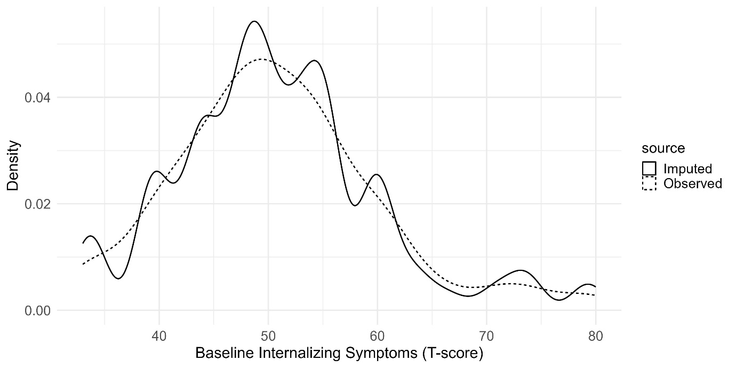
Figure S2
Distribution of Observed vs. Imputed Internalizing-Symptom Scores (Control Group)
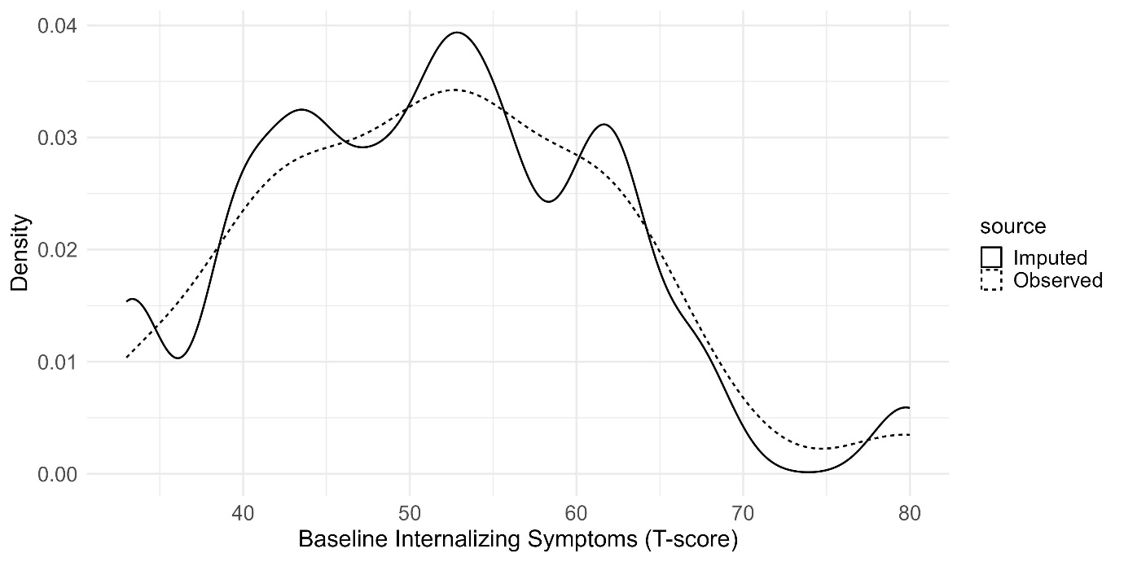

Table S1
Child Internalizing Symptoms at Different Time Points
 | Intervention Group |  | Control Group
 | M | SD | M | SD
Child Internalizing Symptoms at T1 (Baseline) | 51.84 | 9.95 | 49.73 | 10.03
Child Internalizing Symptoms at T2 | 50.21 | 9.24 | 51.50 | 9.92
Child Internalizing Symptoms at T3 | 51.33 | 9.60 | 54.25 | 11.26
Child Internalizing Symptoms at T4 | 49.34 | 8.83 | 52.19 | 11.15
Note. Mean (M) and standard deviation (SD) of child internalizing symptoms at different time points, differentiated for intervention and control groups. N was 46 for the intervention group and 37 for the control group.

Posterior Predictive Checks for Linear Mixed Models
All posterior predictive checks were generated using the pp_check() function from the brms package (Bürkner, 2017) with type = "dens_overlay". Each plot displays 10 posterior predictive draws from the first imputed dataset. The dark blue line represents the observed data distribution, while the light blue lines represent simulated data distributions from the posterior predictive distribution. Across all models, simulated and observed distributions aligned closely, indicating adequate model fit.
Figure S3
Posterior Predictive Checks for the Gender-by-Time Model in the Intervention Arm
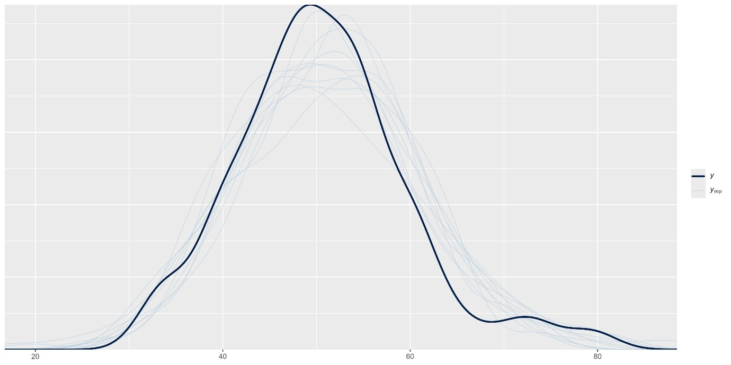

Figure S4
Posterior Predictive Checks for the Age-by-Time Model in the Intervention Arm
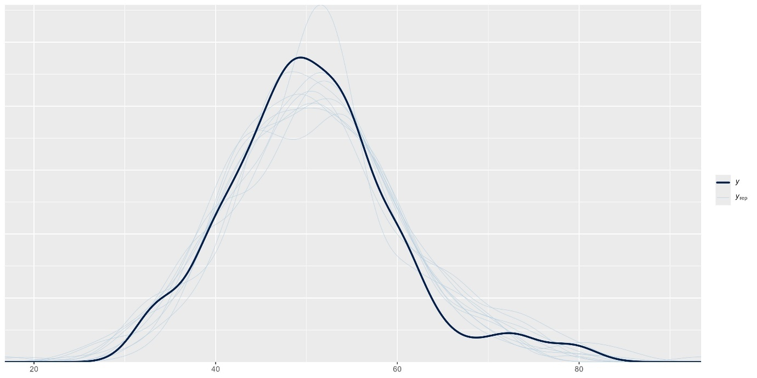
Figure S5
Posterior Predictive Checks for the Parental Symptoms-by-Time Model in the Intervention Arm
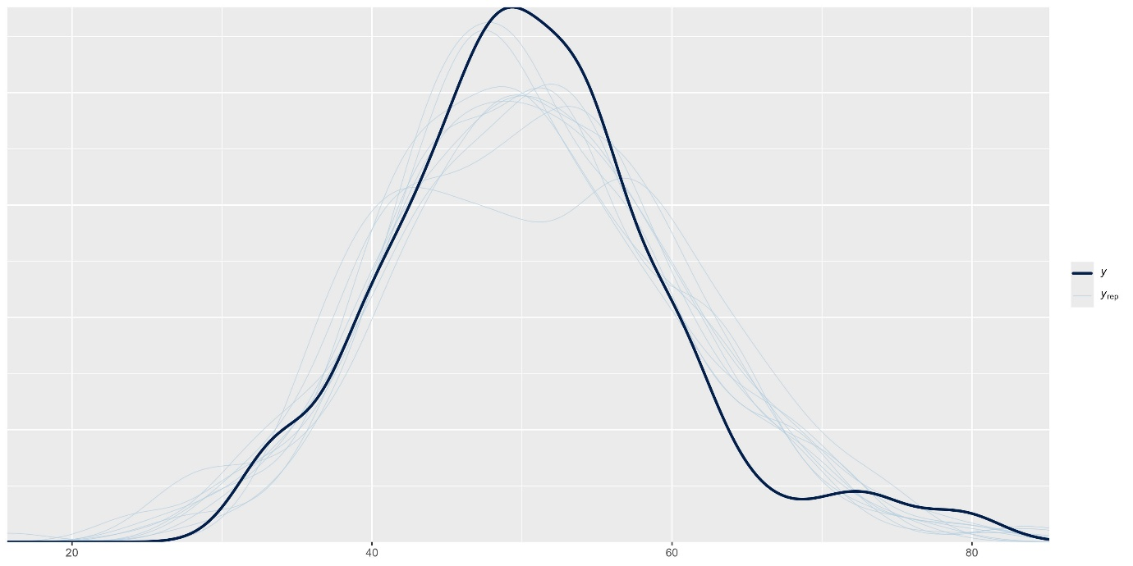

Figure S6
Posterior Predictive Checks for the Baseline Symptoms-by-Time Model in the Intervention Arm
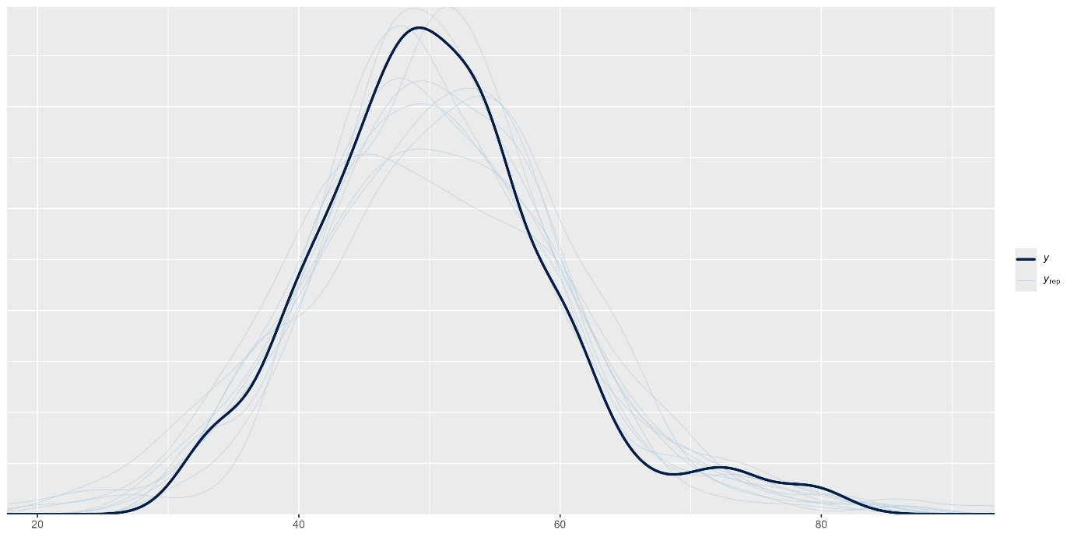
Figure S7
Posterior Predictive Checks for the Gender-by-Time Model in the Control Arm
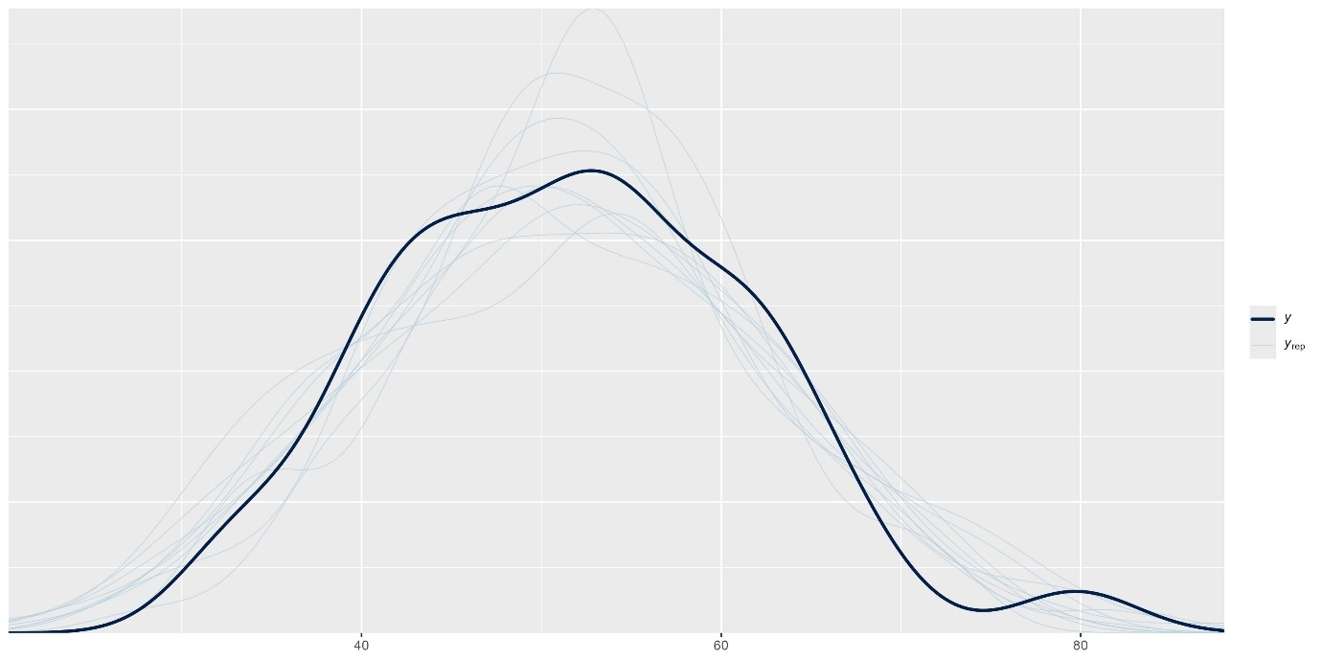

Figure S8
Posterior Predictive Checks for the Age-by-Time Model in the Control Arm
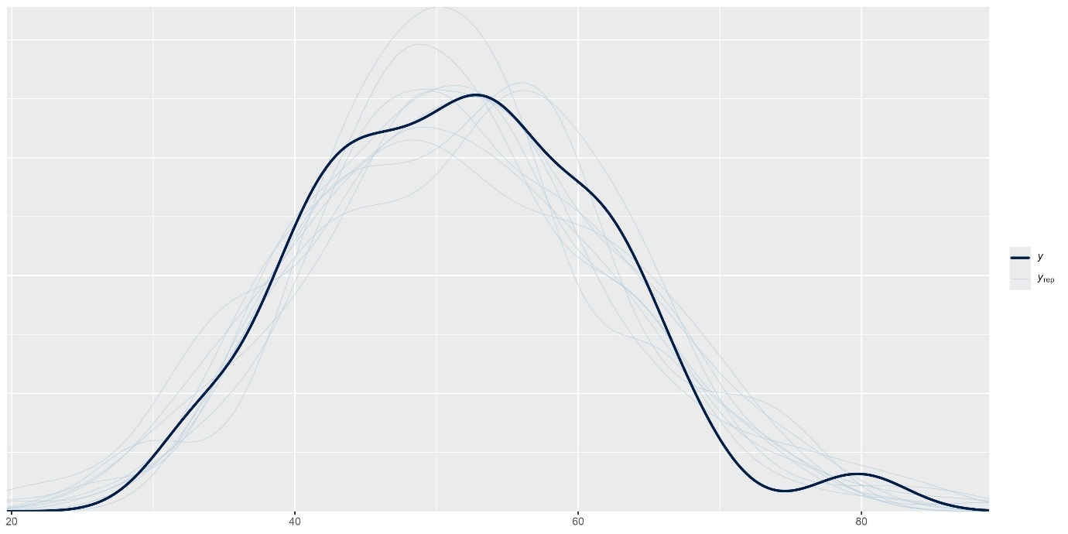
Figure S9
Posterior Predictive Checks for the Parental Symptoms-by-Time Model in the Control Arm
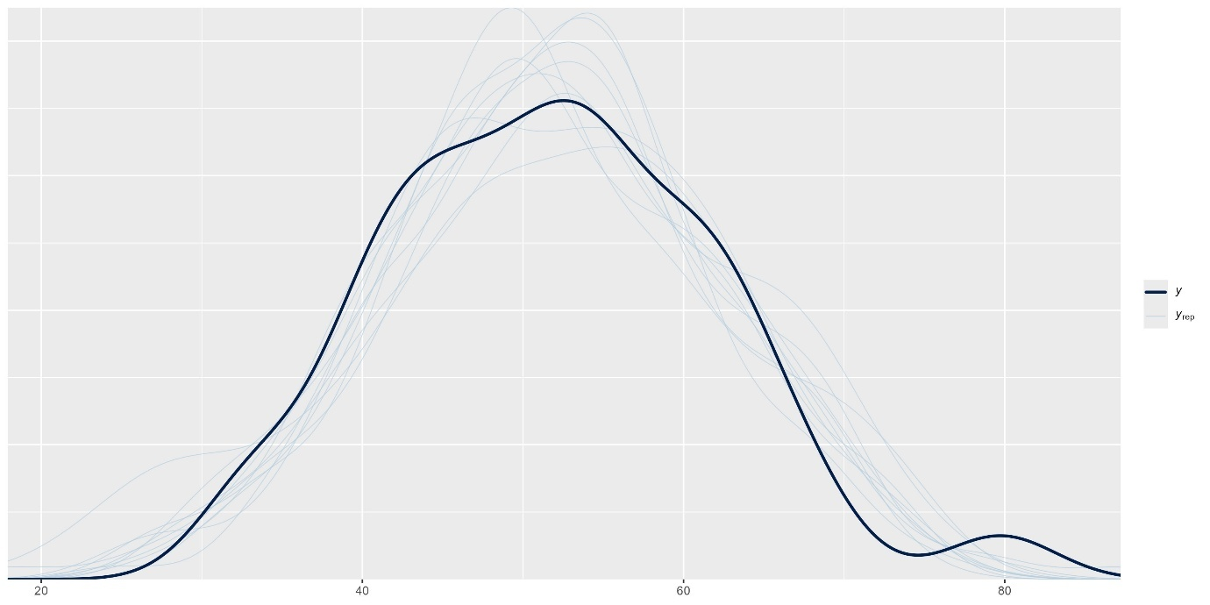

Figure S10
Posterior Predictive Checks for the Baseline Symptoms-by-Time Model in the Control Arm
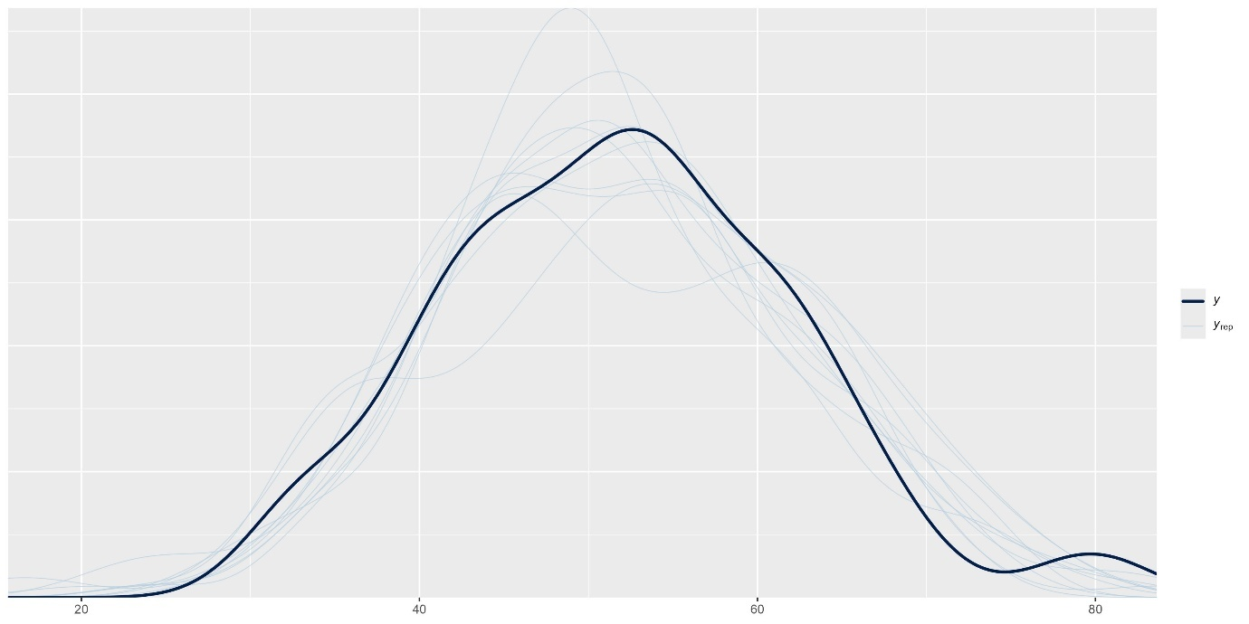

Figure S11
Child Internalizing Symptoms over Time Differentiated by Gender (Imputed Dataset)
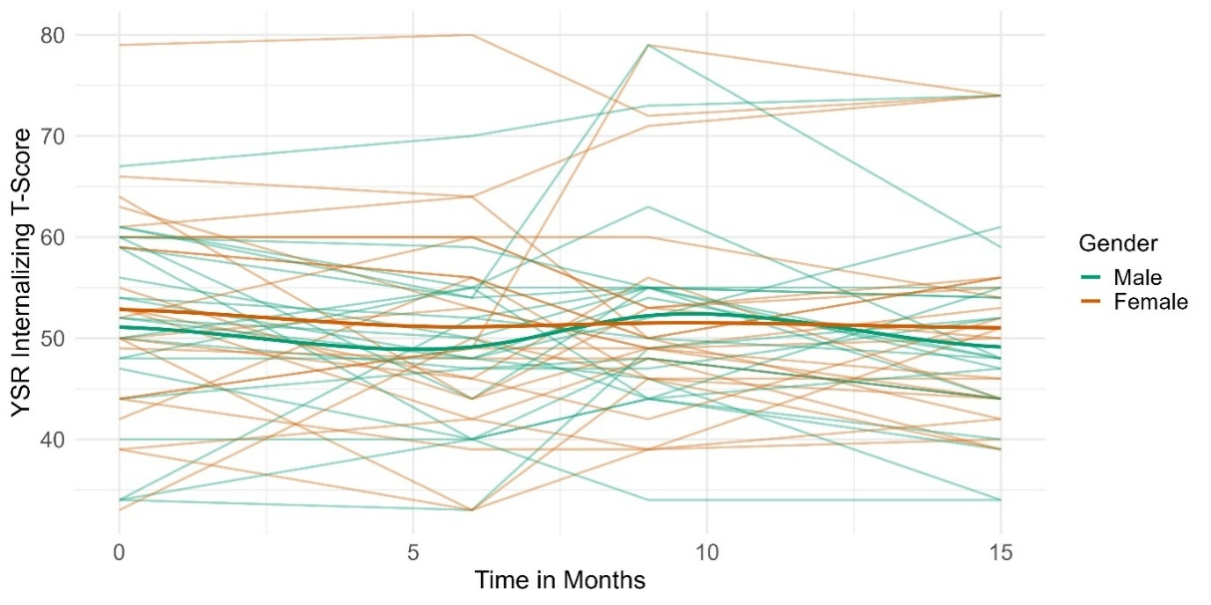
Note. Only one imputed data set is shown.
Figure S12
Child Internalizing Symptoms over Time Differentiated by Age (Imputed Dataset)
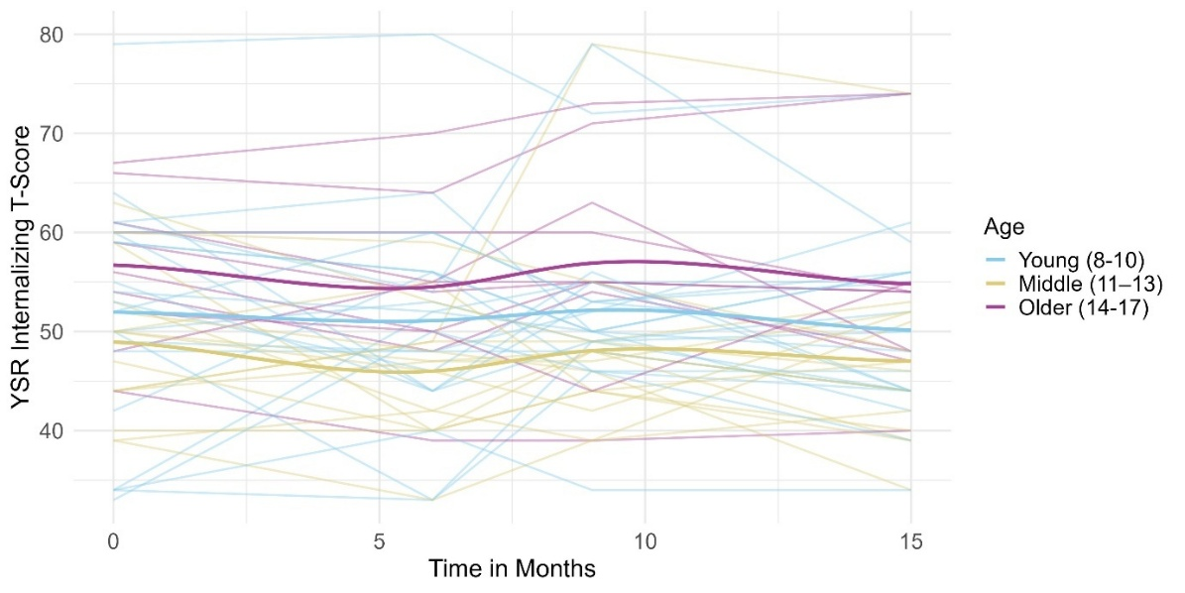
Note. Only one imputed data set is shown.

Figure S13
Child Internalizing Symptoms over Time Differentiated by Baseline Symptoms (Imputed Data)
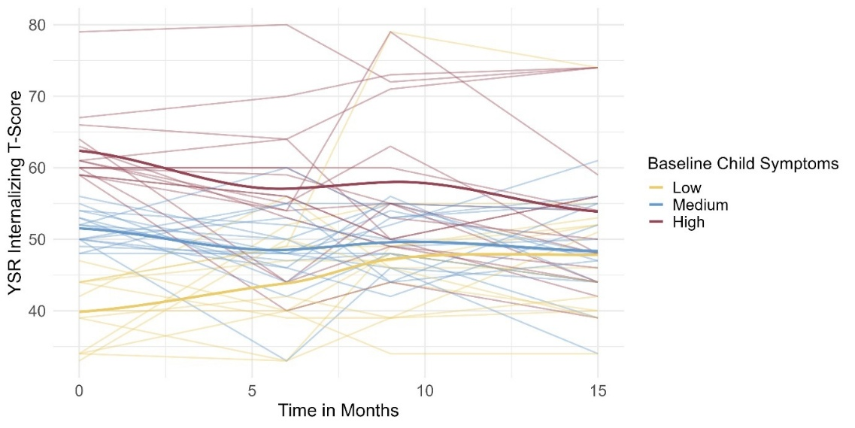
Note. Groups were created using half a standard deviation above and below the mean as cut-offs, due to the high density of scores around the mean. Only one imputed data set is shown.

Figure S14
Child Internalizing Symptoms over Time Differentiated by Parental Symptoms (Imputed Dataset)
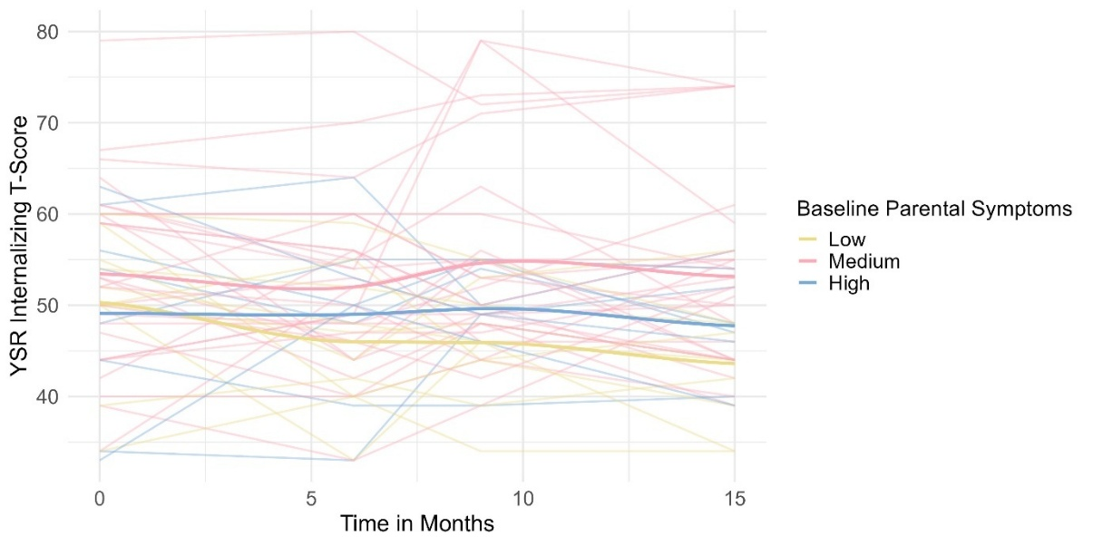

Note. Groups were created using one standard deviation above and below the mean as cut-offs. Only one imputed data set is shown.

Figure S15
Dendrogram of Clustering (Imputed Dataset)
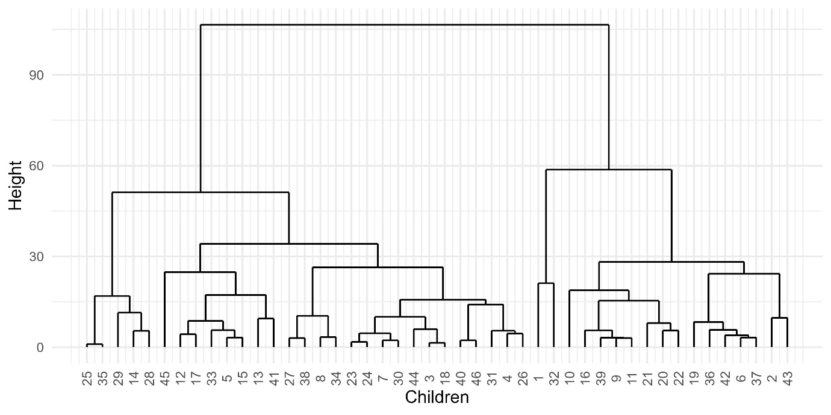
Note. The figure shows a dendrogram generated by hierarchical clustering using Ward’s method with Euclidean distances. The vertical height of each merge reflects the dissimilarity level at which clusters are combined. Child labels denote sequential order within this dataset and are not comparable across Figures S15 and S16.

Figure S16
Dendrogram of Clustering (Complete-Case Dataset)
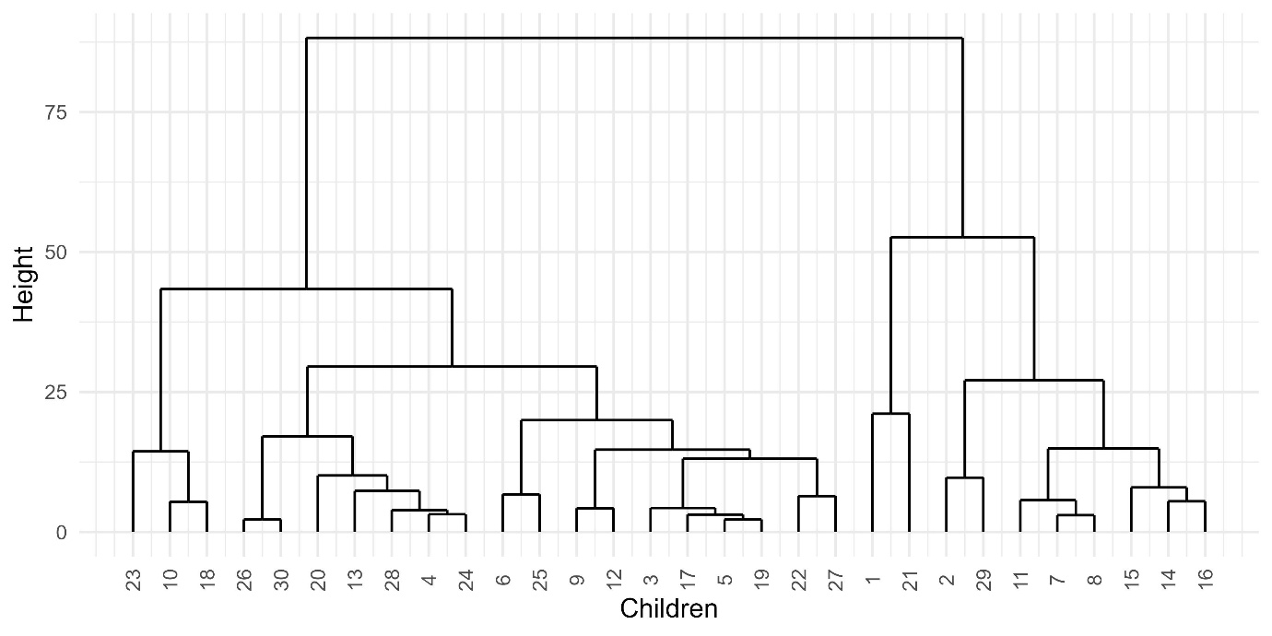

Note. The figure shows a dendrogram generated by hierarchical clustering using Ward’s method with Euclidean distances. The vertical height of each merge reflects the dissimilarity level at which clusters are combined. Child labels denote sequential order within this dataset and are not comparable across Figures S15 and S16.

Table S2
Average Internalizing Symptoms per Time Point Differentiated by Cluster (Imputed Sample)
 | Cluster 1 (Increasing) |  | Cluster 2 (Stable/Decreasing)
Time Point | M | SD |  | M | SD
T2 (6 months after baseline) | 4.88 | 6.52 |  | -5.76 | 6.25
T3 (9 months after baseline) | 7.18 | 9.28 |  | -4.45 | 6.41
T4 (15 months after baseline) | 8.71 | 8.11 |  | -8.01 | 6.50
Note. Mean (M) and standard deviation (SD) of internalizing symptoms separately cluster 1 (n = 17) and cluster 2 (n = 29). Because values were centred on baseline (T1), the baseline time point is omitted.

Table S3
Average Internalizing Symptoms per Time Point Differentiated by Cluster (Complete-Case Sample)
 | Cluster 1 (Increasing) |  | Cluster 2 (Stable/Decreasing)
Time Point | M | SD |  | M | SD
T2 (6 months after baseline) | 6.10 | 8.06 |  | -4.05 | 6.54
T3 (9 months after baseline) | 9.70 | 10.72 |  | -3.25 | 4.62
T4 (15 months after baseline) | 11.70 | 8.04 |  | -6.00 | 7.18
Note. Mean (M) and standard deviation (SD) of internalizing symptoms separately for cluster 1 (n = 10) and cluster 2 (n = 20). Because values were centred on baseline (T1), the baseline time point is omitted. The data come from the complete-case dataset, in which children with missing values on any internalizing symptom were excluded.
Figure S17
Symptom Trajectories by Cluster within the Complete-Case Sample
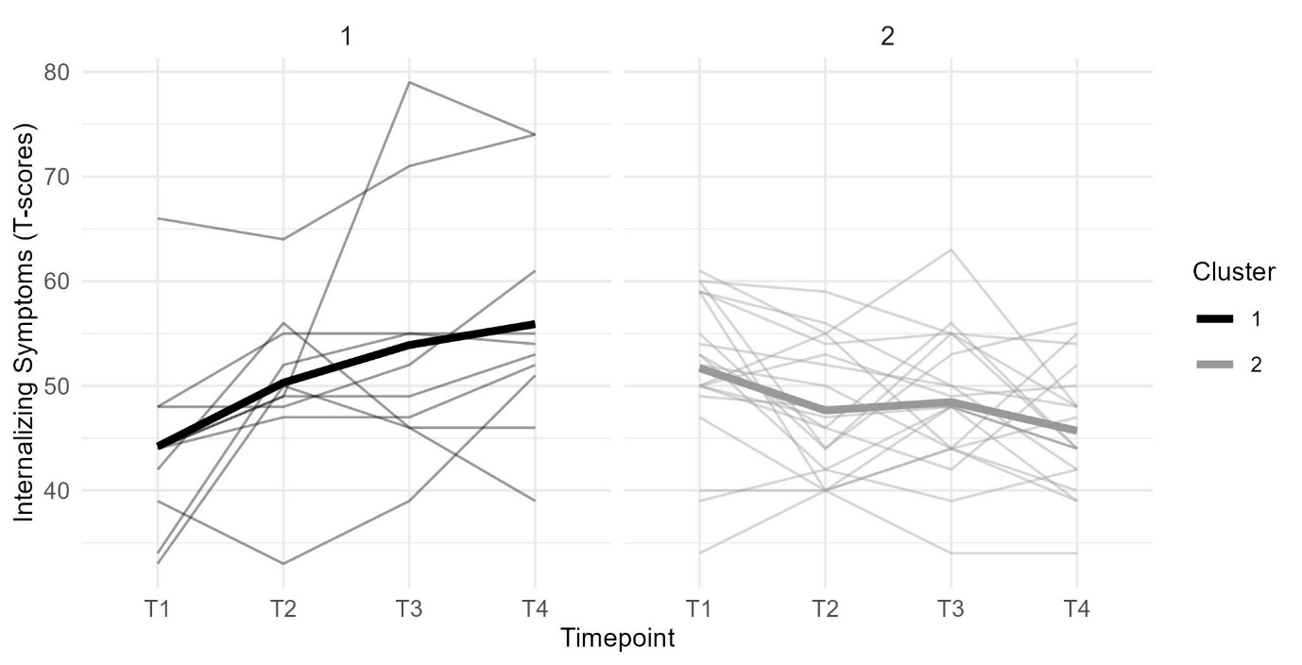
Note. The figure shows individual trajectories of youth-reported internalizing symptoms by cluster membership. The bold line represents the average trajectory for that cluster. T1 = baseline, T2 = 6 months, T3 = 9 months, and T4 = 15 months after baseline.
Table S4
Descriptive Statistics of Baseline Predictors by Cluster (Complete-Case Sample)
 | Cluster 1 (Increasing) |  | Cluster 2 (Stable/Decreasing)
 | M | SD |  | M | SD
Baseline Child Internalizing Symptoms | 44.2 | 8.86 |  | 51.7 | 7.31
Baseline Parent Depressive Symptoms | 19.60 | 8.50 |  | 12.65 | 8.57
Proportion Female | .6 |  |  | .4
Baseline Age | 11.50 | 2.87 |  | 11.25 | 2.38
Note. Mean (M) and standard deviation (SD) of baseline measures by group. n = 10 (Cluster 1), n = 20 (Cluster 2).
References
Bürkner, P.-C. (2017). brms: An R package for Bayesian multilevel models using Stan. Journal of Statistical Software, 80(1). https://doi.org/10.18637/jss.v080.i01

