Supplementary materials

Supplementary methods

Survey measures

For full information, code can be found at https://github.com/AnnaDearman/endophenotype-polygenic-indices/blob/main/survey_data_processing.R

Family intact

“Family disruption” was derived first to obtain more granular information regarding family circumstances (values: “intact”, “parent died”, “parent moved”, “other”). This was then used to assign “family intact” (1=“intact”, 0=“parent died/parent moved/other”). Any evidence of family disruption was considered to warrant a value of 0, regardless of whether parents lived together subsequently. “Intact” was assigned towards the end of the logical tests for all datasets, to ensure other scenarios and conflicting answers were ruled out.

 | UKHLS |  | NCDS |  | BCS70 |  | MCS
Family disruption | n | % | n | % | n | % | n | %
Family intact | 6,868 | 79.52 | 4,970 | 79.22 | 2,629 | 73.99 | 4,341 | 59.11
Parent moved | 913 | 10.57 | 394 | 6.28 | 553 | 15.56 | 2,863 | 38.98
Parent died | 537 | 6.22 | 296 | 4.72 | 184 | 5.18 | 140 | 1.91
Other | 319 | 3.69 | 614 | 9.79 | 187 | 5.26 | 0 | 0
Missing | 640 |  | 50 |  | 1,654 |  | 235
Supplementary Table 1. Family disruption rates, by reason. Values do not represent those in the final analytical samples. BCS70 = the 1970 British Cohort Study, MCS = Millennium Cohort Study, NCDS = the 1958 National Child Development Study, UKHLS = the UK Household Longitudinal Study (Understanding Society).

 | UKHLS |  | NCDS |  | BCS70 |  | MCS
Family intact | n | % | n | % | n | % | n | %
1 | 6,868 | 79.52 | 4,970 | 79.22 | 2,629 | 73.99 | 4,341 | 59.11
0 | 1769 | 20.48 | 1,304 | 20.78 | 924 | 26.01 | 3,003 | 40.89
Supplementary Table 2. Family intact rates. Values do not represent those in the final analytical samples. BCS70 = the 1970 British Cohort Study, MCS = Millennium Cohort Study, NCDS = the 1958 National Child Development Study, UKHLS = the UK Household Longitudinal Study (Understanding Society).

For Understanding Society (UKHLS), questions were asked of adult participants retrospectively. The main question was asked in relation to age 16. For the 1958 National Child Development Study (NCDS), due to the survey questions used, values of “intact” are based on lack of contrary information, so for participants with the least available information there is a higher risk of assigning incorrect values. Hence, a count of the number of productive interviews was derived first. After assigning values other than “intact”, n=50 participants with 0-1 productive interviews were excluded, then “intact” was assigned to n=4,970, followed by a few values of “other”. For the 1970 British Cohort Study (BCS70), there was a lot of missingness (n=1,654, 31.8%). The Millennium Cohort Study (MCS) does not have an age 16 wave, so information from up to age 14 was used.

Father employed

In UKHLS, the question regarding father’s employment was asked in relation to age 14. While MCS has an age 14 questionnaire, NCDS and BCS70 do not, so for these cohorts the information was derived based on other time points, primarily age 15/16 but due to substantial missing data, age 11 was also used. For NCDS, the wording of questions was problematic for harmonisation as they tended to focus on “father figure” rather than the biological father. However, an attempt was made to identify whether the father figure was the biological father using variable n104 (“Relationship person acting as father”). 99.57% of those assigned 1 had values of “natural father” for this variable, while the remaining n=20 had father’s employment noted as a source of income at age 16.

For MCS, most values were based on age 14 variables regarding residency and employment situations, along with variables reflecting who answered the main and partner surveys. For many values, the mother’s variable “does absent parent contribute to maintenance?” was relied upon –
financial contribution does not necessarily indicate employment, but this assumption seems preferable to losing so many participants by assigning missing values (n=1,126).
 | UKHLS |  | NCDS |  | BCS70 |  | MCS
Father employed | n | % | n | % | n | % | n | %
1 | 8,037 | 89.38 | 5,172 | 86.29 | 4,151 | 87.02 | 5,610 | 79.28
0 | 955 | 10.62 | 822 | 13.71 | 619 | 12.98 | 1,466 | 20.72
Missing | 285 |  | 350 |  | 437 |  | 503
Supplementary Table 3. Father employed rates. Values do not represent those in the final analytical samples. BCS70 = the 1970 British Cohort Study, MCS = Millennium Cohort Study, NCDS = the 1958 National Child Development Study, UKHLS = the UK Household Longitudinal Study (Understanding Society).

Mother educated

Given the drastic shifts in women’s education across the UK since the oldest participants’ parents attended school, and the variables available, “mother educated” was dichotomised according to completion of secondary school. None of the questions were asked in relation to a specific age of the mother or participant.

For UKHLS and NCDS, there was a lack of detailed information. For UKHLS, one variable was used, with a high rate of missingness (n=1,148). For NCDS, 1 was assigned where mothers stayed in education after the minimum leaving age, while not staying earned a value of 0. The “age mother left full-time education” variable was used to assign a small minority of values, however its levels were ambiguous, so participants with values of “14 to 15 years” and “15 to 16 years” and no other information were excluded, as the minimum school leaving age was likely 15 for the vast majority of mothers. A sensitivity analysis was performed using an alternative operationalisation which takes into account vocational qualifications, for datasets with sufficiently rich data (BCS70 and MCS). For BCS70, the vast majority of values were assigned based on questions asked when the child was age 10/11 regarding mother’s qualifications. Most remaining values were assigned based on school leaving age, followed by educational and qualification questions asked when the child was 5.

For MCS, missingness was high (n=1,390). Variables originated from the mother’s questionnaire. Questions regarding academic qualifications accounted for the majority of 1s (84.3%) while the remainder, and all of the 0s, were assigned using the “age left full time education” variable – those who were 16 or older were assigned 1 and those who were 15 or younger were assigned 0. For “mother qualifications”, an additional n=110 were assigned 1s based on vocational qualifications, plus n=6 who at some point acquired new qualifications between interviews.
 | UKHLS |  | NCDS |  | BCS70 |  | MCS
Mother educated | n | % | n | % | n | % | n | %
1 | 3,849 | 47.35 | 1,799 | 29.30 | 2,442 | 49.28 | 5,938 | 96.24
0 | 4,280 | 52.65 | 4,340 | 70.70 | 2,513 | 50.72 | 232 | 3.76
Missing | 1,148 |  | 185 |  | 252 |  | 1,390
Supplementary Table 4. Mother educated rates. Values do not represent those in the final analytical samples. BCS70 = the 1970 British Cohort Study, MCS = Millennium Cohort Study, NCDS = the 1958 National Child Development Study, UKHLS = the UK Household Longitudinal Study (Understanding Society).

Deriving additional outcomes

The variables in supplementary table 5 were used in sensitivity analyses. All were scaled and centered separately by sex and sample before excluding individuals with missing environment data.

Study | Age | Scale | Number of items | Derivation
NCDS | 33 | malaise | 24 | The total number of values of “1” across 24 variables beginning with “n5042” were added
NCDS | 42 | GHQ psychological distress | 12 | Coded missing values were set to missing, then GHQ items 1, 3, 4, 7, 8 and 12 were reverse-coded, then all 12 items were added
NCDS | 42 | malaise | 24 | Coded missing values were set to missing, then the total number of values of “1” across 24 variables beginning with “mal” (malaise) were added
NCDS | 50 | malaise | 9 | ND8MAL was used
BCS70 | 16 | GHQ psychological distress | 12 | Coded missing values were set to missing, then GHQ items “c5i[1-6]” were reverse-coded, then all 12 items were added
BCS70 | 16 | malaise | 22 | BD4MAL was used
BCS70 | 30 | GHQ psychological distress | 12 | Coded missing values were set to missing, then GHQ items 1, 3, 4, 7, 8 and 12 were reverse-coded, then all 12 items were added
BCS70 | 30 | malaise | 24 | BD6MAL was used
BCS70 | 34 | Kessler psychological distress | 4 | Coded missing values were set to missing, then the total across variables “b7k[1-4]” was reverse-coded
BCS70 | 34 | malaise | 9 | BD7MAL was used
BCS70 | 42 | malaise | 9 | BD9MAL was used
BCS70 | 46 | malaise | 9 | BD10MAL was used
Supplementary Table 5. Additional mental health outcomes used for sensitivity analyses. BCS70 = the 1970 British Cohort Study, GHQ = general health questionnaire, NCDS = the 1958 National Child Development Study.

Genetic data QC

The UKHLS genetic data comprised 24.7 million genetic variants (including rare variants) and were supplied as 22 file sets (one per autosome), while NCDS, BCS70 and MCS each comprised between 7.5 – 8.7 million variants with minor allele frequency (MAF) >1% and were supplied as one file set each. Principal components (PCs) of ancestry and details regarding genotyped sex were supplied for UKHLS only. All study teams provided ancestry information in a categorical form, i.e. genetically-estimated continental superpopulation. Around 84% of the MCS genetic dataset is of European ancestry, while for the other datasets values are higher (93 - 100%). The main analyses were conducted in European-only (sub)samples for all four datasets, with sensitivity analyses conducted in the full, ancestrally-diverse, MCS sample.

For details of the genotyping, imputation and quality control (QC) performed by the respective study teams prior to this study, see Supplementary Tables 6 and 7 which summarise the information available in the readme files supplied by the University of Essex, in Prins et al (1), and in the online Centre for Longitudinal Studies (CLS) documentation (web pages accessed 6th December 2024): https://cls-genetics.github.io/docs/NCDS.html; https://cls-genetics.github.io/docs/BCS70.html; https://cls-genetics.github.io/docs/MCS.html.

Further QC was carried out on all datasets to ensure harmonisation in the present study. For full details see Supplementary Table 8 and for code see https://github.com/AnnaDearman/endophenotype-polygenic-indices/blob/main/genetic_data_qc.sh.

Pre-imputation QC

 | UKHLS | NCDS | BCS70 | MCS
Genotyping array | Illumina HumanCoreExome-12v1-0 | Illumina (1.2M, Human 660-Quad), Infinium (HumanHap 550K v1.1, HumanHap 550K v3), Affymetrix (v6) | Infinium Global Screening Array-24 v3.0 | Infinium Global Screening Array-24 v1.0
Genotype calling | GenomeStudio (Illumina) GenCall |  | GenomeStudio (v2.0, Illumina) | GenomeStudio (v2.0, Illumina)
Prior QC software | PLINK1.07, R | PLINK1.9, PLINK2.0, R v3.3.2 and RStudio v4.1.2 | PLINK1.9, PLINK2.0 | PLINK1.9, PLINK2.0
Missing data (individuals) | >10% prefiltering, followed by >2%  (59 excluded) | >2% | > 2%  (136 excluded) | > 2%  (677 excluded)
Sex check | Was performed  (55 excluded) | X chromosome homozygosity compared to reported sex (females F value > 0.2, males < 0.8) | X chromosome homozygosity compared to reported sex (females F value > 0.2, males < 0.8)  (15 excluded) | X chromosome homozygosity compared to reported sex (females F value > 0.2, males < 0.8)  (86 excluded)
Heterozygosity | Performed at MAF≥1% and <1%  >3 SD  (148 excluded) | >3 SD from mean | >3 SD from mean  (46 excluded) | >3 SD from mean  (78 excluded)
Relatedness | Household study, so relatedness is permitted.  Samples excluded based on incorrect self-reported relatedness.  Duplicates and potential sample mix-ups excluded based on relatedness metric. | king-cutoff 0.0884 | king-cutoff 0.0884  (35 excluded) | Trios were sampled, so relatedness is permitted.  Samples excluded based on parent-child mix-ups. Samples were not excluded based on relatedness. Inbreeding and relatedness (e.g. cousins, twins) was noted. Mendelian error check to verify trios.  Flag was created to allow users to exclude based on families with multiple mothers and fathers identified (retains one trio per family).
Ancestry | Individual outliers removed after estimating principal components of ancestry alongside individuals from multi-ancestry 1000 Genomes panel.  (340 excluded) | Assessed after imputation. | GenoPred pipeline assigns everyone to a superpopulation. Outliers within groups are defined as >4 SD from mean in the PCs. | GenoPred pipeline assigns everyone to a superpopulation. Outliers within groups are defined as >4 SD from mean in the PCs. Note: MCS was over-sampled to increase representation of different ethnic groups.
Missing data (SNPs) | >10% prefiltering, followed by >2% | >3% | >3% | >3%
HWE | P < 1x10-4 | P < 1x10-6 | P < 1x10-6 | P < 1x10-6
MAF filtering | Not performed as genotyping array is enriched for rare variants | <1% | <1% | <1%
Checked against reference panel for strand issues | HRC-1000G-check-bim.pl (version unspecified) | HRC reference panel r1.1 site list: HRC-1000G-check-bim.pl, v.4.3.0 | HRC reference panel r1.1 site list: HRC-1000G-check-bim.pl, v.4.3.0 | HRC reference panel r1.1 site list: HRC-1000G-check-bim.pl, v.4.3.0
Phasing | SHAPEIT (v2.r) | Eagle2 | Eagle2 | Eagle2
Imputation algorithm | IMPUTE2 (v2.3.0) | Minimac4 | Minimac4 | Minimac4
Imputation panel | UK10K plus 1000 Genomes phase 3 | TOPMed | TOPMed | TOPMed
Supplementary Table 6. Pre-imputation quality control (QC) performed prior to this study. BCS70 = the 1970 British Cohort Study, HWE = Hardy Weinberg Equilibrium test, HRC = Haplotype Reference Consortium, MAF = minor allele frequency, MCS = the Millennium Cohort Study, NCDS = the 1958 National Child Development Study, PCs = principal components, SD = standard deviation, SNPs = single nucleotide polymorphisms, UKHLS = the UK Household Longitudinal Study (Understanding Society).

Post-imputation QC

 | UKHLS | NCDS | BCS70 | MCS
Imputation confidence | IMPUTE info score < 0.4 | R2 INFO score  < 0.8 | R2 INFO score  < 0.8 | R2 INFO score  < 0.8
Missing data (individuals) |  | >2% | >2% | >2%
Number of alleles |  | >2 alleles  (--max-allele 2) | >2 alleles  (--max-allele 2) | >2 alleles  (--max-allele 2)
Missing data (SNPs) |  | >3% | >3% | >3%
HWE | P < 1x10-4 | P < 1x10-6 | P < 1x10-6
MAF |  | <1% | <1%
Relatedness |  | king-cutoff 0.0884  (23 excluded)
Ancestry outliers |  | GenoPred pipeline, >4 SD from mean in PC1  (72 excluded from GenoPred + PCA analyses)
Build | 37 | 38 (step not detailed) | 38 | 38
Supplementary Table 7. Post-imputation quality control (QC) performed prior to this study. BCS70 = the 1970 British Cohort Study, HWE = Hardy Weinberg Equilibrium test, MAF = minor allele frequency, MCS = the Millennium Cohort Study, NCDS = the 1958 National Child Development Study, PC = principal component, PCA = principal component analysis, SD = standard deviation, SNPs = single nucleotide polymorphisms, UKHLS = the UK Household Longitudinal Study (Understanding Society).

The UKHLS data was converted to PLINK format using PLINK1. PLINK2 was used for all subsequent file set updates. Dummy participants were removed from UKHLS, and CLS-supplied flags were used to remove a small number of non-European individuals from BCS70, and to remove twins and families with multiple mothers and fathers from MCS. Duplicate variants were removed based on genomic coordinates, and the majority of rsIDs were assigned using the avsnp151 database, a version of dbSNP 151 reformatted by the ANNOVAR software team (2). The remaining variants were assigned rsIDs by recovering those present in the original file sets: UKHLS (build 37), and NCDS for the three birth cohorts (all build 38), after which duplicate variants were removed based on ID. UKHLS was then merged into one file set, and additionally filtered for variants with long IDs of 20+ characters, which include multiple character-separated rsIDs, and indels with long alleles in the name. Non-rsID variants were removed, having a negligible impact on NCDS and removing 2.1 - 3.0% of variants from the other datasets. Missingness checks were then performed to ensure no variant or individual had >1% missing data - this step removed over five million variants from UKHLS, but no other variants or individuals were removed from any datasets. To avoid the impact of related trios on some of the following QC steps, MCS was then split into a children file set and a parents file set. Variants were removed based on Hardy-Weinberg equilibrium testing, which had a negligible impact on UKHLS and NCDS but removed >3,300 variants from BCS70, >331,000 from MCS children and >540,000 from MCS parents. To calculate relatedness and heterozygosity, temporary file sets were created wherein variants were pruned for linkage disequilibrium (LD). Regions of high LD were removed from the pruned datasets according to scripts “highLDregions4bim_b[build number].awk” downloaded from Jonathan Coleman’s GitHub repository https://github.com/JoniColeman/gwas_scripts. PLINK was then used to estimate relatedness (using the “king” metric) and heterozygosity (F statistic). Using respective cutoffs of 0.0884 (third-degree relatives) and 0.2, I removed 643 individuals from UKHLS, none from NCDS, 3 from BCS70, 18 MCS children and 59 MCS parents. Of these 723 individuals, 669 were removed based on relatedness. Variants with MAF <1% were removed. A separate UKHLS dataset was created which was filtered with a more relaxed MAF threshold (0.5%), retaining 519,927 variants (dataset hereafter referred to as UKHLS-rare). The final variant-filtering step restricted each dataset (aside from UKHLS-rare) to the variants which were present in all datasets, resulting in 3,673,101 variants. Separate European-only file sets were then generated for MCS children and parents using the flag supplied by CLS (the version including non-Europeans will hereafter be referred to as MCS-full).

QC performed in the present study

 | UKHLS | NCDS | BCS70 | MCS
Convert to PLINK format (using PLINK1)  --gen  --oxford-single-chr  --make-bed | Step performed for UKHLS only | NA | NA | NA
Initial numbers of variants and individuals | Variants:  24,727,148  Individuals:  9,961 | Variants:  7,545,708  Individuals:  6,324 | Variants:  8,625,760  Individuals:  5,598 | Variants:  8,720,874  Individuals:  20,247
Manually edit placeholder sample IDs for dummy samples in UKHLS .fam files | Step performed for UKHLS only | NA | NA | NA
Remove dummy samples  --remove  .participants | Individuals: 9,921 (-40) | NA | NA | NA
Restrict BCS70 to European ancestry  --remove  .EUR | NA | NA | Individuals: 5,210 (-388) | (Performed later for MCS)
Remove individuals identified by pre-supplied flags “king_related_families” and “singleton_twin”  --remove  .trios_notwins | NA | NA | NA | Individuals: 19,729 (-518)
Deduplicate based on coordinates (first convert variant ID column to coordinate string, then remove duplicates based on this ID)  --set-all-var-ids @:#[b37] or  --set-all-var-ids @:#[b38]  as appropriate  .allcoord  --rm-dup exclude-all  .dedupcoord | Variants:  24,697,826  (-29,322) | Variants:  7,543,600  (-2,108) | Variants:  8,618,026  (-7,734) | Variants:  8,713,777  (-7,097)
Assign rsIDs using ANNOVAR. For each dataset, make ANNOVAR query file based on .bim, query avsnp151 database using hg19 for UKHLS and hg38 for others - the resulting file from ANNOVAR has suffix “_dropped” which is then deduplicated, then if the returned ID is the same as the queried ID the variant is removed. The resulting file (.avsnp151) is then used to update variant IDs in PLINK
--update-name
.avsnp151
Remove duplicate variants after dbSNP ID update
--rm-dup exclude-all
.deduprsids1
Top up variant IDs with those from the older versions of UKHLS and NCDS. First, overwrite the original data files with as many from avsnp151 as possible
--recover-var-ids partial
.avsnp151
Then apply the variant IDs from these updated original files (containing mostly rsIDs from avsnp151 but also some originally-supplied rsIDs) to the latest data files
--recover-var-ids partial for UKHLS and NCDS
--recover-var-ids partial strict-bim-order for BCS70 and MCS
.avsnp151origids
Deduplicate based on original variant IDs  --rm-dup exclude-all  .deduprsids2 | Variants:  24,697,228  (-598) | Variants:  7,543,592  (-8) | Variants:  8,618,014  (-12) | Variants:  8,713,765  (-12)
Merge chromosomes into one file and remove any duplicates from across chromosomes  --pmerge-list --merge-mode nm-match  .deduprsids2pre  --rm-dup exclude-all  .deduprsids2 | Variants:  24,695,228  (no change) | NA | NA | NA
Variants removed if they have long IDs (20 or more characters) i.e. character-separated multiple rsIDs or indels with alleles in the name  --exclude  .nolongids | Variants:  24,585,368  (-111,860) | Variants:  7,543,592  (-0) | Variants:  8,618,014  (-0) | Variants:  8,713,765  (-0)
All non-rsID variants removed  --exclude  .rsids | Variants:  24,065,402  (-519,966) | Variants:  7,543,398  (-194) | Variants:  8,369,166  (-248,848) | Variants:  8,450,560  (-263,205)
Remove variants with missingness above 1%  --geno 0.01  .lowmissvar | Variants:  18,675,766  (-5,389,636) | Variants:  7,543,398  (no change) | Variants:  8,369,166  (no change) | Variants:  8,450,560  (no change)
Remove individuals with missingness above 1%  --mind 0.01  .lowmiss | Individuals:  9,921  (no change) | Individuals:  6,324  (no change) | Individuals:  5,210  (no change) | Individuals:  19,729  (no change)
Split MCS into children and parents  --keep  --remove | NA | NA | NA | Children: 7,597  Parents: 12,132
Remove variants which do not pass Hardy Weinberg Equilibrium test  --hwe 0.00001  .lowmiss.hwe | Variants:  18,675,587  (-179) | Variants:  7,543,337  (-61) | Variants:  8,365,839  (-3,327) | Children: Variants:  8,119,302  (-331,258)  Parents:  Variants:  7,910,113  (-540,447)
Create a copy of each dataset with variants pruned for LD (with a view to calculating relatedness and heterozygosity)
--indep-pairwise 1500 150 0.2
.LD_one
--extract *LD_one.prune.in
.LD_two
Exclude variants with high LD using highLDregions4bim_b37.awk or highLDregions4bim_38.awk
--exclude
.LD_three
Identify a list of individuals to exclude due to high relatedness
--king-cutoff 0.0884
.unrelated.king.cutoff.out.id
Measure heterozygosity
--het
.het
Make file of individuals with high heterozygosity
.cohort.highhet
Make file to remove highly related individuals and those with high heterozygosity, then remove them  .toexclude  --remove  <cohort name> | Variants:  18,675,587  (no change)  Individuals:  9,278 (-643, none based on heterozygosity) | Variants:  7,543,337  (no change)  Individuals:  6,324 (no change) | Variants:  8,365,839  (no change)  Individuals:  5,207 (-3, two based on heterozygosity) | Children:  Variants:  8,119,302  (no change)  Individuals:  7,579  (-18, fifteen based on heterozygosity)  Parents:  Variants:  7,910,113  (no change)  Individuals:  12,073  (-59, 37 based on heterozygosity)
Remove rare variants  --maf 0.01  .maf0_01 | Variants:  4,542,703  (-14,132,884) | Variants:  7,543,296  (-41) | Variants:  8,343,208  (-22,631) | Children: Variants:  8,092,056  (-27,246)  Parents: Variants:  7,889,764  (-20,349)
Remove rare variants using a different cutoff for sensitivity analysis  --maf 0.005  .maf0_005 | Variants:  5,062,630  (-13,612,957) | NA | NA | NA
Make file to keep overlapping variants across all files, then restrict to these  --extract  .harmonised | maf 0.01: Variants:  3,673,101  (-869,602) | Variants:  3,673,101  (-3,870,195) | Variants:  3,673,101  (-4,670,107) | Children:  Variants:  3,673,101  (-4,418,955)  Parents:  Variants:  3,673,101  (-4,237,012)
Restrict MCS to European ancestry  --remove  .european | NA | NA | NA | Children:  6,476  (-1,103)  Parents:  10,484  (-1,589)
Supplementary Table 8. Quality control (QC) performed in the current study. Bold text indicates PLINK commands. PLINK2 used except where otherwise specified. Italics represents suffix for new file set. BCS70 = the 1970 British Cohort Study, LD = linkage disequilibrium, MCS = the Millennium Cohort Study, NA = not applicable, NCDS = the 1958 National Child Development Study, UKHLS = Understanding Society a.k.a. the UK Household Longitudinal Study.

NPGI selection
Neuropsychiatric polygenic indices (NPGIs) were derived based on studies published on the Psychiatric Genomics Consortium (PGC) website https://pgc.unc.edu/for-researchers/download-results/ [accessed 7th June 2024]. From the 14 sub-headings, ten neuropsychiatric conditions were chosen (anxiety disorders (AD), attention deficit hyperactivity disorder (ADHD), autism spectrum disorder (ASD), bipolar disorder (BD), eating disorders (ED), major depressive disorder (MDD), obsessive-compulsive disorder (OCD), post-traumatic stress disorder (PTSD), schizophrenia (SCZ), substance use disorder (SUD)) and the “cross-disorder” trait, omitting Alzheimer’s Disease, Other and Suicide attempt. There was only one file to choose from for ADHD (3), ASD (4), cross-disorder (5), ED (6) and OCD (7), however the others had multiple options. For AD, the case-control (as opposed to factor score) phenotype was chosen (8), for BD the “all cases” (i.e. bipolar I and bipolar II) (9) file was chosen, for MDD the version excluding 23andMe was chosen (as the inclusive version is restricted to the top 10,000 variants) (10), and the European versions were chosen for PTSD (11), SCZ (12) and SUD (13).

Title | Author, year | Neuropsychiatric condition
Meta-analysis of genome-wide association studies of anxiety disorders | Otowa et al, 2016 | Anxiety disorders (AD)
Genome-wide analyses of ADHD identify 27 risk loci, refine the genetic architecture and implicate several cognitive domains | Demontis et al, 2023 | Attention deficit hyperactivity disorder (ADHD)
Identification of common genetic risk variants for autism spectrum disorder | Grove et al, 2019 | Autism spectrum disorder (ASD)
Genome-wide association study of more than 40,000 bipolar disorder cases provides new insights into the underlying biology | Mullins et al, 2021 | Bipolar disorder (BD)
Genome-wide association study identifies eight risk loci and implicates metabo-psychiatric origins for anorexia nervosa | Watson et al, 2019 | Eating disorders (ED)
Genome-wide meta-analysis of depression identifies 102 independent variants and highlights the importance of the prefrontal brain regions | Howard et al, 2019 | Major depressive disorder (MDD)
Revealing the complex genetic architecture of obsessive-compulsive disorder using meta-analysis | Arnold et al, 2018 | Obsessive-compulsive disorder (OCD)
International meta-analysis of PTSD genome-wide association studies identifies sex- and ancestry-specific genetic risk loci | Nievergelt et al, 2019 | Post-traumatic stress disorder (PTSD)
Mapping genomic loci implicates genes and synaptic biology in schizophrenia | Trubetskoy et al, 2022 | Schizophrenia (SCZ)
Multivariate genome-wide association meta-analysis of over 1 million subjects identifies loci underlying multiple substance use disorders | Hatoum et al, 2023 | Substance use disorder (SUD)
Genomic Relationships, Novel Loci, and Pleiotropic Mechanisms across Eight Psychiatric Disorders | Lee et al, 2019 | Cross-disorder
Supplementary Table 9. Genome-wide association studies (GWAS) whose summary statistics were used for deriving polygenic indices of neuropsychiatric conditions.

Endophenotype PGI selection
The “All associations v1.0” file was downloaded from the NHGRI-EBI GWAS catalog (57) on 19th December 2024. This file contains one row per SNP-trait association (p <= 0.00001) across 36,676 traits and 6,207 studies (earliest publication 2005), resulting in 692,444 rows. The table was deduplicated to leave one row per study-trait pair (n=47,173). All studies without the word “brain” in the title were removed, leaving 82 studies and 2,793 traits. Based on the “DISEASE.TRAIT” column, traits which were unambiguously measured in plasma or cerebrospinal fluid were removed, leaving 2,421 traits, some of which were listed without a specific tissue of origin. Study titles (and where necessary, corresponding traits) were then screened and out-of-scope studies were removed, specifically where a) the topic is pain sensitivity, ageing, frailty, multiple sclerosis, Alzheimer’s disease, Parkinson’s disease, malignancy, brain injury, stroke, intelligence or education, or b) the traits were out-of-scope, i.e. measured in bodily fluids, or behavioural (depression, opioid use, disorder pairs e.g. "Peptic ulcer disease or schizophrenia (pleiotropy)", sleep behaviour, motor coordination, handedness, executive function, restricted and repetitive behaviours, risk-taking behaviour), leaving 49 studies and 2,298 traits. The 49 papers were then downloaded and the full texts were screened. Four were out-of-scope either because the trait was task-based or focussed on brain health with no mention of neuropsychiatric conditions. A further seven brain health papers were excluded from consideration because they only briefly mention one or more neuropsychiatric conditions. Sixteen studies were excluded because they did not attempt to examine genomic overlap between endophenotypes and relevant behavioural outcomes. Ten studies attempted such analyses but found no significant genomic overlaps, while four others found significant results but the summary statistics are un-signed (i.e. lacking effect sizes) so cannot be used to generate PGIs. One study demonstrated genomic overlap between a measure of brain skew and ASD but the summary statistics were not readily available. The remaining seven studies fulfilled the criteria by demonstrating genomic overlap between a relevant behavioural outcome and a non-behavioural brain endophenotype using signed GWAS summary statistics. See supplementary table 10 for details, see supplementary figure 1 for flow chart, and for code see https://github.com/AnnaDearman/endophenotype-polygenic-indices/blob/main/choosing%20endophenotypes.R.

Trait name(s) don’t contain “plasma” or “csf”
(82 studies)
-6,125 studies
-0 studies
Entire association list
(6,207 studies)
“Brain” in study title
(82 studies)
-33 studies
In scope after title screening
(49 studies)

-11 studies

In scope after full text screening
(38 studies)

-26 studies

Trait(s) demonstrate genomic overlap with relevant behavioural trait(s)
(12 studies)

-5 studies

Summary statistics available
with effect sizes
(7 studies)

Supplementary Figure 1. Flow chart of steps taken to identify genome-wide association studies with suitable summary statistics for endophenotype polygenic indices. “Entire association list” refers to the “All associations v1.0” file downloaded from GWAS catalog on 19th December 2024.

Two study teams provided access to summary statistics after we filled in the corresponding form at https://enigma.ini.usc.edu/research/download-enigma-gwas-results/ (14,15) (due to the sensitivity of the phenotypes in the present study, only the “unrestricted” version was granted for Satizabal et al – this version omits four cohorts), one study author shared the summary statistics download link by e-mail (16), and the remaining four were accessed by following the corresponding links available at the respective GitHub repositories: https://www.med.unc.edu/bigs2/data/gwas-summary-statistics/ (17–19) and https://github.com/norment/open-science/tree/main/2021_Elvsashagen_NatComms_ThalamusGenetics (20).

Title | Author, year | Endophenotype | Genomic overlap 1: mental health trait (coefficient) p value | Genomic overlap 2: mental health trait (coefficient) p value
Regional brain volumes
Genome-wide association analysis of 19,629 individuals identifies variants influencing regional brain volumes and refines their genetic co-architecture with cognitive and mental health traits | Zhao et al, 2019 | Total brain volume | Neuro-worry  (-0.14) 0.0002
 | Zhao et al, 2019 | Total grey matter volume | Depressive symptoms  (-0.25) 0.00003 | Bipolar disorder II (0.18) 0.001
 | Zhao et al, 2019 | Left posterior cingulate | Depressive symptoms  (-0.18) 0.02
 | Zhao et al, 2019 | Left rostral middle frontal | Bipolar disorder II (0.22) 0.00006 | Depressive symptoms  (-0.19) 0.01
 | Zhao et al, 2019 | Right lateral ventricle | Neuro-irritable  (0.1) 0.02
 | Zhao et al, 2019 | Right precuneus | Neuro-irritable (0.17) 0.0001
Genetic architecture of subcortical brain structures in 38,851 individuals | Satizabal et al, 2019 | Brainstem volume | ADHD  (-0.15) 0.0001
The genetic architecture of the human thalamus and its overlap with ten common brain disorders | Elvsåshagen et al, 2021 | Posterior thalamic nuclei volume | Bipolar disorder (0.15) 0.002
White matter microstructure
Large-scale GWAS reveals genetic architecture of brain white matter microstructure and genetic overlap with cognitive and mental health traits (n = 17,706) | Zhao et al, 2021 | Fornix/stria terminalis FA | Depression  (-0.18) 0.0004
 | Zhao et al, 2021 | Genu of corpus callosum FA | MDD (-0.18) 0.0001
 | Zhao et al, 2021 | Fornix FA | Drinks per week (-0.18) 0.0003
 | Zhao et al, 2021 | Genu of corpus callosum MD | Drinks per week (0.13) 0.001
 | Zhao et al, 2021 | Splenium of corpus callosum MD | Drinks per week (0.15) 0.0004
 | Zhao et al, 2021 | Fornix/stria terminalis MO | Depression  (-0.19) 0.0006
 | Zhao et al, 2021 | Genu of corpus callosum RD | MDD (0.16) 0.0008 | Drinks per week (0.14) 0.001
Cerebrovascular lesions
Genetic influences on brain and cognitive health and their interactions with cardiovascular conditions and depression | Zhukovsky et al, 2024 | White matter hyperintensities | ADHD (0.16) 0.004
Resting-state functional MRI (brain activity)
Common variants contribute to intrinsic human brain functional networks | Zhao et al, 2022 | Net Edge ICA 1 | Cross-disorder  (-0.25) 0.0002 | Schizophrenia (-0.18) 0.0003
 | Zhao et al, 2022 | Net 100 Node 8 | Cross-disorder  (-0.28) 0.0002
 | Zhao et al, 2022 | Net 100 Pair 11 45 | Bipolar disorder  (-0.24) 0.0007
 | Zhao et al, 2022 | Net 100 Pair 19 45 | ADHD  (-0.22) 0.0008
 | Zhao et al, 2022 | Net 100 Pair 28 47 | Schizophrenia (0.15) 0.0003
 | Zhao et al, 2022 | Net 25 Pair 10 11 | Schizophrenia (-0.19) 0.0005
 | Zhao et al, 2022 | Net 25 Pair 12 15 | MDD (0.5) 0.0002 | Cross-disorder (0.27) 0.0002
Longitudinal changes in brain structure
Genetic variants associated with longitudinal changes in brain structure across the lifespan | Brouwer et al, 2022 | change rate cerebellum white matter volume | Depression (NA) 0.0001 | Schizophrenia (NA) 0.0001
 | Brouwer et al, 2022 | change rate cortical thickness | Schizophrenia (NA) 0.0001
 | Brouwer et al, 2022 | change rate hippocampus volume | Depression (NA) 0.0001 | Schizophrenia (NA) 0.0001
 | Brouwer et al, 2022 | change rate nucleus accumbens volume | Depression (NA) 0.0001 | Schizophrenia (NA) 0.0001
 | Brouwer et al, 2022 | change rate surface area | Depression (NA) 0.0001 | Schizophrenia (NA) 0.0001
 | Brouwer et al, 2022 | change rate thalamus volume | Depression (NA) 0.0001
 | Brouwer et al, 2022 | change rate total brain volume | Depression (NA) 0.0001 | Schizophrenia (NA) 0.0001
Supplementary table 10. Genome-wide association studies (GWAS) and their respective endophenotypes whose summary statistics were used for deriving polygenic indices. N.B. Brouwer and colleagues did not report effect sizes in their genomic overlap analyses. ADHD = attention deficit hyperactivity disorder, FA = fractional anisotropy, ICA = independent components analysis, MD = mean diffusivity, MDD = major depressive disorder, MO = mode of anisotropy, MRI = magnetic resonance imaging, NA = not applicable, Neuro = neuroticism, RD = radial diffusivity.

Generating PGIs

Preparation of summary statistics
To ensure that PRSice software matched variants based solely on rsIDs, the chromosome and base pair location columns were deleted. Where necessary, long file headers (but not column headers) were trimmed off, effect sizes converted to log-odds-ratios, column headers edited to SNP, A1, A2, P and BETA for consistency, and A1 and A2 columns were switched where necessary based on information in the corresponding README. Fifty rows with missing chromosome information in the SUD summary statistics were removed. For white matter hyperintensities, beta was calculated from the Z score provided.

PRSice parameters
Where necessary, a file was passed to the PRSice --target parameter which lists the variants to be included for consideration (these files were generated during failed test runs, and contain the suffix “.valid”). The --binary-target parameter was set to “T” (i.e. “true”). Default parameters were used for --clump-kb (250kb), --clump-p (1.0) and --clump-r2 (0.10). For more information, see code at https://github.com/AnnaDearman/endophenotype-polygenic-indices/blob/main/polygenic_indices.sh.

Cohort differences
328 PGI files were generated: 41 phenotypes (11 diagnoses plus 30 endophenotypes) for eight datasets - six with a harmonised set of 3,673,101 variants and similar LD structure (UKHLS, NCDS, BCS70, MCS children, MCS parents), two datasets with harmonised variants but a more diverse LD structure (MCS-full children, MCS-full parents) and one dataset with additional rare variants (UKHLS-rare) = 41 * 8 = 328.

PRSice chose variants to include in each PGI calculation based on the LD structure in the dataset, meaning that cohort differences in LD could result in different SNPs (and different numbers of SNPs) being used, despite filtering for variants present in all datasets. To demonstrate this, the PRSice output files which list the number of variants used (suffix “.prsice”) were checked. For each PGI phenotype, across all cohorts, the minimum and maximum numbers of variants used per P_{t} were identified, and from this a difference was calculated. These minimums, maximums, and differences were then averaged across all phenotypes. This was done once for the European-only datasets, and again after including the ancestrally diverse MCS-full datasets (for self-reported ethnicity in this sample, see supplementary table 14). UKHLS-rare was excluded from these calculations. Across European-only datasets, the average difference was less than 1% of the average minimum, ranging from 0.76 (for P_{t} 0.0001) to 884.07 (for P_{t} 1.0). When including the ancestrally diverse MCS-full datasets, average differences are much larger, reaching 3.5% of the average minimum for P_{t} 1.0 (an average difference of 3,657.46 SNPs). See supplementary table 11 for more info. Hence, differences in PGI construction were greater for the MCS-full samples.

 | Based on European-only samples |  |  | Including MCS-full samples
P_{t} | Average min n SNPs | Average max n SNPs | Average between-sample difference in n SNPs | Average min n SNPs | Average max n SNPs | Average between-sample difference in n SNPs
0.0001 | 193.68 | 194.44 | 0.76 | 193.85 | 195.73 | 1.88
0.01 | 4,175.51 | 4,187.05 | 11.54 | 4,177.61 | 4,217.98 | 40.37
0.05 | 14,044.98 | 14,097.05 | 52.07 | 14,054.71 | 14,256.93 | 202.22
0.1 | 23,544.71 | 23,648.22 | 103.51 | 23,560.98 | 23,977.56 | 416.59
0.5 | 71,353.49 | 71,897.42 | 543.93 | 71,411.76 | 73,601.44 | 2,189.68
1.0 | 98,598.90 | 99,482.98 | 884.07 | 98,706.49 | 102,363.95 | 3,657.46
Supplementary table 11. Average numbers of variants included in polygenic index calculations, across phenotypes. Min, max and difference were calculated per phenotype, per P_{t}, across samples. Average min, max and difference across phenotypes (per P_{t}) were then calculated and are shown here. For each P_{t}, the average max n SNPs is higher when the ancestrally diverse MCS-full is included, as is the average between-sample difference in n SNPs. MCS = the Millennium Cohort Study, P_{t} = p value threshold, SNPs = single nucleotide polymorphisms.

Sensitivity analyses

Sensitivity analyses were carried out to examine the impacts of inclusion criteria, operationalisation (of polygenic indices (PGIs), mother’s education, and symptom scale used), covariate adjustment, model specification and age at symptom measurement. See below and supplementary table 12.

Inclusion criteria
- Bereaved participants were included in all samples.
- Participants of all ancestries were included in MCS.
- Participants without parental genotype data were excluded - see “Covariate adjustment” point 3.
Operationalisation
- PGIs derived in the UKHLS general population sample (GPS) after using MAF filtering of 0.5% were examined .
- Mother’s education was operationalised to include vocational qualifications in BCS70 and MCS.
- For some waves, NCDS and BCS70 used two different symptom scales contemporaneously. For more detail see “Age at measurement” point 1.
Age at measurement
- Four and eight additional analyses were run for NCDS and BCS70, respectively, using mental health symptoms measured at different ages, some of which used alternative scales.
Covariate adjustment
- Ten ancestry principal components (PCs) were adjusted for in GPS, for paths all paths with a PGI as an explanatory variable.
- Covariates age and age² were omitted from the model in GPS.
- Parental PGIs were adjusted for in MCS. To examine the impact of subsetting (as this entailed a nontrivial reduction in sample size) these analyses were repeated in the sub-sample without adjustment for parental PGIs (see “Inclusion criteria” point 3).
Model specification
- In the main analysis, path models do not model pairwise correlations between the three exposures. Analyses were repeated including these correlation terms.

Dataset | MAF filtering | Ancestry | Age at symptom measurement | Symptom scale | Covariate adjustment | Mother’s education | Exposure pair correlation terms
Main analyses
GPS | 1% | European | 16 – 99  (mean 54) | GHQ-12 | age | Secondary | No
BHPS | 1% | European | 16 – 98  (mean 55) | GHQ-12 | age | Secondary | No
NCDS | 1% | European | 23 | Malaise-24 | none | Secondary | No
BCS70 | 1% | European | 26 | Malaise-24 | none | Secondary | No
MCS | 1% | European | 17 | Kessler-6 | none | Secondary | No
Sensitivity analyses
GPS, bereaved included | 1% | European | 16 – 99  (mean 54) | GHQ-12 | age | Secondary | No
BHPS, bereaved included | 1% | European | 16 – 98  (mean 55) | GHQ-12 | age | Secondary | No
NCDS, bereaved included | 1% | European | 23 | Malaise-24 | none | Secondary | No
BCS70, bereaved included | 1% | European | 26 | Malaise-24 | none | Secondary | No
MCS, bereaved included | 1% | European | 17 | Kessler-6 | none | Secondary | No
MCS – full | 1% | All | 17 | Kessler-6 | none | Secondary | No
MCS – parent PGI sub-sample | 1% | European | 17 | Kessler-6 | none | Secondary | No
GPS – rare | 0.5% | European | 16 – 99  (mean 54) | GHQ-12 | age | Secondary | No
BCS70 | 1% | European | 26 | Malaise-24 | none | Secondary and vocational | No
MCS | 1% | European | 17 | Kessler-6 | none | Secondary and vocational | No
NCDS | 1% | European | 33, 42, 50 | Various | none | Secondary | No
BCS70 | 1% | European | 16, 30, 34,  42, 46 | Various | none | Secondary | No
GPS | 1% | European | 16 – 99  (mean 54) | GHQ-12 | age, ancestry PCs x10 | Secondary | No
GPS | 1% | European | 16 – 99  (mean 54) | GHQ-12 | none | Secondary | No
MCS – parent PGI sub-sample | 1% | European | 17 | Kessler-6 | mother’s PGI, father’s PGI | Secondary | No
GPS | 1% | European | 16 – 99  (mean 54) | GHQ-12 | age | Secondary | Yes
BHPS | 1% | European | 16 – 98  (mean 55) | GHQ-12 | age | Secondary | Yes
NCDS | 1% | European | 23 | Malaise-24 | none | Secondary | Yes
BCS70 | 1% | European | 26 | Malaise-24 | none | Secondary | Yes
MCS | 1% | European | 17 | Kessler-6 | none | Secondary | Yes
Supplementary Table 12. Details of sensitivity analyses. Bold is used to indicate aspects which deviate from the main analyses. BCS70 = the 1970 British Cohort Study, BHPS = British Household Panel Survey, GHQ = general health questionnaire, GPS = general population sample of Understanding Society, MCS = Millennium Cohort Study, NCDS = the 1958 National Child Development Study, PCs = principal components, PGI = polygenic index.
Supplementary results

Descriptive statistics

 | GPS |  | BHPS |  | NCDS |  | BCS70 |  | MCS
 | Men | Women | Men | Women | Men | Women | Men | Women | Men | Women
n (%) | 2,336 (42.9) | 3,115 (57.1) | 723 (44.0) | 920 (56.0) | 2,522 (49.3) | 2,596 (50.7) | 1,093 (43.4) | 1,428 (56.6) | 2,053 (48.4) | 2,187 (51.6)
Year of birth  (age at biospecimen collection for MCS):  mean (SD) range | 1955 (16.0) 1917-1994 | 1957 (15.7) 1915-1994 | 1953 (14.4) 1913-1986 | 1954 (14.8) 1914-1987 | 1958 | 1958 | 1970 | 1970 | 13.7 (0.5) 13-15 | 13.8 (0.5) 13-15
Family intact (%) | 82.4 | 80.9 | 84.0 | 84.0 | 80.9 | 78.0 | 77.8 | 78.9 | 63.4 | 62.8
Father employed (%) | 90.6 | 88.8 | 92.9 | 91.5 | 88.1 | 85.8 | 87.2 | 85.7 | 80.4 | 80.8
Mother educated (%) | 46.7 | 49.0 | 45.8 | 41.1 | 29.7 | 29.1 | 54.2 | 52.6 | 97.3 | 97.3
Supplementary Table 13. Descriptive statistics for the alternative samples used in sensitivity analyses which include individuals whose parent(s) died during youth. When the sample is expanded to include bereaved participants, family intact necessarily decreases - by around five percentage points for most datasets but by less than one for MCS. Father employed decreases by around four percentage points, except for MCS where it decreases by one. BCS70 = the 1970 British Cohort Study, BHPS = British Household Panel Survey, GPS = general population sample of Understanding Society, MCS = Millennium Cohort Study, NCDS = the 1958 National Child Development Study, SD = standard deviation.

 | MCS - full |  | MCS - parent PGIs
 | Men | Women | Men | Women
n (%) | 2,340 (48.5) | 2,488 (51.5) | 1,072 (48.9) | 1,118 (51.1)
Age at biospecimen collection: mean (SD) range | 13.7 (0.5)  13-15 | 13.8 (0.5)  13-15 | 13.7 (0.5)  13-15 | 13.8 (0.5)  13-15
Family intact (%) | 64.9 | 63.9 | 96.1 | 96.9
Father employed (%) | 80.4 | 80.9 | 92.6 | 93.0
Mother educated (%) | 96.5 | 96.5 | 98.4 | 98.8
White (%) | 1,964 (83.9) | 2,099 (84.4)
Pakistani and Bangladeshi (%) | 118 (5.0) | 125 (5.0)
Indian (%) | 57 (2.4) | 60 (2.4)
Black or Black British (%) | 49 (2.1) | 49 (2.0)
Mixed (%) | 42 (1.8) | 59 (2.4)
Other (%) | 30 (1.3) | 20 (0.8)
Missing (%) | 80 (3.4) | 76 (3.1)
Supplementary Table 14. Descriptive statistics for the alternative MCS samples used in sensitivity analyses. MCS-full was not filtered for ancestry. MCS-parent PGIs indicates the sub-sample (of the European dataset) with both parents’ PGIs available. Rates of the three exposures are similar for MCS-full and its European-only counterpart, in contrast to the MCS-parent PGIs sub-sample, for which rates of all three are higher. MCS – parent PGIs sub-sample is around 52% the size of the main sample, which in turn is around 87% the size of MCS-full. MCS = Millennium Cohort Study, PGIs = polygenic indices, SD = standard deviation.

 | BCS70 |  | MCS
 | Men | Women | Men | Women
Mother qualifications (%) | 65.0 | 63.3 | 99.0 | 99.0
Supplementary Table 15. Rates of maternal education when operationalised by including vocational qualifications (“mother qualifications”). BCS70 = the 1970 British Cohort Study, MCS = Millennium Cohort Study.

 | NCDS, 33 (malaise) |  | NCDS, 42 (psych. distress) |  | NCDS, 42 (malaise) |  | NCDS, 50 (malaise) |  | BCS70, 16 (psych. distress) |  | BCS70, 16 (malaise) |  | BCS70, 30 (psych. distress) |  | BCS70, 30 (malaise) |  | BCS70, 34 (psych. distress) |  | BCS70, 34 (malaise) |  | BCS70, 42 (malaise) |  | BCS70, 46 (malaise)
 | M | W | M | W | M | W | M | W | M | W | M | W | M | W | M | W | M | W | M | W | M | W | M | W
n (%) | 2,141 (48.8) | 2,243 (51.2) | 2,305 (49.2) | 2,383 (50.8) | 2,302 (49.2) | 2,380 (50.8) | 2,091 (48.8) | 2,196 (51.2) | 488 (36.9) | 834 (63.1) | 546 (37.4) | 914 (62.6) | 959 (42.9) | 1,275 (57.1) | 960 (42.9) | 1,277 (57.1) | 925 (42.8) | 1,235 (57.2) | 925 (42.8) | 1,235 (57.2) | 905 (42.7) | 1,215 (57.3) | 985 (43.2) | 1,297 (56.8)
Family intact (%) | 85.4 | 82.5 | 85.2 | 82.3 | 85.1 | 82.3 | 84.9 | 82.5 | 84.8 | 85.1 | 82.9 | 83.5 | 82.8 | 83.5 | 83.5 | 83.6 | 83.5 | 83.6 | 83.5 | 83.6 | 82.7 | 83.9 | 81.8 | 83.4
Father employed (%) | 91.6 | 89.5 | 91.3 | 89.5 | 91.3 | 89.5 | 91.5 | 90 | 89.9 | 89.3 | 91.2 | 89.7 | 91.3 | 89.7 | 91.7 | 89.7 | 91.7 | 89.7 | 91.7 | 89.7 | 91.4 | 89.9 | 91.4 | 89.6
Mother educated (%) | 30.6 | 29.3 | 30.1 | 29.3 | 30.1 | 29.4 | 30.7 | 30.4 | 61.4 | 54.6 | 54.1 | 53.3 | 54.1 | 53.4 | 55 | 53.6 | 55 | 53.6 | 55 | 53.6 | 54.1 | 53.7 | 54.7 | 53.8
Supplementary Table 16. Descriptive statistics for the alternative samples used in sensitivity analyses which examine associations with mental health measured at different ages. Sample sizes vary for the NCDS and BCS70 samples which include mental health measures at different ages. Multiple symptom scales were used at some waves, with differential missingness except for BCS70 at age 34. Sample sizes are low for the age 16 analyses in BCS70 especially for men, who also seem to have higher rates of maternal education compared to other time points, or compared to women. BCS70 = the 1970 British Cohort Study, M = men, NCDS = the 1958 National Child Development Study, W = women.

PGI correlations

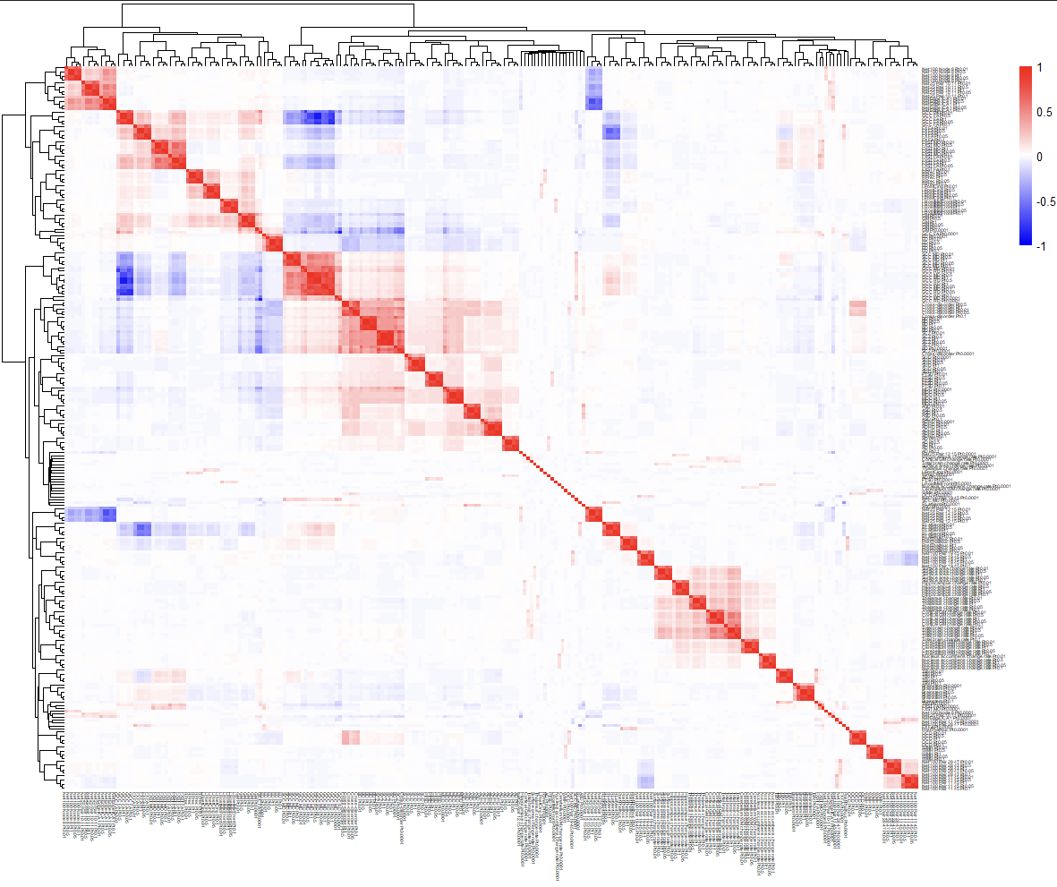Supplementary Figure 2. Full correlation heatmap of all polygenic indices (PGIs). All samples (except UKHLS-rare and MCS-full) and all P_{t}s included. 5x5 squares of high correlation tend to indicate single traits, with each row and column indicating a different P_{t} from 0.01 to 1.0 (PGIs with P_{t} 0.0001 tend to be less collinear with their trait counterparts). These 5x5 squares tend to cluster with those of similar traits, forming larger squares e.g. 15x15 for three resting-state brain activity traits in the top left corner.

Exposure associations with psychological distress

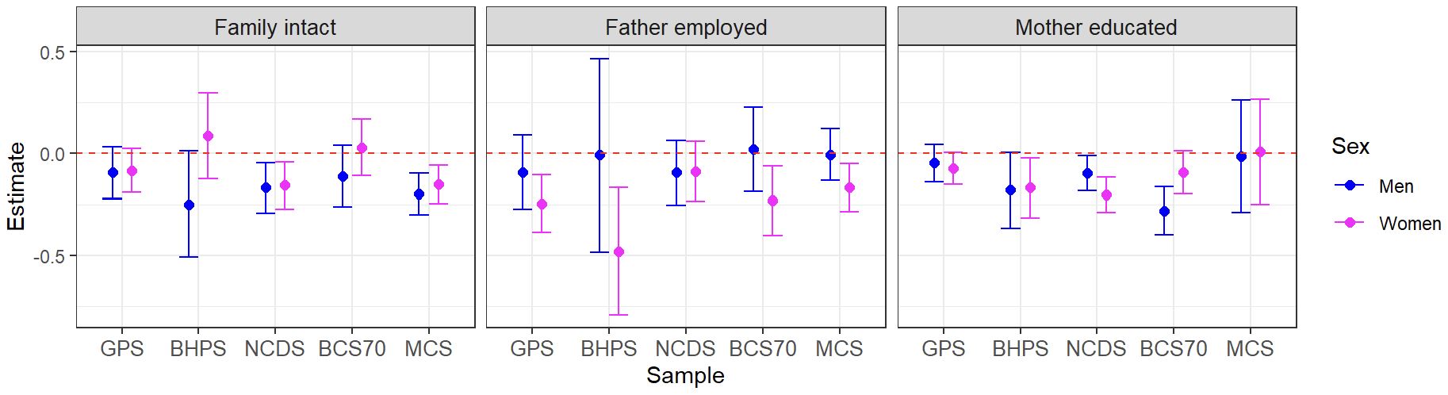
Supplementary Figure 3. Exposure associations with psychological distress as estimated in mutually-adjusted linear regressions. Error bars represent 95% confidence intervals. Family intact was protective for both sexes in NCDS and MCS (p =< 0.008), father employed was protective in women across most datasets (p =< 0.008 excluding NCDS), and mother educated was protective in at least one sex for three samples: BHPS (women, p = 0.025), NCDS (both p =< 0.029) and BCS70 (men, p = 3.74e-6). BCS70 = the 1970 British Cohort Study, BHPS = British Household Panel Survey, GPS = general population sample of Understanding Society, MCS = Millennium Cohort Study, NCDS = the 1958 National Child Development Study.

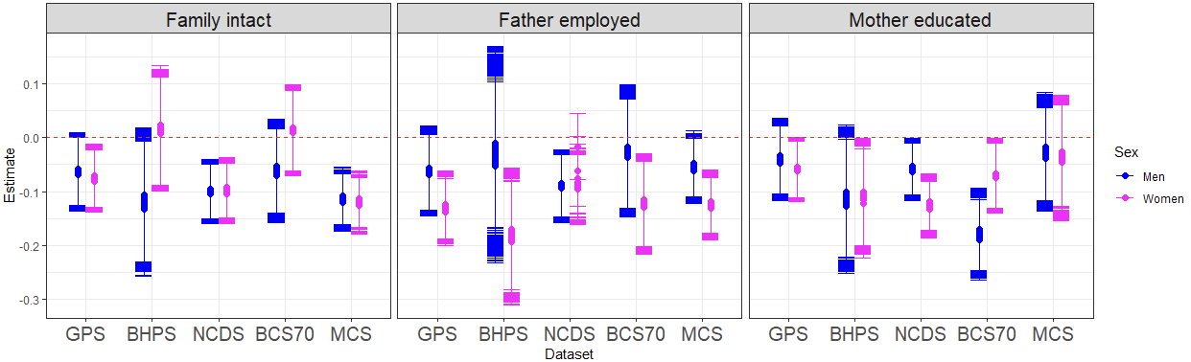Supplementary Figure 4. Exposure associations with psychological distress as estimated in multiple path models, each with a different polygenic index, hence the slight variability in superimposed estimates. Error bars represent 95% confidence intervals. Negative coefficients indicate that the exposure is protective. Compared to linear regression models, additional associations are observed for family intact (GPS women), father employed (NCDS men) and mother educated (BCS70 women). BCS70 = the 1970 British Cohort Study, BHPS = British Household Panel Survey, GPS = general population sample of Understanding Society, MCS = Millennium Cohort Study, NCDS = the 1958 National Child Development Study.

Dataset | Sex | Family intact | Father employed | Mother educated
GPS | Women | 0.009 (0.006-0.019) | 0.000 (0.000-0.000) | 0.036 (0.030-0.053)
GPS | Men | 0.069 (0.050-0.093) | 0.104 (0.068-0.157) | 0.238 (0.182-0.345)
BHPS | Women | 0.812 (0.684-0.883) | 0.002 (0.001-0.004) | 0.029 (0.019-0.046)
BHPS | Men | 0.066 (0.040-0.095) | 0.731 (0.572-0.905) | 0.070 (0.045-0.112)
NCDS | Women | 0.000 (0.000-0.001) | 0.008 (0.004-0.595) | 0.000 (0.000-0.000)
NCDS | Men | 0.000 (0.000-0.001) | 0.006 (0.003-0.008) | 0.026 (0.018-0.047)
BCS70 | Women | 0.760 (0.641-0.828) | 0.005 (0.003-0.009) | 0.034 (0.023-0.044)
BCS70 | Men | 0.148 (0.110-0.242) | 0.638 (0.511-0.777) | 0.000 (0.000-0.000)
MCS | Women | 0.000 (0.000-0.000) | 0.000 (0.000-0.000) | 0.517 (0.397-0.628)
MCS | Men | 0.000 (0.000-0.000) | 0.063 (0.048-0.121) | 0.544 (0.424-0.750)
Supplementary Table 17. P value mean (range) across main analysis path models, for exposures’ associations with psychological distress. Bold indicates significant associations (max p < 0.05). Compared to linear regression models, additional associations are observed for family intact (GPS women), father employed (NCDS men) and mother educated (BCS70 women). BCS70 = the 1970 British Cohort Study, BHPS = British Household Panel Survey, GPS = general population sample of Understanding Society, MCS = Millennium Cohort Study, NCDS = the 1958 National Child Development Study.

Dataset | Sex | Family intact | Father employed | Mother educated
GPS | Women | 0.014 (0.010-0.027) | 0.000 (0.000-0.000) | 0.016 (0.013-0.024)
GPS | Men | 0.132 (0.112-0.165) | 0.298 (0.223-0.364) | 0.207 (0.163-0.299)
BHPS | Women | 0.721 (0.637-0.779) | 0.013 (0.010-0.018) | 0.051 (0.033-0.079)
BHPS | Men | 0.105 (0.072-0.131) | 0.608 (0.499-0.702) | 0.084 (0.053-0.130)
NCDS | Women | 0.000 (0.000-0.001) | 0.003 (0.002-0.009) | 0.000 (0.000-0.000)
NCDS | Men | 0.002 (0.001-0.003) | 0.018 (0.013-0.025) | 0.008 (0.006-0.016)
BCS70 | Women | 0.631 (0.541-0.749) | 0.001 (0.000-0.002) | 0.033 (0.022-0.047)
BCS70 | Men | 0.192 (0.156-0.277) | 0.483 (0.356-0.592) | 0.000 (0.000-0.000)
MCS | Women | 0.000 (0.000-0.000) | 0.000 (0.000-0.000) | 0.526 (0.403-0.634)
MCS | Men | 0.000 (0.000-0.000) | 0.098 (0.073-0.184) | 0.447 (0.341-0.645)
Supplementary Table 18. Analyses including bereaved participants. P value mean (range) across path models, for exposures’ associations with psychological distress. Bold indicates significant associations (max p < 0.05). Compared to main analysis path models, additional associations are observed for father employed (NCDS women) and mother educated (GPS women) while the association for mother educated is lost in BHPS women. BCS70 = the 1970 British Cohort Study, BHPS = British Household Panel Survey, GPS = general population sample of Understanding Society, MCS = Millennium Cohort Study, NCDS = the 1958 National Child Development Study.

Sensitivity analysis | Sex | Family intact | Father employed | Mother educated
MCS – full (all ancestries) | Women | 0.000 (0.000-0.000) | 0.000 (0.000-0.000) | 0.851 (0.759-0.997)
MCS – full (all ancestries) | Men | 0.000 (0.000-0.000) | 0.128 (0.086-0.195) | 0.421 (0.306-0.534)
MCS – parent PGI sub-sample | Women | 0.311 (0.236-0.412) | 0.001 (0.000-0.002) | 0.129 (0.032-0.171)
MCS – parent PGI sub-sample | Men | 0.090 (0.038-0.124) | 0.676 (0.540-0.798) | 0.834 (0.639-0.956)
MCS – parent PGIs adjusted | Women | 0.314 (0.234-0.418) | 0.001 (0.000-0.001) | 0.129 (0.039-0.173)
MCS – parent PGIs adjusted | Men | 0.094 (0.062-0.152) | 0.673 (0.538-0.846) | 0.832 (0.693-0.952)
Supplementary Table 19. MCS-specific sensitivity analyses examining the impact of inclusion criteria, and adjustment for parental PGIs. P value mean (range) across path models, for exposures’ associations with psychological distress. Bold indicates significant associations (max p < 0.05). Compared to main analysis path models, using the parent PGI sub-sample removed the association with family intact. MCS = Millennium Cohort Study, PGI = polygenic index.

Sensitivity analysis | Sex | Family intact | Father employed | Mother educated
Rarer variants included in PGIs | Women | 0.009 (0.006-0.019) | 0.000 (0.000-0.000) | 0.036 (0.028-0.051)
Rarer variants included in PGIs | Men | 0.068 (0.048-0.088) | 0.103 (0.069-0.156) | 0.237 (0.182-0.339)
Adjusted for ancestry PCs | Women | 0.010 (0.007-0.020) | 0.000 (0.000-0.000) | 0.045 (0.039-0.063)
Adjusted for ancestry PCs | Men | 0.048 (0.034-0.074) | 0.092 (0.058-0.153) | 0.255 (0.196-0.357)
No age adjustment | Women | 0.009 (0.006-0.021) | 0.000 (0.000-0.000) | 0.376 (0.332-0.441)
No age adjustment | Men | 0.030 (0.024-0.050) | 0.120 (0.089-0.186) | 0.627 (0.558-0.718)
Supplementary Table 20. GPS-specific sensitivity analyses. P value mean (range) across path models, for exposures’ associations with psychological distress. Bold indicates significant associations (max p < 0.05). Compared to main analysis path models, the only difference observed is that lack of age adjustment induces an association for family intact in GPS men. GPS = general population sample of Understanding Society, PCs = principal components, PGIs = polygenic indices.

Dataset | Sex | Family intact | Father employed | Mother educated
BCS70 | Women | 0.760 (0.641-0.828) | 0.005 (0.003-0.009) | 0.001 (0.001-0.003)
BCS70 | Men | 0.148 (0.110-0.242) | 0.638 (0.511-0.777) | 0.000 (0.000-0.000)
MCS | Women | 0.000 (0.000-0.000) | 0.000 (0.000-0.000) | 0.144 (0.076-0.193)
MCS | Men | 0.000 (0.000-0.000) | 0.063 (0.048-0.121) | 0.841 (0.687-0.985)
Supplementary Table 21. Use of alternative measure of mother’s education which includes vocational qualifications. P value mean (range) across path models, for exposures’ associations with psychological distress. Bold indicates significant associations (max p < 0.05). BCS70 = the 1970 British Cohort Study, MCS = Millennium Cohort Study.

Dataset, age (outcome) | Sex | Family intact | Father employed | Mother educated
NCDS, 33 (malaise) | Women | 0.152 (0.127-0.260) | 0.070 (0.048-0.137) | 0.000 (0.000-0.000)
NCDS, 33 (malaise) | Men | 0.002 (0.002-0.003) | 0.052 (0.032-0.073) | 0.003 (0.002-0.007)
NCDS, 42 (psychological distress) | Women | 0.050 (0.042-0.080) | 0.388 (0.348-0.553) | 0.968 (0.784-1.000)
NCDS, 42 (psychological distress) | Men | 0.021 (0.016-0.027) | 0.568 (0.500-0.629) | 0.047 (0.027-0.060)
NCDS, 42 (malaise) | Women | 0.115 (0.095-0.176) | 0.080 (0.063-0.144) | 0.000 (0.000-0.000)
NCDS, 42 (malaise) | Men | 0.000 (0.000-0.000) | 0.733 (0.350-0.837) | 0.012 (0.009-0.023)
NCDS, 50 (malaise) | Women | 0.061 (0.044-0.085) | 0.101 (0.075-0.154) | 0.063 (0.048-0.111)
NCDS, 50 (malaise) | Men | 0.000 (0.000-0.000) | 0.105 (0.072-0.143) | 0.070 (0.055-0.102)
BCS70, 16 (psychological distress) | Women | 0.471 (0.390-0.573) | 0.010 (0.005-0.019) | 0.322 (0.280-0.395)
BCS70, 16 (psychological distress) | Men | 0.003 (0.001-0.007) | 0.198 (0.135-0.265) | 0.445 (0.343-0.730)
BCS70, 16 (malaise) | Women | 0.851 (0.746-0.978) | 0.004 (0.002-0.007) | 0.547 (0.486-0.639)
BCS70, 16 (malaise) | Men | 0.726 (0.643-1.000) | 0.688 (0.585-0.933) | 0.467 (0.393-0.573)
BCS70, 30 (psychological distress) | Women | 0.667 (0.602-0.754) | 0.354 (0.300-0.430) | 0.648 (0.560-0.702)
BCS70, 30 (psychological distress) | Men | 0.216 (0.171-0.306) | 0.745 (0.659-0.853) | 0.365 (0.311-0.491)
BCS70, 30 (malaise) | Women | 0.349 (0.284-0.404) | 0.338 (0.274-0.401) | 0.435 (0.358-0.483)
BCS70, 30 (malaise) | Men | 0.028 (0.019-0.056) | 0.380 (0.319-0.475) | 0.000 (0.000-0.000)
BCS70, 34 (psychological distress) | Women | 0.779 (0.666-0.837) | 0.065 (0.042-0.101) | 0.360 (0.299-0.419)
BCS70, 34 (psychological distress) | Men | 0.204 (0.157-0.306) | 0.152 (0.108-0.215) | 0.455 (0.372-0.710)
BCS70, 34 (malaise) | Women | 0.703 (0.618-0.815) | 0.019 (0.013-0.033) | 0.373 (0.261-0.443)
BCS70, 34 (malaise) | Men | 0.072 (0.049-0.122) | 0.835 (0.633-0.955) | 0.370 (0.321-0.521)
BCS70, 42 (malaise) | Women | 0.924 (0.823-0.993) | 0.839 (0.746-0.978) | 0.153 (0.109-0.179)
BCS70, 42 (malaise) | Men | 0.731 (0.650-0.848) | 0.422 (0.340-0.498) | 0.123 (0.102-0.178)
BCS70, 46 (malaise) | Women | 0.131 (0.090-0.170) | 0.213 (0.163-0.359) | 0.091 (0.060-0.134)
BCS70, 46 (malaise) | Men | 0.057 (0.038-0.096) | 0.143 (0.101-0.190) | 0.834 (0.721-1.000)
Supplementary Table 22. Mental health measured at different ages. P value mean (range) across path models, for exposures’ associations with psychological distress. Bold indicates significant associations (max p < 0.05). When measuring mental health in NCDS at ages 33, 42 and 50, family intact remained protective in men but became non-significant in women. Father employed became non-significant in both, while mother educated was protective in both sexes at ages 33 and 42 (malaise only) but not 50. For ages 16, 30, 34, 42 and 46 in BCS70, family intact remained largely non-significant, except in men at age 16 (psychological distress but not malaise) and age 30 (malaise but not psychological distress), father employed remained protective in women at ages 16 (both outcomes) and 34 (malaise only), while mother educated became non-significant, except in men at age 30 (malaise only). BCS70 = the 1970 British Cohort Study, NCDS = the 1958 National Child Development Study.

Dataset | Sex | Family intact | Father employed | Mother educated
GPS | Women | 0.925 (0.853-0.994) | 0.007 (0.003-0.010) | 0.257 (0.229-0.344)
GPS | Men | 0.434 (0.368-0.529) | 0.570 (0.478-0.664) | 0.388 (0.319-0.489)
BHPS | Women | 0.089 (0.057-0.108) | 0.001 (0.001-0.002) | 0.048 (0.030-0.065)
BHPS | Men | 0.080 (0.047-0.105) | 0.771 (0.600-0.964) | 0.117 (0.078-0.164)
NCDS | Women | 0.155 (0.001-0.186) | 0.888 (0.018-1.000) | 0.000 (0.000-0.000)
NCDS | Men | 0.126 (0.098-0.196) | 0.844 (0.684-0.904) | 0.043 (0.033-0.079)
BCS70 | Women | 0.616 (0.503-0.682) | 0.015 (0.011-0.025) | 0.271 (0.218-0.302)
BCS70 | Men | 0.167 (0.123-0.281) | 0.559 (0.469-0.643) | 0.000 (0.000-0.000)
MCS | Women | 0.151 (0.124-0.204) | 0.078 (0.067-0.119) | 0.767 (0.665-0.927)
MCS | Men | 0.005 (0.004-0.010) | 0.480 (0.408-0.563) | 0.907 (0.778-1.000)
Supplementary Table 23. Pairwise correlation terms between exposures were modelled in path models. P value mean (range) across path models, for exposures’ associations with psychological distress. Bold indicates significant associations (max p < 0.05). Specifying pairwise correlation terms between exposures had a drastic effect on the associations between exposures and psychological distress in path models: family intact lost four out of five associations, father employed lost two out of five, and mother educated lost three out of five. BCS70 = the 1970 British Cohort Study, BHPS = British Household Panel Survey, GPS = general population sample of Understanding Society, MCS = Millennium Cohort Study, NCDS = the 1958 National Child Development Study, UKHLS = the UK Household Longitudinal Study (Understanding Society).

PGI associations with psychological distress

 | GPS |  |  |  | BHPS |  |  |  | NCDS |  |  |  | BCS70 |  |  |  | MCS
 | P_{t} | 1 | 2 | 3 | P_{t} | 1 | 2 | 3 | P_{t} | 1 | 2 | 3 | P_{t} | 1 | 2 | 3 | P_{t} | 1 | 2 | 3
Men | 0.01 | 2.4 | 1.9 | 1.2 | 0.05 | 3.4 | 2.6 | 1.0 | 1.0 | 3.0 | 1.6 | 0.9 | 0.05 | 4.5 | 3.2 | 0.9 | 0.1 | 2.7 | 1.9 | 1.0
Women | 0.5 | 3.8 | 2.3 | 0.8 | 1.0 | 6.4 | 4.3 | 2.0 | 0.05 | 4.4 | 2.6 | 1.1 | 1.0 | 3.2 | 2.1 | 1.3 | 0.5 | 4.0 | 2.2 | 0.9
Supplementary Table 24. Maximum variance explained in psychological distress (%). BCS70 = the 1970 British Cohort Study, BHPS = British Household Panel Survey, GPS = general population sample of Understanding Society, MCS = Millennium Cohort Study, MDD = major depressive disorder, NCDS = the 1958 National Child Development Study, NPGI = neuropsychiatric polygenic index, P_{t} = p value threshold.
¹ by the combination of MDD NPGI (optimal P_{t} per sex-stratified sample), family intact, father employed and mother educated (and, for GPS and BHPS, age and age²) in path models.
² by the combination of MDD NPGI (optimal P_{t} per sex-stratified sample), family intact, father employed and mother educated (and, for GPS and BHPS, age and age²) in linear regression models.
³ by MDD NPGI (optimal P_{t} per sex-stratified sample) independent of family intact, father employed and mother educated (and, for GPS and BHPS, age and age²) in linear regression models.

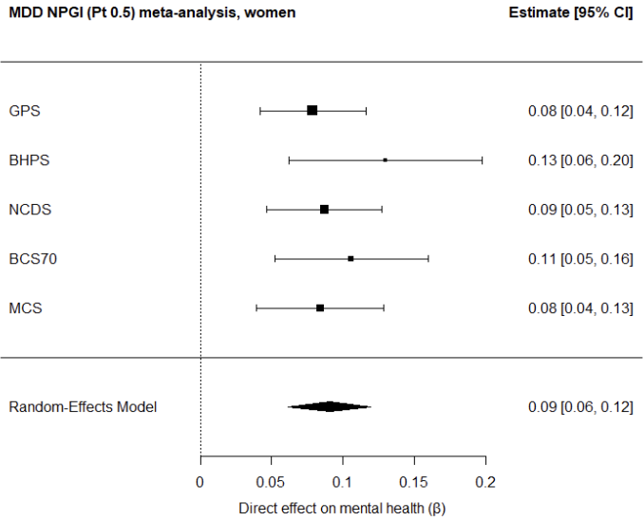
Supplementary Figure 5. Meta-analysis plot for depression PGI (P_{t} 0.5) in women. BCS70 = the 1970 British Cohort Study, BHPS = British Household Panel Survey, CI = confidence interval, GPS = general population sample of Understanding Society, MCS = Millennium Cohort Study, MDD = major depressive disorder, NCDS = the 1958 National Child Development Study, NPGI = neuropsychiatric polygenic index, P_{t} = p value threshold.
 | Men |  |  | Women
PGI | Beta | P | Hetero geneity P | Beta | P | Hetero geneity P
NPGIs
AD Pt 0.0001 | 0.0188 | 0.1550 | 0.8294 | 0.0049 | 0.6592 | 0.7892
AD Pt 0.01 | 0.0234 | 0.3741 | 0.0119 | 0.0177 | 0.1596 | 0.7509
AD Pt 0.05 | 0.0266 | 0.4177 | 0.0005 | 0.0248 | 0.0764 | 0.9695
AD Pt 0.1 | 0.0329 | 0.2617 | 0.0037 | 0.0244 | 0.0765 | 0.9587
AD Pt 0.5 | 0.0297 | 0.2449 | 0.0117 | 0.0189 | 0.1389 | 0.5652
AD Pt 1 | 0.0253 | 0.2773 | 0.0221 | 0.0191 | 0.1362 | 0.4926
ADHD Pt 0.0001 | 0.0272 | 0.1094 | 0.3299 | 0.0413 | 0.0153 | 0.7574
ADHD Pt 0.01 | 0.0504 | 0.0274 | 0.1968 | 0.0622 | 0.0042 | 0.8320
ADHD Pt 0.05 | 0.0468 | 0.0143 | 0.9046 | 0.0646 | 0.0036 | 0.8563
ADHD Pt 0.1 | 0.0390 | 0.0262 | 0.9295 | 0.0630 | 0.0041 | 0.9575
ADHD Pt 0.5 | 0.0468 | 0.0147 | 0.7786 | 0.0531 | 0.0074 | 0.9258
ADHD Pt 1 | 0.0483 | 0.0133 | 0.7255 | 0.0533 | 0.0073 | 0.8486
ASD Pt 0.0001 | 0.0180 | 0.1814 | 0.4477 | 0.0195 | 0.1815 | 0.2790
ASD Pt 0.01 | 0.0201 | 0.2377 | 0.2587 | 0.0106 | 0.3575 | 0.5139
ASD Pt 0.05 | 0.0294 | 0.1619 | 0.0860 | 0.0183 | 0.2343 | 0.1831
ASD Pt 0.1 | 0.0300 | 0.1383 | 0.1347 | 0.0205 | 0.3065 | 0.0303
ASD Pt 0.5 | 0.0232 | 0.1863 | 0.2586 | 0.0203 | 0.2853 | 0.0474
ASD Pt 1 | 0.0250 | 0.1586 | 0.2736 | 0.0192 | 0.3380 | 0.0281
BD Pt 0.0001 | 0.0153 | 0.2443 | 0.5889 | 0.0067 | 0.5609 | 0.3159
BD Pt 0.01 | 0.0207 | 0.1462 | 0.2587 | 0.0163 | 0.1986 | 0.8387
BD Pt 0.05 | 0.0281 | 0.3117 | 0.0082 | 0.0231 | 0.0950 | 0.9053
BD Pt 0.1 | 0.0341 | 0.1622 | 0.0332 | 0.0239 | 0.0859 | 0.8732
BD Pt 0.5 | 0.0408 | 0.0225 | 0.2718 | 0.0255 | 0.0739 | 0.8597
BD Pt 1 | 0.0398 | 0.0243 | 0.1811 | 0.0238 | 0.0882 | 0.8803
Cross-disorder Pt 0.0001 | 0.0336 | 0.0413 | 0.7943 | 0.0048 | 0.6714 | 0.6541
Cross-disorder Pt 0.01 | 0.0459 | 0.0147 | 0.6598 | 0.0214 | 0.1086 | 0.4548
Cross-disorder Pt 0.05 | 0.0534 | 0.0402 | 0.0656 | 0.0333 | 0.0321 | 0.6319
Cross-disorder Pt 0.1 | 0.0495 | 0.0119 | 0.1616 | 0.0363 | 0.0240 | 0.8031
Cross-disorder Pt 0.5 | 0.0467 | 0.0149 | 0.3121 | 0.0411 | 0.0160 | 0.4586
Cross-disorder Pt 1 | 0.0482 | 0.0137 | 0.2437 | 0.0437 | 0.0133 | 0.4924
ED Pt 0.0001 | -0.0179 | 0.1814 | 0.5622 | 0.0020 | 0.8580 | 0.5812
ED Pt 0.01 | -0.0302 | 0.0540 | 0.6964 | -0.0051 | 0.6416 | 0.2848
ED Pt 0.05 | -0.0387 | 0.0254 | 0.5888 | -0.0069 | 0.5432 | 0.5021
ED Pt 0.1 | -0.0412 | 0.0208 | 0.5813 | -0.0028 | 0.7980 | 0.3063
ED Pt 0.5 | -0.0297 | 0.0762 | 0.2964 | 0.0037 | 0.7947 | 0.1030
ED Pt 1 | -0.0280 | 0.0769 | 0.3380 | 0.0044 | 0.7299 | 0.1203
MDD Pt 0.0001 | 0.0668 | 0.0038 | 0.4463 | 0.0434 | 0.0243 | 0.2452
MDD Pt 0.01 | 0.0802 | 0.0021 | 0.8060 | 0.0665 | 0.0031 | 0.8258
MDD Pt 0.05 | 0.0836 | 0.0017 | 0.9558 | 0.0816 | 0.0014 | 0.8467
MDD Pt 0.1 | 0.0893 | 0.0014 | 0.9704 | 0.0843 | 0.0013 | 0.8776
MDD Pt 0.5 | 0.0828 | 0.0019 | 0.9981 | 0.0907 | 0.0010 | 0.7174
MDD Pt 1 | 0.0827 | 0.0019 | 0.9971 | 0.0894 | 0.0010 | 0.6791
OCD Pt 0.0001 | 0.0235 | 0.1015 | 0.8421 | 0.0117 | 0.3176 | 0.9751
OCD Pt 0.01 | 0.0245 | 0.2684 | 0.0339 | 0.0073 | 0.5202 | 0.9722
OCD Pt 0.05 | 0.0233 | 0.2994 | 0.0200 | 0.0029 | 0.7985 | 0.8917
OCD Pt 0.1 | 0.0200 | 0.4256 | 0.0047 | 0.0043 | 0.7015 | 0.9116
OCD Pt 0.5 | 0.0253 | 0.1713 | 0.1329 | -0.0029 | 0.7989 | 0.7866
OCD Pt 1 | 0.0231 | 0.2178 | 0.1065 | -0.0025 | 0.8269 | 0.7521
PTSD Pt 0.0001 | -0.0144 | 0.3585 | 0.2447 | -0.0202 | 0.1225 | 0.5986
PTSD Pt 0.01 | 0.0279 | 0.0673 | 0.7012 | 0.0238 | 0.0828 | 0.4232
PTSD Pt 0.05 | 0.0258 | 0.0839 | 0.7740 | 0.0336 | 0.0634 | 0.2378
PTSD Pt 0.1 | 0.0320 | 0.0455 | 0.9618 | 0.0284 | 0.1497 | 0.0644
PTSD Pt 0.5 | 0.0400 | 0.0238 | 0.9975 | 0.0388 | 0.0669 | 0.0877
PTSD Pt 1 | 0.0401 | 0.0240 | 0.9951 | 0.0382 | 0.0688 | 0.0917
SCZ Pt 0.0001 | 0.0338 | 0.0402 | 0.8433 | -0.0002 | 0.9833 | 0.3358
SCZ Pt 0.01 | 0.0377 | 0.0273 | 0.6255 | 0.0132 | 0.2715 | 0.4244
SCZ Pt 0.05 | 0.0268 | 0.0732 | 0.7557 | 0.0138 | 0.3252 | 0.1995
SCZ Pt 0.1 | 0.0313 | 0.0490 | 0.8539 | 0.0157 | 0.2036 | 0.5920
SCZ Pt 0.5 | 0.0370 | 0.0296 | 0.6713 | 0.0182 | 0.1522 | 0.3687
SCZ Pt 1 | 0.0364 | 0.0309 | 0.6142 | 0.0184 | 0.1475 | 0.3897
SUD Pt 0.0001 | -0.0018 | 0.8789 | 0.2800 | 0.0067 | 0.5544 | 0.7493
SUD Pt 0.01 | 0.0145 | 0.5971 | 0.0053 | 0.0111 | 0.3491 | 0.8091
SUD Pt 0.05 | 0.0235 | 0.1789 | 0.1203 | 0.0141 | 0.2488 | 0.9436
SUD Pt 0.1 | 0.0240 | 0.1042 | 0.2681 | 0.0088 | 0.4465 | 0.8746
SUD Pt 0.5 | 0.0288 | 0.0628 | 0.1284 | 0.0087 | 0.4457 | 0.9379
SUD Pt 1 | 0.0284 | 0.1007 | 0.1117 | 0.0086 | 0.4566 | 0.9689
EPGIs – brain volumes
TBV Pt 0.0001 | -0.0079 | 0.5190 | 0.7509 | -0.0167 | 0.3730 | 0.0453
TBV Pt 0.01 | -0.0318 | 0.0462 | 0.5462 | -0.0273 | 0.1723 | 0.0380
TBV Pt 0.05 | -0.0395 | 0.0259 | 0.4116 | -0.0275 | 0.1680 | 0.0460
TBV Pt 0.1 | -0.0378 | 0.0271 | 0.5388 | -0.0302 | 0.1010 | 0.1245
TBV Pt 0.5 | -0.0350 | 0.0348 | 0.7526 | -0.0246 | 0.1342 | 0.2161
TBV Pt 1 | -0.0331 | 0.0410 | 0.8201 | -0.0229 | 0.1437 | 0.2680
Total GM Pt 0.0001 | -0.0135 | 0.3903 | 0.2459 | -0.0082 | 0.4794 | 0.3606
Total GM Pt 0.01 | 0.0017 | 0.9273 | 0.0691 | -0.0240 | 0.1577 | 0.1768
Total GM Pt 0.05 | -0.0063 | 0.6882 | 0.1797 | -0.0178 | 0.1911 | 0.3670
Total GM Pt 0.1 | -0.0046 | 0.8014 | 0.0738 | -0.0226 | 0.1343 | 0.2808
Total GM Pt 0.5 | -0.0031 | 0.8817 | 0.0299 | -0.0262 | 0.1391 | 0.1246
Total GM Pt 1 | -0.0032 | 0.8734 | 0.0388 | -0.0247 | 0.1309 | 0.1862
LPostCing Pt 0.0001 | -0.0066 | 0.5903 | 0.7657 | -0.0099 | 0.4618 | 0.2274
LPostCing Pt 0.01 | 0.0082 | 0.5072 | 0.8271 | -0.0090 | 0.4593 | 0.4177
LPostCing Pt 0.05 | 0.0062 | 0.6050 | 0.8596 | -0.0175 | 0.1643 | 0.3393
LPostCing Pt 0.1 | 0.0071 | 0.5545 | 0.5679 | -0.0184 | 0.1471 | 0.4169
LPostCing Pt 0.5 | 0.0004 | 0.9754 | 0.9401 | -0.0136 | 0.2547 | 0.8057
LPostCing Pt 1 | 0.0036 | 0.7527 | 0.8520 | -0.0121 | 0.3067 | 0.7744
LRostMidFront Pt 0.0001 | -0.0222 | 0.1211 | 0.6320 | 0.0028 | 0.8012 | 0.8986
LRostMidFront Pt 0.01 | -0.0034 | 0.8823 | 0.0172 | 0.0134 | 0.2711 | 0.8765
LRostMidFront Pt 0.05 | -0.0043 | 0.8783 | 0.0022 | 0.0024 | 0.8240 | 0.8406
LRostMidFront Pt 0.1 | -0.0024 | 0.9354 | 0.0027 | 0.0018 | 0.8852 | 0.3288
LRostMidFront Pt 0.5 | 0.0123 | 0.7436 | 0.0000 | -0.0006 | 0.9616 | 0.4658
LRostMidFront Pt 1 | 0.0119 | 0.7417 | 0.0001 | -0.0011 | 0.9198 | 0.5244
RLatVent Pt 0.0001 | -0.0035 | 0.7715 | 0.8898 | 0.0145 | 0.2390 | 0.9025
RLatVent Pt 0.01 | -0.0069 | 0.6081 | 0.3784 | 0.0036 | 0.7477 | 0.9418
RLatVent Pt 0.05 | -0.0072 | 0.5523 | 0.7282 | 0.0054 | 0.6314 | 0.6817
RLatVent Pt 0.1 | 0.0043 | 0.7169 | 0.4666 | 0.0057 | 0.6190 | 0.9463
RLatVent Pt 0.5 | 0.0093 | 0.4435 | 0.5593 | 0.0034 | 0.7623 | 0.8857
RLatVent Pt 1 | 0.0090 | 0.4864 | 0.4709 | 0.0028 | 0.8052 | 0.9183
RPrec Pt 0.0001 | -0.0163 | 0.2227 | 0.6798 | 0.0067 | 0.6494 | 0.1609
RPrec Pt 0.01 | 0.0036 | 0.7621 | 0.4688 | 0.0014 | 0.9023 | 0.5149
RPrec Pt 0.05 | 0.0067 | 0.6574 | 0.1651 | 0.0025 | 0.8233 | 0.8576
RPrec Pt 0.1 | 0.0079 | 0.6248 | 0.1281 | -0.0048 | 0.6674 | 0.8410
RPrec Pt 0.5 | 0.0041 | 0.7306 | 0.3448 | -0.0069 | 0.5504 | 0.4322
RPrec Pt 1 | 0.0022 | 0.8488 | 0.3960 | -0.0053 | 0.6345 | 0.4642
Brainstem Pt 0.0001 | 0.0202 | 0.2994 | 0.0671 | -0.0194 | 0.1396 | 0.8508
Brainstem Pt 0.01 | -0.0013 | 0.9131 | 0.8781 | -0.0130 | 0.2830 | 0.9724
Brainstem Pt 0.05 | 0.0016 | 0.9323 | 0.0942 | -0.0141 | 0.2489 | 0.9758
Brainstem Pt 0.1 | 0.0034 | 0.8564 | 0.0852 | -0.0092 | 0.4233 | 0.8990
Brainstem Pt 0.5 | 0.0097 | 0.5524 | 0.1833 | -0.0068 | 0.5480 | 0.8725
Brainstem Pt 1 | 0.0084 | 0.5635 | 0.3208 | -0.0083 | 0.4723 | 0.8452
PostThalNuc Pt 0.0001 | 0.0332 | 0.1387 | 0.0490 | 0.0097 | 0.4233 | 0.3946
PostThalNuc Pt 0.01 | 0.0172 | 0.3626 | 0.0784 | 0.0197 | 0.1423 | 0.3753
PostThalNuc Pt 0.05 | 0.0109 | 0.6001 | 0.0303 | 0.0172 | 0.1682 | 0.9915
PostThalNuc Pt 0.1 | 0.0042 | 0.7757 | 0.2309 | 0.0137 | 0.2510 | 0.9752
PostThalNuc Pt 0.5 | 0.0020 | 0.8660 | 0.5036 | 0.0141 | 0.2409 | 0.9661
PostThalNuc Pt 1 | 0.0003 | 0.9800 | 0.4908 | 0.0162 | 0.1872 | 0.8581
EPGIs – white matter microstructure
FXST FA Pt 0.0001 | -0.0207 | 0.1322 | 0.6682 | -0.0014 | 0.8982 | 0.6711
FXST FA Pt 0.01 | -0.0191 | 0.1575 | 0.8463 | -0.0047 | 0.6802 | 0.8605
FXST FA Pt 0.05 | -0.0131 | 0.3717 | 0.2361 | -0.0114 | 0.3416 | 0.4086
FXST FA Pt 0.1 | -0.0115 | 0.5671 | 0.0251 | -0.0067 | 0.5604 | 0.7249
FXST FA Pt 0.5 | -0.0113 | 0.5505 | 0.0407 | -0.0096 | 0.4090 | 0.8477
FXST FA Pt 1 | -0.0126 | 0.5257 | 0.0288 | -0.0070 | 0.5417 | 0.6768
GCC FA Pt 0.0001 | -0.0096 | 0.4476 | 0.6493 | 0.0109 | 0.3719 | 0.3718
GCC FA Pt 0.01 | -0.0158 | 0.2291 | 0.5303 | -0.0226 | 0.1565 | 0.1635
GCC FA Pt 0.05 | -0.0177 | 0.1821 | 0.8891 | -0.0168 | 0.2581 | 0.1697
GCC FA Pt 0.1 | -0.0151 | 0.2402 | 0.8060 | -0.0167 | 0.3302 | 0.0978
GCC FA Pt 0.5 | -0.0138 | 0.2728 | 0.9417 | -0.0206 | 0.1364 | 0.2943
GCC FA Pt 1 | -0.0151 | 0.2377 | 0.9583 | -0.0172 | 0.2135 | 0.2532
FX FA Pt 0.0001 | 0.0210 | 0.1529 | 0.3891 | -0.0007 | 0.9523 | 0.7443
FX FA Pt 0.01 | 0.0074 | 0.5405 | 0.9199 | -0.0064 | 0.5742 | 0.6732
FX FA Pt 0.05 | 0.0171 | 0.1947 | 0.6289 | -0.0011 | 0.9220 | 0.5835
FX FA Pt 0.1 | 0.0187 | 0.1556 | 0.7219 | 0.0002 | 0.9867 | 0.7483
FX FA Pt 0.5 | 0.0153 | 0.2275 | 0.9485 | -0.0015 | 0.8902 | 0.4553
FX FA Pt 1 | 0.0139 | 0.2654 | 0.9697 | -0.0037 | 0.7421 | 0.4589
GCC MD Pt 0.0001 | 0.0186 | 0.1651 | 0.4560 | 0.0053 | 0.7565 | 0.0651
GCC MD Pt 0.01 | 0.0187 | 0.1636 | 0.6977 | 0.0269 | 0.0622 | 0.7318
GCC MD Pt 0.05 | 0.0178 | 0.1790 | 0.9295 | 0.0147 | 0.2315 | 0.6964
GCC MD Pt 0.1 | 0.0163 | 0.2160 | 0.9170 | 0.0212 | 0.1106 | 0.6653
GCC MD Pt 0.5 | 0.0230 | 0.1051 | 0.8029 | 0.0224 | 0.0969 | 0.4964
GCC MD Pt 1 | 0.0220 | 0.1168 | 0.8186 | 0.0236 | 0.0858 | 0.4704
SCC MD Pt 0.0001 | 0.0178 | 0.1875 | 0.5735 | -0.0191 | 0.1435 | 0.7954
SCC MD Pt 0.01 | 0.0245 | 0.2250 | 0.0677 | 0.0007 | 0.9479 | 0.4374
SCC MD Pt 0.05 | 0.0118 | 0.5807 | 0.0388 | 0.0111 | 0.3387 | 0.6593
SCC MD Pt 0.1 | 0.0152 | 0.2514 | 0.2060 | 0.0146 | 0.2308 | 0.4691
SCC MD Pt 0.5 | 0.0198 | 0.3153 | 0.0645 | 0.0135 | 0.2571 | 0.8324
SCC MD Pt 1 | 0.0195 | 0.3257 | 0.0621 | 0.0144 | 0.2334 | 0.8269
FXST MO Pt 0.0001 | -0.0135 | 0.2789 | 0.8501 | -0.0150 | 0.2199 | 0.5999
FXST MO Pt 0.01 | -0.0088 | 0.4706 | 0.3919 | 0.0028 | 0.8497 | 0.1386
FXST MO Pt 0.05 | -0.0067 | 0.6370 | 0.1939 | -0.0124 | 0.3016 | 0.4578
FXST MO Pt 0.1 | -0.0149 | 0.3239 | 0.2417 | -0.0057 | 0.6095 | 0.4574
FXST MO Pt 0.5 | -0.0084 | 0.4870 | 0.5715 | -0.0036 | 0.7499 | 0.5358
FXST MO Pt 1 | -0.0084 | 0.5027 | 0.4841 | -0.0025 | 0.8247 | 0.5527
GCC RD Pt 0.0001 | 0.0120 | 0.3625 | 0.6568 | -0.0135 | 0.4879 | 0.0304
GCC RD Pt 0.01 | 0.0211 | 0.1341 | 0.4136 | 0.0260 | 0.0670 | 0.3564
GCC RD Pt 0.05 | 0.0198 | 0.1412 | 0.9681 | 0.0218 | 0.1641 | 0.1704
GCC RD Pt 0.1 | 0.0119 | 0.3365 | 0.9781 | 0.0158 | 0.2767 | 0.1687
GCC RD Pt 0.5 | 0.0158 | 0.2238 | 0.9786 | 0.0159 | 0.3076 | 0.1406
GCC RD Pt 1 | 0.0139 | 0.2739 | 0.9684 | 0.0203 | 0.1544 | 0.2141
EPGIs – white matter lesions
WMH Pt 0.0001 | 0.0149 | 0.2467 | 0.4675 | -0.0071 | 0.5363 | 0.9683
WMH Pt 0.01 | 0.0011 | 0.9292 | 0.9107 | -0.0122 | 0.3955 | 0.1847
WMH Pt 0.05 | 0.0039 | 0.7754 | 0.2202 | -0.0019 | 0.8665 | 0.5272
WMH Pt 0.1 | 0.0004 | 0.9717 | 0.1816 | -0.0031 | 0.7822 | 0.7500
WMH Pt 0.5 | 0.0004 | 0.9705 | 0.2577 | 0.0033 | 0.7714 | 0.9168
WMH Pt 1 | 0.0000 | 0.9974 | 0.1962 | 0.0043 | 0.7051 | 0.8775
EPGIs – resting-state brain activity
Net Edge ICA1 Pt 0.0001 | 0.0138 | 0.2898 | 0.5904 | -0.0046 | 0.6777 | 0.7305
Net Edge ICA1 Pt 0.01 | -0.0232 | 0.1272 | 0.2319 | -0.0010 | 0.9285 | 0.7176
Net Edge ICA1 Pt 0.05 | -0.0171 | 0.1969 | 0.7807 | -0.0065 | 0.5707 | 0.8919
Net Edge ICA1 Pt 0.1 | -0.0106 | 0.3946 | 0.9991 | -0.0130 | 0.2919 | 0.9848
Net Edge ICA1 Pt 0.5 | -0.0054 | 0.6443 | 0.9881 | -0.0110 | 0.3587 | 0.9156
Net Edge ICA1 Pt 1 | -0.0038 | 0.7454 | 0.9781 | -0.0103 | 0.3858 | 0.8938
Net 100 Node 8 Pt 0.0001 | 0.0003 | 0.9770 | 0.6134 | -0.0014 | 0.8946 | 0.6069
Net 100 Node 8 Pt 0.01 | 0.0031 | 0.7909 | 0.8421 | -0.0109 | 0.4621 | 0.1725
Net 100 Node 8 Pt 0.05 | 0.0081 | 0.5049 | 0.5909 | -0.0160 | 0.2010 | 0.9773
Net 100 Node 8 Pt 0.1 | 0.0048 | 0.7465 | 0.2691 | -0.0163 | 0.1939 | 0.6237
Net 100 Node 8 Pt 0.5 | 0.0055 | 0.7065 | 0.2776 | -0.0221 | 0.0990 | 0.7343
Net 100 Node 8 Pt 1 | 0.0066 | 0.6535 | 0.2645 | -0.0214 | 0.1066 | 0.7647
Net 100 Pair 11 45 Pt 0.0001 | 0.0119 | 0.4750 | 0.1059 | -0.0200 | 0.1987 | 0.2045
Net 100 Pair 11 45 Pt 0.01 | 0.0160 | 0.2301 | 0.3004 | -0.0151 | 0.2661 | 0.2903
Net 100 Pair 11 45 Pt 0.05 | 0.0193 | 0.3468 | 0.0563 | -0.0226 | 0.1790 | 0.1294
Net 100 Pair 11 45 Pt 0.1 | 0.0213 | 0.1419 | 0.2491 | -0.0225 | 0.1880 | 0.1471
Net 100 Pair 11 45 Pt 0.5 | 0.0177 | 0.1982 | 0.3887 | -0.0292 | 0.1093 | 0.1382
Net 100 Pair 11 45 Pt 1 | 0.0184 | 0.1865 | 0.3486 | -0.0312 | 0.1040 | 0.1103
Net 100 Pair 19 45 Pt 0.0001 | -0.0046 | 0.7023 | 0.9201 | -0.0139 | 0.4826 | 0.0248
Net 100 Pair 19 45 Pt 0.01 | -0.0104 | 0.4363 | 0.2910 | 0.0041 | 0.7047 | 0.8697
Net 100 Pair 19 45 Pt 0.05 | -0.0032 | 0.8156 | 0.2584 | 0.0017 | 0.9236 | 0.0520
Net 100 Pair 19 45 Pt 0.1 | -0.0017 | 0.8898 | 0.2574 | 0.0074 | 0.6845 | 0.0490
Net 100 Pair 19 45 Pt 0.5 | -0.0111 | 0.3903 | 0.3329 | 0.0150 | 0.4319 | 0.0390
Net 100 Pair 19 45 Pt 1 | -0.0117 | 0.3685 | 0.3477 | 0.0176 | 0.3738 | 0.0320
Net 100 Pair 28 47 Pt 0.0001 | 0.0094 | 0.4330 | 0.6394 | -0.0160 | 0.2967 | 0.1440
Net 100 Pair 28 47 Pt 0.01 | -0.0053 | 0.6553 | 0.5617 | -0.0127 | 0.2928 | 0.7792
Net 100 Pair 28 47 Pt 0.05 | -0.0130 | 0.2964 | 0.7123 | -0.0138 | 0.2976 | 0.3678
Net 100 Pair 28 47 Pt 0.1 | -0.0092 | 0.4518 | 0.5013 | -0.0199 | 0.2472 | 0.1362
Net 100 Pair 28 47 Pt 0.5 | -0.0043 | 0.7148 | 0.3427 | -0.0211 | 0.2534 | 0.0834
Net 100 Pair 28 47 Pt 1 | -0.0077 | 0.5237 | 0.3734 | -0.0213 | 0.2136 | 0.1374
Net 25 Pair 10 11 Pt 0.0001 | -0.0219 | 0.1700 | 0.2394 | -0.0004 | 0.9701 | 0.9782
Net 25 Pair 10 11 Pt 0.01 | 0.0001 | 0.9936 | 0.1087 | -0.0118 | 0.3080 | 0.9474
Net 25 Pair 10 11 Pt 0.05 | 0.0000 | 0.9970 | 0.3163 | -0.0196 | 0.1238 | 0.6063
Net 25 Pair 10 11 Pt 0.1 | 0.0027 | 0.8462 | 0.2477 | -0.0097 | 0.3947 | 0.6313
Net 25 Pair 10 11 Pt 0.5 | 0.0001 | 0.9927 | 0.1612 | -0.0004 | 0.9684 | 0.5455
Net 25 Pair 10 11 Pt 1 | 0.0026 | 0.8519 | 0.2873 | -0.0004 | 0.9736 | 0.5134
Net 25 Pair 12 15 Pt 0.0001 | -0.0144 | 0.2729 | 0.7175 | -0.0061 | 0.6031 | 0.4218
Net 25 Pair 12 15 Pt 0.01 | -0.0029 | 0.8016 | 0.6087 | 0.0064 | 0.5781 | 0.5867
Net 25 Pair 12 15 Pt 0.05 | -0.0007 | 0.9538 | 0.7439 | -0.0016 | 0.8821 | 0.7396
Net 25 Pair 12 15 Pt 0.1 | -0.0033 | 0.7781 | 0.8290 | -0.0091 | 0.4273 | 0.7992
Net 25 Pair 12 15 Pt 0.5 | -0.0013 | 0.9084 | 0.9748 | -0.0068 | 0.5436 | 0.8895
Net 25 Pair 12 15 Pt 1 | -0.0013 | 0.9127 | 0.9605 | -0.0070 | 0.5372 | 0.8808
EPGIs – longitudinal brain structure
Cerebellum WM change rate Pt 0.0001 | -0.0084 | 0.4922 | 0.7648 | 0.0122 | 0.2991 | 0.4497
Cerebellum WM change rate Pt 0.01 | -0.0006 | 0.9692 | 0.1300 | -0.0108 | 0.3642 | 0.8054
Cerebellum WM change rate Pt 0.05 | -0.0056 | 0.6425 | 0.5354 | -0.0171 | 0.3136 | 0.1003
Cerebellum WM change rate Pt 0.1 | -0.0002 | 0.9911 | 0.1926 | -0.0276 | 0.0567 | 0.6804
Cerebellum WM change rate Pt 0.5 | 0.0010 | 0.9439 | 0.2818 | -0.0363 | 0.0243 | 0.9267
Cerebellum WM change rate Pt 1 | 0.0025 | 0.8523 | 0.3543 | -0.0361 | 0.0247 | 0.8798
Surface area change rate Pt 0.0001 | -0.0123 | 0.3341 | 0.6105 | -0.0175 | 0.1697 | 0.9251
Surface area change rate Pt 0.01 | -0.0157 | 0.2679 | 0.4429 | -0.0140 | 0.3385 | 0.1631
Surface area change rate Pt 0.05 | -0.0181 | 0.4104 | 0.0218 | -0.0113 | 0.3411 | 0.7734
Surface area change rate Pt 0.1 | -0.0159 | 0.3741 | 0.1345 | -0.0042 | 0.7092 | 0.5526
Surface area change rate Pt 0.5 | -0.0192 | 0.2586 | 0.2181 | -0.0028 | 0.8035 | 0.3381
Surface area change rate Pt 1 | -0.0184 | 0.2454 | 0.3047 | -0.0041 | 0.7496 | 0.2169
Cortical GM change rate Pt 0.0001 | -0.0309 | 0.0886 | 0.1136 | -0.0033 | 0.7639 | 0.9175
Cortical GM change rate Pt 0.01 | -0.0044 | 0.7212 | 0.5500 | -0.0095 | 0.4166 | 0.5834
Cortical GM change rate Pt 0.05 | -0.0151 | 0.2442 | 0.7380 | 0.0065 | 0.5723 | 0.4796
Cortical GM change rate Pt 0.1 | -0.0126 | 0.4028 | 0.2602 | 0.0056 | 0.6173 | 0.9584
Cortical GM change rate Pt 0.5 | -0.0177 | 0.2493 | 0.2987 | 0.0032 | 0.7757 | 0.6387
Cortical GM change rate Pt 1 | -0.0164 | 0.2611 | 0.3506 | 0.0034 | 0.7575 | 0.6663
Thalamus change rate Pt 0.0001 | 0.0140 | 0.3463 | 0.3943 | -0.0121 | 0.5018 | 0.0419
Thalamus change rate Pt 0.01 | 0.0060 | 0.6865 | 0.2609 | -0.0125 | 0.3057 | 0.5089
Thalamus change rate Pt 0.05 | 0.0083 | 0.5057 | 0.4895 | -0.0152 | 0.3369 | 0.1660
Thalamus change rate Pt 0.1 | 0.0085 | 0.5447 | 0.3410 | -0.0201 | 0.2195 | 0.1832
Thalamus change rate Pt 0.5 | 0.0002 | 0.9889 | 0.9027 | -0.0186 | 0.1514 | 0.6033
Thalamus change rate Pt 1 | 0.0014 | 0.9044 | 0.9562 | -0.0182 | 0.1587 | 0.5518
Hippocampus change rate Pt 0.0001 | 0.0123 | 0.3422 | 0.8634 | -0.0004 | 0.9784 | 0.2888
Hippocampus change rate Pt 0.01 | -0.0053 | 0.6560 | 0.8527 | -0.0105 | 0.4706 | 0.1693
Hippocampus change rate Pt 0.05 | 0.0044 | 0.7144 | 0.9357 | -0.0102 | 0.3902 | 0.4391
Hippocampus change rate Pt 0.1 | -0.0089 | 0.4706 | 0.7615 | -0.0128 | 0.2930 | 0.6125
Hippocampus change rate Pt 0.5 | -0.0124 | 0.3230 | 0.9943 | -0.0146 | 0.2304 | 0.6872
Hippocampus change rate Pt 1 | -0.0135 | 0.2876 | 0.9802 | -0.0138 | 0.2559 | 0.6358
Total brain change rate Pt 0.0001 | -0.0021 | 0.8590 | 0.8813 | 0.0075 | 0.5185 | 0.4969
Total brain change rate Pt 0.01 | -0.0033 | 0.8340 | 0.1696 | 0.0067 | 0.6069 | 0.2513
Total brain change rate Pt 0.05 | -0.0095 | 0.4748 | 0.3840 | -0.0047 | 0.6705 | 0.4983
Total brain change rate Pt 0.1 | -0.0162 | 0.2493 | 0.3771 | -0.0021 | 0.8624 | 0.3944
Total brain change rate Pt 0.5 | -0.0158 | 0.2325 | 0.5937 | -0.0042 | 0.7046 | 0.7324
Total brain change rate Pt 1 | -0.0153 | 0.2438 | 0.6518 | -0.0029 | 0.7901 | 0.7154
Nucleus accumbens change rate Pt 0.0001 | 0.0165 | 0.5270 | 0.0078 | -0.0112 | 0.3418 | 0.5054
Nucleus accumbens change rate Pt 0.01 | -0.0096 | 0.5243 | 0.2625 | -0.0066 | 0.6649 | 0.1574
Nucleus accumbens change rate Pt 0.05 | -0.0030 | 0.8016 | 0.7304 | 0.0011 | 0.9466 | 0.0795
Nucleus accumbens change rate Pt 0.1 | -0.0039 | 0.7437 | 0.7204 | -0.0036 | 0.8314 | 0.0685
Nucleus accumbens change rate Pt 0.5 | -0.0009 | 0.9410 | 0.4793 | -0.0073 | 0.6368 | 0.1319
Nucleus accumbens change rate Pt 1 | 0.0010 | 0.9348 | 0.5518 | -0.0068 | 0.6569 | 0.1461
Supplementary Table 25. Full meta-analysis results. Bold indicates a p value below 0.05. Polygenic indices nominally associated with mental health symptoms in men are ADHD, BD, cross-disorder, ED, MDD, PTSD, SCZ, and TBV, albeit with some heterogeneity for the latter. Polygenic indices nominally associated with mental health symptoms in women are ADHD, cross-disorder, MDD and cerebellum white matter change rate. AD = anxiety disorders, ADHD = attention deficit hyperactivity disorder, ASD = autism spectrum disorder, BD = bipolar disorder, ED = eating disorder, FA = fractional anisotropy, FX = fornix, FXST = fornix/stria terminalis, GCC = genu of corpus callosum, GM = grey matter, ICA = independent components analysis, LPostCing = left posterior cingulate, LRostMidFront = left rostral middle frontal, MD = mean diffusivity, MDD = major depressive disorder, MO = mode of anisotropy, OCD = obsessive-compulsive disorder, PostThalNuc = posterior thalamic nucleus, Pt = p value threshold, PTSD = post-traumatic stress disorder, RD = radial diffusivity, RLatVent = right lateral ventricle, RPrec = right precuneus, SCC = splenium of corpus callosum, SCZ = schizophrenia, SUD = substance use disorders, TBV = total brain volume, WM = white matter, WMH = white matter hyperintensities.

 |  | GPS |  |  |  | BHPS
 |  | Men |  | Women |  | Men |  | Women
EPGI | Stratum | β | p | β | p | β | p | β | p
LRost  Mid  Front  P_{t} 1.0 | Greatest | 0.0569 | 0.647 | -0.115 | 0.288 | 0.232 | 0.620 | 0.0819 | 0.632
LRost  Mid  Front  P_{t} 1.0 | Silent | -0.0849 | 0.0147 | -0.0229 | 0.520 | 0.0569 | 0.407 | 0.0732 | 0.223
LRost  Mid  Front  P_{t} 1.0 | Baby boomer | -0.0499 | 0.163 | -0.0148 | 0.612 | 0.147 | 0.0375 | -0.0670 | 0.209
LRost  Mid  Front  P_{t} 1.0 | X | -0.0938 | 0.0198 | -0.0468 | 0.189 | 0.215 | 0.0130 | 0.0299 | 0.667
LRost  Mid  Front  P_{t} 1.0 | Millennial | -0.0652 | 0.456 | 0.0805 | 0.273 | -0.261 | 0.473 | -0.0283 | 0.921
GM  P_{t} 0.01 | Greatest | -0.0442 | 0.757 | 0.119 | 0.257 | -0.502 | 0.418 | -0.0474 | 0.829
GM  P_{t} 0.01 | Silent | -0.0520 | 0.140 | -0.0636 | 0.0794 | 0.0903 | 0.156 | -0.0665 | 0.253
GM  P_{t} 0.01 | Baby boomer | -0.0626 | 0.0675 | -0.0705 | 0.0163 | -0.0253 | 0.687 | -0.0480 | 0.398
GM  P_{t} 0.01 | X | -0.0287 | 0.476 | -0.0582 | 0.0927 | 0.159 | 0.0669 | 0.0844 | 0.237
GM  P_{t} 0.01 | Millennial | -0.0615 | 0.478 | -0.119 | 0.107 | -0.494 | 0.274 | 0.0304 | 0.943
TBV  P_{t} 0.01 | Greatest | 0.0520 | 0.686 | -0.131 | 0.254 | 1.66 | 0.0185 | 0.189 | 0.176
TBV  P_{t} 0.01 | Silent | -0.0312 | 0.387 | -0.0686 | 0.0552 | 0.00403 | 0.945 | -0.0078 | 0.898
TBV  P_{t} 0.01 | Baby boomer | -0.0862 | 0.0103 | -0.0631 | 0.0265 | 0.00533 | 0.935 | -0.0065 | 0.905
TBV  P_{t} 0.01 | X | 0.0218 | 0.605 | -0.0555 | 0.129 | -0.0416 | 0.624 | 0.0490 | 0.478
TBV  P_{t} 0.01 | Millennial | 0.0592 | 0.475 | -0.163 | 0.0407 | 0.468 | 0.105 | 0.129 | 0.523
Supplementary Table 26. Polygenic index (PGI) associations with psychological distress in age- and sex-stratified sub-samples of Understanding Society (UKHLS). Coefficients for PGI terms in linear regressions of psychological distress adjusted for family intact, father employed, mother educated, age and age² (covariates individually removed if they lack variation in small sub-samples). BHPS = British Household Panel Survey, EPGI = endophenotype polygenic index, GM = total grey matter volume, GPS = General Population Sample, LRostMidFront = left rostral middle frontal region volume, P_{t} = p value threshold, TBV = total brain volume.
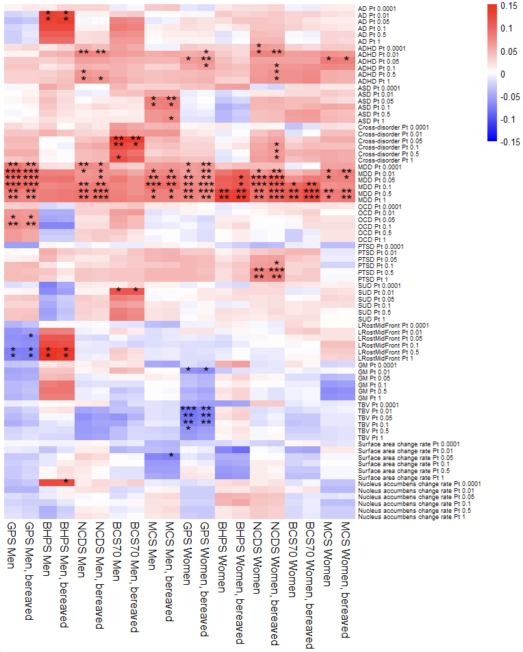Supplementary Figure 6. Associations between polygenic indices (PGIs) and psychological distress in sensitivity analyses which include participants whose parent(s) passed away during youth. Main analysis results are also presented. Cross-disorder PGI becomes associated in NCDS women, surface area change rate PGI becomes associated in MCS men, and nucleus accumbens change rate PGI becomes associated in BHPS men. * = p < 0.05/41, ** = p < 0.01/41, *** = p < 0.001/41. AD = anxiety disorders, ADHD = attention deficit hyperactivity disorder, ASD = autism spectrum disorder, BCS70 = the 1970 British Cohort Study, BHPS = British Household Panel Survey, GM = total grey matter volume, GPS = general population sample of Understanding Society, LRostMidFront = left rostral middle frontal region volume, MCS = Millennium Cohort Study, MDD = major depressive disorder, NCDS = the 1958 National Child Development Study, OCD = obsessive-compulsive disorder, Pt = p value threshold, PTSD = post-traumatic stress disorder, SUD = substance use disorders, TBV = total brain volume.
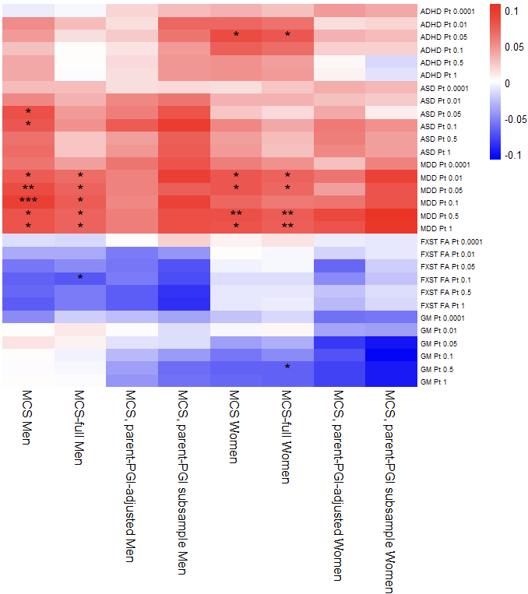
Supplementary Figure 7. Associations between polygenic indices (PGIs) and psychological distress in sensitivity analyses specific to MCS. Main analysis results are also presented. The association with GM PGI in GPS women (main analysis) was replicated in MCS-full women. The association with ASD PGI in MCS men was lost in MCS-full men, but an association was gained with FXST FA PGI in this sample. * = p < 0.05/41, ** = p < 0.01/41, *** = p < 0.001/41. ADHD = attention deficit hyperactivity disorder, ASD = autism spectrum disorder, FA = fractional anisotropy, FXST = fornix/stria terminalis, GM = total grey matter volume, MCS = Millennium Cohort Study, MDD = major depressive disorder, PGI = polygenic index, Pt = p value threshold.

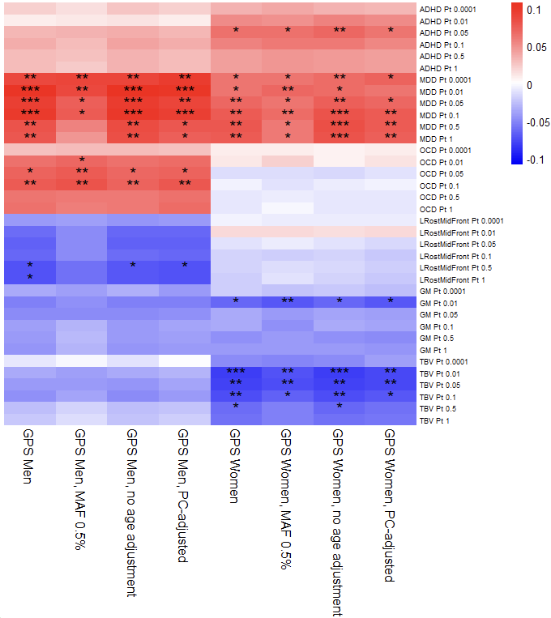
Supplementary Figure 8. Associations between polygenic indices (PGIs) and psychological distress in sensitivity analyses specific to GPS. Main analysis results are also presented. Inclusion of rarer alleles removed the association for LRostMidFront in men. Adjusting for PCs, and not adjusting for age, make little difference. * = p < 0.05/41, ** = p < 0.01/41, *** = p < 0.001/41. ADHD = attention deficit hyperactivity disorder, GM = total grey matter volume, GPS = general population sample of Understanding Society, LRostMidFront = left rostral middle frontal region volume, MAF = minor allele frequency (filtering), MDD = major depressive disorder, OCD = obsessive-compulsive disorder, PC = principal components (of ancestry), Pt = p value threshold, TBV = total brain volume.

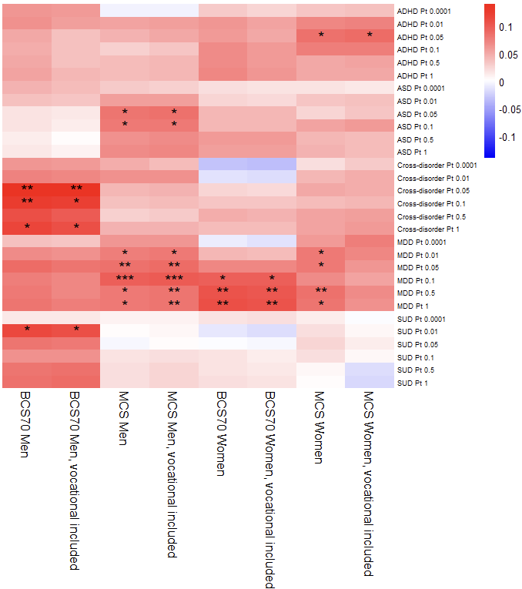
Supplementary Figure 9. Associations between polygenic indices (PGIs) and psychological distress in sensitivity analyses which use an alternative measure of mother’s education (including vocational qualifications). Main analysis results are also presented. The association between MDD PGI and mental health symptoms is lost in MCS women. * = p < 0.05/41, ** = p < 0.01/41, *** = p < 0.001/41. ADHD = attention deficit hyperactivity disorder, ASD = autism spectrum disorder, BCS70 = the 1970 British Cohort Study, MCS = Millennium Cohort Study, MDD = major depressive disorder, Pt = p value threshold, SUD = substance use disorders.
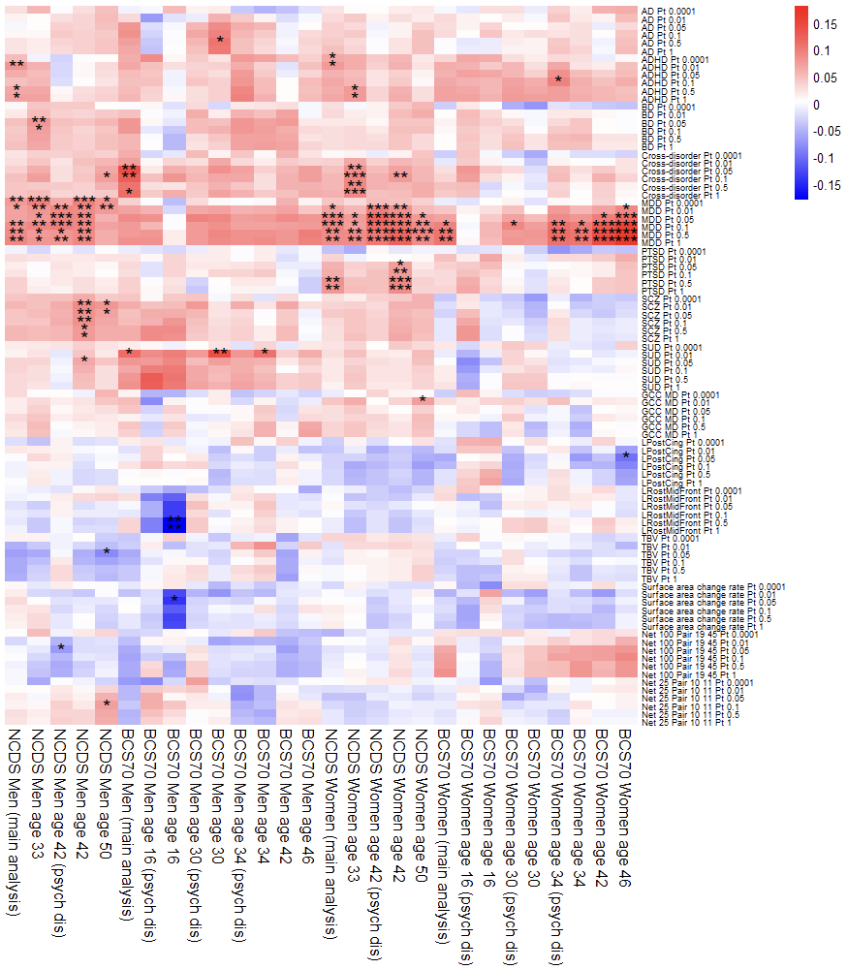Supplementary Figure 10. Associations between polygenic indices (PGIs) and psychological distress in sensitivity analyses using symptom measures at different ages and using different scales. Main analysis results are also presented. MDD PGI associations were generally robust across ages, but ADHD PGI associations in NCDS did not persist for men, and only persisted until the next wave for women. For men, SCZ PGI became associated at ages 42 and 50 in NCDS, and the SUD PGI-malaise association in BCS70 persisted until age 34. Less robust associations appeared in NCDS men for two neuropsychiatric PGIs (BD and cross-disorder), and three endophenotype PGIs (TBV, Net 100 Pair 19 45 and Net25 Pair 10 11), and in BCS70 men for LRostMidFront PGI, surface area change rate PGI, and AD PGI. For women, cross-disorder PGI became associated with malaise at ages 33 and 42 in NCDS, and the PTSD PGI-malaise association in NCDS was repeated at age 42. Less robust associations appeared in NCDS women for GCC MD PGI, and in BCS70 women for LPostCing PGI. In BCS70 men, there were no PGI associations with psychological distress, or with malaise at ages 42 and 46. * = p < 0.05/41, ** = p < 0.01/41, *** = p < 0.001/41. AD = anxiety disorders, ADHD = attention deficit hyperactivity disorder, BCS70 = the 1970 British Cohort Study, BD = bipolar disorder, GCC = genu of corpus callosum, LPostCing = left posterior cingulate volume, LRostMidFront = left rostral middle frontal region volume, MD = mean diffusivity, MDD = major depressive disorder, NCDS = the 1958 National Child Development Study, psych dis = psychological distress, Pt = p value threshold, PTSD = post-traumatic stress disorder, SCZ = schizophrenia, SUD = substance use disorders, TBV = total brain volume.
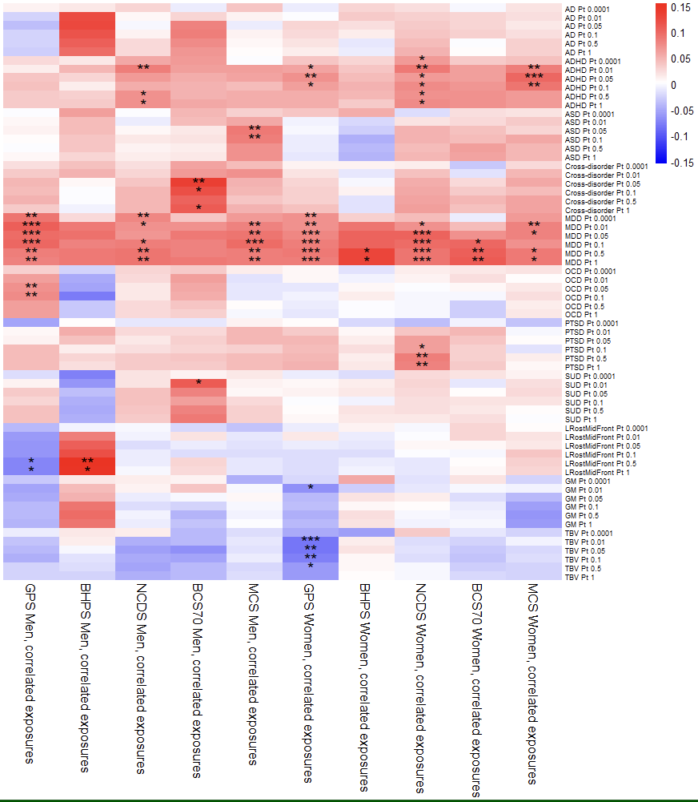
Supplementary Figure 11. Associations between polygenic indices (PGIs) and psychological distress in sensitivity analyses wherein pairwise correlation terms between exposures were modelled. The association with AD PGI is lost in BHPS men. * = p < 0.05/41, ** = p < 0.01/41, *** = p < 0.001/41. AD = anxiety disorders, ADHD = attention deficit hyperactivity disorder, ASD = autism spectrum disorder, BCS70 = the 1970 British Cohort Study, BHPS = British Household Panel Survey, GM = total grey matter volume, GPS = general population sample of Understanding Society, LRostMidFront = left rostral middle frontal region volume, MCS = Millennium Cohort Study, MDD = major depressive disorder, NCDS = the 1958 National Child Development Study, OCD = obsessive-compulsive disorder, Pt = p value threshold, PTSD = post-traumatic stress disorder, SUD = substance use disorders, TBV = total brain volume.

 | Men |  |  |  |  | Women
PGI | GPS | BHPS | NCDS | BCS70 | MCS | GPS | BHPS | NCDS | BCS70 | MCS
AD 0.0001
AD 0.01 |  | -1.068
AD 0.05 |  | 4.857 |  | 9.399 |  |  |  | 18.884
AD 0.1 |  | -6.492 |  | 12.442 |  |  |  | 18.742
AD 0.5 |  | -14.539 |  | 5.397 |  |  |  | 19.963
AD 1.0 |  | -17.120 |  | 6.100 |  |  |  | 18.732
ADHD 0.0001 |  |  | 20.351 | 27.373 |  | 21.423 |  | 19.794 |  | 30.384
ADHD 0.01 |  |  | 10.726 | 32.224 | 31.431 | 15.111 |  | 26.087 | 6.760 | 28.754
ADHD 0.05 | 26.676 |  | 12.679 | 38.644 | 36.505 | 12.083 |  | 35.006 | 15.667 | 23.427
ADHD 0.1 | 20.916 |  | 12.894 | 39.901 | 49.651 | 16.844 |  | 31.850 | 14.738 | 25.241
ADHD 0.5 |  |  | 11.300 | 36.409 | 38.668 | 20.559 |  | 32.885 | 19.448 | 34.185
ADHD 1.0 |  |  | 9.956 | 34.212 | 39.046 | 19.597 |  | 29.860 | 18.723 | 34.283
ASD 0.0001 |  |  |  |  |  | 0.566
ASD 0.01 |  |  |  |  | 12.738
ASD 0.05 |  |  |  |  | 10.905 |  |  | 5.171
ASD 0.1 |  |  |  |  | 12.069 |  |  | 9.702 |  | -1.180
ASD 0.5 |  |  |  |  | 12.438 |  |  | 9.790 | 10.383 | 6.153
ASD 1.0 |  |  |  |  | 10.911 |  |  | 8.697 | 10.628 | 4.902
Cross-disorder 0.0001 |  |  |  | -6.493 | 10.089
Cross-disorder 0.01 |  |  |  | -13.200 | 14.434 |  |  | 16.545 |  | 21.002
Cross-disorder 0.05 | -6.967 |  |  | -5.951 | 26.639 |  |  | 8.095 |  | 18.517
Cross-disorder 0.1 | -5.465 |  | -5.329 | -9.618 | 30.032 |  |  | 4.352 |  | 26.633
Cross-disorder 0.5 | -10.235 |  | 8.528 | -4.334 |  |  |  | 9.475 |  | 18.948
Cross-disorder 1.0 |  |  | 10.261 | -6.450 | 17.154 | 5.432 |  | 0.722 |  | 16.765
MDD 0.0001 | 1.644 |  | 7.202 |  | 14.531 | 17.565 |  | 12.531 |  | 17.362
MDD 0.01 | 3.286 | 20.614 | 12.025 | 20.710 | 19.905 | 22.884 | 15.979 | 16.531 |  | 18.095
MDD 0.05 | 7.616 | 24.324 | 11.700 | 12.720 | 15.538 | 13.869 | 17.292 | 16.951 | 16.378 | 19.776
MDD 0.1 | 6.568 | 24.490 | 7.139 | 14.344 | 13.969 | 12.367 | 17.578 | 11.375 | 10.706 | 24.524
MDD 0.5 | 7.593 | 22.616 | 9.251 | 13.809 | 16.538 | 12.112 | 16.507 | 14.738 | 8.014 | 21.318
MDD 1.0 | 8.235 | 23.803 | 8.558 | 12.588 | 16.880 | 12.194 | 16.877 | 15.101 | 7.959 | 22.339
OCD 0.0001
OCD 0.01 | -12.096
OCD 0.05 | -5.382
OCD 0.1 | -5.788
OCD 0.5 | -8.777
OCD 1.0 | -9.464
PTSD 0.0001 | -4.794
PTSD 0.01 |  |  |  |  | 13.098 |  |  | 23.613 | 16.958
PTSD 0.05 |  |  |  |  | 15.696 | -3.125 |  | 11.368
PTSD 0.1 | 3.000 |  |  |  |  | -5.793 |  | 16.700
PTSD 0.5 | -0.941 |  |  |  | 13.658 | 2.336 |  | 7.116
PTSD 1.0 | -2.156 |  |  |  | 13.624 | 2.541 |  | 6.907
SUD 0.0001
SUD 0.01 |  |  |  | 7.362
SUD 0.05 |  |  | 33.952 | 16.435 |  |  |  | 51.593
SUD 0.1 |  |  | 35.433 | 20.078
SUD 0.5 | 11.855 |  | 39.179 | 14.602
SUD 1.0 | 10.760 |  | 41.739 | 13.976
LRostMidFront 0.0001
LRostMidFront 0.01 | -6.714 | 6.460
LRostMidFront 0.05 | -8.231 | 1.451
LRostMidFront 0.1 | -5.011 | -5.669
LRostMidFront 0.5 | -1.687 | 1.874
LRostMidFront 1.0 | -3.040 | 1.416
GM 0.0001 |  |  |  |  | 3.539
GM 0.01 | -2.338 |  |  |  |  | 3.644
GM 0.05 | -3.797 |  |  |  |  | 17.846 |  |  |  | 21.399
GM 0.1 |  | 7.261 |  |  |  | 17.366 |  |  |  | 12.449
GM 0.5 |  | -0.546 |  |  |  | 0.167 |  |  |  | 0.798
GM 1.0 | -13.760 | -1.970 |  |  |  | -0.027 |  |  |  | -1.173
TBV 0.0001 |  |  |  |  |  | 15.433
TBV 0.01 |  |  | -27.689 |  |  | -12.680
TBV 0.05 | 4.263 |  | -33.496 | -8.629 |  | -15.541
TBV 0.1 | 5.475 |  | -32.199 |  |  | -11.197
TBV 0.5 |  |  | -29.071 |  |  | -10.216
TBV 1.0 |  |  | -30.336 |  |  | -11.661
Supplementary Table 27. Estimates of “per cent mediated”, i.e. the extent to which polygenic index (PGI) associations with psychological distress are mediated by the rearing environment. Significant associations shown in bold. Values of 0 and below represent no environmental mediation while positive values indicate some environmental mediation. Values were not calculated when both the linear regression (for estimating total genetic effects) and the path model (for estimating direct genetic effects) had p values greater than 0.05. AD = anxiety disorders, ADHD = attention deficit hyperactivity disorder, ASD = autism spectrum disorder, BCS70 = the 1970 British Cohort Study, BHPS = British Household Panel Survey, GM = total grey matter volume, GPS = general population sample of Understanding Society, LRostMidFront = left rostral middle frontal region volume, MCS = Millennium Cohort Study, MDD = major depressive disorder, NCDS = the 1958 National Child Development Study, OCD = obsessive-compulsive disorder, PGI = polygenic index, PTSD = post-traumatic stress disorder, SUD = substance use disorders, TBV = total brain volume.

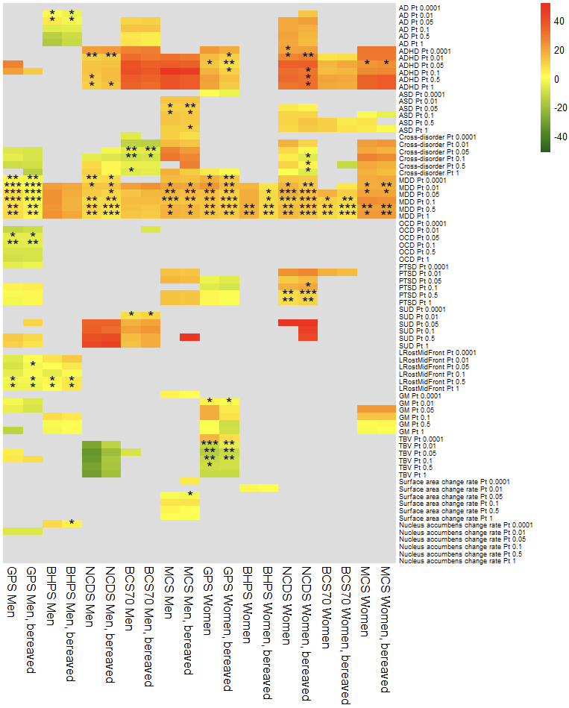Supplementary Figure 12. Estimates of environmental mediation of associations between polygenic indices (PGIs) and psychological distress. Sensitivity analysis results for analyses which include participants whose parent(s) passed away during youth. Main analysis results are also shown. * = p < 0.05/41, ** = p < 0.01/41, *** = p < 0.001/41. AD = anxiety disorders, ADHD = attention deficit hyperactivity disorder, ASD = autism spectrum disorder, BCS70 = the 1970 British Cohort Study, BHPS = British Household Panel Survey, GM = total grey matter volume, GPS = general population sample of Understanding Society, LRostMidFront = left rostral middle frontal region volume, MCS = Millennium Cohort Study, MDD = major depressive disorder, NCDS = the 1958 National Child Development Study, OCD = obsessive-compulsive disorder, Pt = p value threshold, PTSD = post-traumatic stress disorder, SUD = substance use disorders, TBV = total brain volume.

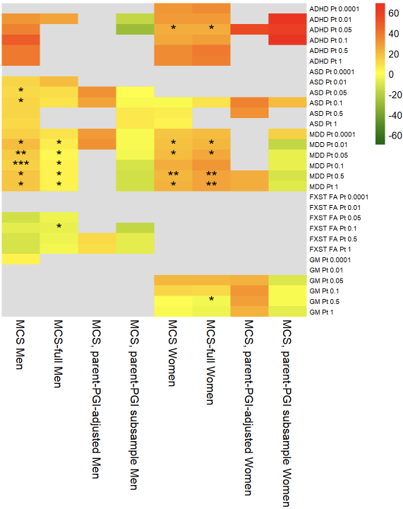
Supplementary Figure 13. Estimates of environmental mediation of associations between polygenic indices (PGIs) and psychological distress. Results for MCS-specific sensitivity analyses, and MCS main analysis, are shown. * = p < 0.05/41, ** = p < 0.01/41, *** = p < 0.001/41. ADHD = attention deficit hyperactivity disorder, ASD = autism spectrum disorder, FA = fractional anisotropy, FXST = fornix/stria terminalis, GM = total grey matter volume, MCS = Millennium Cohort Study, MDD = major depressive disorder, PGI = polygenic index, Pt = p value threshold.

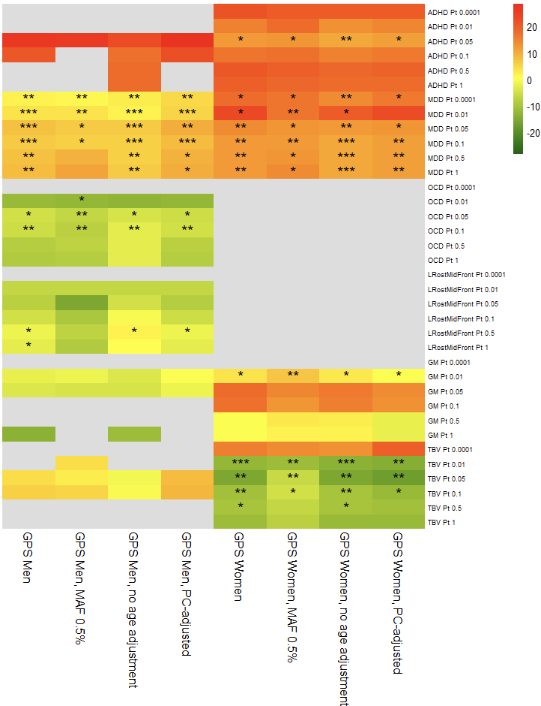
Supplementary Figure 14. Estimates of environmental mediation of associations between polygenic indices (PGIs) and psychological distress. Results for GPS-specific sensitivity analyses, and GPS main analysis, are shown. * = p < 0.05/41, ** = p < 0.01/41, *** = p < 0.001/41. ADHD = attention deficit hyperactivity disorder, GM = total grey matter volume, GPS = general population sample of Understanding Society, LRostMidFront = left rostral middle frontal region volume, MAF = minor allele frequency (filtering), MDD = major depressive disorder, OCD = obsessive-compulsive disorder, PC = principal components (of ancestry), Pt = p value threshold, TBV = total brain volume.
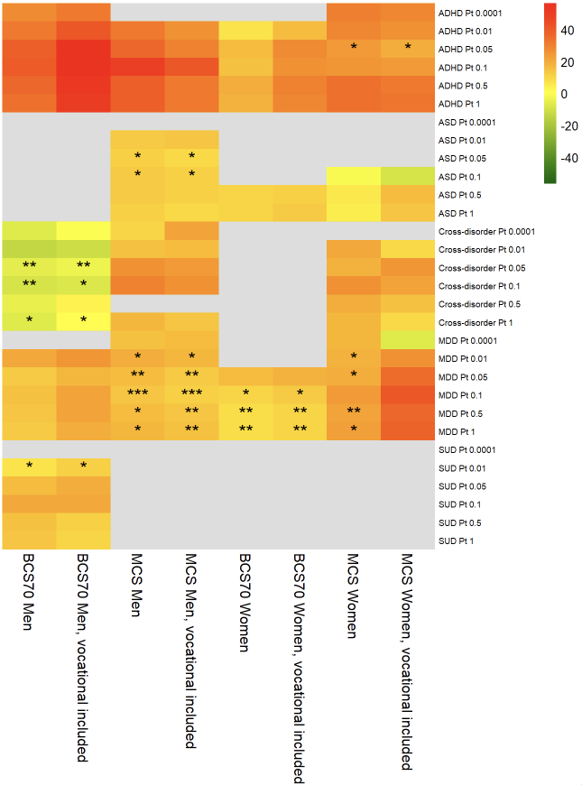
Supplementary Figure 15. Estimates of environmental mediation of associations between polygenic indices (PGIs) and psychological distress. Sensitivity analysis results are shown for BCS70 and MCS using an alternative measure of mother’s education which includes vocational qualifications. Main analysis results are also shown. * = p < 0.05/41, ** = p < 0.01/41, *** = p < 0.001/41. ADHD = attention deficit hyperactivity disorder, ASD = autism spectrum disorder, BCS70 = the 1970 British Cohort Study, MCS = Millennium Cohort Study, MDD = major depressive disorder, Pt = p value threshold, SUD = substance use disorders.
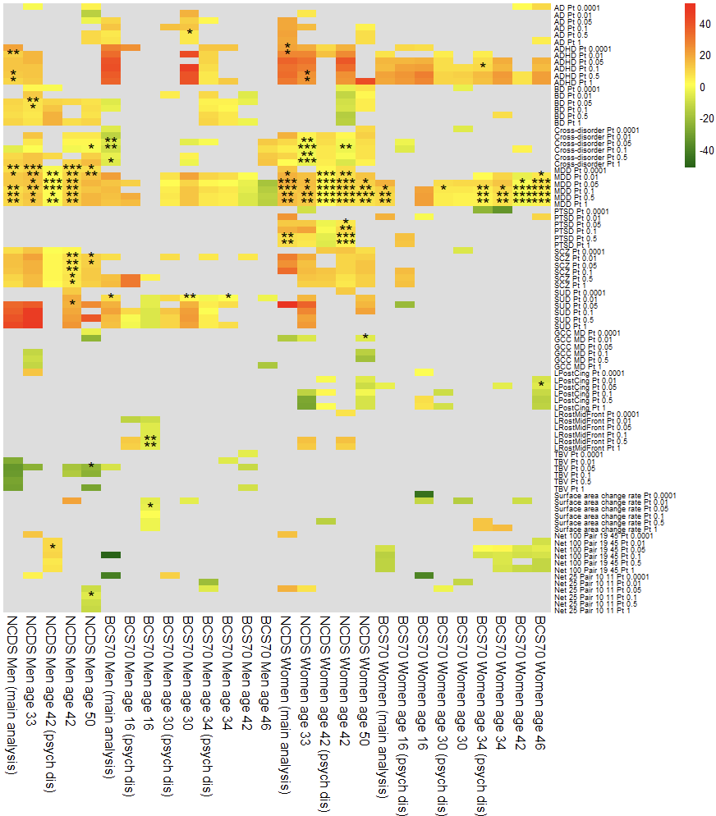Supplementary Figure 16. Estimates of environmental mediation of associations between polygenic indices (PGIs) and psychological distress. Sensitivity analysis results for NCDS and BCS70 using mental health outcomes at different ages. Mediation estimates were mostly attenuated with increasing age - for example, SUD PGI’s association with malaise became less mediated in BCS70 men (main analysis age 26: 7.4%, age 30: 2.1%, age 34: 0.0%, P_{t} 0.01), and MDD PGI’s associations generally became less mediated in women (main analysis age 26: 16.4%, age 34: 12.8%, age 46: 6.0%, P_{t} 0.05). Mediation was generally lower for psychological distress compared to contemporaneous measures of malaise. * = p < 0.05/41, ** = p < 0.01/41, *** = p < 0.001/41. AD = anxiety disorders, ADHD = attention deficit hyperactivity disorder, BCS70 = the 1970 British Cohort Study, BD = bipolar disorder, GCC = genu of corpus callosum, LPostCing = left posterior cingulate, LRostMidFront = left rostral middle frontal, MD = mean diffusivity, MDD = major depressive disorder, NCDS = the 1958 National Child Development Study, psych dis = psychological distress, PTSD = post-traumatic stress disorder, SCZ = schizophrenia, SUD = substance use disorders, TBV = total brain volume.
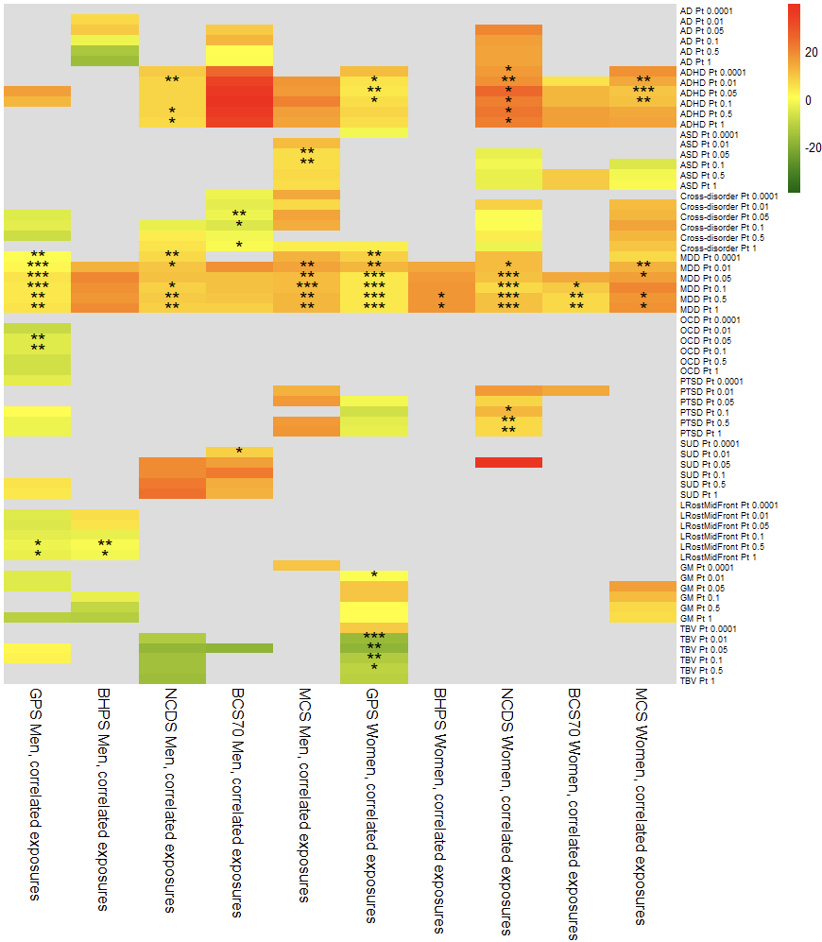 Supplementary Figure 17. Estimates of environmental mediation of associations between polygenic indices (PGIs) and psychological distress. Sensitivity analysis results for path models with pairwise correlation terms for the three exposures. Mediation estimates were mostly attenuated by modelling pairwise correlation terms between the exposures. * = p < 0.05/41, ** = p < 0.01/41, *** = p < 0.001/41. AD = anxiety disorders, ADHD = attention deficit hyperactivity disorder, ASD = autism spectrum disorder, BCS70 = the 1970 British Cohort Study, BHPS = British Household Panel Survey, GM = total grey matter volume, GPS = general population sample of Understanding Society, LRostMidFront = left rostral middle frontal, MCS = Millennium Cohort Study, MDD = major depressive disorder, NCDS = the 1958 National Child Development Study, OCD = obsessive-compulsive disorder, PTSD = post-traumatic stress disorder, SUD = substance use disorders, TBV = total brain volume.

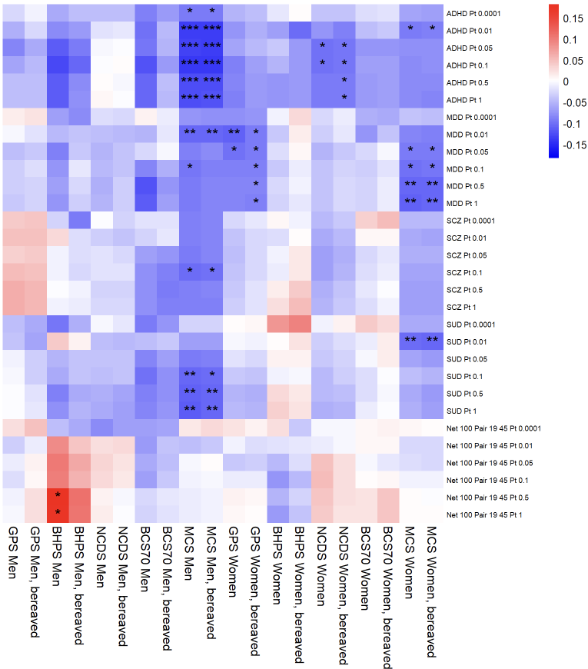Supplementary Figure 18. Associations between PGIs and family intact. Sensitivity analysis results for analyses which include participants whose parent(s) passed away during youth. Main analysis results are also shown. * = p < 0.05/41, ** = p < 0.01/41, *** = p < 0.001/41. ADHD = attention deficit hyperactivity disorder, BCS70 = the 1970 British Cohort Study, BHPS = British Household Panel Survey, GPS = general population sample of Understanding Society, MCS = Millennium Cohort Study, MDD = major depressive disorder, NCDS = the 1958 National Child Development Study, Pt = p value threshold, SCZ = schizophrenia, SUD = substance use disorders.

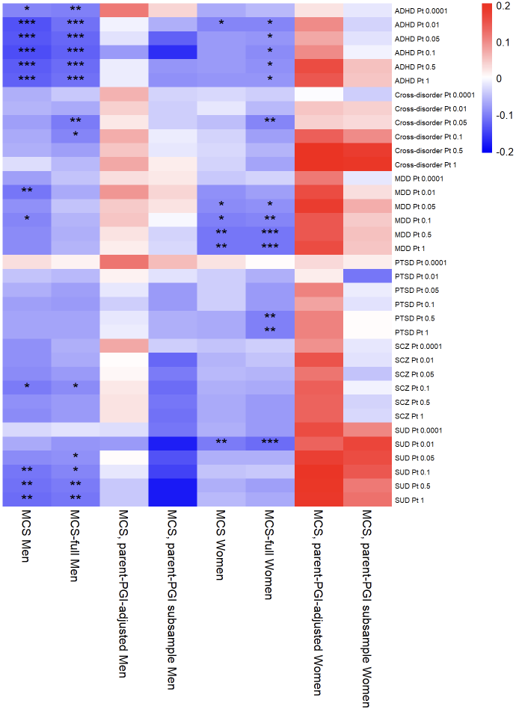
Supplementary Figure 19. Associations between polygenic indices (PGIs) and family intact. Results for MCS-specific sensitivity analyses, and MCS main analysis, are shown. Including all ancestries leads to greater gene-environment correlation (rGE) in women, while restricting to participants with parents’ PGIs removes all rGE. * = p < 0.05/41, ** = p < 0.01/41, *** = p < 0.001/41. ADHD = attention deficit hyperactivity disorder, MCS = Millennium Cohort Study, MDD = major depressive disorder, PGI = polygenic index, Pt = p value threshold, PTSD = post-traumatic stress disorder, SCZ = schizophrenia, SUD = substance use disorder.
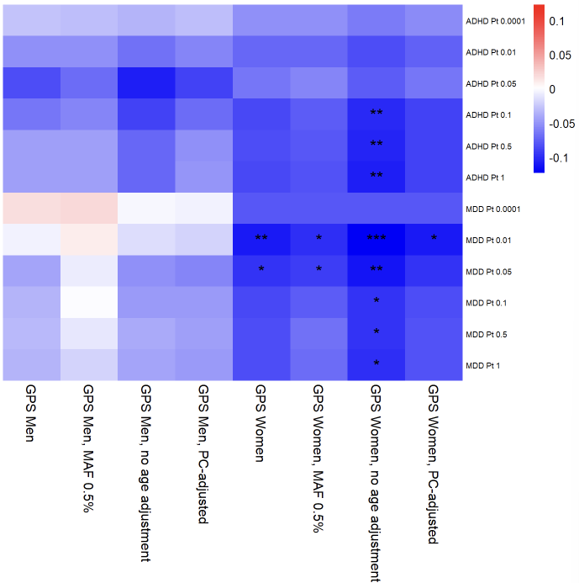
Supplementary Figure 20. Associations between polygenic indices (PGIs) and family intact. Results for GPS-specific sensitivity analyses, and GPS main analysis, are shown. * = p < 0.05/41, ** = p < 0.01/41, *** = p < 0.001/41. ADHD = attention deficit hyperactivity disorder, GPS = general population sample of Understanding Society, MAF = minor allele frequency (filtering), MDD = major depressive disorder, PC = principal components (of ancestry), Pt = p value threshold.
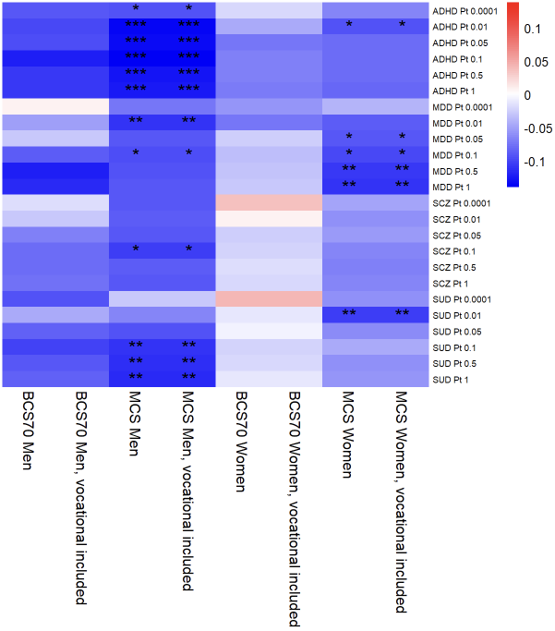
Supplementary Figure 21. Associations between polygenic indices (PGIs) and family intact. Sensitivity analysis results are shown for BCS70 and MCS using an alternative measure of mother’s education which includes vocational qualifications. Main analysis results are also shown. * = p < 0.05/41, ** = p < 0.01/41, *** = p < 0.001/41. ADHD = attention deficit hyperactivity disorder, BCS70 = the 1970 British Cohort Study, BHPS = British Household Panel Survey, MCS = Millennium Cohort Study, MDD = major depressive disorder, Pt = p value threshold, SCZ = schizophrenia, SUD = substance use disorders.

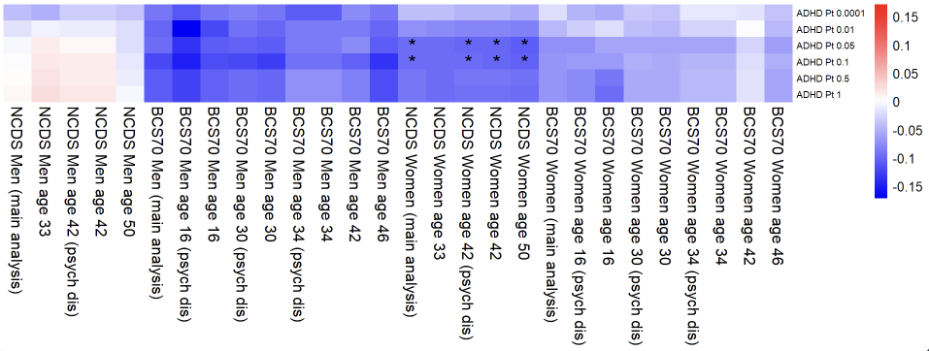Supplementary Figure 22. Associations between polygenic indices (PGIs) and family intact. Sensitivity analysis results for NCDS and BCS70 using mental health outcomes at different ages. * = p < 0.05/41, ** = p < 0.01/41, *** = p < 0.001/41. ADHD = attention deficit hyperactivity disorder, BCS70 = the 1970 British Cohort Study, NCDS = the 1958 National Child Development Study, Pt = p value threshold, psych dis = psychological distress.
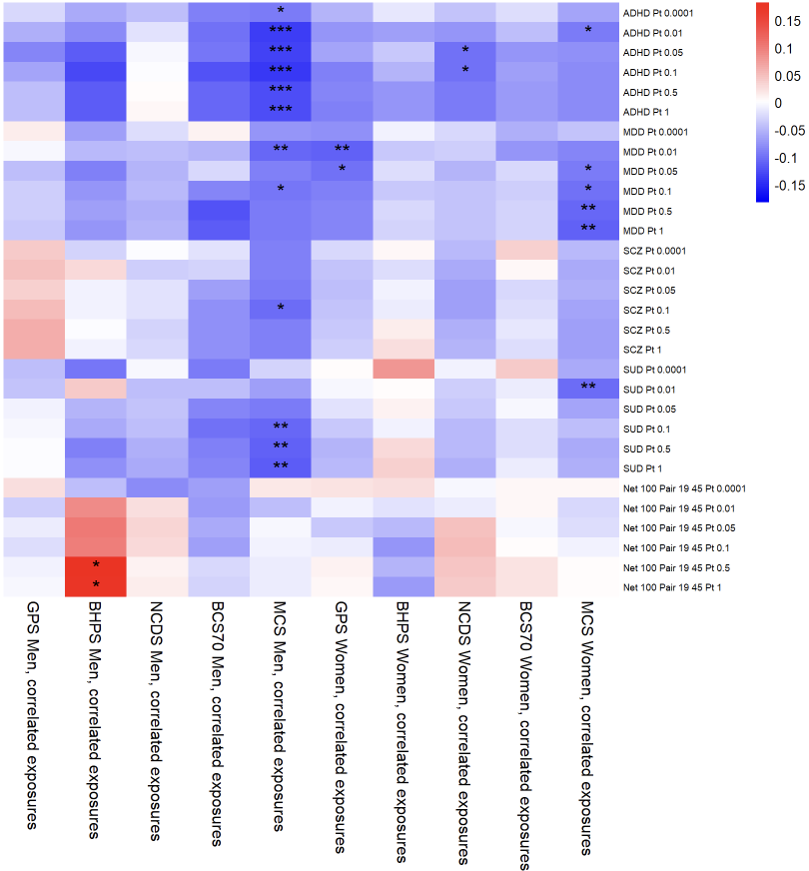
Supplementary Figure 23. Associations between polygenic indices (PGIs) and family intact. Sensitivity analysis results for path models with pairwise correlation terms for the three exposures. Results are identical to main analysis. * = p < 0.05/41, ** = p < 0.01/41, *** = p < 0.001/41. ADHD = attention deficit hyperactivity disorder, BCS70 = the 1970 British Cohort Study, BHPS = British Household Panel Survey, GPS = general population sample of Understanding Society, MCS = Millennium Cohort Study, MDD = major depressive disorder, NCDS = the 1958 National Child Development Study, P_{t} = p value threshold, SCZ = schizophrenia, SUD = substance use disorders.

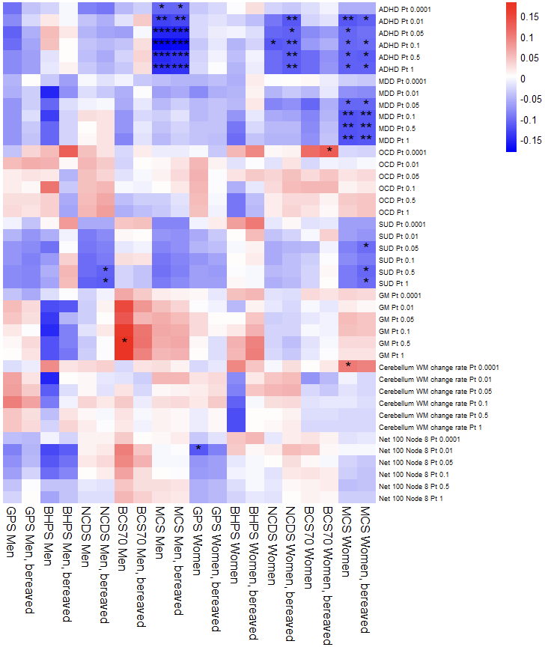
Supplementary Figure 24. Associations between polygenic indices (PGIs) and father employed. Sensitivity analysis results for analyses which include participants whose parent(s) passed away during youth. Main analysis results are also shown. SUD PGI becomes associated with father employed in two samples, while non-robust associations are gained or lost for OCD PGI and three endophenotype PGIs. * = p < 0.05/41, ** = p < 0.01/41, *** = p < 0.001/41. ADHD = attention deficit hyperactivity disorder, BCS70 = the 1970 British Cohort Study, BHPS = British Household Panel Survey, GM = total grey matter volume, GPS = general population sample of Understanding Society, MCS = Millennium Cohort Study, MDD = major depressive disorder, NCDS = the 1958 National Child Development Study, OCD = obsessive-compulsive disorder, Pt = p value threshold, SUD = substance use disorders, WM = white matter.

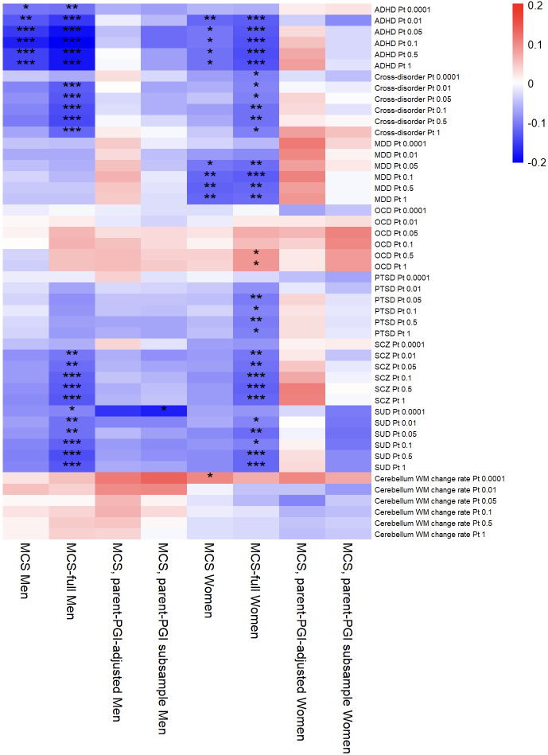Supplementary Figure 25. Associations between polygenic indices (PGIs) and father employed. Results for MCS-specific sensitivity analyses, and MCS main analysis, are shown. Including all ancestries leads to greater gene-environment correlation (rGE), while restricting to participants with parents’ PGIs removes most rGE. * = p < 0.05/41, ** = p < 0.01/41, *** = p < 0.001/41. ADHD = attention deficit hyperactivity disorder, MCS = Millennium Cohort Study, MDD = major depressive disorder, OCD = obsessive-compulsive disorder, PTSD = post-traumatic stress disorder, PGI = polygenic index, Pt = p value threshold, SCZ = schizophrenia, SUD = substance use disorder, WM = white matter.

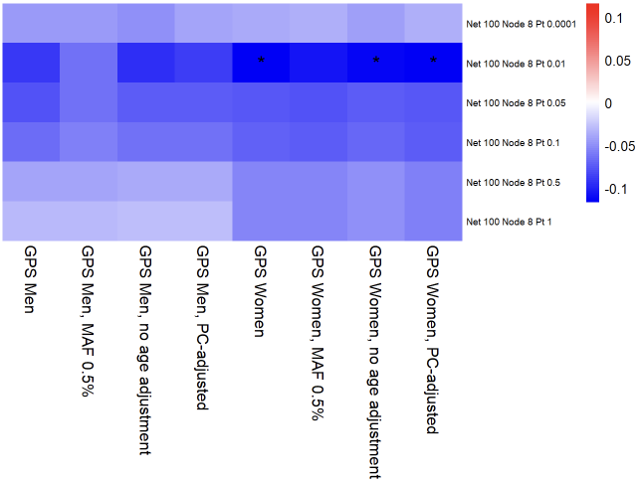
Supplementary Figure 26. Associations between polygenic indices (PGIs) and father employed. Results for GPS-specific sensitivity analyses, and GPS main analysis, are shown. * = p < 0.05/41, ** = p < 0.01/41, *** = p < 0.001/41. GPS = general population sample of Understanding Society, MAF = minor allele frequency (filtering), PC = principal components (of ancestry), Pt = p value threshold.

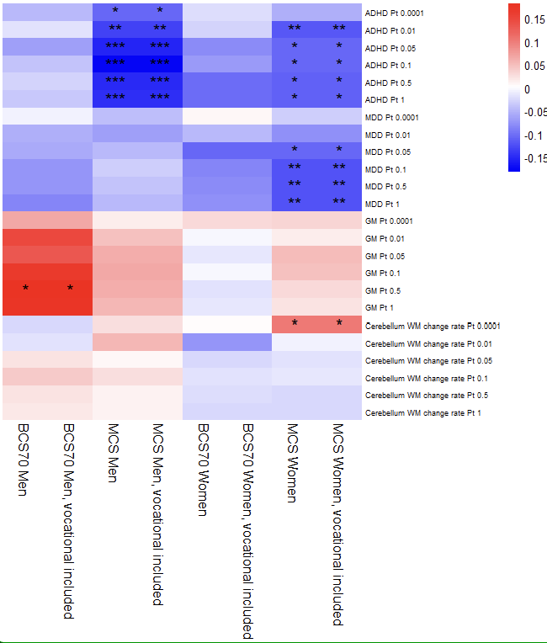
Supplementary Figure 27. Associations between polygenic indices (PGIs) and father employed. Sensitivity analysis results are shown for BCS70 and MCS using an alternative measure of mother’s education which includes vocational qualifications. Main analysis results are also shown. * = p < 0.05/41, ** = p < 0.01/41, *** = p < 0.001/41. ADHD = attention deficit hyperactivity disorder, BCS70 = the 1970 British Cohort Study, GM = total grey matter volume, MCS = Millennium Cohort Study, MDD = major depressive disorder, Pt = p value threshold, WM = white matter.

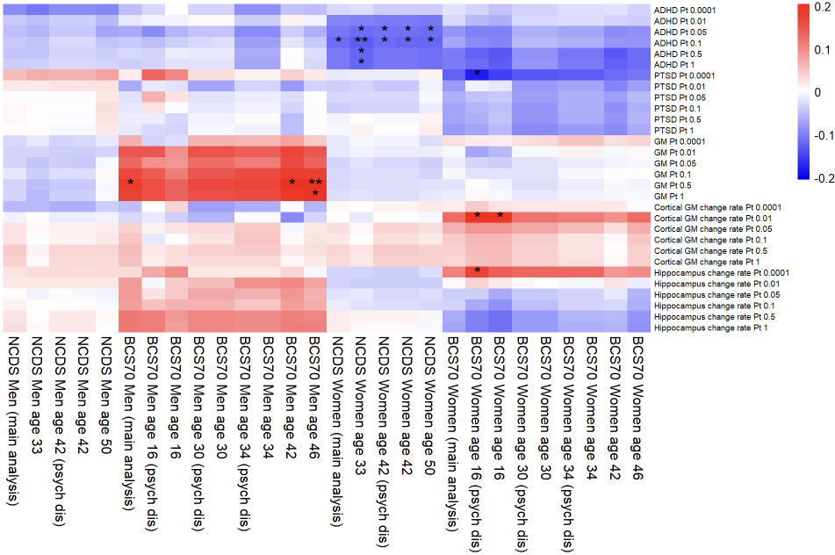
Supplementary Figure 28. Associations between polygenic indices (PGIs) and father employed. Sensitivity analysis results for NCDS and BCS70 using mental health outcomes at different ages. * = p < 0.05/41, ** = p < 0.01/41, *** = p < 0.001/41. ADHD = attention deficit hyperactivity disorder, BCS70 = the 1970 British Cohort Study, GM = grey matter volume, NCDS = the 1958 National Child Development Study, psych dis = psychological distress, PTSD = post-traumatic stress disorder.
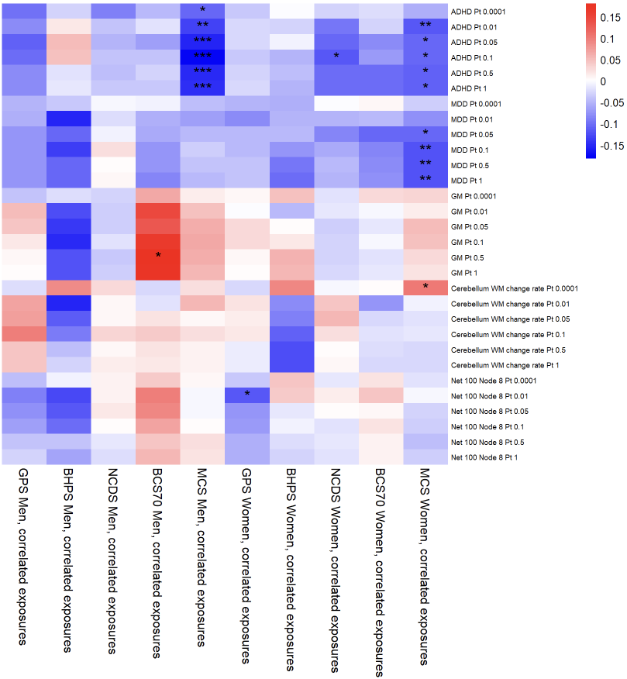
Supplementary Figure 29. Associations between polygenic indices (PGIs) and father employed. Sensitivity analysis results for path models with pairwise correlation terms for the three exposures. Results are identical to main analysis. * = p < 0.05/41, ** = p < 0.01/41, *** = p < 0.001/41. ADHD = attention deficit hyperactivity disorder, BCS70 = the 1970 British Cohort Study, BHPS = British Household Panel Survey, GM = total grey matter volume, GPS = general population sample of Understanding Society, MCS = Millennium Cohort Study, MDD = major depressive disorder, NCDS = the 1958 National Child Development Study, Pt = p value threshold, WM = white matter.

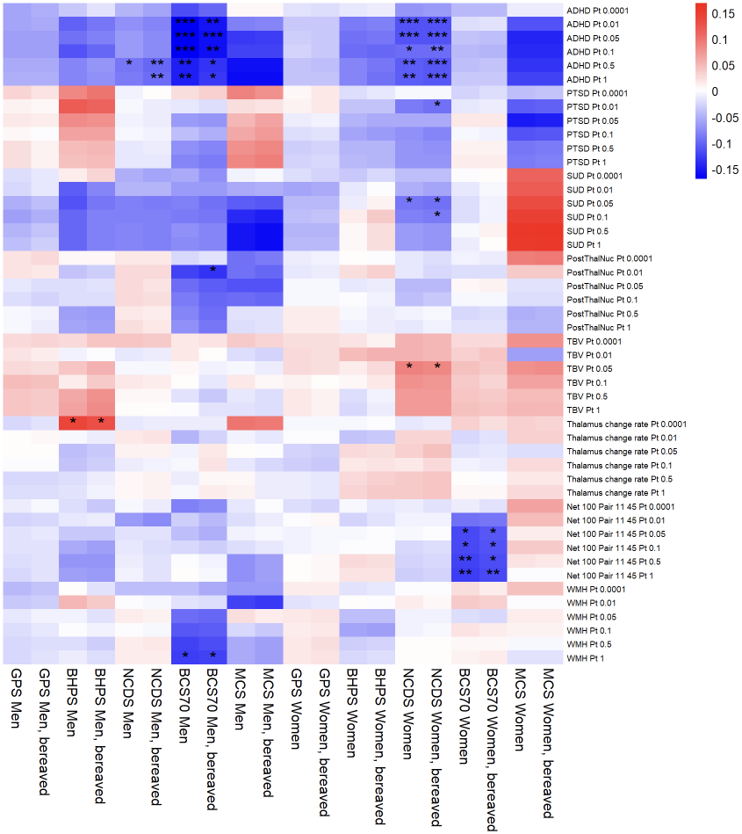
Supplementary Figure 30. Associations between polygenic indices (PGIs) and mother educated. Sensitivity analysis results for analyses which include participants whose parent(s) passed away during youth. Main analysis results are also shown. PTSD PGI becomes associated in NCDS women. * = p < 0.05/41, ** = p < 0.01/41, *** = p < 0.001/41. ADHD = attention deficit hyperactivity disorder, BCS70 = the 1970 British Cohort Study, BHPS = British Household Panel Survey, GM = total grey matter volume, GPS = general population sample of Understanding Society, MCS = Millennium Cohort Study, NCDS = the 1958 National Child Development Study, PostThalNuc = posterior thalamic nuclei volume, Pt = p value threshold, PTSD = post-traumatic stress disorder, SUD = substance use disorders, TBV = total brain volume, WMH = white matter hyperintensities.

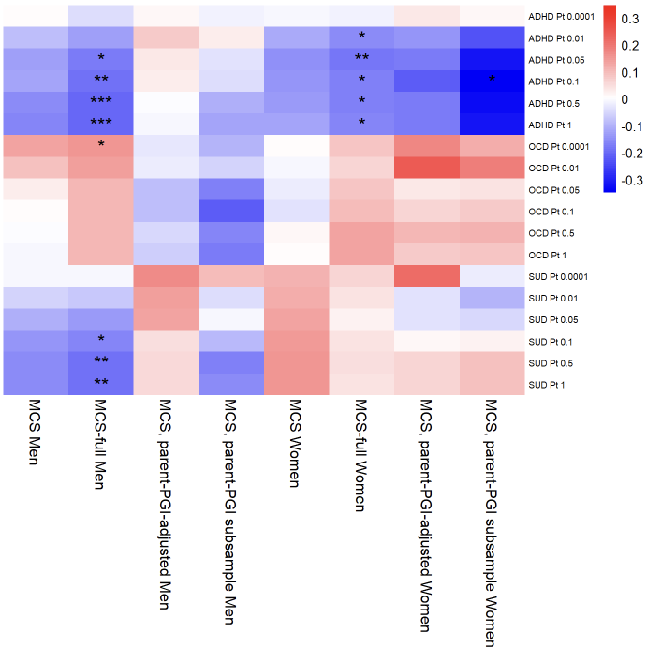
Supplementary Figure 31. Associations between polygenic indices (PGIs) and mother educated. Results for MCS-specific sensitivity analyses, and MCS main analysis, are shown. Including all ancestries leads to greater rGE, while restricting to participants with parents’ PGIs removes all rGE. * = p < 0.05/41, ** = p < 0.01/41, *** = p < 0.001/41. ADHD = attention deficit hyperactivity disorder, MCS = Millennium Cohort Study, OCD = obsessive-compulsive disorder, PGI = polygenic index, Pt = p value threshold, SUD = substance use disorders.

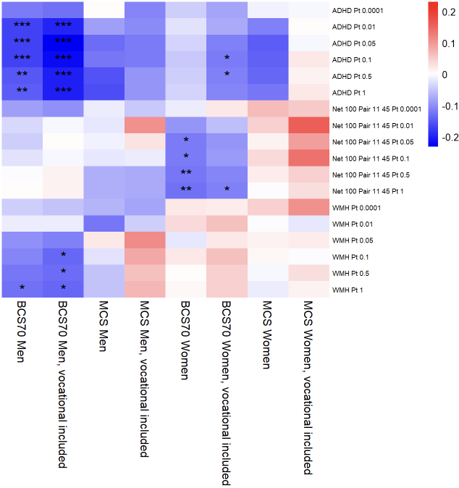
Supplementary Figure 32. Associations between polygenic indices (PGIs) and mother educated. Sensitivity analysis results are shown for BCS70 and MCS using an alternative measure of mother’s education which includes vocational qualifications. Main analysis results are also shown. * = p < 0.05/41, ** = p < 0.01/41, *** = p < 0.001/41. ADHD = attention deficit hyperactivity disorder, BCS70 = the 1970 British Cohort Study, MCS = Millennium Cohort Study, Pt = p value threshold, WMH = white matter hyperintensities.
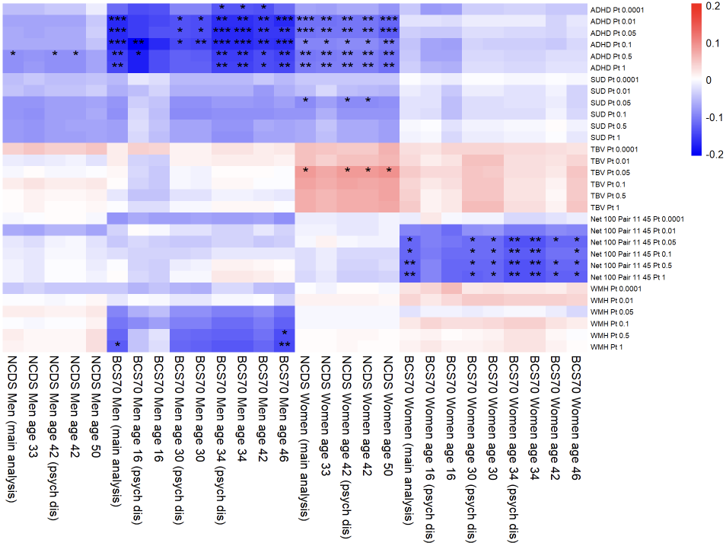
Supplementary Figure 33. Associations between polygenic indices (PGIs) and mother educated. Sensitivity analysis results for NCDS and BCS70 using mental health outcomes at different ages. * = p < 0.05/41, ** = p < 0.01/41, *** = p < 0.001/41. ADHD = attention deficit hyperactivity disorder, BCS70 = the 1970 British Cohort Study, NCDS = the 1958 National Child Development Study, psych dis = psychological distress, Pt = p value threshold, SUD = substance use disorders, TBV = total brain volume, WMH = white matter hyperintensities.
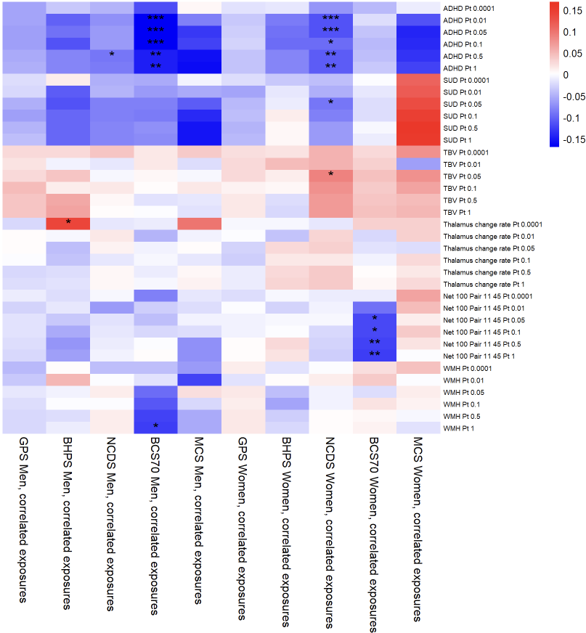Supplementary Figure 34. Associations between polygenic indices (PGIs) and mother educated. Sensitivity analysis results for path models with pairwise correlation terms for the three exposures. Results are identical to main analysis. * = p < 0.05/41, ** = p < 0.01/41, *** = p < 0.001/41. ADHD = attention deficit hyperactivity disorder, BCS70 = the 1970 British Cohort Study, BHPS = British Household Panel Survey, GPS = general population sample of Understanding Society, MCS = Millennium Cohort Study, NCDS = the 1958 National Child Development Study, Pt = p value threshold, SUD = substance use disorders, TBV = total brain volume, WMH = white matter hyperintensities.

References

1. Prins BP, Kuchenbaecker KB, Bao Y, Smart M, Zabaneh D, Fatemifar G, et al. Genome-wide analysis of health-related biomarkers in the UK Household Longitudinal Study reveals novel associations. Sci Rep. 2017 Dec 1;7(1). doi:10.1038/s41598-017-10812-1 PubMed PMID: 28887542.
2. Wang K, Li M, Hakonarson H. ANNOVAR: functional annotation of genetic variants from high-throughput sequencing data. Nucleic Acids Res. 2010;38(16). doi:10.1093/nar/gkq603
3. Demontis D, Walters GB, Athanasiadis G, Walters R, Therrien K, Nielsen TT, et al. Genome-wide analyses of ADHD identify 27 risk loci, refine the genetic architecture and implicate several cognitive domains. Nat Genet. 2023 Feb 1;55(2):198–208. doi:10.1038/s41588-022-01285-8 PubMed PMID: 36702997.
4. Grove J, Ripke S, Als TD, Mattheisen M, Walters RK, Won H, et al. Identification of common genetic risk variants for autism spectrum disorder. Nat Genet. 2019 Mar 1;51(3):431–44. doi:10.1038/s41588-019-0344-8 PubMed PMID: 30804558.
5. Lee PH, Anttila V, Won H, Feng YCA, Rosenthal J, Zhu Z, et al. Genomic Relationships, Novel Loci, and Pleiotropic Mechanisms across Eight Psychiatric Disorders. Cell. 2019 Dec;179(7):1469-1482.e11. doi:10.1016/j.cell.2019.11.020
6. Watson HJ, Yilmaz Z, Thornton LM, Hübel C, Coleman JRI, Gaspar HA, et al. Genome-wide association study identifies eight risk loci and implicates metabo-psychiatric origins for anorexia nervosa. Nat Genet. 2019 Aug 1;51(8):1207–14. doi:10.1038/s41588-019-0439-2
7. Arnold PD, Askland KD, Barlassina C, Bellodi L, Bienvenu OJ, Black D, et al. Revealing the complex genetic architecture of obsessive-compulsive disorder using meta-analysis. Mol Psychiatry. 2018 May 1;23(5):1181–8. doi:10.1038/mp.2017.154 PubMed PMID: 28761083.
8. Otowa T, Hek K, Lee M, Byrne EM, Mirza SS, Nivard MG, et al. Meta-analysis of genome-wide association studies of anxiety disorders. Mol Psychiatry. 2016 Oct 1;21(10):1391–9. doi:10.1038/mp.2015.197 PubMed PMID: 26754954.
9. Mullins N, Forstner AJ, O’Connell KS, Coombes B, Coleman JRI, Qiao Z, et al. Genome-wide association study of more than 40,000 bipolar disorder cases provides new insights into the underlying biology. Nat Genet. 2021 Jun 1;53(6):817–29. doi:10.1038/s41588-021-00857-4 PubMed PMID: 34002096.
10. Howard DM, Adams MJ, Clarke TK, Hafferty JD, Gibson J, Shirali M, et al. Genome-wide meta-analysis of depression identifies 102 independent variants and highlights the importance of the prefrontal brain regions. Nat Neurosci. 2019 Mar 1;22(3):343–52. doi:10.1038/s41593-018-0326-7 PubMed PMID: 30718901.
11. Nievergelt CM, Maihofer AX, Klengel T, Atkinson EG, Chen CY, Choi KW, et al. International meta-analysis of PTSD genome-wide association studies identifies sex- and ancestry-specific genetic risk loci. Nat Commun. 2019 Dec 1;10(1). doi:10.1038/s41467-019-12576-w PubMed PMID: 31594949.
12. Trubetskoy V, Pardiñas AF, Qi T, Panagiotaropoulou G, Awasthi S, Bigdeli TB, et al. Mapping genomic loci implicates genes and synaptic biology in schizophrenia. Nature. 2022 Apr 21;604(7906):502–8. doi:10.1038/s41586-022-04434-5
13. Hatoum AS, Colbert SMC, Johnson EC, Huggett SB, Deak JD, Pathak GA, et al. Multivariate genome-wide association meta-analysis of over 1 million subjects identifies loci underlying multiple substance use disorders. Nature Mental Health. 2023 Mar 22;1(3):210–23. doi:10.1038/s44220-023-00034-y
14. Brouwer RM, Klein M, Grasby KL, Schnack HG, Jahanshad N, Teeuw J, et al. Genetic variants associated with longitudinal changes in brain structure across the lifespan. Nat Neurosci. 2022 Apr 1;25(4):421–32. doi:10.1038/s41593-022-01042-4 PubMed PMID: 35383335.
15. Satizabal CL, Adams HHH, Hibar DP, White CC, Knol MJ, Stein JL, et al. Genetic architecture of subcortical brain structures in 38,851 individuals. Nat Genet. 2019 Nov 1;51(11):1624–36. doi:10.1038/s41588-019-0511-y PubMed PMID: 31636452.
16. Zhukovsky P, Tio ES, Coughlan G, Bennett DA, Wang Y, Hohman TJ, et al. Genetic influences on brain and cognitive health and their interactions with cardiovascular conditions and depression. Nat Commun. 2024 Dec 1;15(1). doi:10.1038/s41467-024-49430-7 PubMed PMID: 38890310.
17. Zhao B, Zhang J, Ibrahim JG, Luo T, Santelli RC, Li Y, et al. Large-scale GWAS reveals genetic architecture of brain white matter microstructure and genetic overlap with cognitive and mental health traits (n = 17,706). Mol Psychiatry. 2021 Aug 1;26(8):3943–55. doi:10.1038/s41380-019-0569-z PubMed PMID: 31666681.
18. Zhao B, Luo T, Li T, Li Y, Zhang J, Shan Y, et al. Genome-wide association analysis of 19,629 individuals identifies variants influencing regional brain volumes and refines their genetic co-architecture with cognitive and mental health traits. Nat Genet. 2019 Nov 1;51(11):1637–44. doi:10.1038/s41588-019-0516-6 PubMed PMID: 31676860.
19. Zhao B, Li T, Smith SM, Xiong D, Wang X, Yang Y, et al. Common variants contribute to intrinsic human brain functional networks. Nat Genet. 2022 Apr 1;54(4):508–17. doi:10.1038/s41588-022-01039-6 PubMed PMID: 35393594.
20. Elvsåshagen T, Shadrin A, Frei O, van der Meer D, Bahrami S, Kumar VJ, et al. The genetic architecture of the human thalamus and its overlap with ten common brain disorders. Nat Commun. 2021 Dec 1;12(1). doi:10.1038/s41467-021-23175-z PubMed PMID: 34006833.

