Supplementary Figures 3
Supplementary Figure 1: Sampling of Llullaillaco mummies 3
Supplementary Figure 2: Computational analysis 4
Supplementary Figure 3: Linear regression modeling for pangenome mapping parameters 5
Supplementary Figure 4: Pangenome mapping improves coverage of difficult-to-map medical genes 8
Supplementary Figure 5: Genome-wide localization of pangenome mapping improvements for La Niña del Rayo and El Niño. 10
Supplementary Figure 6: Computational resource consumption 12
Supplementary Methods 13
Generation of genomic annotation files 13
Statistical modeling of parameter optimization 14
Identification of outlier low-coverage medically relevant genes 14
Supplementary Tables 15
Supplementary Table 1: Mapping statistics 15
Supplementary Table 2: Read Counts 15
Supplementary Table 3: Variant Counts 15
Supplementary Table 4: HLA Genotyping 15
Supplementary Table 5a-c: Genomic regions with better coverage in linear alignment 15
Supplementary Table 6a-c: Genomic regions with better coverage in pangenome alignment 15
Supplementary Table 7: Medically relevant genes with with better coverage in pangenome alignment 15
Supplementary Table 8: Computational resource consumption 16

A Pangenomic Approach to High-Resolution HLA Genotyping in Ancient DNA

Supplementary Figures

Supplementary Figure 1: Sampling of Llullaillaco mummies
We sampled the Llullaillaco mummies across multiple body locations using hair, skin, or swab sampling (for details, see Hämmerle et al. in review). We processed and analyzed each sample as an independent sequencing library. Following alignment, we merged the resulting data into a single BAM file for each individual.
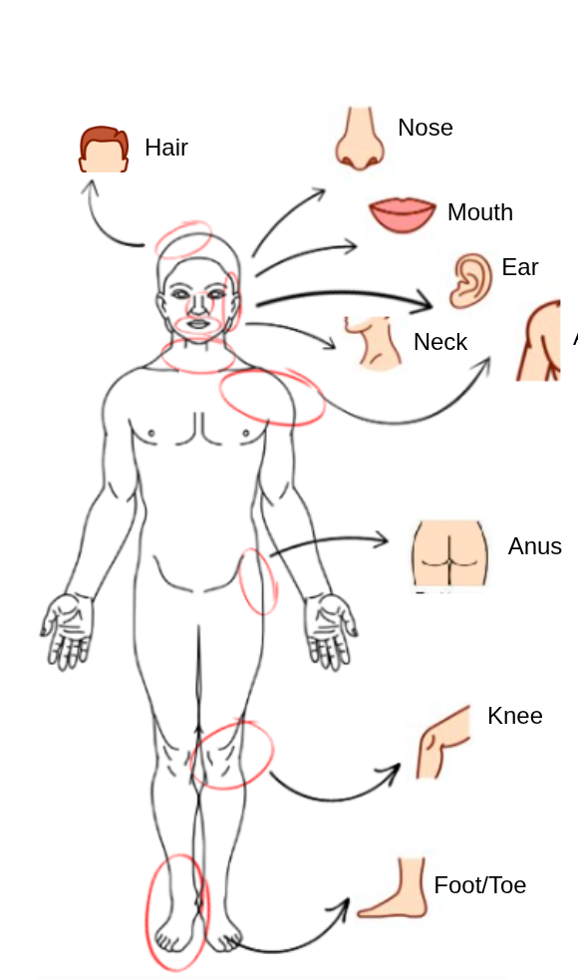

Supplementary Figure 1| Anatomical sampling locations of the Llullaillaco mummies
This schematic illustrates the specific body sites targeted during the sampling process.

Supplementary Figure 2: Computational analysis

Computational analysis included both linear and pangenome mapping for the Llullaillaco mummies. Within the pangenome pipeline, we systematically modified specific processing steps to test and optimize alignment parameters.

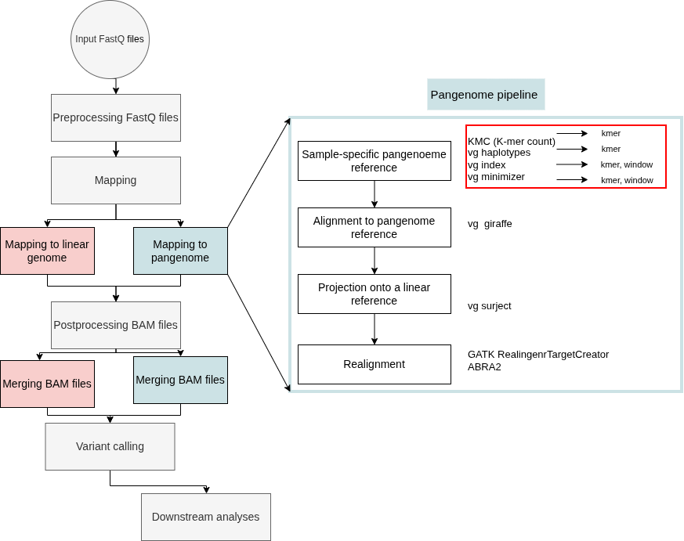

Supplementary Figure 2| Computational analysis pipeline
Schematic overview of the analysis workflow. The flowchart illustrates the distinct processing steps and key differences between the pangenome and linear genome alignment pipelines. Steps specific to the pangenome analysis are enclosed in the blue box. Red circles highlight the specific stages where default parameters were modified and optimized for ancient DNA.

Supplementary Figure 3: Linear regression modeling for pangenome mapping parameters
To systematically optimize mapping parameters, we constructed linear regression models evaluating the interaction between k-mer size and window size on the abundance of high-quality mapped reads (MQ≥30). Response surface plots were generated for each individual.
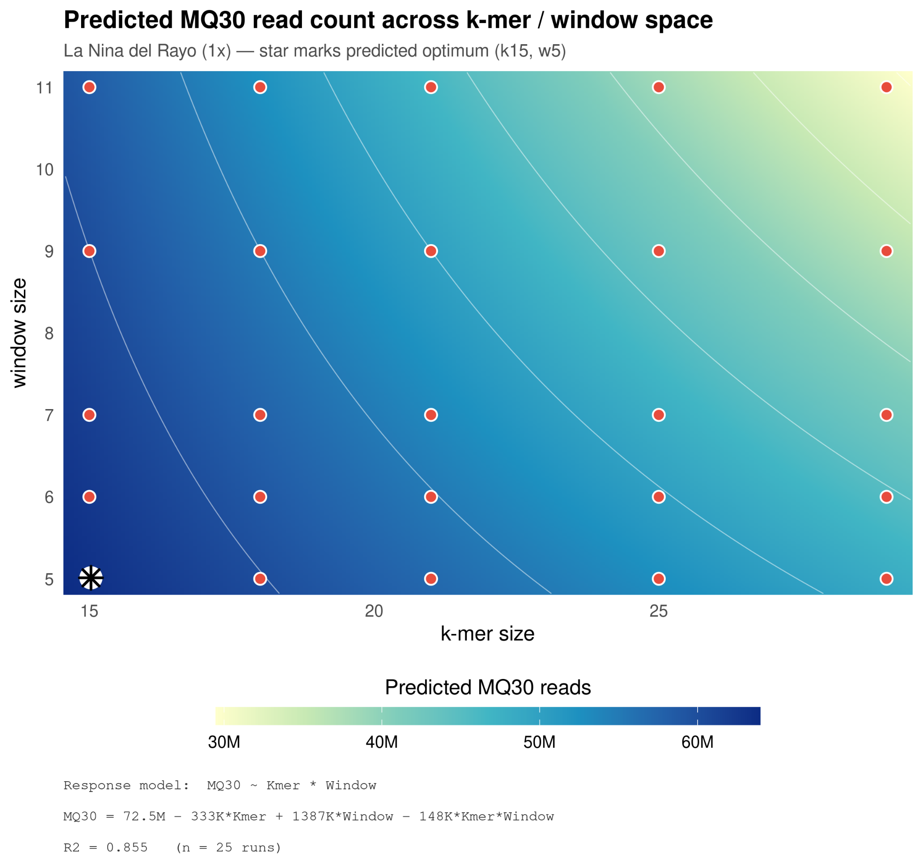
Supplementary Figure 3a| Parameter optimization response surface for La Niña del Rayo (1x) Predicted high-quality read count (MQ>=30) across the evaluated k-mer and window size parameter space. The contour gradient represents predicted read abundance, ranging from low (light green/yellow) to high (dark blue). Red circles denote the empirical evaluation coordinates (n = 25 runs), and the black star marks the predicted optimal parameter configuration. We display the full regression model formula and coefficient of determination (R² = 0.855) in the lower panel.

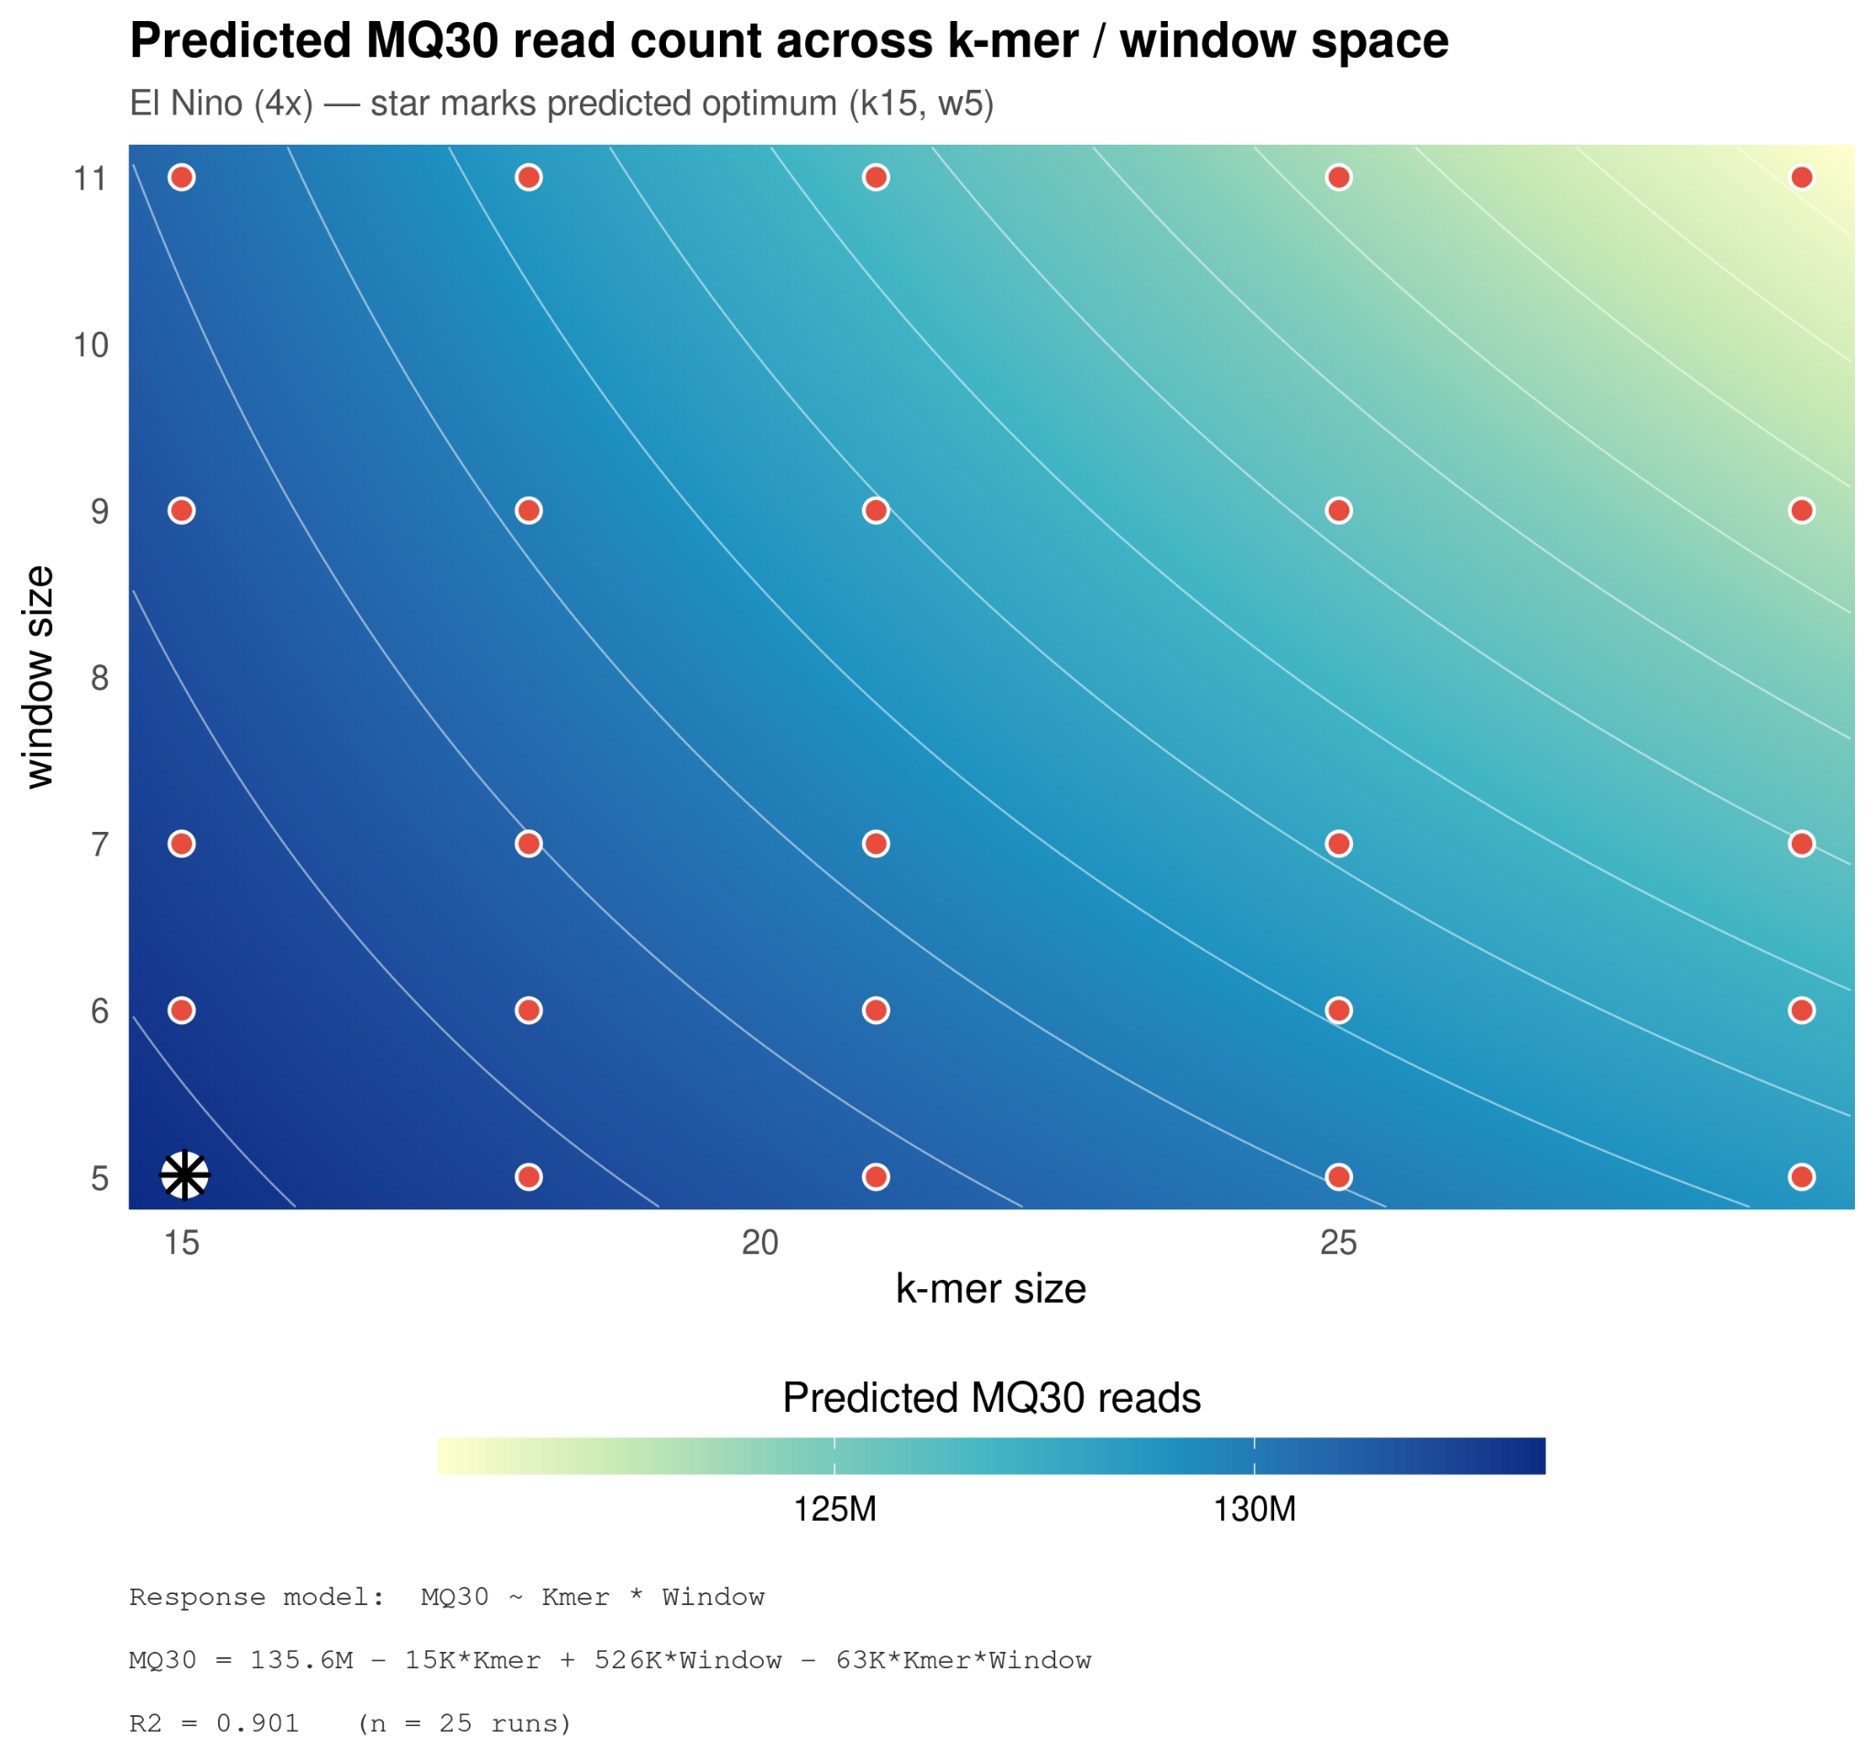

Supplementary Figure 3b| Parameter optimization response surface for El Niño (4x) Predicted high-quality read count (MQ>=30) across the evaluated k-mer and window size parameter space. The contour gradient represents predicted read abundance, ranging from low (light green/yellow) to high (dark blue). Red circles denote the empirical evaluation coordinates (n = 25 runs), and the black star marks the predicted optimal parameter configuration. We display the full regression model formula and coefficient of determination (R² = 0.901) in the lower panel.

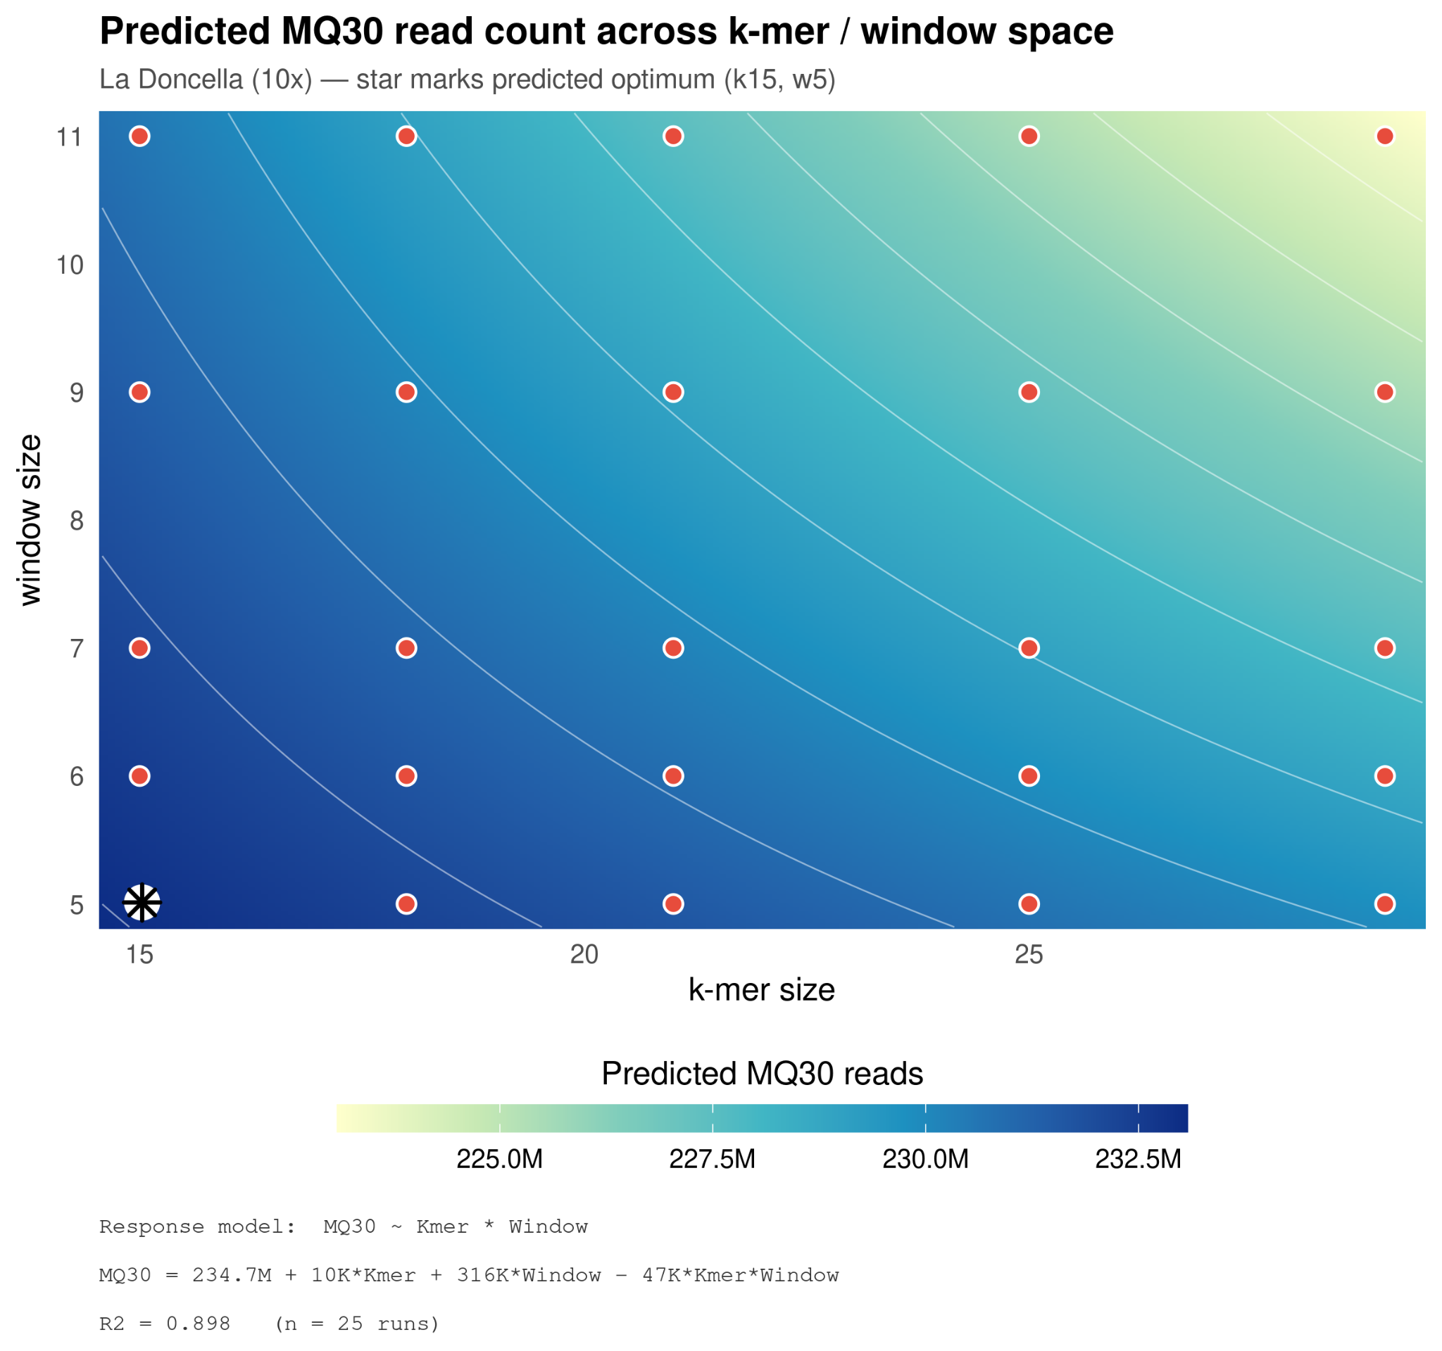

Supplementary Figure 3c| Parameter optimization response surface for La Doncella (10x) Predicted high-quality read count (MQ>=30) across the evaluated k-mer and window size parameter space. The contour gradient represents predicted read abundance, ranging from low (light green/yellow) to high (dark blue). Red circles denote the empirical evaluation coordinates (n = 25 runs), and the black star marks the predicted optimal parameter configuration. We display the full regression model formula and coefficient of determination (R² = 0.898) in the lower panel.

Supplementary Figure 4: Pangenome mapping improves coverage of difficult-to-map medical genes
To evaluate the performance of our alignment strategies across complex loci, we benchmarked the coverage of 273 challenging, medically relevant autosomal genes (CMRGs)⁵⁵ across all three individuals (Supplementary Fig. 4 and Supplementary Table 7). Under standard linear alignment (GRCh38), we identified 27 of these genes as low-coverage outliers, falling more than two standard deviations below the cohort mean (mean coverage ≤ 6 %). Transitioning to the pangenome reference yielded a highly significant, consistent recovery of these loci across all specimens (paired Wilcoxon signed-rank test, p = 1.2 × 10⁻⁷), elevating average gene coverage to up to 83%. This robust rescue of critical genes (e.g., PTPRC, TPO, GP6) demonstrates that reference bias, rather than physical molecular degradation, was the primary driver of poor mapping in these clinically relevant genomic regions.
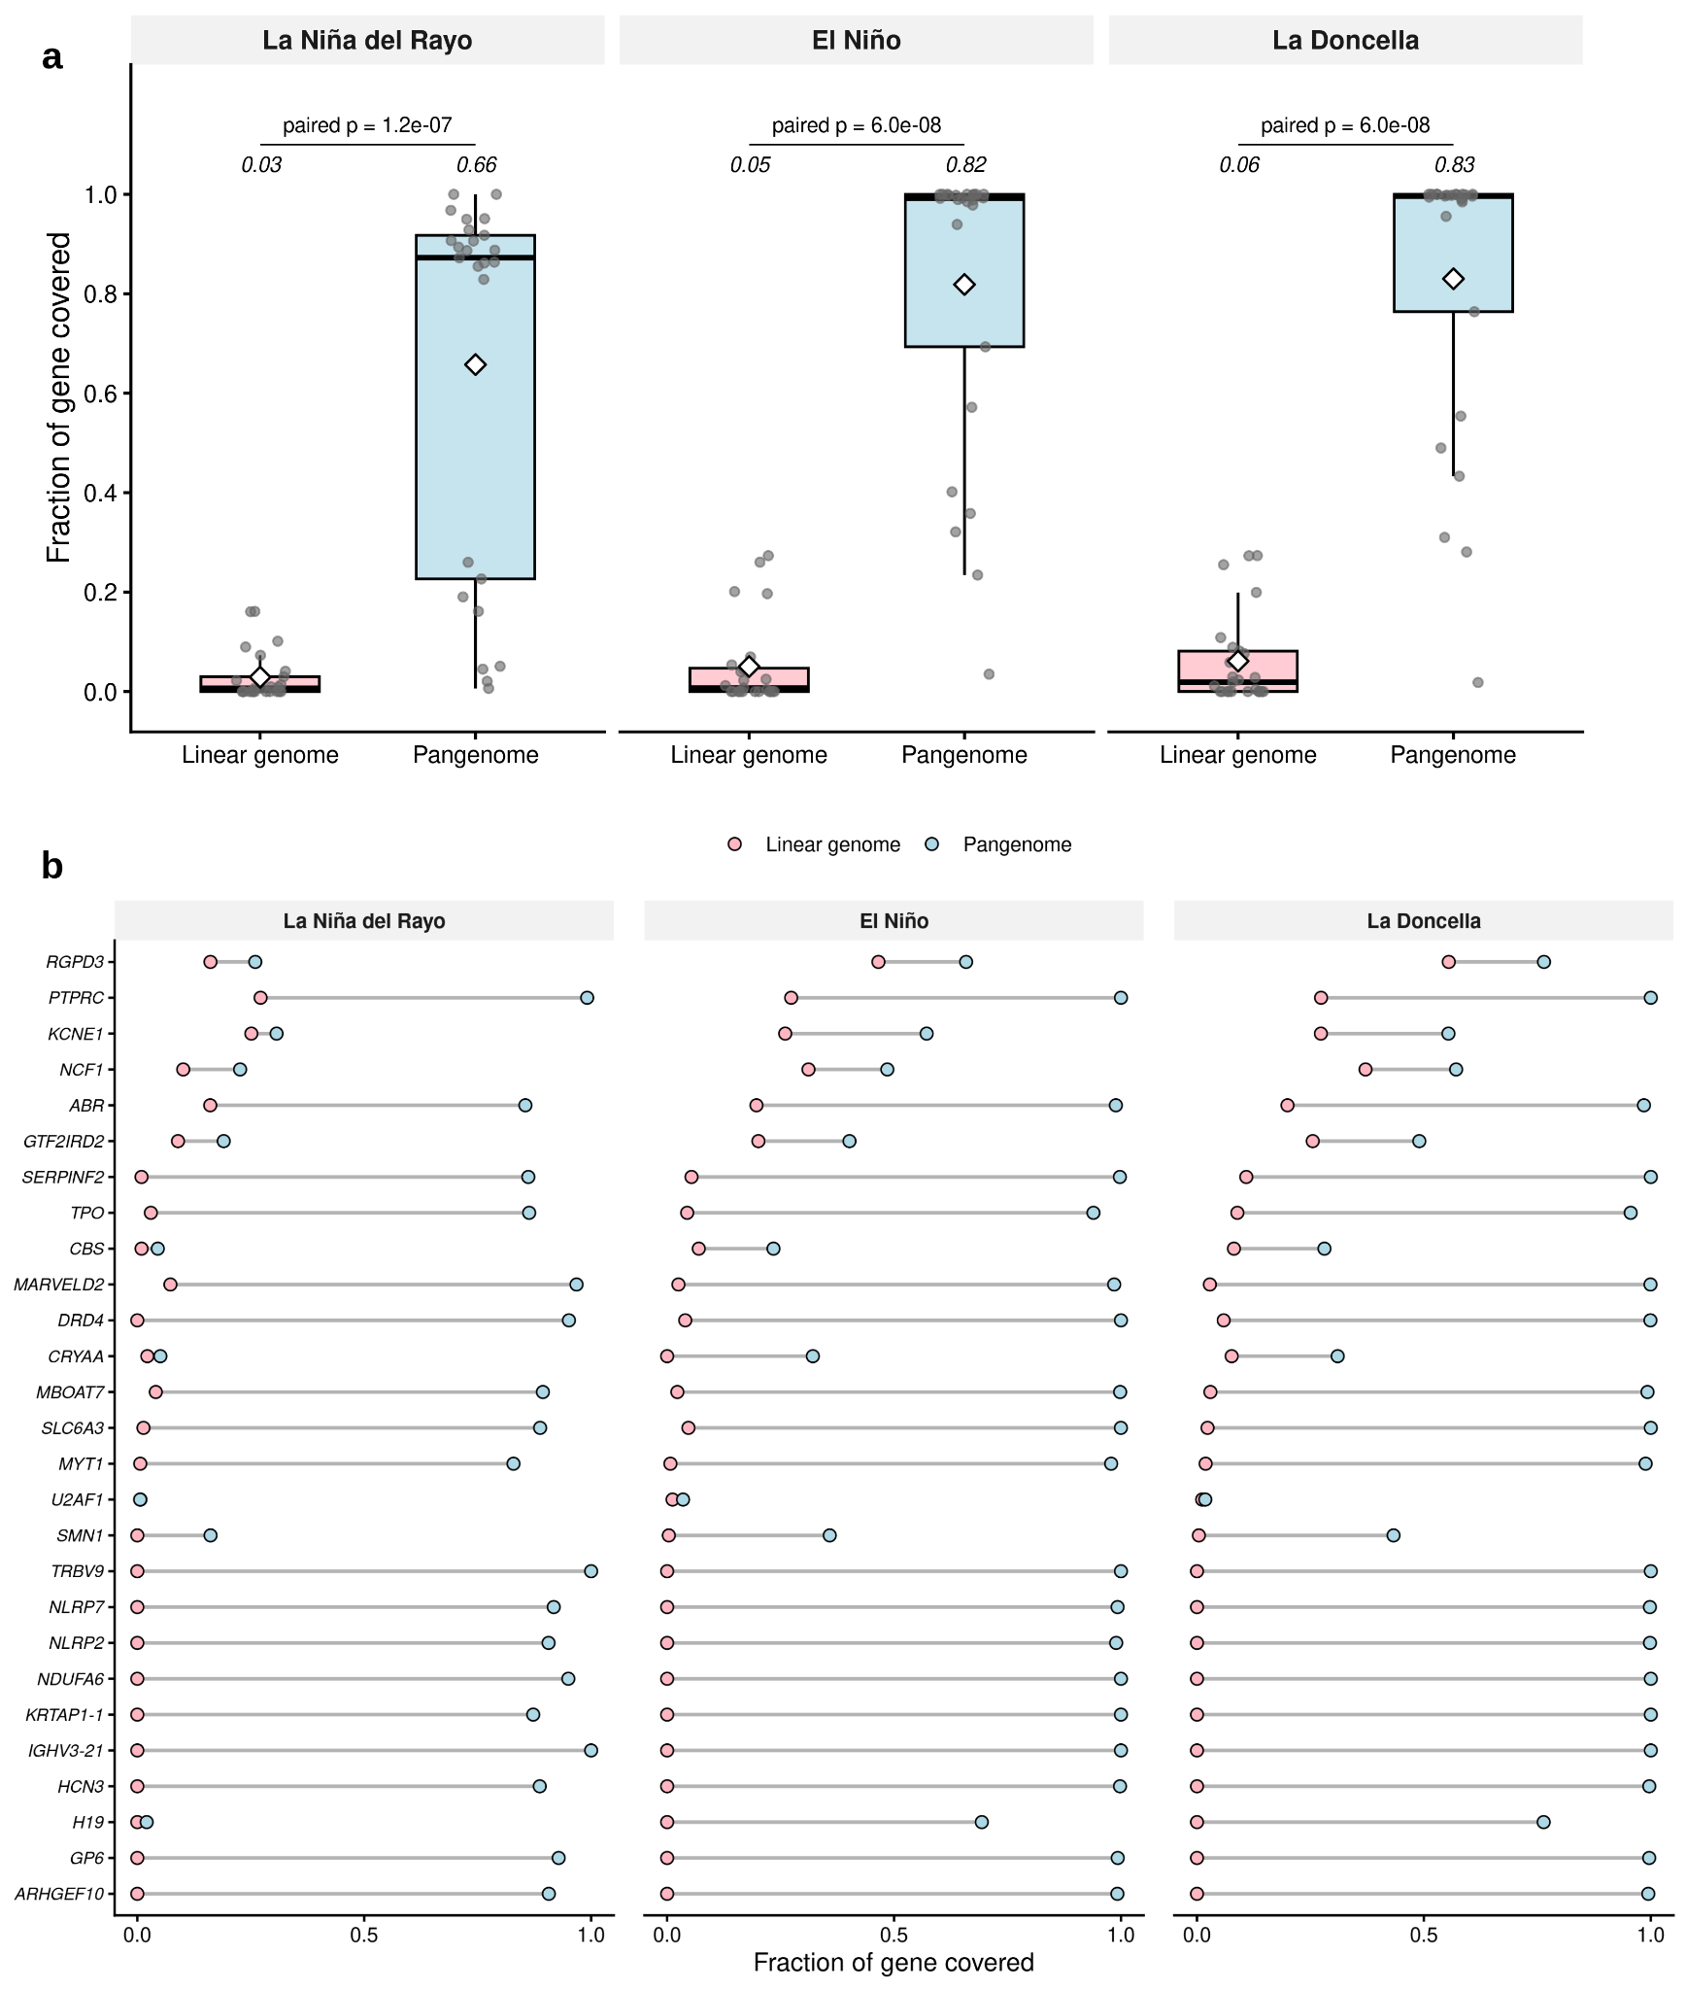

Supplementary Figure 4| Improved mapping of medically challenging genes
This figure represents the subset of medically challenging genes where the pangenome outperforms the linear genome. (a) Boxplots representing the overall distribution of the base coverage fractions for this subset of genes for La Niña del Rayo, El Niño, and La Doncella. Each grey point is an individual gene observation. We calculated statistical significance using a paired Wilcoxon signed-rank test. (b) Dumbbell plots illustrating the gene-by-gene improvement in the fraction of covered bases for this same subset of genes.

Supplementary Figure 5: Genome-wide localization of pangenome mapping improvements for La Niña del Rayo and El Niño.
We present the analyses from Figure 4 of the main manuscript for the remaining two individuals here. These genome-wide coverage enhancements were largely consistent across all three individuals analyzed. For a detailed breakdown of specific loci, please refer to Supplementary Tables 5 and 6.

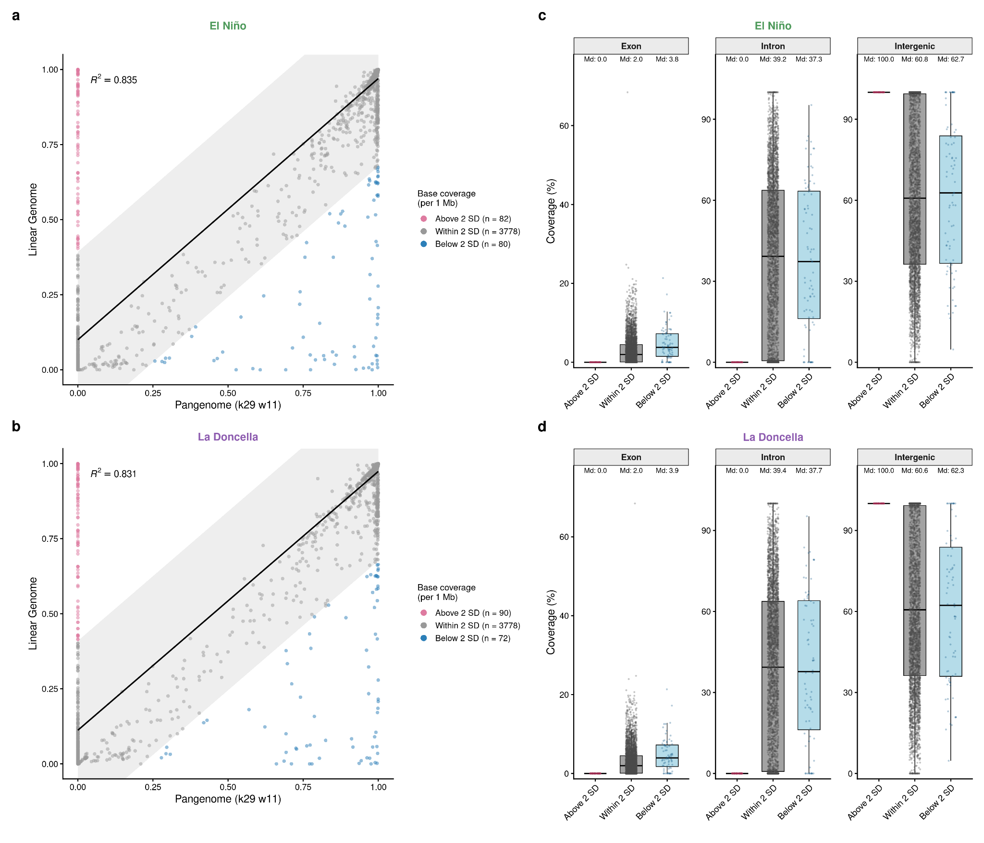
Supplementary Figure 5 | Genome-wide mapping coverage and genomic feature composition
Genome-wide coverage and feature composition analysis (as described in Figure 4) replicated for El Niño (a-c) and (b-d) La Doncella.

Supplementary Figure 6: Computational resource consumption
We benchmarked the computational performance of the optimized parameter configuration (k = 15, w = 5) against the default settings (k = 29, w = 11) in triplicate across varying depths of input sequence coverage. The optimized parameters significantly increased computational demand, requiring approximately 100% to 150% more CPU hours (a 2- to 2.5-fold increase) than the default configuration across all tested coverage levels. While both workflows scaled linearly with input coverage depth, the optimized parameters exhibited a significantly steeper growth slope. This scaling disparity was most pronounced at the maximum tested depth (x10), where the optimized pipeline required a mean of 212.2 CPU hours compared to 79.2 CPU hours for the default settings.

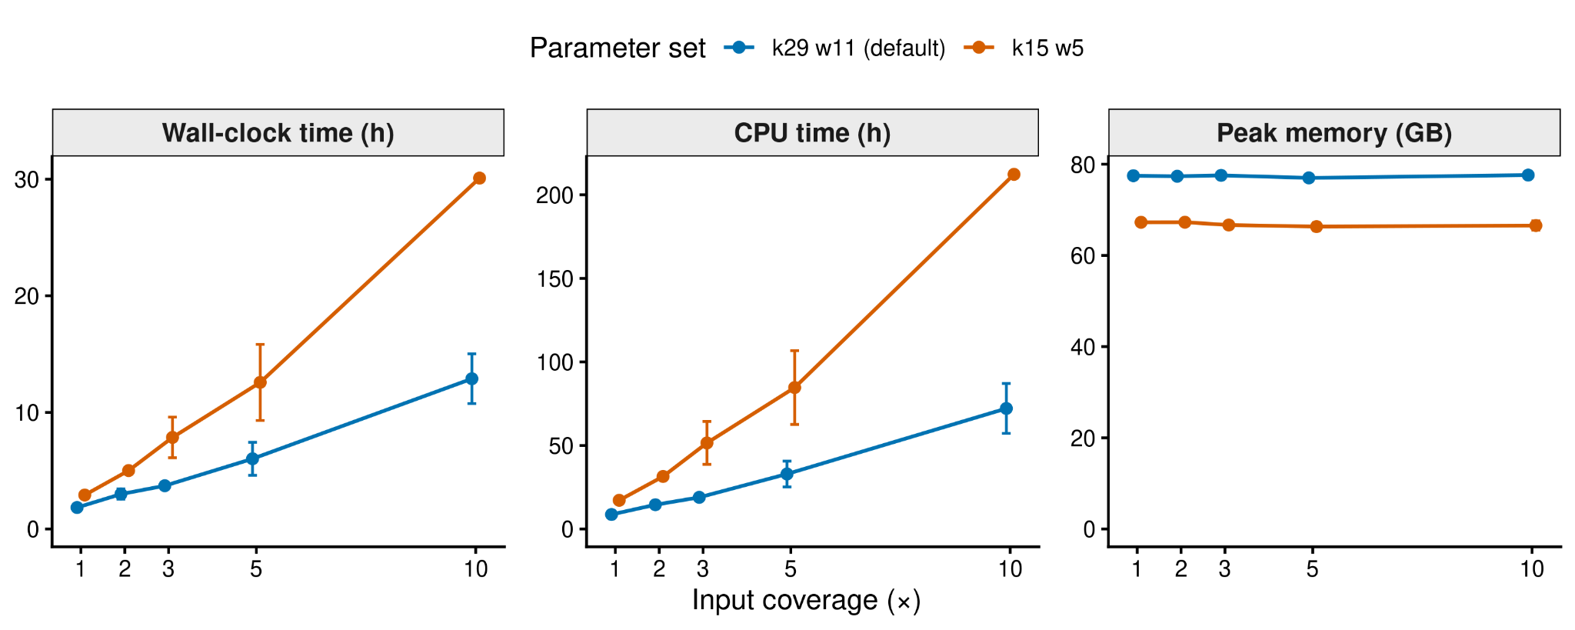

Supplementary Figure 6 | Computational resource usage comparison across parameter sets Evaluation of computational efficiency for the default parameter set (k = 29, w = 11, blue) and the optimized parameter set (k = 15, w = 5, orange) across simulated input coverages (1x, 2x, 3x, 5x, and 10x). Performance metrics are split across three panels: Wall-clock time (left), CPU time (middle), and Peak memory (right). Points and error bars represent the mean ± standard deviation calculated across independent triplicate runs (n = 3).

Supplementary Methods

Generation of genomic annotation files
This section describes how we generated the exon, intron, and intergenic annotation files.
We extracted genomic features from the GENCODE comprehensive gene annotation file (downloaded from https://www.gencodegenes.org/human/release_44.html)⁶⁶. We parsed protein-coding exons using awk, converted the coordinates to 0-based BED format, and merged overlapping features using bedtools merge. We defined intronic intervals by subtracting merged exon coordinates from protein-coding gene boundaries using bedtools subtract. Finally, to define intergenic regions, we concatenated and merged the exon and intron BED files to capture all genic space and identified the remaining genomic intervals using bedtools complement relative to the GRCh38 chromosome size file.

# 1. Extract exonic intervals from protein-coding genes
zcat <annotation_file>.gtf.gz | \
awk -F"\t" 'BEGIN {OFS="\t"} $3 == "exon" && $9 ~ /gene_type "protein_coding"/ {print $1, $4-1, $5, $9}" | \
sort -k1,1 -k2,2n | \
bedtools merge -i stdin -c 4 -o distinct > exons_protein_coding.bed

# 2. Extract full gene intervals for protein-coding genes
zcat <annotation_file>.gtf.gz | \
awk -F"\t" 'BEGIN {OFS="\t"} $3 == "gene" && $9 ~ /gene_type "protein_coding"/ {print $1, $4-1, $5, $9}" | \
sort -k1,1 -k2,2n > genes_protein_coding.bed

# 3. Derive intronic intervals by subtracting exons from genes
bedtools subtract -a genes_protein_coding.bed -b exons_protein_coding.bed > introns_protein_coding.bed

# 4. Concatenate and merge all genic spaces (exons + introns)
cat introns_protein_coding.bed exons_protein_coding.bed | \
sort -k1,1 -k2,2n | \
bedtools merge -i stdin -c 4 -o distinct > merged_exons_introns_protein_coding.bed

# 5. Create intergenic intervals by complementing merged genic regions
bedtools complement -i merged_exons_introns_protein_coding.bed -g hg38.chrom.sizes.sorted > intergenic.bed



Statistical modeling for parameter optimization

To evaluate the joint influence of k-mer and window sizes on high-quality aligned read yields (MQ>30), we constructed an ordinary least squares (OLS) multiple linear regression model with an interaction term in R.
Using the fitted response surface model (parameters detailed in Supplementary Figure 6), we projected predicted read yields across a high-resolution 10,000-point grid spanning the experimental parameter boundaries. We then visualized this predictive surface as a topographical contour heatmap using the ggplot2 package in R, overlaying raw experimental coordinates to evaluate model concordance.

Identification of outlier low-coverage medically relevant genes
This section details how we identified the genes presented in Supplementary Figure 4.
We analyzed base-level coverage across 273 autosomal genes defined in the challenging medically relevant genes (CMRG) v1.0 benchmark to evaluate sequence recovery across complex loci. We projected the genomic coordinates for the CMRG targets to the GRCh38 reference.
We calculated the fraction of bases covered at ≥ 1x depth for each target gene across all three individuals using bedtools coverage on both the linear and pangenome alignment workflows. We defined outlier low-coverage genes using the linear reference alignment baseline, identifying any locus where the fraction of covered bases fell more than two standard deviations below the cohort mean:
$$OutlierCriteria<μ_{linear}±δ_{linear}$$
We extracted the corresponding gene coverage fractions from both alignments for all identified outlier loci to perform subsequent statistical testing and visualization (see Supplementary Figure 4).

Supplementary Tables
Overview of tables and accompanying descriptions:

Supplementary Table 1: Mapping statistics
- Includes sample specifications alongside raw, mapped, and high-quality (MQ > 30) read counts for linear mapping and pangenome mapping with parameters k29 w11 and k15 w5

Supplementary Table 2: Read Counts
- Includes read counts for reads mapped uniquely to pangenome (k29 w11) or to linear genome and shared reads

Supplementary Table 3: Variant Counts
- Includes variants (SNPs and INDELs) counts for unique and shared variants for pangenome (k29 w11 and k15 w5) and linear alignments

Supplementary Table 4: HLA Genotyping
- Includes HLA genotypes with read depth and objective values supporting each genotype

Supplementary Table 5a-c: Genomic regions with better coverage in linear alignment
- Lists all genomic regions where the linear alignment outperformed the pangenome alignment, defined as regions falling above +2 standard deviations from the regression line (Figure 4A)
- a-c for La Niña del Rayo, El Niño and La Doncella respectively

Supplementary Table 6a-c: Genomic regions with better coverage in pangenome alignment
- Lists all genomic regions where the pangenome alignment outperformed the linear alignment, defined as regions falling below -2 standard deviations from the regression line (Figure 4A)
- a-c for La Niña del Rayo, El Niño and La Doncella respectively

Supplementary Table 7: Medically relevant genes with with better coverage in pangenome alignment
- Lists the subset of medically relevant genes where linear genome coverage is more than two standard deviations below the mean, alongside the corresponding base coverage percentages achieved by the linear and pangenome alignment pipelines.

Supplementary Table 8: Computational resource consumption
- Summary of computational resource metrics recorded for each independent replicate run.

