Supplementary Materials

Appendix 1 Supplementary information for methods and data
Supplementary Table 1 Data source and indicator preprocessing
Issue (system) | Subsystem | No. | Indicator (attribute) | Data source | Indicator preprocessing and calculation
Environmental sustainability of agricultural production | Resource efficiency and environmental performance of agricultural development | 1 | Agricultural sector output per unit of cultivated land | China Statistical Yearbook and China Agricultural and Rural Statistical Yearbook | Public data, directly accessible.  Among these, data on cultivated land area have been officially released by the Chinese government only for the years 2013, 2015–2017, 2019, 2022, and 2023. Consequently, for the remaining years, estimates are derived from the 30 m-resolution annual China Land Cover Dataset (CLCD) (Yang and Huang, 2021).
Environmental sustainability of agricultural production |  | 2 | Water use per unit of agricultural sector output | China Statistical Yearbook
Environmental sustainability of agricultural production |  | 3 | Fertilizer, pesticide, and agricultural film application per unit cultivated area | China Statistical Yearbook and China Agricultural and Rural Statistical Yearbook
Environmental sustainability of agricultural production |  | 4 | Large livestock breeding per capita in rural area | China Statistical Yearbook
Environmental sustainability of agricultural production |  | 5 | The share of capture in aquatic production | China Statistical Yearbook and China Agricultural and Rural Statistical Yearbook
Environmental sustainability of agricultural production | Resource and environmental endowment of agricultural production | 6 | Cultivated land area per capita | China Statistical Yearbook and China Agricultural and Rural Statistical Yearbook | Same as the previous subsystem.
Environmental sustainability of agricultural production |  | 7 | The proportion of effectively irrigated area to cultivated land | China Statistical Yearbook and China Agricultural and Rural Statistical Yearbook | Same as the previous subsystem.
Environmental sustainability of agricultural production |  | 8 | Grain yield per unit area | China Statistical Yearbook | Same as the previous subsystem.
Environmental sustainability of agricultural production |  | 9 | Water resources per capita | China Statistical Yearbook | Same as the previous subsystem.
Environmental sustainability of agricultural production | Resilience of agricultural resources and environment | 10 | Rural reservoir capacity per capita | China Statistical Yearbook | Same as the previous subsystem.
Environmental sustainability of agricultural production | Resilience of agricultural resources and environment | 11 | The ratio of cultivated land under waterlogging control | China Statistical Yearbook and China Agricultural and Rural Statistical Yearbook | Same as the previous subsystem.
Environmental sustainability of agricultural production | Resilience of agricultural resources and environment | 12 | The proportion of crop area affected by natural disasters, the ratio of crop damaged area to disaster-affected area | China Statistical Yearbook and China Agricultural and Rural Statistical Yearbook | Same as the previous subsystem.
Environmental sustainability of agricultural production | Resilience of agricultural resources and environment | 13 | Agricultural planting diversity index | China Statistical Yearbook | Same as the previous subsystem.
Ecosystem sustainability of rural areas | Pressures on rural environment and ecosystems | 14 | The proportion of cultivated land acquisition to the total land acquisition area | China Urban and Rural Construction Statistical Yearbook | Public data, directly accessible.
Ecosystem sustainability of rural areas | Pressures on rural environment and ecosystems | 15 | Rural population density | China Urban and Rural Construction Statistical Yearbook | Public data, directly accessible.
Ecosystem sustainability of rural areas | Pressures on rural environment and ecosystems | 16 | Agricultural water scarcity index | China Statistical Yearbook | Public data, directly accessible. Calculated as the ratio of the agricultural sector's water use to total provincial water resources.
Ecosystem sustainability of rural areas | Pressures on rural environment and ecosystems | 17 | Forestry harvesting pressure index | China Statistical Yearbook | Public data, directly accessible. Calculated as the ratio of timber production to the total provincial standing forest stock.
Ecosystem sustainability of rural areas | Rural ecosystem quality and stability | 18 | Forest coverage | China Statistical Yearbook | Public data, directly accessible.
Ecosystem sustainability of rural areas | Rural ecosystem quality and stability | 19 | Carbon sink per unit forest area | A 1-km resolution forest biomass carbon pool dataset (Chen et al., 2023) | Public data, directly accessible.
Ecosystem sustainability of rural areas | Rural ecosystem quality and stability | 20 | Water surface rate | CLCD (Yang and Huang, 2021) | Public data, directly accessible.
Ecosystem sustainability of rural areas | Rural ecosystem quality and stability | 21 | Soil erosion rate | National Soil and Water Conservation Bulletin and China Statistical Yearbook | Public data, directly accessible.  Since the bulletin reports soil erosion rate data only from 2018 onward, this study estimated the soil erosion rates for earlier years by the following steps. First, we obtained provincial-level soil erosion control area data for 2006 to 2023 from the China Statistical Yearbook. Second, we calculated the annual average conversion ratio between the soil erosion control area and the actual erosion reduction area for Chinese provinces based on the data from 2018 to 2023. Third, the pre-2018 soil erosion rates for Chinese provinces can be estimated.
Ecosystem sustainability of rural areas | Rural ecosystem quality and stability | 22 | Biological richness index | The Ministry of Ecology and Environment of China (MEE) | Need to apply to the MEE for the raw data. The definition and calculation method of the biological richness index is specified in the Technical Criterion for Ecosystem Status Evaluation (HJ 192-2015) issued by the MEE.
Ecosystem sustainability of rural areas | Rural ecosystem quality and stability | 23 | NDVI | A Chinese local NDVI dataset with a spatial resolution of 1 km | The raw data is provided by the Ecological Meteorological Cloud Service Platform, operated by the Chinese Academy of Meteorological Sciences (https://em.cams.cma.cn/#/dashhome).
Ecosystem sustainability of rural areas | Ecological protection and construction activities in rural areas | 24 | The proportion of nature reserves to the land area | China Statistical Yearbook and China Agricultural and Rural Statistical Yearbook | Public data, directly accessible.
Ecosystem sustainability of rural areas |  | 25 | The proportion of ecological protection red line to land area | Planning documents or bulletins issued by Chinese provinces | Public data, can be searched directly on the Internet.
Ecosystem sustainability of rural areas |  | 26 | Rural greening rate, per capita park green area in rural areas | China Urban and Rural Construction Statistical Yearbook | Public data, directly accessible.
Ecosystem sustainability of rural areas |  | 27 | The proportion of afforestation to regional area | China Statistical Yearbook | Public data, directly accessible.
Quality and sustainability of rural residential environment | Environmental pressures associated with rural lives | 28 | Domestic sewage treatment pressure | China Urban and Rural Construction Statistical Yearbook, China Statistical Yearbook, and the Manual on Methods and Coefficients for Calculating Pollution Production and Emission from Emission Source Statistics Survey issued by the MEE | Public data, directly accessible.  The pressure of domestic sewage treatment is assessed by the ratio of rural domestic sewage generation to the available treatment capacity. Rural domestic sewage generation is estimated using province-specific rural population data and corresponding per capita sewage generation coefficients.
Quality and sustainability of rural residential environment | Environmental pressures associated with rural lives | 29 | Pressure of domestic waste collection and transportation | China Urban and Rural Construction Statistical Yearbook, China Statistical Yearbook, and Li et al. (2018). | Public data, directly accessible.  The pressure associated with domestic waste collection and transportation is evaluated based on the total volume of domestic waste generated in rural areas and the number of collection and transportation stations. Rural domestic waste generation is estimated using provincial data on rural population and per capita waste generation. The per capita domestic waste generation parameters are derived from high-quality survey statistics (Li et al., 2018), which closely align with the benchmark values recommended in the Guideline on Project Construction and Investment for Rural Garbage Classification ＆ Click-Transport and Treatment (issued by the MEE).
Quality and sustainability of rural residential environment | Environmental pressures associated with rural lives | 30 | CO₂ emissions per capita | Carbon Emission Accounts and Datasets (CEADs) (Guan et al., 2021; Shan et al., 2016; Shan et al., 2018; Shan et al., 2020; Xu et al., 2024) | Public data, directly accessible.  The CEADs do not provide CO₂ emission data for 2022 and 2023. Therefore, this study estimates the data based on the trend data obtained from the Open-source Data Inventory for Anthropogenic CO₂ (ODIAC) (Oda et al., 2018).
Quality and sustainability of rural residential environment | Rural environmental quality | 31 | City average concentration of ambient PM_{2.5} and ozone in rural areas | The ChinaHighPM_{2.5} dataset (Wei et al., 2020; Wei et al., 2021) and the ChinaHighO₃ dataset (Wei et al., 2022; Yang et al., 2025) | Public data, directly accessible.  The original PM_{2.5} data consists of daily average values on a 1-km grid. In this study, the data are aggregated into annual averages at the city level, followed by the calculation of provincial averages based on the mean values of cities within each province.  The original data consists of daily average values on a 1-km grid. In this study, the data are aggregated into DMA8 and peak-season average values at the city level, followed by the calculation of provincial averages based on the mean values of cities within each province.
Quality and sustainability of rural residential environment | Rural environmental quality | 32 | The proportion of surface water where the water quality reaches national standard level-3 or above | The China National Environmental Monitoring Center | The approach for obtaining data is introduced in our published work (Guan et al., 2024). The national standard is the Environmental Quality Standards for Surface Water (GB 3838-2002) issued by the MEE.
Quality and sustainability of rural residential environment | Rural environmental quality | 33 | The proportion of coastal water where the seawater quality reaches national standard level-2 or above | The National Marine Environmental Monitoring Center | The approach for obtaining data is introduced in our published work (Guan et al., 2025). The national standard is the Sea Water Quality Standard (GB 3097-1997) issued by the MEE.
Quality and sustainability of rural residential environment | Rural environmental quality | 34 | Accumulation levels of eight major heavy metal(loid)s in soil environment | A literature providing part data from the first national soil pollution survey data (Chen et al., 2015) | Public data, directly accessible.
Quality and sustainability of rural residential environment | Rural environmental infrastructure | 35 | Penetration rate of sanitary toilets in rural areas | China Agricultural and Rural Statistical Yearbook and China Urban and Rural Construction Statistical Yearbook | Public data, directly accessible.  After 2017, the China Agricultural and Rural Statistical Yearbook stopped providing data on rural sanitary toilets. Consequently, this study estimates the rural sanitary toilet penetration rates for subsequent years based on rural toilet quantity and investment data sourced from the China Urban and Rural Construction Statistical Yearbook.
Quality and sustainability of rural residential environment | Rural environmental infrastructure | 36 | Penetration rate of water supply, penetration rate of gas supply, and road area per capita in rural areas | China Urban and Rural Construction Statistical Yearbook | Public data, directly accessible.
Quality and sustainability of rural residential environment | Rural environmental infrastructure | 37 | The proportion of towns and villages collecting and treating domestic sewage, density of drainage network | China Urban and Rural Construction Statistical Yearbook | Public data, directly accessible.
Quality and sustainability of rural residential environment | Rural environmental infrastructure | 38 | Treatment rate of rural domestic waste | China Urban and Rural Construction Statistical Yearbook | Public data, directly accessible.
Quality and sustainability of rural residential environment | Rural environmental infrastructure | 39 | Proportion of administrative villages that have finished rural environmental upgrading | China Urban and Rural Construction Statistical Yearbook | Public data, directly accessible.  After 2017, the China Urban and Rural Construction Statistical Yearbook stopped providing data on rural environmental upgrading. Consequently, this study estimates the rural environmental upgrading data for subsequent years based on rural environmental upgrading investment data.

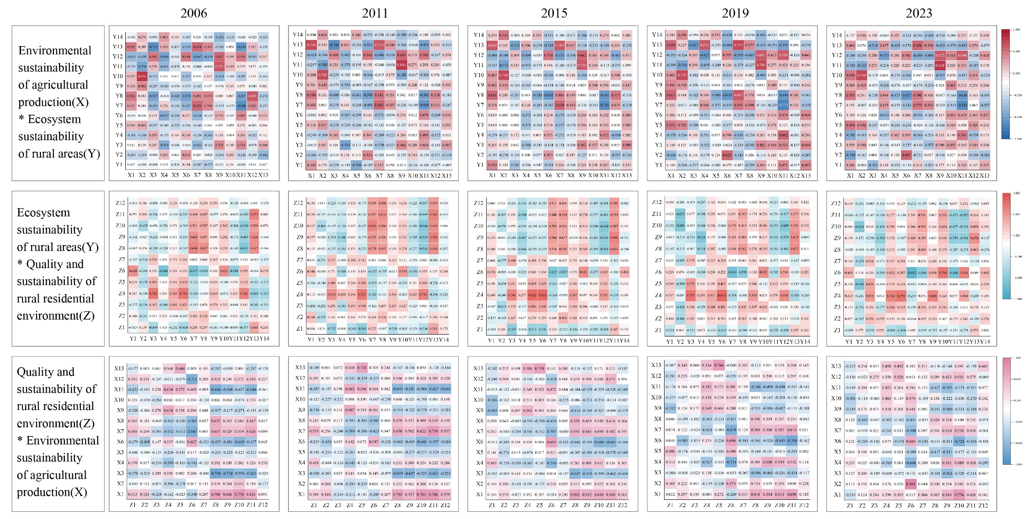
Supplementary Fig.1 Correlation of indicators between subsystems

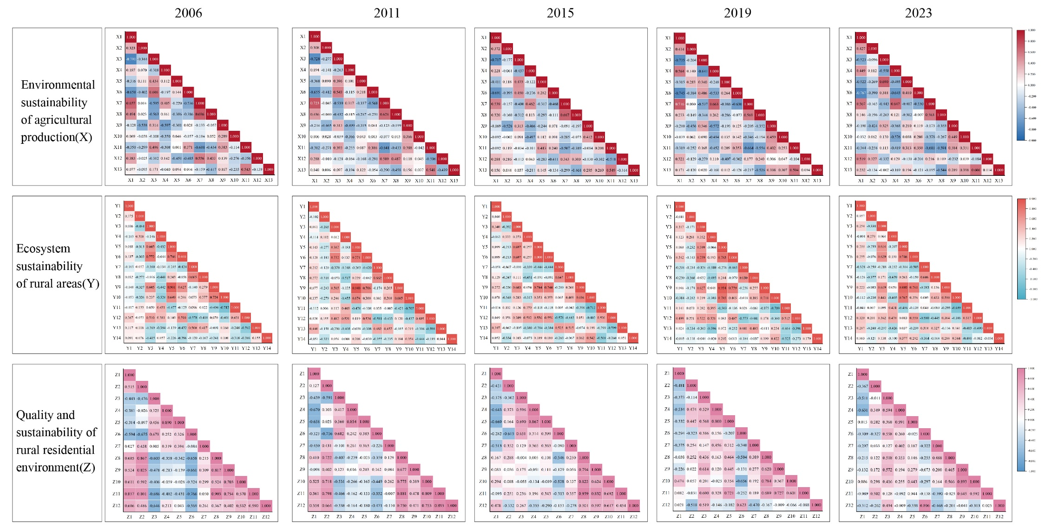 Supplementary Fig.2 Correlation of indicators within the subsystem

Supplementary Table 2 Socio-economic indicators
system | No. | Indicator
Socio-economic indicators | E1 | GDP per capita
Socio-economic indicators | E2 | Per capita disposable income of rural residents
Socio-economic indicators | E3 | Per capita consumption expenditure of rural residents
Socio-economic indicators | E4 | Urban-rural income ratio
Socio-economic indicators | E5 | Urbanization rate of permanent population
Socio-economic indicators | E6 | The proportion of added value of the secondary industry to GDP
Socio-economic indicators | E7 | The proportion of added value of the tertiary industry to GDP
Socio-economic indicators | E8 | Local fiscal pressure
Socio-economic indicators | E9 | Average number of household cars owned by rural residents per hundred households at the end of the year (per hundred households)
Socio-economic indicators | E10 | Average number of computers owned by rural residents per 100 households at the end of the year (units)
Socio-economic indicators | E11 | Per capita grain consumption of rural residents (kg)
Socio-economic indicators | E12 | Highway network density
Socio-economic indicators | E13 | Per capita express delivery volume

