Supplementary Information

Antipsychotics Chlorpromazine and Clozapine Inhibit Membrane Fusion Through Direct Interaction with Lipid Bilayers

Hugo Fumat^{1#}, Vladimir Adrien^{1,2,3,#}, Sébastien Nola¹, Kristina Niort^{1,4}, Thierry Galli¹, Philippe Nuss⁵, David Tareste^{1,4*}

¹ Université Paris Cité, Institute of Psychiatry and Neuroscience of Paris (IPNP), INSERM U1266, Team Membrane Traffic in Healthy & Diseased Brain, 75014 Paris, France.
² AP-HP, Avicenne Hospital, Department of Child, Adolescent and General Psychiatry, F-93009, Bobigny, France.
³ Université Sorbonne Paris Nord, Laboratoire Éducations et Promotion de la Santé, UR 3412, Bobigny, France.
⁴ Université Paris Cité, Institute of Psychiatry and Neuroscience of Paris (IPNP), INSERM U1266, Biochemistry and Biophysics (B&B) Core Facility, 75014 Paris, France.
⁵ Sorbonne Université, Centre de Recherche Saint-Antoine, INSERM UMR-S 938, Department of Psychiatry, Hôpital Saint-Antoine, Paris, France.

# Co-first authors
* Corresponding author: david.tareste@inserm.fr

Supplementary Materials and Methods

Chemicals
1-palmitoyl-2-oleoyl-sn-glycero-3-phosphocholine (POPC); 1,2-dioleoyl-sn-glycero-3-phospho-L-serine (DOPS); 1,2-dioleoyl-sn-glycero-3-phosphoethanolamine (DOPE); 1,2-dioleoyl-sn-glycero-3-phosphoethanolamine-N-(Lissamine Rhodamine B sulfonyl) (ammonium salt) (Rho-PE); 1,2-dioleoyl-sn-glycero-3-phosphoethanolamine-N-(7-nitro-2-1,3-benzoxadiazol-4-yl) (ammonium salt) (NBD-PE); and 1,2-dioleoyl-sn-glycero-3-phospho-L-serine-N-(7-nitro-2-1,3-benzoxadiazol-4-yl) (ammonium salt) (NBD-PS) were purchased from Avanti Polar Lipids (Alabaster, AL, USA) as chloroform solutions.
Chlorpromazine (CPZ); clozapine (CLOZ); amisulpride (AMI); N-2-hydroxyethylpiperazine-N′-2-ethanesulfonic acid (HEPES, OmniPur grade); potassium hydroxide solution 47% (KOH 47%, EMSURE grade for analysis); potassium chloride (KCl, OmniPur grade); glycerol (Molecular Biology grade); n-octyl-β-D-glucopyranoside (β-OG, ≥98% GC); n-dodecyl β-D-maltoside (DDM, ULTROL grade); dimethylsulfoxide (DMSO, Molecular Biology grade); dithiothreitol (DTT, OmniPur grade); ethanol (EMSURE grade for analysis, ≥99.9% GC); chloroform (EMSURE grade for analysis, ≥99% GC); methanol (EMSURE grade for analysis, ≥99% GC); 1,3-diaza-2,4-cyclopentadiene (Imidazole, ≥99% titration); cOmplete EDTA-free protease inhibitor cocktail; ethylenediaminetetraacetic acid disodium salt dihydrate (EDTA, 99-101% titration); polyethylene glycol 8000 (PEG 8000, BioUltra); and t-octylphenoxypolyethoxyethanol (Triton X-100) were purchased from Sigma-Aldrich (St. Louis, MO, USA).
D-α-Aminobenzoylpenicillin sodium salt (Ampicillin, sodium salt); kanamycin sulfate; and isopropyl β-D-thiogalactopyranoside (IPTG) were purchased from Euromedex. LB-Agar medium capsules and phosphate buffer saline tablets (PBS) were acquired from MP Biomedicals. MES SDS running buffer for NuPAGE (20X); LDS NuPAGE sample buffer (4X); SeeBlue Plus2 Pre-stained Protein Standard; and Super Optimal broth with Catabolite repression (S.O.C) medium were purchased from Invitrogen (Waltham, MA, USA). 5-(N-2,3-dihydroxypropylacetamido)-2,4,6-tri-iodo-N,N′-bis-(2,3-dihydroxypropyl)isophthalamide (Nycodenz, ≥ 98%) was ordered from Proteogenix (Schiltigheim, France). Dulbecco’s Modified Eagle Medium (DMEM, Gibco) and PageBlue protein staining solution (Coomassie) were purchased from ThermoFisher Scientific (Waltham, MA, USA).
Antipsychotic drugs were prepared as stock solutions in an organic solvent mixture (chloroform:methanol (9:1, v/v)) or in aqueous buffer H (25 mM HEPES/KOH, pH 7.5; 150 mM KCl; 10% (v/v) glycerol) supplemented with 10% (v/v) DMSO.
All aqueous solutions were prepared using 18.2 MΩ ultrapure water and filtered with sterile 0.22 μm polyethersulfone (PES) membranes.

SNARE protein expression and purification
All SNARE proteins were expressed in BL21 (DE3) competent Escherichia coli cells from New England Biolabs (Ipswich, MA, USA).

Stx1A/His₆-SNAP25 and VAMP2-His₆
The full-length t-SNARE complex, composed of rat Stx1A and mouse His6-SNAP25, was expressed from the polycistronic plasmid pTW34 (1). The plasmid conferred resistance to kanamycin (KAN). Bacterial transformation was performed using competent cells following a standard heat-shock protocol. Transformed cells were selected on LB agar plates supplemented with KAN (100 µg.mL⁻¹). A single colony was used to inoculate a starter culture, which was expanded stepwise into a 4 L LB culture containing KAN (100 µg.mL⁻¹). Cells were grown at 37°C under agitation until the optical density at 600 nm reached ∼0.7. Protein expression was induced by the addition of 1 mM IPTG, and cultures were incubated for an additional 3-4 h at 37°C. Cells were harvested by centrifugation at 4,000 rpm for 10 min at 4°C (JLA-9.1000 rotor, Beckman Coulter) and either used immediately or stored at -80°C.
Cell pellets were resuspended in breaking buffer (25 mM HEPES/KOH, pH 7.5; 100 mM KCl; 10% (v/v) glycerol; 4% (v/v) Triton X-100; 1 mM DTT; 10 mM imidazole, and EDTA-free protease inhibitor cocktail) and lysed using a high-pressure homogenizer (Emulsiflex-C3, Avestin) for 3-5 cycles while maintaining the sample on ice. Cell debris was removed by ultracentrifugation at 40,000 rpm for 45 min at 4°C (Ti45 rotor, Beckman Coulter).
Purification was performed by nickel-affinity chromatography using a 1 mL HisTrap FF crude column (GE Healthcare) on an ÄKTA Pure 25 M system. The column was equilibrated with washing buffer A (25 mM HEPES/KOH, pH 7.5; 200 mM KCl; 10% (v/v) glycerol; 1% (v/v) Triton X-100; 1 mM DTT; 10 mM imidazole), and the clarified lysate was loaded at a flow rate of 1 mL.min⁻¹. After washing for approximately 15 column volumes, nonspecifically bound proteins were further removed using washing buffer B (25 mM HEPES/KOH, pH 7.5; 200 mM KCl; 10% (v/v) glycerol; 1% (w/v) β-OG; 1 mM DTT; 50 mM imidazole).
Proteins were eluted using a linear imidazole gradient from 50 to 500 mM at a flow rate of 0.5 mL.min⁻¹, prepared by slowly mixing washing buffer B with elution buffer (25 mM HEPES/KOH, pH 7.5; 200 mM KCl; 10% (v/v) glycerol; 1% (w/v) β-OG; 1 mM DTT; 500 mM imidazole). Elution fractions corresponding to the absorbance peak at 280 nm were collected and analyzed by SDS-PAGE using stain-free 4-20% Mini-PROTEAN TGX gels (Bio-Rad). Gels were subsequently stained with Coomassie Blue and imaged using the ChemiDoc Touch system (Bio-Rad).
Fractions containing the t-SNARE complex were pooled, and protein concentrations were determined spectrophotometrically using a BioDrop instrument and validated by SDS-PAGE. Purified proteins were aliquoted, flash-frozen in liquid nitrogen, and stored at -80°C until use.
The full-length mouse VAMP2-His₆ was expressed from the plasmid pTW2 (2) and purified following the same protocol as described above, except for the modifications detailed below.
For the expression of full-length VAMP2-His₆, the plasmid conferred resistance to ampicillin (AMPI). All LB media were supplemented with AMPI (500 µg.mL⁻¹), and additional AMPI (100 µg.mL⁻¹) was added hourly to the main culture before and after IPTG induction. Furthermore, breaking buffer and washing buffer A contained 400 mM KCl, whereas washing buffer B and elution buffer contained 100 mM KCl.

His₆-SUMO-Stx1A, His₆-SNAP25 and His₆-SUMO-VAMP2
Alternatively, full-length Stx1A and VAMP2 proteins were expressed from plasmids encoding an N-terminal His₆-SUMO tag.
Full-length rat His₆-SUMO-Stx1A and rat His₆-SUMO-VAMP2 were expressed from pET28a vectors. The plasmids conferred resistance to kanamycin (KAN). Expression and harvesting conditions were similar to those described above, except that induction was performed with 1 mM IPTG for 4 h at 30°C.
Cells were resuspended in breaking buffer composed of PBS (pH 7.4); 0.2% (v/v) Triton X-100; 2 mM DTT; 20 mM imidazole; 2 mM EDTA; 1% (w/v) DDM; and protease inhibitors, and lysed by high-pressure homogenization. Clarified lysates were incubated with Ni-NTA His-Bind resin beads (Qiagen) for batch purification at 4°C.
Beads were washed extensively with PBSTI buffer (PBS, pH 7.4; 0.2% (v/v) Triton X-100; 20 mM imidazole), followed by a final wash with PBST (PBSTI buffer lacking imidazole). Proteins were eluted using a Tris-based elution buffer (25 mM Tris-HCl, pH 7.4; 150 mM NaCl; 1% (w/v) β-OG). Removal of the SUMO tag was achieved by overnight incubation with thrombin protease (30 U; Cytiva) at 4°C, followed by an additional 1 h incubation at room temperature. Proteins were collected using a gravity-flow elution column.
Full-length rat His₆-SNAP25 was expressed from a pET28a vector and purified following the same protocol as described above, except that DDM was omitted from the breaking buffer, Triton X-100 was omitted from the PBSTI and PBST buffers, elution was performed using 500 mM imidazole, and imidazole was removed after purification using a desalting column (Cytiva).
Elution fractions were analyzed by SDS-PAGE, and protein concentrations were determined using a BioDrop spectrophotometer and independently validated by Coomassie-stained NuPAGE Novex 4-12% Bis-Tris gels (ThermoFisher Scientific) using appropriate molecular weight standards (e.g., ribonuclease A for VAMP2 and carbonic anhydrase for Stx1A and SNAP25). Purified proteins were aliquoted, flash-frozen in liquid nitrogen, and stored at -80°C until use.
Separately expressed Stx1A and His₆-SNAP25 were incubated together on ice for 10 min to form the t-SNARE complex prior to reconstitution into liposomes.

Cytosolic Domain of VAMP2 (CDV)
The cytosolic domain of VAMP2 (CDV) carrying an N-terminal His₆ tag was expressed from the plasmid pJM51 (3). Expression and purification were performed following the same protocol as described for the full-length mouse VAMP2-His₆, except that detergents were omitted from all buffers.

Liposome reconstitution
All steps involving chloroform were performed under a ventilated chemical hood. Due to the aggressive nature of this solvent, direct contact with plastic materials was strictly avoided. All glass tubes were thoroughly cleaned prior to use by sequential rinsing with ultrapure water, 20% (v/v) ethanol, 100% (v/v) ethanol, and chloroform (three times each).
Liposomes composed of POPC:DOPS:DOPE (65:10:25 mol%; final lipid concentration of 1 mM) were reconstituted by the detergent-assisted method, as previously described (4). For each reconstitution, two distinct liposome populations were generated: acceptor liposomes, which were non-fluorescent, and donor liposomes, which contained a fluorescence resonance energy transfer (FRET) lipid pair composed of NBD-PS or NBD-PE and Rho-PE.
APs were incorporated at an AP-to-lipid molar ratio (AP/L) of 1/100 from a chloroform:methanol (9:1, v/v) stock solution prior to lipid film formation. This AP/L ratio was selected to approximate membrane drug concentrations reached under chronic treatment conditions.
The required amounts of individual lipids were carefully deposited on separate areas of a 13 x 100 mm round-bottom glass tube (Fisher Scientific) using Hamilton syringes (Hamilton Company, NV, USA). Lipid mixtures were dried under a gentle stream of argon gas and placed under vacuum for 2 h to ensure the complete removal of residual organic solvents. Dried lipid films were resuspended in buffer H supplemented with 1% (w/v) n-octyl-β-D-glucopyranoside (β-OG) and incubated for 30 min at room temperature under vigorous vortexing to form lipid-detergent mixed micelles. Liposomes were generated by gradual detergent dilution below the critical micellar concentration through slow addition of buffer H, followed by complete detergent removal by overnight flow dialysis against 4 L of buffer H at 4°C using a micro-dialysis chamber.
Freshly prepared liposomes were recovered from the micro-dialysis chamber, stored at 4°C, and used within three weeks.

SNARE reconstitution into liposomes
In all experiments, v-SNARE proteins were reconstituted with a donor lipid mix containing the FRET pair of fluorescent lipids NBD-PS (or NBD-PE) and Rho-PE. t-SNARE proteins were reconstituted with an acceptor lipid mix lacking fluorescent lipids. SNARE proteins were added during the resuspension of the lipid film with buffer H, supplemented with 1% (v/v) β-OG and 1 mM dithiothreitol (DTT), at concentrations set to achieve the desired lipid-to-protein (L/P) ratio (i.e., L/P = 100 for VAMP2 and L/P = 200 for Stx1A/SNAP25 (5)). Co-expressed t-SNARE proteins were added directly to the lipid film, while separately expressed t-SNARE proteins Stx1A and SNAP25, obtained from SUMO purification, were pre-mixed on ice for 10 min at the appropriate concentration before being applied to the lipid film. The mixture was then vigorously vortexed for 45 min to ensure even distribution of proteins across lipid/detergent/protein micelles, followed by dilution and dialysis as described above. The L/P ratios were determined after Nycodenz flotation gradient by Coomassie blue staining on SDS-PAGE gels.

Proteoliposome flotation assay
Flotation on a Nycodenz step gradient was used to purify and concentrate v- and t-SNARE proteoliposomes and to determine L/P ratios, which can influence fusion activity. A fresh 100% (w/v) Nycodenz stock solution (Proteogenix) was prepared prior to each experiment.
For t-SNARE acceptor proteoliposomes, 500 µL of dialyzed proteoliposomes were mixed with 1 mL of buffer H/DTT (buffer H supplemented with 1 mM DTT) and 1.5 mL of 80% (w/v) Nycodenz in buffer H/DTT in an ultra-clear centrifuge tube (13 × 51 mm, Beckman Coulter), previously washed with ultrapure water and buffer H/DTT, to generate a 40% (w/v) Nycodenz bottom layer. This layer was then overlaid with 1.5 mL of 30% (w/v) Nycodenz in buffer H/DTT, followed by 250 µL of buffer H/DTT (0% Nycodenz layer). Due to the limited volume of reconstituted v-SNARE donor proteoliposomes (typically 300 µL), flotation was performed in small ultra-clear centrifuge tubes (5 × 41 mm, Beckman Coulter). Briefly, 150 µL of v-SNARE proteoliposomes were mixed with 150 µL of 80% (w/v) Nycodenz in buffer H/DTT in 0.5 mL Eppendorf tubes and then transferred into centrifuge tubes. Gradients were completed by layering 250 µL of 30% (w/v) Nycodenz in buffer H/DTT on top of the 40% layer, followed by 50 µL of buffer H/DTT.
Prepared Nycodenz gradients containing t- and v-SNARE proteoliposomes were centrifuged at 45,000 rpm for 4 h at 4°C in an Optima XPN-80 ultracentrifuge (Beckman Coulter) equipped with an SW55 Ti rotor (Beckman Coulter). Following centrifugation, buoyant proteoliposomes were concentrated at the 0/30% Nycodenz interface. For v-SNARE liposomes, 75 µL were carefully collected from this interface, whereas 250 µL were harvested for t-SNARE proteoliposomes. Recovered proteoliposomes were stored at 4°C protected from light for up to three weeks.

Multi-Angle Dynamic Light Scattering (MADLS)
The size distribution of liposomes was determined by Multi-Angle Dynamic Light Scattering (MADLS) with the Zetasizer Ultra Red device (Malvern Panalytical, Worcestershire, UK). Each sample was diluted in order to have a final concentration within the detection range of the instrument: 5 µL of liposomes at 1 mM were diluted by adding 95 µL of buffer H and placed in a quartz cuvette (ZEN2112, Malvern Panalytical) at 22°C. The average size distribution was obtained by measuring the correlation function in three scattering directions: back scatter (173°), side scatter (90°), and forward scatter (13°).

FRET-based lipid mixing assays
For each assay involving proteoliposomes, 45 µL of non-fluorescent t-SNARE proteoliposomes (1 mM total lipid) were added to the bottom of a flat 96-well plate (ThermoFisher Scientific, Waltham, MA, USA) and pre-incubated at 37°C for 7 min in a SpectraMax M5 microplate reader (Molecular Devices, San Jose, CA, USA). Fusion was initiated by adding 5 µL of fluorescent v-SNARE proteoliposomes (1 mM total lipid) to the side of the well, followed by rapid and gentle shaking to ensure synchronous mixing across wells.
Lipid mixing was monitored by measuring NBD fluorescence dequenching, reflecting the dilution of the donor fluorescent lipids into the acceptor membrane, at 37°C for 90 min with one read per min (excitation at 460 nm, emission at 535 nm; automatic cutoff, low gain). Fusion kinetics were recorded in real time using SoftMax Pro software (v6.3, Molecular Devices). After 90 min, 10 µL of 2.5% (w/v) n-dodecyl-β-D-maltoside (DDM) was added to fully solubilize the liposomes and determine the maximal NBD fluorescence at infinite dilution, F_{max}(NBD). Lipid mixing was expressed as a percentage of maximal fluorescence according to:
where F_{min} corresponds to the minimum NBD fluorescence measured during the first 30 min of acquisition, and F_{max} represents the mean fluorescence of the final 10 data points following detergent solubilization.
Lipid mixing assays with protein-free liposomes were performed similarly, except that fusion was triggered by the addition of 50 µL of pre-warmed 10% (w/v) PEG 8000 (Sigma-Aldrich) instead of SNARE proteins. In this case, 45 µL of acceptor liposomes were pre-warmed at 37°C, followed by the addition of 5 µL of donor liposomes and immediate PEG addition. Fusion kinetics were recorded under identical conditions at a final lipid concentration of 500 µM.

Partition coefficient and membrane fraction of AP drugs within lipid bilayers
The partition coefficients and membrane-bound fractions of CPZ, CLOZ, and AMI were determined using second-derivative analysis of absorption spectra, as described previously (6). Due to experimental constraints associated with this method (including the absorption of SNARE proteins at 280 nm that masks the AP signal, and the poor solubility of CLOZ in buffer H), APs were added from a solution in buffer H supplemented with DMSO after liposome formation, rather than during the preparation of the initial lipid mixture in organic solvent, and only protein-free liposomes were used. Adding APs to preformed liposomes also allowed us to work with a fixed and perfectly controlled AP concentration while progressively varying the lipid concentration.
In short, preformed protein-free liposomes composed of PC:PS:PE (65:10:25 mol%) were diluted in buffer H to a series of total lipid concentrations ranging from 0 to 0.8 mM. APs were added to each liposome sample to achieve a final DMSO concentration of 1% (v/v) and a final AP final concentration of 30 µM (AP/L ratio = 1/33; unless otherwise indicated), which is higher than the ratio used in the fusion assays (10 µM AP; AP/L ratio = 1/100) due to the limiting signal of CLOZ at lower concentrations. Samples were incubated at 37°C for 30 min. Absorption spectra were recorded from 200 to 400 nm using a UV-visible microplate reader (SpectraMax M5e, Molecular Devices, San Jose, CA, USA), and spectra of AP-containing samples were blanked by subtraction of the corresponding liposome spectrum without AP. Second-derivative spectra were calculated using the Savitzky-Golay algorithm (7) to minimize light-scattering artifacts (6,8–11), and well-defined derivative isosbestic points confirmed a two-state partitioning between aqueous and membrane phases. Changes in the second-derivative signal (ΔD) at the chosen absorption maximum were plotted as a function of lipid concentration and fitted by nonlinear least squares to extract the molar partition coefficient (Kp) and the maximum derivative change (ΔD_{max}), according to the following partitioning equation:

where [L] and [W] are the molar lipid and water concentrations, respectively, with [W] = 55.5 M. The fraction of membrane-bound drug was then calculated as ΔD/ΔD_{max}.

Cell culture and transfection
COS-7 (African green monkey kidney fibroblast-like) cells were cultured in DMEM supplemented with 10% (v/v) fetal bovine serum (FBS) at 37°C in a humidified atmosphere containing 5% CO₂ and passaged before reaching full confluence using 0.05% trypsin-EDTA. An appropriate number of COS-7 cells was seeded onto 12mm-diameter coverslips placed in 24-well plates. Following the manufacturer’s instructions, cells were transfected at approximately 50% confluency using JetPRIME (Polyplus) with the VAMP2-pHluorin plasmid (a kind gift from Dr. Tim Ryan, Cornell University, USA). In this study, we did not exploit the pH-sensitive properties of pHluorin, a fluorescent protein derived from GFP, but rather its localization at the C-terminus of VAMP2, which enables its exposure at the cell surface following exocytosis. For simplicity, this construct is called "VAMP2-GFP" throughout this article.

Surface staining
The transfected cells were treated overnight with APs at a final concentration of 10 µM (prepared from DMSO stock solutions) one day before the experiment. On the day of the experiment, coverslips were processed on ice to selectively label surface-exposed VAMP2-GFP.
For surface labeling, 35 µL drops of mouse monoclonal anti-GFP antibody (Roche; 1:300 dilution in Krebs-Ringer buffer supplemented with 1% (v/v) FBS) were placed on a parafilm-covered chilled metal slab. Cells were washed twice with ice-cold PBS, and coverslips were placed cell-side down onto the antibody drops and incubated for 20 min on ice. Coverslips were then turned cell-side up and washed three times with ice-cold PBS.
Cells were next fixed with 4% (w/v) paraformaldehyde (PFA) for 20 min on ice. Free aldehyde groups were quenched by incubation in PBS supplemented with 50 mM NH₄Cl for 20 min at room temperature. Cells were permeabilized with 0.1% Triton X-100 for 5 min, followed by PBS washes. To prevent nonspecific antibody binding, coverslips were incubated in PBS supplemented with 10% (v/v) FBS for 20 min at room temperature.
Total VAMP2-GFP was immunostained by incubation with a rabbit polyclonal anti-GFP antibody (TG32 pHI A2, homemade; 1:300 dilution in PBS supplemented with 1% (v/v) FBS) for at least 2 h at room temperature. After three 5 min washes with PBS, coverslips were incubated for 45-60 min at room temperature with secondary antibodies diluted in PBS supplemented with 1% (v/v) FBS: goat anti-mouse Cy3 (1:500), goat anti-rabbit Alexa Fluor 488 (1:500), and DAPI (4’,6-diamino-2-phenylindole) (1:500). Coverslips were washed three times with PBS and once with ultrapure water before mounting.
Samples were mounted cell-side down on glass slides using ProLong antifade mounting medium (Life Technologies, refractive index 1.47) and allowed to cure before imaging. Fluorescence images were acquired using a motorized Leica DMRA2 epifluorescence microscope equipped with a 20x objective and a Hamamatsu ORCA-Flash4.0 LT CMOS camera. Acquisition settings (exposure time and gain) were kept constant within each experiment. Samples were protected from light throughout the preparation and imaging process.
Image analysis was performed using ImageJ/FIJI. For each experiment, image stacks were generated, and background subtraction was applied (rolling ball radius = 50). Individual transfected cells were selected using the wand tool on thresholded total GFP images. In case of adjacent cells, manual boundaries were drawn to separate regions of interest. Integrated fluorescence density was measured for surface and total GFP channels for each cell. The surface-to-total fluorescence ratio was calculated and normalized to the mean value of the untreated control condition (set to 1). Graphical representation and statistical analyses were performed using GraphPad Prism version 5.03.

Statistics
Statistical analyses were performed using GraphPad Prism version 10.1.1 (GraphPad Software, Boston, MA, USA) or R (version 4.2.3). Data normality was first systematically assessed. When data followed a normal distribution, parametric tests were applied; otherwise, nonparametric tests were used. Comparisons between two conditions were performed using a paired Student’s t-test or, when normality was not satisfied, the nonparametric Mann-Whitney U test. Comparisons among multiple conditions were conducted using a one-way analysis of variance (ANOVA), followed by Tukey’s or Bonferroni’s post hoc tests for multiple comparisons. In vitro liposome fusion experiments were analyzed using R with linear mixed-effects models (LMMs). LMMs were fitted with the lmer function from the lme4 package, including AP treatment as a fixed effect and experiment (batch) as a random intercept. Estimated marginal means and pairwise contrasts versus the control group were computed using the emmeans package, with 95% confidence intervals. Fewer replicates were performed for the AMI condition; these were appropriately accounted for and incorporated into the model estimation. Graphs were generated in GraphPad Prism using the data obtained from R.

Supplementary Text

Determination of lipid-to-protein ratios in neuronal SNARE-reconstituted proteoliposomes
The protein surface density of SNARE-reconstituted proteoliposomes is a critical parameter controlling both the kinetics and the extent of SNARE-mediated liposome fusion. Previous work has established the minimal densities of v- and t-SNAREs required for efficient fusion in this in vitro system (5). Specifically, lipid-to-t-SNARE ratios below 800-1600 and lipid-to-v-SNARE ratios below 480 are required to support robust fusion activity. These values are consistent with the average physiological surface densities of t-SNAREs in the plasma membrane (∼800, with locally higher concentrations in cholesterol- and sphingomyelin-rich ordered domains) and of v-SNAREs in synaptic vesicle membranes (∼120) (5,12).
Lipid-to-protein (L/P) ratios were determined by SDS-PAGE following flotation of the proteoliposomes, by quantifying the recovery of both lipids and proteins in the floated fractions (Fig. S2). For each reconstitution condition, floated and non-floated proteoliposomes were loaded on the same polyacrylamide gel (precast NuPAGE 4-12% Bis-Tris gels, 1 mm, 12 wells; Invitrogen). Gels were stained with Coomassie Blue G-250 (PageBlue Protein Staining solution; ThermoFisher Scientific) and imaged using a ChemiDoc Touch Imaging System (Bio-Rad).
Loading floated and non-floated proteoliposomes from the same condition on the same gel ensured identical electrophoretic migration and staining conditions, thereby minimizing variability in band intensities that could introduce bias during signal quantification. When possible, proteoliposomes were loaded with an empty well between adjacent samples to improve band resolution and to avoid overlapping between protein and lipid signals.
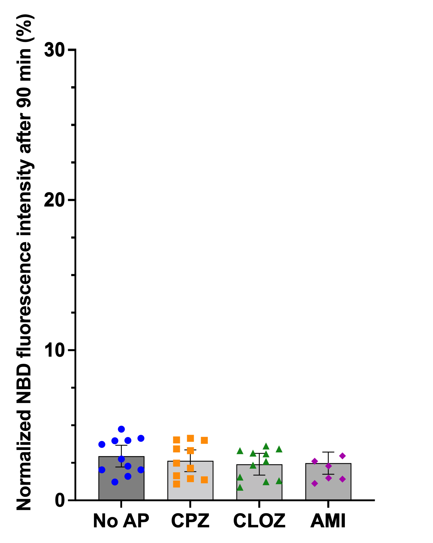
Supplementary Figures
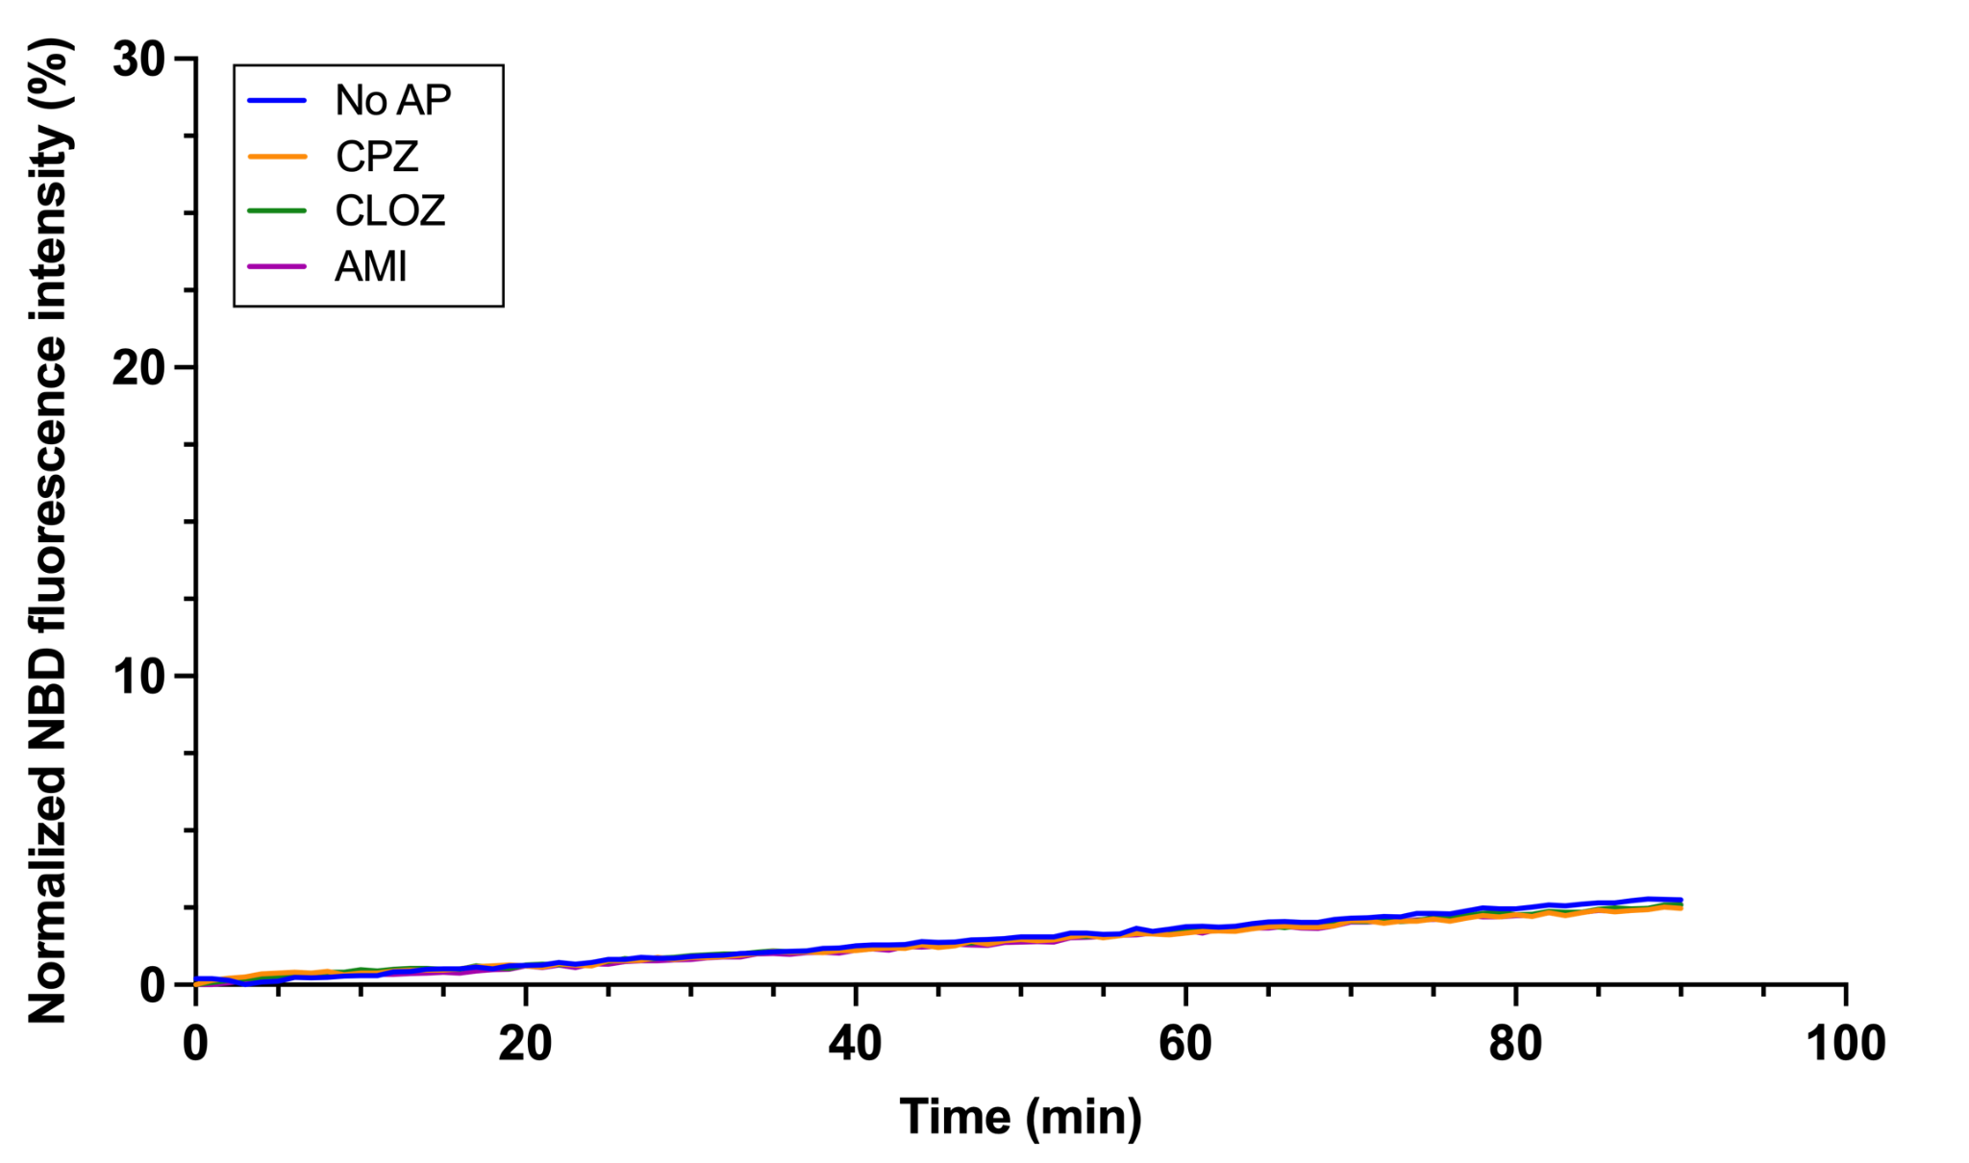

Figure S1. Control experiments for PEG-mediated liposome fusion in vitro. Left: Representative fusion kinetics of liposomes composed of PC:PS:PE (65:10:25 mol%; 500 µM final lipid concentration) in the absence or presence of CPZ, CLOZ, or AMI incorporated at an AP/L molar ratio of 1/100. In this FRET-based lipid mixing assay, PEG 8000 was replaced with buffer H. Right: Control experiment statistics after 90 min. Bars represent estimated marginal means derived from a linear mixed-effects model, including AP treatment as a fixed effect and experiment as a random intercept. Error bars denote 95% confidence intervals. Individual observations are displayed as points. Fewer replicates were performed for the AMI condition; these were appropriately accounted for and incorporated into the model estimation.

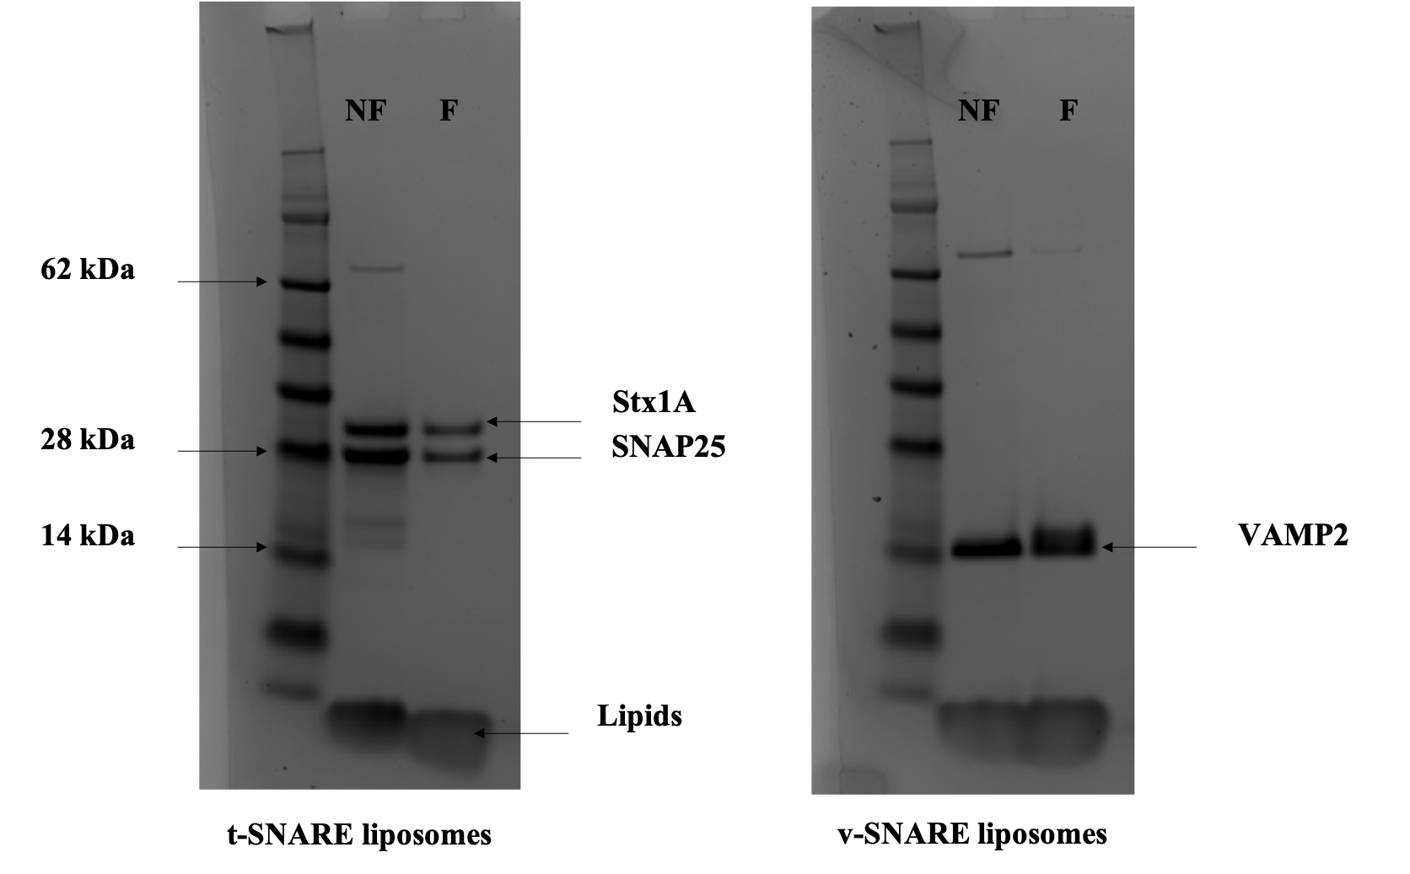

Figure S2. Estimation of lipid-to-protein ratios in neuronal SNARE-reconstituted proteoliposomes. Example of gels used for the quantification in the case of SNARE liposomes without APs. Equal volumes of non-floated (NF) and floated (F) proteoliposomes were loaded onto a polyacrylamide gel, followed by Coomassie Blue staining and imaging. The intensity of each band of interest (Stx1A, SNAP25, VAMP2, and lipids) was quantified using ImageJ. Lipid and protein recovery percentages, as well as lipid-to-protein ratios, were calculated from these measurements.

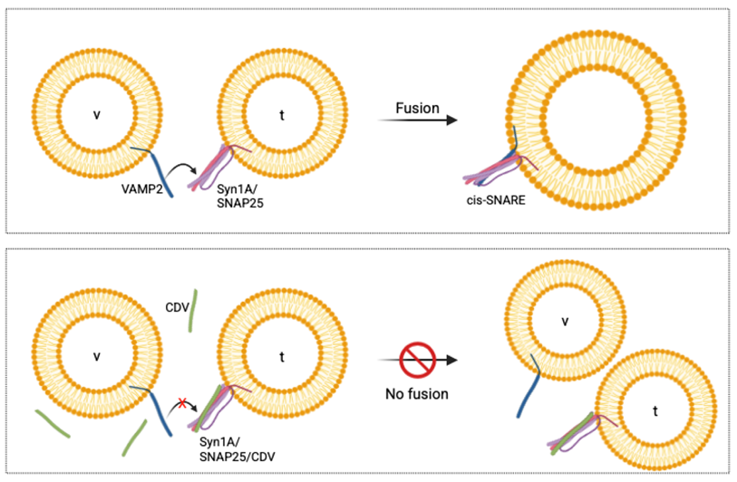

(a)

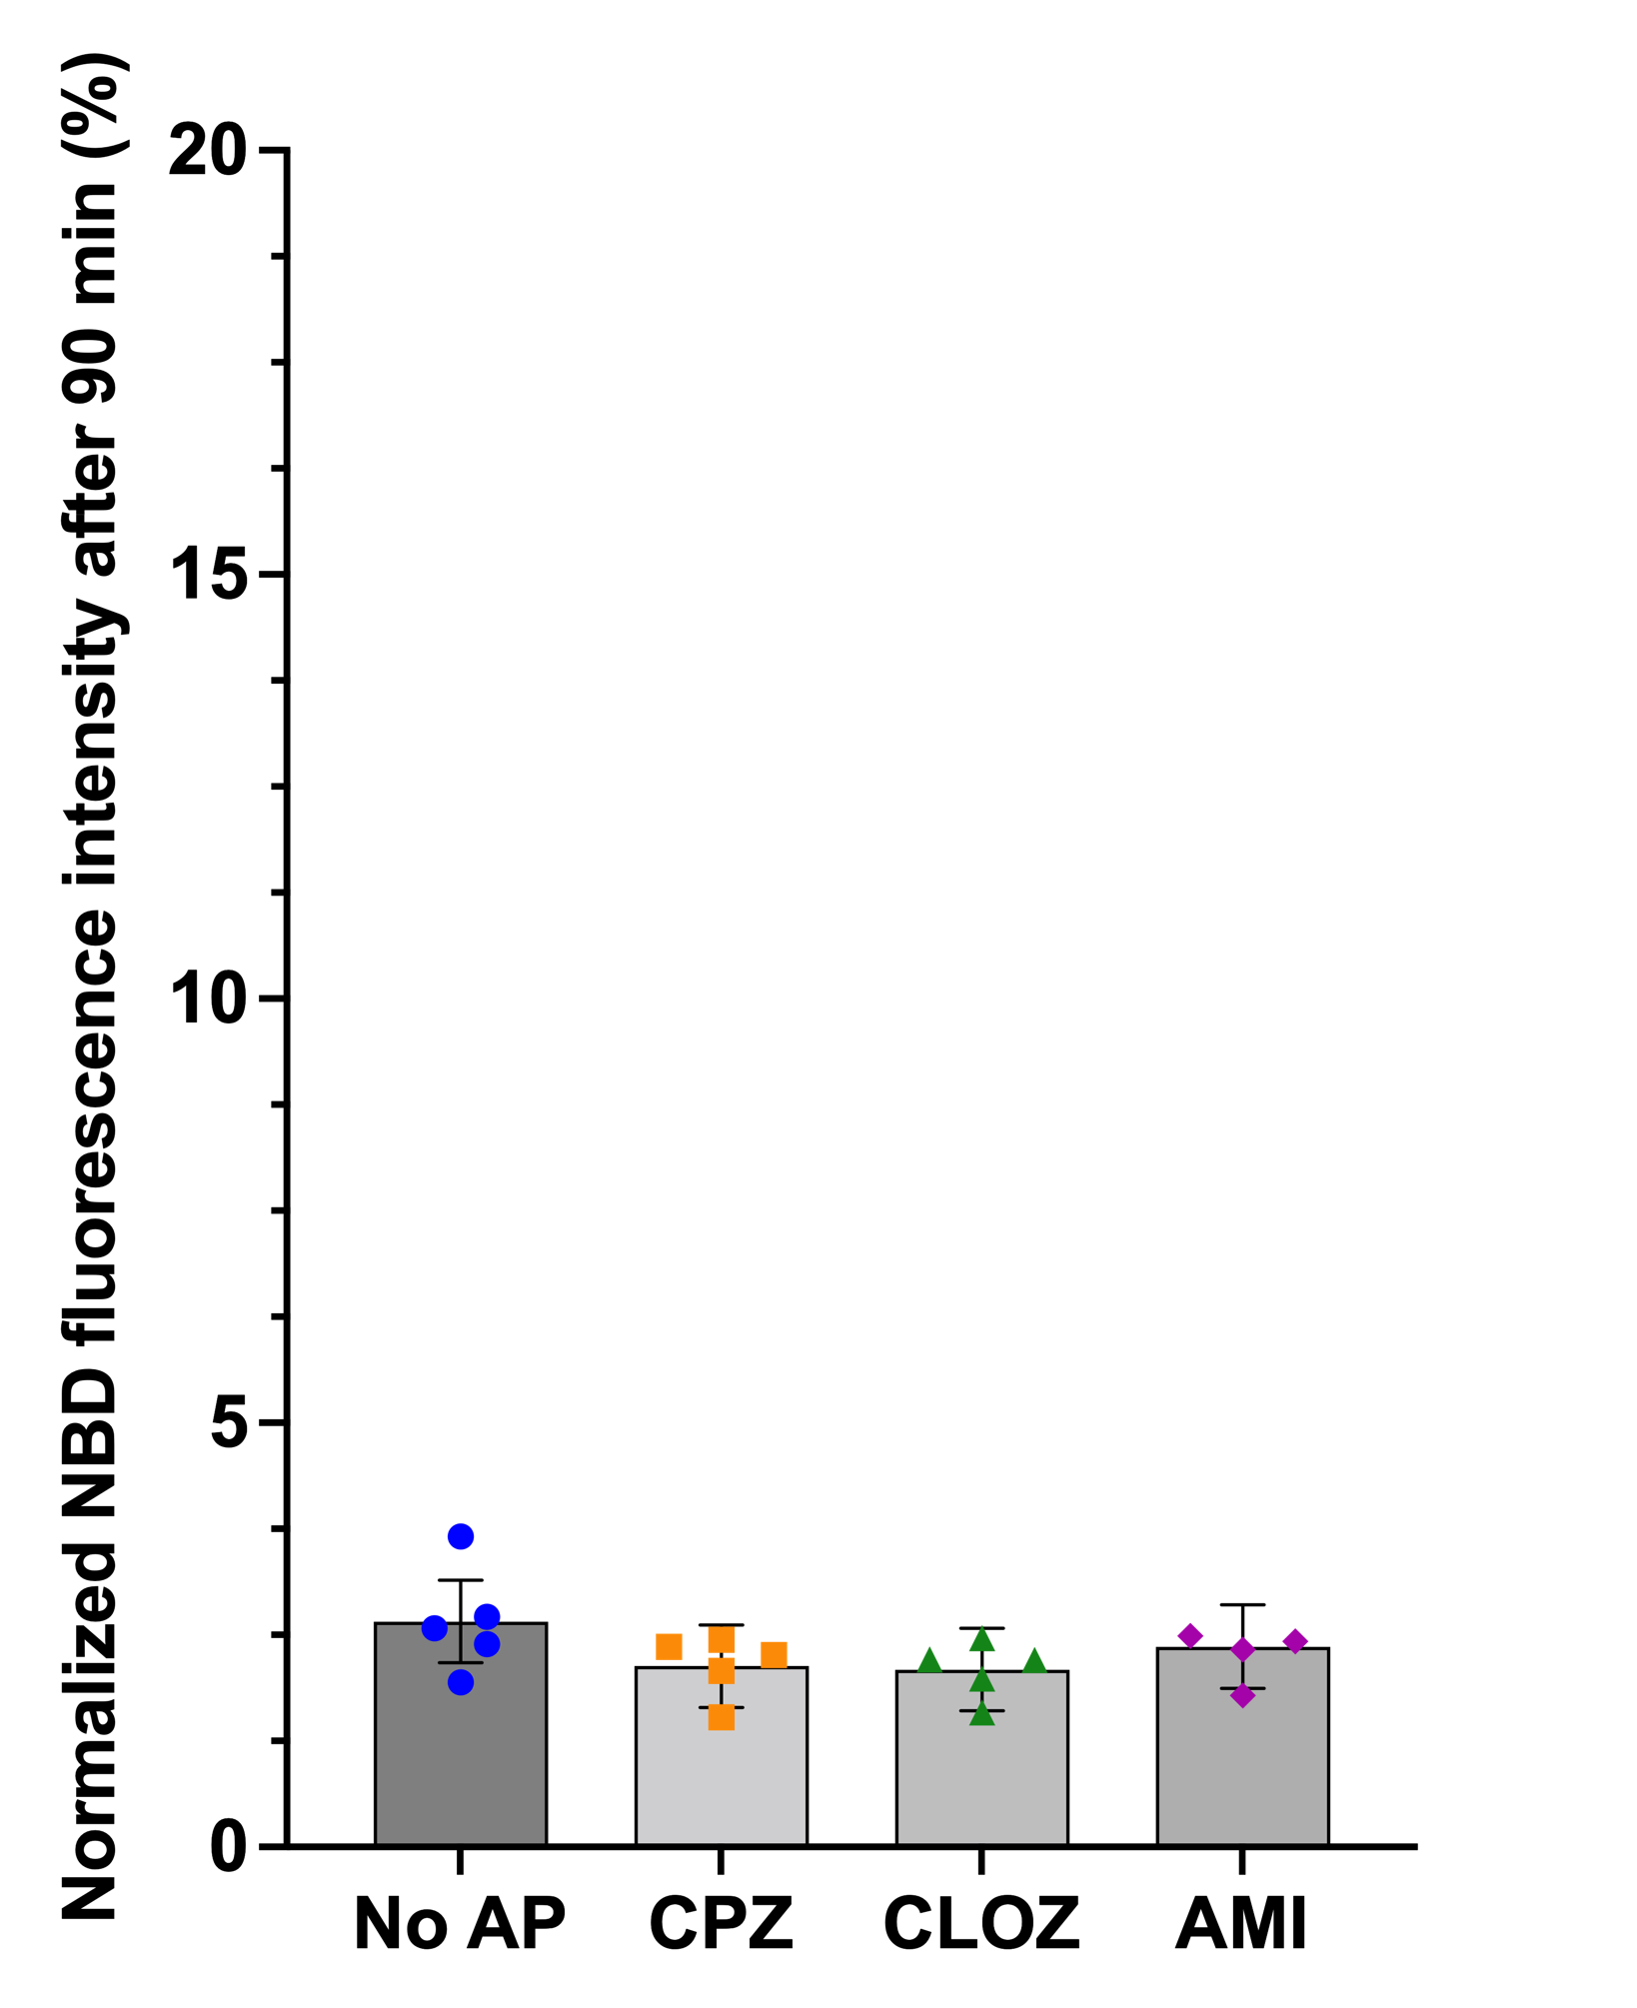
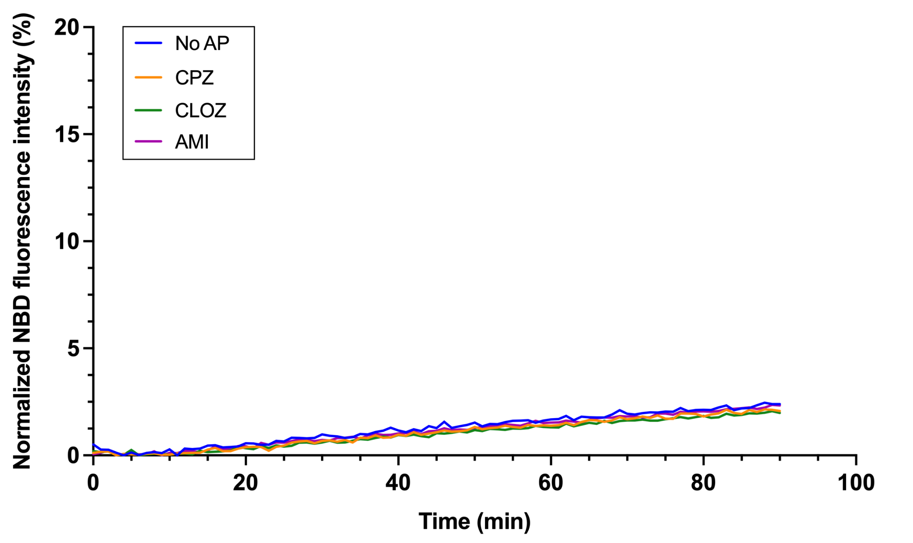

(b)

Figure S3. Control experiments for SNARE-mediated liposome fusion in vitro. (a) Mechanism of action of CDV. Top: In the absence of CDV, cognate v- and t-SNARE proteins assemble to form the trans-SNARE complex, driving liposome fusion. Bottom: When t-SNARE liposomes are pre-incubated with CDV, the resulting Stx1A/SNAP25/CDV complex prevents full-length VAMP2 in donor liposomes from engaging in the trans-SNARE complex. As a result, membrane fusion is blocked. (b) Left: Representative fusion kinetics of liposomes composed of PC:PS:PE (65:10:25 mol%; 1 mM final lipid concentration) in the absence or presence of CPZ, CLOZ, or AMI incorporated at an AP/L molar ratio of 1/100. Right: Control experiment statistics after 90 min. Bars represent estimated marginal means derived from a linear mixed-effects model, including AP treatment as a fixed effect and experiment as a random intercept. Error bars denote 95% confidence intervals. Individual observations are displayed as points. Fewer replicates were performed for the AMI condition; these were appropriately accounted for and incorporated into the model estimation.

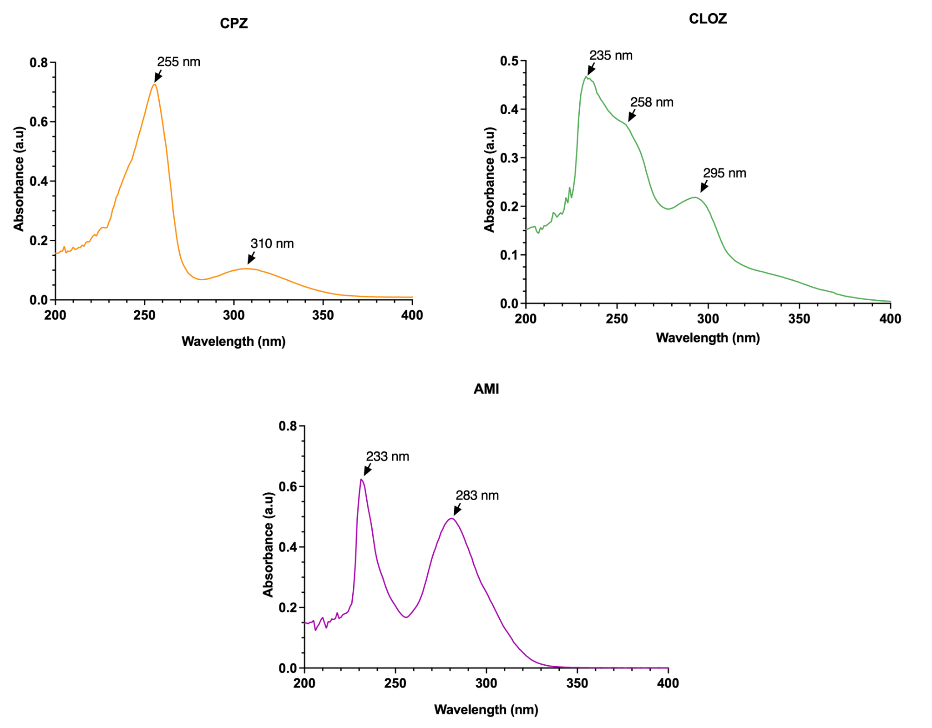

Figure S4. Absorption spectra of CPZ, CLOZ, and AMI. Absorption spectra of CPZ, CLOZ, and AMI (30 µM) in buffer H supplemented with 1% (v/v) DMSO, after subtraction of the buffer signal. Absorption peaks of each AP are indicated by arrows. For partition coefficient calculations, the following wavelengths were selected: 255 nm for CPZ, 295 nm for CLOZ, and 283 nm for AMI.

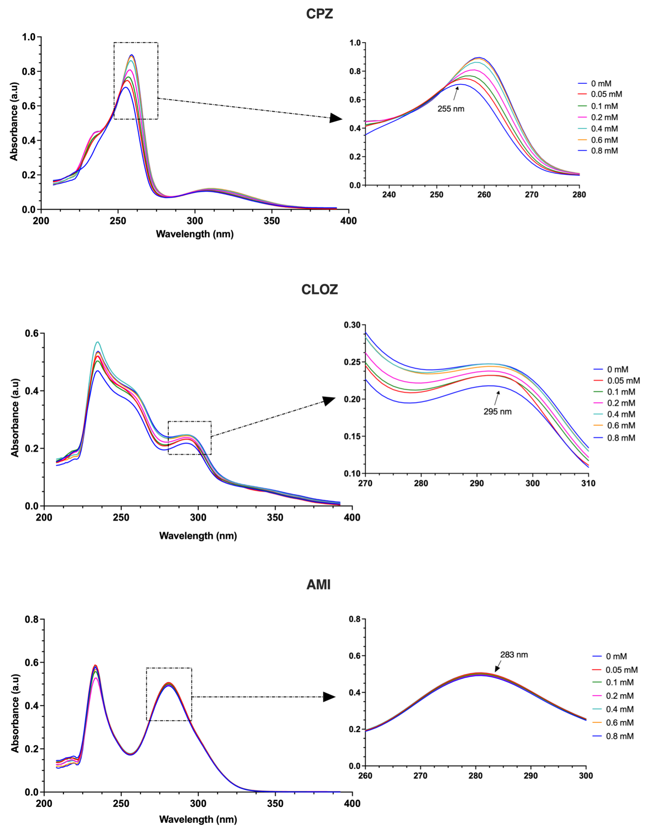

Figure S5. Lipid concentration-dependent spectral changes of APs upon membrane interaction. Absorption spectra of CPZ, CLOZ, and AMI (30 µM) recorded in the presence of protein-free PC:PS:PE (65:10:25 mol%) liposomes at increasing lipid concentrations in buffer H supplemented with 1% (v/v) DMSO, after subtraction of the liposome signal. Zoomed-in panels highlight the absorption maxima used for membrane partition coefficient calculations. CPZ and CLOZ exhibit a progressive increase in intensity and red shift in their absorption peaks with increasing lipid concentration, consistent with membrane insertion, whereas no detectable changes are observed for AMI under identical conditions.

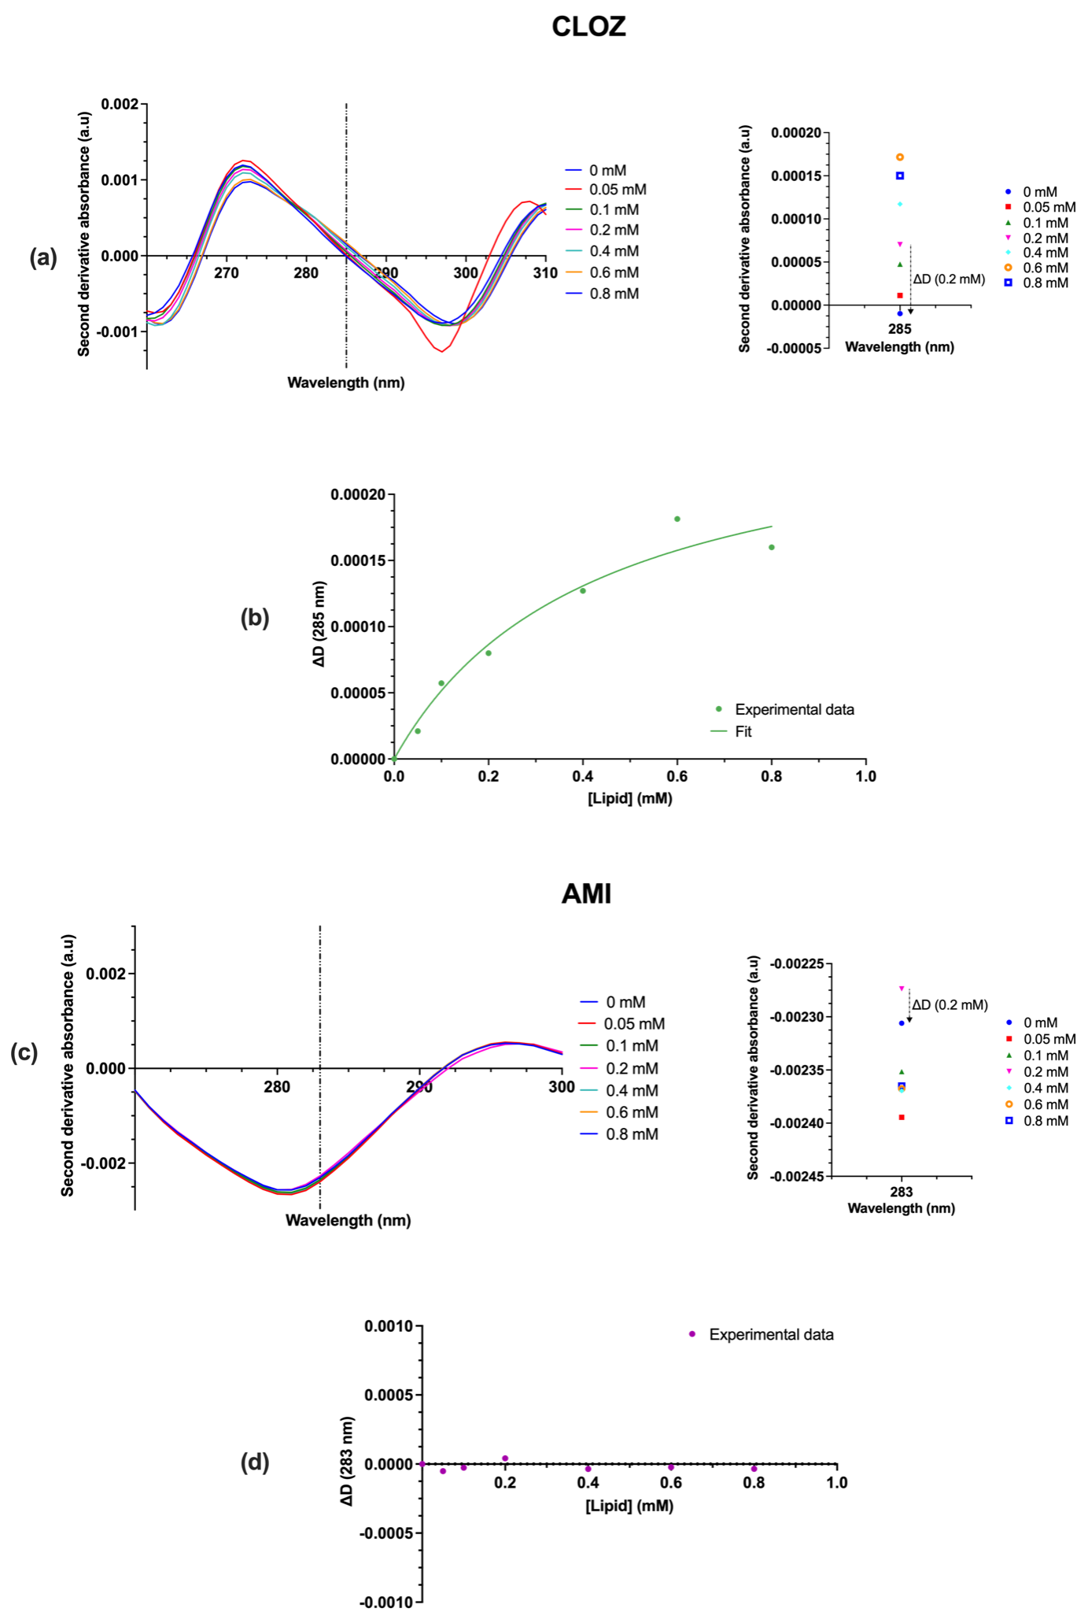

Figure S6. Analysis of second-derivative absorption spectra for CLOZ and AMI. (a) Second-derivative absorption spectra of CLOZ (30 µM) at increasing lipid concentrations in buffer H supplemented with 1% (v/v) DMSO. Vertical dashed lines indicate the wavelengths used for partition coefficient determination. For CLOZ, 285 nm was selected rather than 295 nm due to signal instability observed at 0.05 mM lipid (red curve). Small variations in the working wavelength near the initially selected value do not significantly affect the determination of partition coefficients, as previously reported (6). ΔD values were calculated as the difference between the second-derivative intensity measured at a given lipid concentration and that obtained in the absence of liposomes (right panel, example at 0.2 mM lipid). (b) ΔD values for CLOZ at 285 nm plotted as a function of lipid concentration and fitted using a membrane partitioning model to extract the molar partition coefficient (Kp) and the maximal derivative change (ΔD_{max}). Symbols represent the experimental data points. (c) Second-derivative absorption spectra of AMI (30 µM) at increasing lipid concentrations in buffer H supplemented with 1% (v/v) DMSO. (d) ΔD values for AMI at 283 nm plotted as a function of lipid concentration. No reliable fit could be obtained for AMI under these conditions.

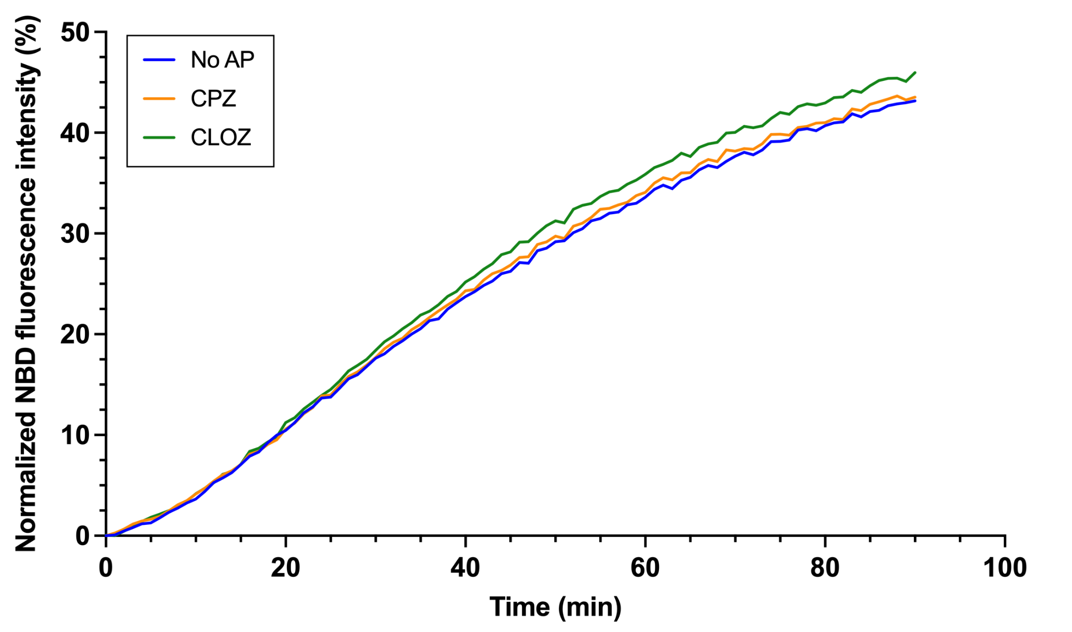

(a)

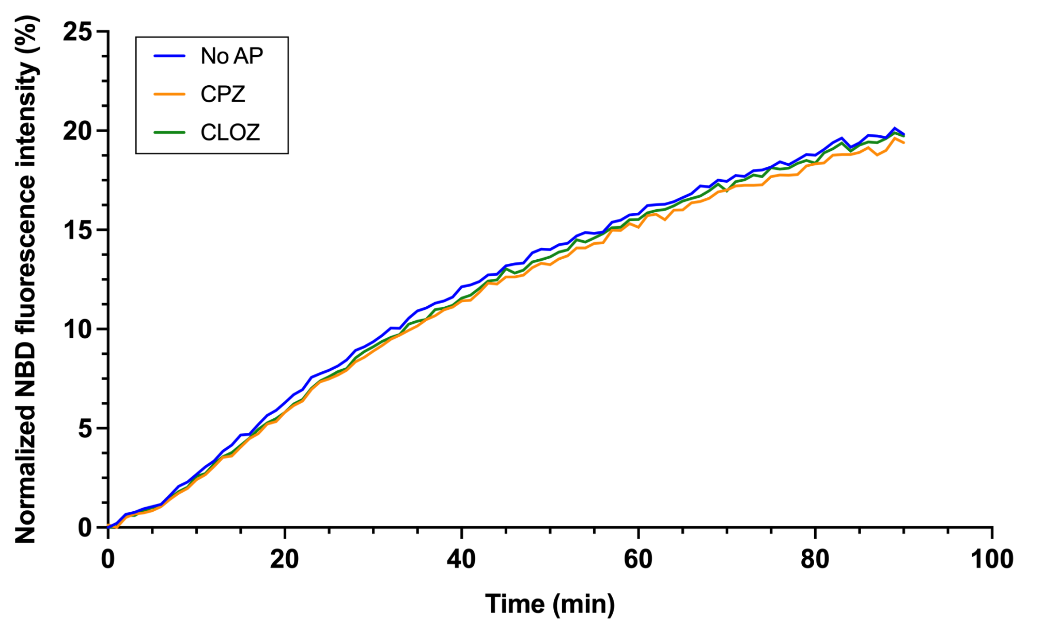

(b)

Figure S7. Effects of the antipsychotics CPZ and CLOZ on PEG- and SNARE-mediated liposome fusion in vitro following their addition to pre-formed liposomes. (a) Representative fusion kinetics of PEG-mediated liposome fusion for liposomes composed of PC:PS:PE (65:10:25 mol%; 500 µM final lipid concentration) in the absence or presence of APs added at an AP/L molar ratio of 1/100. (b) Representative fusion kinetics of SNARE-mediated liposome fusion for liposomes composed of PC:PS:PE (65:10:25 mol%; 1 mM final lipid concentration) in the absence or presence of APs added at an AP/L molar ratio of 1/100. Fluorescent donor and non-fluorescent acceptor liposomes were separately pre-incubated with APs for 30 min at 37°C immediately before the start of the fusion assay. APs were added from a 10% (v/v) DMSO solution, and all fusion experiments (with or without APs) were performed with a final DMSO concentration of 1% (v/v) in buffer H.
Supplementary Table

 | CPZ 10 µM | CPZ 30 µM
Kp (95% CI) | 263 187 (192 652-361 122) | 232 014 (185 212-291 540)
ΔD_{max} (95% CI) | 7.77 (5.95-11.90) x 10⁻⁴ | 1.71 (1.35-2.41) x 10⁻³
ΔD/ΔD_{max} (0.5 mM lipid) | 70% | 68%
ΔD/ΔD_{max} (1 mM lipid) | 79% | 83%

Table S1. Membrane partition coefficient parameters of CPZ at 10 and 30 µM in buffer H in the presence of PC:PS:PE (65:10:25 mol%) liposomes. 95% CI, 95% confidence interval.

References
1. Parlati F, Weber T, McNew JA, Westermann B, Söllner TH, Rothman JE. Rapid and efficient fusion of phospholipid vesicles by the alpha-helical core of a SNARE complex in the absence of an N-terminal regulatory domain. Proc Natl Acad Sci USA. 1999 Oct 26;96(22):12565–70.
2. Weber T, Zemelman BV, McNew JA, Westermann B, Gmachl M, Parlati F, et al. SNAREpins: minimal machinery for membrane fusion. Cell. 1998 Mar 20;92(6):759–72.
3. McNew JA, Weber T, Parlati F, Johnston RJ, Melia TJ, Söllner TH, et al. Close is not enough: SNARE-dependent membrane fusion requires an active mechanism that transduces force to membrane anchors. J Cell Biol. 2000 Jul 10;150(1):105–17.
4. Scott BL, Van Komen JS, Liu S, Weber T, Melia TJ, McNew JA. Liposome fusion assay to monitor intracellular membrane fusion machines. Meth Enzymol. 2003;372:274–300.
5. Ji H, Coleman J, Yang R, Melia TJ, Rothman JE, Tareste D. Protein determinants of SNARE-mediated lipid mixing. Biophys J. 2010 Jul 21;99(2):553–60.
6. Kitamura K, Imayoshi N, Goto T, Shiro H, Mano T, Nakai Y. Second derivative spectrophotometric determination of partition coefficients of chlorpromazine and promazine between lecithin bilayer vesicles and water. Anal Chim Acta. 1995 Mar;304(1):101–6.
7. Savitzky Abraham, Golay MJE. Smoothing and differentiation of data by simplified least squares procedures. Anal Chem. 1964 Jul;36(8):1627–39.
8. Videira RA, Antunes-Madeira M do C, Custódio JB, Madeira VM. Partition of DDE in synthetic and native membranes determined by ultraviolet derivative spectroscopy. Biochim Biophys Acta. 1995 Aug 23;1238(1):22–8.
9. de Castro B, Gameiro P, Lima JL, Matos C, Reis S. A fast and reliable spectroscopic method for the determination of membrane--water partition coefficients of organic compounds. Lipids. 2001 Jan;36(1):89–96.
10. Omran AA, Kitamura K, Takegami S, El-Sayed AA, Abdel-Mottaleb M. Determination of partition coefficients of diazepam and flurazepam between phosphatidylcholine bilayer vesicles and water by second derivative spectrophotometric method. J Pharm Biomed Anal. 2001 May;25(2):319–24.
11. Rodrigues C, Gameiro P, Reis S, Lima JL, de Castro B. Derivative spectrophotometry as a tool for the determination of drug partition coefficients in water/dimyristoyl-L-alpha-phosphatidylglycerol (DMPG) liposomes. Biophys Chem. 2001 Dec 11;94(1–2):97–106.
12. Takamori S, Holt M, Stenius K, Lemke EA, Grønborg M, Riedel D, et al. Molecular anatomy of a trafficking organelle. Cell. 2006 Nov 17;127(4):831–46.

