Supplementary material
A leakage-aware benchmark for evaluating chemical and cellular generalization in single-cell perturbation-response prediction

Supplementary methods

Fixed manifests and integrity checks
For each seed, fixed manifests assign every record to train, test, or, for joint tasks, excluded. Random-control draws are deterministic functions of the same seed and fixed random manifest. Joint record identities are used only to obtain target counts and are never transferred into random-control partitions. Prediction archives are checked for aligned record identifiers, target and prediction vector length, and exclusion of test or excluded records from fitting, normalization, validation, early stopping, or hyperparameter selection.

Model input contracts
Transparent probes use only information available under the manifest. The control-conditioned nonlinear benchmark uses basal/control expression, a 1,024-bit fingerprint, log dose, and cell-line one-hot features; its validation partition is derived only from training records. It is not a full reproduction of TranSiGen. PRnet-interface results remain adaptation-status outputs.

Supplementary Figure S1
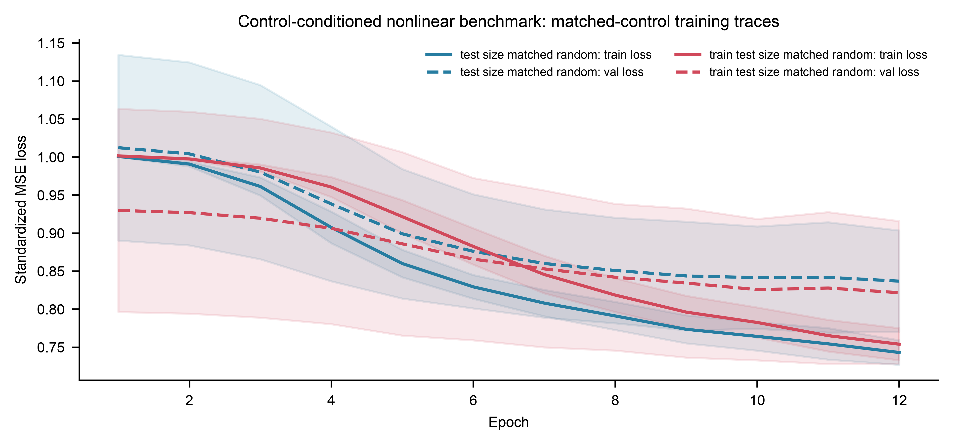
Supplementary Figure S1. Training and validation loss traces for the control-conditioned nonlinear benchmark under Sci-Plex 3 matched-random controls. Lines show the mean across completed fixed seeds and shaded regions show one standard deviation.

Supplementary Table S1. Fixed split accounting
Dataset | Split | Seeds | Manifest train | Manifest test | Excluded | Evaluable test
OpenProblems | cell held-out | 100 | 414.7 ± 1.9 | 138.3 ± 1.9 | 0.0 ± 0.0 | 136.3 ± 1.9
OpenProblems | joint held-out | 100 | 333.5 ± 2.1 | 27.2 ± 1.0 | 192.3 ± 1.5 | 26.8 ± 1.2
OpenProblems | random | 100 | 443.0 ± 8.7 | 110.0 ± 8.7 | 0.0 ± 0.0 | 108.4 ± 8.5
OpenProblems | scaffold held-out | 100 | 444.7 ± 2.6 | 108.3 ± 2.6 | 0.0 ± 0.0 | 106.7 ± 3.7
Sci-Plex 3 | cell held-out | 30 | 1,468.8 ± 10.5 | 731.2 ± 10.5 | 0.0 ± 0.0 | 731.2 ± 10.5
Sci-Plex 3 | joint held-out | 30 | 1,183.7 ± 25.8 | 141.9 ± 11.8 | 874.4 ± 14.9 | 141.9 ± 11.8
Sci-Plex 3 | random | 30 | 1,762.5 ± 16.4 | 437.5 ± 16.4 | 0.0 ± 0.0 | 437.5 ± 16.4
Sci-Plex 3 | scaffold held-out | 30 | 1,772.9 ± 35.0 | 427.1 ± 35.0 | 0.0 ± 0.0 | 427.1 ± 35.0

Supplementary Table S2. Completed multi-probe performance
Dataset | Probe | Random | Scaffold held-out | Joint held-out
OpenProblems | Global mean | 0.234 ± 0.016 | 0.234 ± 0.032 | 0.172 ± 0.048
OpenProblems | Cell-context or cell-line mean | 0.303 ± 0.016 | 0.307 ± 0.031 | 0.172 ± 0.048
OpenProblems | Drug mean | 0.287 ± 0.016 | 0.234 ± 0.032 | 0.172 ± 0.048
OpenProblems | Cell-context ridge | 0.303 ± 0.016 | 0.307 ± 0.032 | 0.172 ± 0.048
OpenProblems | Drug-fingerprint ridge | 0.295 ± 0.016 | 0.164 ± 0.027 | 0.118 ± 0.034
OpenProblems | Cell-context + drug-fingerprint ridge | 0.362 ± 0.016 | 0.234 ± 0.027 | 0.118 ± 0.034
Sci-Plex 3 | Global mean | 0.162 ± 0.007 | 0.160 ± 0.018 | 0.076 ± 0.026
Sci-Plex 3 | Cell-context or cell-line mean | 0.232 ± 0.007 | 0.230 ± 0.020 | 0.076 ± 0.026
Sci-Plex 3 | Drug mean | 0.240 ± 0.008 | 0.160 ± 0.018 | 0.076 ± 0.026
Sci-Plex 3 | Drug-fingerprint ridge | 0.243 ± 0.008 | 0.126 ± 0.018 | 0.058 ± 0.023
Sci-Plex 3 | Cell-line + dose + drug-fingerprint ridge | 0.292 ± 0.008 | 0.189 ± 0.019 | 0.060 ± 0.025
Sci-Plex 3 | Control-conditioned nonlinear benchmark | 0.233 ± 0.013 | 0.212 ± 0.020 | 0.017 ± 0.017

Supplementary Table S3. Train-and-test-size-matched random contrasts
Dataset | Probe | Seeds | Difference | 95% CI
OpenProblems | Cell-context + fingerprint ridge | 100 | 0.218 | 0.208 to 0.228
Sci-Plex 3 | Control-conditioned nonlinear benchmark | 30 | 0.228 | 0.219 to 0.238

