Supplementary Material for
Beyond Aggregation Bias: The Importance of Consistency with Official Statistics in MRIO-Based Carbon Footprints

Figure SM1 shows the consistency between the final demand elements of European countries reported in the 2025 edition of Eurostat and the macroaggregates reported by Eurostat, which are the same as those reported to the UN. The results show that there is a very high consistency between both sources with only a few outliers, which in case report differences below 1%. Thus, the different editions of FIGARO represent a good benchmark against which the macroaggregate data of academic MRIO databases can be compared.

Figure SM1: Comparison between the final demand elements of FIGARO for European countries and data reported by Eurostat
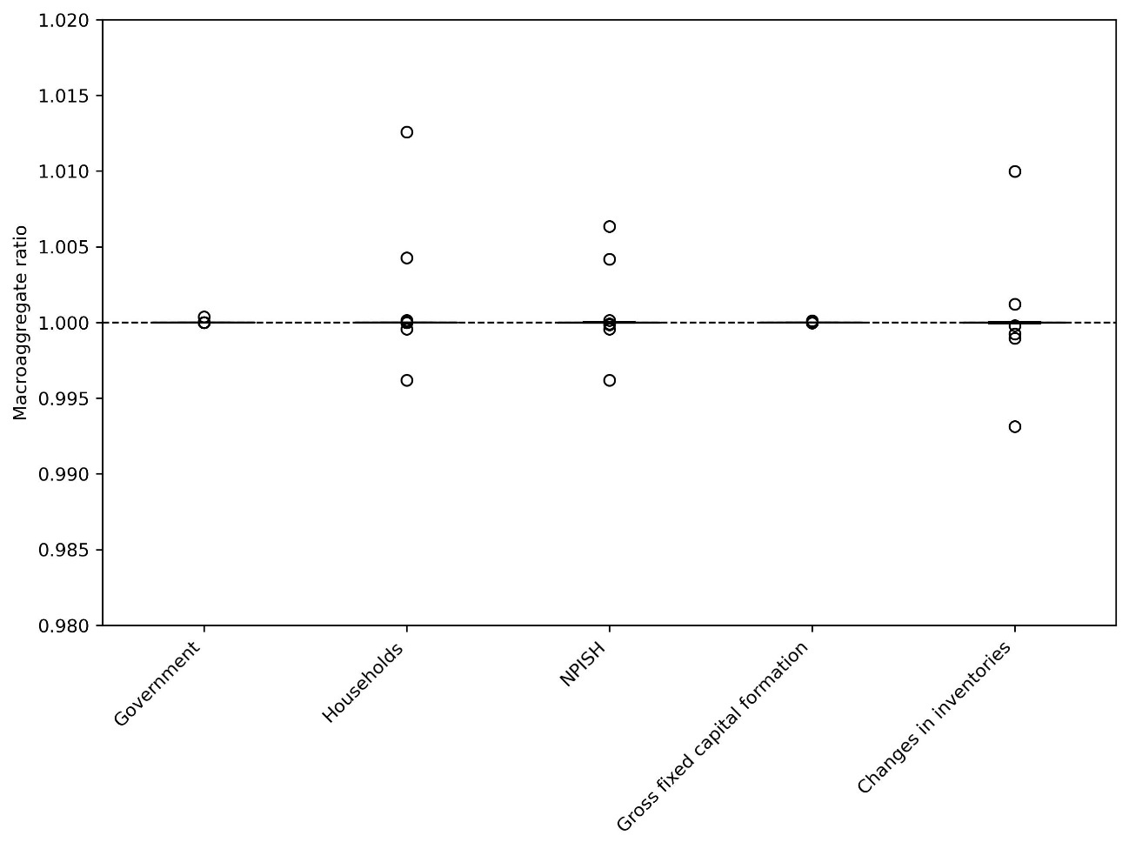

As shown in Figure SM2, agreement with FIGARO values differs both in terms of database and specific element of the final demand. Thus, EXIOBASE shows a high agreement in the case of government and household final demand, but the differences increase in the other elements, in particular changes in inventories.
Figure SM2: Comparison between the final demand elements of academic databases and FIGARO
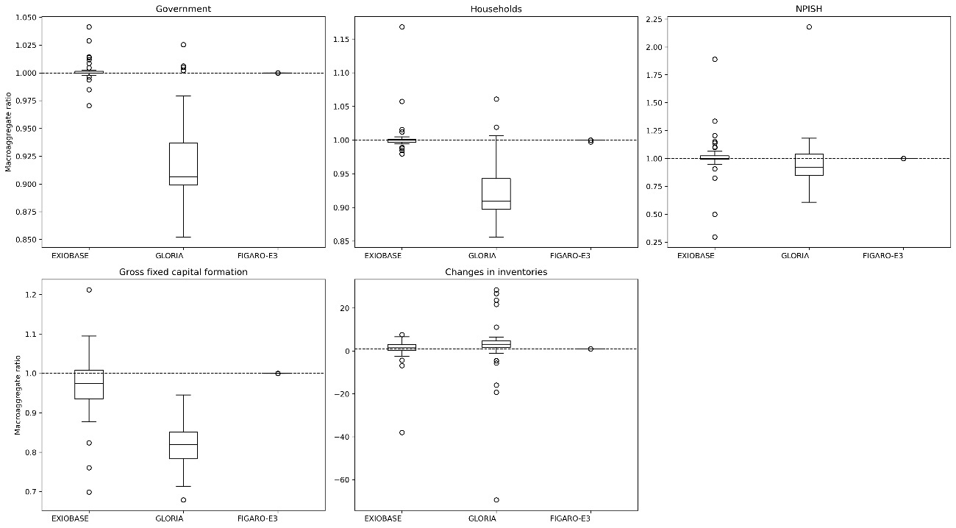

Figure SM3 shows the aggregation bias of the carbon footprint of the products with the highest footprint. While the results vary depending on the database, they seem to agree that electricity and agricultural products are the products most impacted by the aggregation bias. For EXIOBASE, the aggregation bias varies between -73% to 96% in those five product categories. For GLORIA, the range goes from -63% to +78%, while for FIGARO-E3, the range is -81% to +37%.

Figure SM3: Product carbon footprint comparison between aggregated and disaggregated academic MRIO databases (only European countries)
