SUPPLEMENTARY MATERIAL
Supplementary Table S1. List of 30 forage sorghum genotypes evaluated in the study (source: ICAR–IIMR, Hyderabad).
Code | Type | Genotype name | Pedigree
G1 | B Line | 403B | (NSSB 1003 × NSSB 26)-3-1
G2 | B Line | 301B | (NSSB 2 × 2219B)-3-1
G3 | B Line | 412B | (NSSB 1002 × NSSB 1005)-3-5-3
G4 | B Line | 354B | (ICSB 342 × ICSB 687)-1-3-2
G5 | B Line | ICS56B | (Serere elite × IS 9530)-2
G6 | B Line | 429B | (ICSB 342 × ICSB 687)-1-3-2
G7 | B Line | NSS11B | Pedigree not available
G8 | B Line | 402B | (NSSB 1003 × NSSB 26)-2-2
G9 | B Line | 428B | (ICSB 342 × ICSB 467)-10-2-2
G10 | Variety | CSV33MF | EMS mutant of CO FS 29
G11 | B Line | 384B | (NSSB 5 × 2219B)-5-1
G12 | B Line | 308B | (NSSB 5 × 2219B)-4-2
G13 | B Line | 370B (Black) | (90001B × NSSB 1005)-4-1-2
G14 | Variety | CSV27 | (GJ 38 × Indore 12)-2-1-2-1
G15 | B Line | 382B | (NSSB 2 × 2219B)-3-2
G16 | Restorer | RS29 | Pedigree not available
G17 | B Line | 467B | [((ICSB 11 × ICSV 700) × PS 19349B) × ICSB 13]4-1
G18 | B Line | Red B | Pedigree not available
G19 | B Line | 327B | (NSSB 1003 × NSSB 26)-2-2
G20 | Variety/Restorer | CSV33MF | Derived from COFS29
G21 | Variety/Restorer | CSV32F | HC 260 × B 35
G22 | Variety/Restorer | CSV21F | GSSV 148 × SR 897
G23 | Restorer | UPMC503 | Selection from IS 5977
G24 | B Line | 348B | (ICSB 342 × ICSB 467)-2-3-3
G25 | B Line | 424B | (ICSB 342 × ICSB 467)-2-3-3
G26 | B Line | 314B | (NSSB 15 × 296B)-2-1
G27 | Restorer | PCD-8-1-2 | Not available
G28 | B Line | 307B | (NSSB 5 × 2219B)-4-1
G29 | B Line | 409B | (27B × NSSB 1002)-8-2
G30 | Restorer | SSG-59-3 | Non-sweet sudan grass × IS-263

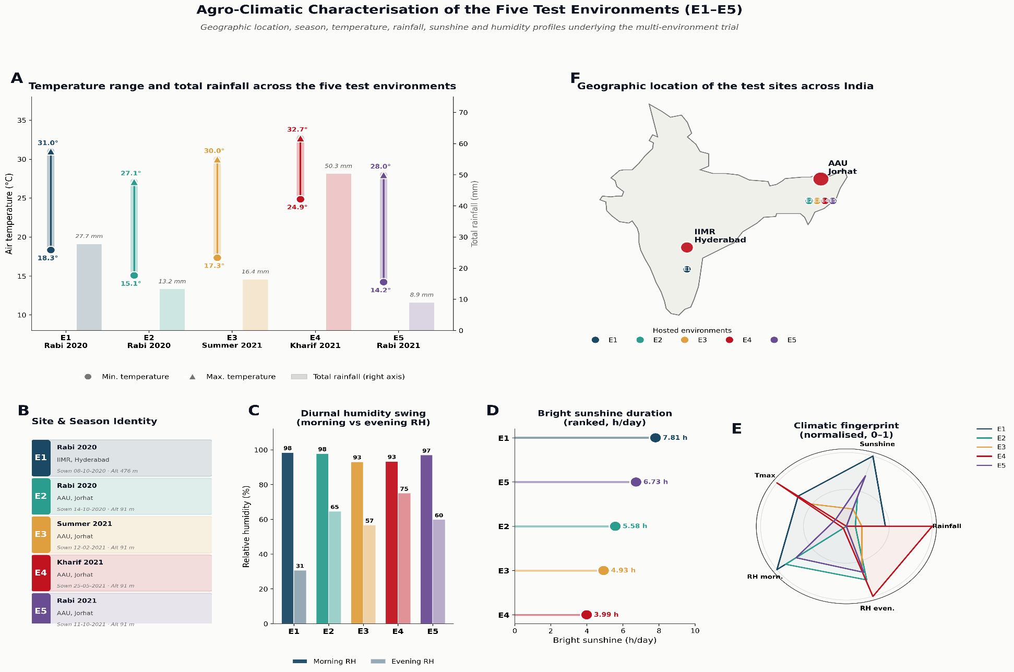
Supplementary Figure S1 Agro-climatic characterization of the five test environments by location, growing season and meteorological parameters.

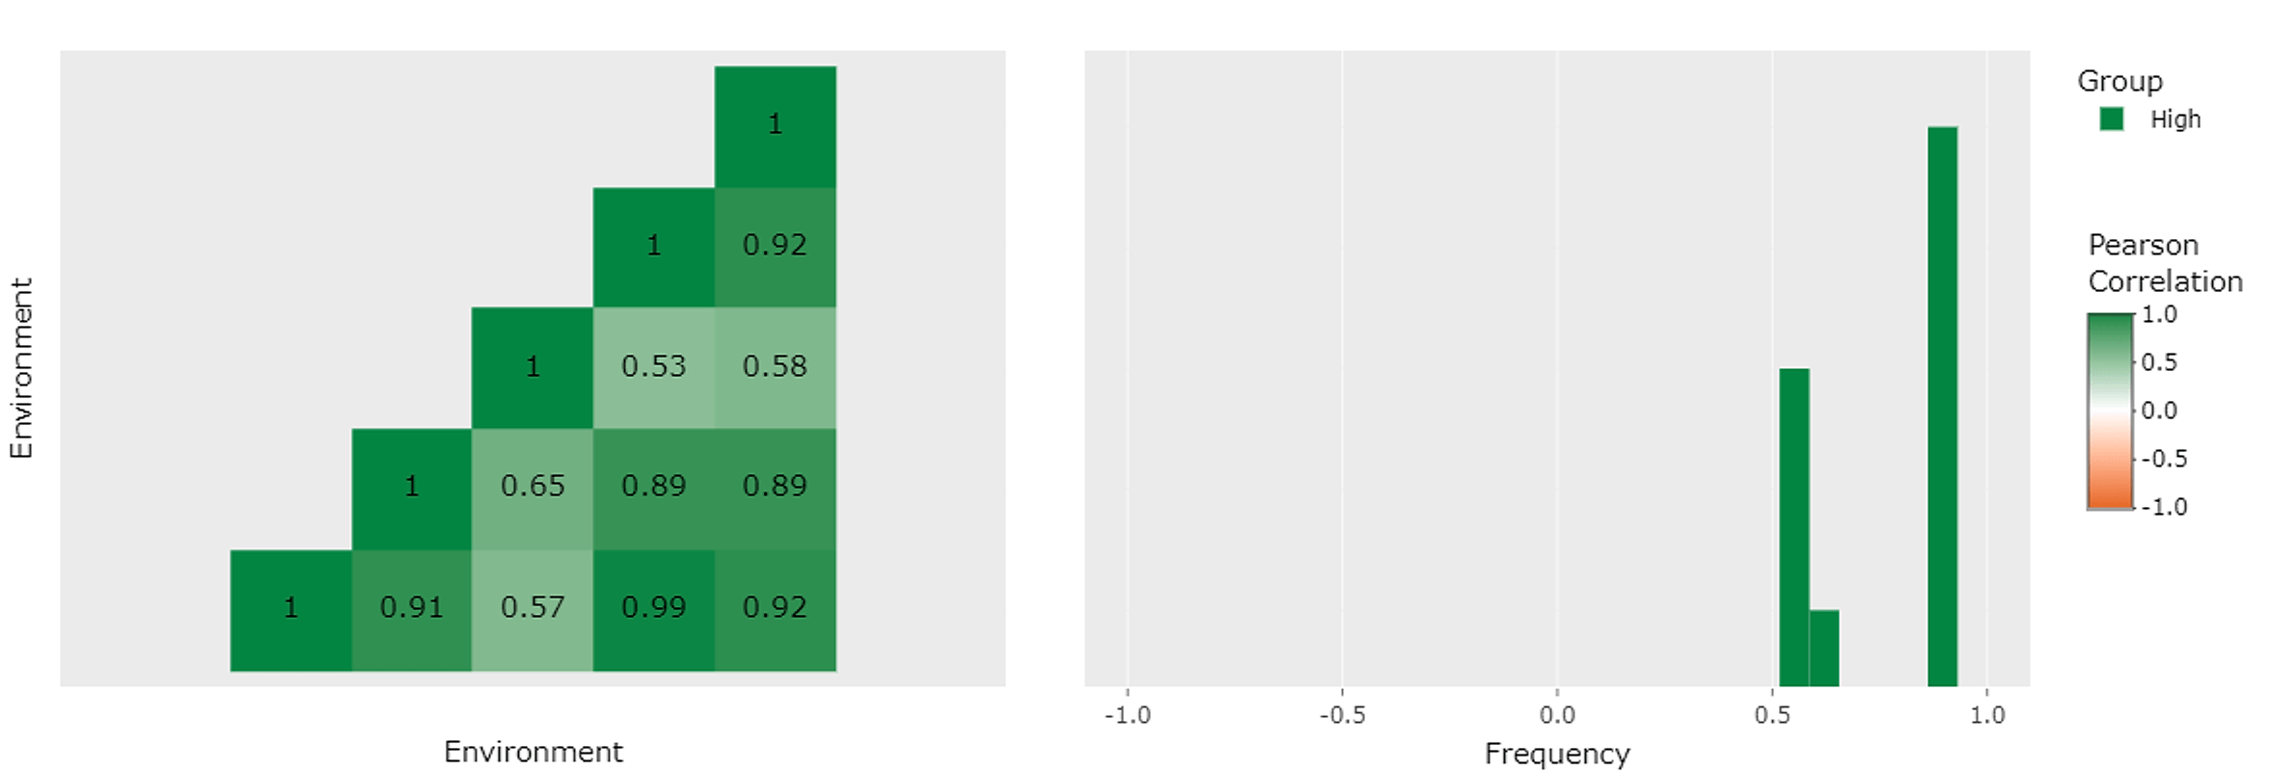
Supplementary Figure S2. Pairwise Pearson correlations among environments (heat map, left) and their frequency distribution (right). Most environments are strongly positively correlated.
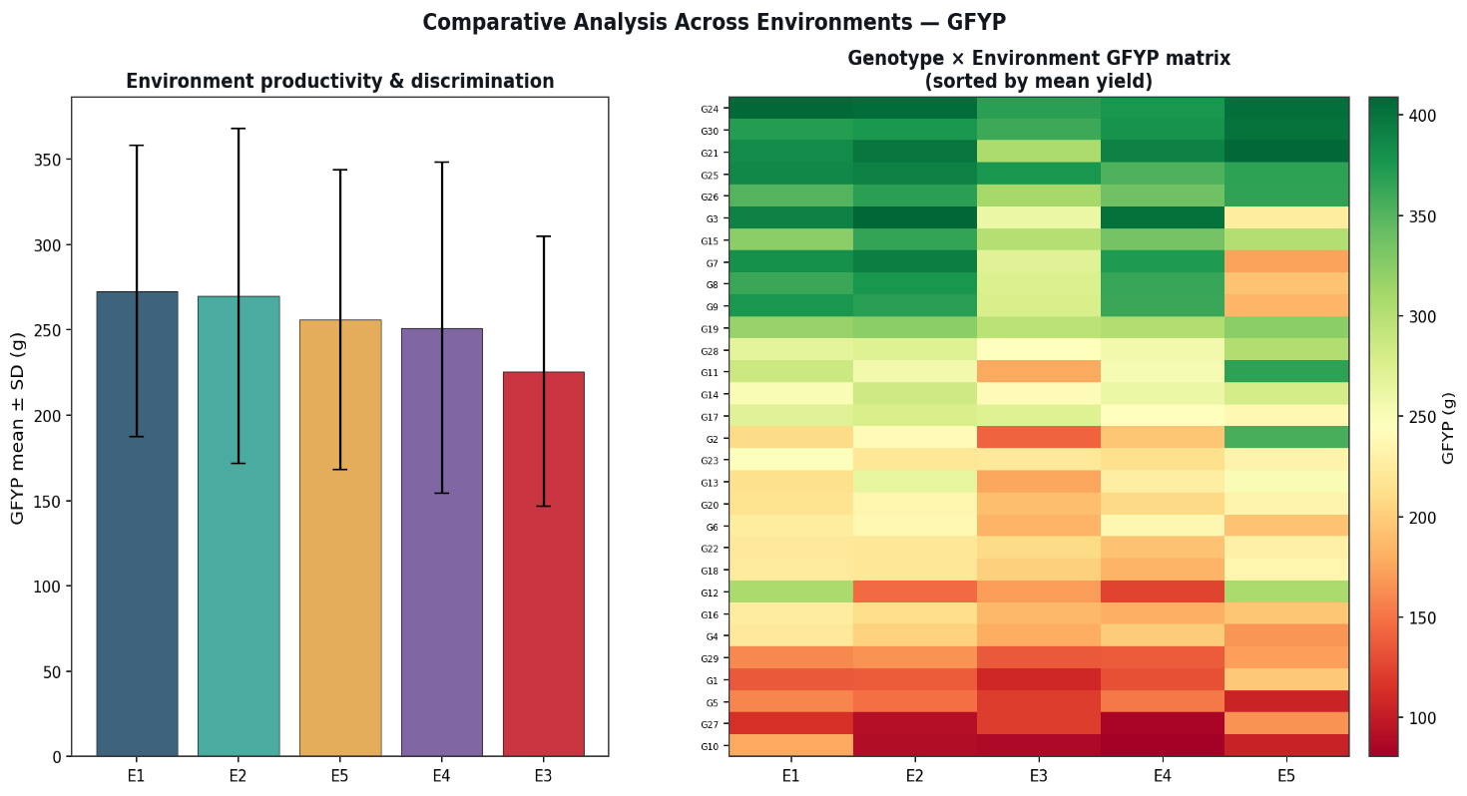
Supplementary Figure S3. Box plots of green forage yield per plant across the five environments, showing variation in median, range and spread of genotypic performance.

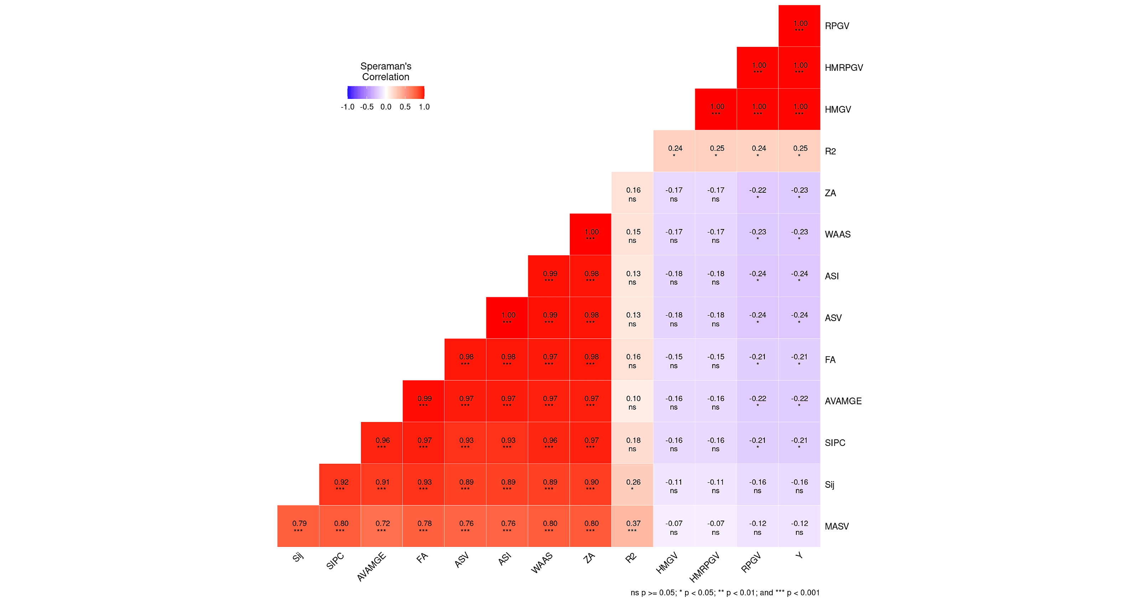
Supplementary Figure S4. Correlation among AMMI-based stability parameters for green forage yield per plant. All stability measures are strongly positively correlated, while mean yield (Y) correlates negatively with the stability indices.

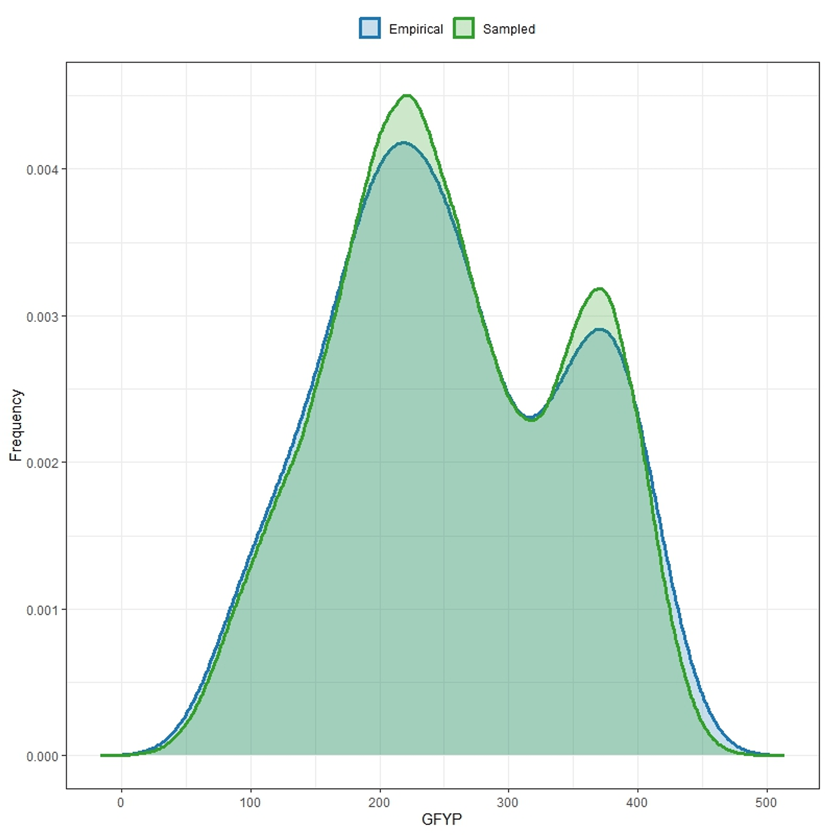
Supplementary Figure S5. Density plot comparing empirical (observed) and sampled (model-estimated) GFYP distributions; close overlap of the two bimodal curves confirms model convergence.
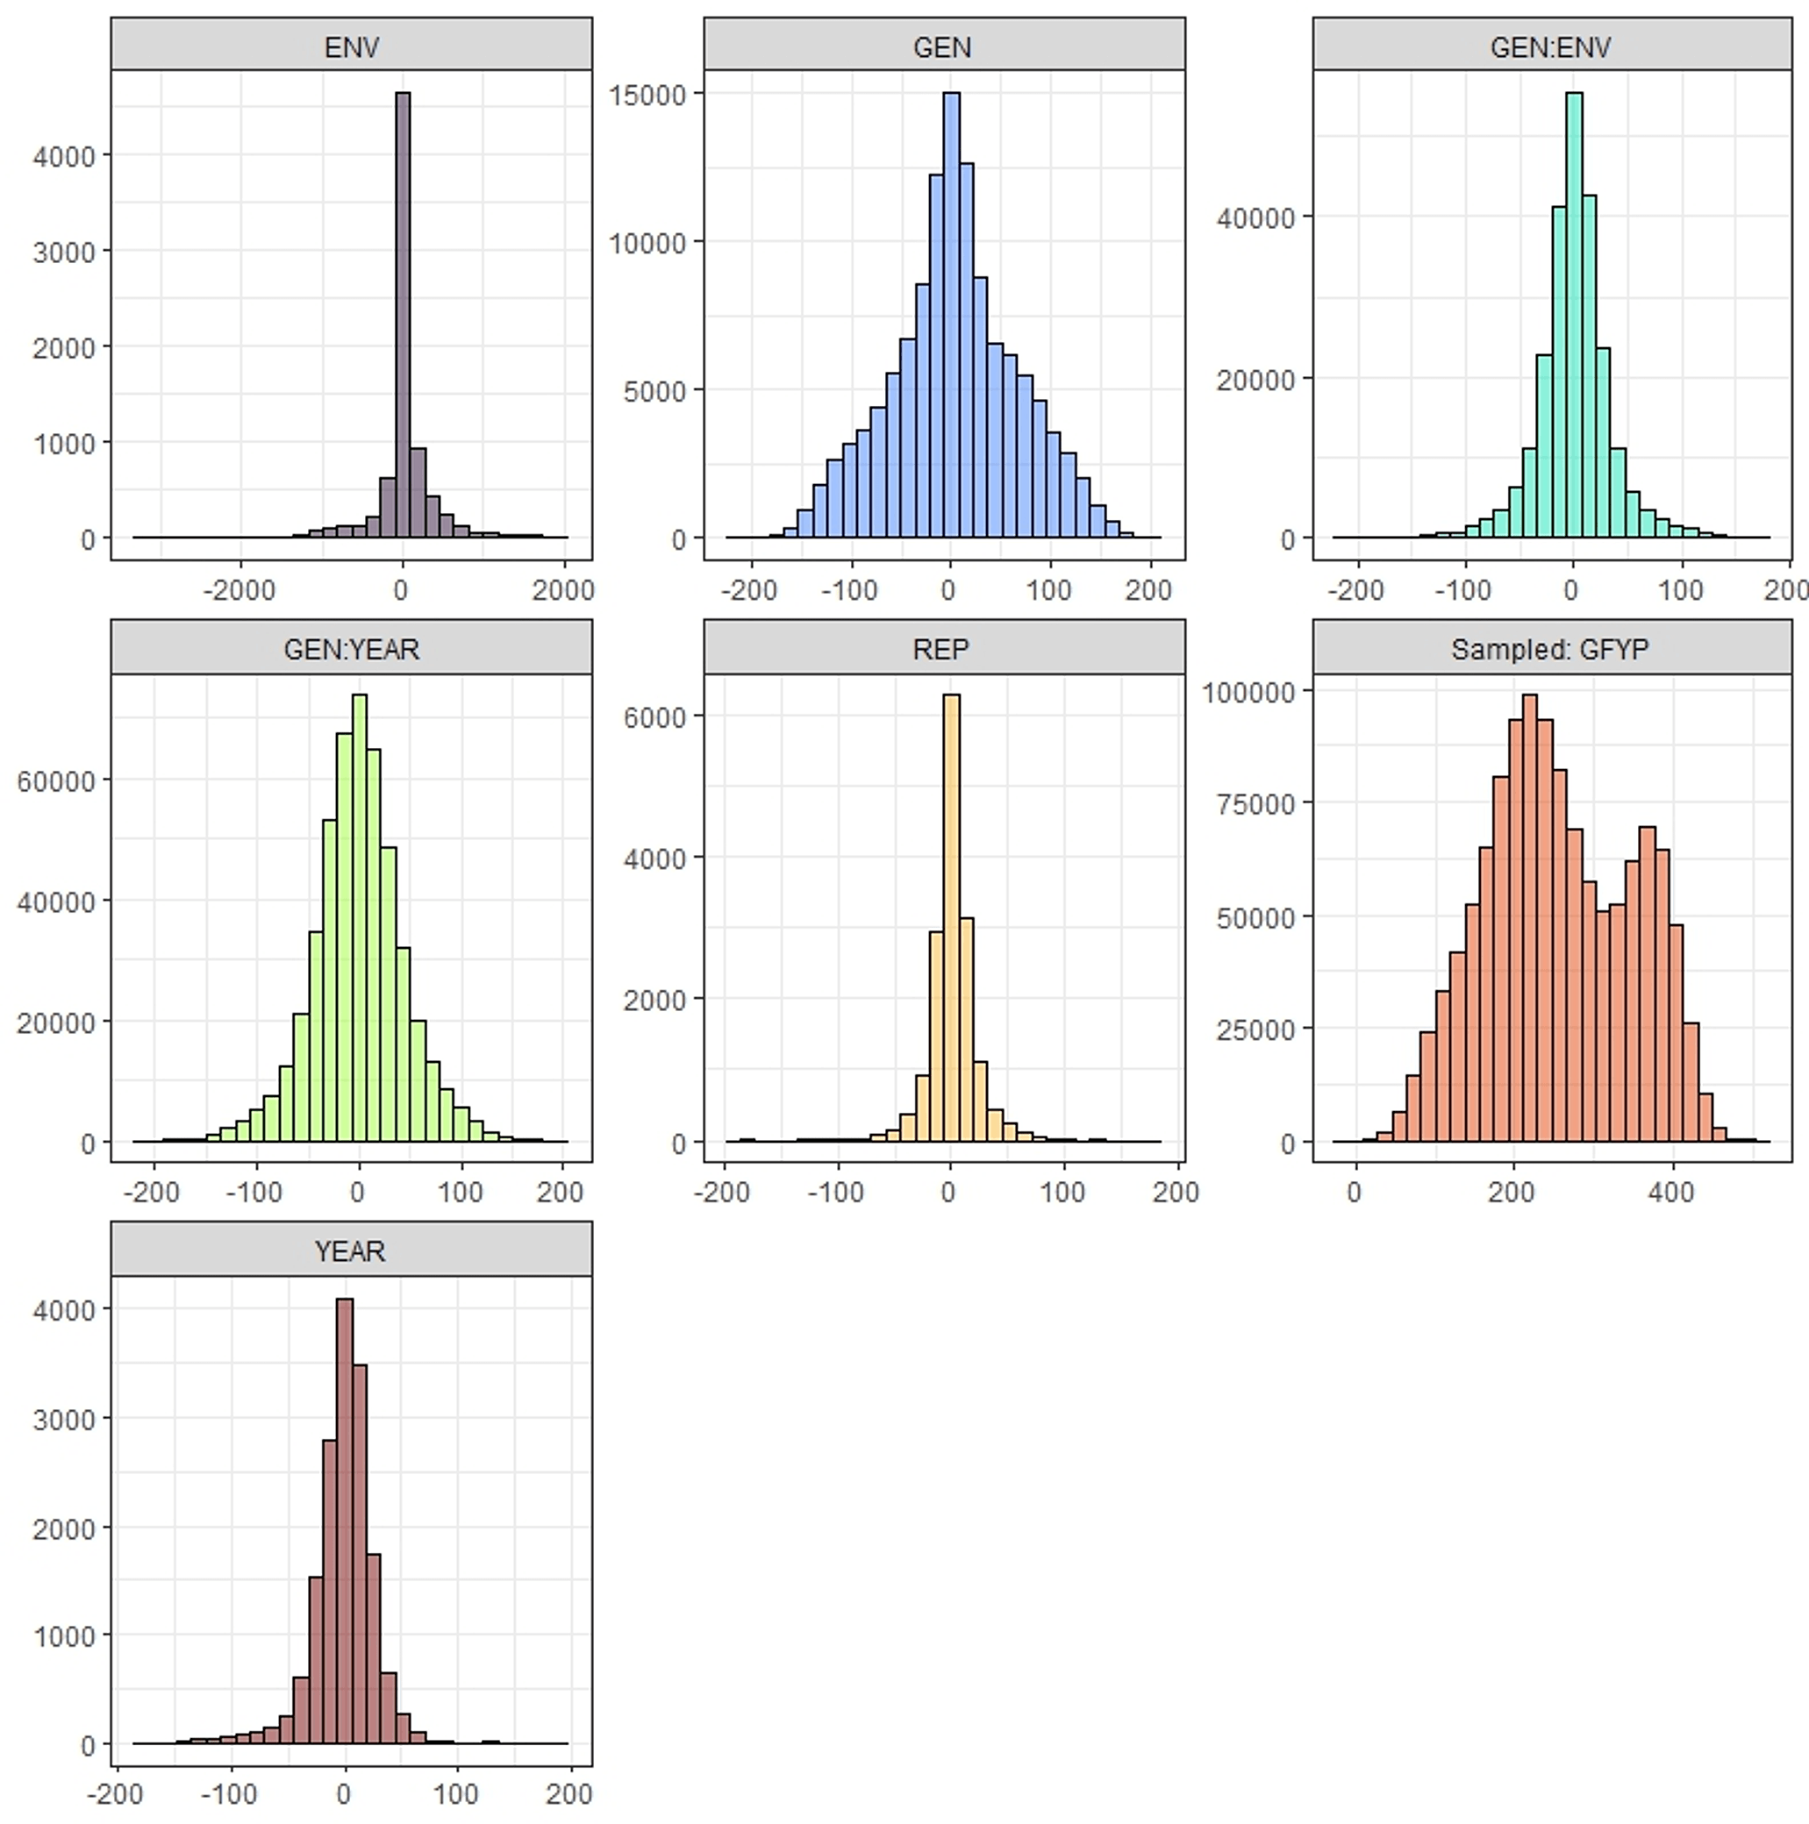
Supplementary Figure S6. Probability distributions of the variance components for green forage yield per plant (ENV, GEN, GEN×ENV, GEN×YEAR, REP, YEAR and sampled GFYP)

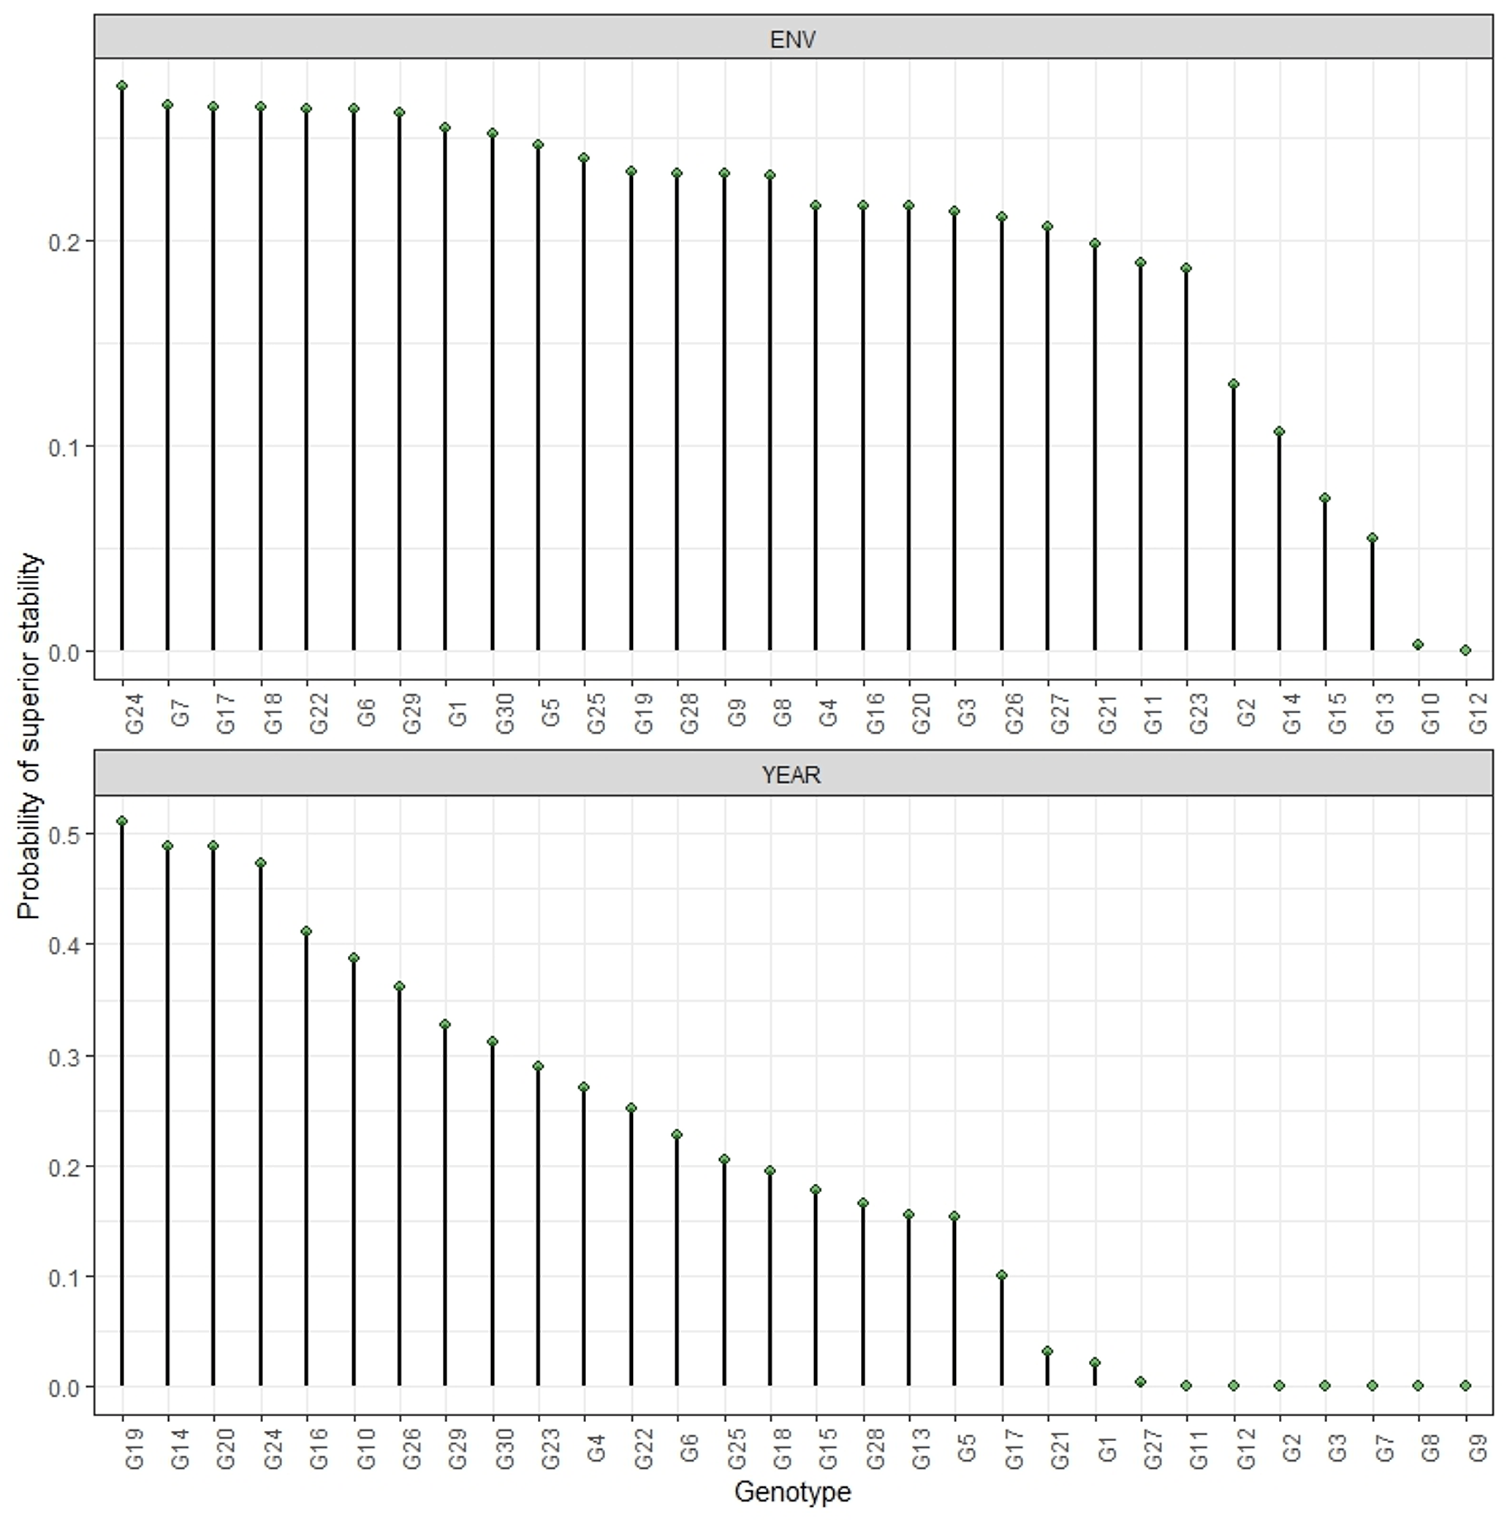
Supplementary Figure S7. Probability of superior stability of forage sorghum genotypes across environments (top) and years (bottom); only a few genotypes (e.g. G19, G20, G24, G16) combine high stability probabilities
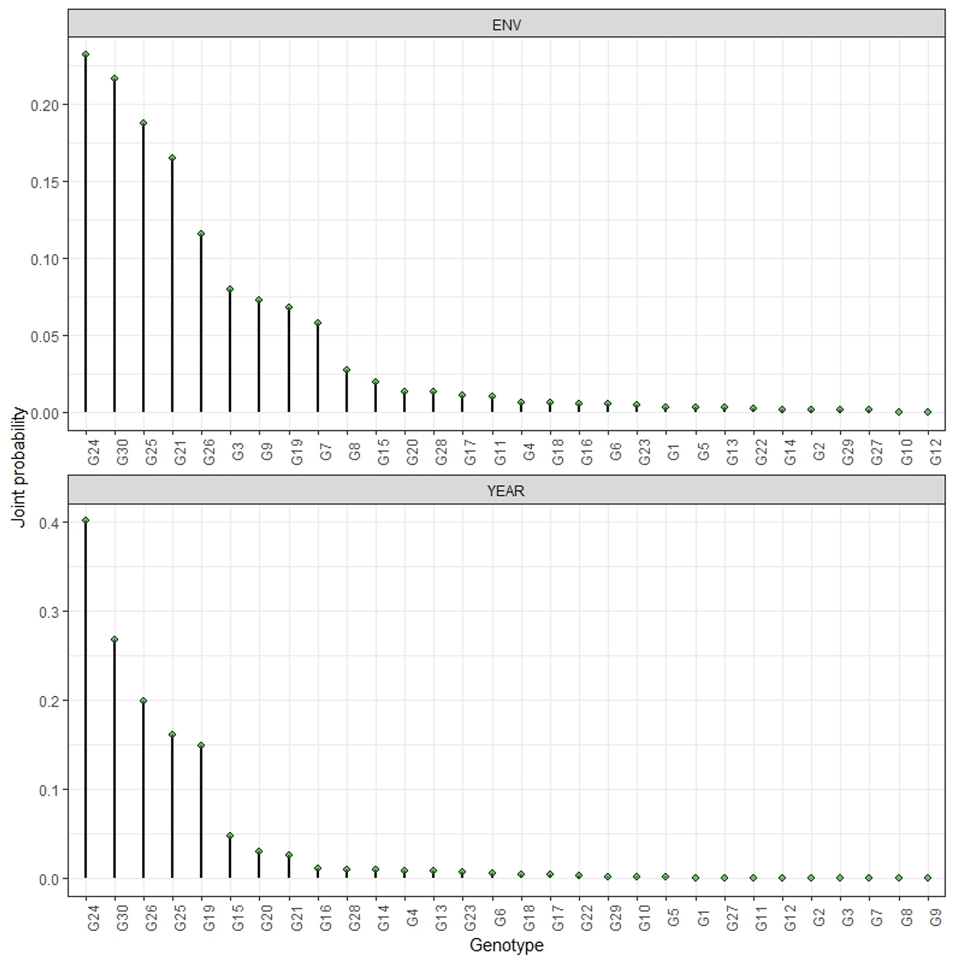
Supplementary Figure S8. Joint probability of superior stability integrating performance and stability across environments and years; G24, G30, G25, G26 and G19 lead.
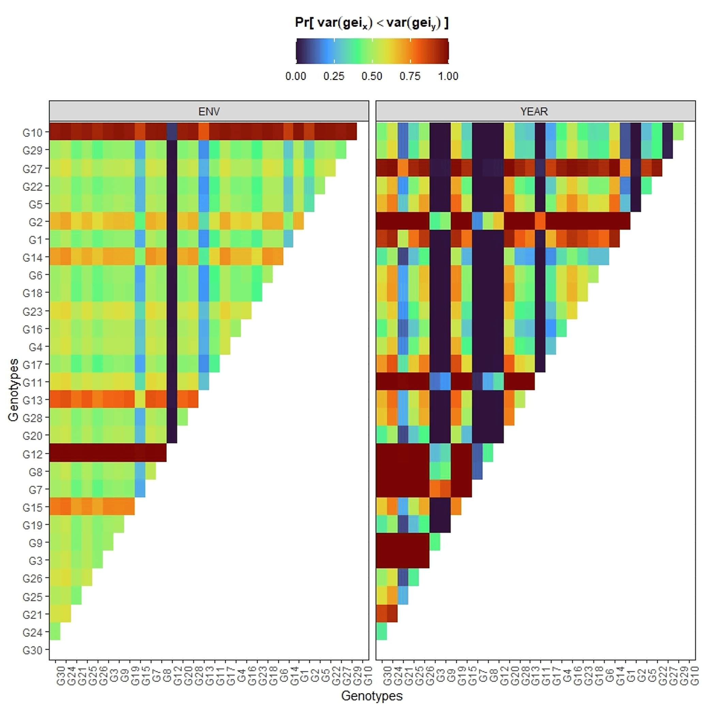
Supplementary Figure S9. Joint pairwise probability matrix Pr[var(geiₓ) < var(geiᵧ)] across environments and years, comparing genotype stability head-to-head.

