Headache questionnaire interpretation guide – how to interpret the answers for a headache diagnosis

Table of contents
Why has this questionnaire been created? 1
How can each section help with your headache consultation? 2
Diagnostic criteria breakdown for migraine, tension-type headache and cluster headache 3
Migraine (see Q10–14, followed by Q2, 4) 3
Tension-type headache (TTH) (See Q10–12 and Q14, followed by Q2 and 4) 4
Cluster headache (CH) (See Q10–12 and Q14, followed by Q2 and 3) 5
Medication-overuse headache (MOH) (See Q4, 8 and 9) 6

Why has this questionnaire been created?
This GP diagnostic questionnaire was produced following a recommendation from an advisory board of headache specialists. By creating this questionnaire in collaboration with headache specialists, it aims to help GPs make a more accurate headache diagnosis, hopefully leading to more appropriate and timely interventions for patients with headache complaints.

Migraine is the most common headache problem seen in general practice. In one study, based on longitudinal data after an expert panel review, 94% of patients were diagnosed with migraine or probable migraine.(1) Tension-type headache (TTH) is considered to be very common, with the lifetime prevalence in the general population ranging from 30% to 78% in different studies. Frequent episodic tension-type headache can be associated with considerable disability and sometimes warrants treatment.(2) Cluster headache (CH), despite being relatively rare (lifetime population prevalence of 0.12%), is considered to be extremely painful,(3) so identification and treatment of these patients is important.

Disclaimer: This questionnaire should be used as a guide to aid GPs with the differential diagnosis of primary headaches. Red flags for secondary headache concerns should be addressed appropriately as part of your consultation with the patient. If you are unsure of the correct diagnosis, please refer your patient to the relevant specialist.

How can each section help with your headache consultation?

You:
This section aims to provide important general background information about the patient. Please also see the background information document provided alongside this questionnaire for information about headache-related implications of the answers to these questions.
You and your headache history:
This section can help remind the patient to share important information about previous consultations, characteristics of previous headaches and secondary headache red flags. These are important factors to consider before attempting to make a primary headache diagnosis.
You and your current headache problem:
This section, which is the main focus of the rest of this document, considers current treatments and symptoms. The acute treatment-related questions help provide information about the potential risk of medication-overuse headache. Below you can find the answer combinations that point towards different primary headache diagnoses, e.g. migraine.

Diagnostic criteria breakdown for migraine, tension-type headache and cluster headache

Migraine (see Q10–14, followed by Q2, 4)
According to the International Classification of Headache Disorders-3 (ICHD-3), if the patient has had five attacks that match the symptoms indicated below and is not better accounted for by another ICHD-3 diagnosis, a migraine diagnosis can be made.
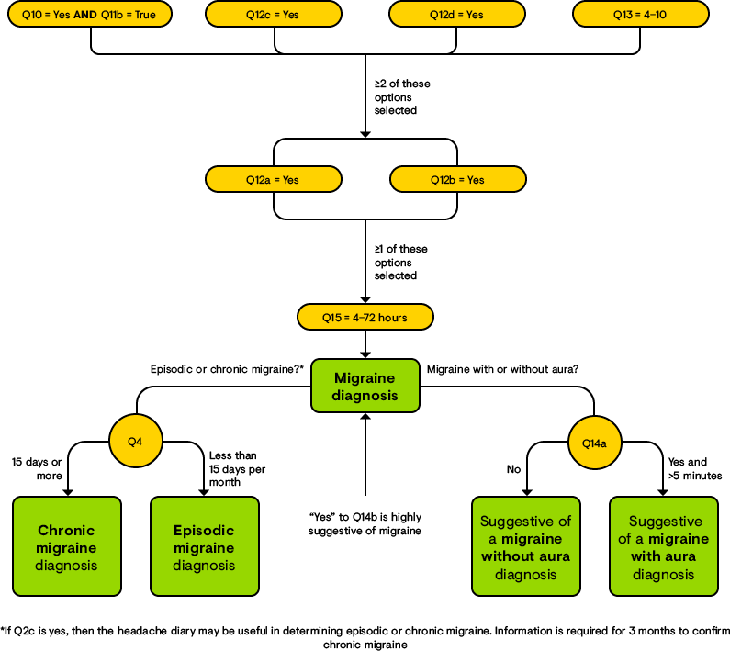
Please follow this flow chart for help with a migraine diagnosis (we suggest continuing through the flow chart if one step fails, because if only one step is not met this is suggestive of a probable migraine diagnosis):

Tension-type headache (TTH) (See Q10–12 and Q14, followed by Q2 and 4)
According to the ICHD-3, if the patient has had at least 10 or more episodes of headache that match the symptoms indicated below and is not better accounted for by another ICHD-3 diagnosis, a TTH diagnosis can be made.
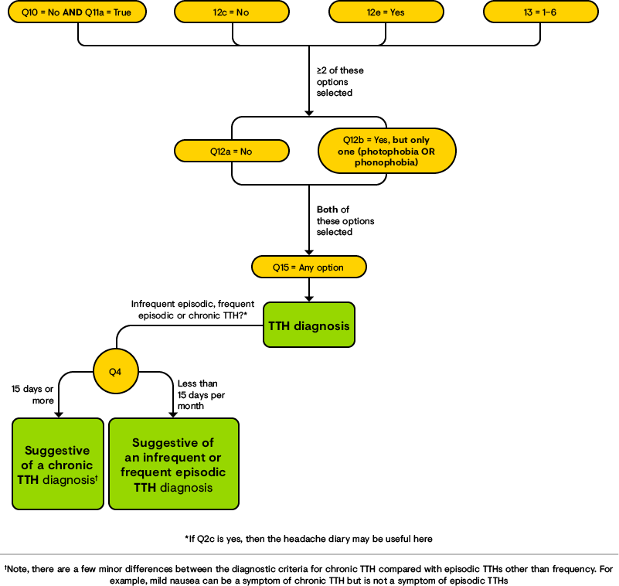
Please follow this flow chart for help with a TTH diagnosis (we suggest continuing through the flow chart if one step fails, because if only one step is not met this is suggestive of a probable TTH diagnosis):

Cluster headache (CH) (See Q10–12 and Q14, followed by Q2 and 3)
According to the ICHD-3, if the patient has five or more attacks that match the symptoms indicated below and is not better accounted for by another ICHD-3 diagnosis, a CH diagnosis can be made.
Please follow this flow chart for help with a CH diagnosis (we suggest continuing through the flow chart if one step fails, because if only one step is not met this is suggestive of a probable CH diagnosis):
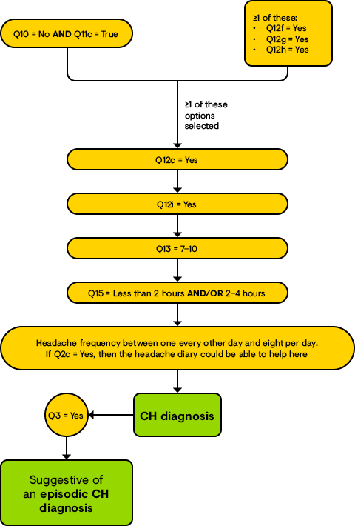

Medication-overuse headache (MOH) (See Q4, 8 and 9)
According to the ICHD-3, if the patient has had the following symptoms for 3 months with a pre-existing primary headache disorder and is not better accounted for by another ICHD-3 diagnosis, this is suggestive of a MOH diagnosis.
Please follow this flow chart for help with a MOH diagnosis:
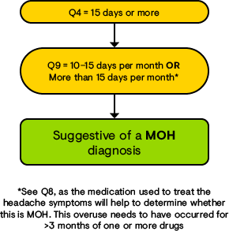

References:
1. Tepper SJ, Dahlöf CGH, Dowson A, Newman L, Mansbach H, Jones M, et al. Prevalence and diagnosis of migraine in patients consulting their physician with a complaint of headache: Data from the landmark study. Headache. 2004;44:856–64.
2. Vincent M, Wang S. Headache Classification Committee of the International Headache Society (IHS) The International Classification of Headache Disorders, 3rd edition. Cephalalgia. 2018;38:1–211.
3. Schenck LAM, Andrasik F. Behavioral and psychological aspects of cluster headache: an overview. Neurol Sci. 2019;40:5–9.

