]

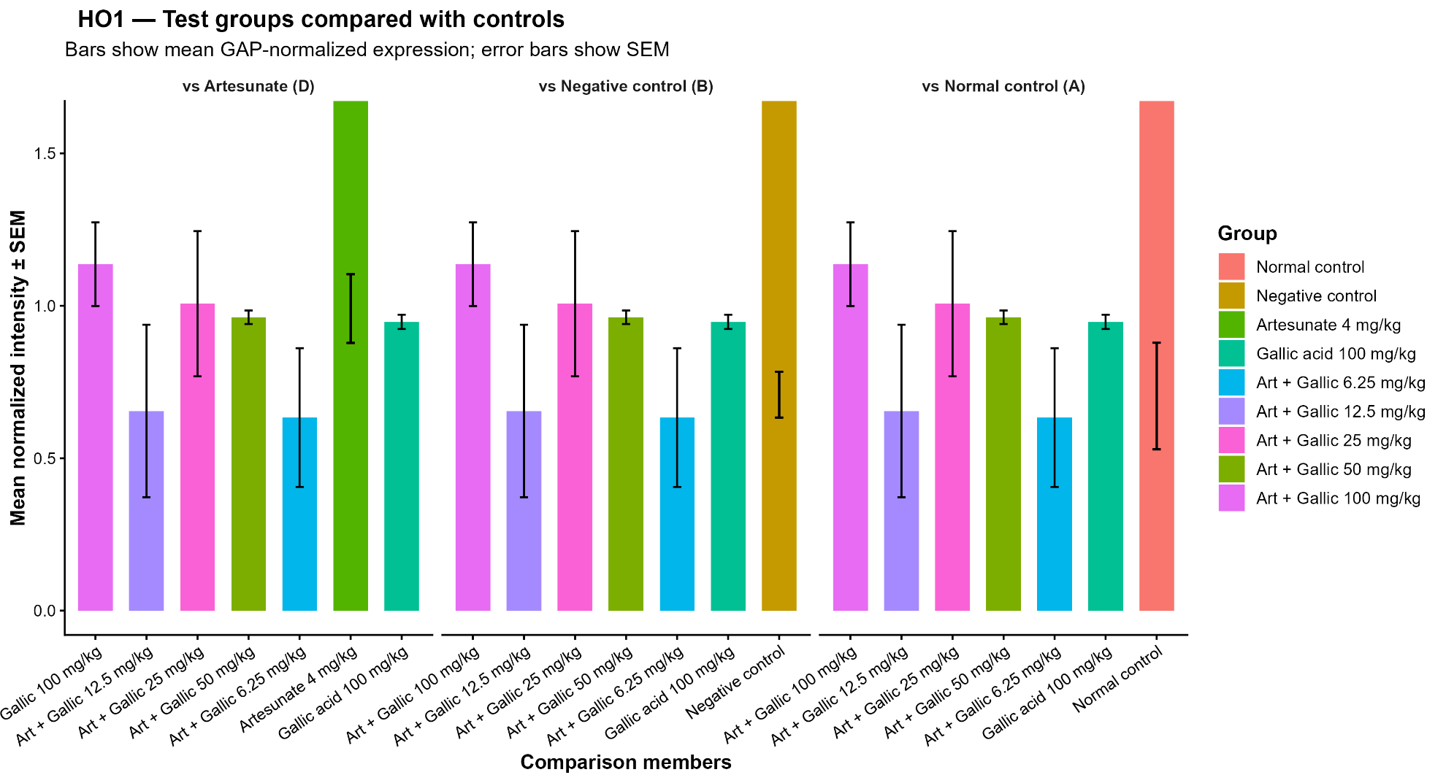
Figure S3. Heme oxygenase-1 (HO1) GAPDH-normalized mRNA expression in liver tissue of experimental groups. Comparative bar plots illustrate differences between treatment groups and the normal control, negative control, and artesunate-treated groups. Values are presented as mean ± SEM.
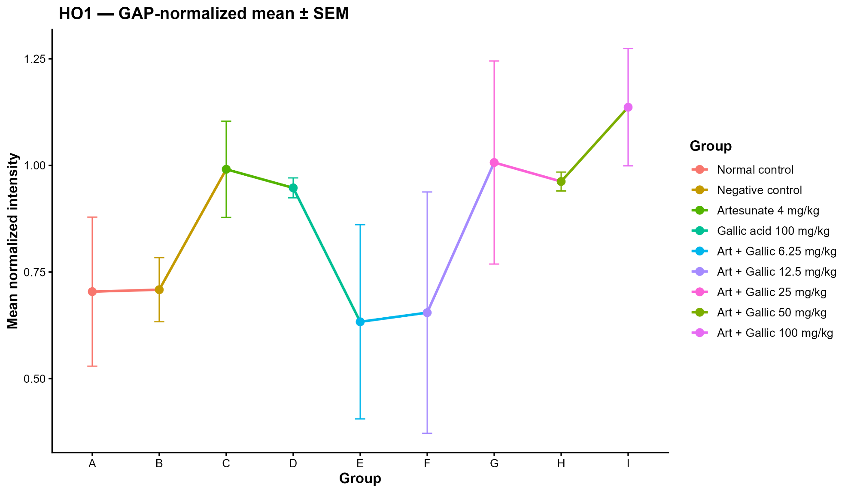
Figure S4. Comparative analysis of Heme oxygenase-1 (HO1) gene expression in liver tissue across experimental groups. The trend-scatter plot depicts mean expression values with SEM, illustrating the overall pattern of hepatic antioxidant signaling among treatment conditions.
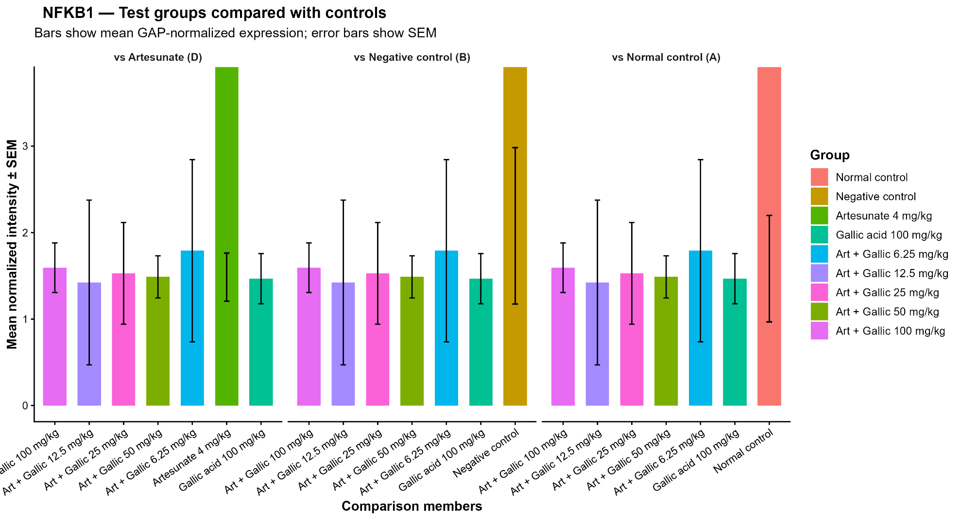
Figure S5. Nuclear factor kappa B subunit 1 (NF-κB1) gene expression profile in liver tissue across experimental groups. Comparative bar plots illustrate differences between treatment groups and the normal control, negative control, and artesunate-treated groups. Values are presented as mean ± SEM.

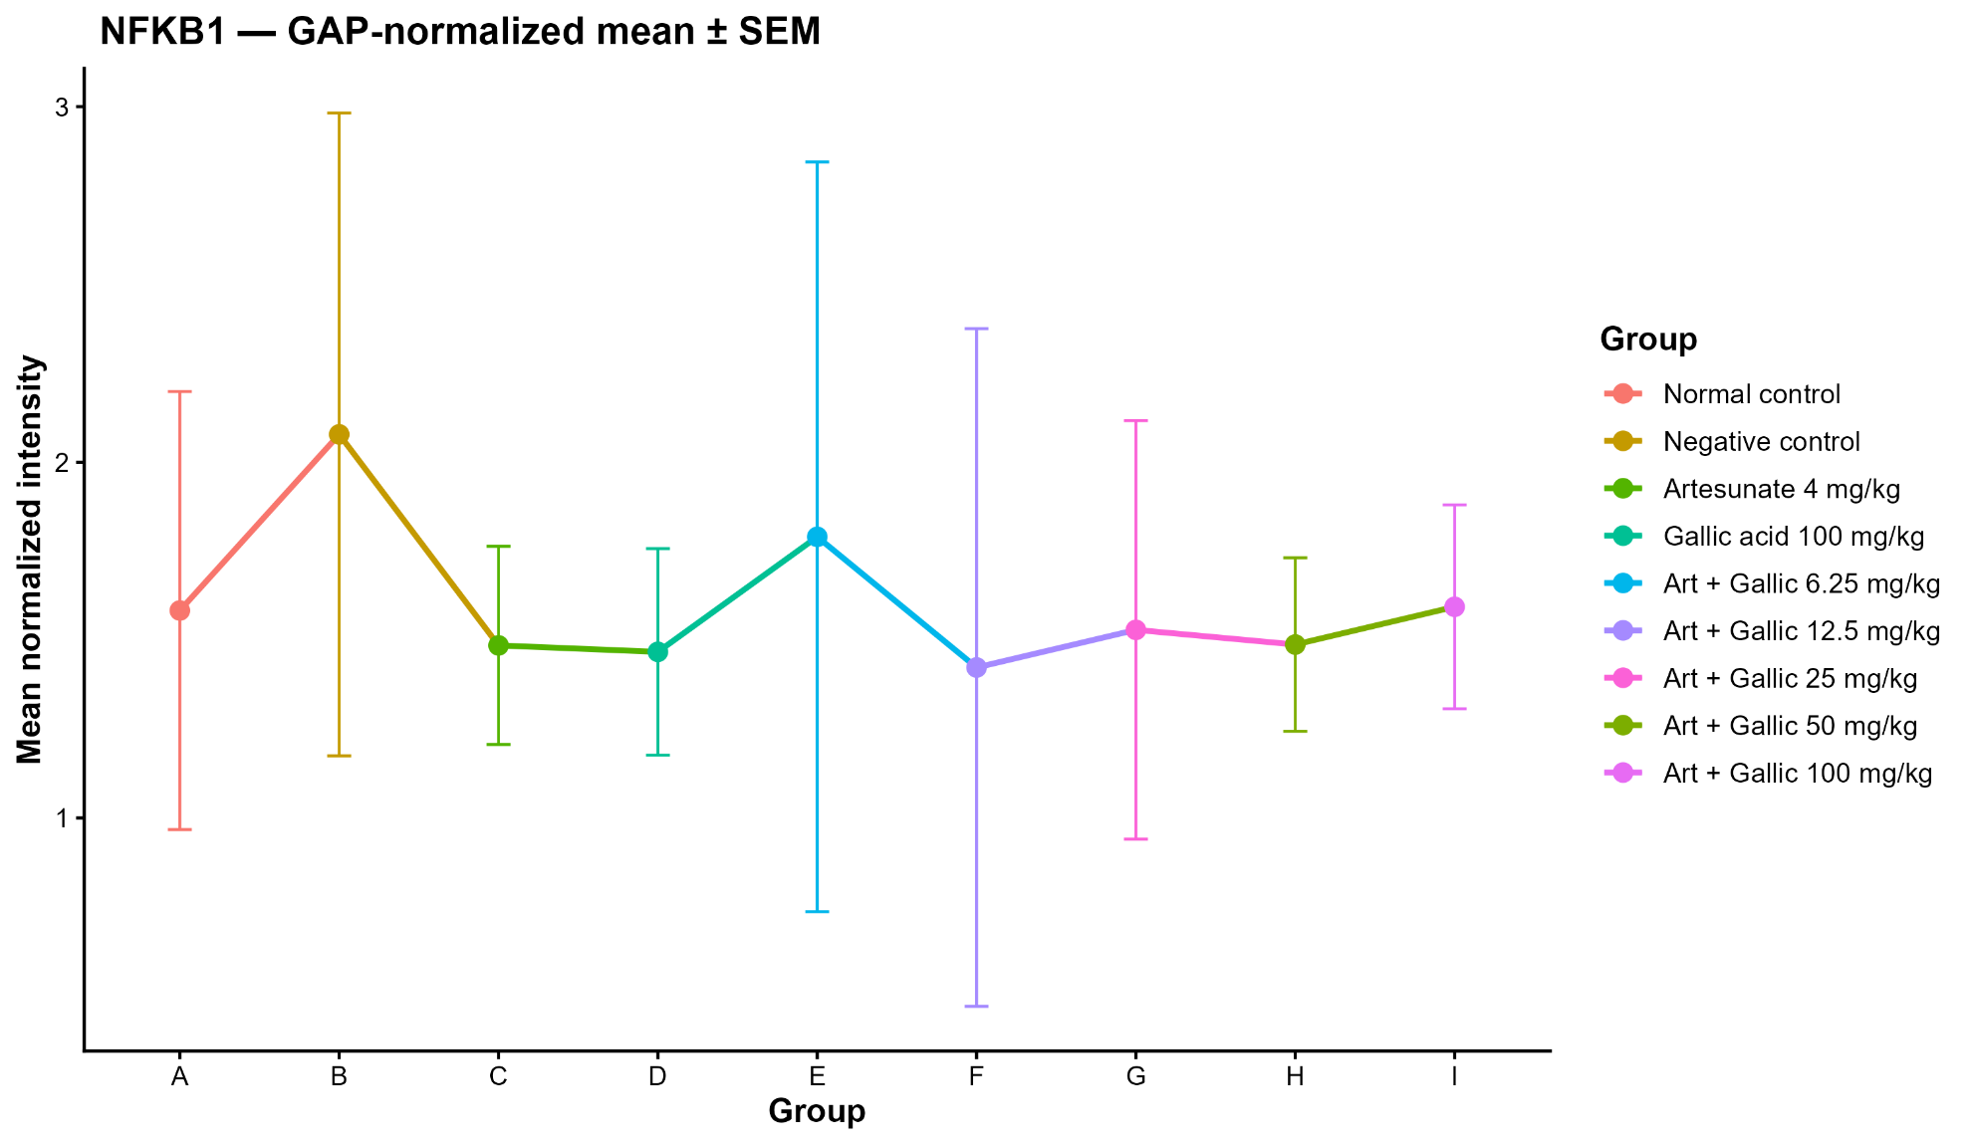

Figure S6. Comparative analysis of normalized nuclear factor kappa B subunit 1 (NF-κB1) gene expression in liver tissue across experimental groups. The trend-scatter plot depicts mean expression values with SEM, illustrating the overall pattern of hepatic inflammatory signaling among treatment conditions.

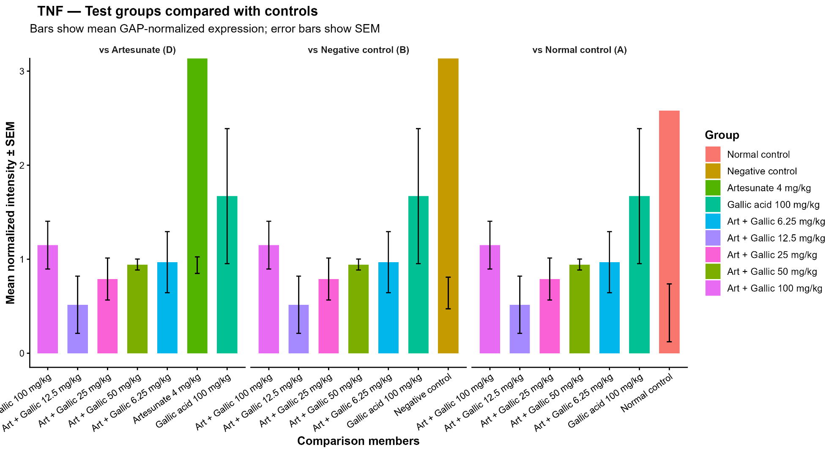
Figure S7. Tumor Necrosis Factor alpha (TNF-α) gene expression profile in liver tissue across experimental groups. Comparative bar plots illustrate differences between treatment groups and the normal control, negative control, and artesunate-treated groups. Values are presented as mean ± SEM.

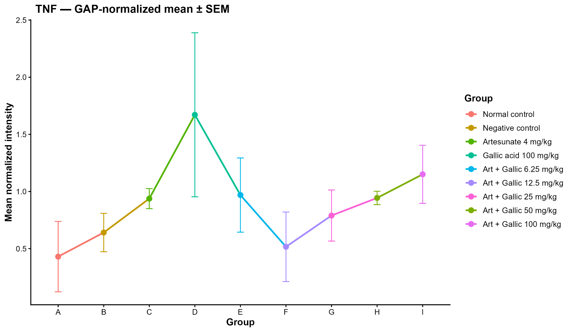

Figure S8. Comparative analysis of normalized tumor necrosis factor alpha (TNF-α) gene expression in liver tissue across experimental groups. The trend-scatter plot depicts mean expression values with SEM, illustrating the overall pattern of hepatic inflammatory signaling among treatment conditions.

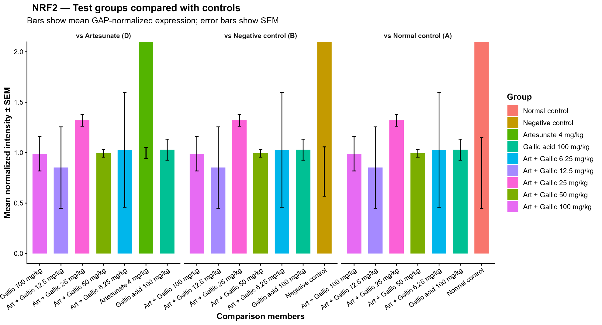

Figure S9. Comparative assessment of liver Nrf2 expression among treatment groups relative to the normal control (A), negative control (B), and artesunate-treated group (C). Bars represent mean GAPDH-normalized expression values and error bars indicate SEM. Nrf2 expression was analyzed as a marker of antioxidant signaling and oxidative stress adaptation in liver tissue.

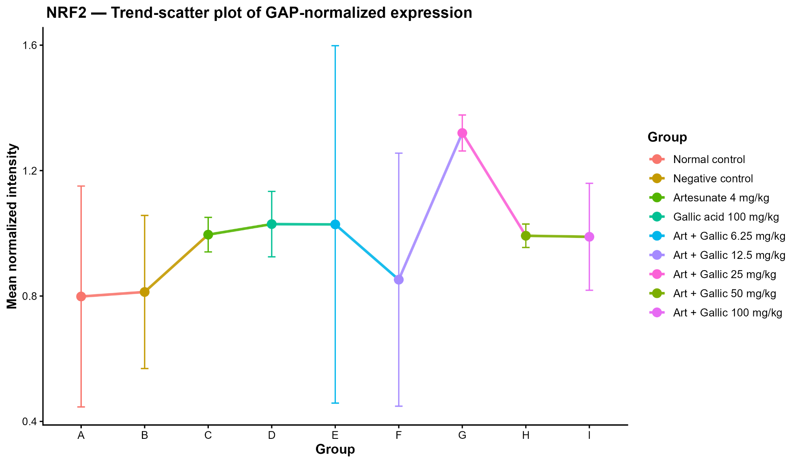
Figure S10. GAPDH-normalized nuclear factor erythroid 2–related factor 2 (Nrf2) gene expression in liver tissue across treatment groups. The trend-scatter plot illustrates mean expression levels ± SEM across all experimental groups, highlighting treatment-associated modulation of liver antioxidant defense pathways.
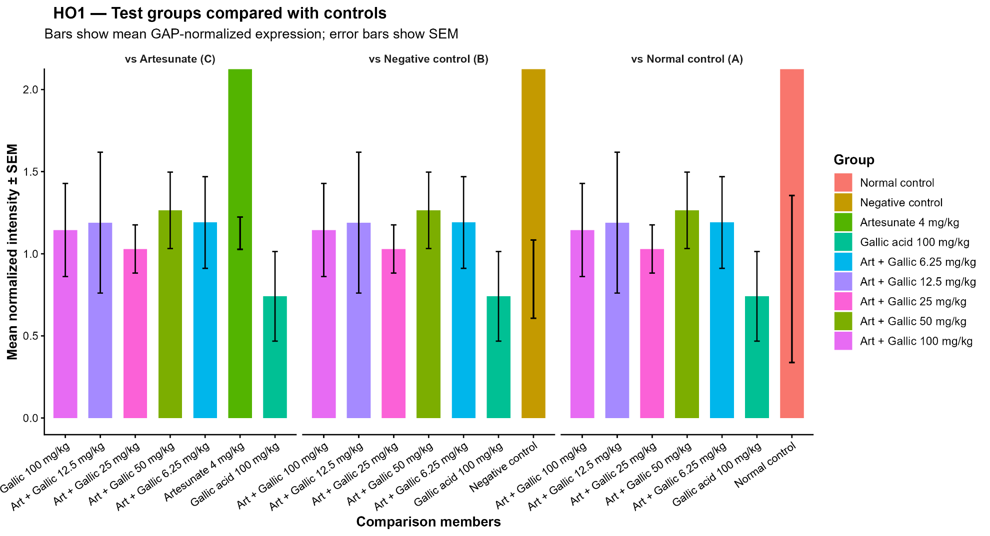
Figure S11: GAPDH-normalized expression of heme oxygenase-1 (HO1) gene in spleen tissue across experimental groups. The comparative bar plots show differences between treatment groups relative to the normal control (A), negative control (B), and artesunate-treated group (C). HO1 expression was evaluated to assess spleen antioxidant and cytoprotective responses following treatment
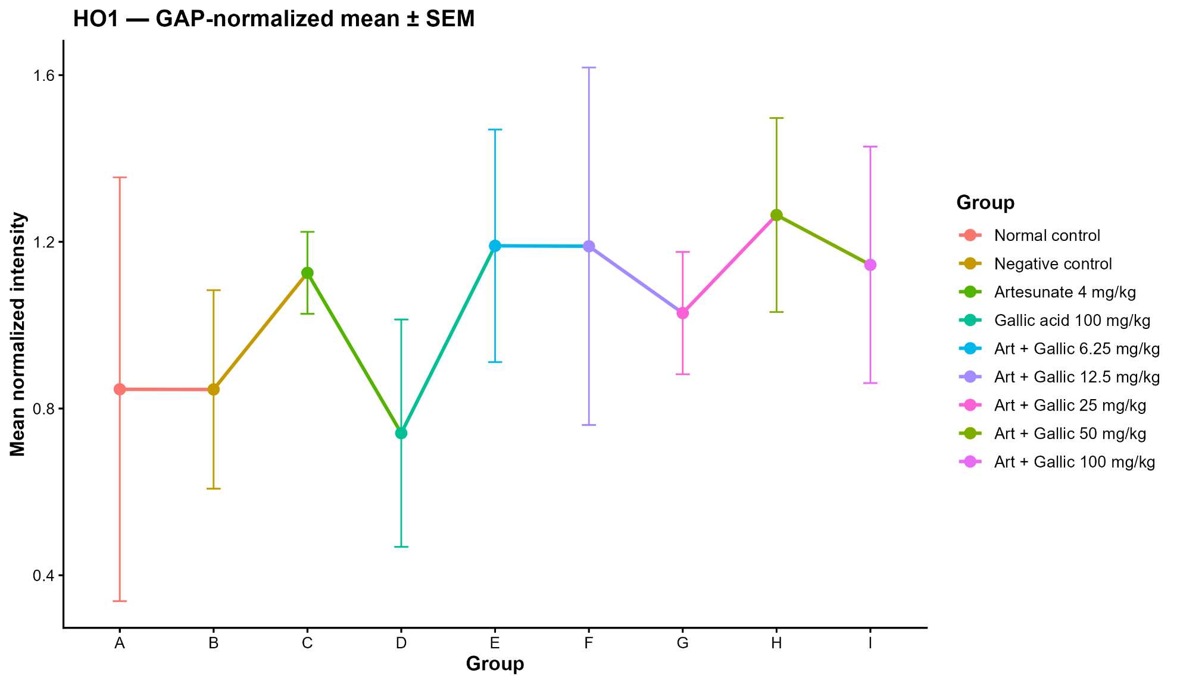

Figure S12. Comparative analysis of normalized heme oxygenase-1 (HO1) gene expression in spleen tissue across experimental groups. The trend-scatter plot depicts mean expression values with SEM, illustrating the overall pattern of hepatic inflammatory signaling among treatment conditions.

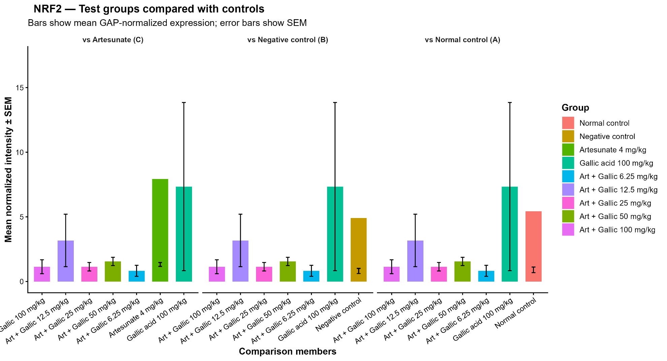
Figure S13. Comparative assessment of spleen Nrf2 expression among treatment groups relative to the normal control (A), negative control (B), and artesunate-treated group (C). Bars represent mean GAPDH-normalized expression values and error bars indicate SEM. Nrf2 expression was analyzed as a marker of antioxidant signaling and oxidative stress adaptation in spleen tissue.
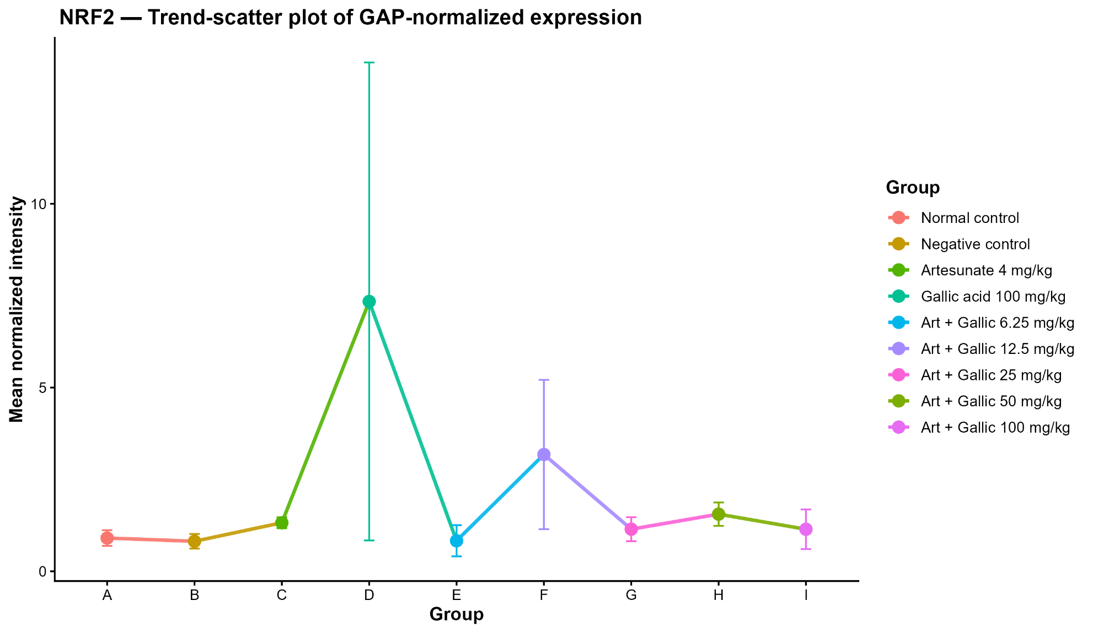
Figure S14. GAPDH-normalized nuclear factor erythroid 2–related factor 2 (Nrf2) gene expression in spleen tissue across treatment groups. The trend-scatter plot illustrates mean expression levels ± SEM across all experimental groups, highlighting treatment-associated modulation of spleen antioxidant defense pathways.
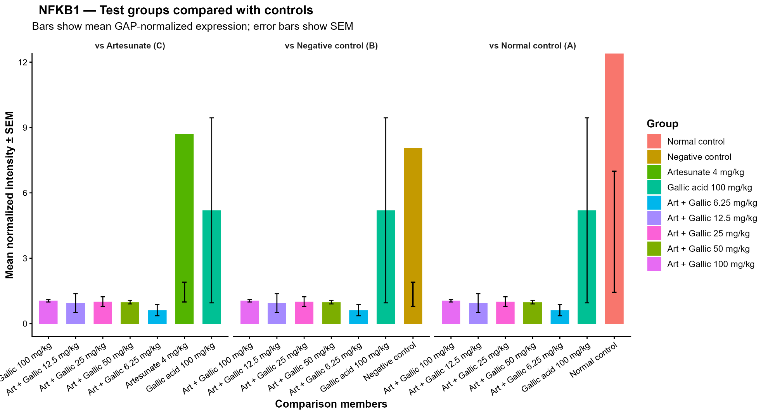

Figure S15. Comparison of spleen NF-KB1 expression among treatment groups relative to the normal control (A), negative control (B), and artesunate-treated group (C). Bars represent mean GAPDH-normalized expression ± SEM. The figure illustrates the effects of treatment on spleen inflammatory responses mediated through the NF-κB pathway.
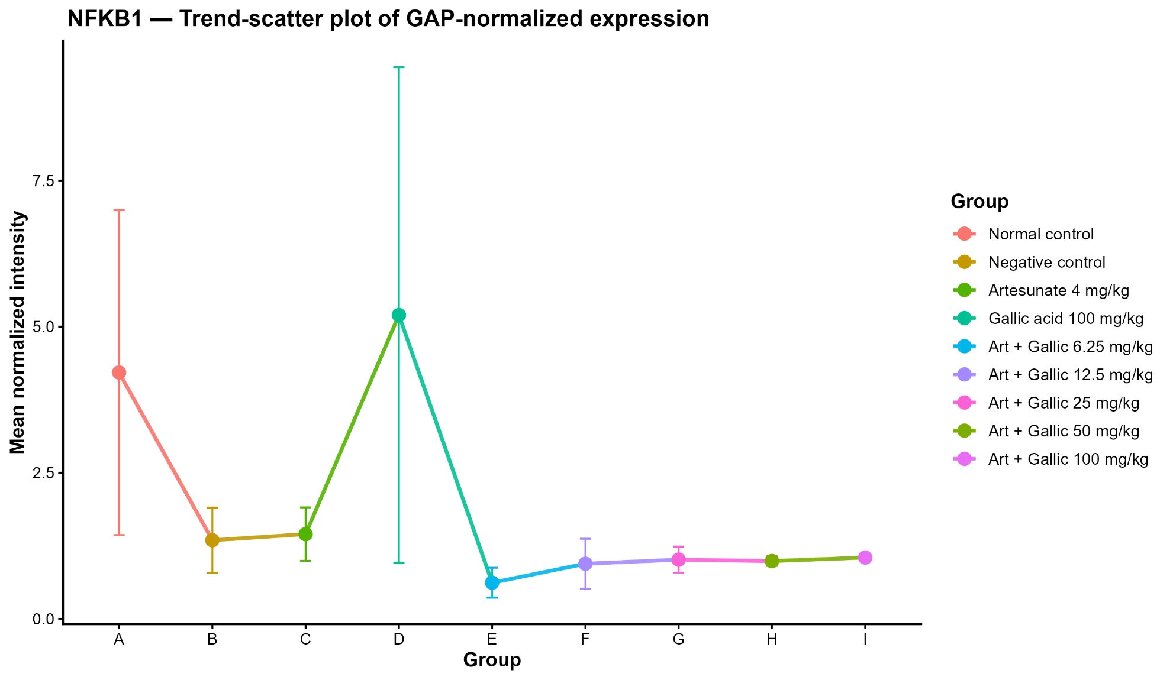
Figure S16. GAPDH-normalized expression profile of nuclear factor kappa B subunit 1 (NF-KB1) in spleen tissue across treatment groups. The trend-scatter plot displays mean expression values ± SEM across experimental groups and demonstrates treatment-related alterations in spleen inflammatory signaling.
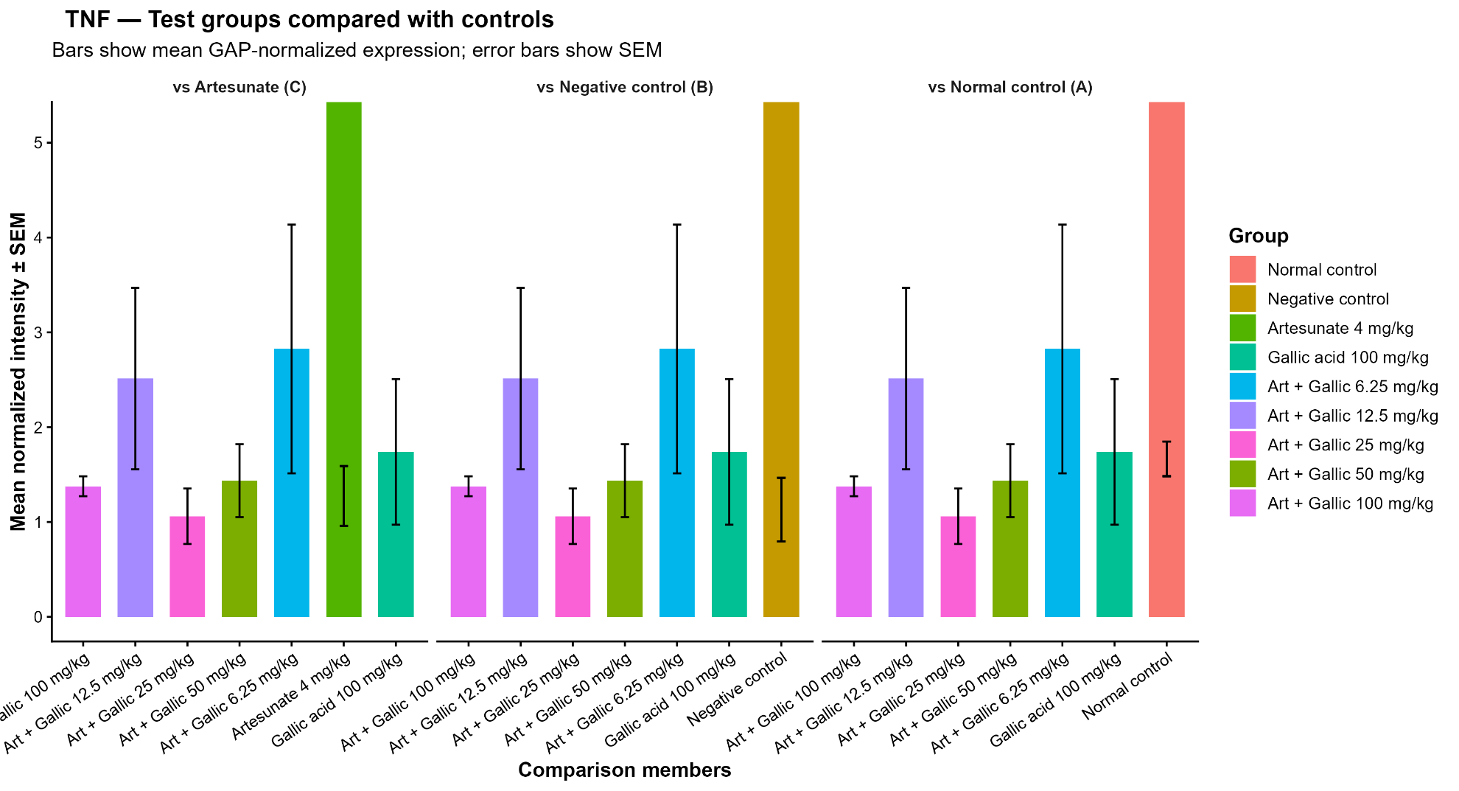
Figure S17. Comparison of splenic TNF expression among treatment groups relative to the normal control (A), negative control (B), and artesunate-treated group (C). Bars represent mean GAPDH-normalized expression levels with SEM. TNF expression was evaluated as an indicator of splenic inflammatory activity and treatment response.
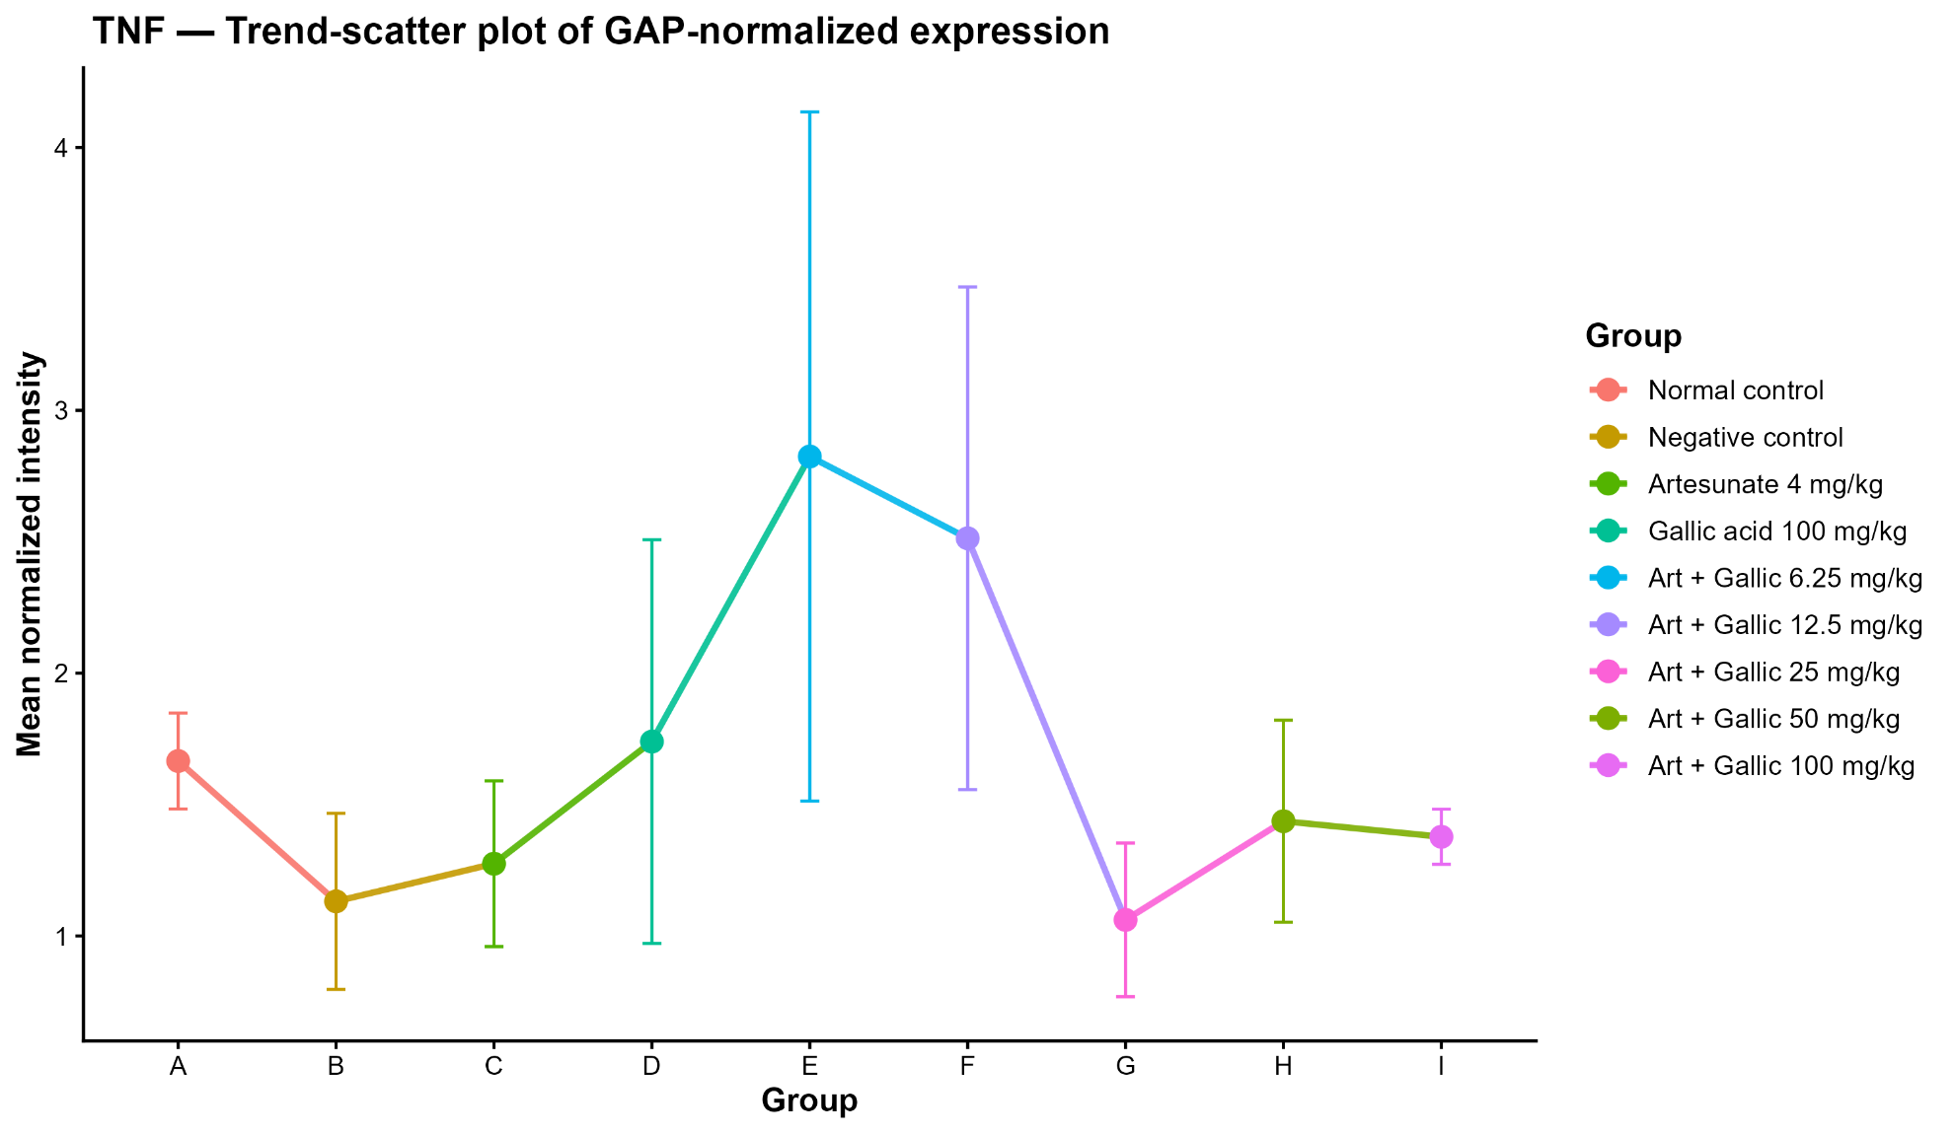
Figure S18. GAPDH-normalized tumor necrosis factor (TNF) expression in spleen tissue across treatment groups. The trend-scatter plot shows mean expression values ± SEM across all experimental groups and provides an overview of treatment-associated changes in spleen pro-inflammatory cytokine expression.

Supplementary Tables
Table S1. Primer sequences, accession numbers, and expected amplicon sizes used for RT-PCR analysis in Mus musculus
Gene | Forward Primer (5′–3′) | Reverse Primer (5′–3′) | Accession ID | Expected Amplicon Size
Nrf2 | CGCCGAGTATAGCTGCCTCAAG | CTGGCTCCTAACGTACTCTTCC | NM_009697 | 130 bp
HO-1 | CACTCTGGAGATGACACCTGAG | GTGTTCCTCTGTCAGCATCACC | NM_010442 | 115 bp
NF-κB1 | GCTGCCAAAGAAGGACACGACA | GGCAGGCTATTGCTCATCACAG | NM_008689 | 131 bp
GAPDH | CATCACTGCCACCCAGAAGACTG | ATGCCAGTGAGCTTCCCGTTCAG | NM_008084 | 153 bp
Tnf-α | GGTGCCTATGTCTCAGCCTCTT | GCCATAGAACTGATGAGAGGGAG | NM_011905 | 121bp

Table S2a. GAPDH-Normalized Densitometric Analysis of Hepatic HO1, NF-κB1, NRF2, and TNF-α Expression Across Experimental Groups
GAPDH-normalized descriptive summary
gene | group_code | group_label | n | mean_raw | mean_gapdh | mean_norm | sd_norm | sem_norm | mean_fc_vs_A | mean_log2fc_A
HO1 | A | Normal control | 3 | 4,193.366 | 5,441.330 | 0.7040663 | 0.30263454 | 0.17472613 | 1.0000000 | -0.092727626
HO1 | B | Negative control | 3 | 2,955.360 | 4,541.616 | 0.7085841 | 0.13026964 | 0.07521121 | 1.0064167 | -0.007710507
HO1 | C | Artesunate 4 mg/kg | 3 | 9,223.408 | 9,201.351 | 0.9909326 | 0.19536899 | 0.11279634 | 1.4074423 | 0.475016402
HO1 | D | Gallic acid 100 mg/kg | 3 | 8,690.172 | 9,181.098 | 0.9472834 | 0.04052232 | 0.02339557 | 1.3454464 | 0.427202751
HO1 | E | A:G6.25 | 3 | 2,665.854 | 4,552.502 | 0.6333323 | 0.39423033 | 0.22760898 | 0.8995351 | -0.433426128
HO1 | F | A:G12.5 | 3 | 2,786.133 | 3,395.845 | 0.6547809 | 0.49002188 | 0.28291427 | 0.9299990 | -0.602392955
HO1 | G | A:G25 | 3 | 5,994.869 | 5,154.778 | 1.0067894 | 0.41235785 | 0.23807491 | 1.4299640 | 0.412366478
HO1 | H | A:G50 | 3 | 7,547.125 | 7,846.223 | 0.9622814 | 0.03836602 | 0.02215063 | 1.3667484 | 0.449975213
HO1 | I | A:G100 | 3 | 8,348.573 | 7,637.913 | 1.1363762 | 0.23793353 | 0.13737099 | 1.6140188 | 0.668506985
NF-κB1 | A | Normal control | 3 | 9,964.015 | 5,441.330 | 1.5831968 | 1.06662795 | 0.61581793 | 1.0000000 | -0.274119634
NF-κB1 | B | Negative control | 3 | 9,379.469 | 4,541.616 | 2.0784029 | 1.56533783 | 0.90374822 | 1.3127888 | 0.143494951
NF-κB1 | C | Artesunate 4 mg/kg | 3 | 13,577.231 | 9,201.351 | 1.4850724 | 0.48260957 | 0.27863477 | 0.9380214 | -0.141628713
NF-κB1 | D | Gallic acid 100 mg/kg | 3 | 13,145.766 | 9,181.098 | 1.4669436 | 0.50292754 | 0.29036535 | 0.9265706 | -0.163390421
NF-κB1 | E | A:G6.25 | 3 | 8,765.809 | 4,552.502 | 1.7903584 | 1.82562903 | 1.05402741 | 1.1308502 | -0.341327515
NF-κB1 | F | A:G12.5 | 3 | 7,320.728 | 3,395.845 | 1.4229944 | 1.65032477 | 0.95281545 | 0.8988108 | -1.349852765
NF-κB1 | G | A:G25 | 3 | 9,754.819 | 5,154.778 | 1.5287618 | 1.01911606 | 0.58838693 | 0.9656170 | -0.345975545
NF-κB1 | H | A:G50 | 3 | 11,611.018 | 7,846.223 | 1.4875755 | 0.42264300 | 0.24401305 | 0.9396024 | -0.134293012
NF-κB1 | I | A:G100 | 3 | 11,525.688 | 7,637.913 | 1.5935638 | 0.49658065 | 0.28670097 | 1.0065482 | -0.045486522
Nrf2 | A | Normal control | 3 | 5,471.454 | 5,441.330 | 0.7984313 | 0.61014318 | 0.35226633 | 1.0000000 | -0.648629586
Nrf2 | B | Negative control | 3 | 3,723.121 | 4,541.616 | 0.8127994 | 0.42286461 | 0.24414100 | 1.0179955 | -0.163057749
Nrf2 | C | Artesunate 4 mg/kg | 3 | 9,118.455 | 9,201.351 | 0.9956546 | 0.09545308 | 0.05510986 | 1.2470135 | 0.314197967
Nrf2 | D | Gallic acid 100 mg/kg | 3 | 9,369.307 | 9,181.098 | 1.0293079 | 0.18068847 | 0.10432054 | 1.2891628 | 0.351880874
Nrf2 | E | A:G6.25 | 3 | 3,961.930 | 4,552.502 | 1.0283644 | 0.98717290 | 0.56994454 | 1.2879811 | -0.238995979
Nrf2 | F | A:G12.5 | 3 | 3,458.076 | 3,395.845 | 0.8521071 | 0.69899679 | 0.40356599 | 1.0672266 | -0.931960305
Nrf2 | G | A:G25 | 3 | 6,773.977 | 5,154.778 | 1.3198859 | 0.09932029 | 0.05734260 | 1.6530989 | 0.722436845
Nrf2 | H | A:G50 | 3 | 7,821.122 | 7,846.223 | 0.9921460 | 0.06471999 | 0.03736610 | 1.2426191 | 0.311281856
Nrf2 | I | A:G100 | 3 | 7,152.657 | 7,637.913 | 0.9888235 | 0.29540638 | 0.17055295 | 1.2384579 | 0.263801687
TNF-α | A | Normal control | 3 | 2,449.665 | 5,441.330 | 0.4301704 | 0.53326256 | 0.30787928 | 1.0000000 | -1.097671758
TNF-α | B | Negative control | 3 | 3,498.107 | 4,541.616 | 0.6408407 | 0.29101351 | 0.16801673 | 1.4897369 | 0.467113524
TNF-α | C | Artesunate 4 mg/kg | 3 | 8,564.203 | 9,201.351 | 0.9376015 | 0.15237499 | 0.08797374 | 2.1796050 | 1.111903962
TNF-α | D | Gallic acid 100 mg/kg | 3 | 15,046.302 | 9,181.098 | 1.6711249 | 1.24300996 | 0.71765213 | 3.8847979 | 1.714947616
TNF-α | E | A:G6.25 | 3 | 4,689.794 | 4,552.502 | 0.9689095 | 0.56240800 | 0.32470641 | 2.2523855 | 1.015463367
TNF-α | F | A:G12.5 | 3 | 2,568.541 | 3,395.845 | 0.5161790 | 0.52668280 | 0.30408046 | 1.1999408 | -0.281788448
TNF-α | G | A:G25 | 3 | 4,827.040 | 5,154.778 | 0.7895938 | 0.38712464 | 0.22350652 | 1.8355374 | 0.718891855
TNF-α | H | A:G50 | 3 | 7,346.381 | 7,846.223 | 0.9435782 | 0.10088643 | 0.05824681 | 2.1934989 | 1.127925555
TNF-α | I | A:G100 | 3 | 8,242.974 | 7,637.913 | 1.1502104 | 0.44025232 | 0.25417980 | 2.6738486 | 1.350748522

Descriptive statistics of GAPDH-normalized protein expression levels in liver tissue, including normalized expression values, fold change relative to the normal control group (A), log2 fold change, standard deviation (SD), standard error of the mean (SEM), median, and interquartile range (IQR) for HO1, NF-κB1, NRF2, and TNF-α.

Table 2b. Raw Densitometric Band Intensity Measurements of Hepatic HO1, NF-κB1, Nrf2, TNF-α, and GAPDH Across Experimental Groups

gene | group_code | group_label | n | mean | sd | sem | median | iqr | min | max
GAPDH | A | Normal control | 3 | 5,441.330 | 2,784.53597 | 1,607.65259 | 6,334.175 | 2,675.0255 | 2,319.882 | 7,669.933
GAPDH | B | Negative control | 3 | 4,541.616 | 3,029.42556 | 1,749.03966 | 4,316.054 | 3,023.1210 | 1,631.276 | 7,677.518
GAPDH | C | Artesunate 4 mg/kg | 3 | 9,201.351 | 829.81516 | 479.09400 | 9,171.560 | 829.4140 | 8,386.832 | 10,045.660
GAPDH | D | Gallic acid 100 mg/kg | 3 | 9,181.098 | 1,149.93500 | 663.91528 | 8,829.711 | 1,108.9390 | 8,247.853 | 10,465.731
GAPDH | E | A:G6.25 | 3 | 4,552.502 | 1,166.73083 | 673.61236 | 5,167.832 | 1,037.9245 | 3,206.912 | 5,282.761
GAPDH | F | A:G12.5 | 3 | 3,395.845 | 2,375.81257 | 1,371.67603 | 2,149.861 | 2,116.6315 | 1,902.205 | 6,135.468
GAPDH | G | A:G25 | 3 | 5,154.778 | 2,936.79446 | 1,695.55907 | 6,453.225 | 2,712.9850 | 1,792.569 | 7,218.539
GAPDH | H | A:G50 | 3 | 7,846.223 | 849.64723 | 490.54406 | 8,265.903 | 767.9855 | 6,868.397 | 8,404.368
GAPDH | I | A:G100 | 3 | 7,637.913 | 2,109.80221 | 1,218.09488 | 7,007.368 | 2,037.9095 | 5,915.276 | 9,991.095
HO1 | A | Normal control | 3 | 4,193.366 | 2,867.04647 | 1,655.29005 | 5,121.690 | 2,752.0205 | 977.184 | 6,481.225
HO1 | B | Negative control | 3 | 2,955.360 | 1,521.48237 | 878.42826 | 3,132.912 | 1,513.6925 | 1,352.891 | 4,380.276
HO1 | C | Artesunate 4 mg/kg | 3 | 9,223.408 | 2,649.54833 | 1,529.71744 | 8,575.539 | 2,589.4605 | 6,957.882 | 12,136.803
HO1 | D | Gallic acid 100 mg/kg | 3 | 8,690.172 | 1,075.25015 | 620.79597 | 8,141.175 | 964.4245 | 8,000.246 | 9,929.095
HO1 | E | A:G6.25 | 3 | 2,665.854 | 1,458.72624 | 842.19599 | 3,115.447 | 1,405.8030 | 1,035.255 | 3,846.861
HO1 | F | A:G12.5 | 3 | 2,786.133 | 3,402.35306 | 1,964.34945 | 1,442.669 | 3,197.2385 | 260.627 | 6,655.104
HO1 | G | A:G25 | 3 | 5,994.869 | 4,412.57589 | 2,547.60188 | 7,881.933 | 4,098.7885 | 952.548 | 9,150.125
HO1 | H | A:G50 | 3 | 7,547.125 | 842.35194 | 486.33212 | 7,603.924 | 840.9145 | 6,677.811 | 8,359.640
HO1 | I | A:G100 | 3 | 8,348.573 | 429.46161 | 247.94977 | 8,180.347 | 403.9955 | 8,028.690 | 8,836.681
NF-κB1 | A | Normal control | 3 | 9,964.015 | 7,984.32973 | 4,609.75492 | 11,621.560 | 7,854.2300 | 1,281.012 | 16,989.472
NF-κB1 | B | Negative control | 3 | 9,379.469 | 7,483.04421 | 4,320.33759 | 9,573.439 | 7,481.1585 | 1,801.326 | 16,763.643
NF-κB1 | C | Artesunate 4 mg/kg | 3 | 13,577.231 | 4,274.18553 | 2,467.70216 | 11,430.439 | 3,848.6525 | 10,801.974 | 18,499.279
NF-κB1 | D | Gallic acid 100 mg/kg | 3 | 13,145.766 | 3,150.14080 | 1,818.73464 | 11,375.146 | 2,751.7385 | 11,279.338 | 16,782.815
NF-κB1 | E | A:G6.25 | 3 | 8,765.809 | 10,171.26187 | 5,872.38078 | 3,116.347 | 8,917.2445 | 2,673.296 | 20,507.785
NF-κB1 | F | A:G12.5 | 3 | 7,320.728 | 11,037.68680 | 6,372.61145 | 1,758.569 | 9,931.1290 | 170.678 | 20,032.936
NF-κB1 | G | A:G25 | 3 | 9,754.819 | 8,674.53688 | 5,008.24620 | 10,192.146 | 8,666.2650 | 869.891 | 18,202.421
NF-κB1 | H | A:G50 | 3 | 11,611.018 | 3,428.90203 | 1,979.67751 | 11,330.317 | 3,420.2740 | 8,331.095 | 15,171.643
NF-κB1 | I | A:G100 | 3 | 11,525.688 | 1,818.62395 | 1,049.98303 | 10,730.489 | 1,683.1925 | 10,240.095 | 13,606.480
Nrf2 | A | Normal control | 3 | 5,471.454 | 4,737.82761 | 2,735.38605 | 6,720.589 | 4,612.6735 | 234.213 | 9,459.560
Nrf2 | B | Negative control | 3 | 3,723.121 | 3,729.46811 | 2,153.20942 | 1,742.912 | 3,311.7990 | 1,401.426 | 8,025.024
Nrf2 | C | Artesunate 4 mg/kg | 3 | 9,118.455 | 491.42319 | 283.72331 | 9,272.681 | 472.9245 | 8,568.418 | 9,514.267
Nrf2 | D | Gallic acid 100 mg/kg | 3 | 9,369.307 | 1,328.92555 | 767.25552 | 9,090.610 | 1,306.8240 | 8,201.832 | 10,815.480
Nrf2 | E | A:G6.25 | 3 | 3,961.930 | 2,912.24580 | 1,681.38589 | 4,136.811 | 2,908.3050 | 966.184 | 6,782.794
Nrf2 | F | A:G12.5 | 3 | 3,458.076 | 4,060.86744 | 2,344.54291 | 2,302.569 | 3,935.6380 | 100.192 | 7,971.468
Nrf2 | G | A:G25 | 3 | 6,773.977 | 3,817.33530 | 2,203.93956 | 8,801.418 | 3,389.5665 | 2,370.690 | 9,149.823
Nrf2 | H | A:G50 | 3 | 7,821.122 | 1,318.12212 | 761.01816 | 8,512.196 | 1,174.4185 | 6,301.167 | 8,650.004
Nrf2 | I | A:G100 | 3 | 7,152.657 | 396.70148 | 229.03570 | 6,950.681 | 356.0565 | 6,897.589 | 7,609.702
TNF-α | A | Normal control | 3 | 2,449.665 | 3,568.54799 | 2,060.30214 | 504.749 | 3,146.0310 | 276.092 | 6,568.154
TNF-α | B | Negative control | 3 | 3,498.107 | 3,386.52927 | 1,955.21358 | 2,696.447 | 3,314.6020 | 584.335 | 7,213.539
TNF-α | C | Artesunate 4 mg/kg | 3 | 8,564.203 | 901.68044 | 520.58545 | 8,810.196 | 876.1525 | 7,565.054 | 9,317.359
TNF-α | D | Gallic acid 100 mg/kg | 3 | 15,046.302 | 10,722.08250 | 6,190.39722 | 9,356.489 | 9,522.7400 | 8,368.468 | 27,413.948
TNF-α | E | A:G6.25 | 3 | 4,689.794 | 3,332.93847 | 1,924.27292 | 4,082.397 | 3,291.1670 | 1,702.326 | 8,284.660
TNF-α | F | A:G12.5 | 3 | 2,568.541 | 3,711.69954 | 2,142.95073 | 569.355 | 3,283.1625 | 284.971 | 6,851.296
TNF-α | G | A:G25 | 3 | 4,827.040 | 3,739.51156 | 2,159.00801 | 6,056.317 | 3,584.7740 | 627.627 | 7,797.175
TNF-α | H | A:G50 | 3 | 7,346.381 | 60.88549 | 35.15225 | 7,367.175 | 58.1615 | 7,277.823 | 7,394.146
TNF-α | I | A:G100 | 3 | 8,242.974 | 1,293.75572 | 746.95022 | 7,830.711 | 1,243.5165 | 7,205.589 | 9,692.622
Descriptive summary of raw densitometric band intensities obtained from liver tissue immunoblot analyses. Values include mean intensity, SD, SEM, median, IQR, minimum, and maximum measurements for target proteins (HO1, NF-κB1, Nrf2, and TNF-α) and the housekeeping protein GAPDH

Table 3a. GAPDH-Normalized Expression Profiles of HO1, NF-κB1, Nrf2, and TNF-α in Spleen Tissue Across Experimental Groups.
GAPDH-normalized descriptive summary
gene | group_code | group_label | n | mean_raw |  | mean_gapdh | mean_norm | sd_norm | sem_norm | mean_fc_vs_A | mean_log2fc_A
HO1 | A | Normal control | 3 | 4,599.111 |  | 5,602.415 | 0.8462309 | 0.88078740 | 0.50852284 | 1.0000000 | -0.50492574
HO1 | B | Negative control | 3 | 4,742.610 |  | 7,284.876 | 0.8458085 | 0.41255102 | 0.23818644 | 0.9995008 | -0.15605320
HO1 | C | Artesunate 4 mg/kg | 3 | 11,068.514 |  | 10,145.816 | 1.1255409 | 0.17035788 | 0.09835617 | 1.3300636 | 0.40040022
HO1 | D | Gallic acid 100 mg/kg | 3 | 8,415.839 |  | 8,379.539 | 0.7409090 | 0.47240611 | 0.27274379 | 0.8755399 | -0.52981436
HO1 | E | A:G6.25 | 3 | 7,707.743 |  | 6,199.365 | 1.1903977 | 0.48324859 | 0.27900371 | 1.4067056 | 0.41715257
HO1 | F | A:G12.5 | 3 | 4,672.479 |  | 5,439.449 | 1.1893708 | 0.74293538 | 0.42893394 | 1.4054920 | 0.32018540
HO1 | G | A:G25 | 3 | 10,679.245 |  | 10,786.321 | 1.0290679 | 0.25432903 | 0.14683693 | 1.2160603 | 0.25107674
HO1 | H | A:G50 | 3 | 9,789.190 |  | 8,278.688 | 1.2643137 | 0.40309138 | 0.23272491 | 1.4940529 | 0.53164189
HO1 | I | A:G100 | 3 | 9,760.985 |  | 9,187.540 | 1.1447384 | 0.49131785 | 0.28366249 | 1.3527494 | 0.34625589
NF-κB1 | A | Normal control | 3 | 21,468.953 |  | 5,602.415 | 4.2159409 | 4.81806493 | 2.78171108 | 1.0000000 | -0.81417965
NF-κB1 | B | Negative control | 3 | 8,120.386 |  | 7,284.876 | 1.3443810 | 0.96647505 | 0.55799463 | 0.3188804 | -1.87947606
NF-κB1 | C | Artesunate 4 mg/kg | 3 | 13,109.158 |  | 10,145.816 | 1.4492359 | 0.79345104 | 0.45809917 | 0.3437515 | -1.67261756
NF-κB1 | D | Gallic acid 100 mg/kg | 3 | 9,018.911 |  | 8,379.539 | 5.2000073 | 7.35047979 | 4.24380148 | 1.2334156 | -0.90721116
NF-κB1 | E | A:G6.25 | 3 | 4,211.577 |  | 6,199.365 | 0.6175209 | 0.44326657 | 0.25592007 | 0.1464729 | -3.07459641
NF-κB1 | F | A:G12.5 | 3 | 3,545.600 |  | 5,439.449 | 0.9426482 | 0.74092022 | 0.42777049 | 0.2235914 | -2.44561128
NF-κB1 | G | A:G25 | 3 | 11,020.882 |  | 10,786.321 | 1.0123543 | 0.38701613 | 0.22344387 | 0.2401254 | -2.14103557
NF-κB1 | H | A:G50 | 3 | 8,047.491 |  | 8,278.688 | 0.9883225 | 0.14443395 | 0.08338898 | 0.2344251 | -2.10284287
NF-κB1 | I | A:G100 | 3 | 9,474.767 |  | 9,187.540 | 1.0485189 | 0.09565985 | 0.05522924 | 0.2487034 | -2.01156434
Nrf2 | A | Normal control | 3 | 5,012.213 |  | 5,602.415 | 0.9053923 | 0.37014429 | 0.21370291 | 1.0000000 | -0.07301557
Nrf2 | B | Negative control | 3 | 6,498.418 |  | 7,284.876 | 0.8168948 | 0.34412139 | 0.19867858 | 0.9022550 | -0.25651409
Nrf2 | C | Artesunate 4 mg/kg | 3 | 13,093.254 |  | 10,145.816 | 1.3216936 | 0.25871192 | 0.14936740 | 1.4598021 | 0.52615249
Nrf2 | D | Gallic acid 100 mg/kg | 3 | 8,570.112 |  | 8,379.539 | 7.3422766 | 11.26417010 | 6.50337164 | 8.1094973 | 1.23216609
Nrf2 | E | A:G6.25 | 3 | 4,817.616 |  | 6,199.365 | 0.8311896 | 0.73530304 | 0.42452741 | 0.9180435 | -1.34458598
Nrf2 | F | A:G12.5 | 3 | 8,664.409 |  | 5,439.449 | 3.1786895 | 3.51837296 | 2.03133357 | 3.5108421 | 1.17717652
Nrf2 | G | A:G25 | 3 | 11,911.531 |  | 10,786.321 | 1.1461533 | 0.56467858 | 0.32601733 | 1.2659189 | 0.18912622
Nrf2 | H | A:G50 | 3 | 12,127.719 |  | 8,278.688 | 1.5553108 | 0.55119044 | 0.31822995 | 1.7178308 | 0.72536442
Nrf2 | I | A:G100 | 3 | 8,994.651 |  | 9,187.540 | 1.1445195 | 0.93453433 | 0.53955365 | 1.2641144 | -0.65907492
TNF-α | A | Normal control | 3 | 9,508.766 |  | 5,602.415 | 1.6656028 | 0.31616240 | 0.18253645 | 1.0000000 | -0.01660061
TNF-α | B | Negative control | 3 | 8,786.467 |  | 7,284.876 | 1.1316347 | 0.58036640 | 0.33507470 | 0.6794145 | -0.73669489
TNF-α | C | Artesunate 4 mg/kg | 3 | 12,070.841 |  | 10,145.816 | 1.2748775 | 0.54621963 | 0.31536005 | 0.7654151 | -0.50088711
TNF-α | D | Gallic acid 100 mg/kg | 3 | 8,652.024 |  | 8,379.539 | 1.7394878 | 1.33044714 | 0.76813401 | 1.0443593 | -0.24004219
TNF-α | E | A:G6.25 | 3 | 17,828.976 |  | 6,199.365 | 2.8243822 | 2.27112906 | 1.31123697 | 1.6957118 | 0.43679426
TNF-α | F | A:G12.5 | 3 | 9,616.554 |  | 5,439.449 | 2.5131410 | 1.65678505 | 0.95654529 | 1.5088478 | 0.40083978
TNF-α | G | A:G25 | 3 | 10,670.070 |  | 10,786.321 | 1.0610955 | 0.50628285 | 0.29230254 | 0.6370639 | -0.79531629
TNF-α | H | A:G50 | 3 | 10,681.347 |  | 8,278.688 | 1.4365730 | 0.66582595 | 0.38441479 | 0.8624944 | -0.34865957
TNF-α | I | A:G100 | 3 | 12,360.624 |  | 9,187.540 | 1.3774136 | 0.18169439 | 0.10490131 | 0.8269760 | -0.28295488

Descriptive statistics of GAPDH-normalized expression levels of HO1, NF-κB1, Nrf2, and TNF-α in spleen tissue. The table includes normalized expression values, standard deviation (SD), standard error of the mean (SEM), median, interquartile range (IQR), fold change relative to the normal control group (A), and log2 fold change. Values were derived from densitometric analysis following normalization to the housekeeping protein GAPDH.

Table 3b. Raw Densitometric Band Intensity Measurements of HO1, NF-κB1, Nrf2, TNF-α, and GAPDH in Spleen Tissue.

gene | group_code | group_label | n | mean | sd | sem | median | iqr | min | max
GAPDH | A | Normal control | 3 | 5,602.415 | 841.5070 | 485.8443 | 5,305.752 | 801.3285 | 4,949.418 | 6,552.075
GAPDH | B | Negative control | 3 | 7,284.876 | 5,420.9305 | 3,129.7757 | 4,879.610 | 5,004.7485 | 3,482.761 | 13,492.258
GAPDH | C | Artesunate 4 mg/kg | 3 | 10,145.816 | 3,202.9560 | 1,849.2275 | 11,206.581 | 3,068.3890 | 6,547.045 | 12,683.823
GAPDH | D | Gallic acid 100 mg/kg | 3 | 8,379.539 | 7,052.1800 | 4,071.5780 | 12,060.388 | 6,290.6085 | 248.506 | 12,829.723
GAPDH | E | A:G6.25 | 3 | 6,199.365 | 1,905.2757 | 1,100.0114 | 6,930.288 | 1,797.0500 | 4,036.853 | 7,630.953
GAPDH | F | A:G12.5 | 3 | 5,439.449 | 3,954.2323 | 2,282.9771 | 5,596.903 | 3,951.8805 | 1,408.841 | 9,312.602
GAPDH | G | A:G25 | 3 | 10,786.321 | 2,569.2866 | 1,483.3783 | 11,286.217 | 2,532.5505 | 8,003.823 | 13,068.924
GAPDH | H | A:G50 | 3 | 8,278.688 | 2,746.1336 | 1,585.4810 | 7,666.024 | 2,694.3890 | 5,890.631 | 11,279.409
GAPDH | I | A:G100 | 3 | 9,187.540 | 2,510.2714 | 1,449.3058 | 8,493.459 | 2,437.2425 | 7,097.338 | 11,971.823
HO1 | A | Normal control | 3 | 4,599.111 | 4,592.5353 | 2,651.5015 | 2,323.761 | 4,148.3090 | 1,588.477 | 9,885.095
HO1 | B | Negative control | 3 | 4,742.610 | 1,109.6721 | 640.6695 | 5,091.510 | 1,067.7425 | 3,500.418 | 5,635.903
HO1 | C | Artesunate 4 mg/kg | 3 | 11,068.514 | 2,233.5673 | 1,289.5507 | 12,147.723 | 2,028.6210 | 8,500.288 | 12,557.530
HO1 | D | Gallic acid 100 mg/kg | 3 | 8,415.839 | 7,246.3281 | 4,183.6695 | 12,540.309 | 6,304.8260 | 48.778 | 12,658.430
HO1 | E | A:G6.25 | 3 | 7,707.743 | 4,374.9569 | 2,525.8826 | 7,831.803 | 4,373.6375 | 3,272.075 | 12,019.350
HO1 | F | A:G12.5 | 3 | 4,672.479 | 1,831.0259 | 1,057.1433 | 4,597.024 | 1,829.8595 | 2,880.347 | 6,540.066
HO1 | G | A:G25 | 3 | 10,679.245 | 1,083.5874 | 625.6095 | 10,152.744 | 982.9850 | 9,959.510 | 11,925.480
HO1 | H | A:G50 | 3 | 9,789.190 | 752.3752 | 434.3840 | 10,057.874 | 715.4895 | 8,939.359 | 10,370.338
HO1 | I | A:G100 | 3 | 9,760.985 | 1,860.6728 | 1,074.2600 | 8,949.217 | 1,722.7530 | 8,444.116 | 11,889.622
NF-κB1 | A | Normal control | 3 | 21,468.953 | 23,322.0086 | 13,464.9679 | 12,510.258 | 21,993.6905 | 3,954.610 | 47,941.991
NF-κB1 | B | Negative control | 3 | 8,120.386 | 4,549.0682 | 2,626.4057 | 9,282.673 | 4,436.3090 | 3,102.933 | 11,975.551
NF-κB1 | C | Artesunate 4 mg/kg | 3 | 13,109.158 | 2,706.8308 | 1,562.7895 | 13,733.986 | 2,652.1925 | 10,144.551 | 15,448.936
NF-κB1 | D | Gallic acid 100 mg/kg | 3 | 9,018.911 | 5,925.0636 | 3,420.8370 | 8,448.501 | 5,904.4350 | 3,399.681 | 15,208.551
NF-κB1 | E | A:G6.25 | 3 | 4,211.577 | 3,350.7292 | 1,934.5444 | 4,270.510 | 3,350.3405 | 831.770 | 7,532.451
NF-κB1 | F | A:G12.5 | 3 | 3,545.600 | 1,937.0344 | 1,118.3473 | 2,521.953 | 1,722.2695 | 2,335.154 | 5,779.693
NF-κB1 | G | A:G25 | 3 | 11,020.882 | 5,803.7770 | 3,350.8122 | 8,816.371 | 5,480.7780 | 6,642.359 | 17,603.915
NF-κB1 | H | A:G50 | 3 | 8,047.491 | 2,354.8591 | 1,359.5785 | 6,754.693 | 2,071.6820 | 6,622.208 | 10,765.572
NF-κB1 | I | A:G100 | 3 | 9,474.767 | 1,684.9842 | 972.8261 | 9,001.723 | 1,634.4245 | 8,076.865 | 11,345.714
Nrf2 | A | Normal control | 3 | 5,012.213 | 1,877.8734 | 1,084.1907 | 4,571.660 | 1,838.7070 | 3,393.782 | 7,071.196
Nrf2 | B | Negative control | 3 | 6,498.418 | 5,727.3801 | 3,306.7044 | 5,265.489 | 5,626.9705 | 1,487.912 | 12,741.853
Nrf2 | C | Artesunate 4 mg/kg | 3 | 13,093.254 | 3,920.2474 | 2,263.3559 | 11,632.731 | 3,710.5920 | 10,112.924 | 17,534.108
Nrf2 | D | Gallic acid 100 mg/kg | 3 | 8,570.112 | 6,537.3890 | 3,774.3633 | 5,053.782 | 5,784.8095 | 4,543.468 | 16,113.087
Nrf2 | E | A:G6.25 | 3 | 4,817.616 | 5,053.3940 | 2,917.5784 | 3,976.418 | 5,000.6080 | 237.607 | 10,238.823
Nrf2 | F | A:G12.5 | 3 | 8,664.409 | 1,524.4396 | 880.1356 | 8,709.966 | 1,523.9290 | 7,117.702 | 10,165.560
Nrf2 | G | A:G25 | 3 | 11,911.531 | 5,487.4019 | 3,168.1530 | 13,058.581 | 5,396.7385 | 5,941.267 | 16,734.744
Nrf2 | H | A:G50 | 3 | 12,127.719 | 2,423.2210 | 1,399.0473 | 12,910.338 | 2,326.5060 | 9,409.903 | 14,062.915
Nrf2 | I | A:G100 | 3 | 8,994.651 | 7,149.1628 | 4,127.5711 | 12,253.167 | 6,568.6440 | 796.749 | 13,934.037
TNF-α | A | Normal control | 3 | 9,508.766 | 3,297.0385 | 1,903.5461 | 8,250.317 | 3,111.7025 | 7,026.288 | 13,249.693
TNF-α | B | Negative control | 3 | 8,786.467 | 8,734.2405 | 5,042.7161 | 5,365.380 | 8,216.3910 | 2,280.619 | 18,713.401
TNF-α | C | Artesunate 4 mg/kg | 3 | 12,070.841 | 4,725.8146 | 2,728.4503 | 10,682.750 | 4,570.3640 | 8,194.522 | 17,335.250
TNF-α | D | Gallic acid 100 mg/kg | 3 | 8,652.024 | 8,344.1381 | 4,817.4904 | 7,742.359 | 8,306.8660 | 799.991 | 17,413.723
TNF-α | E | A:G6.25 | 3 | 17,828.976 | 16,845.8343 | 9,725.9469 | 8,314.116 | 14,692.9475 | 7,893.459 | 37,279.354
TNF-α | F | A:G12.5 | 3 | 9,616.554 | 3,336.7565 | 1,926.4773 | 9,738.986 | 3,335.0715 | 6,220.267 | 12,890.410
TNF-α | G | A:G25 | 3 | 10,670.070 | 3,838.1715 | 2,215.9694 | 11,688.580 | 3,735.4435 | 6,425.371 | 13,896.258
TNF-α | H | A:G50 | 3 | 10,681.347 | 2,624.1027 | 1,515.0264 | 11,525.220 | 2,520.2825 | 7,739.128 | 12,779.693
TNF-α | I | A:G100 | 3 | 12,360.624 | 1,718.2511 | 992.0328 | 12,544.572 | 1,710.8505 | 10,557.800 | 13,979.501

Descriptive summary of raw densitometric band intensities obtained from spleen tissue. Statistics include mean intensity, SD, SEM, median, IQR, minimum, and maximum values for HO1, NF-κB1, Nrf2, TNF-α, and GAPDH across all experimental groups prior to normalization.

Original agarose gel electrophoresis images for hepatic and splenic gene
expression profiles
HO-1, NF-κB1, Nrf2, TNF-α and corresponding GAPDH reference bands in Plasmodium berghei-infected mice
treated with artesunate and gallic acid
Standardized lane labels: L, A, B, C, D, E, F, G, H, I

Supplementary file | Lane key and experimental groups

Lane labels used in all gel panels
L | A | B | C | D | E | F | G | H | I
Experimental group key for lanes A–I
A Uninfected untreated mice (normal control) | F Infected mice treated with artesunate (4 mg/kg) plus gallic acid (12.5 mg/kg)
B Infected untreated mice (negative control) | G Infected mice treated with artesunate (4 mg/kg) plus gallic acid (25 mg/kg)
C Infected mice treated with artesunate (4 mg/kg body weight) | H Infected mice treated with artesunate (4 mg/kg) plus gallic acid (50 mg/kg)
D Infected mice treated with gallic acid (100 mg/kg body weight) | I Infected mice treated with artesunate (4 mg/kg) plus gallic acid (100 mg/kg)
E Infected mice treated with artesunate (4 mg/kg) plus gallic acid (6.25 mg/kg) | L DNA ladder
Amplicon sizes shown in the captions: HO-1 (115 bp), NF-κB1 (131 bp), Nrf2 (130 bp), GAPDH (153 bp).

Figure S1 | Hepatic expression profiles

Figure S1. Hepatic expression profiles of HO-1, NF-κB1, Nrf2, and TNF-α genes in Plasmodium berghei-infected mice treated with artesunate and gallic acid. Representative agarose gel electrophoresis images showing PCR amplification products of (a) HO-1 (115 bp), (b) NF-κB1 (131 bp), (c) Nrf2 (130 bp), and (d) TNF-α, together with the corresponding GAPDH (153 bp) housekeeping gene bands used as an internal reference. A DNA ladder was included for molecular size estimation. Lanes A–I represent the experimental groups as follows: A, uninfected untreated mice (normal control); B, infected untreated mice (negative control); C, infected mice treated with artesunate (4 mg/kg body weight); D, infected mice treated with gallic acid (100 mg/kg body weight); E, infected mice treated with artesunate (4 mg/kg) plus gallic acid (6.25 mg/kg); F, infected mice treated with artesunate (4 mg/kg) plus gallic acid (12.5 mg/kg); G, infected mice treated with artesunate (4 mg/kg) plus gallic acid (25 mg/kg); H, infected mice treated with artesunate (4 mg/kg) plus gallic acid (50 mg/kg); and I, infected mice treated with artesunate (4 mg/kg) plus gallic acid (100 mg/kg). Distinct bands corresponding to the expected amplicon sizes were observed, confirming successful amplification of the target transcripts. Variations in band intensity among the treatment groups suggest differential modulation of hepatic antioxidant defense pathways, represented by HO-1 and Nrf2, and inflammatory signaling pathways, represented by NF-κB1 and TNF-α. The relatively stable expression of GAPDH across samples validates its use as an internal control for comparative gene expression analysis. Primer sequences and expected amplicon sizes were based on Mus musculus gene-specific primers.

Figure S1a | Hepatic gel panel: HO-1 (115 bp) and corresponding GAPDH

(a) HO-1 (115 bp); corresponding GAPDH reference panel shown on the right.
Liver HO-1 | Liver GAPDH (153 bp)
  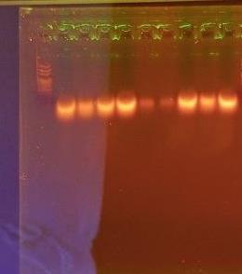
  L | A | B | C | D | E | F | G | H | I
  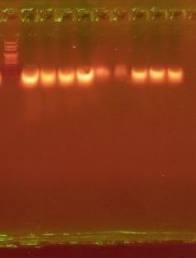
  L | A | B | C | D | E | F | G | H | I

Figure S1b | Hepatic gel panel: NF-κB1 (131 bp) and corresponding GAPDH

(b) NF-κB1 (131 bp); corresponding GAPDH reference panel shown on the right.
Liver NF-κB1 | Liver GAPDH (153 bp)
  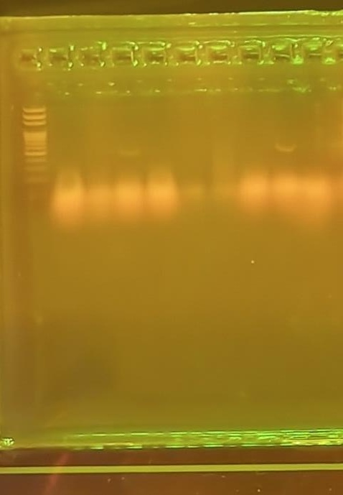
  L | A | B | C | D | E | F | G | H | I
  L | A | B | C | D | E | F | G | H | I

Figure S1c | Hepatic gel panel: Nrf2 (130 bp) and corresponding GAPDH

(c) Nrf2 (130 bp); corresponding GAPDH reference panel shown on the right.
Liver Nrf2 | Liver GAPDH (153 bp)
  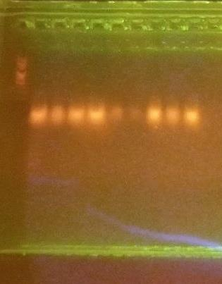
  L | A | B | C | D | E | F | G | H | I
  L | A | B | C | D | E | F | G | H | I

Figure S1d | Hepatic gel panel: TNF-α and corresponding GAPDH

(d) TNF-α; corresponding GAPDH reference panel shown on the right.
Liver TNF-α | Liver GAPDH (153 bp)
  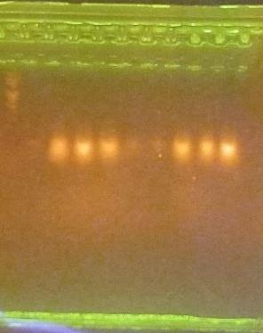
  L | A | B | C | D | E | F | G | H | I
  L | A | B | C | D | E | F | G | H | I

Figure S2 | Splenic expression profiles

Figure S2. Splenic expression profiles of HO-1, NF-κB1, Nrf2, and TNF-α genes in Plasmodium berghei-infected mice treated with artesunate and gallic acid. Representative agarose gel electrophoresis images showing PCR amplification products of (a) HO-1 (115 bp), (b) NF-κB1 (131 bp), (c) Nrf2 (130 bp), and (d) TNF-α, together with the corresponding GAPDH (153 bp) housekeeping gene bands used as an internal reference. A DNA ladder was included for molecular size estimation. Lanes A–I represent the experimental groups as follows: A, uninfected untreated mice (normal control); B, infected untreated mice (negative control); C, infected mice treated with artesunate (4 mg/kg body weight); D, infected mice treated with gallic acid (100 mg/kg body weight); E, infected mice treated with artesunate (4 mg/kg) plus gallic acid (6.25 mg/kg); F, infected mice treated with artesunate (4 mg/kg) plus gallic acid (12.5 mg/kg); G, infected mice treated with artesunate (4 mg/kg) plus gallic acid (25 mg/kg); H, infected mice treated with artesunate (4 mg/kg) plus gallic acid (50 mg/kg); and I, infected mice treated with artesunate (4 mg/kg) plus gallic acid (100 mg/kg). Distinct bands corresponding to the expected amplicon sizes were observed, confirming successful amplification of the target transcripts. Variations in band intensity among the treatment groups suggest differential modulation of splenic antioxidant defense pathways, represented by HO-1 and Nrf2, and inflammatory signaling pathways, represented by NF-κB1 and TNF-α. The relatively stable expression of GAPDH across samples validates its use as an internal control for comparative gene expression analysis. Primer sequences and expected amplicon sizes were based on Mus musculus gene-specific primers.

Figure S2a | Splenic gel panel: HO-1 (115 bp) and corresponding GAPDH

(a) HO-1 (115 bp); corresponding GAPDH reference panel shown on the right.
Spleen HO-1 | Spleen GAPDH (153 bp)
  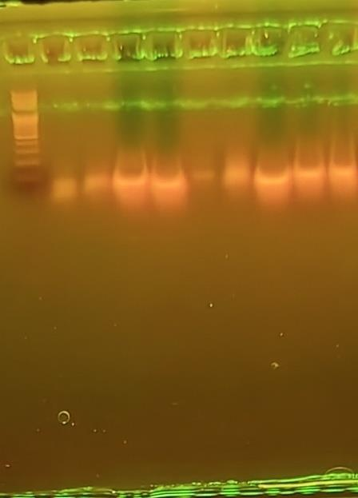
  L | A | B | C | D | E | F | G | H | I
  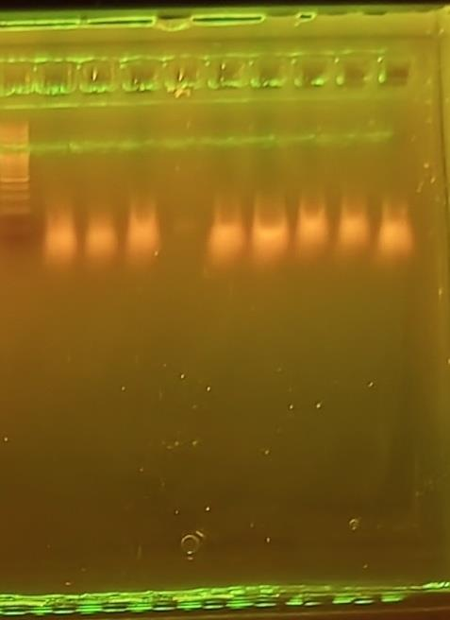
  L | A | B | C | D | E | F | G | H | I

Figure S2b | Splenic gel panel: NF-κB1 (131 bp) and corresponding GAPDH

(b) NF-κB1 (131 bp); corresponding GAPDH reference panel shown on the right.
Spleen NF-κB1 | Spleen GAPDH (153 bp)
  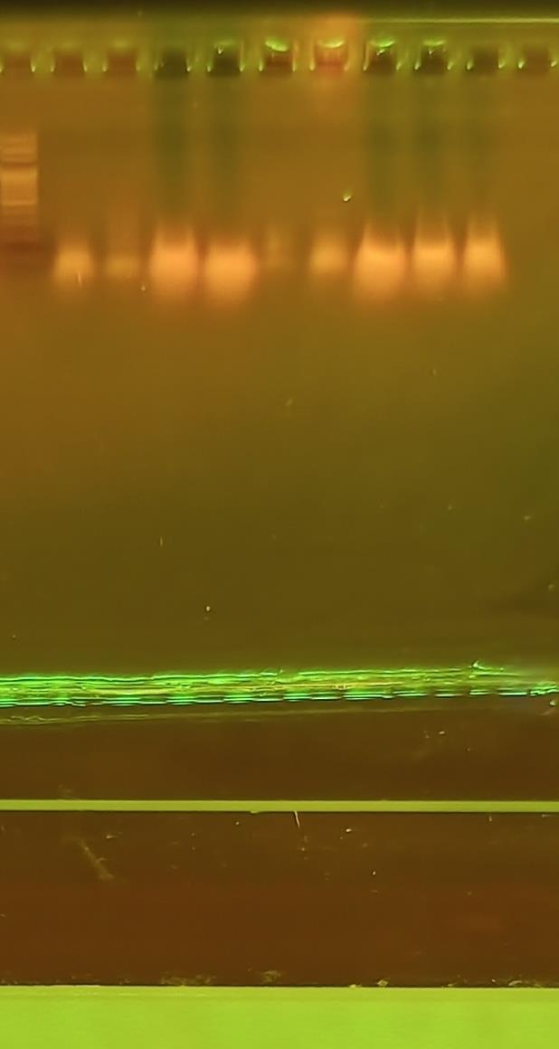
  L | A | B | C | D | E | F | G | H | I
  L | A | B | C | D | E | F | G | H | I

Figure S2c | Splenic gel panel: Nrf2 (130 bp) and corresponding GAPDH

(c) Nrf2 (130 bp); corresponding GAPDH reference panel shown on the right.
Spleen Nrf2 | Spleen GAPDH (153 bp)
  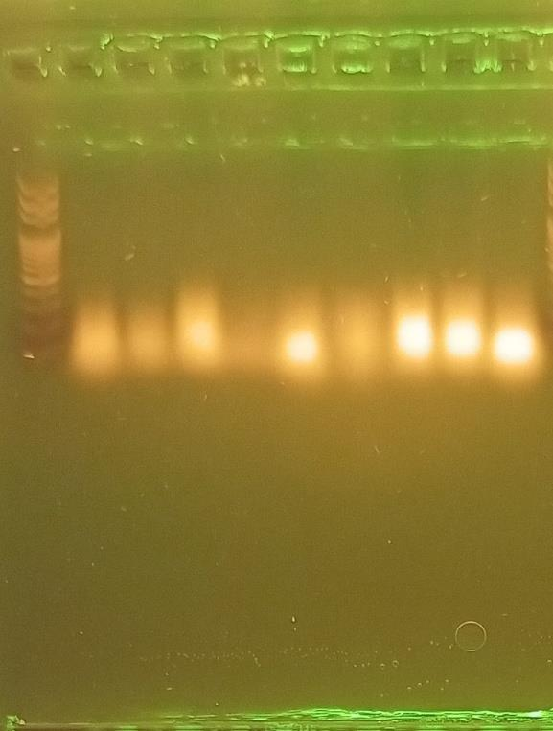
  L | A | B | C | D | E | F | G | H | I
  L | A | B | C | D | E | F | G | H | I

Figure S2d | Splenic gel panel: TNF-α and corresponding GAPDH

(d) TNF-α; corresponding GAPDH reference panel shown on the right.
Spleen TNF-α | Spleen GAPDH (153 bp)
  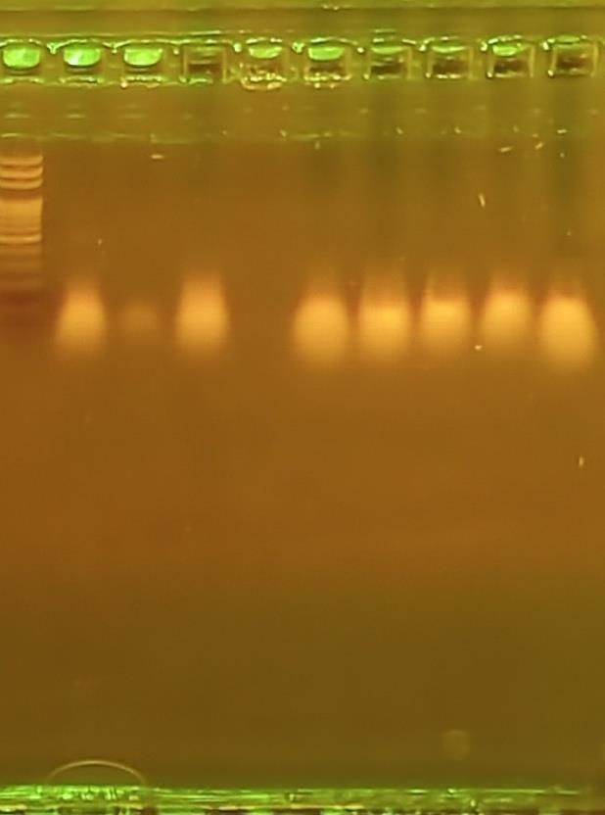
  L | A | B | C | D | E | F | G | H | I
  L | A | B | C | D | E | F | G | H | I

