Supplementary Information
Article Title:
Development of a Dissolution-Informed PBPK-Assisted In Vitro–In Silico Correlation Framework for Predicting Food Effects of Lurasidone Hydrochloride
Authors:
Dr. Minal R. Narkhede¹, Sonal Y. Mhaske¹, Jitendra Nehete²
Affiliations:
¹Department of Pharmaceutics, SMBT College of Pharmacy, Nashik, India
²Department of Pharmacognosy, Mahatma Gandhi Vidyamandir's Pharmacy College, Nashik, India
Corresponding Author:
Dr. Minal Narkhede
Email: smbt_pharmaceutics@rediffmail.com
HOD, Department Pharmaceutics,
SMBT College of Pharmacy
Nashik, India
93711 66112
ORCID ID: 0000-0002-8068-0450
Supplementary Figures
Figure S1. Zero-Order Kinetic Plots of Lurasidone Hydrochloride in Biorelevant Media
Figure S2. First-Order Kinetic Plots of Lurasidone Hydrochloride in Biorelevant Media
Figure S3. Higuchi Kinetic Plots of Lurasidone Hydrochloride in Biorelevant Media
Figure S4. Korsmeyer–Peppas Kinetic Plots of Lurasidone Hydrochloride in Biorelevant Media
Figure S5. Goodness-of-fit analysis of the developed PBPK model for lurasidone hydrochloride.
Figure S6. Visual predictive check (VPC) of the developed PBPK model for lurasidone hydrochloride.
Figure S7. Mechanistic pathway linking biorelevant dissolution behaviour with PBPK-predicted pharmacokinetic performance of lurasidone hydrochloride under fasting and fed conditions.

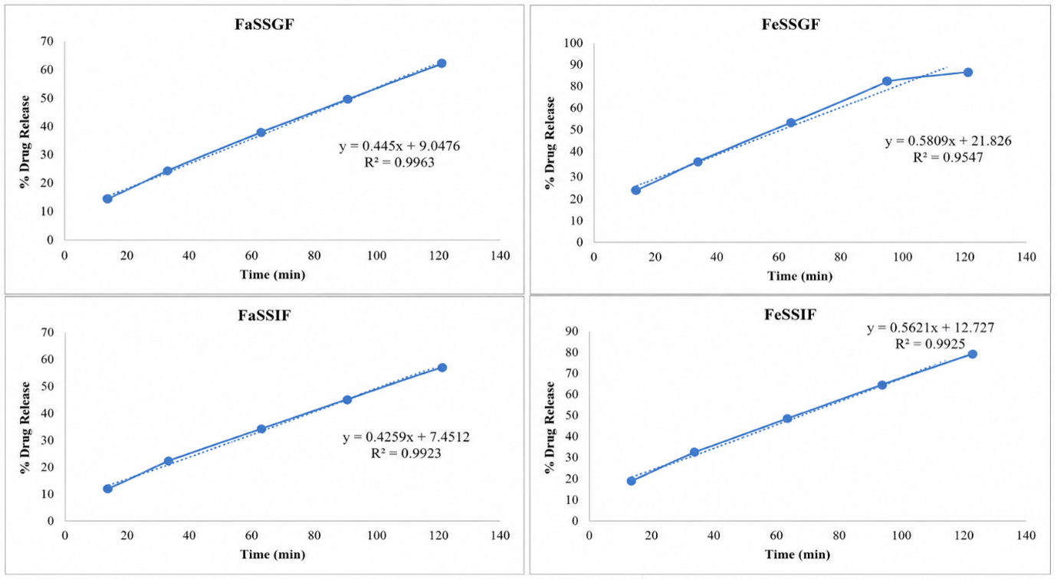 Figure S1. Zero-Order Kinetic Plots of Lurasidone Hydrochloride in Biorelevant Media 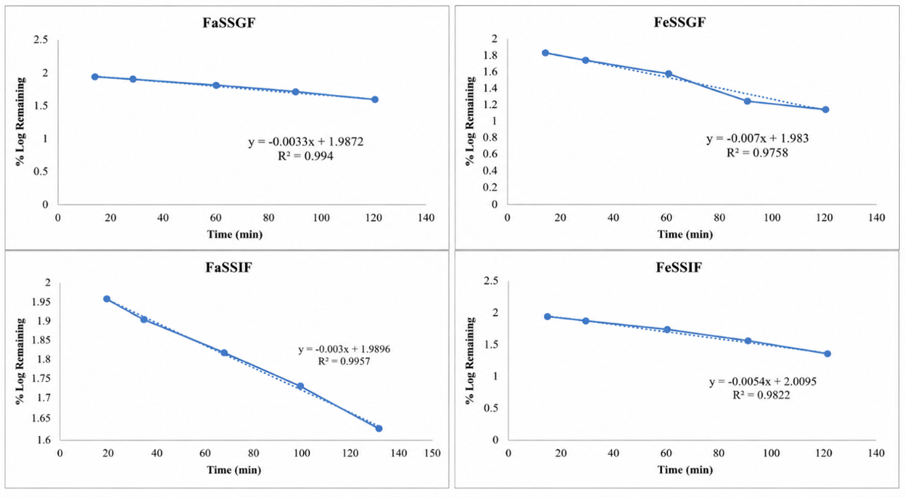 Figure S2. First-Order Kinetic Plots of Lurasidone Hydrochloride in Biorelevant Media 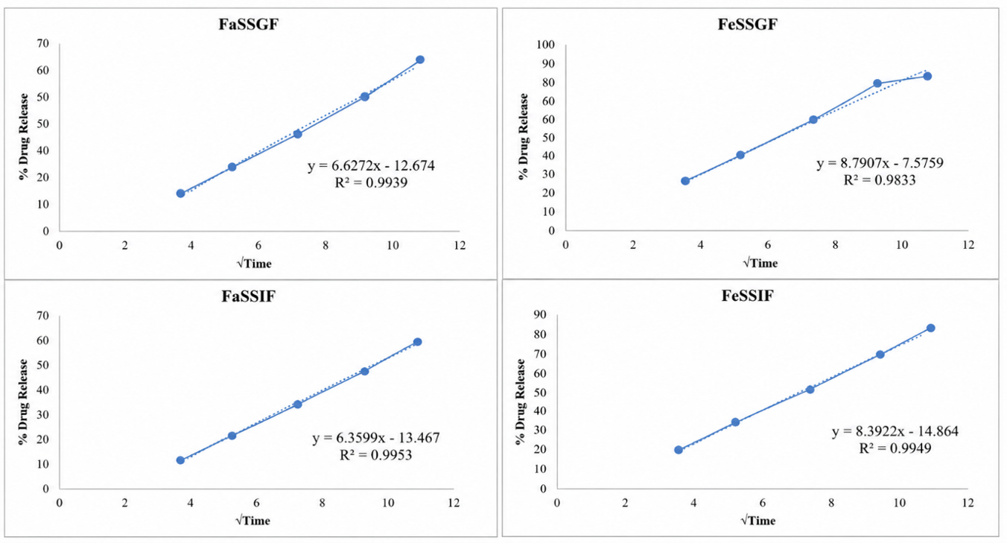 Figure S3. Higuchi Kinetic Plots of Lurasidone Hydrochloride in Biorelevant Media
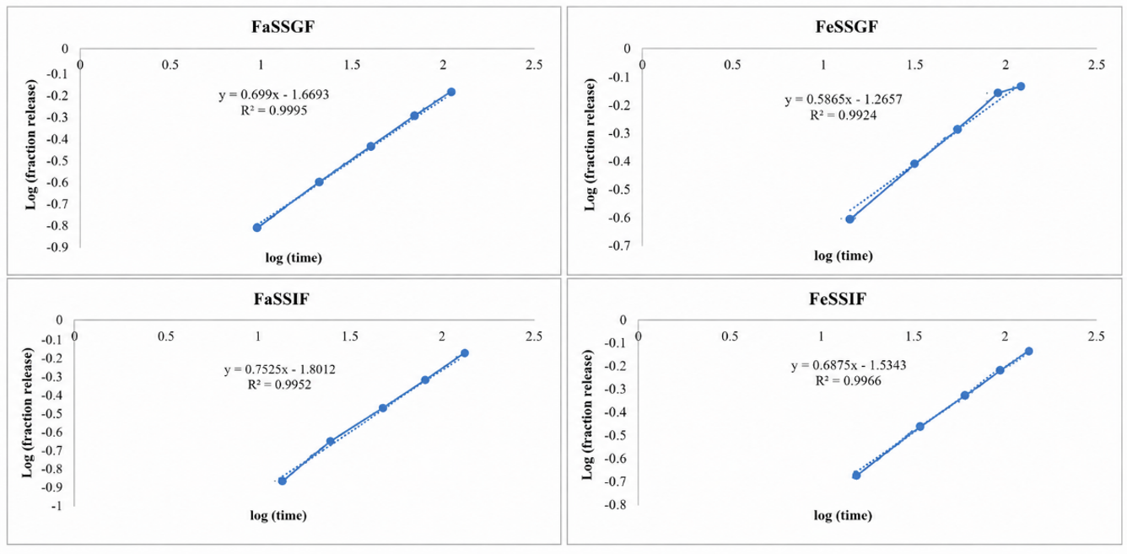 Figure S4. Korsmeyer–Peppas Kinetic Plots of Lurasidone Hydrochloride in Biorelevant Media
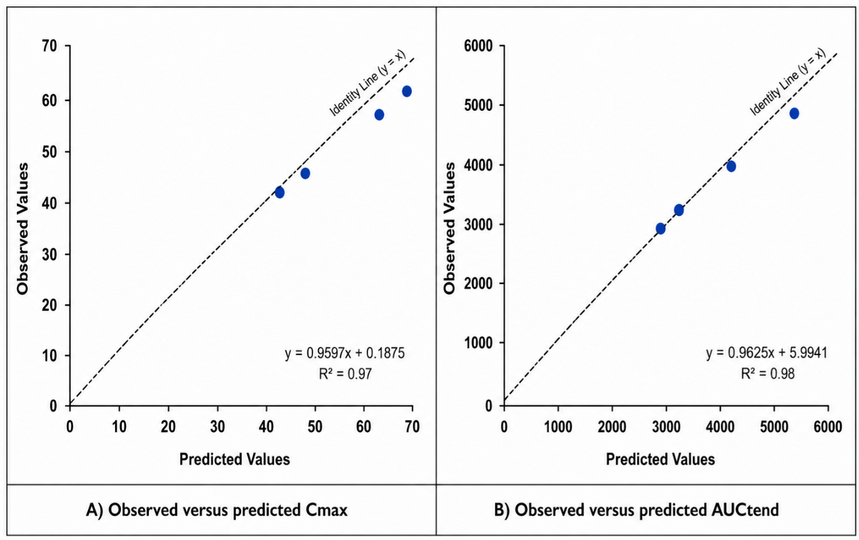Figure S5. Goodness-of-fit analysis of the developed PBPK model for lurasidone hydrochloride.
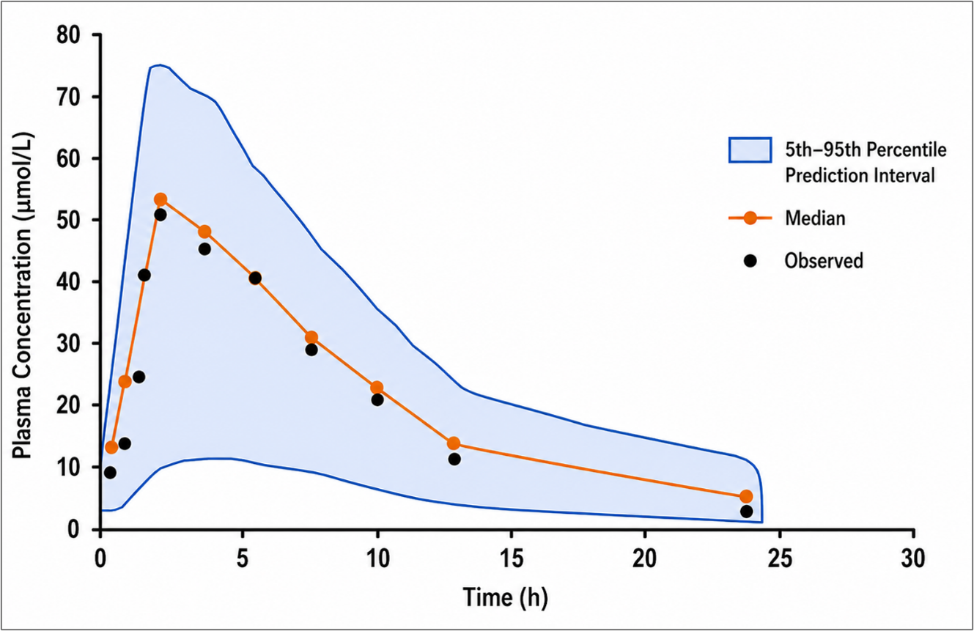Figure S6. Visual predictive check (VPC) of the developed PBPK model for lurasidone hydrochloride.
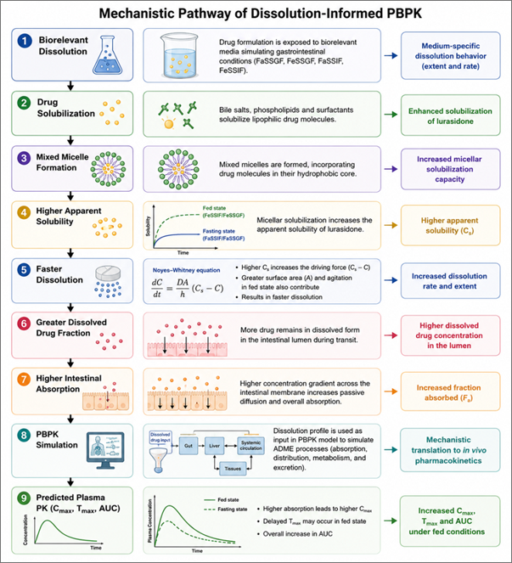Figure S7. Mechanistic pathway linking biorelevant dissolution behaviour with PBPK-predicted pharmacokinetic performance of lurasidone hydrochloride under fasting and fed conditions.

Supplementary Tables
Table S1. Analytical Method Validation Parameters for Lurasidone Hydrochloride
Table S2. Observed Absorbance Values for Calibration Curve Construction in Biorelevant Media
Table S3. Percentage Drug Release of Lurasidone Hydrochloride in Biorelevant Media with 95% Confidence Intervals and One-Way ANOVA
Table S4. Coefficients of Determination (R²) and Release Exponent Values Obtained from Dissolution Kinetic Modeling of Lurasidone Hydrochloride
Table S5. Similarity Factor (f₂) Values for Dissolution Profile Comparisons
Table S6. Normalized sensitivity coefficients of selected physiological and formulation-related parameters affecting predicted Cmax and AUCtend of lurasidone hydrochloride.
Table S7. Simulated Percentile Ranges and Observed Concentrations Used for VPC Analysis
Table S8. Predicted Pharmacokinetic Parameters in Healthy Adults and Hepatic Impairment Population

Table S1. Analytical Method Validation Parameters for Lurasidone Hydrochloride
Parameter | Result
Wavelength (λmax) | 232 nm
Linearity Range | 5–30 µg/mL
Correlation Coefficient (R²) | 0.999
LOD | 0.42 µg/mL
LOQ | 1.28 µg/mL
Intra-day Precision (%RSD) | 1.24%
Inter-day Precision (%RSD) | 2.08%

Table S2. Observed Absorbance Values for Calibration Curve Construction in Biorelevant Media
Sr. No. | Concentration (ppm) | FaSSGF | FeSSGF | FaSSIF | FeSSIF
1 | 5 | 0.170 | 0.198 | 0.167 | 0.186
2 | 10 | 0.336 | 0.393 | 0.320 | 0.369
3 | 15 | 0.503 | 0.588 | 0.479 | 0.552
4 | 20 | 0.669 | 0.783 | 0.638 | 0.735
5 | 25 | 0.836 | 0.978 | 0.797 | 0.918
6 | 30 | 0.981 | 0.996 | 0.956 | 0.992
Table S3. Percentage Drug Release of Lurasidone Hydrochloride in Biorelevant Media with 95% Confidence Intervals and One-Way ANOVA
Time (min) | FaSSGF (% Release) | 95% CI | FeSSGF (% Release) | 95% CI | FaSSIF (% Release) | 95% CI | FeSSIF (% Release) | 95% CI | p-value
0 | 0.0 ± 0.0 | 0.0–0.0 | 0.0 ± 0.0 | 0.0–0.0 | 0.0 ± 0.0 | 0.0–0.0 | 0.0 ± 0.0 | 0.0–0.0 | NS
15 | 14.2 ± 1.2 | 11.2–17.2 | 26.4 ± 1.5 | 22.7–30.1 | 11.6 ± 1.0 | 9.1–14.1 | 18.3 ± 1.3 | 15.1–21.5 | <0.001
30 | 23.3 ± 1.8 | 18.8–27.8 | 39.7 ± 2.1 | 34.5–44.9 | 22.0 ± 1.7 | 17.8–26.2 | 32.0 ± 1.9 | 27.3–36.7 | <0.001
60 | 37.1 ± 2.3 | 31.4–42.8 | 59.7 ± 2.8 | 52.7–66.7 | 34.2 ± 2.2 | 28.7–39.7 | 47.4 ± 2.5 | 41.2–53.6 | <0.001
90 | 49.0 ± 2.8 | 42.0–56.0 | 81.2 ± 3.4 | 72.8–89.6 | 45.9 ± 2.7 | 39.2–52.6 | 64.2 ± 3.0 | 56.7–71.7 | <0.001
120 | 61.8 ± 3.2 | 53.9–69.7 | 85.1 ± 3.6 | 76.2–94.0 | 57.7 ± 3.0 | 50.2–65.2 | 78.8 ± 3.4 | 70.4–87.2 | <0.001

Table S4. Coefficients of Determination (R²) and Release Exponent Values Obtained from Dissolution Kinetic Modeling of Lurasidone Hydrochloride
Medium | Zero-Order R² | First-Order R² | Higuchi R² | Korsmeyer–Peppas R² | Release Exponent (n)
FaSSGF | 0.9963 | 0.9940 | 0.9939 | 0.9995 | 0.699
FeSSGF | 0.9547 | 0.9758 | 0.9833 | 0.9924 | 0.586
FaSSIF | 0.9923 | 0.9957 | 0.9953 | 0.9952 | 0.753
FeSSIF | 0.9925 | 0.9822 | 0.9949 | 0.9966 | 0.688

Table S5. Similarity Factor (f₂) Values for Dissolution Profile Comparisons
Comparison | f₂ Value
FaSSGF vs FeSSGF | 32.47
FaSSIF vs FeSSIF | 66.92
FaSSGF vs FaSSIF | 75.38
FeSSGF vs FeSSIF | 47.84

Table S6. Normalized sensitivity coefficients of selected physiological and formulation-related parameters affecting predicted Cmax and AUCtend of lurasidone hydrochloride.
Parameter | Sensitivity Coefficient (Cmax) | Sensitivity Coefficient (AUCtend) | Relative Influence
Solubility | 1.00 | 1.00 | Highest
CYP3A4 Clearance | -0.95 | -0.98 | Highest
Oral Dose | 0.90 | 0.92 | Highest
Peff (Effective Permeability) | 0.85 | 0.75 | Significant
Intestinal Transit Time | 0.60 | 0.65 | Significant
Gastric Emptying Time | -0.55 | -0.35 | Moderate
Dissolution Time (50% Dissolved) | -0.45 | -0.50 | Significant
Tablet Delay Factor | -0.15 | -0.10 | Minor

Table S7. Simulated Percentile Ranges and Observed Concentrations Used for VPC Analysis
Time (h) | 5th Percentile (µmol/L) | Median (µmol/L) | 95th Percentile (µmol/L) | Observed (µmol/L)
0.5 | 5.2 | 8.4 | 13.6 | 8.0
1.0 | 12.8 | 21.4 | 33.5 | 22.0
1.5 | 25.4 | 39.8 | 58.2 | 40.5
2.0 | 35.7 | 51.6 | 72.4 | 50.8
3.0 | 31.2 | 46.8 | 66.1 | 46.0
4.0 | 24.8 | 38.9 | 55.6 | 38.2
6.0 | 16.5 | 28.4 | 42.7 | 27.5
8.0 | 10.2 | 18.3 | 30.8 | 17.6
12.0 | 4.6 | 8.9 | 17.2 | 8.2
24.0 | 0.8 | 2.4 | 6.3 | 2.1

Table S8. Predicted Pharmacokinetic Parameters in Healthy Adults and Hepatic Impairment Population
Population | Cmax (µmol/L) | Tmax (h) | AUCtend (µmol·min/L)
Healthy | 64.2 | 2.0 | 5138.05
Hepatic impairment | 77.0 | 2.3 | 5395.20

