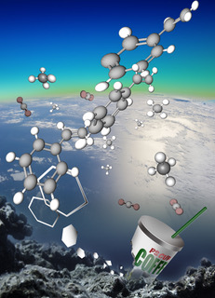
Graphical Abstract; Based on http://eoi.jsc.nasa.gov/

