Supplementary Information
How digital transformation reshapes organisational governance for sustainability: a socio-technical case study of Haier Smart Home

Table S1. Interview sample composition and role coverage
Code Group | Role Coverage | Participant Count (n) | Primary Evidence Contribution
M1–M7 | Senior executives, strategic and HR-platform leaders, business-unit leadership, and a RenDanHeYi expert | 7 | Strategic intent, organizational design, HR platformization, and model interpretation
T1–T11 | Chain-group, platform, regional, industry, finance, HR, and functional leaders | 11 | Mechanism operation, cross-unit coordination, performance accountability, and value sharing
E1–E17 | Frontline creators and personnel in R&D, manufacturing, supply chains, sales, service, logistics, digital operations, and overseas marketing | 17 | Operational experience, user interaction, digital-tool use, collaboration tensions, and adaptation
Total | All role categories | 35 | Mechanism development and triangulation
Note: Counts were reconciled against the anonymized participant roster. All 35 coded records are present in the consolidated Chinese-language transcript archive. Interviews were conducted through Tencent Meeting from November 2025 to March 2026. The participant log records 65-112 min per interview (mean 80.1 min; 2805 min in total). Direct identifiers are excluded.

Table S2. Representative interview quotations
Interview ID | Role Category | Interview Date | Evidence Theme | Representative Quotation
M1 | Senior executive | 2025/11/12 | Strategic positioning of digital transformation | “Digitalization is our infrastructure; RenDanHeYi is our operating rule; ecosystemization is the destination.”
M1 | Senior executive | 2025/11/12 | Dynamic strategic alignment | “The essence of our reform is a shift from top-down control to bottom-up user-value creation.”
M1 | Senior executive | 2025/11/12 | User-value-based incentives | “Employees used to look to their leaders for evaluation; now their income, promotion, and opportunities are all linked to user value.”
M2 | Senior executive | 2025/11/27 | Digital infrastructure | “Without digitalization, there would be no Haier Smart Home as it is today, and RenDanHeYi could not be implemented.”
M2 | Senior executive | 2025/11/27 | Chain-group collaboration | “When users need a whole-home solution, the chain group receives the order, designs, matches, delivers, and serves as one unit, and the value is shared among participants.”
M3 | HR platform leader | 2025/12/10 | HR platformization | “The HR platform has no hierarchy or approval power; it only has service power and empowerment power.”
M3 | HR platform leader | 2025/12/10 | Dynamic resource reconfiguration | “Through the Haidayuan talent platform and the HR data middle platform, people and orders are matched in real time.”
M3 | HR platform leader | 2025/12/10 | User-paid compensation | “Without user value, there is no compensation return. This is an iron rule.”
M4 | Business unit leader | 2025/12/26 | Digital transformation in manufacturing | “Digitalization enables us to accurately capture every user pain point in laundry and garment care.”
T2 | Chain-group leader | 2025/11/14 | Order-based operation | “There are no tasks assigned by superiors; there are only value orders required by users.”
T2 | Chain-group leader | 2025/11/14 | Chain-group contract governance | “Collaboration does not rely on administrative instructions; it relies on chain-group contracts.”
M5 | External expert | 2026/1/9 | Theoretical interpretation of order-based assembly and disassembly | “Talent resources shift from being owned by the enterprise to being shared by the platform, and from superior assignment to market selection.”
Note: Quotations are English translations of the archived Chinese transcripts. Coded identifiers are used to protect participants.

Table S3. Coding framework and audit trail
First-Order Evidence | Second-Order Theme | Aggregate Dimension | Audit-Trail Use
User needs, scenario requirements, market opportunities, and user pain points | User-Signal Identification | Digital-Transformation Triggers | Linked to coded transcript excerpts and triangulated with public documentary evidence.
HR platforms, HR shared service centers, talent data, business support, and decentralized authority | HR Platformization | Dynamic Strategic Alignment | Linked to coded transcript excerpts and triangulated with public documentary evidence.
Capability tags, talent profiles, project records, and contribution histories | Talent Visibility | Dynamic Resource Reconfiguration | Linked to coded transcript excerpts and triangulated with public documentary evidence.
Value orders, active participation, temporary team formation, and task completion | Order-Based Assembly and Disassembly | Dynamic Resource Reconfiguration | Linked to coded transcript excerpts and triangulated with public documentary evidence.
User feedback, order value, market outcomes, satisfaction, and service quality | User-Value Measurement | User-Value-Based Incentives | Linked to coded transcript excerpts and triangulated with public documentary evidence.
User-paid compensation, contribution-based rewards, and value sharing | Incentive Restructuring | User-Value-Based Incentives | Linked to coded transcript excerpts and triangulated with public documentary evidence.
Chain groups, micro-enterprises, functional platforms, and ecosystem partners | Cross-Boundary Collaboration | Platform Governance | Linked to coded transcript excerpts and triangulated with public documentary evidence.
Platform rules, process records, responsibility definition, and dispute resolution | Rule-Based Platform Governance | Platform Governance | Linked to coded transcript excerpts and triangulated with public documentary evidence.

Table S4. Negative and disconfirming interview evidence
Interview ID | Role Category | Interview Date | Disconfirming Theme | English Translation of Archived Chinese Evidence | Analytical Qualification
E9 | Frontline installation-service creator | 27 January 2026 | Income volatility and the need for a basic safeguard | "The basic guaranteed salary is intended to stabilize the livelihoods of long-serving frontline service staff ... and prevent experienced technicians from leaving when off-season order volumes make income unstable." | User-value-linked pay requires a basic income safeguard and cannot rely exclusively on variable orders or ratings.
E17 | Frontline market-operations manager | 11 March 2026 | Cross-boundary coordination burden | "The fourth challenge is coordination difficulty. We have to work with many departments and partners, each with different ideas and work rhythms. Sometimes coordination is exhausting ... we must communicate repeatedly and keep following up, which takes a great deal of effort." | Digital connectivity does not eliminate conflicting priorities or the labor of cross-boundary follow-up.
T1 | Chain-group leader | 13 November 2025 | Digitally intensified work pressure | "My biggest feeling is that the work shifted from tiring the mind to tiring the legs and the heart ... as a chain-group leader, I must constantly attend to user needs and resolve problems ... it is more exhausting than before." | Continuous user-signal monitoring and problem resolution can increase physical and psychological work intensity.
Note: Ellipses shorten the translated quotations without changing their substantive meaning. The Chinese transcripts and coding records are retained under encrypted, restricted-access storage.

Table S5. Documentary source inventory
Source Type | Document or Portal | Date | Public/Internal | URL or Archive Identifier | Analytical Use
Annual report | Haier Smart Home Annual Report 2021 | 2022 | Public | https://smart-home.haier.com/en/investor-relations/#financial-reports | 2021 baseline for strategy, governance, and financial context.
Annual report | Haier Smart Home Annual Report 2022 | 2023 | Public | https://smart-home.haier.com/en/investor-relations/#financial-reports | Longitudinal context for digital and operating development.
Annual report | Haier Smart Home Annual Report 2023 | 2024 | Public | https://smart-home.haier.com/en/investor-relations/#financial-reports | Evidence on dealer, logistics, service, and supply-chain digitalization.
Annual report | Haier Smart Home Annual Report 2024 | 2025 | Public | https://smart-home.haier.com/en/investor-relations/#financial-reports | Evidence on deeper digital transformation and response-cycle improvement.
Annual report | Haier Smart Home Annual Report 2025 | 2026 | Public | https://smart-home.haier.com/en/investor-relations/#financial-reports | 2025 financial, strategic, supply-chain, and AI-enabled R&D context.
ESG report | Haier Smart Home Environmental, Social and Governance Report 2025 | 2026 | Public | https://www.haier.com/global/csr/ | Environmental, employee, supplier, circularity, and user-side sustainability context.
Disclosure portal | Haier Smart Home Investor Relations - Financial Reports | Accessed 18 July 2026 | Public | https://smart-home.haier.com/en/investor-relations/#financial-reports | Verification and retrieval of annual reports.
Disclosure portal | Haier Global Corporate Social Responsibility | Accessed 18 July 2026 | Public | https://www.haier.com/global/csr/ | Verification and retrieval of ESG disclosures.

Figure S1. Measurement framework for chain-group contract governance
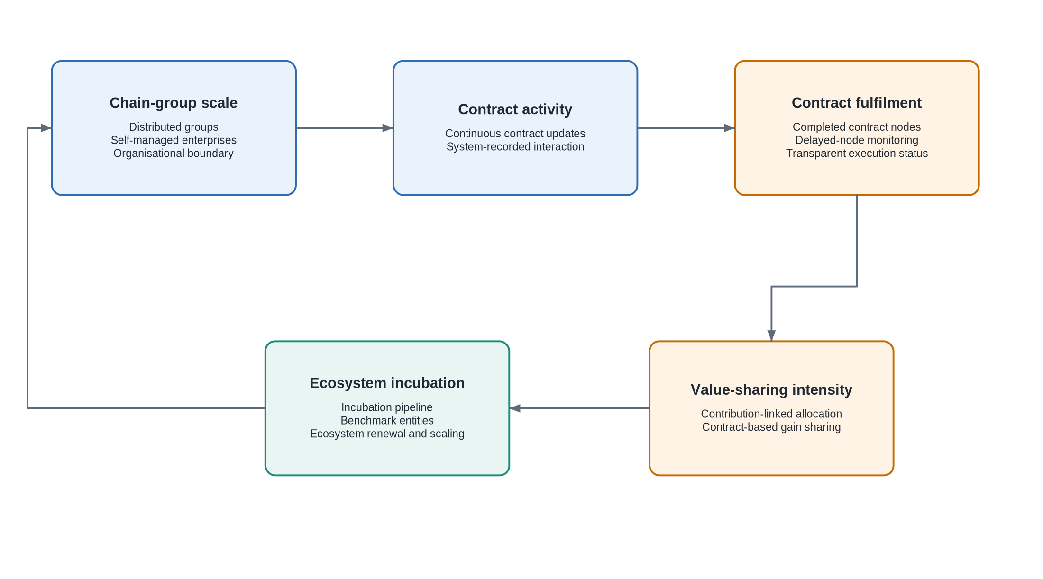
Figure S1. Qualitative measurement dimensions for chain-group contract governance. The dimensions are analytical and do not constitute causal validation.

File S1. Semi-structured interview protocol
This blank protocol records the interview domains used across the archived interview records. Question order and follow-up probes varied according to participant role and the organizational practice being discussed.
1. Please describe your role and involvement in Haier Smart Home's digital transformation.
2. Which digital platforms, data systems, or AI tools are most relevant to your work?
3. How are user needs and market signals identified and translated into organizational action?
4. How have HR platforms and decentralized authority affected strategy execution?
5. How are employee capabilities recorded, matched, and reconfigured around value orders?
6. How does order-based assembly and disassembly operate in practice?
7. How are user value, contribution, compensation, and value sharing connected?
8. How do chain-group contracts define goals, responsibilities, delivery, and benefit sharing?
9. What outcomes have improved, and what alternative explanations should be considered?
10. What tensions or risks have emerged concerning income volatility, coordination, monitoring, privacy, fairness, or psychological pressure?

File S2. Blank verbal informed-consent script
This blank script records the consent information documented for the remote interviews. The study protocol and consent procedure were approved before data collection by the authors' institutional ethics committee. Full committee details, protocol code and signed documentation have been provided confidentially to the Editorial Office.
You are invited to participate in an academic study of digital transformation and sustainable management in manufacturing.
Participation is voluntary. You may decline to answer any question or stop the interview at any time without penalty.
With your permission, the Tencent Meeting interview will be recorded and transcribed for academic analysis.
Your name and direct personal identifiers will be removed. Findings will use coded identifiers and anonymized English translations of selected excerpts.
The anonymized material may be used in academic publications and presentations.
Recordings, transcripts, and coding files will be stored in encrypted, access-restricted form and used only for authorized research purposes.
Do you understand this information and verbally agree to participate?

Use of artificial intelligence tools
During manuscript preparation, ChatGPT and OpenAI Codex (OpenAI; accessed July 2026) were used for Chinese-English translation, language restructuring and preliminary conceptual brainstorming. They were not used for data collection, independent qualitative coding, theme determination, empirical findings or research conclusions. No generative-AI images are included. The authors reviewed and verified all outputs and retain full responsibility for the submitted material.

