Supplementary Information
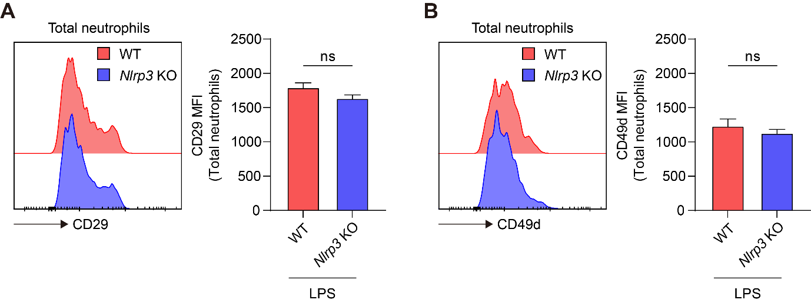
Supplementary Figure S1. (A and B) Representative histograms and mean fluorescence intensity (MFI) of (A) CD29 and (B) CD49d on total neutrophils. VLA-4 is an integrin heterodimer composed of CD29 (β1) and CD49d (α4). Data represent the results of at least three independent experiments. Mean values are shown with error bars representing the SEM. ns: non-significant.
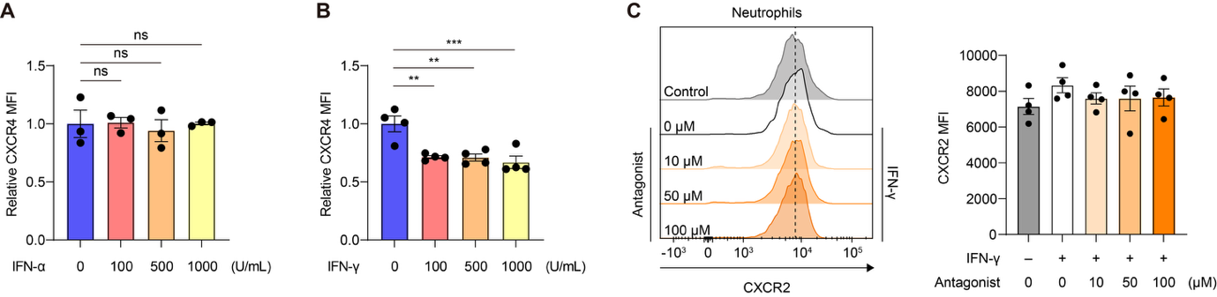
Supplementary Figure S2. Mean fluorescence intensity (MFI) of CXCR4 on BM neutrophils treated with the indicated concentrations of (A) IFN-α or (B) IFN-γ. (C) Representative histograms and mean fluorescence intensity (MFI) of CXCR2 on BM neutrophils treated with 500 U/mL IFN-γ in the presence or absence of the indicated concentrations of an IFN-γ antagonist. Data represent the results of at least three independent experiments. Mean values are shown with error bars representing the SEM. ns: non-significant. **P<0.01, ***P<0.001.
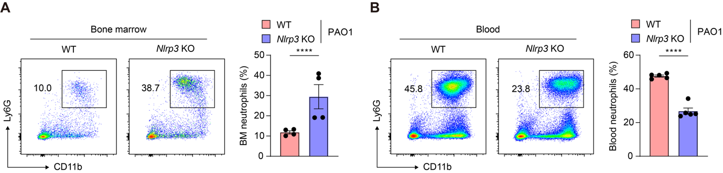
Supplementary Figure S3. WT and Nlrp3 KO mice were intraperitoneally infected with PAO1 (1 x 10⁶ c.f.u. per mouse). Bone marrow and blood neutrophils were analyzed 6 h after infection. (A and B) Representative scatter plots and percentages of (A) bone marrow neutrophils and (B) blood neutrophils. Data represent the results of at least three independent experiments. Mean values are shown with error bars representing the SEM. ****P<0.0001.
Supplementary Table 1. Antibody lists.
Antibody | Product information
APC anti-mouse/human CD11b | M1/70, Biolegend, 101212
PE anti-mouse Ly6G | 1A8, Biolegend, 127608
BV421 anti-mouse CD184 (CXCR4) | L276F12, Biolegend, 146511
FITC anti-mouse CXCL12 | 79018, Thermofisher, MA5-23547
PE/Fire 810 anti-mouse Ly6G | 1A8, Biolegend, 127673
BV421 anti-mouse SiglecF | S17007L, Biolegend, 155509
BV711 anti-mouse F4/80 | BM8, Biolegend, 123147
BV 605 anti-mouse CD117 (c-Kit) | 2B8, Biolegend, 105847
APC anti-mouse CD200R3 | Ba13, Biolegend, 142207
PE anti-mouse Ly6C | HK1.4, Biolegend, 128008
APC/Cyanine7 anti-mouse CD45 | 30-F11, Biolegend, 103116
BV 605 anti-mouse IFN-γ | XMG1.2, Biolegend, 505839
PE anti-mouse CD4 Antibody | RM4-4, Biolegend, 116005
PE/Cyanine5 anti-mouse CD8a | 53-6.7, Biolegend, 100709
FITC anti-mouse CD11c Antibody | N418, Biolegend, 117305
FITC anti-mouse Ly-6G | 1A8, Biolegend, 127606
PE anti-mouse/rat CD29 | HMβ1-1, Biolegend, 102207
PE anti-mouse CD49d | R1-2, Biolegend, 103607
PE anti-mouse CD182 (CXCR2) | SA044G4, Biolegend, 149303

Supplementary Table 2. Primers used for qPCR.
Tbp
Forward primer | GAG TTG CTT GCT CTG TGC TG
Reverse primer | CTG GCT TGT GTG GGA AAG AT
Cxcl12
Forward primer | CTT TCA CTC TCG GTC CAC CT
Reverse primer | GGC ACA GTT TGG AGT GTT GA
Csf3
Forward primer | GCA CTA TGG TCA GGA CGA GA
Reverse primer | TCT TCC TCA CTT GCT CCA GG

