Supplementary Table S1 PRISMA flow diagram of literature screening
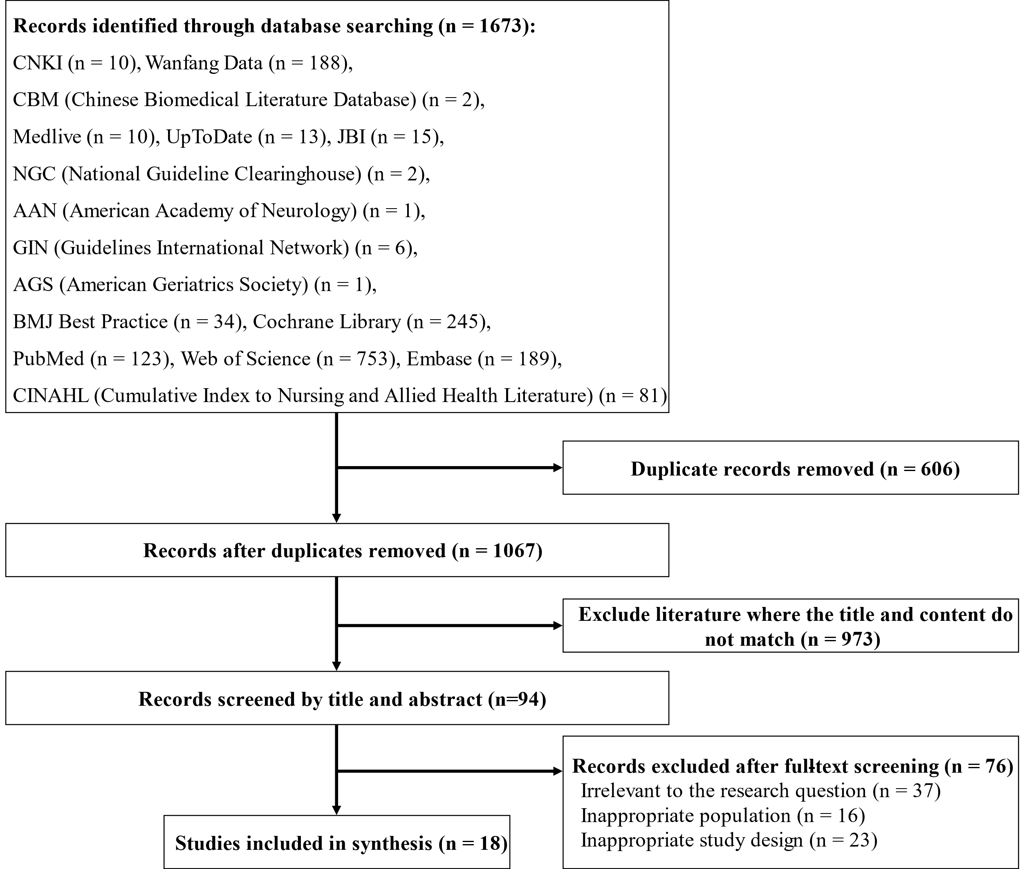

Supplementary Table S2 General characteristics of the included literature
This table summarises the characteristics of the 18 publications included in the evidence synthesis. Citation numbers correspond to the reference list in the main manuscript.
Table S2 General characteristics of the included literature (n = 18)
Included Literature | Year | Source | Type | Topic
Italian National Institute of Health [21] | 2024 | Medlive | Guideline | The Italian guideline on the diagnosis and treatment of dementia and mild cognitive impairment
Chinese Medical Doctor Association, Neurology Branch [22] | 2022 | Wanfang Database | Guideline | Chinese guidelines for cognitive training (2022 edition)
Petersen et al. [23] | 2018 | American Academy of Neurology (AAN) | Guideline | Practice guideline update summary: Mild cognitive impairment
Cognitive Impairment Disease Professional Committee, Neurology Branch, Chinese Medical Doctor Association [24] | 2018 | Wanfang Database | Guideline | 2018 Chinese guidelines for the diagnosis and treatment of dementia and cognitive impairment (V): diagnosis and treatment of mild cognitive impairment
Brain Cognitive Health Management Chinese Expert Consensus Formulation Committee [25] | 2023 | Medlive | Expert Consensus | Chinese expert consensus on brain cognitive health management (2023)
Chinese Medical Association, Neurology Branch, Dementia and Cognitive Impairment Study Group [26] | 2024 | Medlive | Expert Consensus | Chinese expert consensus on the diagnosis and treatment of mild cognitive impairment due to Alzheimer's disease (2024)
Dunne R A et al. [27] | 2021 | Medlive | Expert Consensus | Mild cognitive impairment: the Manchester consensus
Mei XF et al. [28] | 2019 | CNKI | Systematic Review | Effects of multidomain non-pharmacological interventions for mild cognitive impairment: a meta-analysis
Zou C et al. [29] | 2024 | Embase | Systematic Review | Effect of home-based lifestyle interventions on cognition in older adults with mild cognitive impairment: a systematic review
Gómez-Soria I et al. [30] | 2022 | PubMed | Systematic Review | Effects of multidomain non-pharmacological interventions on cognition in participants with mild cognitive impairment: a systematic review and meta-analysis
Salzman T et al. [31] | 2022 | PubMed | Systematic Review | Associations of multidomain interventions with improvements in cognition in mild cognitive impairment: a systematic review and meta-analysis
Sakurai, T et al. [7] | 2024 | PubMed | Randomized Controlled Trial | Japan multidomain intervention trial for the prevention of dementia: a randomized controlled trial
Yang, Q. H et al. [32] | 2022 | PubMed | Randomized Controlled Trial | Effects of a multicomponent intervention to slow mild cognitive impairment progression: a randomized controlled trial
Moon SY et al. [33] | 2025 | PubMed | Randomized Controlled Trial | South Korean study to prevent cognitive impairment and promote brain health through multidomain interventions via face-to-face and video communication platforms in mild cognitive impairment (SUPERBRAIN-MEET): a randomized controlled trial
Fan, M et al. [34] | 2024 | PubMed | Randomized Controlled Trial | Effect of multidomain intervention in individuals with mild cognitive impairment: a randomized clinical trial in Shanghai
Bae, S et al. [35] | 2019 | PubMed | Randomized Controlled Trial | Effect of a multicomponent intervention to promote community activity on cognitive function in older adults with mild cognitive impairment: a randomized controlled trial
Jeong, M. K. et al. [36] | 2021 | PubMed | Randomized Controlled Trial | Multicomponent intervention program on habitual physical activity parameters and cognitive function in patients with mild cognitive impairment: a randomized controlled trial
Zhang RF et al. [37] | 2024 | CNKI | Quasi-experimental study | Effects of multidomain nursing interventions on patients with mild cognitive impairment

Supplementary Table S3 The multidomain intervention implementation plan for patients with MCI based on MTM
Table S3. Multidomain intervention implementation plan for patients with MCI based on MTM
Intervention Phase | Intervention Dimension | Timing | Intervention Content | Delivery Format | Duration and Frequency of Intervention
Behavioral Initiation | Participatory Dialogue | Within 48 hours after a positive screening result | 1. Conduct a multidisciplinary team discussion involving patients and their families to explore illness experiences; use visual aids (e.g., graphics, videos) to differentiate normal aging from MCI and correct misconceptions.  2. Explain risks of non-intervention using clinical evidence and cases.  3. Establish real-life contextual linkages and develop a "behavior–function" comparison table, integrating animations, graphics, and other education materials to clearly illustrate the benefits and value of multidomain interventions.  4. Conduct one-on-one motivational interviewing to facilitate patient’s expression of their genuine concerns regarding behavioral barriers, with an initial focus on questions such as, "What difficulties do you anticipate encountering when participating in the intervention?", and collaboratively develop tailored solutions. | Group sessions; One-on-one motivational interviews  Location: in-person at a multidisciplinary clinic or community health service center | Group meetings: 30 minutes; motivational interviews:15–20 minutes.
Behavioral Initiation | Behavioral Confidence | Within 72 hours of enrollment; first month | 1. Provide feedback on assessment results to both the patient and their family in a positive, non-judgmental manner; use specific case examples to clearly highlight the potential benefits of adhering to the training regimen.  2. Collaboratively set intervention goals with the patient, breaking them down into smaller, manageable daily objectives; provide a task checklist aligned with these goals to seamlessly integrate the intervention into their daily routine.  3. Configure the computer-based cognitive training tasks to function in an adaptive mode, starting at a foundational level suited to the patient’s current abilities and gradually increasing the difficulty to minimize cognitive fatigue.  4. Organize and facilitate patient experience-sharing sessions, inviting patients with prior experience to share their positive outcomes from the multidomain interventions. This will help boost the confidence of new participants and encourage their active engagement in the program. | Face-to-face sessions  Location: in-person, held in a clinic consultation room or community health service center activity room | 10–20 minutes
Behavioral Initiation | Physical Environment Modification | Within 1 week of enrollment | 1. Provide patients with the Multidomain Intervention Guidebook for Patients with Mild Cognitive Impairment, which covers topics such as early symptom recognition, risk factor identification, detailed multidomain intervention strategies, caregiver empowerment, and guidance on accessing healthcare services.  2. Supply a multidomain intervention toolkit—including the guidebook, a cognitive diary, cue cards, resistance bands, and exercise mats—to support structured home-based training.  3. Assist patients and their families in setting up digital cognitive training equipment (e.g., tablets or computers), and provide ongoing technical support and consultation as needed.  4. Establish a dedicated WeChat-based service platform for cognitive intervention to facilitate appointment scheduling and follow-up management, complemented by an online hospital system to provide remote consultations.  5. Where feasible, guide patients in creating a designated "Cognitive Activity Corner" at home—a fixed, well-equipped space containing items such as puzzles, books, and art supplies—to optimize the training environment and minimize environmental "cognitive distractions" during practice.  6. Place visual cue cards in key areas associated with daily routines; these cues function as prompts to "anchor" specific training behaviors to habitual activities, thereby promoting consistency and adherence. | Face-to-face and online guidance  Location: Offered both in-person at the clinic or through online consultations | Face-to-face health education: 5-10 minutes; online guidance: 20 minutes
Behavior Maintenance | Emotional Transformation | Week 3 post-enrollment | 1. Reinforce intervention goals by guiding the patient to focus on attainment of stage-specific objectives, and adjust short-term goals dynamically according to training progress.  2. Support patients in selecting intervention modalities aligned with their personal values and preferences, thereby enhancing their identification with the intervention plan and promoting intrinsic motivation, while reducing the psychological burden associated with an overemphasis on "goal completion rates".  3. For patients experiencing anxiety, implement "body–emotion regulation strategies", such as guiding patients to perform 3–5 mindful breaths before initiating cognitive training.  4. Provide individualized, detailed feedback on patient progress, and incorporate preference-based reward mechanisms to enhance positive training experiences.  5. Encourage patients to document "behavioral benefit moments", thereby reinforcing positive emotional experiences associated with task completion and enhancing awareness of personal progress and intervention value. | Face-to-face and online guidance  Location: Offered both in-person at the clinic or through online consultations | 10–15 minutes per session
Behavior Maintenance | Behavior Change Practice | Week 1 post-enrollment; ongoing weekly | 1. Instruct the patient to maintain a cognitive diary documenting daily activities, adherence to the multidomain intervention plan, and any difficulties encountered during training.  2. Teach self-regulation strategies using an "If-Then" framework to support situational coping, defining "situation recognition" and "coping behavior" to improve the ability to manage problems or difficulties.  3. Provide weekly summaries of monitoring data and use visualization tools to deliver feedback on training performance, guiding the patient in self-evaluation and reflective practice, and collaboratively developing improvement strategies.  4. Conduct a monthly feedback session involving nurses, patients, and family members to jointly evaluate goal attainment. Based on adherence, performance, and identified challenges, dynamically adjust intervention goals, training content, and difficulty levels.  5. Provide a structured multidomain intervention checklist, including: cognitive training (30–40 min/session, 3 sessions/week); physical exercise (30-45 min/session, 5 sessions/week); social activities (30 min/session, ≥3 sessions/week); dietary guidance promoting adherence to the Mediterranean or MIND diet (reinforced monthly); and regular monitoring of vascular risk factors (every 3-6 months). | Face-to-face and online guidance  Location: Offered both in-person at the clinic or through online consultations | Self-regulation and self-reflection guidance:r 5-10 minutes per session, once a week.
Behavior Maintenance | Social and environmental support | Week 1 post-enrollment; monthly thereafter | 1. Deliver empowerment training for family caregivers, including guidance on designating a primary caregiver responsible for accompanying patients and supervising adherence to daily training tasks.  2. Organize regular in-person group activities and implement peer-pairing and mutual-support programs within the community to enhance social engagement and support.  3. Provide ongoing engagement through digital reminders (e.g., WeChat messages sent three times per week) accompanied by motivational content and maintain continuous nurse–patient interaction through monthly in-person consultations or follow-up calls, thereby fostering sustained therapeutic relationships and trust. | Face-to-face and online guidance  Location: Offered both in-person at the clinic or through online consultations | Family caregiver empowerment training: 20 minutes, once a month; patient group activities: 30 minutes, once a week; nurse–patient communication: 10–20 minutes per session, at least once a week.

