Novel Transparent Machine Learning Algorithm - Predicting Sepsis from Routine ED Data. Supplementary Material
Supplementary Values 1: Healthy and Extreme vitals’ ranges
Respiratory rate healthy 12-18, extreme <10 or >60
Heart rate healthy 60-100, extreme <35 or >195
Systolic blood pressure healthy 90-129, extreme <60 or >240
Temperature healthy 36.1-37.2, extreme <25 or >45
Glasgow coma scale score healthy 15, extreme/incorrect <3 or >15
Supplementary Figures 1: Shapley Values for remaining Vitals and Age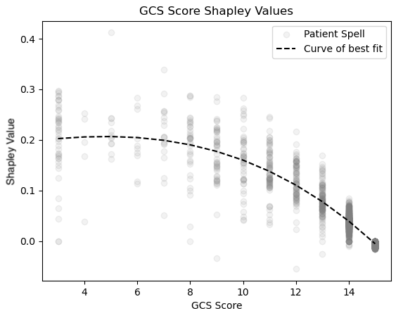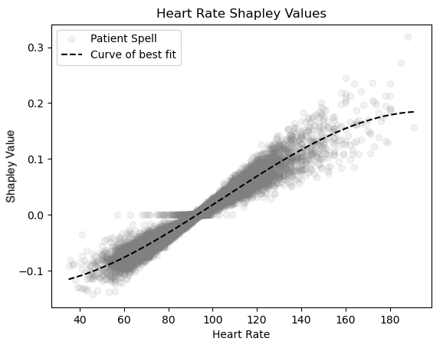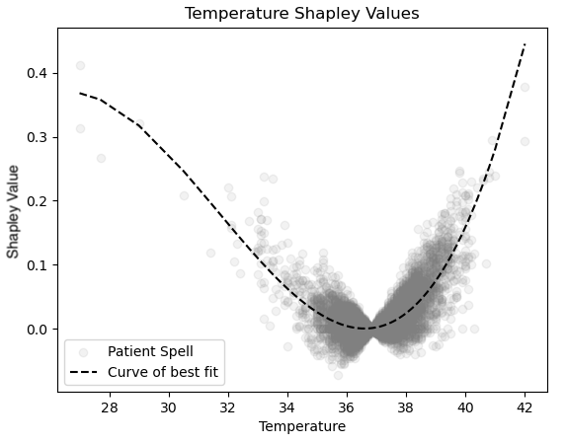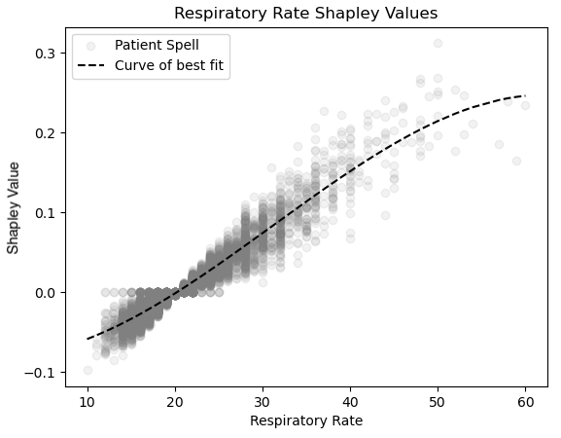
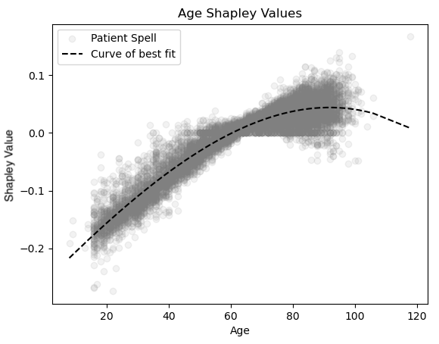
Supplementary Values 2: ICD10 codes for Sepsis and Suspicion of Sepsis
Sepsis diagnosis from an ICD10 code starting A40 or A41
SoS codes, attach separately.
Supplementary Figures 2: Machine Learning Models’ Training Figures
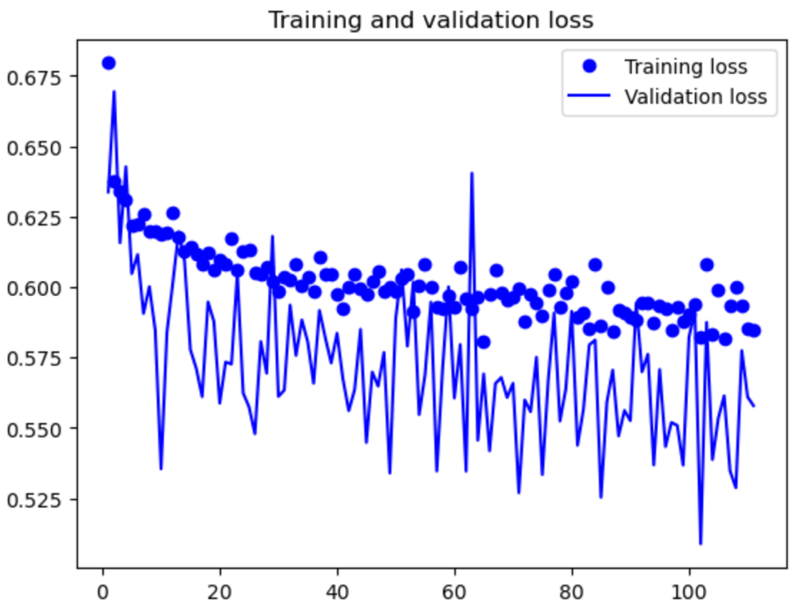
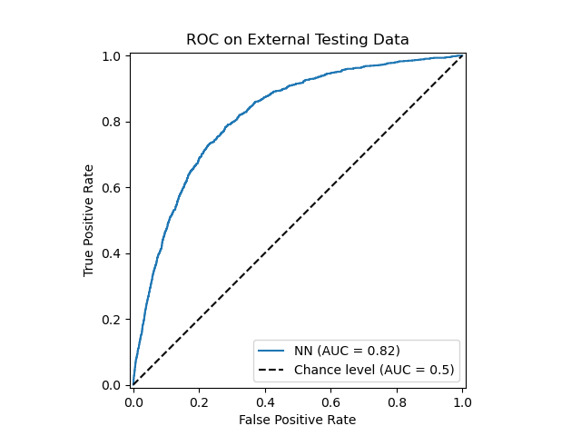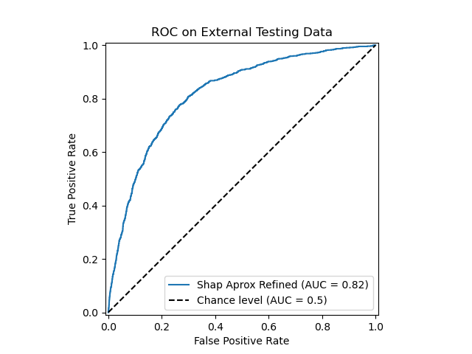
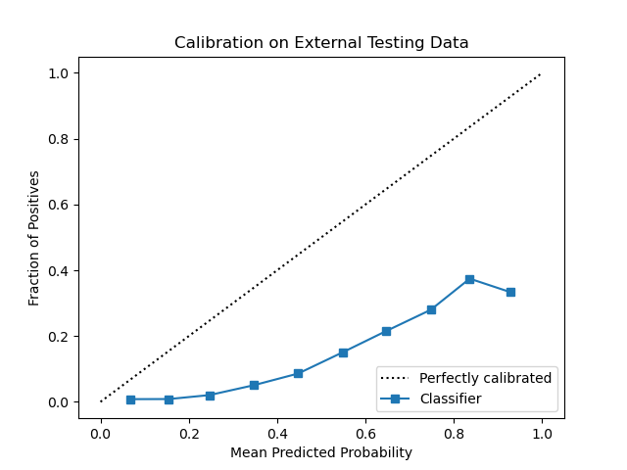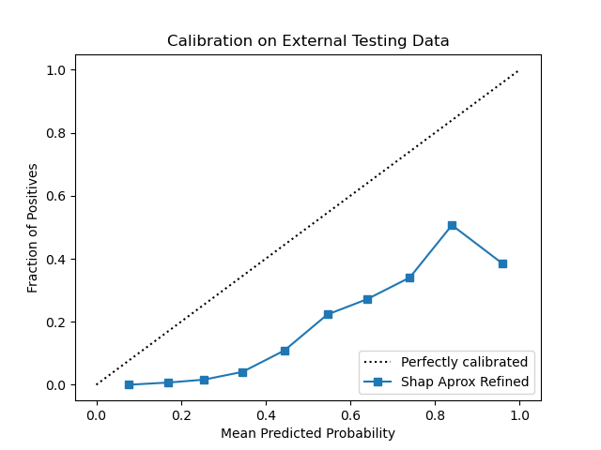
Supplementary Table: Patient Vitals Post-Imputation
Site |  | Site 1 |  |  |  | Site 2
Sepsis Diagnosis |  | Non-Sepsis |  | Sepsis |  | Non-Sepsis |  | Sepsis
 | Count | 11735 | 89.6% | 1359 | 10.4% | 13932 | 93.0% | 1046 | 7.0%
Respiratory Rate | Mean (SD) | 19.94 | (4.67) | 22.09 | (6.37) | 18.09 | (4.07) | 20.81 | (5.71)
Heart Rate | Mean (SD) | 91.41 | (20.77) | 199.86 | (23.81) | 91.89 | (19.46) | 1102.47 | (23.33)
Systolic Blood Pressure | Mean (SD) | 133.31 | (26.14) | 1124.69 | (27.93) | 120.17 | (23.93) | 1124.16 | (25.43)
Temperature | Mean (SD) | 36.81 | (0.87) | 337.02 | (1.23) | 36.95 | (0.78) | 37.39 | (1.14)
GCS Score | Mean (SD) | 14.74 | (1.16) | 14.30 | (1.98) | 14.79 | (1.05) | 114.39 | (1.72)

