Supplementary Methods

In vivo oral ulcer model
All animal experiments were approved by the Institutional Animal Care and Use Committee (IACUC) of the authors' institution and conducted in accordance with institutional guidelines. Male C57BL/6 mice aged 6–8 weeks (20–23 g) were obtained from an accredited laboratory animal supplier. Upon arrival, animals were acclimatised to the facility for one week prior to any experimental procedures. Animals were housed under controlled conditions (constant temperature, 50% relative humidity, 12-hour light/dark cycle) with free access to standard chow and water.
Two experimental groups were used: an oral ulcer control group and a PDLSC-treated group (n = 5 per group; total n = 10), with the single mouse as the experimental unit. Sample size was determined based on previous studies and pilot experiments. Group allocation was performed without formal randomisation; however, all animals were maintained under identical housing conditions throughout the experiment to minimise potential confounding effects of environmental variables. No predefined inclusion or exclusion criteria were established, and no animals were excluded from the analysis.
Oral ulcers were created on the buccal mucosa using a 3-mm dermatological punch under general anaesthesia (alfaxalone 80 mg/kg and xylazine 10 mg/kg, intraperitoneally) to minimise pain and distress during the procedure. PDLSCs were transplanted into the ulcer site immediately following ulcer induction. Animals were monitored regularly for general health status and wound healing throughout the experimental period. No unexpected adverse events were observed during the study.
At the end of the experimental period, buccal mucosal tissues were harvested and fixed in 4% paraformaldehyde, paraffin-embedded, and sectioned at 4 μm. Haematoxylin and eosin staining was performed for morphological evaluation. Immunohistochemical analyses were performed using antibodies against CD30, CD44, and Ki-67, with HRP-conjugated secondary antibodies and DAB visualisation, to assess inflammasome-related protein expression and tissue repair. The primary outcome measure was inflammasome activation and inflammatory response modulation in the context of PDLSC-mediated tissue healing. Histological and immunohistochemical assessments were performed in a blinded manner. Images were acquired using a light microscope.

Metabolite Extraction and LC-MS/MS Analysis
Cells were harvested and extracted with cold methanol/water (80:20, v/v) containing internal standards, followed by centrifugation at 14,000 × g for 15 min at 4 °C. Supernatants were dried under nitrogen and reconstituted in 50% acetonitrile. Metabolomic profiling was performed using a Q Exactive Orbitrap LC-MS/MS system (Thermo Fisher Scientific) equipped with an HILIC column. Data were acquired in both positive and negative ionization modes. Raw data were processed with Compound Discoverer (Thermo Fisher Scientific) for peak alignment, deconvolution, and annotation against KEGG and HMDB databases. Metabolite intensities were normalized to total ion current and subjected to log2 transformation prior to statistical testing.

Proteomic Sample Preparation and LC-MS/MS Acquisition
Proteins were precipitated using cold acetone and digested with sequencing-grade trypsin overnight at 37 °C. Peptides were desalted using C18 spin columns (Thermo Fisher Scientific) and resuspended in 0.1% formic acid. LC-MS/MS was conducted using a Q Exactive HF mass spectrometer (Thermo Fisher Scientific) coupled to an Easy-nLC 1200 system. Peptides were separated on a 25 cm C18 column (75 μm ID, 2 μm particle size). The MS was operated in data-dependent acquisition mode with a resolution of 60,000 for MS1 and 15,000 for MS2.

Proteomic Data Processing and Statistical Analysis
Raw proteomic data were analyzed using MaxQuant (version 2.0) with the UniProt Homo sapiens database. Carbamidomethylation of cysteine was set as a fixed modification, while oxidation of methionine and N-terminal acetylation were set as variable modifications. False discovery rates (FDR) for proteins and peptides were controlled at 1%. Label-free quantification was performed using the LFQ algorithm implemented in MaxQuant. Differentially expressed proteins were identified using the limma R package, with Benjamini–Hochberg correction (q < 0.1).

Pathway and Network Analysis
Pathway enrichment of significant proteins and metabolites was performed using KEGG, Reactome, and Gene Ontology (GO) databases. Protein–protein interaction (PPI) networks were constructed using STRING v11.5 with a high confidence interaction score (>0.9) and visualized in Cytoscape. Integrated pathway analysis of proteomics and metabolomics datasets was performed in MetaboAnalyst 5.0 using the Joint Pathway Analysis module, applying hypergeometric testing for enrichment and degree centrality for topology weighting.

Supplementary Figures

FIGURE S1 Characterization of multi-lineage differentiation potential of PDLSCs. (A) Representative images of PDLSCs after differentiation induction. Osteogenic differentiation was confirmed by Alizarin Red S staining showing calcium deposits (red). Chondrogenic differentiation was verified by Alcian Blue staining indicating proteoglycan accumulation (blue). Adipogenic differentiation was demonstrated by Oil Red O staining revealing lipid droplet formation (red). Control groups showed no positive staining. Scale bars = 100 μm. (B) Flow cytometry analysis of mesenchymal stem cell surface markers on PDLSCs. Cells were positive for CD73 (99.7%), CD90 (97.9%), and CD105 (99.6%), while negative for the hematopoietic marker CD45 (0.9%). Black lines represent isotype control IgG; red lines represent specific antibody staining.

FIGURE S2 Representative H&E-stained tissue sections comparing control and PDLSC-treated groups at different time points. Left panels (Control group): Day 3 and Day 5 control samples showing severe tissue damage characterized by epithelial disruption, loss of keratinized layers, and inflammatory cell infiltration within the lamina propria. Right panels (PDLSC group): Day 3 and Day 5 PDLSC-treated samples demonstrating therapeutic effects with extensive but organized inflammatory infiltration, reduced inflammatory infiltration, organized connective tissue formation, and preserved epithelial continuity. Red arrows indicate areas of tissue damage and inflammatory infiltration; green arrows highlight preserved structural elements and tissue repair processes. PDLSC treatment promotes faster healing with maintained tissue architecture compared to control conditions.

FIGURE S3 Quality control, global expression distribution, and pathway enrichment analysis of transcriptomic data from THP-1 macrophages co-cultured with PDLSCs (A) Box plots showing the distribution of log₂-transformed gene expression values after quantile normalization in THP-1 monoculture and PDLSC co-culture samples, demonstrating comparable signal distributions across conditions. (B) Histogram of expression level frequencies illustrating similar global expression profiles between THP-1 monoculture and PDLSC co-culture samples after normalization. (C) Pairwise scatter plot and density distribution of gene expression levels between THP-1 monoculture and PDLSC co-culture samples, with Pearson’s correlation coefficient (r = 0.982) indicating high reproducibility and minimal technical variation. (D) Correlation matrix heatmap confirming strong overall correlation between samples, supporting the robustness of the transcriptomic dataset. (E) Two-way hierarchical clustering heatmap of significantly regulated probes (|FC| ≥ 1.5), showing clear segregation between THP-1 monoculture and PDLSC co-culture groups. (F) Scatter plot comparing probe expression levels between THP-1 monoculture and PDLSC co-culture conditions, with significantly altered probes highlighted, indicating broad transcriptional remodeling induced by PDLSC co-culture. (G) KEGG pathway enrichment analysis of differentially expressed genes, highlighting immune- and inflammation-related pathways, including cytokine–cytokine receptor interaction, IL-17 signaling, PI3K-Akt signaling, NF-κB signaling, and JAK-STAT signaling pathways.

FIGURE S4 Functional enrichment analysis reveals modulation of innate immune and interferon-related pathways in PDLSC co-cultured THP-1 macrophages (A) Gene Ontology (GO) Biological Process enrichment analysis of differentially expressed genes between THP-1 monoculture and PDLSC co-culture conditions. Significantly enriched terms are predominantly associated with antiviral defense, innate immune responses, and regulation of viral processes, including defense response to virus, response to virus, innate immune response, and interleukin-27–mediated signaling. (B) Reactome pathway enrichment analysis highlighting immune-related signaling pathways affected by PDLSC co-culture. Enriched pathways include interferon alpha/beta signaling, interferon signaling, cytokine signaling in the immune system, innate immune system, neutrophil degranulation, and antiviral mechanisms mediated by interferon-stimulated genes (ISGs).

FIGURE S5 Metabolomic profiling reveals distinct metabolic reprogramming induced by PDLSC co-culture (A) Manhattan plot showing differential metabolite features between THP-1 monoculture and PDLSC co-culture. Red and blue dots indicate significantly altered metabolites (p < 0.05) above the threshold line, with distinct clusters corresponding to reduced or elevated abundance. (B) Hierarchical clustering heatmap of significantly regulated metabolites showing clear separation between THP-1 monoculture and PDLSC co-culture, highlighting distinct metabolic signatures.

FIGURE S6 Pathway-specific metabolomic alterations between THP-1 macrophages and PDLSC co-culture system. (A-P) Representative pathway maps illustrating metabolite-level alterations across multiple metabolic pathways in THP-1 macrophages under monoculture and PDLSC co-culture conditions. Each panel depicts pathway-specific changes in metabolite abundance identified by LC–MS-based metabolomic profiling. Differentially regulated metabolites were determined based on variable importance in projection (VIP) scores > 1 from OPLS-DA and statistical significance (p < 0.05) from univariate analysis. Metabolites showing significant differences between groups are highlighted within each pathway, reflecting coordinated alterations in nucleotide, amino acid, carbohydrate, lipid, and energy-related metabolic processes associated with PDLSC co-culture.

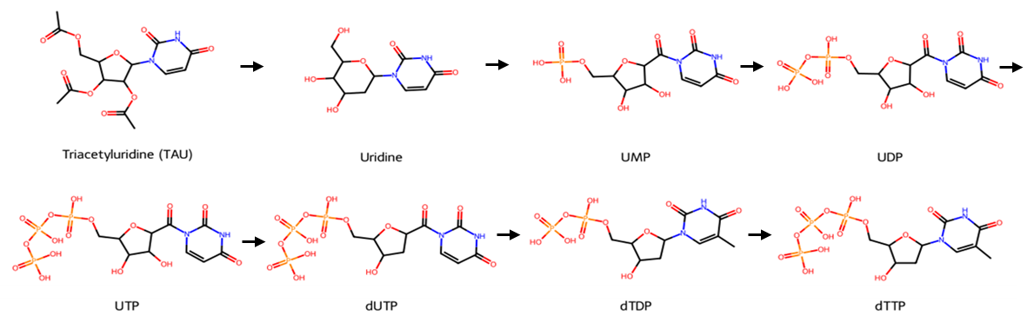
FIGURE S7 Metabolic conversion of triacetyluridine (TAU) within the pyrimidine biosynthetic pathway Schematic representation of the metabolic conversion of triacetyluridine (TAU) into downstream pyrimidine nucleotides. TAU is rapidly deacetylated to uridine, which subsequently enters the pyrimidine biosynthetic pathway through sequential phosphorylation to uridine monophosphate (UMP), uridine diphosphate (UDP), and uridine triphosphate (UTP). UTP can further contribute to deoxypyrimidine nucleotide synthesis through conversion to deoxyuridine triphosphate (dUTP), deoxythymidine diphosphate (dTDP), and deoxythymidine triphosphate (dTTP). This pathway illustrates how TAU supplementation functionally increases intracellular pyrimidine nucleotide pools, providing a metabolic basis for its use as a surrogate modulator of pyrimidine metabolism in the present study.

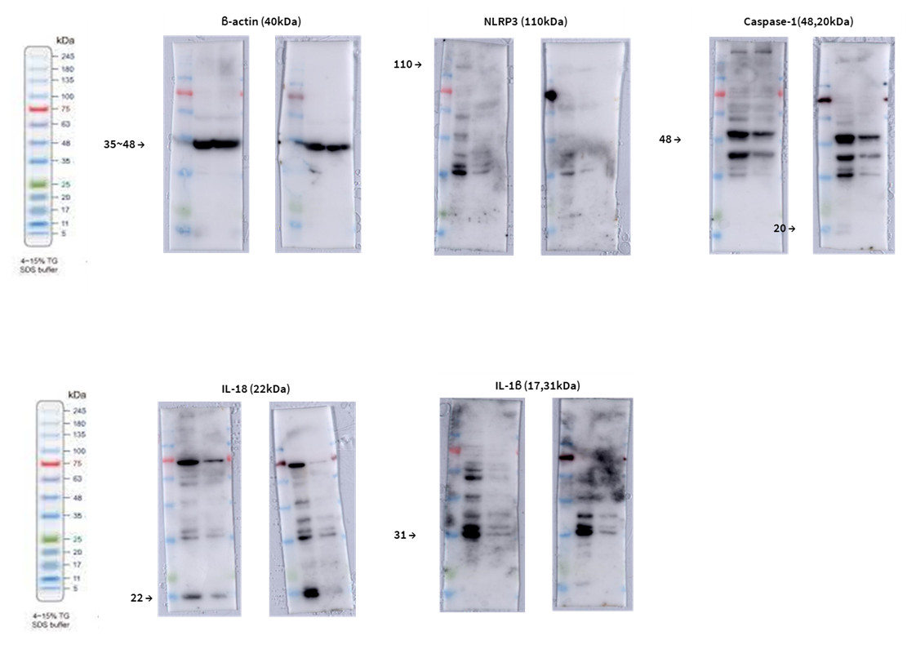Original Western blot images for protein expression analysis. Uncropped Western blot membranes are shown for the detection of target proteins across experimental conditions. Molecular weight markers (kDa) are indicated on the left of each blot for reference.

