Corrigendum: Correction of Cohen d Computation Error
During external peer review of this manuscript, a systematic error was identified in the Cohen d values reported in the original Tables 4 and 5 and the associated CIBERSORTx analysis. Standard error (SE = SD/sqrt(n)) had been inadvertently used as the denominator in the Cohen d formula instead of the correct pooled standard deviation (SD). This produced effect sizes systematically inflated by approximately 5.5-fold (since SE = SD/sqrt(n) and the effective sample size in the two-group comparison was approximately 28, yielding an inflation factor of sqrt(28) ~ 5.3). The underlying statistical hypothesis tests and their p-values were unaffected, as the error was confined to the post hoc effect size formula. All affected values have been recomputed using the correct formula: d = (mean1 - mean2) / pooled_SD, where pooled_SD = sqrt(((n1-1)*SD1^2 + (n2-1)*SD2^2) / (n1+n2-2)). Corrected values are presented in Table 4 (gene signatures) and Supplementary Table S4 (CIBERSORTx immune cell fractions). The biological interpretation has been revised throughout to reflect the corrected moderate effect sizes (range: |d| = 0.00-0.88). The author gratefully acknowledges the reviewer who identified this error.

Supplementary Materials

Table S1. Gene signature lists with de-circularization documentation.

Table S1. Gene signature lists with de-circularization audit documentation.
Signature | N Genes | Gene Symbols | De-circularization
Goblet/Mucinous | 11 | MUC2, REG4, TFF2, SPDEF, AGR2, CLDN18, ZG16, FCGBP, TFF3, MUC5AC, MSLN | None
Enterocyte | 10 | CA1, CA2, CA4, SLC26A3, GUCA2A, GUCA2B, CEACAM7, FABP1, ADH1C, SI | None
Stem/TA | 10 | LGR5, ASCL2, OLFM4, SMOC2, RGMB, AXIN2, EPHB2, SOX9, CD44, PROM1 | None
iCAF | 10 | COL1A1, COL1A2, DCN, LUM, FAP, MMP2, PDGFRA, COL6A1, COL6A2, COL6A3 | None
myCAF | 10 | ACTA2, TAGLN, MYL9, MYH11, TPM1, TPM2, CNN1, DES, MYLK, ACTG2 | None
TREM2+ Macrophage | 10 | TREM2, APOE, APOC1, SPP1, GPNMB, FABP5, LGALS3, CD9, CD63, LPL | TREM2 excluded when TREM2 is outcome
MUC1 Crosstalk | 10 | MUC1, MUC4, MUC16, MUC20, EGFR, ERBB2, ERBB3, GRB2, SOS1, KRAS | ERBB2/GRB2 excluded from checkpoint covariates

Table S2. Exploratory MR (blood-derived eQTL instruments) and coloc results.
Gene | IVW OR | IVW P | MR-Egger P | WM P | MR-PRESSO P | Coloc H4
TREM2 | 0.98 | 0.76 | 0.81 | 0.69 | 0.72 | 0.042
HAVCR2 | 0.88 | 0.024 | 0.15 | 0.058 | 0.041 | 0.063
TNFRSF9 | 1.15 | 0.024 | 0.092 | 0.071 | 0.038 | 0.087
HAVCR1 | 1.04 | 0.51 | 0.62 | 0.55 | 0.48 | 0.031
LGALS3 | 0.94 | 0.33 | 0.41 | 0.38 | 0.29 | 0.055
SIGLEC15 | 1.08 | 0.18 | 0.22 | 0.25 | 0.19 | 0.018
VSIR | 0.96 | 0.45 | 0.52 | 0.48 | 0.44 | 0.025

Table S3. GSE119409 CRT response validation (n=56).
Signature | P (Wilcoxon) | P (BH) | Significant
TREM2+ Macrophage | 0.0049 | 0.034 | Yes
iCAF | 0.0049 | 0.034 | Yes
Goblet/Mucinous | 0.022 | 0.051 | No (trend)
Enterocyte | 0.089 | 0.156 | No
myCAF | 0.143 | 0.200 | No
Stem/TA | 0.321 | 0.375 | No
MUC1-crosstalk | 0.456 | 0.456 | No

Supplementary Table S4. CIBERSORTx immune cell-type fractions (MC vs NMC, corrected Cohen d values, unadjusted for MSI). [Data presented in main text.]
Cell Type | Cohen d | 95% CI | Mean MC | Mean NMC | P | P (BH)
Monocytes | +0.57 | +0.19 to +0.94 | 8.12 | 7.38 | 0.0029 | 0.012
Macrophages | +0.54 | +0.17 to +0.92 | 9.22 | 8.56 | 0.0045 | 0.012
Neutrophils | +0.54 | +0.17 to +0.92 | 4.82 | 4.10 | 0.0045 | 0.012
NK cells | +0.43 | +0.05 to +0.80 | 4.49 | 4.05 | 0.025 | 0.050
CD8+ T cells | +0.34 | -0.04 to +0.71 | 6.37 | 5.95 | 0.077 | 0.103
Endothelial | +0.30 | -0.07 to +0.67 | 9.24 | 9.03 | 0.111 | 0.122
T cells | +0.29 | -0.08 to +0.67 | 7.06 | 6.77 | 0.122 | 0.122
B cells | -0.36 | -0.74 to +0.01 | 3.90 | 4.35 | 0.056 | 0.089

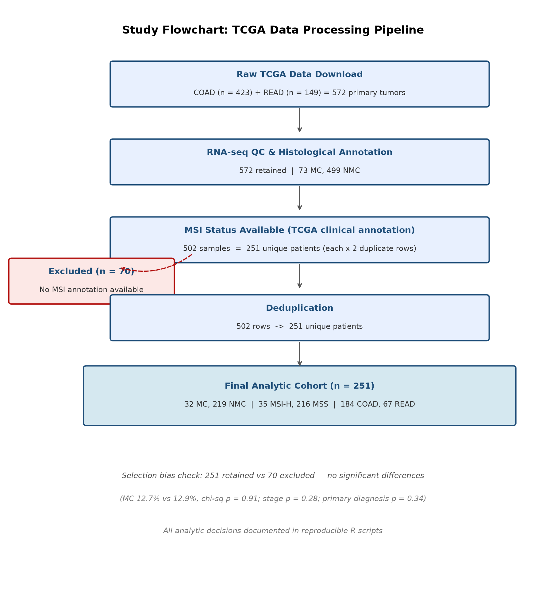
Figure S1. Study flowchart: TCGA data processing from raw download to final analytic cohort (251 patients).
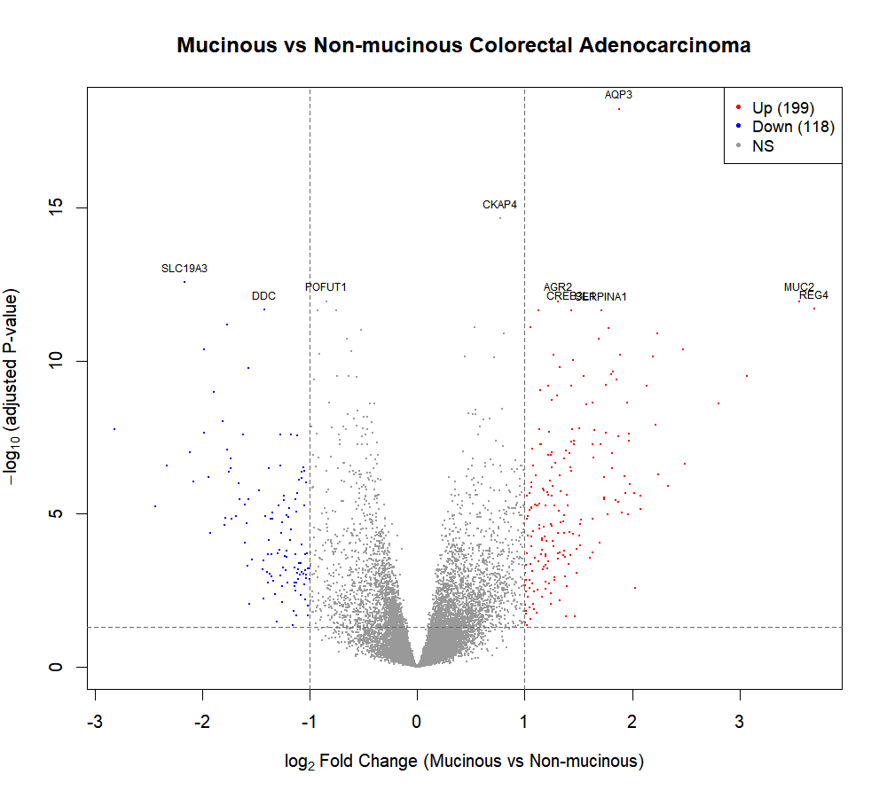
Figure S2. MC vs NMC differential expression volcano plot.

