Supplementary Materials

Supplementary Methods

Signal processing
Raw force-time and displacement-time records were processed using custom code in MATLAB (R2026a, MathWorks, MA, USA). For drop-tower tests, force and displacement records were first aligned using a common trigger signal, and the impact window was isolated before conversion to stress-strain data. Contact onset was identified using a two-stage threshold algorithm in which the Gaussian-smoothed post-trigger force signal was searched to identify the first point exceeding the pre-trigger baseline mean by 40 standard deviations, then backtracked to the last point below the baseline mean plus 3 standard deviations. The first 10 ms after triggering were excluded to avoid trigger artefacts. The end of the impact window was defined as either the first significant local force maximum, identified using a prominence threshold of 1% of the post-onset smoothed force range, or the midpoint of the minimum displacement plateau, corresponding to peak compression. Gaussian smoothing was used only for impact-window detection, while final force data were filtered using an SAE J211 CFC 1000 Butterworth filter with a 1650 Hz corner frequency.
Because high-speed video displacement data were pixel-quantised, producing stepwise force-displacement traces, a back-corner skeleton algorithm was used to estimate the underlying mechanical response from adjacent displacement levels. The resulting skeleton points were fitted with a fourth-order polynomial to generate a smooth force-displacement curve, which was extrapolated to the observed peak force where required. Displacement was then zeroed at first contact, and engineering stress-strain curves were calculated for each specimen. Transverse compression strain (ε) was calculated as ε = d / dₙ, where d is indenter displacement and dₙ is the initial anteroposterior diameter of the surrogate cord (8 mm). Nominal stress (σ) was calculated by dividing measured force by the initial projected contact area, consistent with previous approaches (Fradet, Cliche et al. 2016). All processed curves were cropped to the interval from loading onset to specimen failure, defined by a distinct drop in force, and manually reviewed to account for data anomalies. Raw stress-strain curves are provided in Supplementary Figures S4-S38.

Benchmark comparison
Biomechanical fidelity was assessed by comparing hydrogel characteristic curves with published spinal cord tissue data from Karimi et al. (2017) and Fradet et al. (2016). Benchmark curves were digitised from the original publications and are therefore treated as proxies rather than exact reproductions; variability bounds were available only for Fradet et al. Benchmark comparisons were made at corresponding loading rates: Karimi et al. for Speed 1 (0.01 s⁻¹), and the two Fradet et al. datasets for Speed 2 (0.5 s⁻¹) and Speed 3 (50 s⁻¹). For each comparison, hydrogel curves were cropped to the strain range of the corresponding benchmark, with the Fradet et al. comparisons cropped at the reported mechanical failure strains of ε = 0.74 and ε = 0.67. Agreement with benchmark data was assessed by visual comparison of curve shape and by calculating the mean squared residual (MSR) between each formulation curve and benchmark curve. Tangent modulus was calculated from each characteristic curve using the longest segment ending at the benchmark failure strain for which a first-order linear fit achieved R² ≥ 0.99, with a minimum window length of 10% of the strain range. The same approach was applied to the benchmark curves to enable like-for-like comparison. Throughout the manuscript, “stiffness” is used qualitatively to describe higher stress at an equivalent strain, whereas tangent modulus refers to the quantitative slope-based measure described above.

Example of tangent modulus calculations
Tangent modulus (E_{tan}) was extracted from the ARCGen characteristic curve for each formulation group using the algorithm described in Section 2.7; an example is provided below.

- The input to the algorithm is the ARCGen characteristic curves.
- The algorithm operates up to the failure strain ε_{fail} for each curve, defined as the lesser of the benchmark failure strain, or that curves failure strain.
- Beginning at the leftmost data point and scanning rightward, a first-order linear regression is fitted to each candidate sub-interval [s, ε_{fail}].
- Candidate windows spanning less than 10% of the total strain range are rejected to prevent degenerate near-zero-length fits.
- The leftmost start point s at which R² ≥ 0.99 is satisfied is considered the toe-linear transition point and the start of the linear regression.
- The slope of the accepted regression is taken as E_{tan} (kPa).
- If no candidate window achieves R² ≥ 0.99, the start point yielding the highest available R² is used.
- Steps 1–7 are applied identically to the benchmark reference curve, ensuring a like-for-like comparison of E_{tan} values between the hydrogel and biological tissue data.

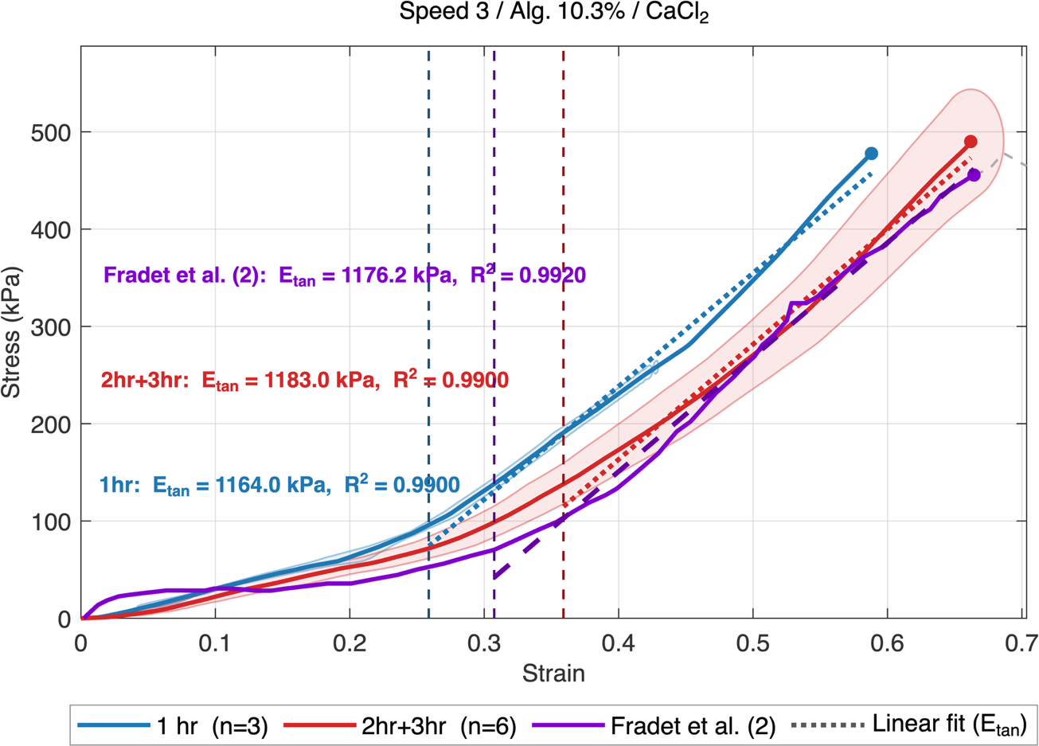
Figure S 1 – Example diagnostic output of the tangent modulus algorithm for one representative condition (Speed 3 / CaCl₂ / 10.3%). Solid lines show the characteristic curves for the 1 hr (blue; n = 3) and 2hr+3hr pooled (red; n = 6) immersion time groups; the purple line shows the Fradet et al. (2) benchmark. Shaded bands represent the standard-deviation corridors for each group. Vertical dashed lines indicate the algorithmically identified toe–linear transition for each curve (blue: ε ≈ 0.26; red: ε ≈ 0.36; purple: ε ≈ 0.31). Dotted lines show the accepted linear regression fits, spanning from the identified transition point to the benchmark failure strain (ε_{fail} = 0.67). Filled circles mark the stress at ε_{fail} for each curve. Portions of the characteristic curves extending beyond ε_{fail} are rendered as grey dashed lines and were excluded from analysis.

Statistical analysis
Stress-strain responses were analysed within each formulation and loading-rate group using ARCGen (Arc-length Re-parameterization and Characteristic Response Generation) to account for nonlinear curve shape, variable curve length, and inter-specimen variability (Hartlen and Cronin 2022). ARCGen was used to generate characteristic mean curves and standard deviation corridors for each group. Statistical comparisons were performed using statistical parametric mapping with the multivariate hypothesis-testing framework described by Hartlen and Cronin (2025), with significance set at α = 0.05. This approach identifies regions of the stress-strain curve where group responses differ significantly. The effect of each formulation parameter was first assessed by comparing characteristic stress-strain responses across immersion duration, ionic crosslinking ion, alginate concentration, and loading rate. Where levels of a given parameter did not produce a statistically significant difference in mechanical behaviour, those levels were pooled for subsequent analyses to reduce redundancy and improve group-level response estimates.

Supplementary Figures
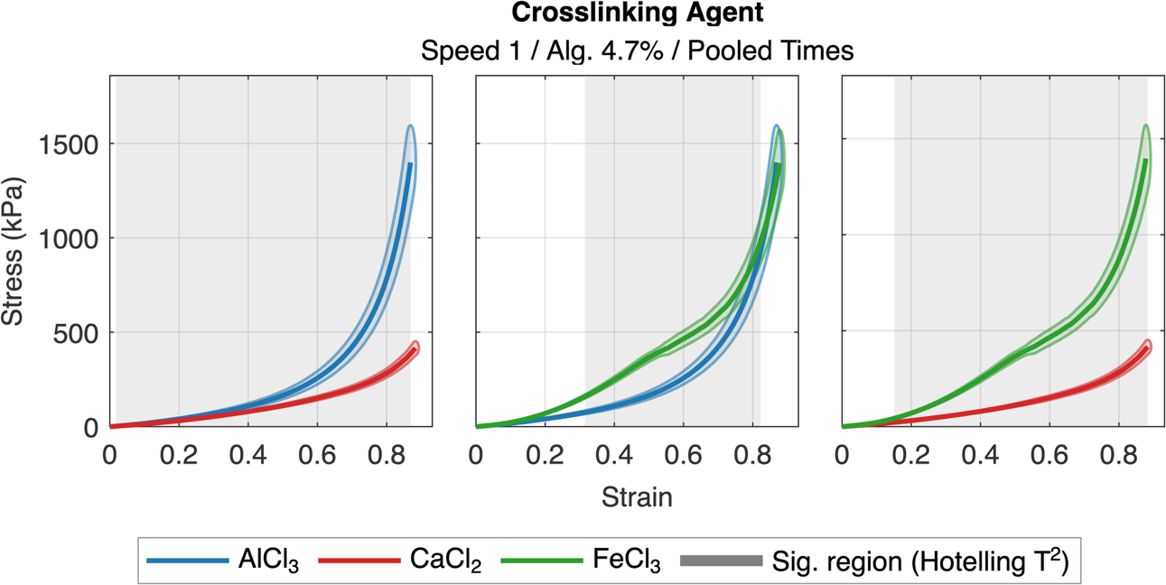
Figure S 2. Characteristic stress-strain curves comparing crosslinking salt type for 4.7% alginate hydrogels tested at Speed 1 with pooled immersion times. Pairwise Hotelling's T-squared comparisons from left to right: AlCl₃ vs CaCl₂, AlCl₃ vs FeCl₃, and CaCl₂ vs FeCl₃. Solid lines represent characteristic curves and shaded envelopes denote ±1 standard deviation corridors. Grey bands indicate strain regions in which a statistically significant difference was detected by one-dimensional Statistical Parametric Mapping (SPM1D; Šidák-corrected Hotelling's T-squared, family-wise α = 0.05). AlCl₃: n = 10; CaCl₂: n = 6; FeCl₃: n = 6.

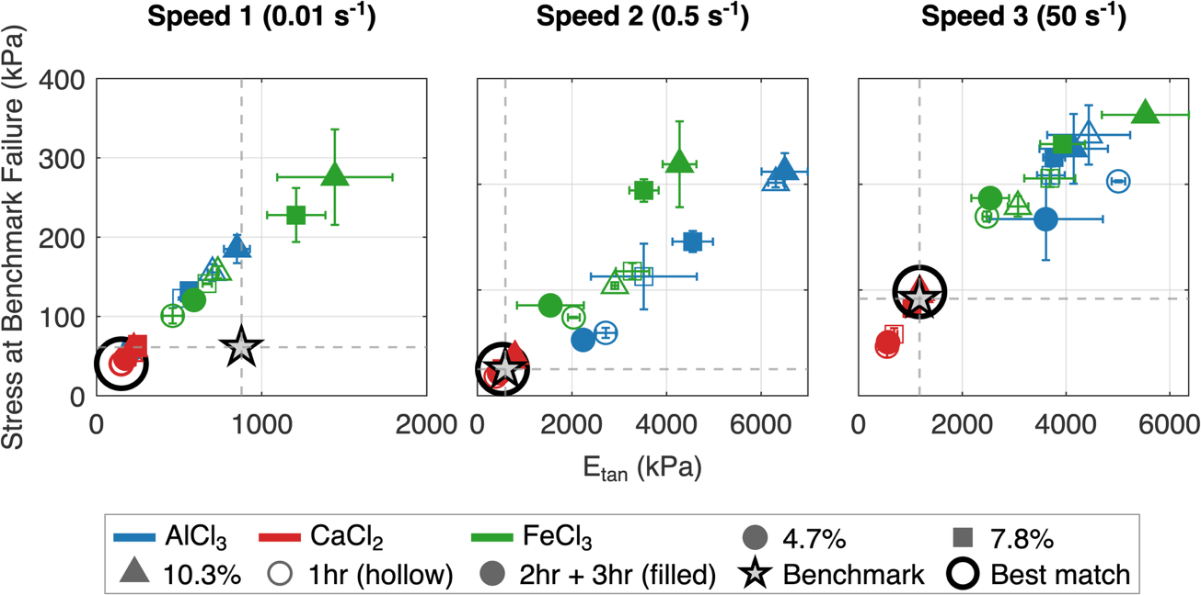
Figure S 3. Scatter plot comparing all 18 hydrogel formulations (3 alginate concentrations × 3 crosslinking salts × 2 immersion time groups) against tissue benchmarks, from left to right: Speed 1 (0.01 s⁻¹) vs Karimi et al., Speed 2 (0.5 s⁻¹) vs Fradet et al. (1), and Speed 3 (50 s⁻¹) vs Fradet et al. (2). The x-axis shows tangent modulus (E_tan) and the y-axis shows stress evaluated at the benchmark failure strain, both derived from group characteristic curves. Marker colour encodes crosslinking ion (blue: AlCl₃; red: CaCl₂; green: FeCl₃), marker shape encodes alginate concentration (circle: 4.7%; square: 7.8%; triangle: 10.3%), and marker fill encodes immersion time (hollow: 1 hr; filled: 2+3 hr). Error bars denote ±1 SD across individual specimens within each group. The grey star marks the benchmark target; dashed crosshairs indicate its E_tan and stress values. The bold ring identifies the best-matching formulation for each speed (minimum mean squared residual). Benchmark curves were digitised manually from published figures and are presented for illustrative comparison only.

Original Sample Stress Strain Curves
Figure S4-S38 – Individual specimen stress–strain curves for each formulation. Lines are coloured by immersion time (blue: 1hr, red: 2hr, green: 3hr). Each panel title indicates speed, crosslinking salt, and alginate concentration.

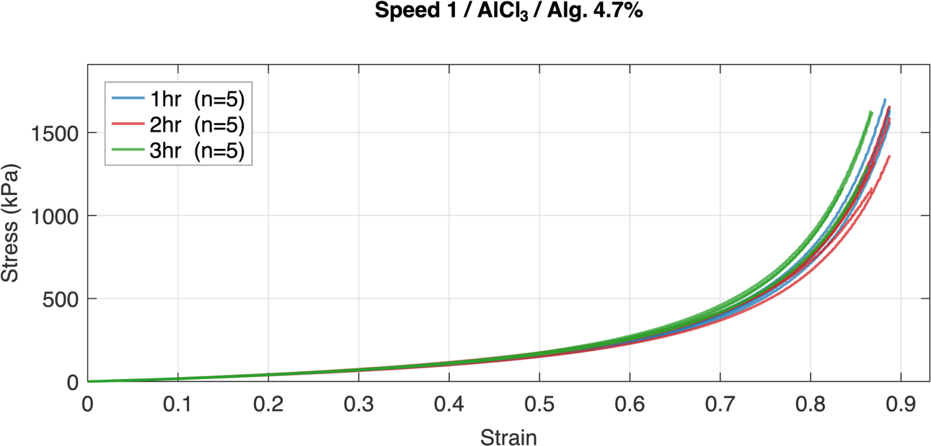
Figure S 4
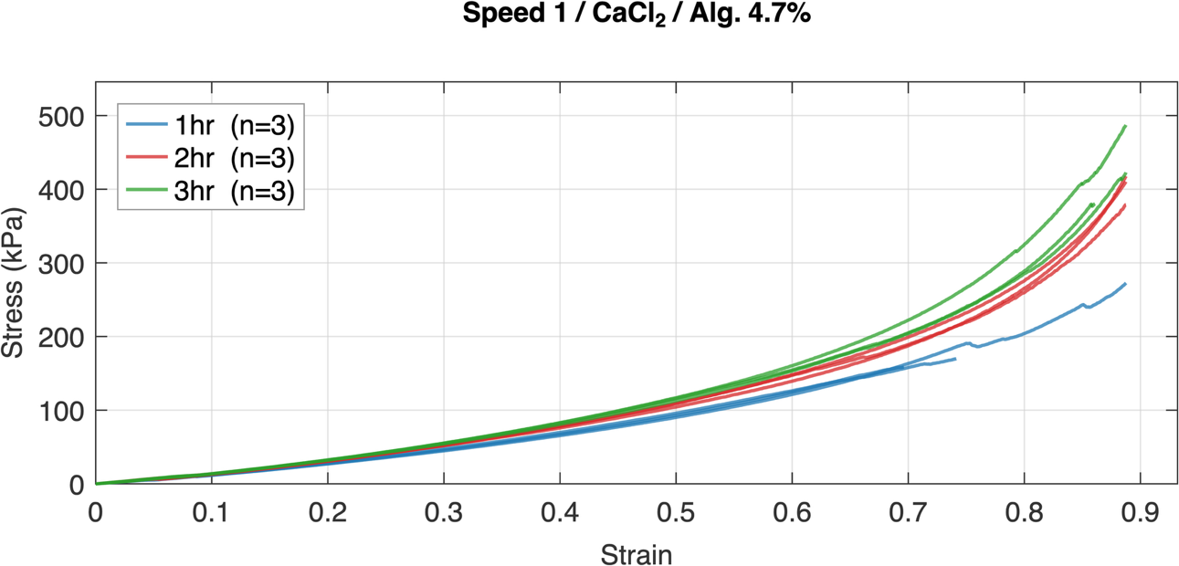
Figure S 5
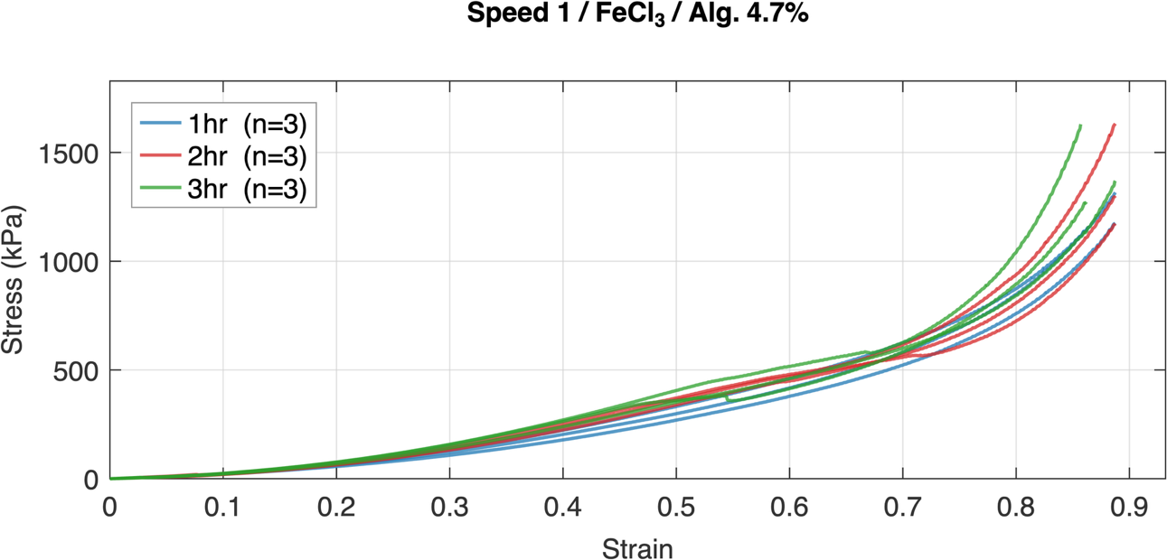
Figure S 6
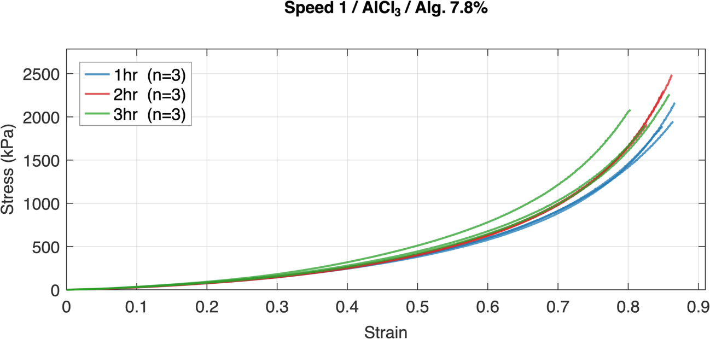
Figure S 7
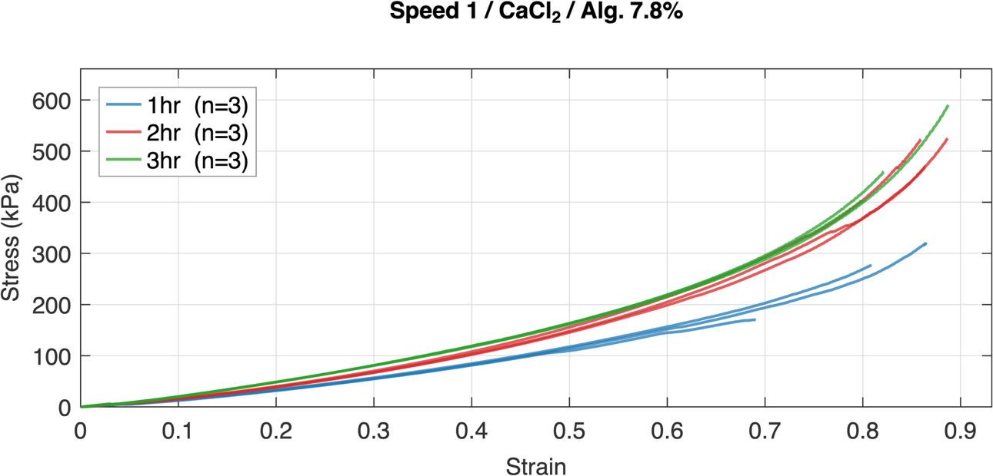
Figure S 8
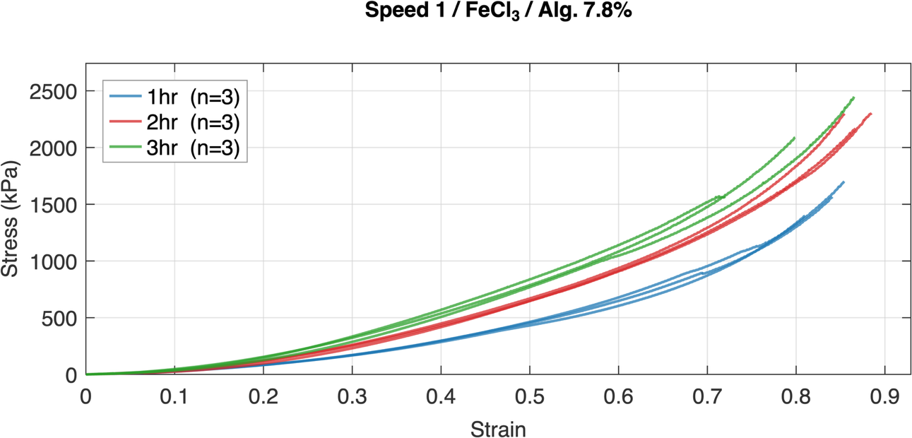
Figure S 9
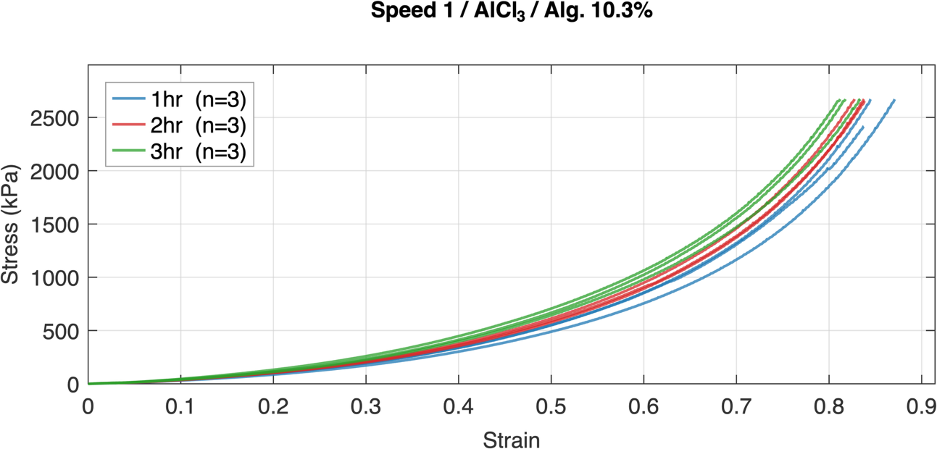
Figure S 10
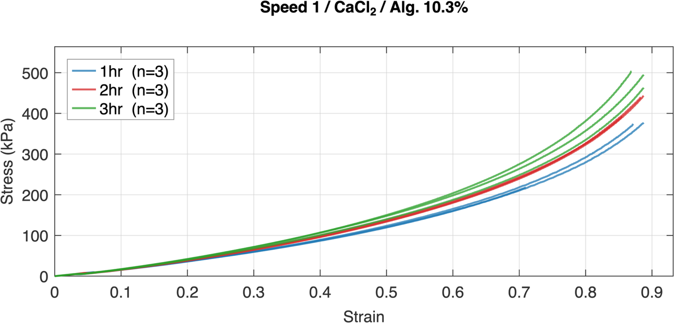
Figure S 11
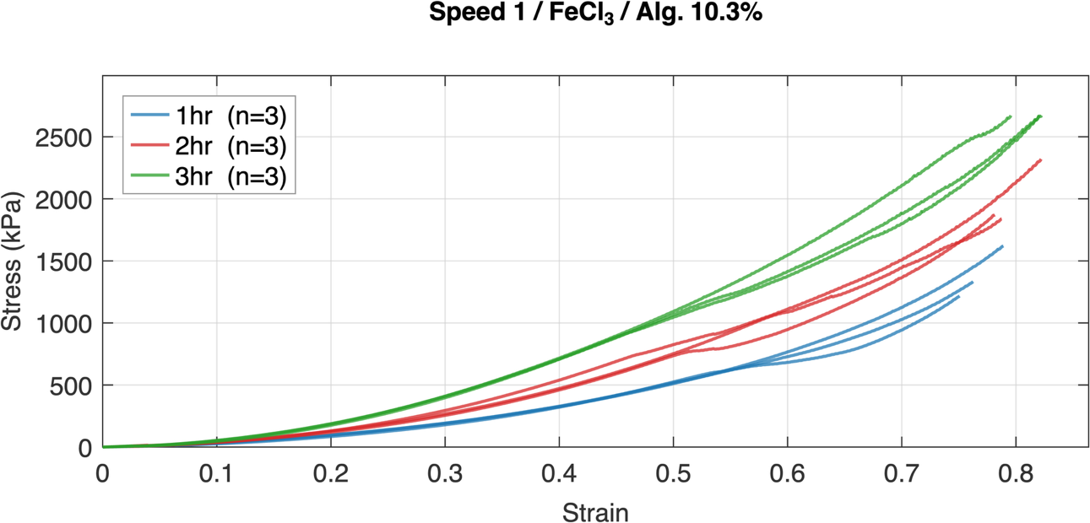
Figure S 12
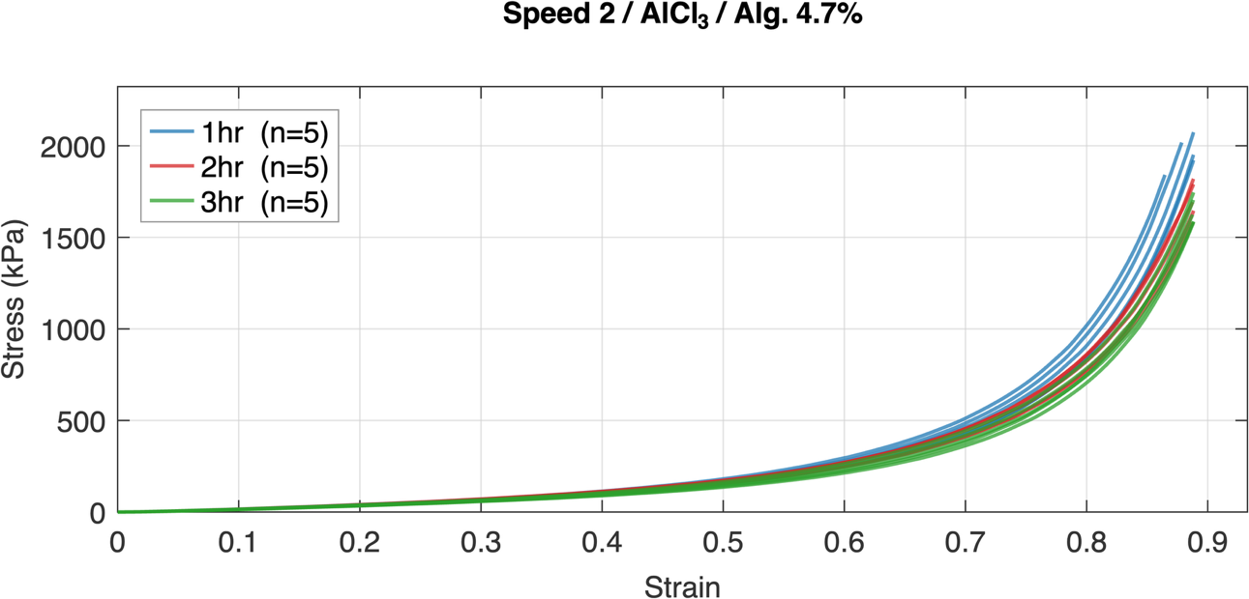
Figure S 13
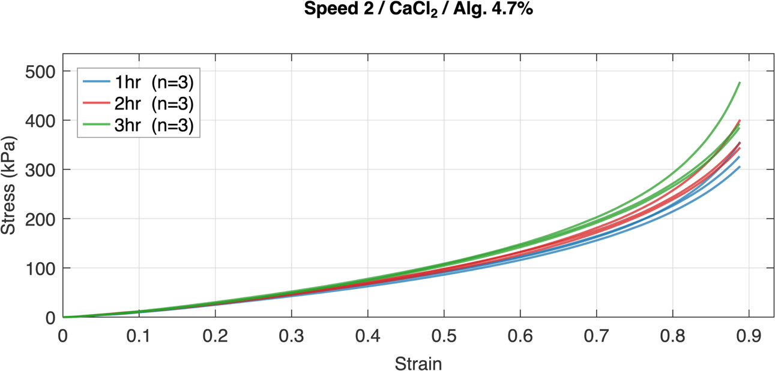
Figure S 14
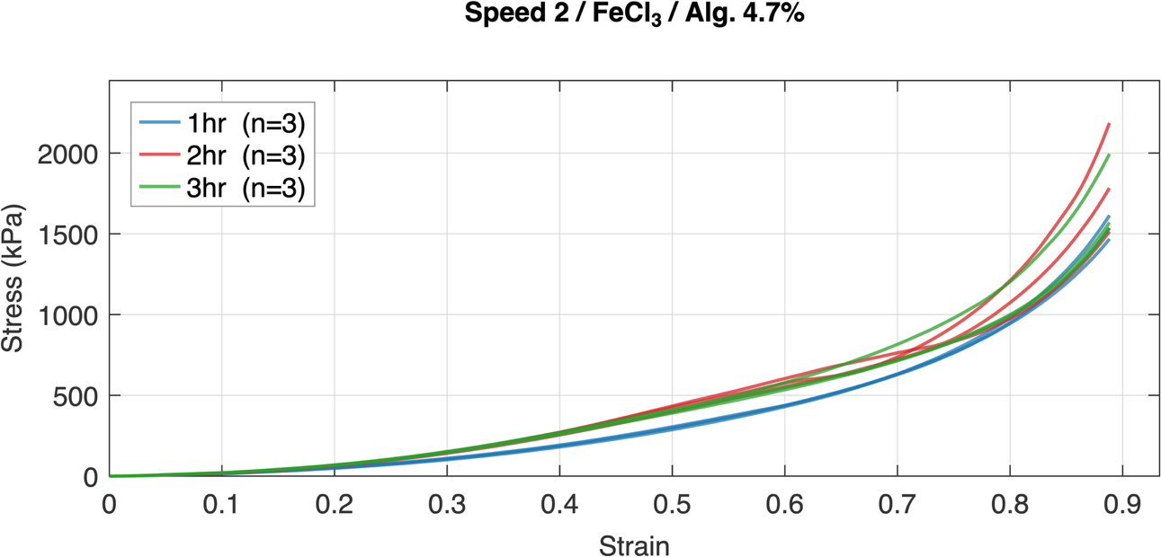
Figure S 15
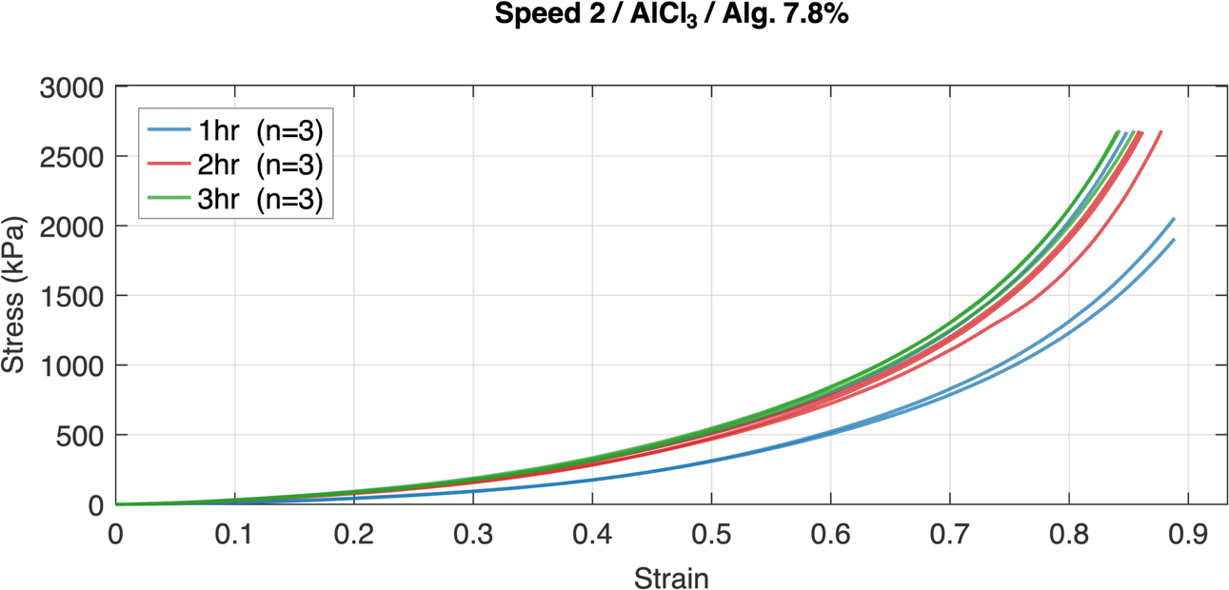
Figure S 16
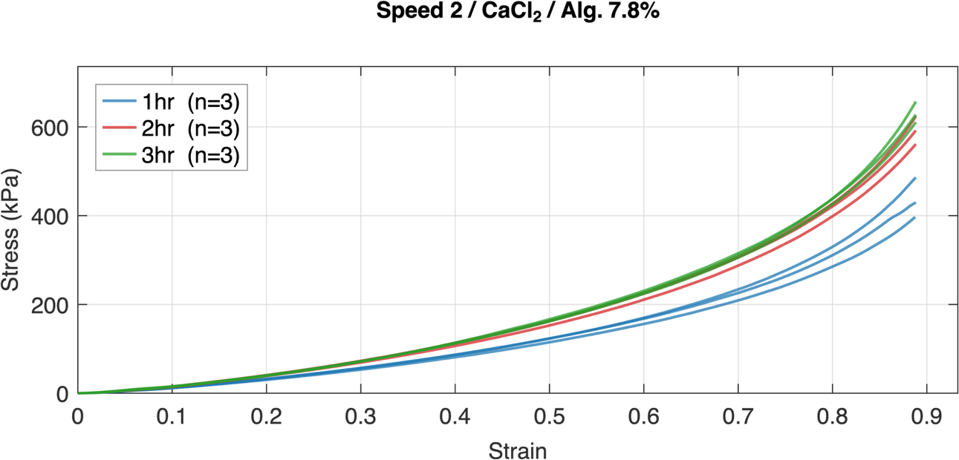
Figure S 17
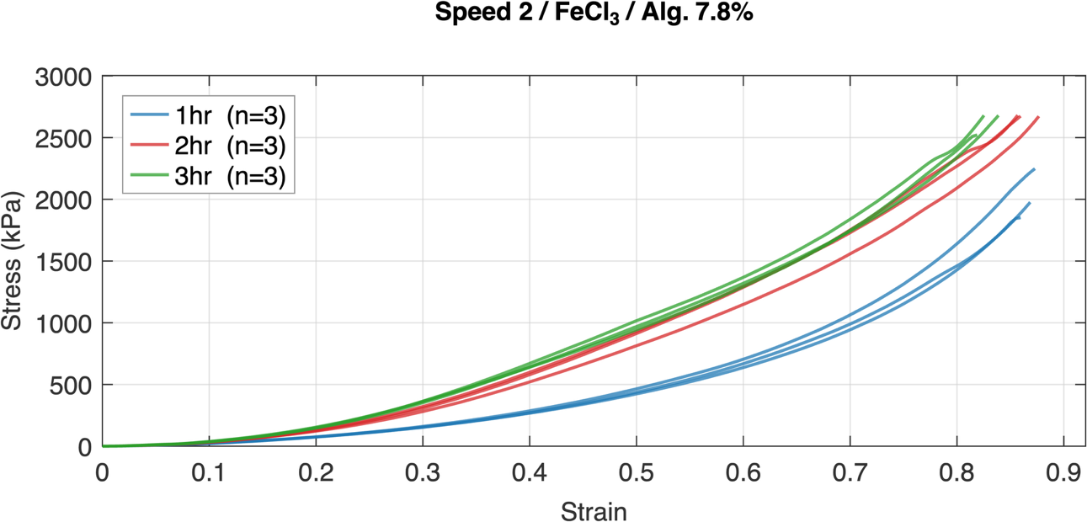
Figure S 18
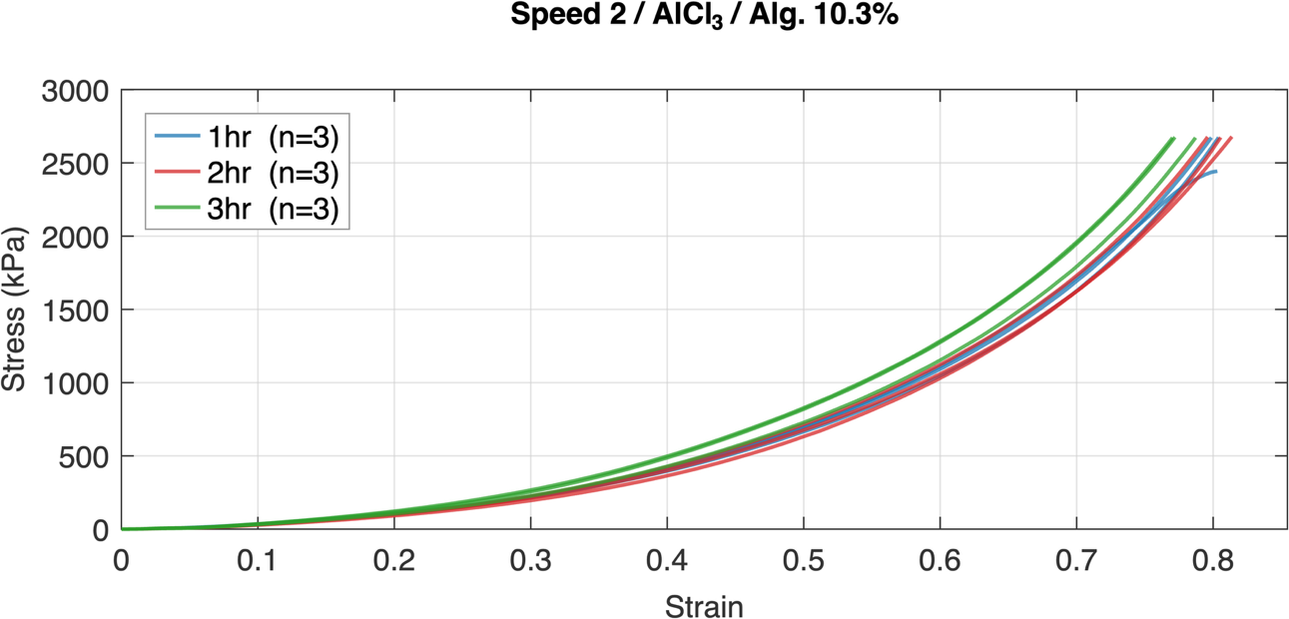
Figure S 19
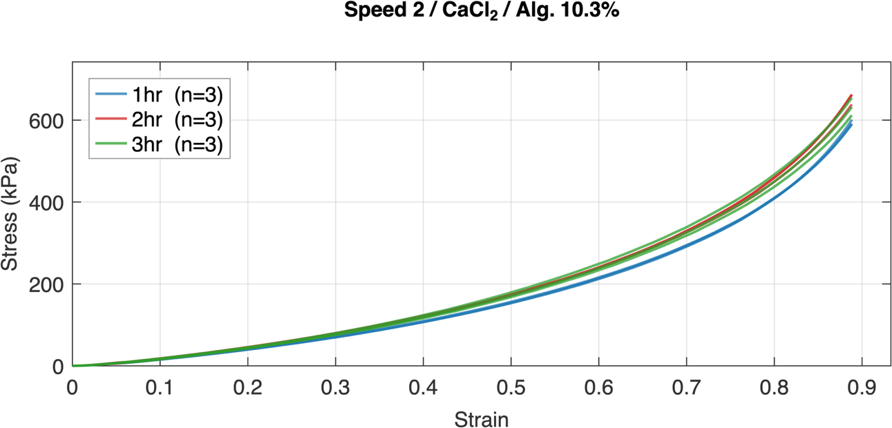
Figure S 20
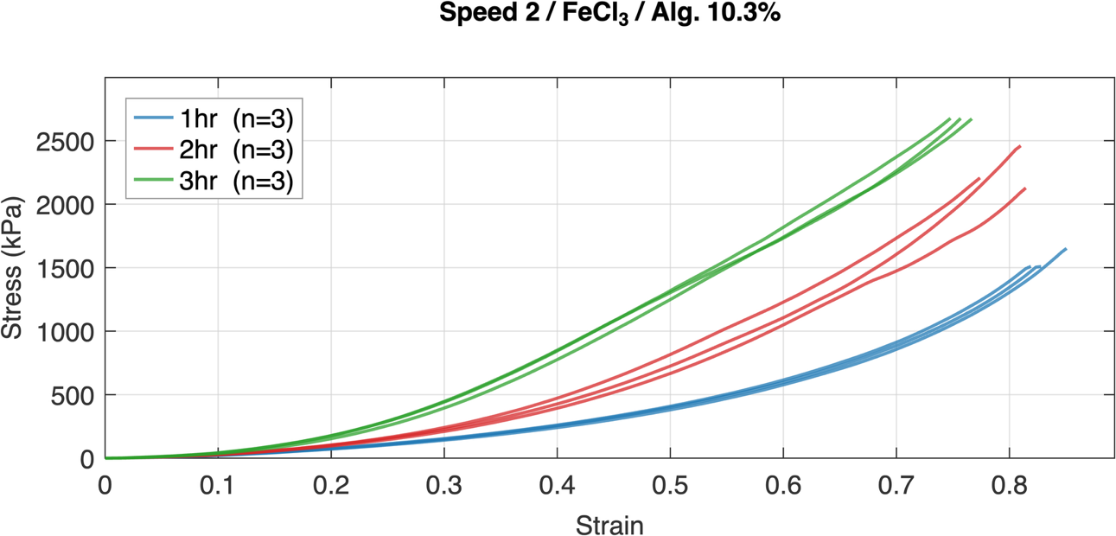
Figure S 21
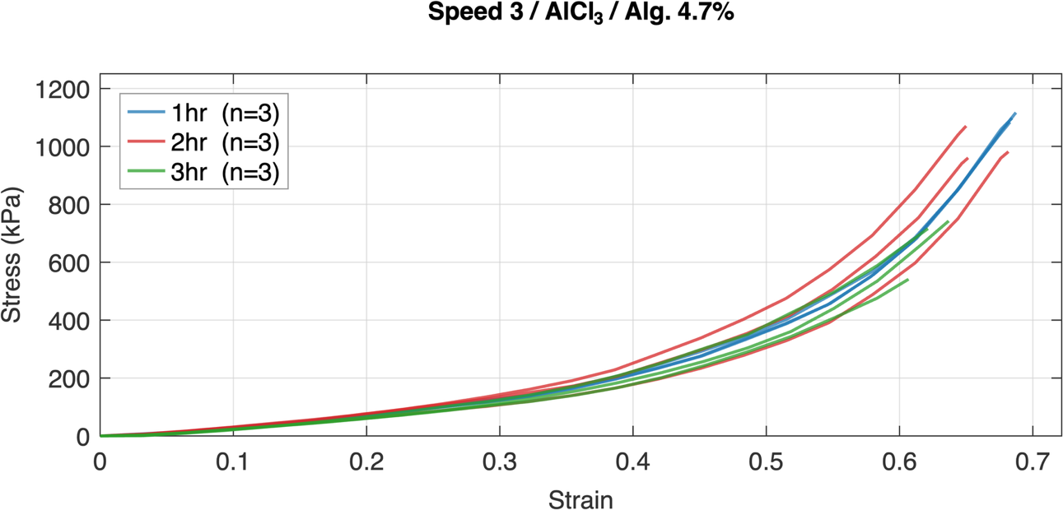
Figure S 22
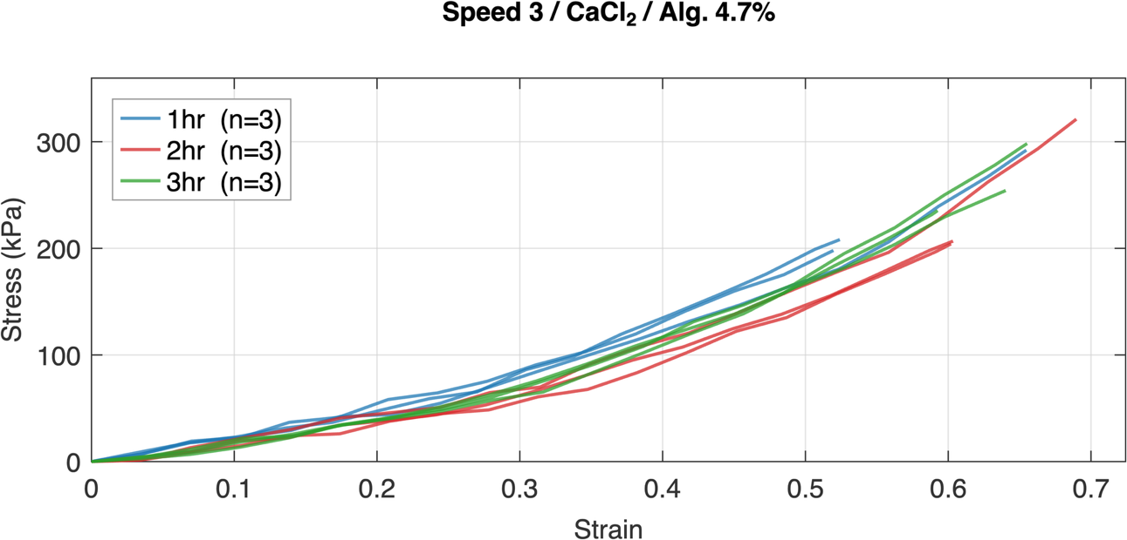
Figure S 23
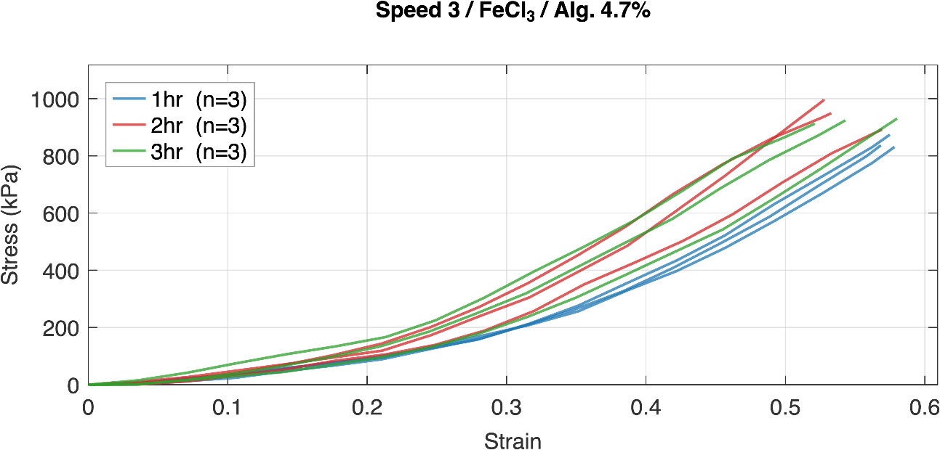
Figure S 24
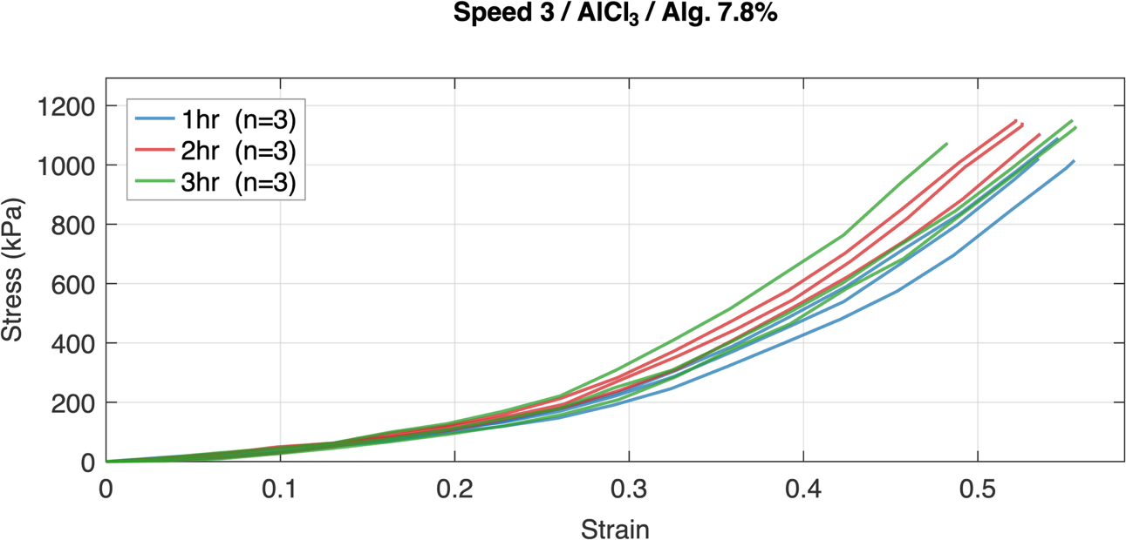
Figure S 25
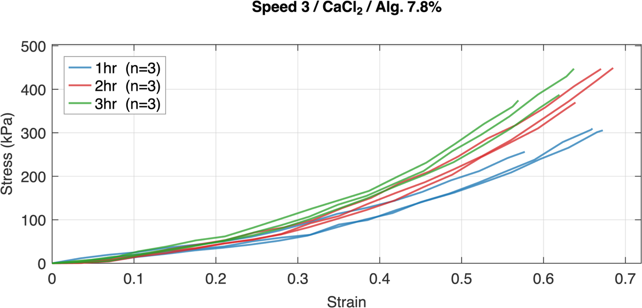
Figure S 26
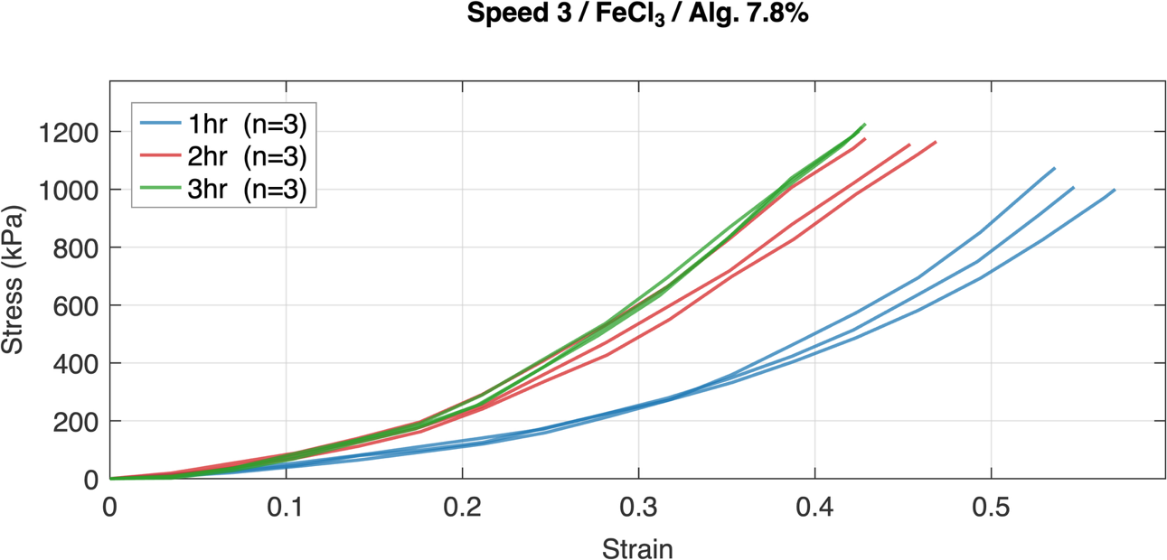
Figure S 27
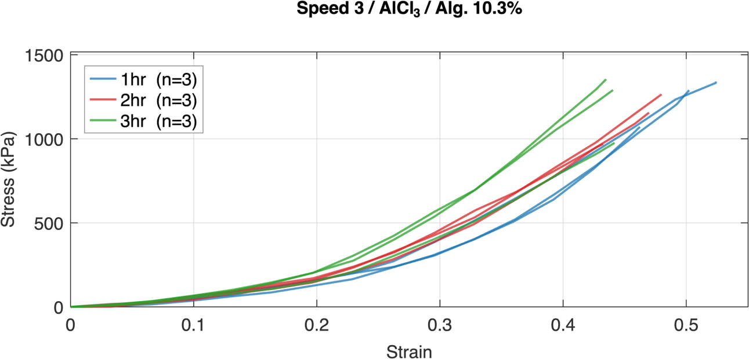
Figure S 28
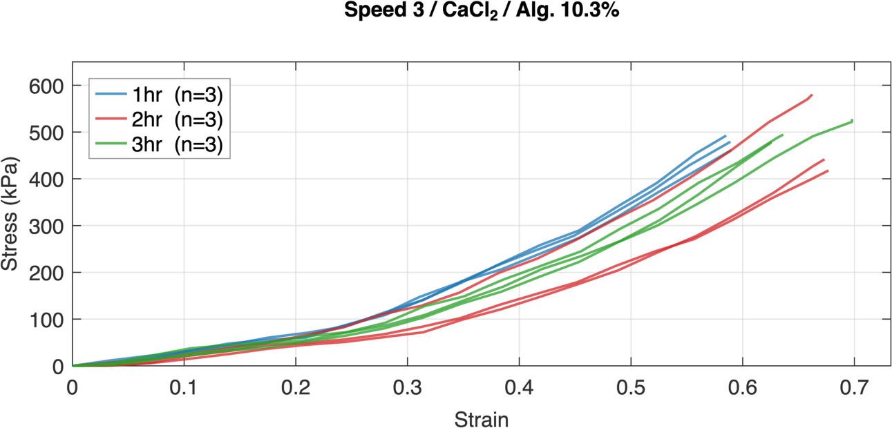
Figure S 29
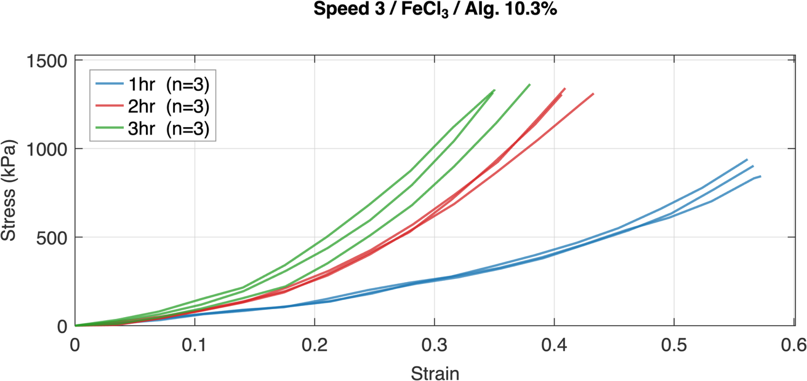
Figure S 30
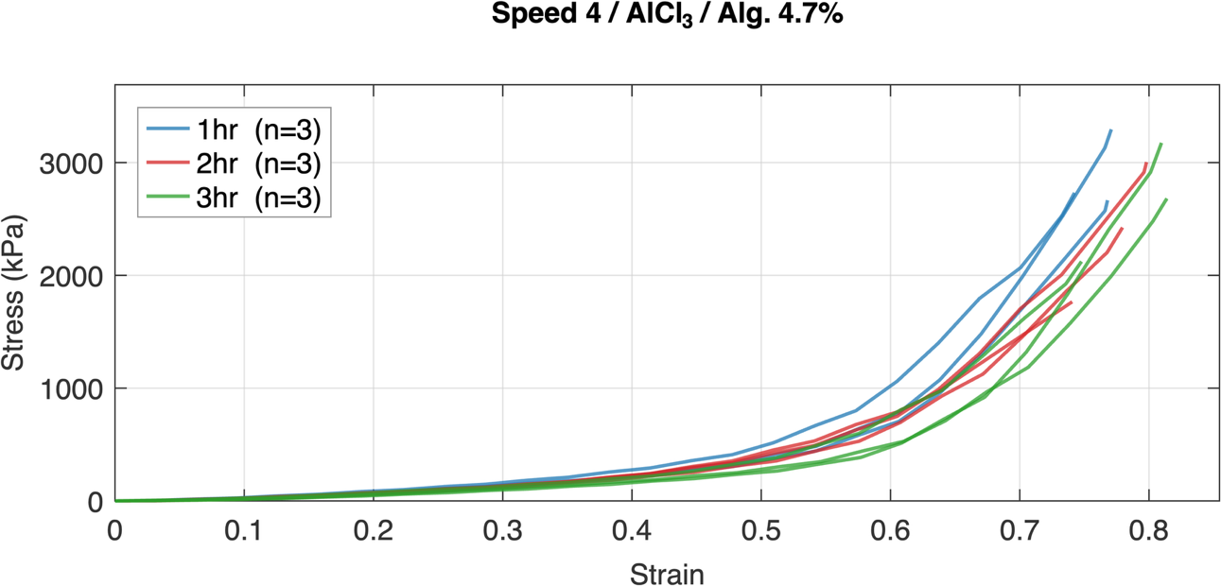
Figure S 31
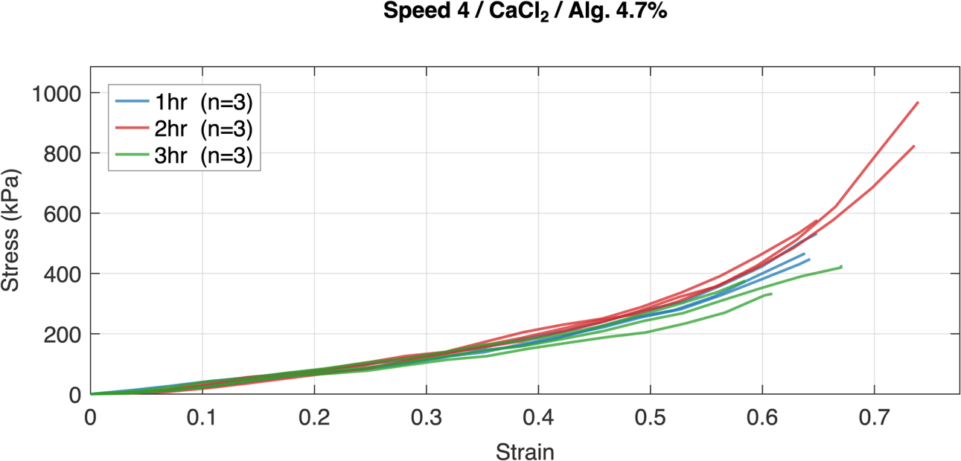
Figure S 32
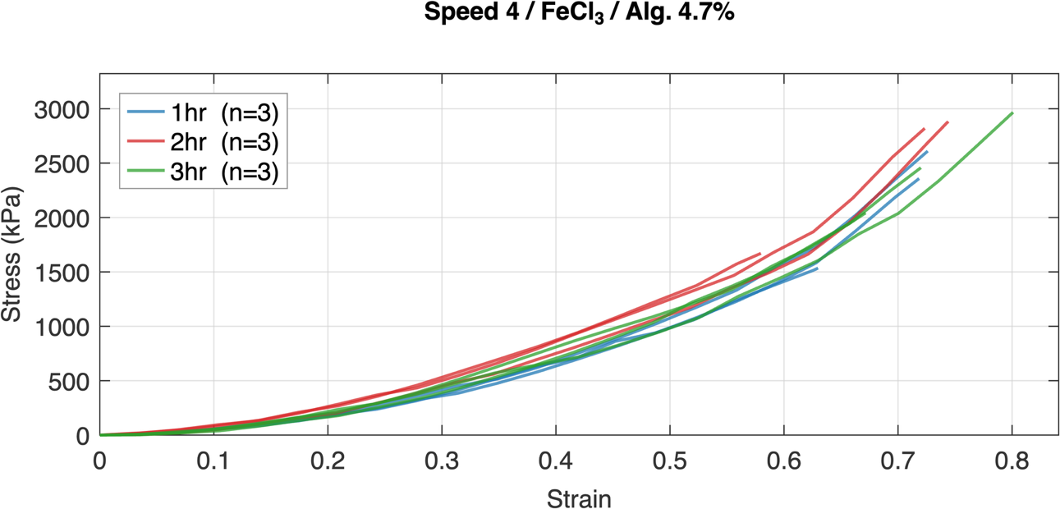
Figure S 33
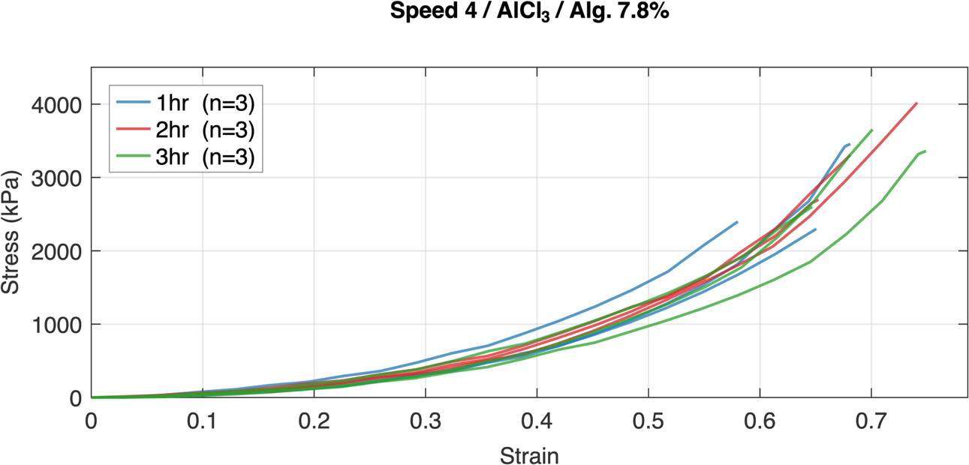
Figure S 34

Speed 4 / CaCl₂ / Alg. 7.8% Unavailable

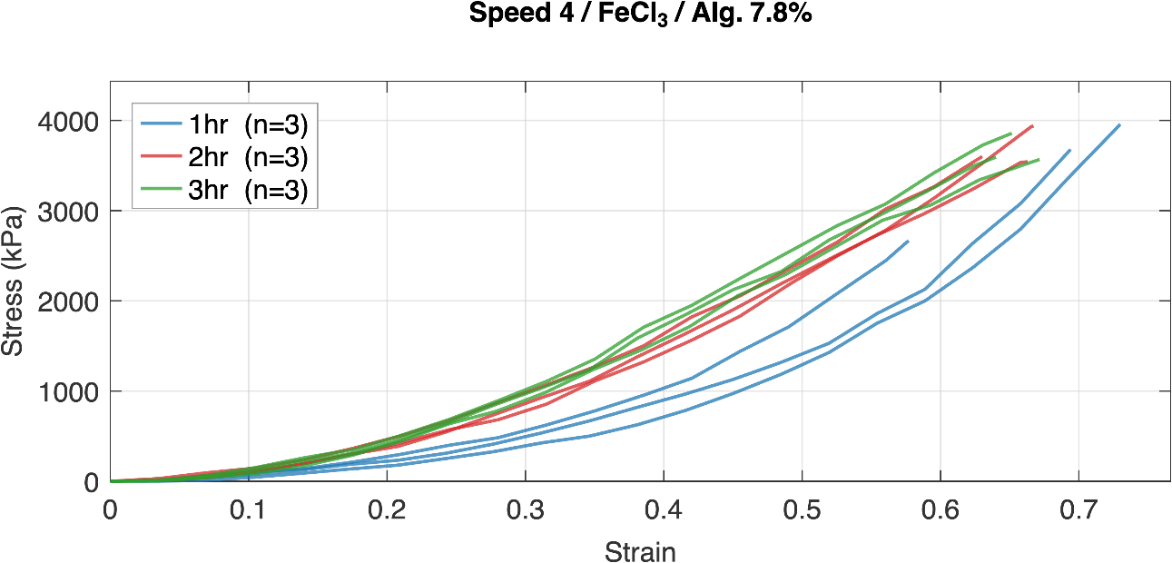
Figure S 35
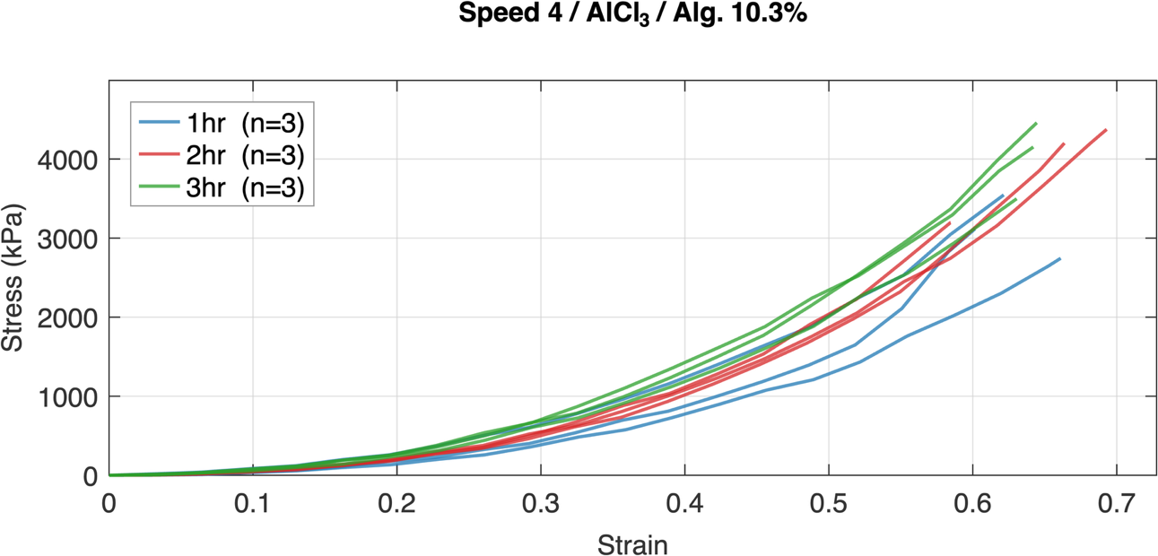
Figure S 36
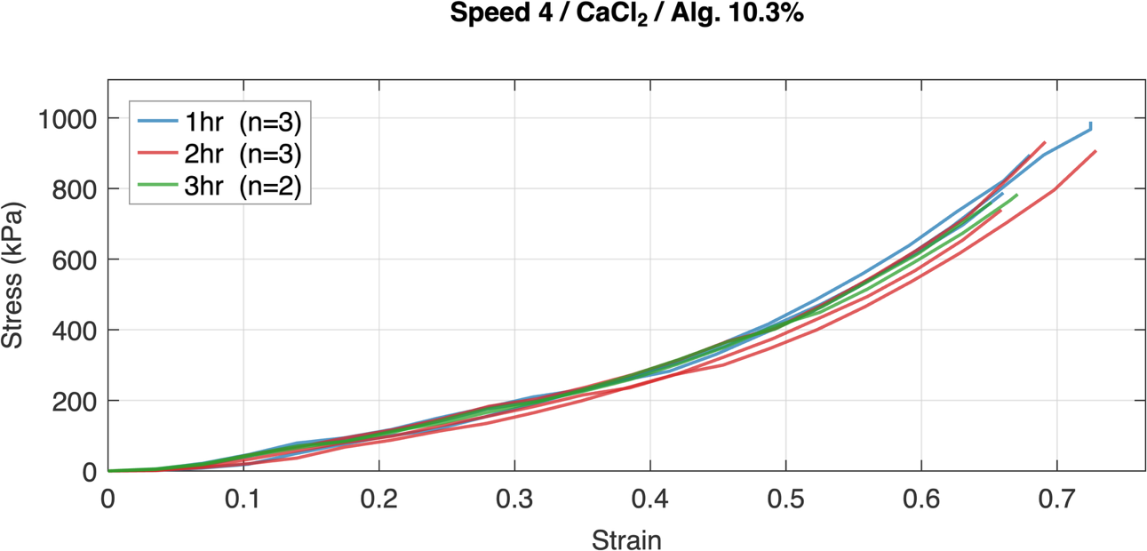
Figure S 37
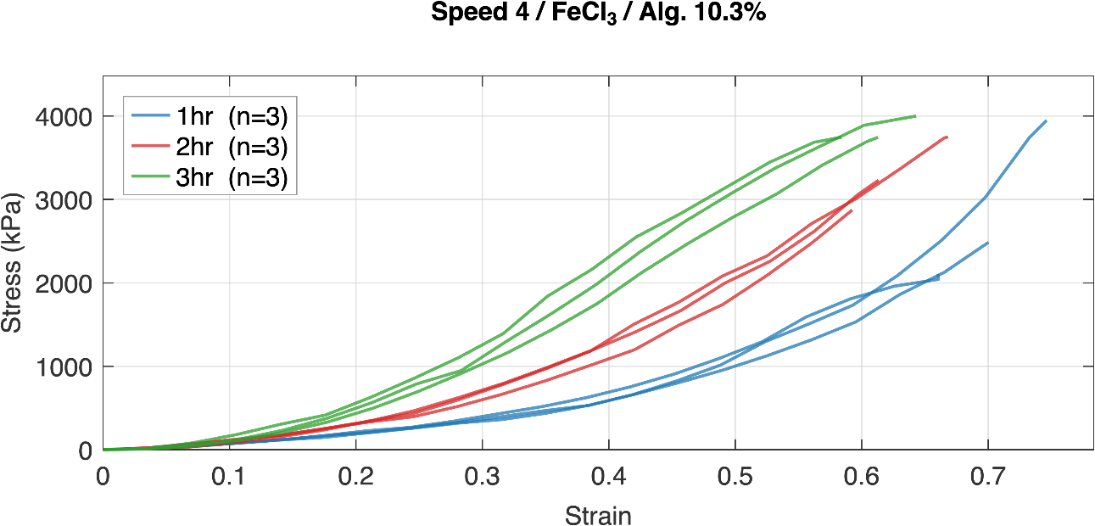
Figure S 38

Supplementary Tables
Table S 1. Number of specimens retained for mechanical analysis, organised by loading speed and ionic crosslinker. Each cell represents the sum across all alginate concentrations (4.7%, 7.8%, 10.3%) and immersion durations (1 hr, 2 hr, 3 hr) within each speed-crosslinker group. The AlCl₃ groups at Speed 1 and Speed 2 include five replicates for the 4.7% alginate formulation; all other formulation-speed combinations comprise three replicates. †Four specimens excluded due to failed force-displacement records: two CaCl₂ / 7.8% / 1 hr, one CaCl₂ / 7.8% / 2 hr, and one CaCl₂ / 10.3% / 3 hr; cell value reflects specimens retained.
Speed | AlCl3 | CaCl2 | FeCl3 | Total
1 | 33 | 27 | 27 | 87
2 | 33 | 27 | 27 | 87
3 | 27 | 27 | 27 | 81
4 | 27 | 23 † | 27 | 54
Total | 120 | 81 | 108 | 309

Table S 2. Summary of Hotelling's T² test comparisons between immersion time groups (1 hr vs. 2hr+3hr pooled) for all loading speed and alginate concentration combinations. Each matrix cell indicates the outcome of a pairwise Hotelling's T² test for a specific crosslinking ion (columns) and speed × alginate concentration combination (rows): a checkmark (✓) denotes a significant difference was detected by one-dimensional Statistical Parametric Mapping (SPM1D; Šidák-corrected Hotelling's T-squared, family-wise α = 0.05), a dash (−) denotes failure to reject the null hypothesis, and N/A indicates insufficient specimens for analysis.
Speed | Alg. (%) | AlCl3 | CaCl2 | FeCl3
1 | 4.70 | - |  | -
1 | 7.80 | - |  | 
1 | 10.30 | - | - | -
2 | 4.70 |  | - | 
2 | 7.80 | - |  | 
2 | 10.30 | - |  | 
3 | 4.70 | - |  | 
3 | 7.80 | - |  | 
3 | 10.30 | - |  | 
4 | 4.70 | - | - | -
4 | 7.80 | - | N/A | 
4 | 10.30 | - | - | 

Table S 3. Summary of multivariate statistical comparisons of stress–strain responses across crosslinking ion for all combinations of alginate concentration, immersion time, and loading speed. Each matrix cell indicates the outcome of pairwise Hotelling's T² tests between crosslinking ions: a checkmark (✓) denotes a significant difference was detected by one-dimensional Statistical Parametric Mapping (SPM1D; Šidák-corrected Hotelling's T-squared, family-wise α = 0.05), a dash (−) denotes failure to reject the null hypothesis, and N/A indicates insufficient specimens for analysis. Rows correspond to formulation combinations (displacement rate × alginate concentration).
Spd. | Alg. (%) | 1 hr Immersion |  |  | 2 hr + 3 hr Immersion
Spd. | Alg. (%) | AlCl3 Vs CaCl2 | AlCl3 Vs FeCl3 | CaCl2 Vs FeCl3 | AlCl3 Vs CaCl2 | AlCl3 Vs FeCl3 | CaCl2 Vs FeCl3
1 | 4.70 |  |  |  |  |  | 
1 | 7.80 |  | - |  |  |  | 
1 | 10.30 |  | - | - |  |  | 
2 | 4.70 |  |  |  |  |  | 
2 | 7.80 |  | - |  |  |  | 
2 | 10.30 |  |  |  |  |  | 
3 | 4.70 |  |  |  |  |  | 
3 | 7.80 |  | - |  |  |  | 
3 | 10.30 |  | - |  |  |  | 
4 | 4.70 | - | - |  |  |  | 
4 | 7.80 | N/A | N/A | N/A |  |  | 
4 | 10.30 | - | - | - |  | - | 

Table S 4. Summary of multivariate statistical comparisons of stress–strain responses across alginate concentrations for all crosslinking ion, immersion time, and loading speed combinations. Each matrix cell indicates the outcome of pairwise Hotelling's T² tests between alginate concentrations (remaining columns): a checkmark (✓) denotes a significant difference was detected by one-dimensional Statistical Parametric Mapping (SPM1D; Šidák-corrected Hotelling's T-squared, family-wise α = 0.05), a dash (−) denotes failure to reject the null hypothesis, and N/A indicates insufficient specimens for analysis. Rows correspond to formulation combinations (loading speed × crosslinking ion).
Spd. | Salt | 1 hr Immersion |  |  | 2 hr + 3 hr Immersion
Spd. | Salt | 4.7% Vs 7.8% | 4.7% Vs 10.3% | 7.8% Vs 10.3% | 4.7% Vs 7.8% | 4.7% Vs 10.3% | 7.8% Vs 10.3%
Speed 1 | AlCl3 |  |  | - |  |  | 
Speed 1 | CaCl2 | - | - | - |  |  | -
Speed 1 | FeCl3 | - | - |  |  |  | -
Speed 2 | AlCl3 |  |  | - |  |  | 
Speed 2 | CaCl2 | - |  | - |  |  | 
Speed 2 | FeCl3 |  |  | - |  |  | 
Speed 3 | AlCl3 |  |  | - |  |  | 
Speed 3 | CaCl2 | - |  |  |  |  | -
Speed 3 | FeCl3 | - | - | - |  |  | 
Speed 4 | AlCl3 | - | - | - |  |  | 
Speed 4 | CaCl2 | N/A | N/A | N/A | - |  | -
Speed 4 | FeCl3 |  | - | - |  |  | -

Table S 5. Summary of multivariate statistical comparisons of stress–strain responses across loading speeds for all combinations of crosslinking ion, alginate concentration, and immersion time. Each matrix cell indicates the outcome of pairwise Hotelling's T² test between loading speeds: a checkmark (✓) denotes a significant difference was detected by one-dimensional Statistical Parametric Mapping (SPM1D; Šidák-corrected Hotelling's T-squared, family-wise α = 0.05), a dash (−) denotes failure to reject the null hypothesis, and N/A indicates insufficient specimens for analysis. Rows correspond to formulation combinations (crosslinking ion × alginate concentration).
Salt | Alg. (%) | 1 hr Immersion |  |  |  |  |  | 2 hr + 3 hr Immersion
Salt | Alg. (%) | Sp. 1 Vs Sp. 2 | Sp. 1 Vs Sp. 3 | Sp. 1 Vs Sp. 4 | Sp. 2 Vs Sp. 3 | Sp. 2 Vs Sp. 4 | Sp. 3 Vs Sp. 4 | Sp. 1 Vs Sp. 2 | Sp. 1 Vs Sp. 3 | Sp. 1 Vs Sp. 4 | Sp. 2 Vs Sp. 3 | Sp. 2 Vs Sp. 4 | Sp. 3 Vs Sp. 4
AlCl3 | 4.7% |  |  |  |  |  | - |  |  |  |  |  | 
AlCl3 | 7.8% | - | - | - |  | - | - |  |  |  |  |  | 
AlCl3 | 10.3% | - | - | - |  | - | - |  |  |  |  |  | 
CaCl2 | 4.7% |  |  | N/A |  | N/A | N/A |  |  |  |  |  | 
CaCl2 | 7.8% | - |  | N/A |  | N/A | N/A |  |  |  |  |  | 
CaCl2 | 10.3% |  |  | N/A |  | N/A | N/A |  |  |  |  |  | 
FeCl3 | 4.7% | - |  |  |  |  |  |  |  |  |  |  | 
FeCl3 | 7.8% | - |  |  |  |  |  |  |  |  |  |  | 
FeCl3 | 10.3% |  |  |  |  |  |  |  |  |  |  |  | 

Tabulated Stress at Benchmark Failure and Tangent Modulus
Table S 6. Summary table of key mechanical properties for all formulations and literature benchmarks across the benchmarked loading speeds. Each panel presents a tabulated comparison with columns for crosslinking ion, alginate concentration, immersion time, tangent modulus (kPa), and stress at benchmark failure strain (kPa). The top row of each panel corresponds to the literature benchmark (Karimi et al. for Speed 1; Fradet et al. (1) and (2) for Speeds 2 and 3, respectively); subsequent rows list all formulations ordered by crosslinking ion, alginate concentration, and immersion time. Values are reported as central value ± variation. Central values are based on the characteristic curve whereas variation is the standard deviation calculated based on individual sample curves.
Crosslinker | Alg (%) | Immersion | Speed 1 |  | Speed 2 |  | Speed 3
Crosslinker | Alg (%) | Immersion | E_tan (kPa) | Stress at Benchmark Failure (kPa) | E_tan (kPa) | Stress at Benchmark Failure (kPa) | E_tan (kPa) | Stress at Benchmark Failure (kPa)
Benchmark | -- | -- | 878.3 | 61.2 | 591.7 | 251.0 ± 46.5 | 1176.2 | 458.7 ± 258.5
AlCl3 | 4.7 | 1 hr | 220.5 ± 4.7 | 59.4 ± 1.3 | 2716.5 ± 208.1 | 594.1 ± 47.9 | 5006.8 ± 129.2 | 1014.1 ± 5.1
AlCl3 | 4.7 | 2hr + 3hr | 225.9 ± 7.6 | 60.9 ± 1.9 | 2234.3 ± 111.5 | 529.0 ± 38.2 | 3613.3 ± 1097.2 | 835.4 ± 193.4
AlCl3 | 7.8 | 1 hr | 516.4 ± 4.6 | 122.6 ± 1.4 | 3516.8 ± 1120.8 | 1127.5 ± 310.2 | 3708.4 ± 263.8 | 1042.2 ± 41.7
AlCl3 | 7.8 | 2hr + 3hr | 561.8 ± 50.9 | 132.5 ± 10.6 | 4552.9 ± 429.3 | 1457.9 ± 99.7 | 3769.4 ± 211.4 | 1125.8 ± 30.1
AlCl3 | 10.3 | 1 hr | 700.9 ± 27.9 | 155.5 ± 10.5 | 6308.3 ± 159.9 | 2014.9 ± 43.2 | 4436.5 ± 802.6 | 1233.5 ± 140.3
AlCl3 | 10.3 | 2hr + 3hr | 849.9 ± 78.3 | 185.0 ± 17.7 | 6497.2 ± 490.9 | 2119.2 ± 174.9 | 4147.3 ± 662.8 | 1168.2 ± 164.6
CaCl2 | 4.7 | 1 hr | 150.4 ± 5.1 | 40.4 ± 1.1 | 385.1 ± 13.1 | 182.6 ± 5.1 | 550.3 ± 162.9 | 232.8 ± 51.6
CaCl2 | 4.7 | 2hr + 3hr | 173.8 ± 4.4 | 46.7 ± 1.3 | 462.8 ± 45.5 | 212.8 ± 14.1 | 566.3 ± 172.3 | 253.4 ± 42.7
CaCl2 | 7.8 | 1 hr | 184.1 ± 3.6 | 48.7 ± 1.1 | 528.4 ± 67.9 | 252.9 ± 15.9 | 686.4 ± 65.1 | 290.5 ± 29.5
CaCl2 | 7.8 | 2hr + 3hr | 247.4 ± 22.7 | 64.8 ± 6.6 | 744.0 ± 24.9 | 347.0 ± 11.0 | 1032.9 ± 93.1 | 412.4 ± 35.9
CaCl2 | 10.3 | 1 hr | 198.5 ± 1.4 | 53.1 ± 0.3 | 725.2 ± 6.4 | 333.0 ± 1.5 | 1164.0 ± 21.6 | 477.7 ± 15.6
CaCl2 | 10.3 | 2hr + 3hr | 225.1 ± 11.4 | 59.4 ± 2.7 | 791.5 ± 25.3 | 372.1 ± 7.8 | 1183.0 ± 192.3 | 490.1 ± 58.9
FeCl3 | 4.7 | 1 hr | 460.7 ± 61.9 | 100.9 ± 9.7 | 2039.1 ± 122.6 | 739.5 ± 6.9 | 2471.5 ± 85.0 | 847.3 ± 23.3
FeCl3 | 4.7 | 2hr + 3hr | 589.3 ± 38.6 | 120.6 ± 8.8 | 1541.9 ± 705.1 | 855.1 ± 55.3 | 2537.7 ± 361.7 | 934.7 ± 36.8
FeCl3 | 7.8 | 1 hr | 669.2 ± 27.6 | 141.3 ± 0.7 | 3277.0 ± 352.7 | 1177.3 ± 76.8 | 3688.1 ± 490.8 | 1027.7 ± 40.9
FeCl3 | 7.8 | 2hr + 3hr | 1209.3 ± 176.0 | 227.8 ± 34.1 | 3522.1 ± 308.4 | 1941.9 ± 106.7 | 3932.3 ± 430.2 | 1190.2 ± 28.8
FeCl3 | 10.3 | 1 hr | 734.7 ± 5.9 | 155.9 ± 7.6 | 2906.1 ± 71.2 | 1042.4 ± 32.3 | 3073.7 ± 197.6 | 895.2 ± 48.4
FeCl3 | 10.3 | 2hr + 3hr | 1442.9 ± 349.7 | 275.7 ± 60.4 | 4274.2 ± 358.1 | 2190.1 ± 404.9 | 5527.6 ± 836.5 | 1328.3 ± 22.1

References:
Fradet, L., F. Cliche, Y. Petit, J.-M. Mac-Thiong and P.-J. Arnoux (2016). "Strain rate dependent behavior of the porcine spinal cord under transverse dynamic compression." Proceedings of the Institution of Mechanical Engineers, Part H: Journal of Engineering in Medicine 230(9): 858-866.
Hartlen, D. C. and D. S. Cronin (2022). "Arc-length re-parametrization and signal registration to determine a characteristic average and statistical response corridors of biomechanical data." Frontiers in bioengineering and biotechnology 10: 843148.
Hartlen, D. C. and D. S. Cronin (2025). "Hypothesis Testing of Multivariate Biomechanical Responses using Statistical Parametric Mapping and Arc-Length Re-parameterization: DC Hartlen, DS Cronin." Annals of Biomedical Engineering 53(10): 2536-2550.
Karimi, A., A. Shojaei and P. Tehrani (2017). "Mechanical properties of the human spinal cord under the compressive loading." Journal of chemical neuroanatomy 86: 15-18.

