Graphical Abstract. Sensory Regulation → Food Exploration → Food Acceptance → Feeding Development.
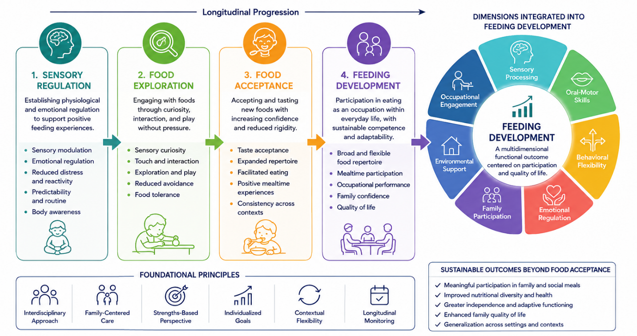
Graphical Abstract. The graphical abstract summarizes the conceptual model developed in the present study. Feeding intervention is represented as a longitudinal developmental continuum in which sensory regulation facilitates food exploration, leading to progressive food acceptance and, ultimately, Feeding Development. Within this framework, Feeding Development is conceptualized as a multidimensional functional outcome integrating sensory processing, oral-motor competence, behavioral flexibility, family participation, environmental support, and occupational engagement. The model emphasizes that food acceptance represents an intermediate developmental milestone rather than the final outcome of intervention, highlighting participation and functional performance as the primary indicators of therapeutic success.

