Extended Figures and Tables for:

The dopamine transporter counter-transports potassium to increase the uptake of dopamine

Solveig G. Schmidt¹, Mette G. Malle^{2,3,#}, Anne Kathrine Nielsen^{1,4,#}, Søren S.-R. Bohr^{2,3}, Ciara F. Pugh¹, Jeppe C. Nielsen¹, Ida H. Poulsen¹, Kasper D. Rand⁴, Nikos S. Hatzakis^{2,3}, Claus J. Loland^{1,*}

¹Laboratory for Membrane Protein Dynamics, Department of Neuroscience, Faculty of Health and Medical Sciences, University of Copenhagen, Copenhagen, Denmark.

²Nano-Science Center, Department of Chemistry, Faculty of Science, University of Copenhagen, Denmark

³Novo Nordisk Foundation Centre for Protein Research, Faculty of Health and Medical Sciences, University of Copenhagen, 2200 Copenhagen, Denmark

⁴Protein Analysis Group, Department of Pharmacy, Faculty of Health and Medical Sciences, University of Copenhagen, Copenhagen, Denmark.

#These two authors contributed equally to the manuscript
*Correspondence:
Claus J. Loland, Department of Neuroscience, University of Copenhagen, Denmark, cllo@sund.ku.dk

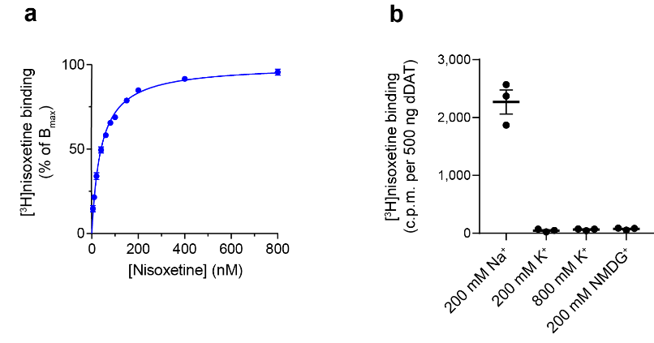

Extended Data Figure 1 | [³H]nisoxetine binding to detergent solubilized dDAT. (a) Saturation binding of [³H]nisoxetine to dDAT in a buffer containing 200 mM NaCl showed a K_{d} of 40 ± 2 nM. Data are shown as mean ± SEM (error bars), n = 4 in duplicates, and fitted to a one-site specific binding curve using GraphPad Prism 7.0. (b) Binding of 120 nM [³H]nisoxetine to dDAT in indicated salt conditions. Specific binding was observed in Na⁺, whilst all other salt conditions did not promote [³H]nisoxetine binding separate from background (1 mM nortriptyline). The ionic concentration was kept constant by substitution of Na⁺ and K⁺ with NMDG⁺. Data points represent mean ± SEM (error bars), n = 3.

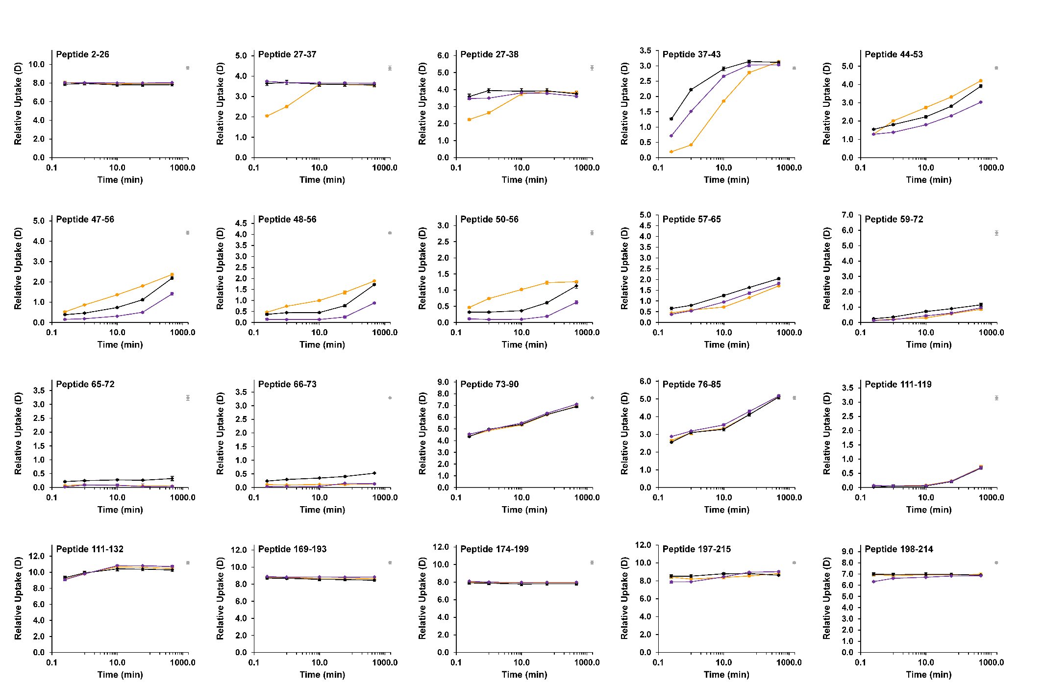
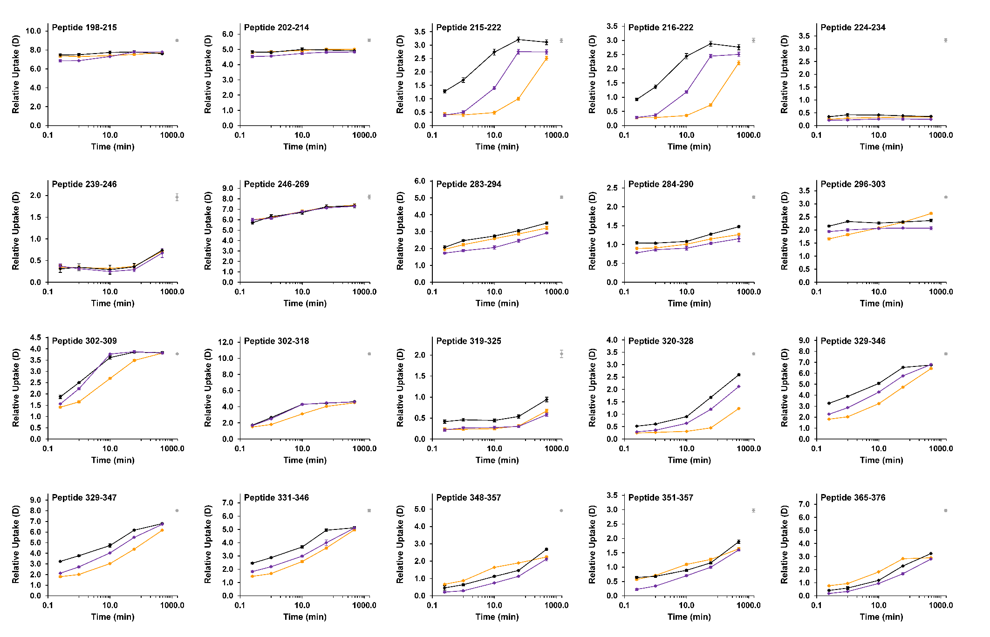
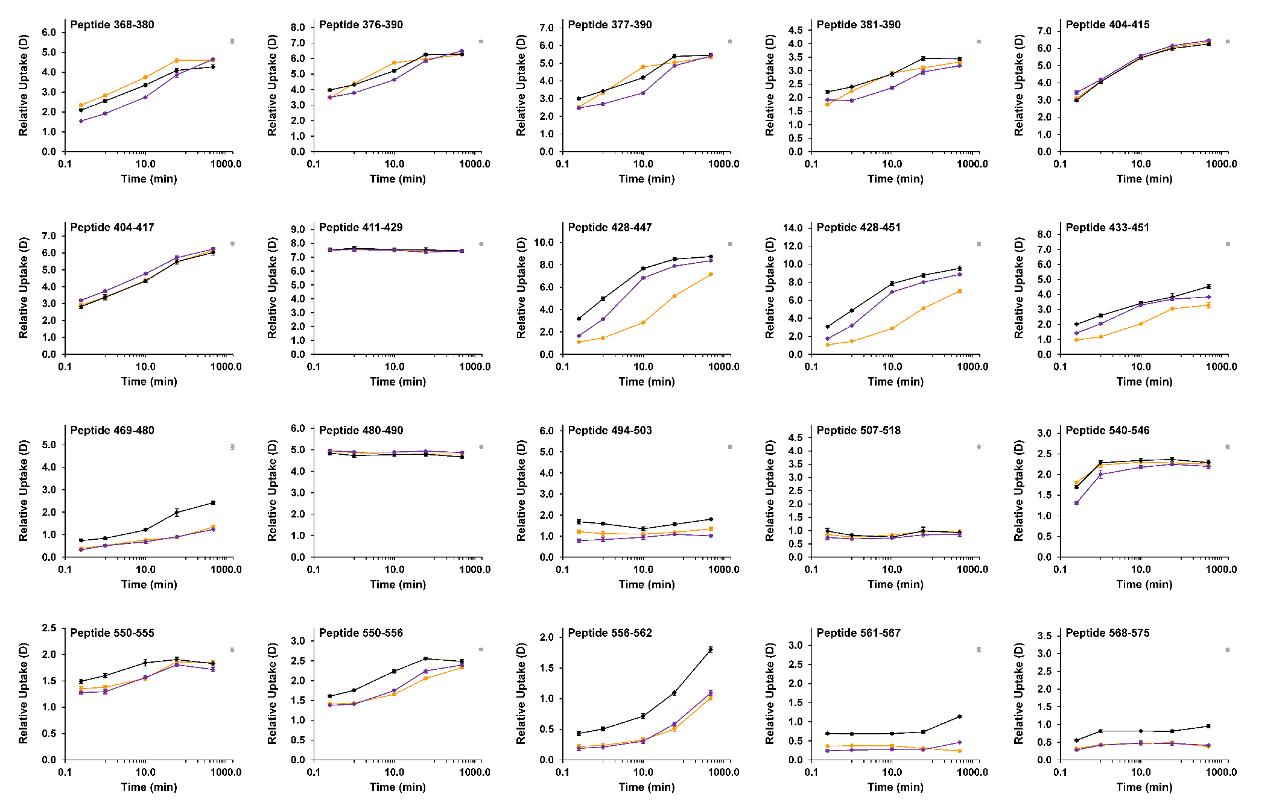
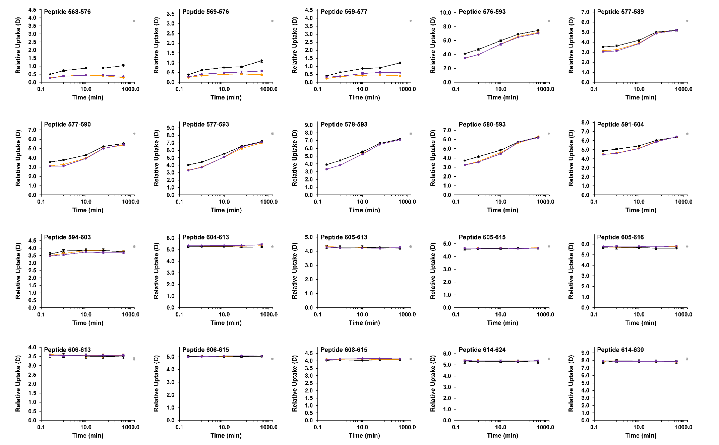
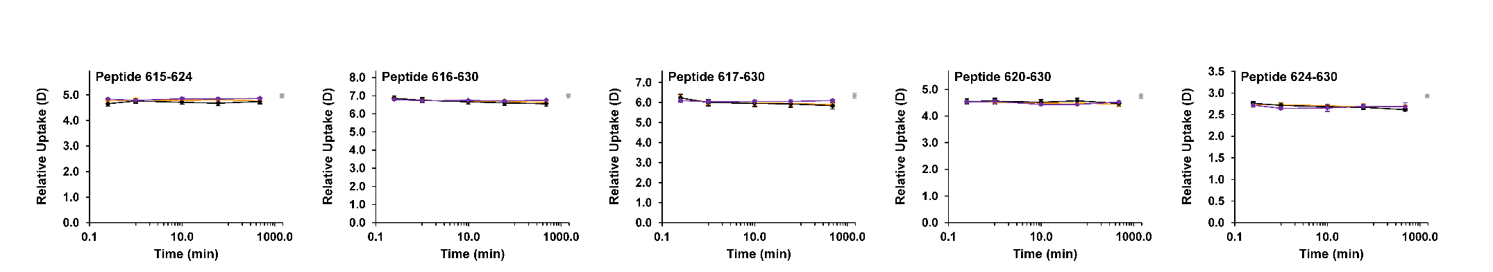

Extended Data Figure 2 | Deuterium uptake plots for dDAT peptides. Deuterium uptake plots for representative peptides of dDAT showing the relative deuterium uptake as a function of labeling time (0.25 – 480 min) for the K⁺ (purple), Cs⁺ (black), and Na⁺-bound (orange) states. Values represent means of three (for Cs⁺ and K⁺) or six (Na⁺) independent measurements with SE values plotted as error bars but are in most instances too small to be visible. Maximum-labeled control samples are shown as grey circles at 1440 min. Data for the Cs⁺ and Na⁺-bound states as well as for the maximum labeled control samples were published previously¹, but acquired together with the data for the K⁺ state and shown here for comparison.

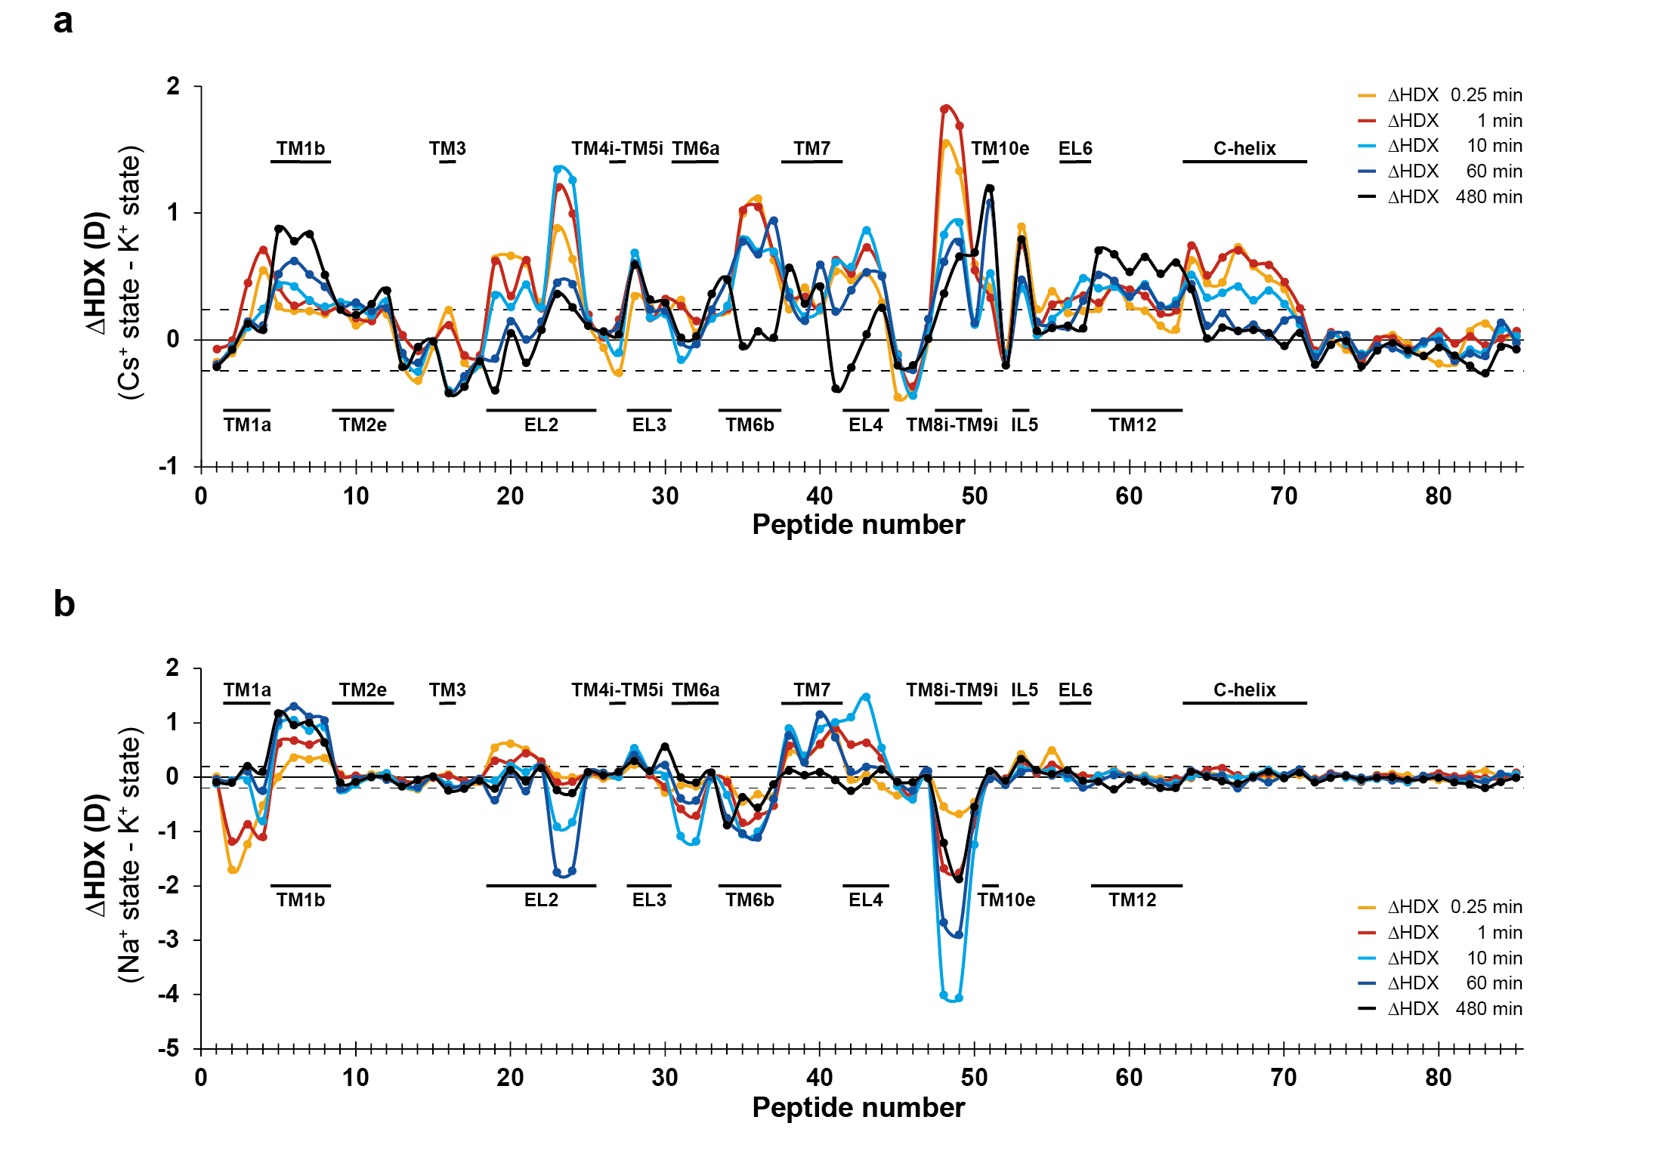

Extended Data Figure 3 | Differential uptake charts (ΔHDX). Differential uptake charts comparing differences in the average deuterium uptake (ΔHDX) between (a) the apo (Cs⁺) state to the K⁺ state and (b) the Na⁺- state to the K⁺ state for the 85 identified peptides at the five sampled time points (orange: 0.25 min; red: 1 min; cyan: 10 min; blue: 1 h; black: 8h). The individual dDAT peptides are arranged along the x-axis starting from the N-terminal and ending on the C-terminal. The peptide number refer to Extended Data Table 3. Positive and negative values indicate reduced and increased HDX, respectively, for the K⁺-containing sample. Values represent means of at least three independent measurements. Structural dDAT motifs are marked along the x-axis. The dotted lines (±0.26 D) mark a threshold value for the 95% confidence interval, calculated from the pooled SD for all time points.

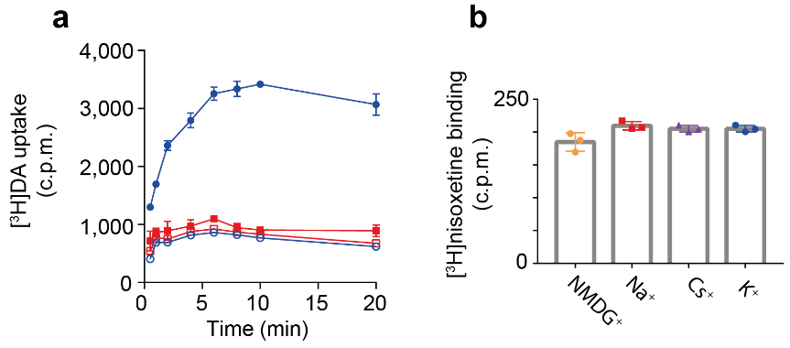

Extended Data Figure 4 | [³H]dopamine uptake in proteoliposomes and [³H]nisoxetine binding to dDAT from solubilized proteoliposomes. (a) dDAT [³H]dopamine uptake into PLs in uptake buffer with an intra-vesicular buffer with either 200 mM K⁺ (blue circles) or 200 mM Na⁺ (red filled squares), and with 100 µM nortriptyline added to the uptake buffer (K⁺: open blue circles, Na⁺: open red squares). (b) Binding of [³H]nisoxetine to dDAT from re-solubilized PLs was measured in saturating conditions (approximately 20x K_{d}). Data are shown as mean ± S.D. (error bars), from one representative experiment performed in triplicates.

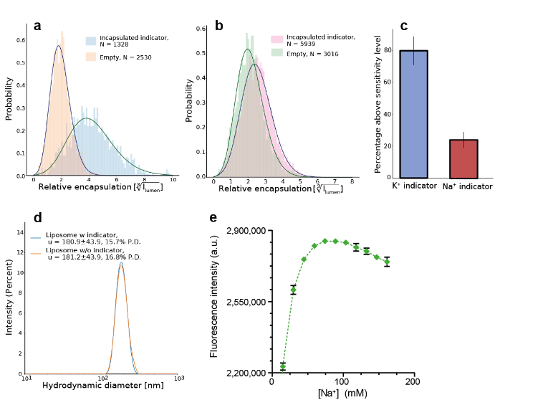

Extended Data Figure 5 | Encapsulation and sensitivity of the fluorescent indicators. Quantitative calibration of the encapsulation efficiency of both the fluorescent K⁺ indicator and the fluorescent Na⁺ indicator, to quantify the sensitivity of the system, and thereby the upper percentage of liposomes with sufficient indicator to enable a quantitative measurable signal in the real time TIRF monitoring. (a) Empty (indicator-free) PLs and PLs with 10 mM K⁺ indicator imaged with identical settings and co-localized for quantifications of encapsulated dye signal. By comparing the background crosstalk signal and the indicator signal we found 79.8 ± 8.9% of the PLs to have measurable signal sensitivity and encapsulation. (b) Empty PLs and PLs with 10 mM Na⁺ indicator imaged with identical settings. Comparison showed 24.2 ± 4.9% of the PLs had measurable signal sensitivity and encapsulation. (c) Integration of the crosstalk signal from the membrane dye and the indicator signal for both conditions (10 mM K⁺ indicator with 100 mM K⁺, 100 mM NMDG⁺ intra-vesicular concentration, and 10 mM Na⁺ indicator with 200 mM Na⁺ intra-vesicular concentration) gives a quantification of the percentage of PLs with sensitive settings allowing the direct observation of respectively uptake of Na⁺ and outflow of K⁺. The K⁺ indicator assay allowed an upper quantification percentage of 79.8 ± 8.9% of the individual PLs, and the Na⁺-indicator assay allowed an upper quantification percentage of 24.2 ± 4.9% of the individual PLs. The upper quantification percentage is the maximum percentage of liposomes with sufficient indicator to enable a quantitative measurable signal in the TIRFm set-up. (d) Dynamic light scattering (DLS) measurement of PLs reconstituted with fluorescent indicator in the lumen (blue) and without (orange) showing that the indicator does not influence the size or polydispersity of the liposomes. (e) Na⁺ indicator (10 mM) was excited at 503 nm and fluorescence was measured at maximum emission (529 nm) in increasing [NaCl] (0-160 mM) in buffer containing 20 mM HEPES (pH 7.5) and 1 mM L-ascorbic acid. The maximal fluorescence intensity was reached at 75 mM NaCl. The fluorescence signal obtained in 160 mM matched the signal intensity at 45 mM. Data are shown as mean ± S.D. (error bars), n = 1 performed in triplicates.

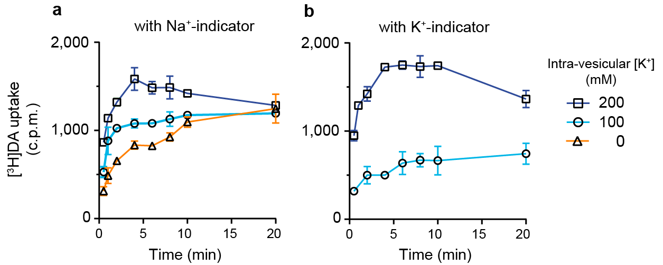

Extended Data Figure 6 | Proteoliposomes reconstituted with membrane dye and biotinylated PEG-DOPE, encapsulating ion indicator. PLs with both Na⁺ indicator (a) and K⁺ indicator (b) showed Na⁺ dependent [³H]dopamine uptake with varying [K⁺] in the lumen. Data are shown from one representative experiment as mean ± S.D. (error bars) performed in duplicates.

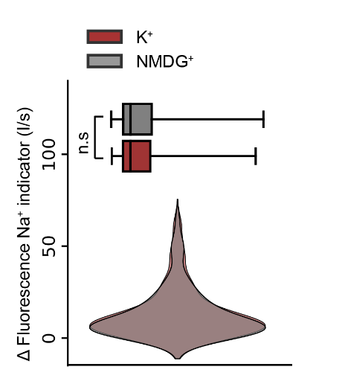

Extended Data Figure 7 | Translocation kinetics of sodium in absence of dopamine. (Bottom panel) Violin plot displaying Na⁺ uptake rates in vesicles containing intra-vesicular K⁺ or NMDG⁺, respectively. (Top panel) Box plot showing the median and the statistical dispersion of the fluorescence signal increase rates from all single vesicle data in the violin plot. Comparing the effect of Na⁺ uptake revealed no significant rate difference in the absence of dopamine (P > 0.05, validated by p-value two sided KS-test and two-sided t-test). This suggest that the continuous translocation of Na⁺ across vesicle membranes is independent of intra-vesicular K⁺.

Extended Data Table 1 | Effect of K⁺ on Na⁺-dependent [³H]nisoxetine binding to dDAT WT
[K⁺]  (mM) | B_{max}  (normalized) | EC₅₀  (mM) | Hill Slope | n
0 | 97.6 ± 4.1 | 60 [53;67] | 1.96 ± 0.42 | 3
20 | 99.3 ± 3.4 | 68 [62;75] | 1.72 ± 0.27 | 3
50 | 99.3 ± 4.6 | 106 [96;118] | 1.50 ± 0.24 | 3
100 | 94.8 ± 7.4 | 122 [103;145] | 1.54 ± 0.40 | 3
200 | 96.8 ± 5.0 | 170 [154;188] | 1.98 ± 0.36 | 3
400 | 97.5 ± 3.3 | 210 [198;222] | 2.52 ± 0.34 | 3
600 | 99.4 ± 3.2 | 319 [303;335] | 2.39 ± 0.19 | 3
800 | 100.0 ± 4.0 | 436 [416;458] | 2.39 ± 0.19 | 3
Data determined by binding of 120 nM [³H]nisoxetine to dDAT WT in increasing Na⁺ in the presence of the indicated K⁺ concentrations. The ionic strength was maintained by substitution of Na⁺ and K⁺ with NMDG⁺. Data shown as mean ± SEM or [SEM interval], n = 3 biological replicates from 2 independent dDAT WT purifications.

Extended Data Table 2 | HDX Data summary table
Data Set | K⁺ state
HDX reaction details | 40 mM Tris, 5% glycerol, 1 mM DDM, 0.2 mM CHS, 14 µM lipids (POPC:POPE:POPG; weight ratio 3:1:1), 200 mM KCl.  Percent deuterium: 75.2%, pD_{read} = 8.036, 25°C.
HDX time course | 0.25 min, 1 min, 10 min, 60 min, 480 min
HDX control samples | Maximum-labeled control using predigested dDAT.
Back-exchange (mean / IQR) | 32.1% / 9.55%
# of Peptides | 85
Sequence coverage | 75.5% (77.2% of the dDAT sequence)
Average peptide length / Redundancy | 12.44 / 2.17
Replicates (biological or technical) | 3 (technical)
Repeatability | 0.0504 (average standard deviation)
Summary table of HDX experimental conditions and data.
Extended Data Table 3 | HDX data table.
Extended Data Table 4 | Time dependent [³H]dopamine uptake
Intra-vesicular  cation | Max uptake  (normalized) | k  (min⁻¹) | R² | n
K⁺ | 100 ± 1 | 0.68 ± 0.05 | 0.93 | 4
Cs⁺ | 20 ± 1 | 0.94 ± 0.2 | 0.55 | 3
NMDG⁺ | 20 ± 1 | 0.99 ± 0.3 | 0.40 | 3
The maximal uptake and rate constants (k) estimated for time dependent uptake of [³H]dopamine uptake fitted to a one phase association. See also Fig. 3a and methods. Data are shown as mean ± SEM.

Extended Data Table 5 | Concentration dependent [³H]dopamine uptake
Intra-vesicular  [K⁺] (mM) | V_{max}  (normalized) | K_{m}  (µM) | R² | n
200 | 99 ± 3 | 0.85 ± 0.08 | 0.97 | $$4$$
150 | 53 ± 4 | 2.13 ± 0.38 | 0.95 | $$3$$
100 | 35 ± 3 | 1.81 ± 0.40 | 0.92 | $$3$$
100 no gradient | 24 ± 4 | 2.20 ± 0.76 | 0.87 | 3
0 | 38 ± 9 | 4.46 ± 1.76 | 0.86 | 4
Maximum dopamine uptake and K_{m} estimates for concentration dependent [³H]dopamine uptake over 3 min in the indicated intra-vesicular K⁺ concentrations including the condition with equimolar K⁺ across the membrane (100 no gradient). See also Fig. 3b and methods. Data are shown as mean ± SEM.

REFERENCES FOR EXTENDED DATA FIGURES AND TABLES
1 Nielsen, A. K. et al. Substrate-induced conformational dynamics of the dopamine transporter. Nat Commun 10, 2714, doi:10.1038/s41467-019-10449-w (2019).

