Supplement 1
Recruitment Flyer 1
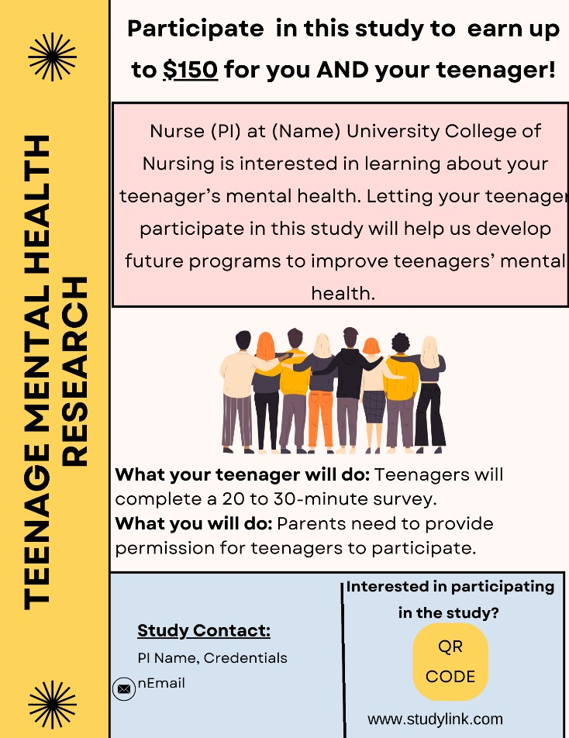

Supplement 2
Recruitment Flyer 2
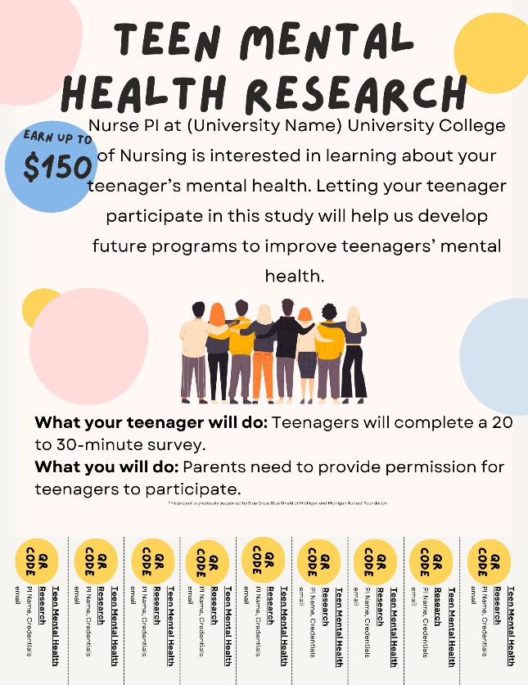

Supplement 3

Item-Based Confirmatory Factor Analysis for Each Subscale
 | Item | λ | SE | AVE | CR | Alpha | Omega | CFI | TLI | SRMR
Stress |  |  |  | 0.67 | 0.88 | 0.94 | 0.93 | 0.93 | 0.91 | 0.05
Perceived Stress Scale | 1 | 0.84 | 0.03
 | 2 | 0.72 | 0.02
 | 3 | 0.83 | 0.03
 | 4 | 0.67 | 0.05
 | 5 | 0.82 | 0.03
 | 6 | 0.81 | 0.03
 | 7 | 0.71 | 0.04
 | 8 | 0.78 | 0.04
 | 9 | 0.77 | 0.04
 | 10 | 0.88 | 0.02
Bullying |  |  |  | 0.72 | 0.91 | 0.89 | 0.90 | 1.00 | 1.00 | 0.02
Illinois Bullying Scale | 4 | 0.89 | 0.04
 | 5 | 0.88 | 0.04
 | 6 | 0.86 | 0.10
 | 7 | 0.65 | 0.14
Hopeless |  |  |  | 0.55 | 0.84 | 0.88 | 0.86 | 0.86 | 0.85 | 0.08
Beck’s Hopelessness Scale | 1 | 0.85 | 0.06
 | 2 | 0.88 | 0.07
 | 3 | 0.72 | 0.09
 | 4 | 0.58 | 0.09
 | 5 | 0.69 | 0.07
 | 6 | 0.64 | 0.09
 | 7 | 0.73 | 0.13
 | 8* | 0.30 | 0.13
 | 9 | 0.70 | 0.08
 | 10 | 0.52 | 0.13
 | 11 | 0.84 | 0.08
 | 12 | 0.84 | 0.05
 | 13 | 0.43 | 0.12
 | 14 | 0.82 | 0.07
 | 15 | 0.86 | 0.05
 | 16 | 0.83 | 0.07
 | 17 | 0.87 | 0.06
 | 18 | 0.82 | 0.07
 | 19 | 0.80 | 0.10
 | 20 | 0.77 | 0.10
Hopeless removed |  |  |  | 0.58 | 0.83 | 0.86 | 0.86 | 0.99 | 0.99 | 0.08

Table 4B.1 (cont’d)
Intrapersonal resilience  Connor-Davidson Resilience Scale |  |  |  |  | 0.58 | 0.90 | 0.89 | 0.90 | 0.98 | 0.97 | 0.04
 | 1 |  | 0.72 |  | 0.05
 | 2 |  | 0.73 |  | 0.05
 | 3 |  | 0.47 |  | 0.09
 | 4 |  | 0.66 |  | 0.07
 | 5 |  | 0.74 |  | 0.04
 | 6 |  | 0.74 |  | 0.05
 | 7 |  | 0.73 |  | 0.05
 | 8 |  | 0.80 |  | 0.03
 | 9 |  | 0.66 |  | 0.08
 | 10 |  | 0.50 |  | 0.11
CFE |  |  |  |  | 0.48 | 0.95 | 0.95 | 0.95 | 0.95 | 0.94 | 0.06
Collective Family Efficacy Scale | 1 |  | 0.72 |  | 0.05
 | 2 |  | 0.63 |  | 0.07
 | 3 |  | 0.78 |  | 0.04
 | 4 |  | 0.67 |  | 0.05
 | 5 |  | 0.68 |  | 0.06
 | 6 |  | 0.70 |  | 0.05
 | 7 |  | 0.76 |  | 0.04
 | 8 |  | 0.81 |  | 0.04
 | 9 |  | 0.77 |  | 0.04
 | 10 |  | 0.67 |  | 0.04
 | 11 |  | 0.68 |  | 0.06
 | 12 |  | 0.77 |  | 0.05
 | 13 |  | 0.73 |  | 0.05
 | 14 |  | 0.63 |  | 0.07
 | 15 |  | 0.61 |  | 0.05
 | 16 |  | 0.56 |  | 0.07
 | 17 |  | 0.68 |  | 0.05
 | 18 |  | 0.78 |  | 0.04
 | 19 |  | 0.68 |  | 0.05
 | 20 |  | 0.51 |  | 0.06
Social support |  |  |  |  | 0.35 | 0.91 | 0.92 | 0.93 | 0.95 | 0.94 | 0.10
Adolescent Resilience Questionnaire | 1 |  | 0.72 |  | 0.05
 | 2 |  | 0.64 |  | 0.06
 | 3 |  | 0.67 |  | 0.06
 | 4 |  | 0.58 |  | 0.07
 | 5 |  | 0.58 |  | 0.07
 | 6 |  | 0.60 |  | 0.07
 | 7 |  | 0.44 |  | 0.08
 |  | 8 |  | 0.51 | 0.07
 |  | 9 |  | 0.42 | 0.08

Table 4B.1 (cont’d)
 | 10 |  |  | 0.42 |  | 0.08
 | 11 |  |  | 0.53 |  | 0.08
 | 12 |  |  | 0.42 |  | 0.11
 | 13 |  |  | 0.37 |  | 0.11
 | 14 |  |  | 0.51 |  | 0.09
 | 15 |  |  | 0.55 |  | 0.06
 | 16 |  |  | 0.70 |  | 0.04
 | 17 |  |  | 0.62 |  | 0.05
 | 18 |  |  | 0.71 |  | 0.05
 | 19 |  |  | 0.65 |  | 0.05
 | 20 |  |  | 0.74 |  | 0.05
 | 21 |  |  | 0.72 |  | 0.05
 | 22* |  |  | 0.12 |  | 0.11
 | 23 |  |  | 0.75 |  | 0.05
 | 24 |  |  | 0.60 |  | 0.07
 | 25 |  |  | 0.55 |  | 0.07
 | 26 |  |  | 0.61 |  | 0.06
Social support removed |  |  |  |  |  | 0.36 | 0.91 | 0.93 | 0.93 | 0.99 | 0.99 | 0.10
Family coping (minus passive appraisal: 12,  17, 26, 28) |  |  |  |  |  | 0.48 | 0.94 | 0.94 | 0.94 | 0.94 | 0.93 | 0.11
F. COPES | 1 |  |  | 0.56 |  | 0.06
 | 2 |  |  | 0.50 |  | 0.06
 | 3 |  |  | 0.54 |  | 0.07
 | 4 |  |  | 0.55 |  | 0.06
 | 5 |  |  | 0.62 |  | 0.05
 | 6 |  |  | 0.76 |  | 0.04
 | 7 |  |  | 0.70 |  | 0.04
 | 8 |  |  | 0.70 |  | 0.05
 | 9 |  |  | 0.60 |  | 0.04
 | 10 |  |  | 0.79 |  | 0.04
 | 11 |  |  | 0.46 |  | 0.08
 | 13 |  |  | 0.63 |  | 0.05
 | 14 |  |  | 0.75 |  | 0.04
 | 15 |  |  | 0.39 |  | 0.08
 | 16 |  |  | 0.42 |  | 0.06
 | 18 |  |  | 0.40 |  | 0.08
 | 19 |  |  | 0.45 |  | 0.08
 | 20 |  |  | 0.56 |  | 0.06
 | 21 |  |  | 0.55 |  | 0.06
 | 22 |  |  | 0.40 |  | 0.08
 |  | 23 | 0.77 |  | 0.04
 |  | 24 | 0.65 |  | 0.06
 |  | 25 | 0.67 |  | 0.06
 |  | 27 | 0.77 |  | 0.04
 |  | 29 | 0.82 |  | 0.03
Table 4B.1 (cont’d)
 |  |  |  | 30 |  |  | 0.69 |  | 0.04
 | Thwarted belongingness |  |  |  |  |  |  |  | 0.52 |  |  | 0.88 |  | 0.89 |  | 0.90 |  |  | 0.98 |  |  | 0.98 |  | 0.07
 | Interpersonal needs questionnaire |  |  | 7 |  |  | 0.71 |  | 0.05
 |  |  |  | 8 |  |  | 0.82 |  | 0.04
 |  |  |  | 9* |  |  | 0.27 |  | 0.10
 |  |  |  | 10 |  |  | 0.75 |  | 0.05
 |  |  |  | 11 |  |  | 0.78 |  | 0.05
 |  |  |  | 12 |  |  | 0.69 |  | 0.06
 |  |  |  | 13 |  |  | 0.80 |  | 0.05
 |  |  |  | 14 |  |  | 0.81 |  | 0.06
 |  |  |  | 15 |  |  | 0.72 |  | 0.06
 | Thwarted  belongingness removed |  |  |  |  |  |  |  | 0.58 |  |  | 0.90 |  | 0.92 |  | 0.91 |  |  | 1.00 |  |  | 1.00 |  | 0.07
 | Perceived burdensomeness |  |  |  |  |  |  |  | 0.74 |  |  | 0.94 |  | 0.94 |  | 0.94 |  |  | 0.92 |  |  | 0.89 |  | 0.03
 | Interpersonal needs questionnaire |  |  | 1 |  |  | 0.85 |  | 0.07
 |  |  |  | 2 |  |  | 0.91 |  | 0.04
 |  |  |  | 3 |  |  | 0.83 |  | 0.07
 |  |  |  | 4 |  |  | 0.78 |  | 0.05
 |  |  |  | 5 |  |  | 0.95 |  | 0.02
 |  |  |  | 6 |  |  | 0.83 |  | 0.06
 | Passive SI |  |  |  |  |  |  |  | 0.55 |  |  | 0.87 |  | 0.88 |  | 0.90 |  |  | 0.97 |  |  | 0.95 |  | 0.10
 | Suicidal Ideation Questionnaire |  |  | 1 |  |  | 0.75 |  | 0.06
 |  |  |  | 2 |  |  | 0.79 |  | 0.04
 |  |  |  | 3 |  |  | 0.73 |  | 0.05
 |  |  |  | 4 |  |  | 0.69 |  | 0.07
 |  |  |  | 5 |  |  | 0.81 |  | 0.04
 |  |  |  | 6 |  |  | 0.63 |  | 0.07
 |  |  |  | 12 |  |  | 0.80 |  | 0.08
 |  |  |  | 13 |  |  | 0.73 |  | 0.06
 | Active SI |  |  |  |  |  |  |  | 0.47 |  |  | 0.82 |  | 0.85 |  | 0.85 |  |  | 1.00 |  |  | 1.17 |  | 0.07
 | Suicidal Ideation Questionnaire |  |  | 7 |  |  | 0.44 |  | 0.13
 |  |  |  | 8 |  |  | 0.55 |  | 0.15
 |  |  | 9 |  |  | 0.78 |  | 0.07
 |  |  | 10 |  |  | 0.76 |  | 0.07
 |  |  | 11 |  |  | 0.86 |  | 0.07
 |  |  | 14 |  |  | 0.63 |  | 0.16
 |  |  | 15 |  |  | 0.81 |  | 0.06
 |  |  | 16 |  |  | 0.57 |  | 0.10

Supplement 4

Descriptives and correlation table
 | Mean | SD | 1 | 2 | 3 | 4 | 5 | 6 | 7 | 8 | 9 | 10 | 11 | VIFPSI | VIFASI | SW
(1) Stress | 16.80 | 7.09 | 1 | 0.31** | 0.65** | 0.63** | 0.65** | -0.73** | -0.68** | -0.73** | -0.70** | 0.45** | 0.39** | 3.26 | 3.27 | 0.98
(2) Bully | 1.84 | 3.08 |  | 1 | 0.25* | 0.24* | 0.21* | -0.23* | -0.17* | -0.27* | -0.28* | 0.32** | 0.31** | 1.20 | 1.21 | 0.65
(3) Hope | 3.13 | 3.60 |  |  | 1 | 0.69** | 0.79** | -0.48** | -0.58** | -0.64** | -0.57** | 0.49** | 0.45** | 2.83 | 2.87 | 0.82
(4) TB | 18.67 | 10.17 |  |  |  | 1 | 0.63** | -0.62** | -0.65** | -0.79** | -0.63** | 0.38** | 0.46** | 3.39 | 3.35 | 0.89
(5) PB | 8.72 | 5.52 |  |  |  |  | 1 | -0.47** | -0.53** | -0.6** | -0.53** | 0.53** | 0.45** | 2.77 | 2.65 | 0.57
(6) CFE | 105.22 | 19.55 |  |  |  |  |  | 1 | 0.74** | 0.79** | 0.69** | -0.35** | -0.29** | 3.73 | 3.74 | 0.96
(7) Cope | 91.46 | 19.25 |  |  |  |  |  |  | 1 | 0.78** | 0.66** | -0.36** | -0.28* | 3.35 | 3.39 | 0.96
(8) Support | 83.03 | 15.78 |  |  |  |  |  |  |  | 1 | 0.70** | -0.41** | -0.37** | 5.59 | 5.50 | 0.98
(9) Intra | 28.03 | 6.86 |  |  |  |  |  |  |  |  | 1 | -0.30** | -0.27* | 2.58 | 2.60 | 0.98
(10) PSI | 12.95 | 6.44 |  |  |  |  |  |  |  |  |  | 1 | 0.78** |  | 1.75 | 0.81
(11) ASI | 9.60 | 3.40 |  |  |  |  |  |  |  |  |  |  | 1 | 1.77 |  | 0.62

Note. Stress = perceived stress; bully = victimization subscale; hope = hopelessness; intra = intrapersonal resilience; CFE = Collective family efficacy; Cope = family coping; support = family social support; TB = thwarted belongingness; PB = perceived burdensomeness; PSI= passive suicidal ideations; ASI = active suicidal ideations; SD = standard deviation; ^ = total score/100, ** = p < .01, * = p < .05; VIF = valiance infraction factor; SW = Shapiro-Wilkson Test; Mardia Skewness 1594.85 <0.001, Mardia Kurtosis 28.66 <0.001

