Changing malaria infection prevalence in Ghana: a multi-diagnostic spatiotemporal analysis

Authors list
Samuel Oppong^{1,2,3}*, Nana Yaw Peprah³, Wahjib Mohammed³, Kefyalew Addis Alene^{1,2}, Punam Amratia^{2,4}, Tasmin Symons^{1,2}, Hilarius Abiwu³, Peter Gething^{1,2}

Author affiliations
¹Building 400, School of Population Health, Curtin University, Kent Street, Bentley, 6102, Western Australia, Australia
²The Kids Research Institute Australia, 15 Hospital Avenue, Nedlands, 6009, Western Australia, Australia
³National Malaria Elimination Programme, Ghana Health Service, P.O. Box KB 493, Korle-Bu, Accra, Ghana
⁴Malaria Atlas Project-East Africa Node, Ifakara Health Institute, Dar es Salam, Tanzania

*Corresponding author

Corresponding author email
s.oppong@postgrad.curtin.edu.au, Samuel.oppong@thekids.org.au

Table of Contents
Supplementary Methods 4
Variables 4
Distribution of survey data 4
Covariates 5
Exploratory analysis 6
Clusters with missing covariates 7
Exploring relationships 7
Relationship between covariates 8
Model selection 10
Model structure 12
Results 12
Covariate effects 12
Model selection 13
Spatial and temporal random effects 14
Model validation 16
In sample model validation 16
Out of sample model validation 17
Predicted malaria prevalence 18
Prediction maps with 95% Credible interval 19
Microscopy Predicted Prevalence maps 19
RDT predicted prevalence maps 22
Stratification 25
References 27

Supplementary Tables
Supplementary Table 1: Proposed covariates, spatial resolution and sources 4
Supplementary Table 2: Number of clusters with missing covariates overall 6
Supplementary table 3: Covariates maintained after assessment of multicollinearity using Variance Inflation Factor (VIF) 8
Supplementary Table 4: Results of non-spatial model to select the best temporal structure 9
Supplementary Table 5: Candidate models considered and their unique components 10
Supplementary Table 6: Results of model selection process showing DIC and WAICs of candidate models considered 12
Supplementary Table 7: Relative malaria risk for each year by diagnostic method 13
Supplementary Table 8: Summary table of results from cross validation methods 16
Supplementary Table 9: Predicted microscopy and RDT prevalence by year with 95% credible intervals 17

Supplementary Figures
Supplementary Figure 1: Density distribution of Months of sampling per year 4
Supplementary Figure 2: Plot of relationship between outcome variable and covariates by diagnostic methods 8
Supplementary Figure 3: Correlation matrix of relationship between each pair of covariates 10
Figure 4: Posterior means (Odds ratio) of model covariates and corresponding 95% credible intervals. Red vertical line indicates reference value for considering a covariate important. Covariates with credible interval bands touching/crossing the red line are considered not important to malaria prevalence in the model. 13
Supplementary Figure 5: Year-on-year effect of malaria prevalence by diagnostic method with 95% credible intervals (blue lines). Grey horizontal line indicate reference where no change was observed between years. 14
Supplementary Figure 6: Spatial range and Matern correlation densities 15
Supplementary Figure 7: Spatial patterns of underlying malaria risk by method for each year 15
Supplementary Figure 8: Empirical semi-variogram and fitted model for microscopy and RDT prevalence showing distance where spatial locations become independent 16
Supplementary Figure 9: In sample correlation plot between observed and predicted malaria prevalence by diagnostic method 17
Supplementary Figure 10: Cross-validation plots for spatial, temporal and spatio-temporal strategies. 18
Supplementary figure 11: Prediction maps of P. falciparum malaria by microscopy for Ghana from 2011 to 2025. There was general decline in malaria prevalence across the years. Few areas in the Western and Eastern region (close to the Volta lake) showed relatively high prevalence in 2025. 22
Supplementary figure 12: Prediction maps of P. falciparum malaria by RDT for Ghana from 2011 to 2025 with 95% credible intervals. There was general decline in malaria prevalence across the years. Few areas in the Western, Savannah and Eastern region (close to the Volta lake) showed relatively high prevalence 25
Supplementary figure 13: Proportionr of districts in different prevalence categories for each method in 2025 in Ghana 26

Supplementary Methods

Variables
In this project, we analysed data from sampled households that had eligible children tested for malaria parasite using microscopy and RDT. Information extracted included: cluster id, household id, child id, interview month, interview year, status of consent for malaria testing, results for RDT testing, results for microscopy testing and cluster coordinates (longitude and latitude). We created a variable we named examined which was coded as one (1) if a child was granted consent by primary caregiver and had a result for either RDT or microscopy and zero (0) otherwise. RDT results were recoded as 1 if positive and 0 if negative. For microscopy results, we filtered out results for other malaria parasite species other than P. falciparum. In the case of mixed infection (infection with more than one malaria parasite), we maintained results that included P. falciparum. We then recoded microscopy result as 1 if P. falciparum was seen and 0 if not seen. Since geographic coordinates where unique at cluster level but not at child level, we aggregated the data for each survey month and year by cluster. Thus, for each cluster year and month, we derived the sums of children examined, number positive for RDT and number positive for microscopy. For each cluster, we also generated the start/end month and start/ end year of sampling by finding the first and last interview month and year respectively.

All surveys, except those from 2014 and 2017, had data available for both microscopy result and RDT result. Years 2014 and 2017 had only data on RDT results available. Data for 2023 were from data collection exercise conducted in January 2023 as part of the 2022 GDHS. Thus, data for this project included 719 sites from 2011, 417 in 2014, 183 in 2016, 85 sites in 2017, 181 in 2019, 501 in 2022 and 77 in 2023. Figure 2 shows the location of sampled clusters for each survey year while the months within which clusters were surveyed in each survey year are shown in Supplementary Figure 1. The analysis was conducted with R (version 4.4.3)¹.

Distribution of survey data
We first mapped the number of children sampled each month in each year for the two diagnostic methods to visualise the temporal differences in observations for the two methods.
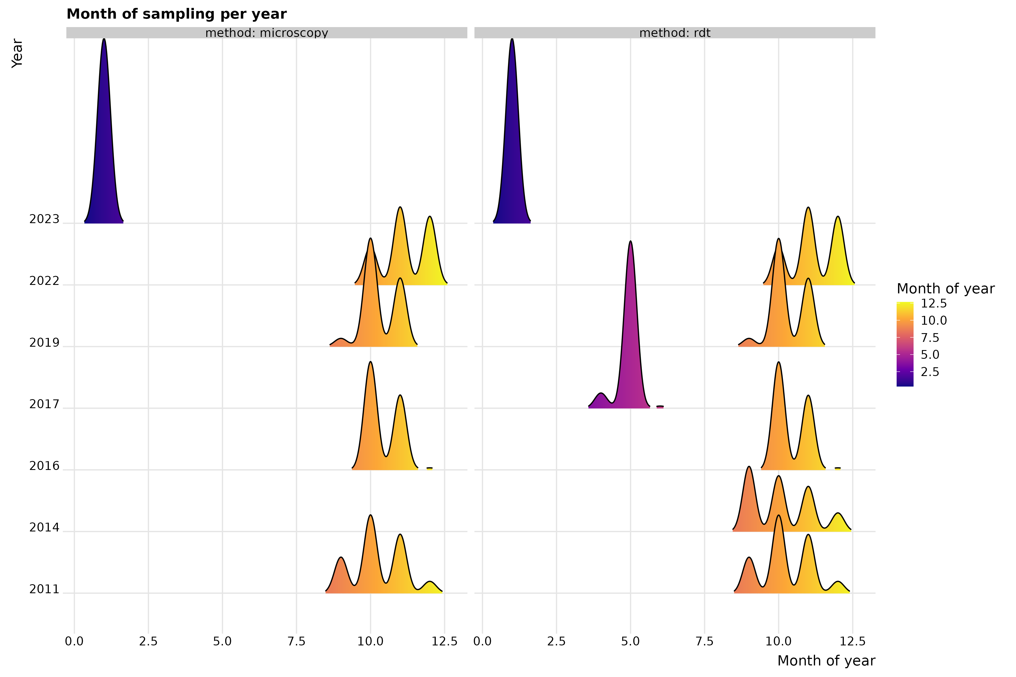
Supplementary Figure 1: Density distribution of Months of sampling per year

Covariates
A total of 31 covariates were considered a priori based on their association with malaria from literature. These covariates were then assessed for multiple collinearity using variable inflation factor (VIF).

Supplementary Table 1: Proposed covariates, spatial resolution and sources
Covariates | Description | Temporality | Variable selection | Source
Travel time to cities (travel_cities) | Distance to cities with population >50,000 | Static | Yes | Nelson²
Elevation (elev) | Elevation as measured by the Shuttle Radar Topography Mission (SRTM) | Static | Yes | SRTM derivative³
Slope | GIS-derived surface calculated from SRTM elevation surface | Static | Yes | MAP (from SRTM³)
Nighttime lights | Index that measures the presence of lights from towns, cities and other sites with persistent lighting | Annual | Yes | NOAA⁴
Urbanization (urban) | Proportion of area considered urban | Static | Yes | MAP (from SRTM⁵)
Population counts (pop) | Estimated population per 1 km × 1 km pixel | Annual | Yes | WorldPop⁶
EVI | Enhanced vegetation index | Monthly | Lag 0, 1, 2 | MODIS derivative⁷
LST_day | Daytime land surface temperature | Monthly | Lag 0, 1, 2 | MODIS derivative⁸
LST_diurdiff | Diurnal difference in land surface temperature | Monthly | Lag 0, 1, 2 | MODIS derivative⁸
LST_night | Night-time land surface temperature | Monthly | Lag 0, 1, 2 | MODIS derivative⁸
TCB | Tasseled cap brightness; measure of land reflectance | Monthly | Lag 0, 1, 2 | MODIS derivative⁹
TCW | Tasseled cap wetness | Monthly | Lag 0, 1, 2 | MODIS derivative⁹
TSI | Temperature suitability index | Monthly | Lag 0, 1, 2 | MAP¹⁰
CHIRPS | Climate Hazards Group Infrared Precipitation with Station Data | Monthly | Lag 0, 1, 2 | CHIRPS¹¹

Exploratory analysis
We examined the full data for data quality issues. Specifically, we looked for outliers, investigated clusters with missing covariate values, and determined the spread of the cluster values around the mean for both diagnostic methods. We omitted clusters with missing covariate values since they were a very small proportion – 0.032% (Supplementary Table 2). We then explored the relationship between each covariate and the outcome variable by visualizing the relationship (Supplementary Figure 2). This was to determine whether the relationship between the outcome and the covariate differed by the diagnostic method. Additionally, we checked for dependency by visualizing the distribution of the of sampled locations on the map of Ghana. This enabled us to determine if there is enough spread of the spatial points across the country for each method and across the years in the data.

Clusters with missing covariates
We assessed the data for missingness and observed a total of 125 cluster locations with missing covariate values. We excluded these locations since we considered their effect to be negligible.

Supplementary Table 2: Number of clusters with missing covariates overall
 | Year | Total number of clusters | Number of clusters with missing covariates | Proportion of missing covariates
1 | 2011 | 1452 | 8 | 0.00551
2 | 2014 | 419 | 0 | 0
3 | 2016 | 384 | 18 | 0.0469
4 | 2017 | 90 | 5 | 0.0556
5 | 2019 | 384 | 22 | 0.0573
6 | 2022 | 1070 | 66 | 0.0617
7 | 2023 | 160 | 6 | 0.0375
 | Total |  | 125 | 0.032

Exploring relationships
Each covariate was plotted against the outcome (malaria prevalence) for both diagnostic methods to visual the relationship. We noted a non-linear relationship between the outcome and all the covariates
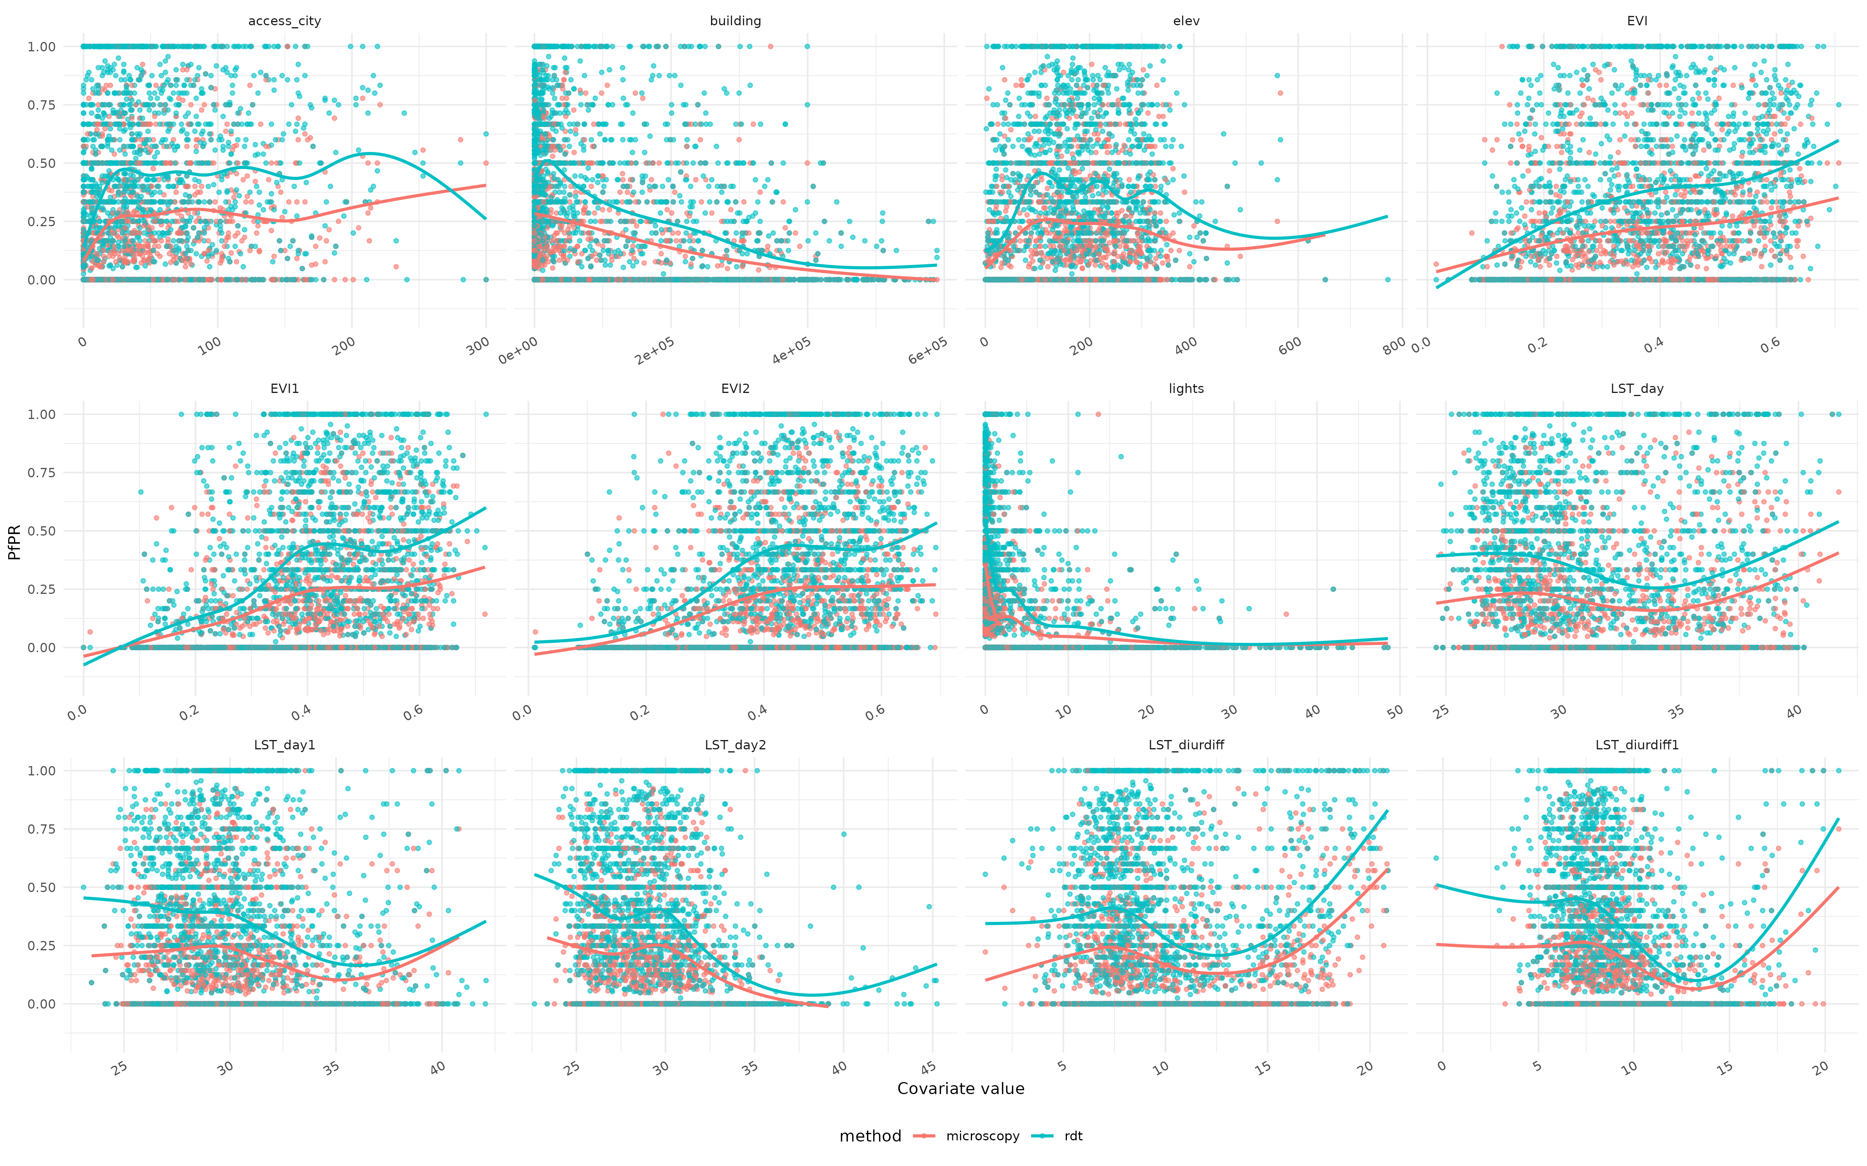
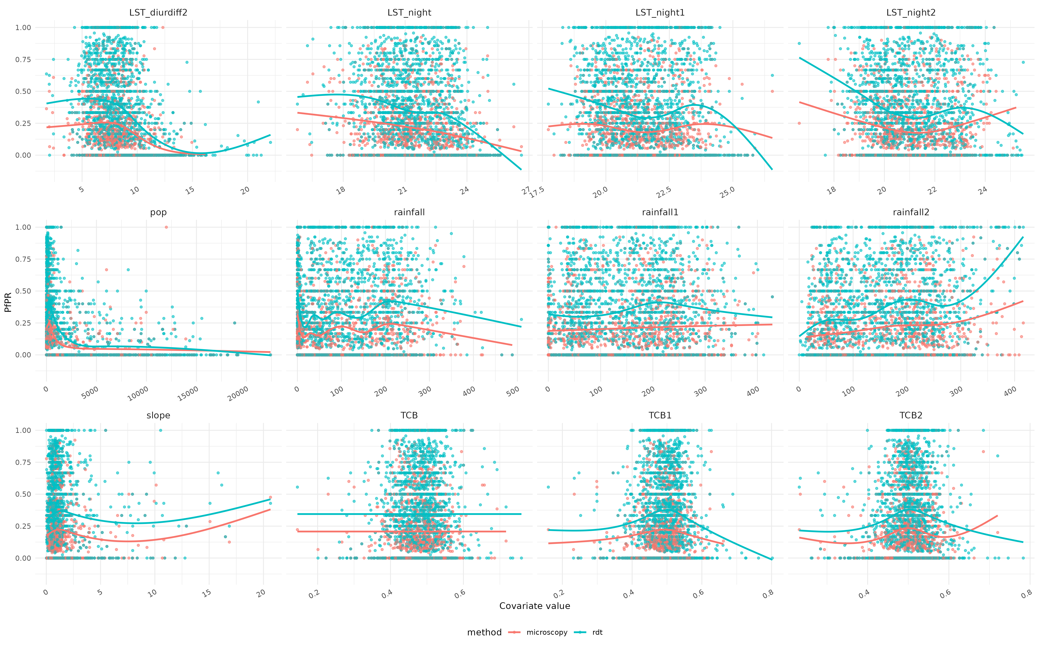
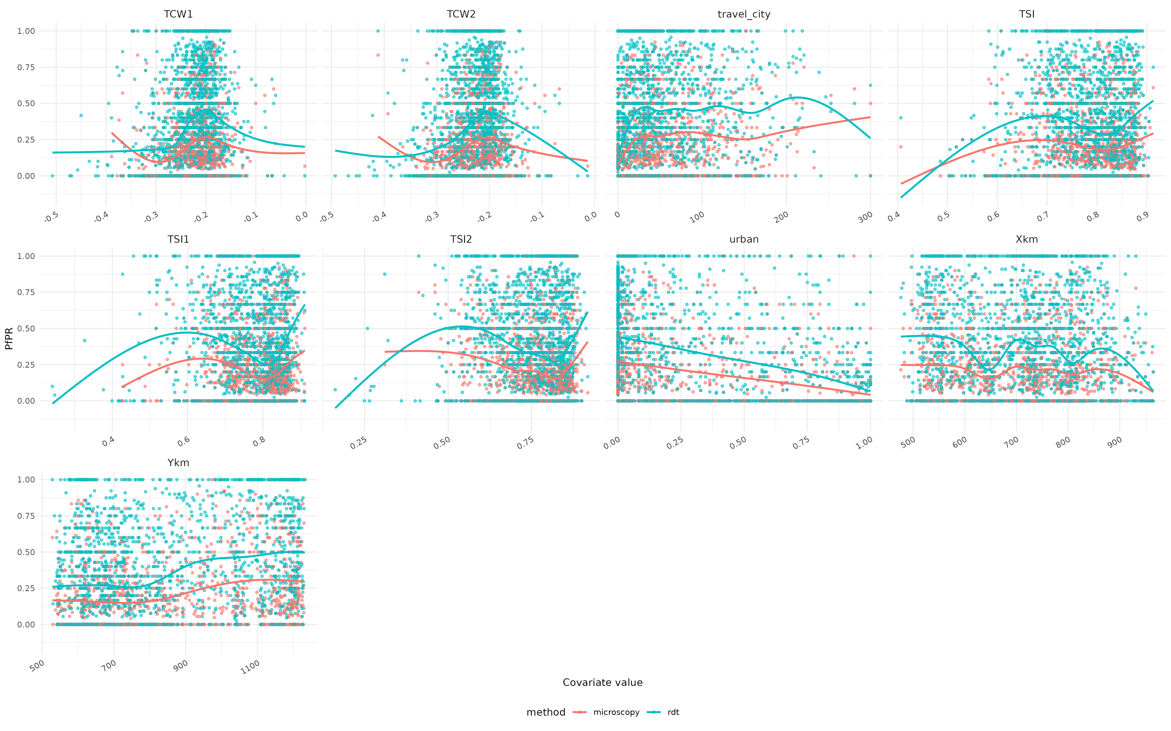
Supplementary Figure 2: Plot of relationship between outcome variable and covariates by diagnostic methods

Relationship between covariates
We then assess for multicollinearity between each pair of covariates via VIF. This allowed us to exclude variables which are highly colinear with each other. We maintained variables with VIF values of <5 (Supplementary table 2).

Supplementary table 3: Covariates maintained after assessment of multicollinearity using Variance Inflation Factor (VIF)
Covariate | Variance inflation factor
elev | 1.469733
slope | 1.134708
TSI | 2.721338
TSI1 | 3.51626
TSI2 | 3.884517
rainfall | 2.410272
rainfall1 | 2.014172
rainfall2 | 2.075695
TCB | 3.127385
TCB2 | 2.848071
LST_day | 4.583659
LST_night | 3.190086
LST_night2 | 3.129059
LST_diurdiff1 | 4.230487
LST_diurdiff2 | 3.51475
pop | 2.991745
lights | 3.607773
travel_city | 1.462925
urban | 2.809566

We also assessed correlation between each pair of covariates to select between 2 candidate variables. Pairs of variables are correlated if the correlation coefficient is 0.7 or more (Supplementary figure 3).
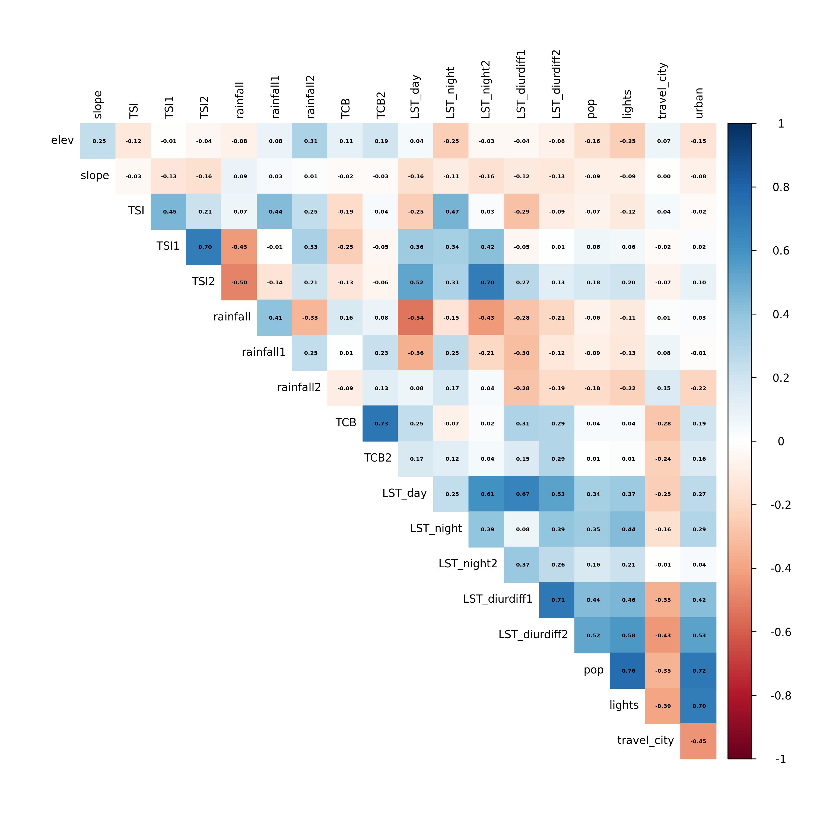
Supplementary Figure 3: Correlation matrix of relationship between each pair of covariates

Model selection
We first fitted four non-spatial models with covariates to determine which temporal structure best fit the data. Using the WAIC value, a model with year as first-order autoregressive effect was found to best fit the data (Supplementary Table 4).

Supplementary Table 4: Results of non-spatial model to select the best temporal structure
Model | WAIC
Model with only month | 16757
model with month and year as iid | 13468
Model with month and year as random walk order 1 (rw1) | 13468
Model with month and year as first-order autoregressive (ar1) | 13467

Recognizing that the same location may have measurements for both diagnostic methods, we investigated a number of candidate models that capture dependency. These models included using method as random effect to account for the differences in diagnostic methods, method-specific intercept with shared covariates and spatial field, method-specific spatial field and temporal term etc. In total, 11 candidate models were explored to justify each term that will be included in the final model. Supplementary table 5 provides details of components for each model.

Supplementary Table 5: Candidate models considered and their unique components
No | Component | Models
 | Component | B1 | B2 | B3 | B4 | B5 | B6 | B7 | B8 | B9 | B10 | B11
1 | Overall intercept | √ | √ | √ | √ | √ | √
2 | Method specific intercept |  |  |  |  |  |  | √ | √ | √ | √ | √
3 | Covariates |  | √ | √ | √ | √ | √ | √ | √ | √ | √ | √
4 | Static spatial field | √ | √ | √ | √
5 | Autoregressive  spatial field - shared |  |  |  |  | √ | √ |  |  | √
6 | Autoregressive spatial field – method specific |  |  |  |  |  |  | √ |  |  | √
7 | Autoregressive spatial field with method-specific priors |  |  |  |  |  |  |  | √ |  |  | √
8 | Month term |  |  |  | √ |  | √
9 | Shared temporal process |  |  | √ | √ | √ | √ |  |  |  | √ | √
10 | Method specific temporal process |  |  |  |  |  |  | √ | √ | √

Model structure
The number of positives at each georeferenced cluster $j$ was assumed to be a binomial random variable: $Y_{j} \sim Binomial (n_{j}, p_{j})$; where $Y_{j}$ is the number of malaria-positive children, $n_{j}$ is the total number examined (tested), and $p_{j}$ is the predicted malaria prevalence at location $j$.
A logistic regression model that linked the predicted prevalence to the covariates, a spatial random effect and temporal trend is expressed as:
$${logit (p}_{j})= β_{0}+\sum_{z=1}^{z}{β_{n}, X_{n,j}+ξ_{j}+ γ_{j}}$$
Where, $β_{0}$ is the intercept, $β_{n}$ are the coefficients of covariates $X_{n}$ , $ξ_{j}$ is a spatially structured random effect and $γ_{j}$ is a temporal term modelled using a Gaussian Markov Random Field (GMRF) with a Matérn covariance function. The spatial random effect captures residual spatial variation not explained by the covariates. The Matérn covariance function is defined by two hyperparameters: range (ρ), the distance beyond which spatial correlation becomes negligible, and standard deviation (σ), the marginal variance of the spatial process. Within a spatio-temporal framework the equation was modified as
$${p\left(s,t\right)}_{j}={logit}^{-1}{(η(s,t)}_{j}$$
where $s$ represent space, $t$ represents time and $η$ is the linear predictor.

Results

Covariate effects
Six out of 10 covariates were found to be associated with malaria prevalence for both diagnostic methods

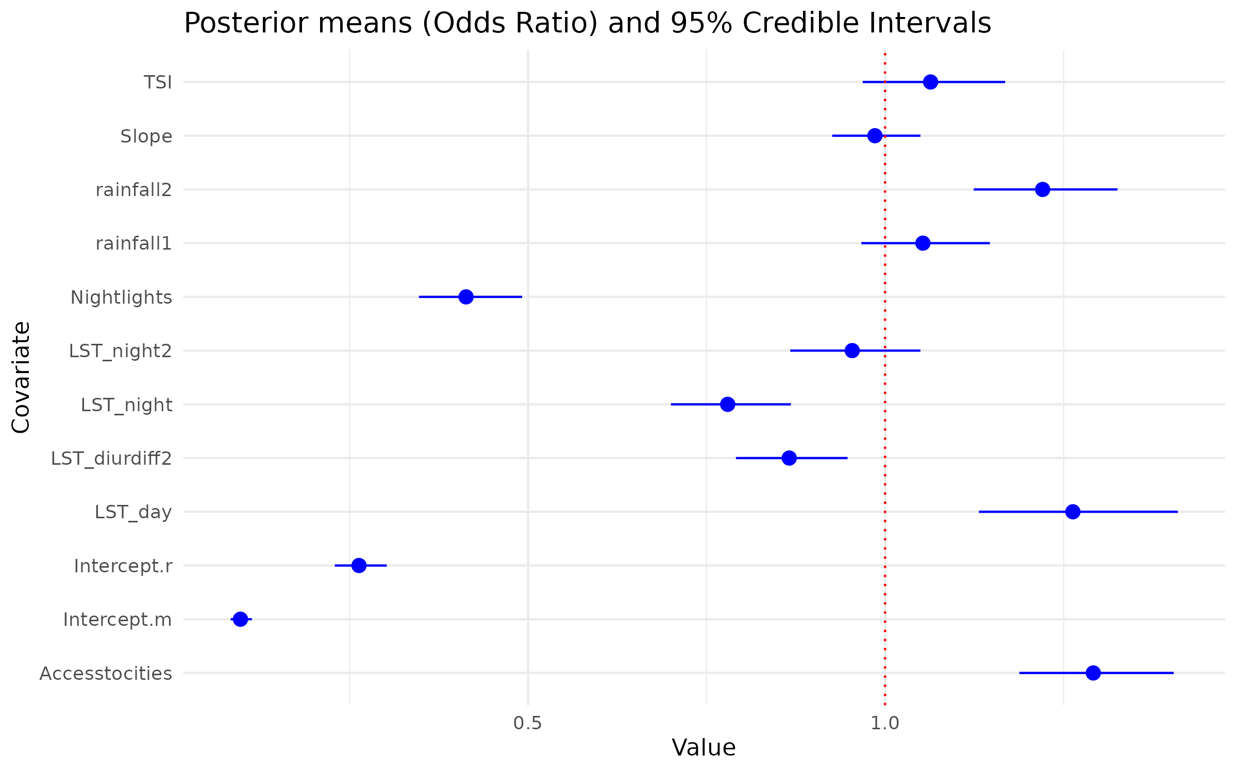
Figure 4: Posterior means (Odds ratio) of model covariates and corresponding 95% credible intervals. Red vertical line indicates reference value for considering a covariate important. Covariates with credible interval bands touching/crossing the red line are considered not important to malaria prevalence in the model.

Model selection
Out of the 11 candidate models considered, model 9 was preferred due to its lower DIC/WAIC values (Table 2). This model included method-specific intercept, shared covariates, shared autoregressive spatial-temporal field, and method-specific temporal terms, producing the optimal balance between model complexity and overfitting.

Supplementary Table 6: Results of model selection process showing DIC and WAICs of candidate models considered
 | Models | DIC | WAIC
1 | B1 | 12042.1 | 12864.5
2 | B2 | 10861.2 | 11356.8
3 | B3 | 10288.4 | 10672.1
4 | B4 | 10288.8 | 10672.7
5 | B5 | 9920.7 | 9905.0
6 | B6 | 9921.3 | 9905.6
7 | B7 | 10628.4 | 10744.6
8 | B8 | 10634.6 | 10759.4
9 | B9 | 9852.1 | 9815.4
10 | B10 | 10637.3 | 10759.1
11 | B11 | 10642.5 | 10772.2
Key: DIC - Deviance Information Criterion; WAIC – Watanabe-Akaike Information Criterion

Spatial and temporal random effects
The risk of malaria was higher in 2011 for both diagnostic methods than the rest of the years (Supplementary table 6). The odds of malaria prevalence (risk) was 2.89 times in 2011 for microscopy and 3.95 times for RDT in the same year. There was reduced risk for all methods in 2022 and 2023.

Supplementary Table 7: Relative malaria risk for each year by diagnostic method
Year | Microscopy | RDT
2011 | 2.89 (2.42–3.46) | 3.95 (3.33–4.70)
2014 | NA | 1.98 (1.66–2.36)
2016 | 1.54 (1.24–1.90) | 1.09 (0.89–1.33)
2017 | NA | 0.99 (0.73–1.36)
2019 | 1.03 (0.83–1.27) | 0.84 (0.69–1.03)
2022 | 0.46 (0.38–0.56) | 0.46 (0.39–0.55)
2023 | 0.47 (0.32–0.69) | 0.30 (0.21–0.44)

The partial effect of the year for the two methods is shown Supplementary Figure 5. Both methods show a declining trend from 2011 to 2023. However, there seems to be an increasing trend from 2022 for microscopy compared with RDT

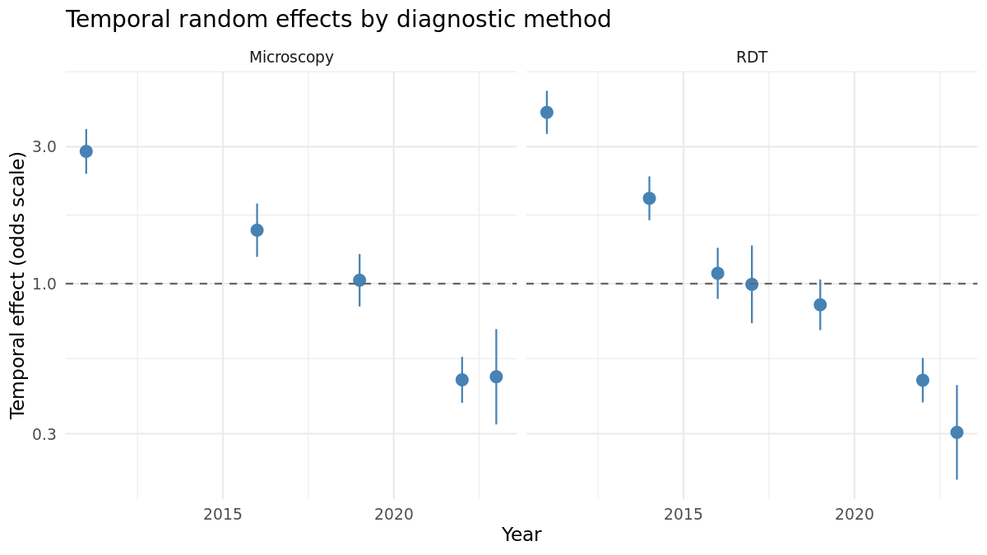
Supplementary Figure 5: Year-on-year effect of malaria prevalence by diagnostic method with 95% credible intervals (blue lines). Grey horizontal line indicate reference where no change was observed between years.

The spatial range within which malaria prevalence is correlated was found to be approximately 20km in Ghana (Supplementary Figure 6).
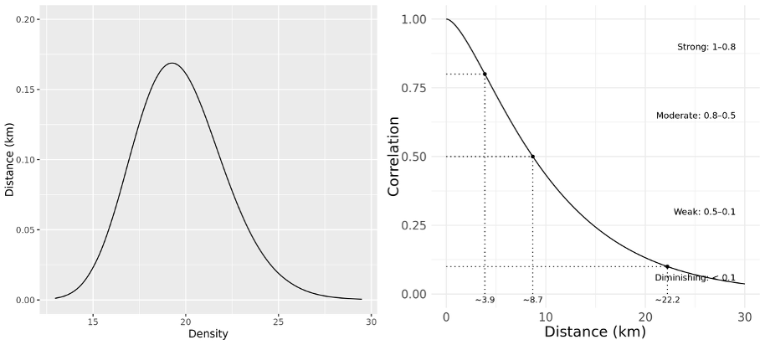
Supplementary Figure 6: Spatial range and Matern correlation densities

After accounting for covariate and temporal effect, we noticed an underlying risk pattern across the country (Supplementary figure 7). Between 2011 and 2016, the risk was higher in Northwest and Northeastern parts of the country and relatively lower in the southern part of the country. From 2017, this pattern had shifted with some parts of the middle and coastal areas of the country showing elevated risk compared to the northern part of the country.
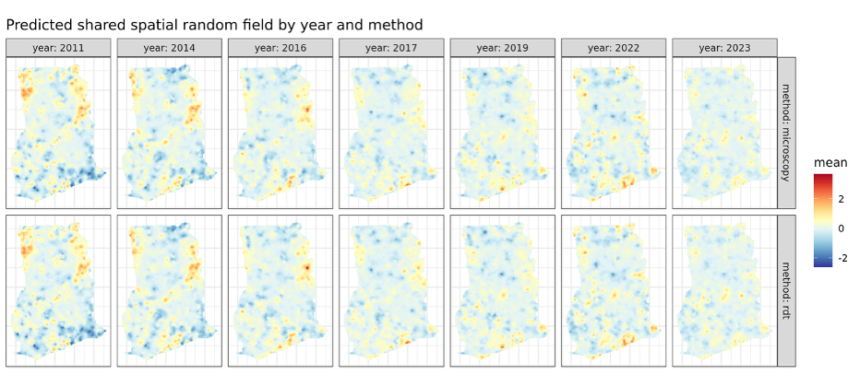
Supplementary Figure 7: Spatial patterns of underlying malaria risk by method for each year
We observed higher spatial variability in RDT-derived prevalence estimates compared with microscopy (Supplementary figure 8). The semi-variogram plot revealed positive spatial autocorrelation for both methods which plateaued at ~50-60 km. This suggests that spatial patterns for malaria prevalence in Ghana are not correlated beyond this distance.

A semi-variogram plot that shows spatial decay for both diagnostic methods is shown in Supplementary Figure 8. Both diagnostic methods assume independence at 50 km with microscopy decaying faster than RDT.
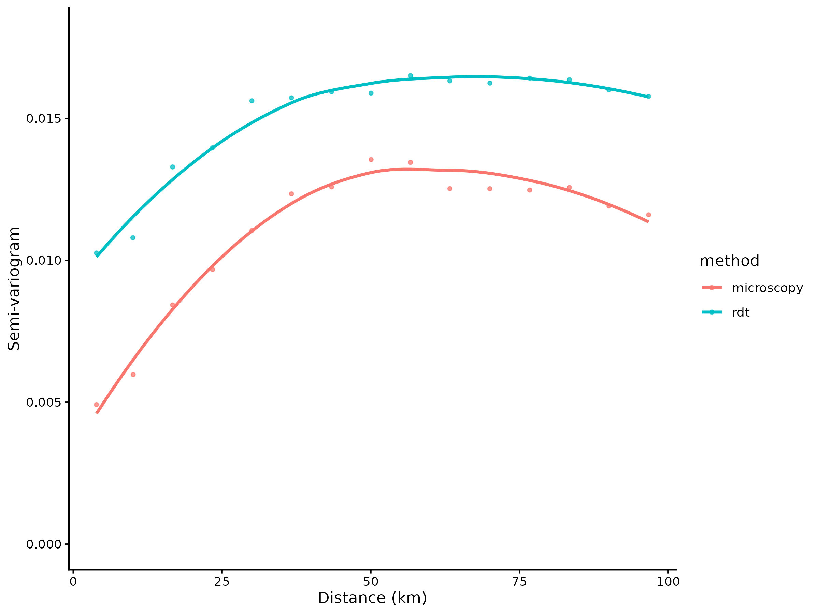
Supplementary Figure 8: Empirical semi-variogram and fitted model for microscopy and RDT prevalence showing distance where spatial locations become independent

Model validation

In sample model validation
Comparing the observed mean prevalence for the survey months to the predicted prevalence for the same months, we noted a perfect fit with an correlation coefficient (R) value of 1 (Supplementary figure 9)

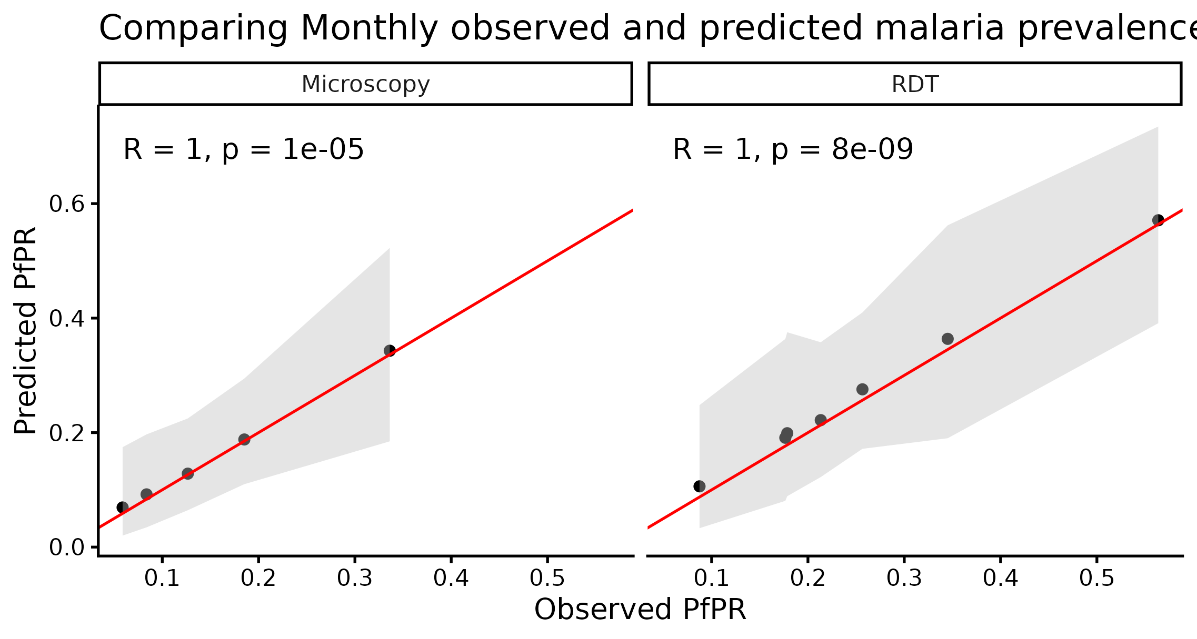
Supplementary Figure 9: In sample correlation plot between observed and predicted malaria prevalence by diagnostic method

Out of sample model validation
Results of the three cross-validation methods implemented are shown in Supplementary table 8.
Supplementary Table 8: Summary table of results from cross validation methods
No | CV strategy | Number of folds | Mean RMSE | SD RMSE | Mean MAE | Mean Cor | Mean Bias | Mean 95% Covarage
Microscopy
1 | Spatial blocking | 10 | 0.208 | 0.0360 | 0.158 | 0.539 | 0.00597 | 0.516
2 | LOTBO | 5 | 0.173 | 0.0752 | 0.128 | 0.402 | -0.0191 | 0.414
3 | ST-CV | 47 | 0.168 | 0.0674 | 0.133 | 0.426 | 0.00358 | 0.524
RDT
4 | Spatial blocking | 10 | 0.247 | 0.0264 | 0.201 | 0.642 | 0.0162 | 0.592
5 | LOTBO | 7 | 0.220 | 0.0606 | 0.172 | 0.482 | -0.00776 | 0.480
6 | ST-CV | 67 | 0.214 | 0.0652 | 0.177 | 0.444 | 0.00880 | 0.598
Key: LOTBO: Leave-one-temporal-block-out; ST-CV: Spatio-temporal cross-validation
Supplementary Figure 10 shows the outputs for each of the cross validation strategies implemented during model validation.
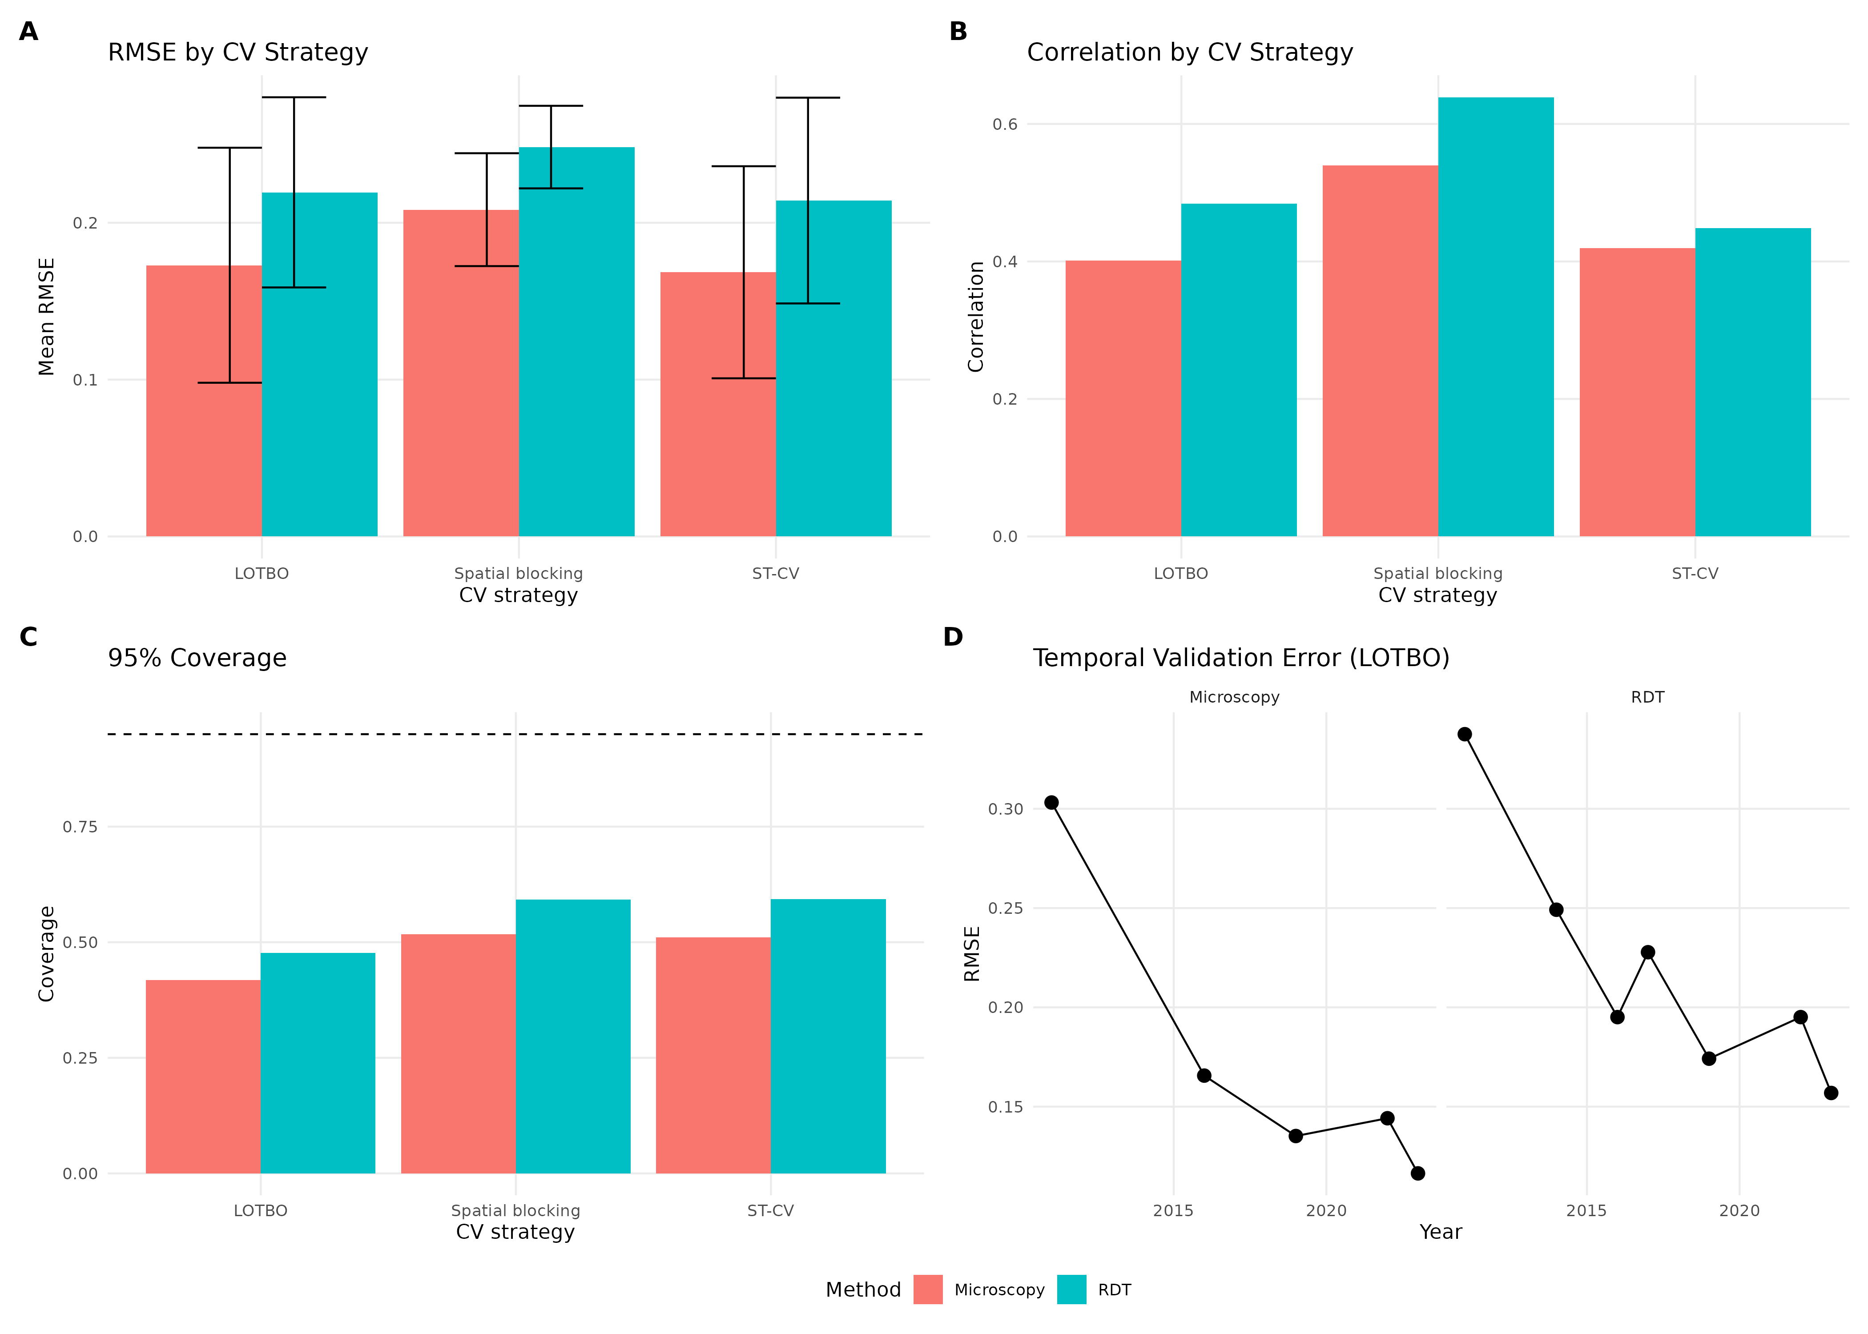
Supplementary Figure 10: Cross-validation plots for spatial, temporal and spatio-temporal strategies.

Predicted malaria prevalence
Predicted malaria prevalence for both diagnostic methods are shown in Supplementary Table 9.

Supplementary Table 9: Predicted microscopy and RDT prevalence by year with 95% credible intervals
Year | Microscopy |  |  | RDT
 | Predicted PfPR | Lower CrI | Upper CrI | Predicted PfPR | Lower CrI | Upper CrI
2011 | 0.231 | 0.078 | 0.442 | 0.427 | 0.207 | 0.633
2012 | 0.204 | 0.075 | 0.384 | 0.379 | 0.189 | 0.570
2013 | 0.182 | 0.061 | 0.359 | 0.333 | 0.150 | 0.530
2014 | 0.177 | 0.048 | 0.382 | 0.307 | 0.111 | 0.535
2015 | 0.151 | 0.046 | 0.322 | 0.253 | 0.095 | 0.460
2016 | 0.139 | 0.032 | 0.338 | 0.211 | 0.057 | 0.445
2017 | 0.134 | 0.025 | 0.352 | 0.210 | 0.047 | 0.475
2018 | 0.113 | 0.028 | 0.275 | 0.190 | 0.055 | 0.398
2019 | 0.103 | 0.021 | 0.276 | 0.179 | 0.044 | 0.404
2020 | 0.077 | 0.019 | 0.198 | 0.147 | 0.042 | 0.325
2021 | 0.063 | 0.015 | 0.164 | 0.129 | 0.037 | 0.289
2022 | 0.054 | 0.011 | 0.158 | 0.118 | 0.028 | 0.291
2023 | 0.051 | 0.007 | 0.172 | 0.080 | 0.012 | 0.244
2024 | 0.046 | 0.006 | 0.157 | 0.072 | 0.010 | 0.223
2025 | 0.044 | 0.006 | 0.151 | 0.069 | 0.010 | 0.217

Prediction maps with 95% Credible interval

Here we show the predicted malaria prevalence maps for microscopy and RDT from 2011 to 2025.

Microscopy Predicted Prevalence maps

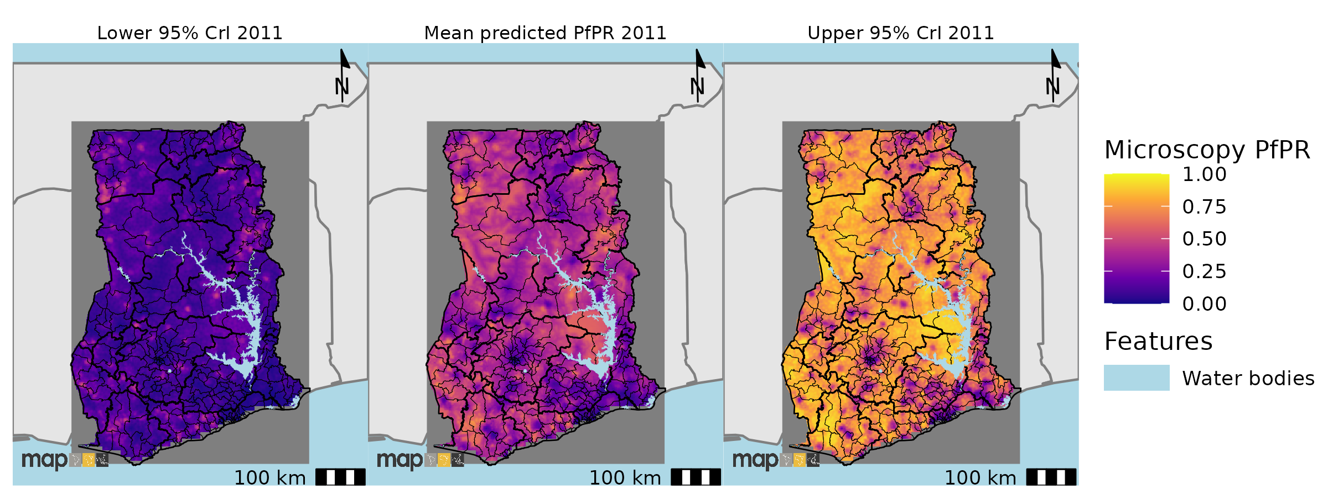
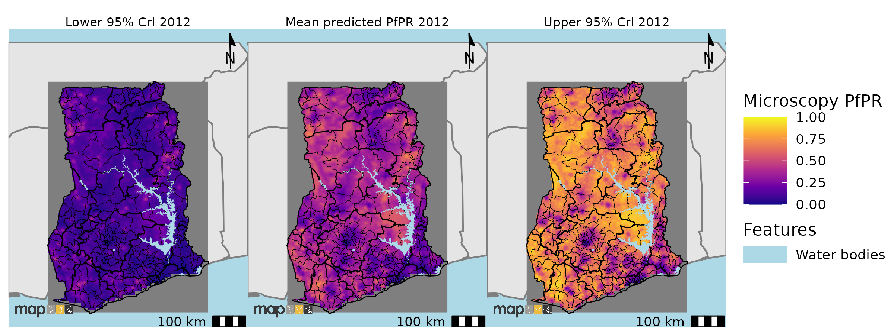
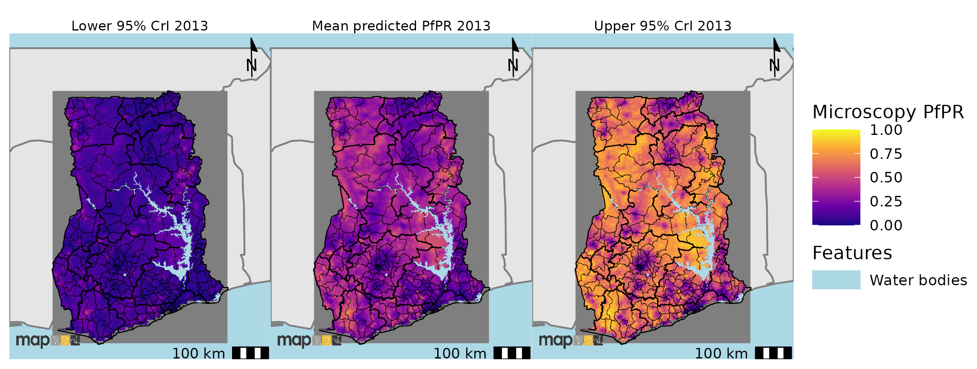
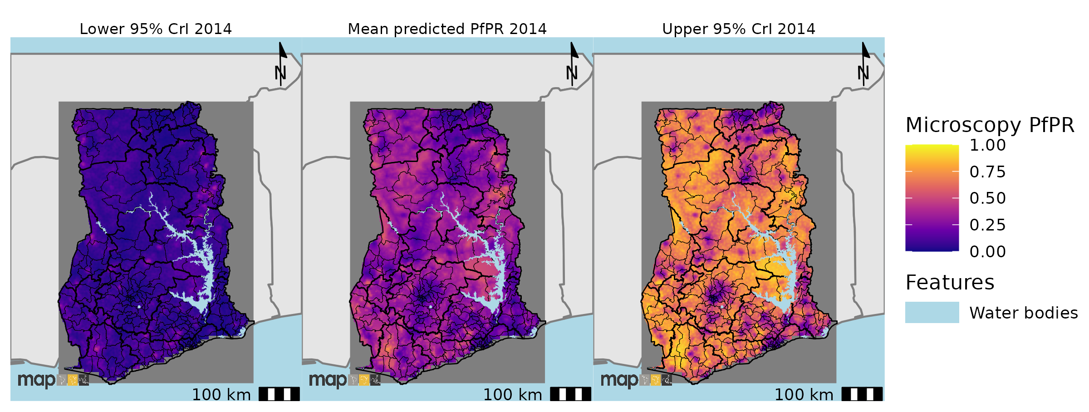
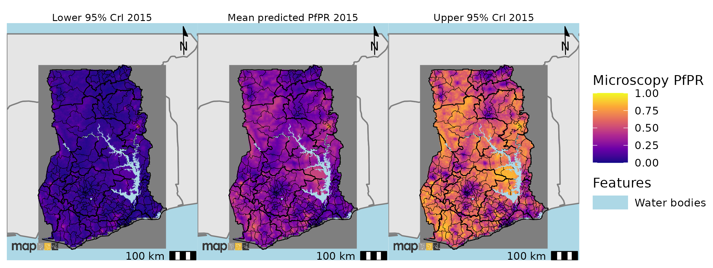
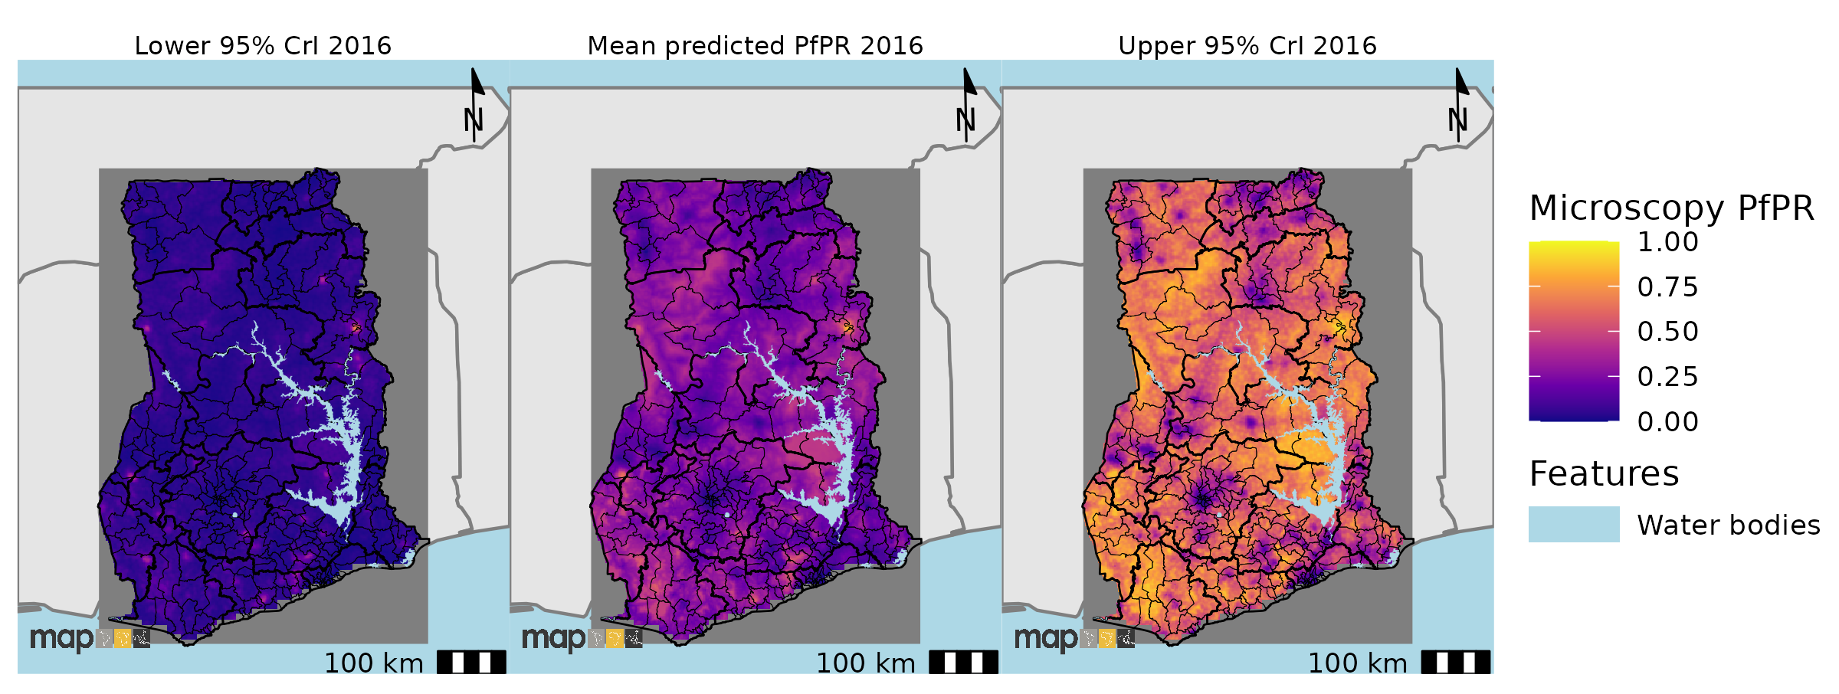
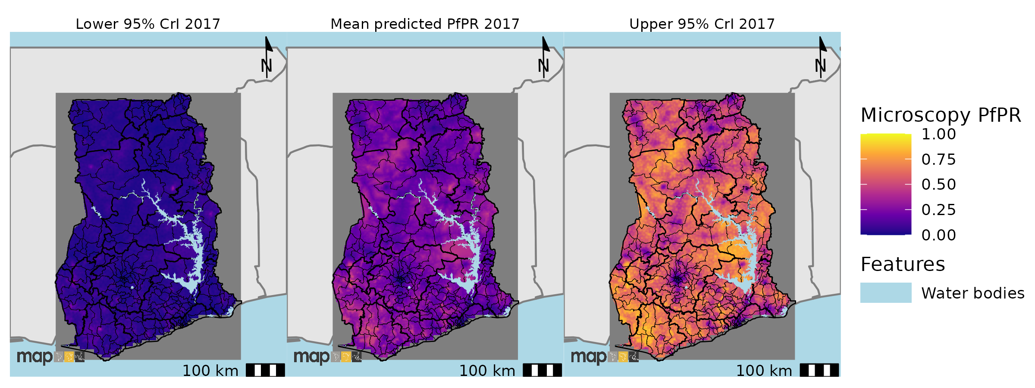
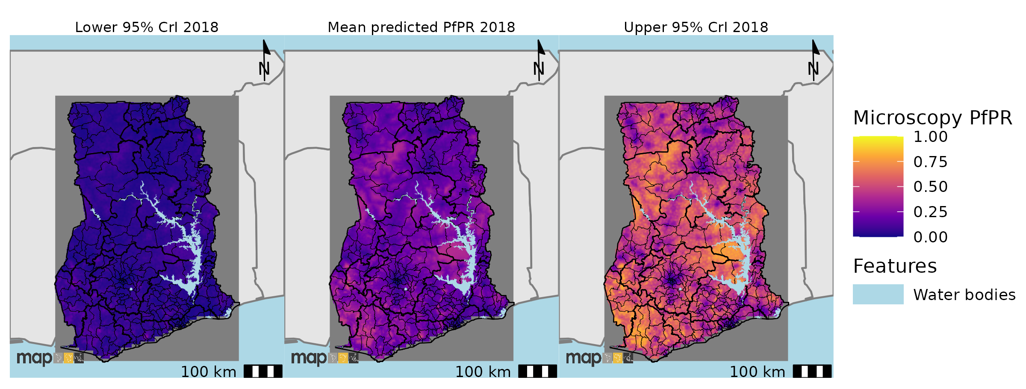
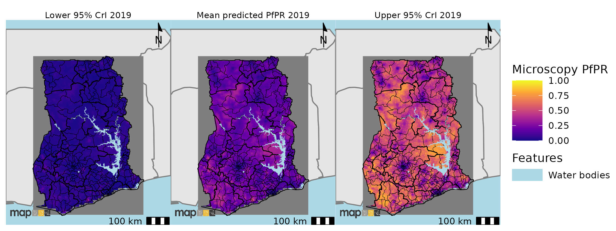
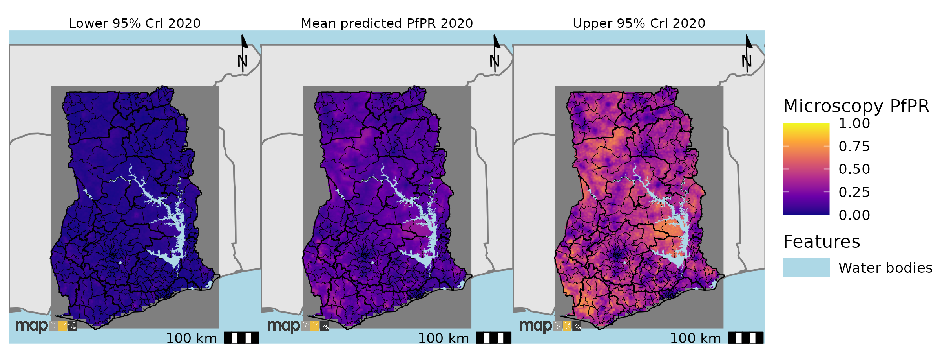
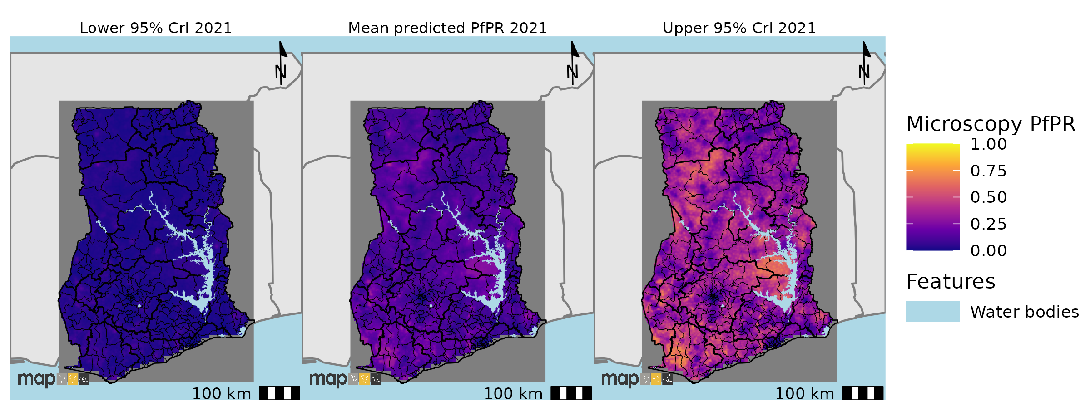
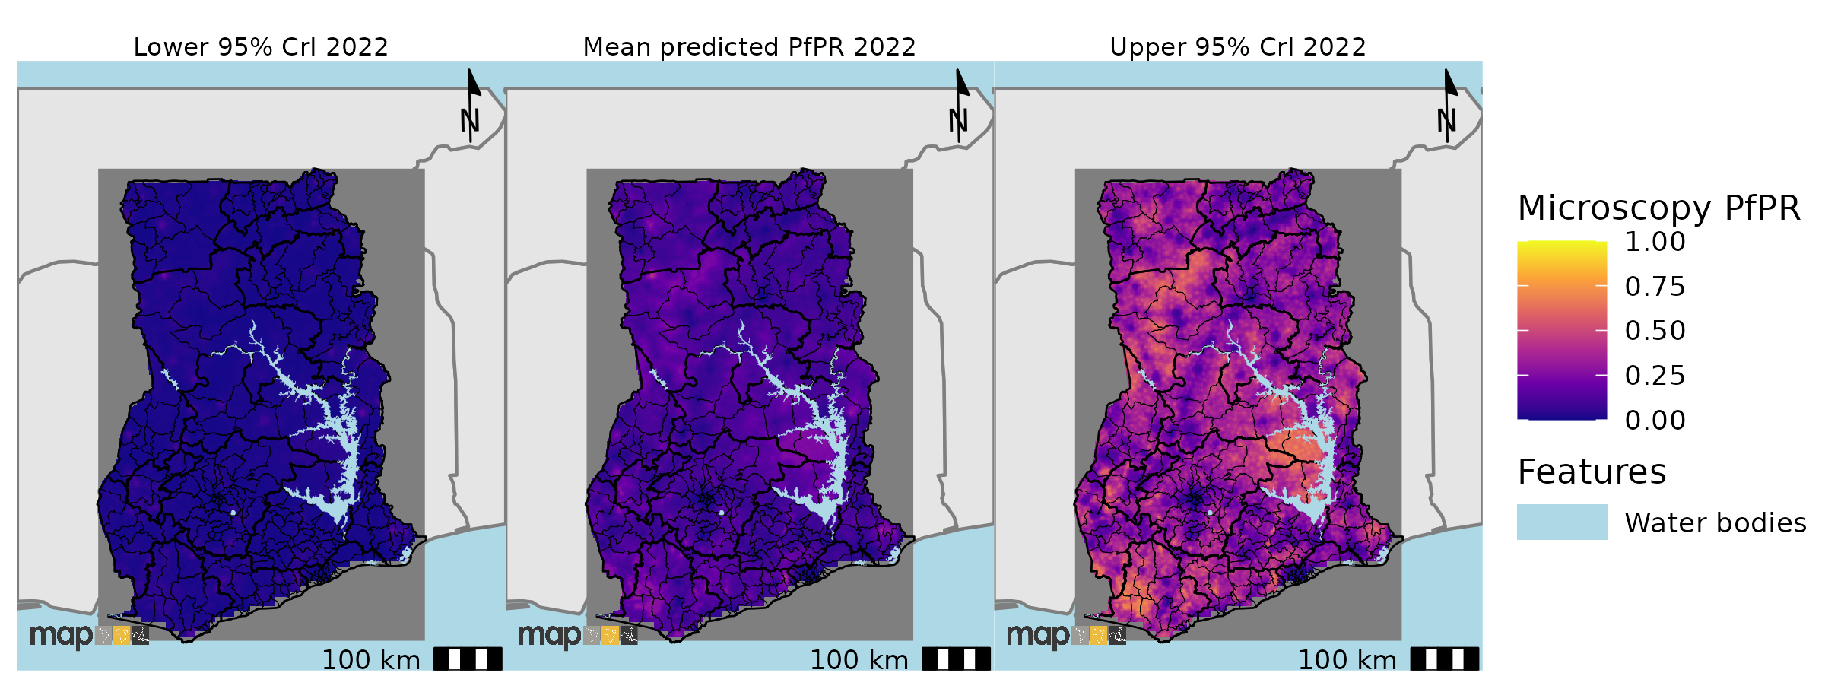
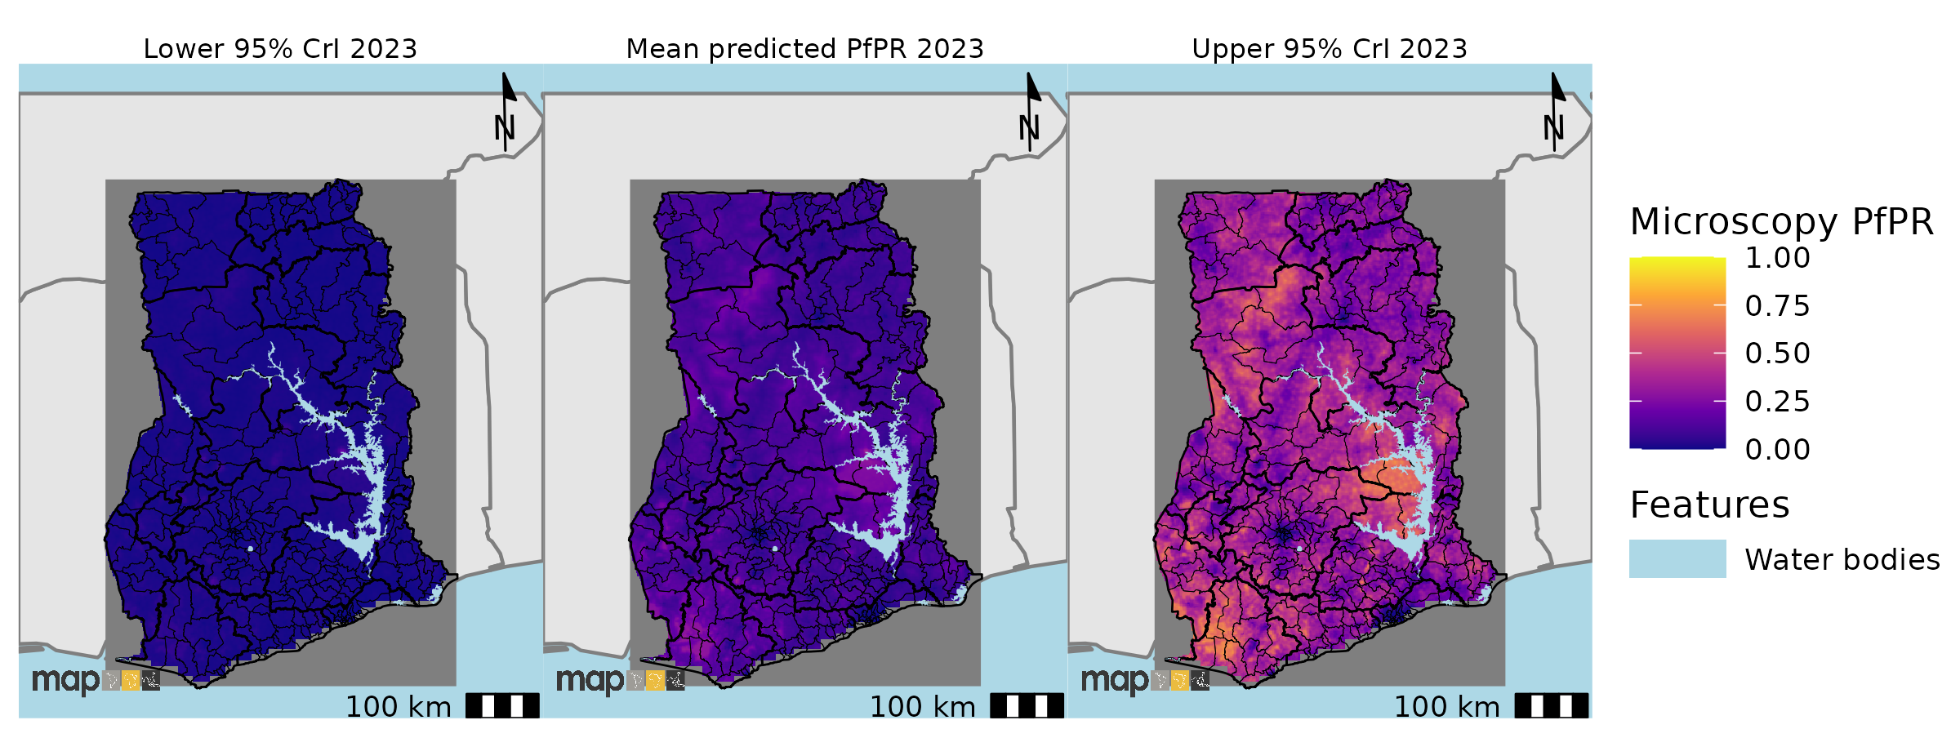
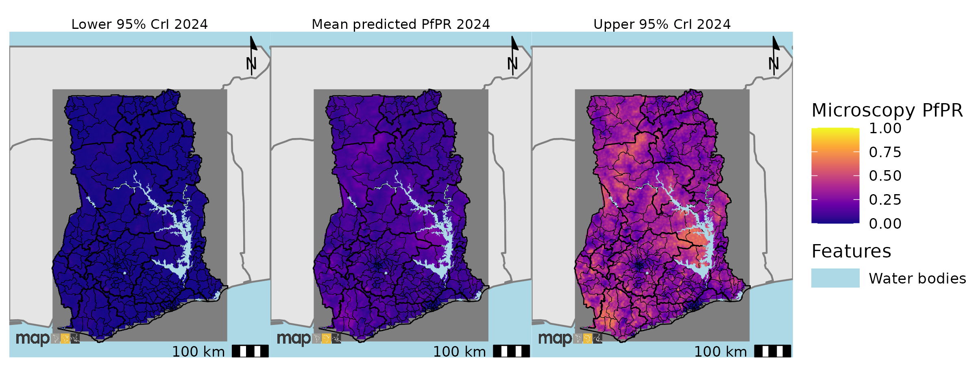
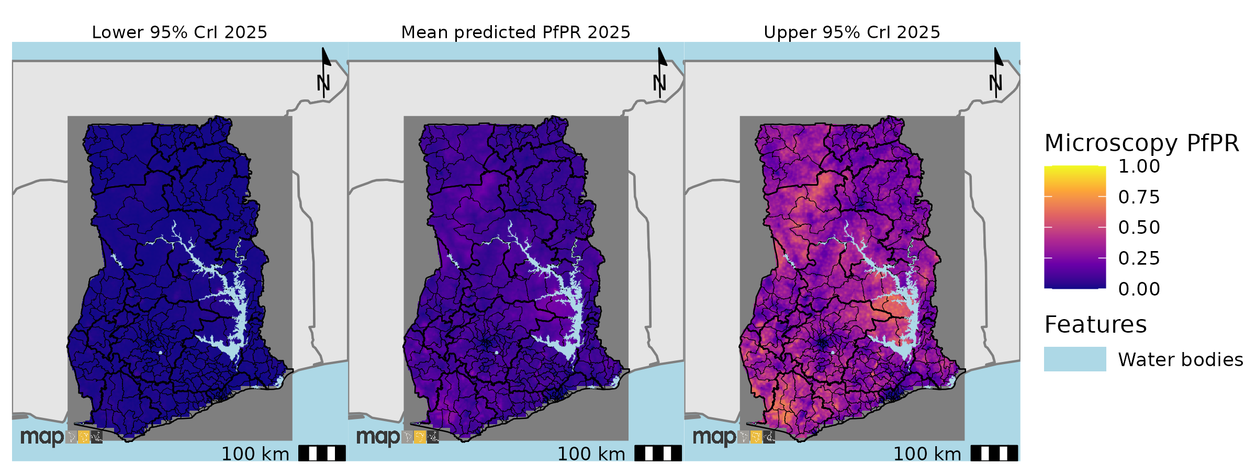
Supplementary figure 11: Prediction maps of P. falciparum malaria by microscopy for Ghana from 2011 to 2025. There was general decline in malaria prevalence across the years. Few areas in the Western and Eastern region (close to the Volta lake) showed relatively high prevalence in 2025.

RDT predicted prevalence maps

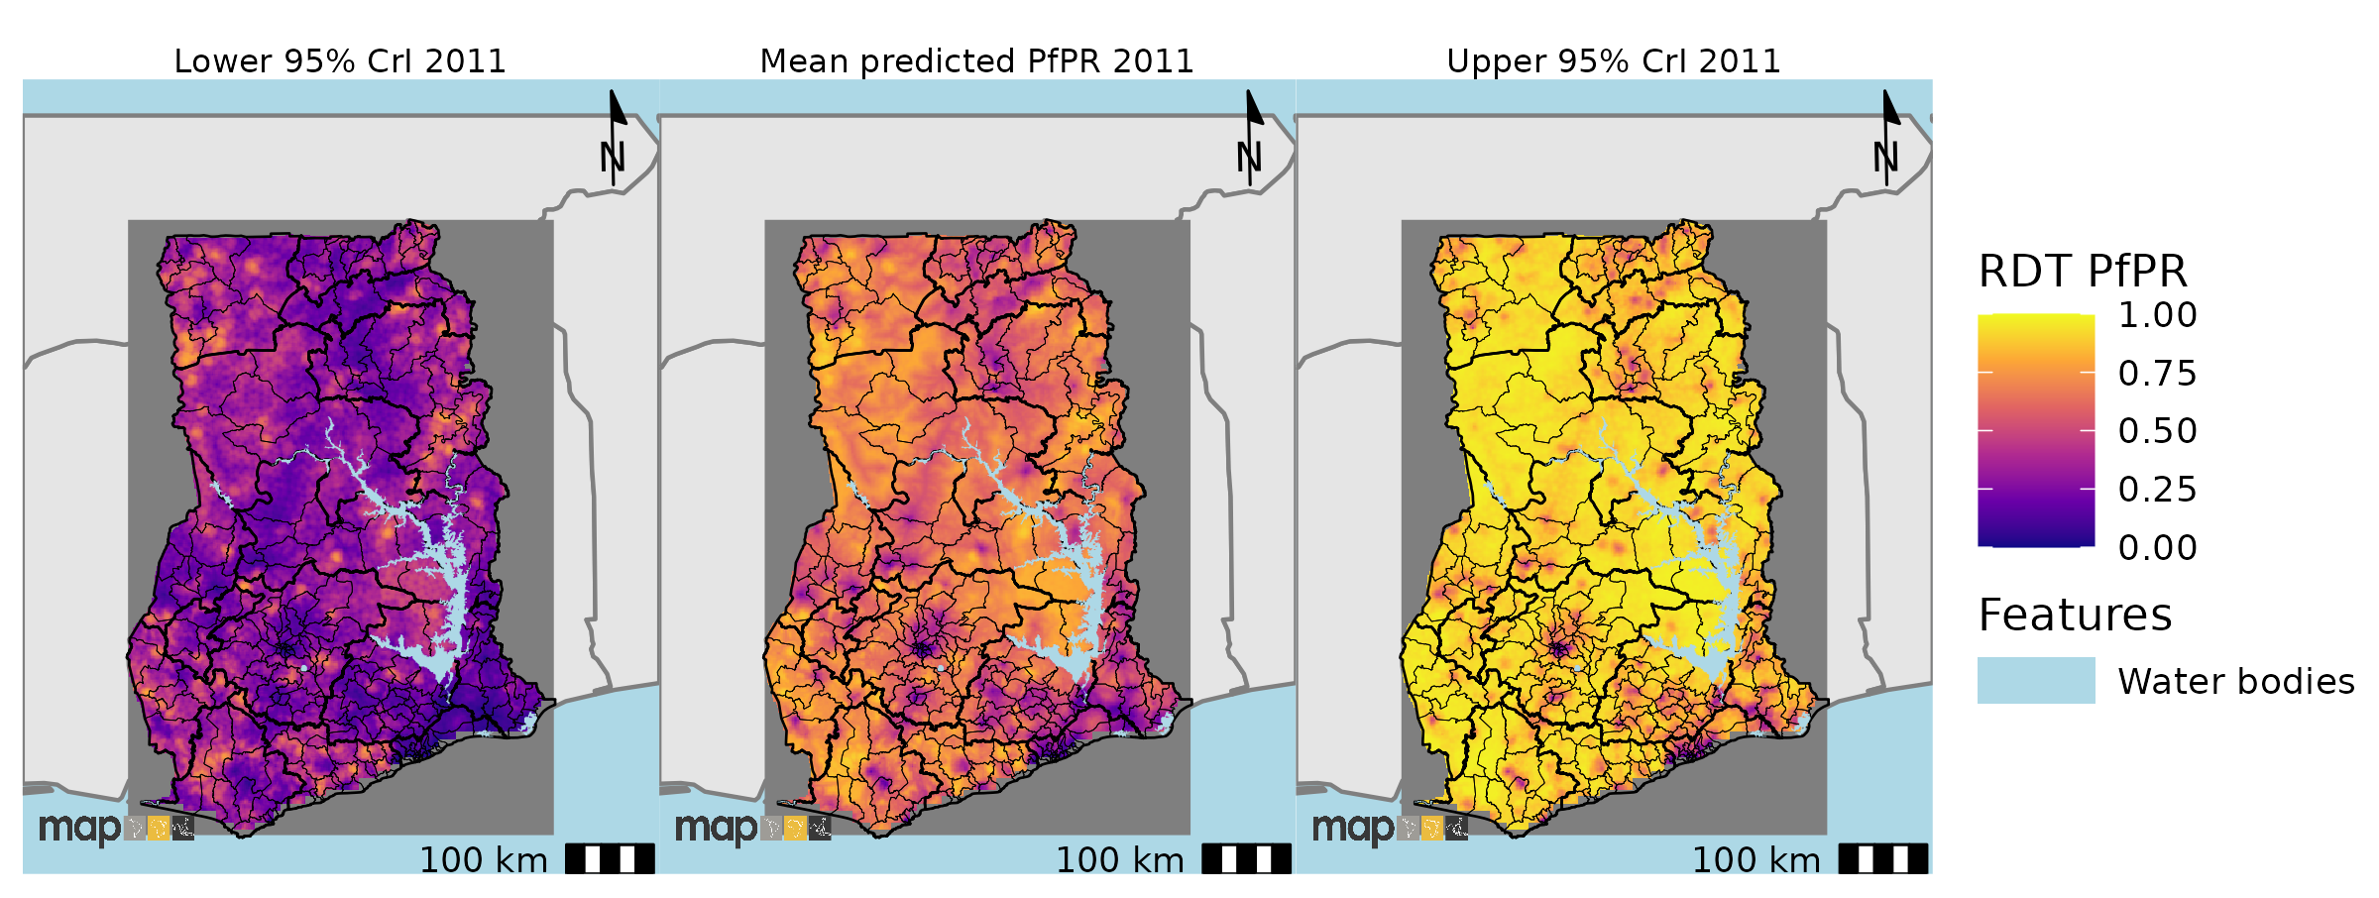
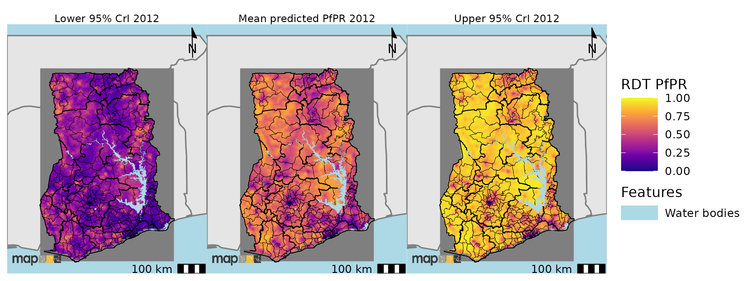
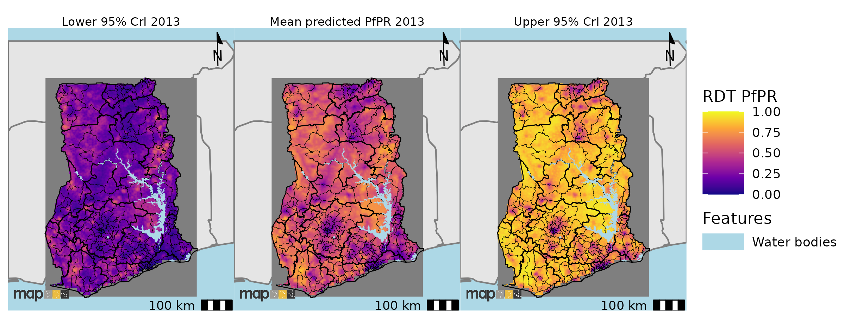
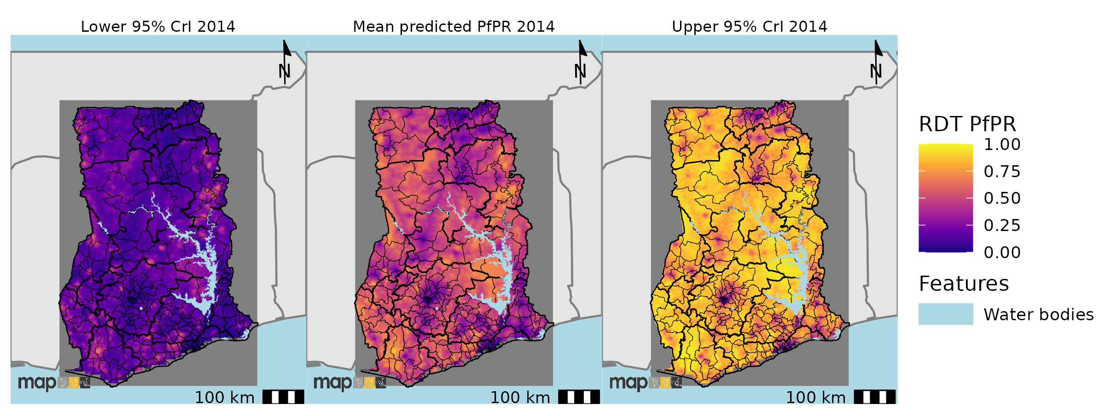
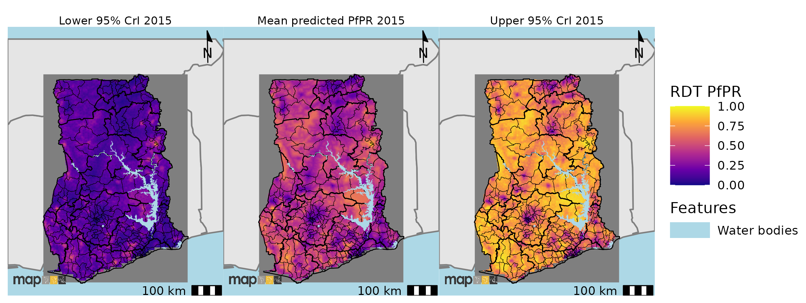
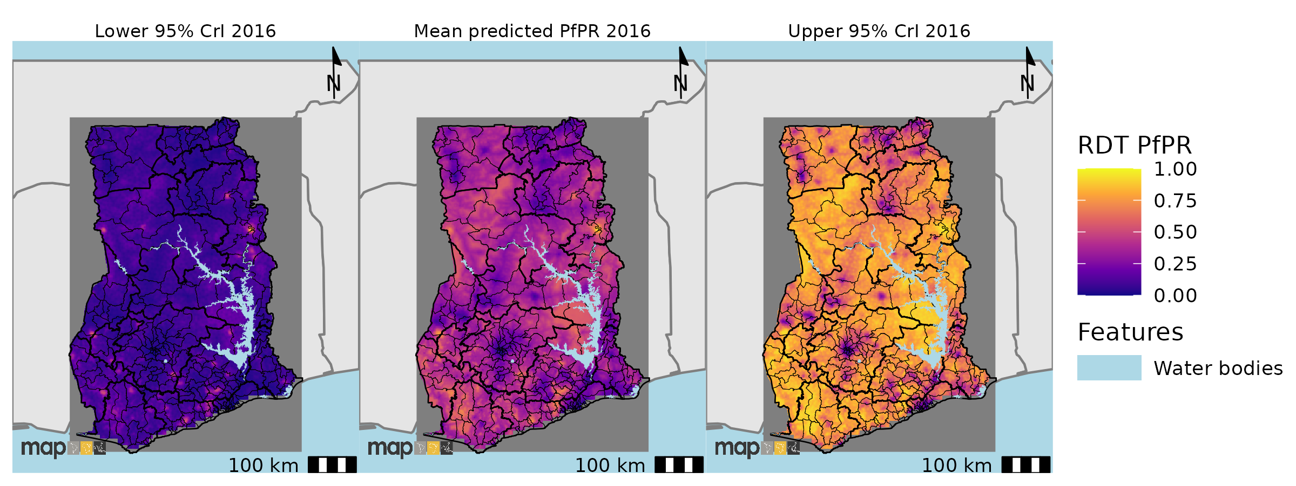
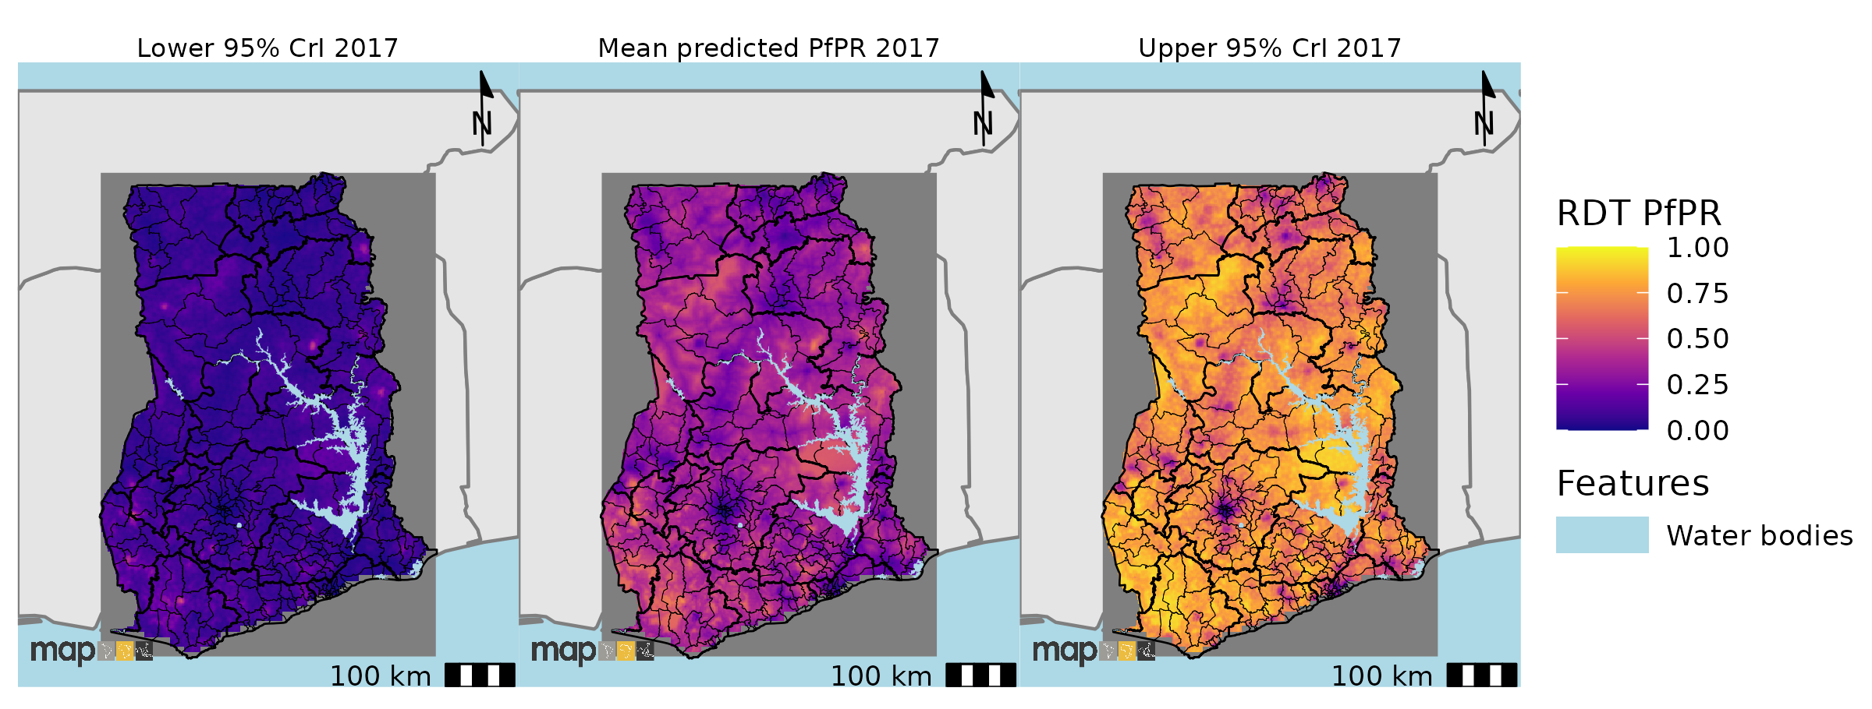
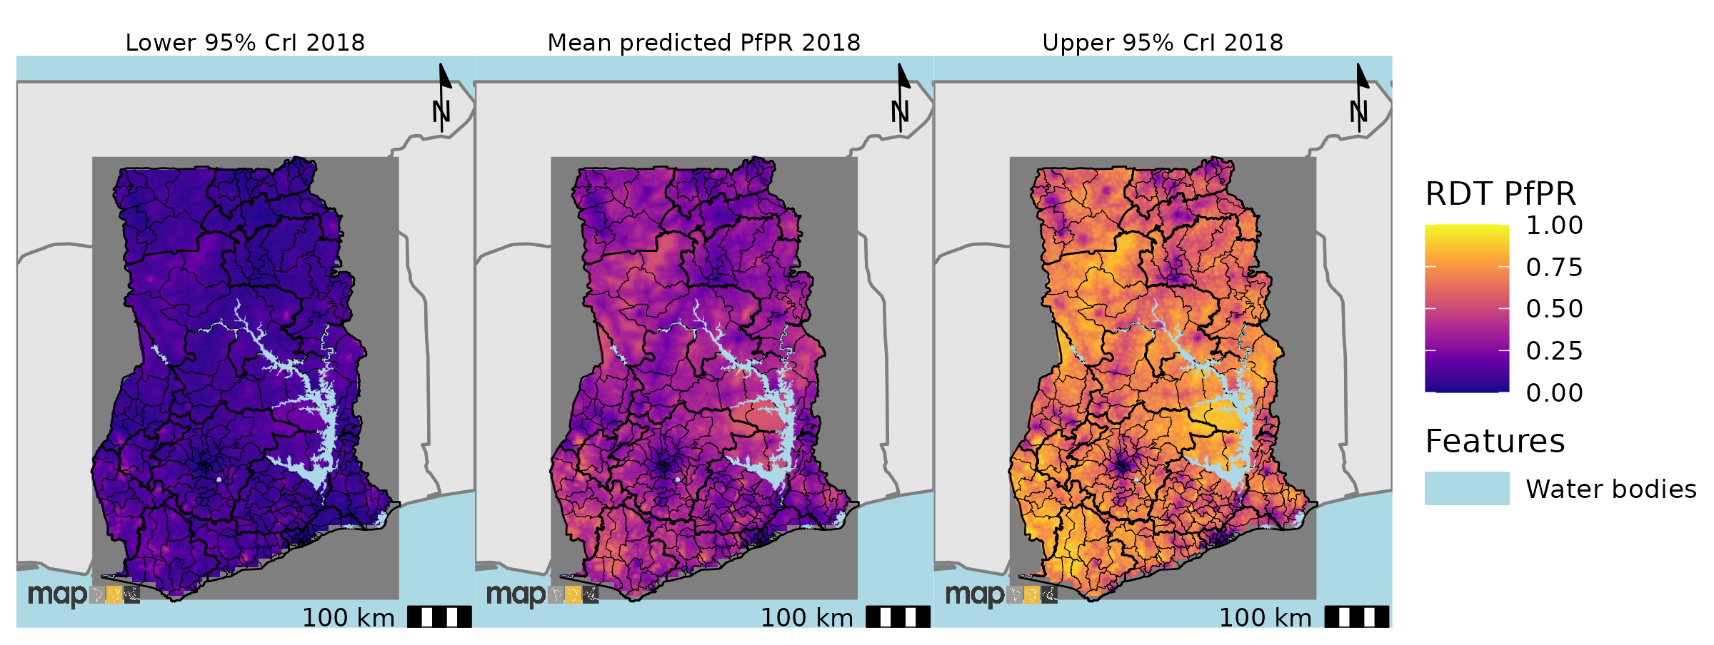
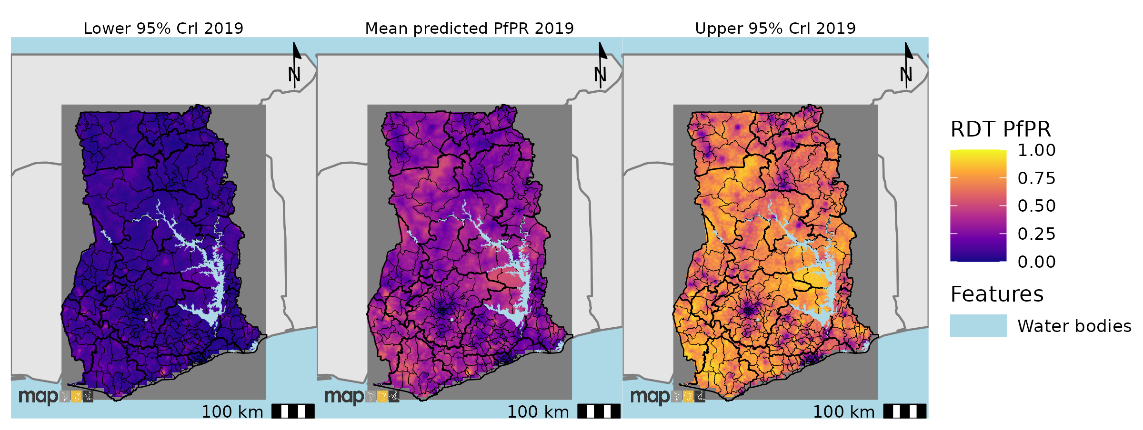
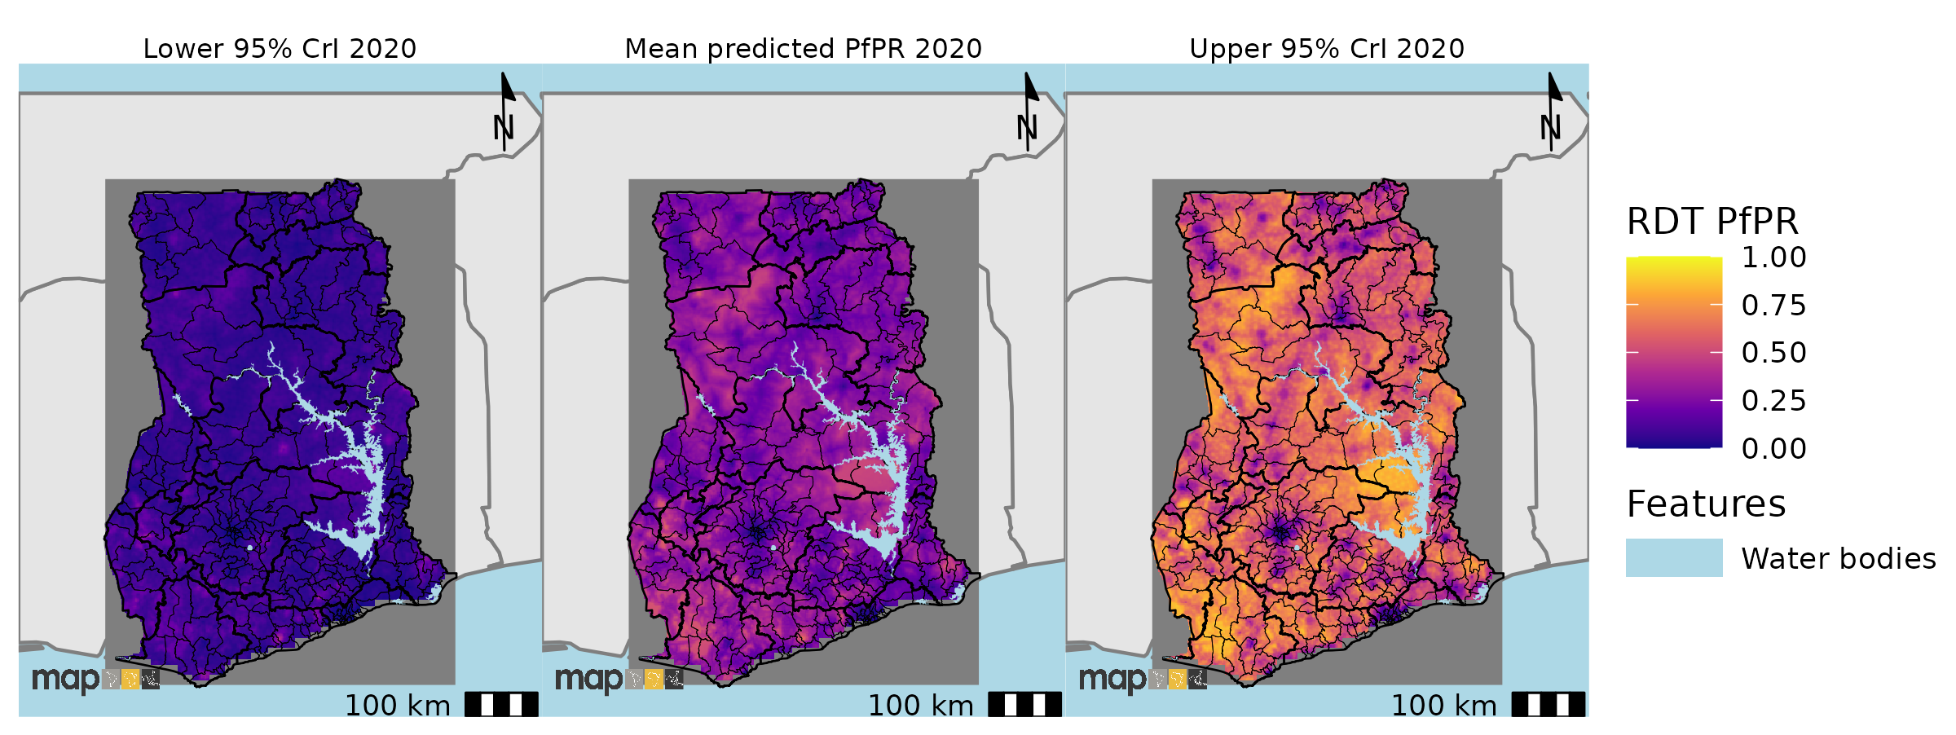
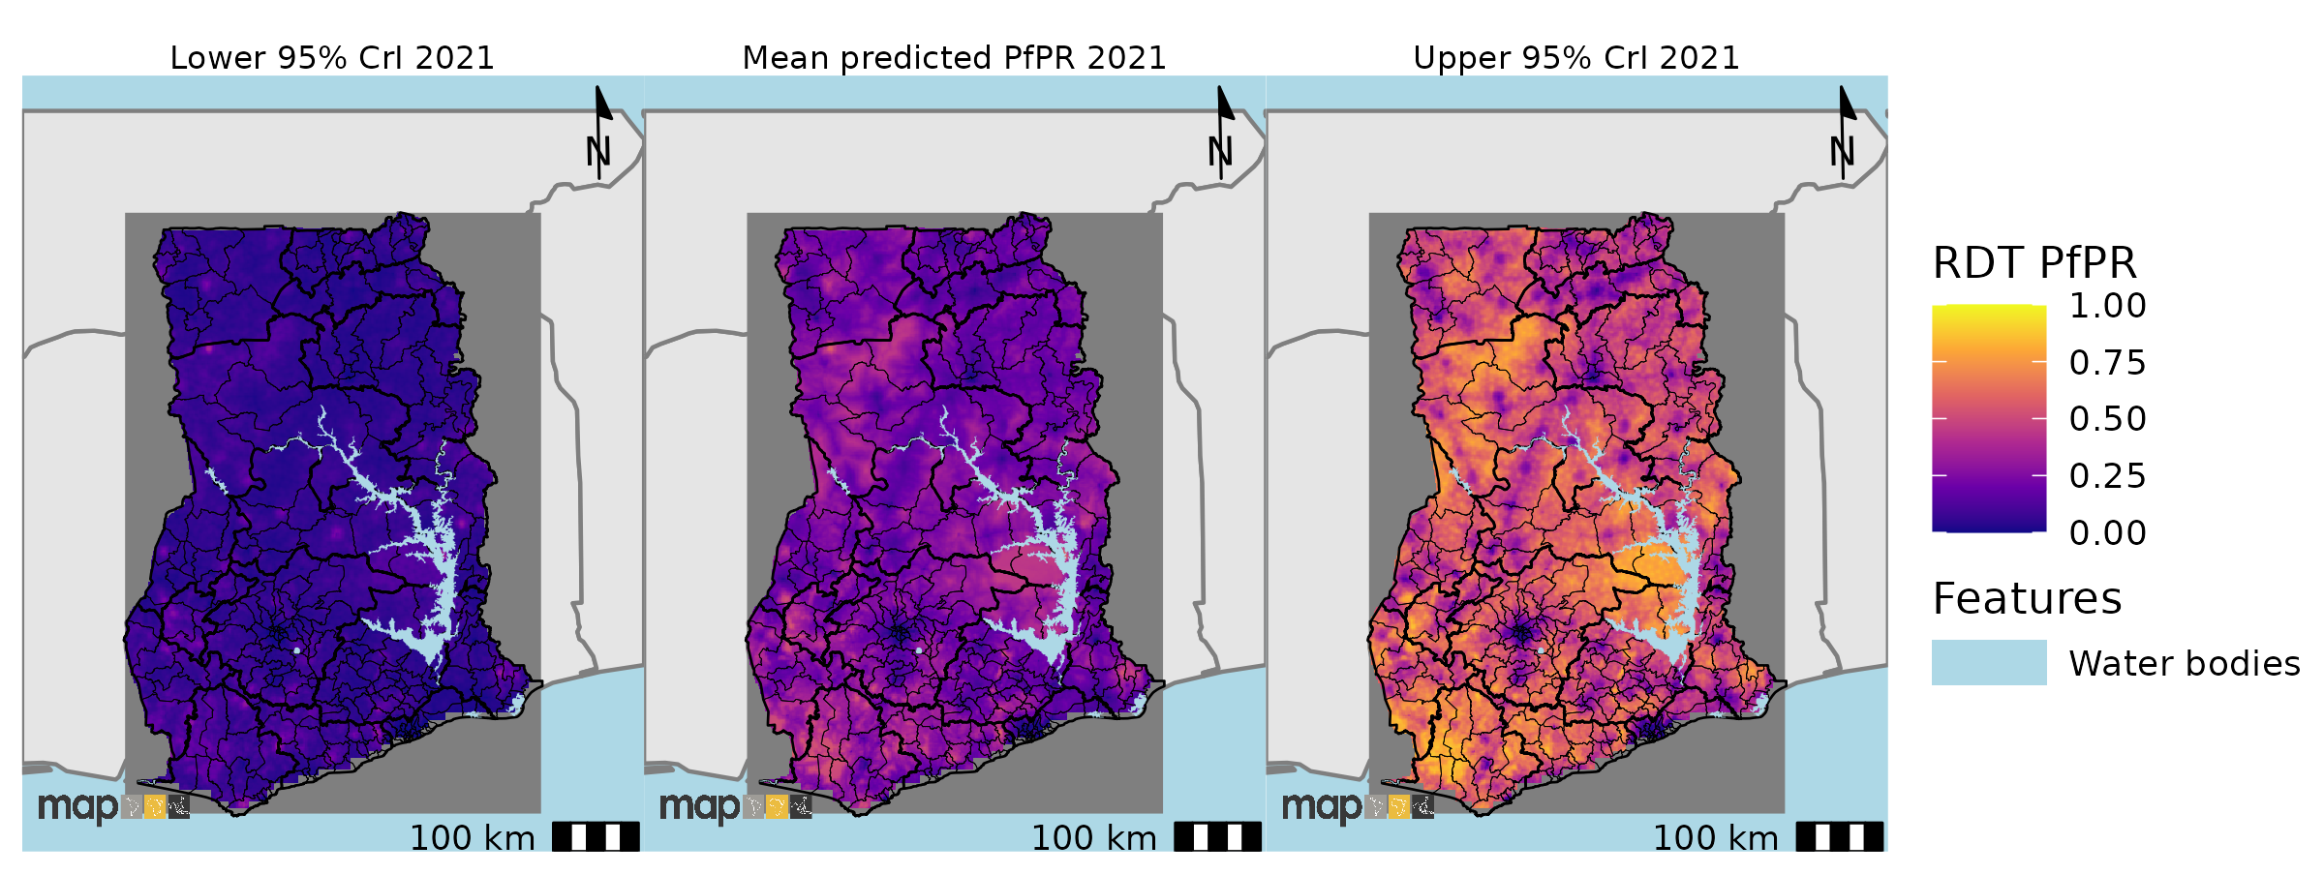
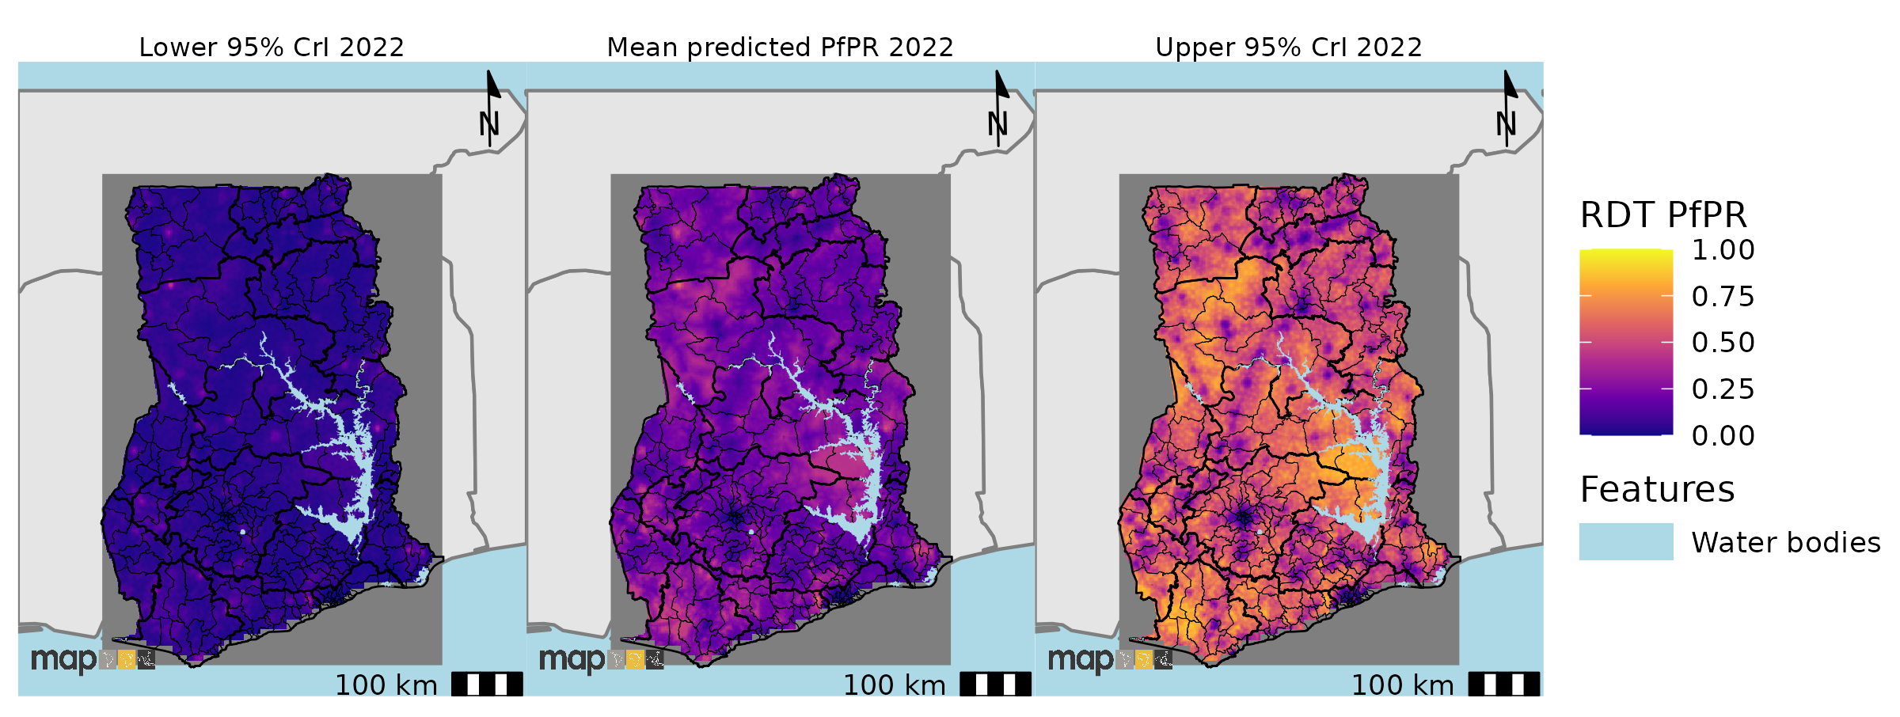
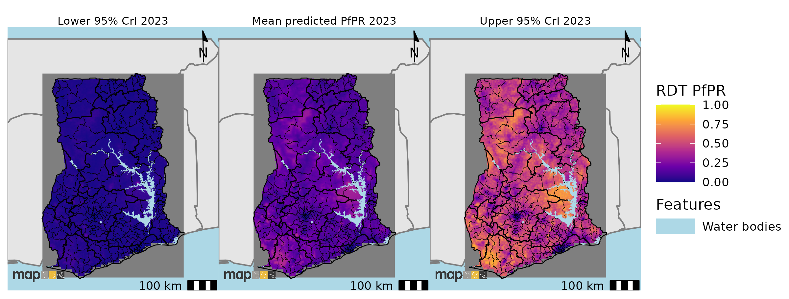
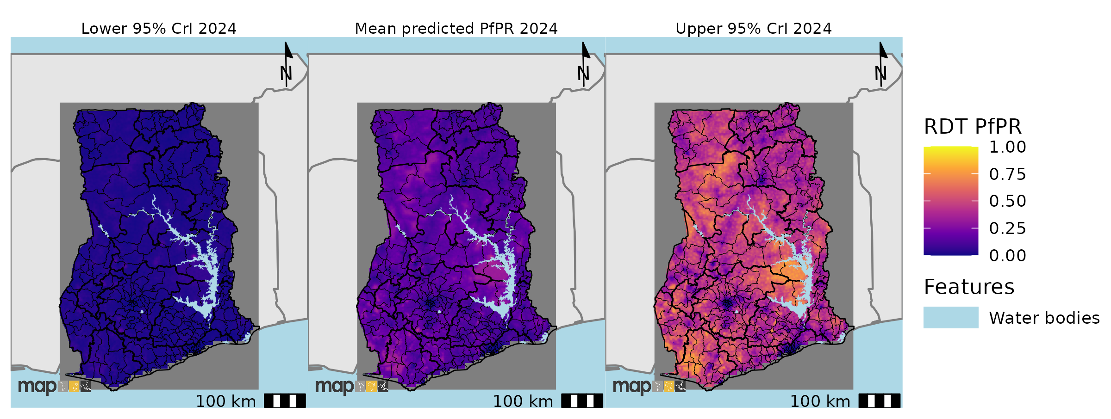
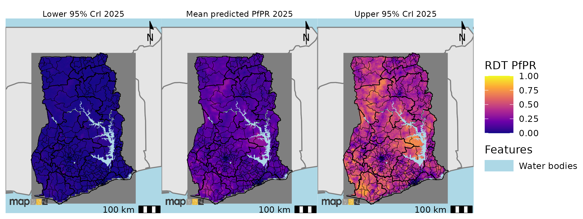
Supplementary figure 12: Prediction maps of P. falciparum malaria by RDT for Ghana from 2011 to 2025 with 95% credible intervals. There was general decline in malaria prevalence across the years. Few areas in the Western, Savannah and Eastern region (close to the Volta lake) showed relatively high prevalence

Stratification
Here we show the proportion of districts that fall into the various stratified categories for the two diagnostic methods.

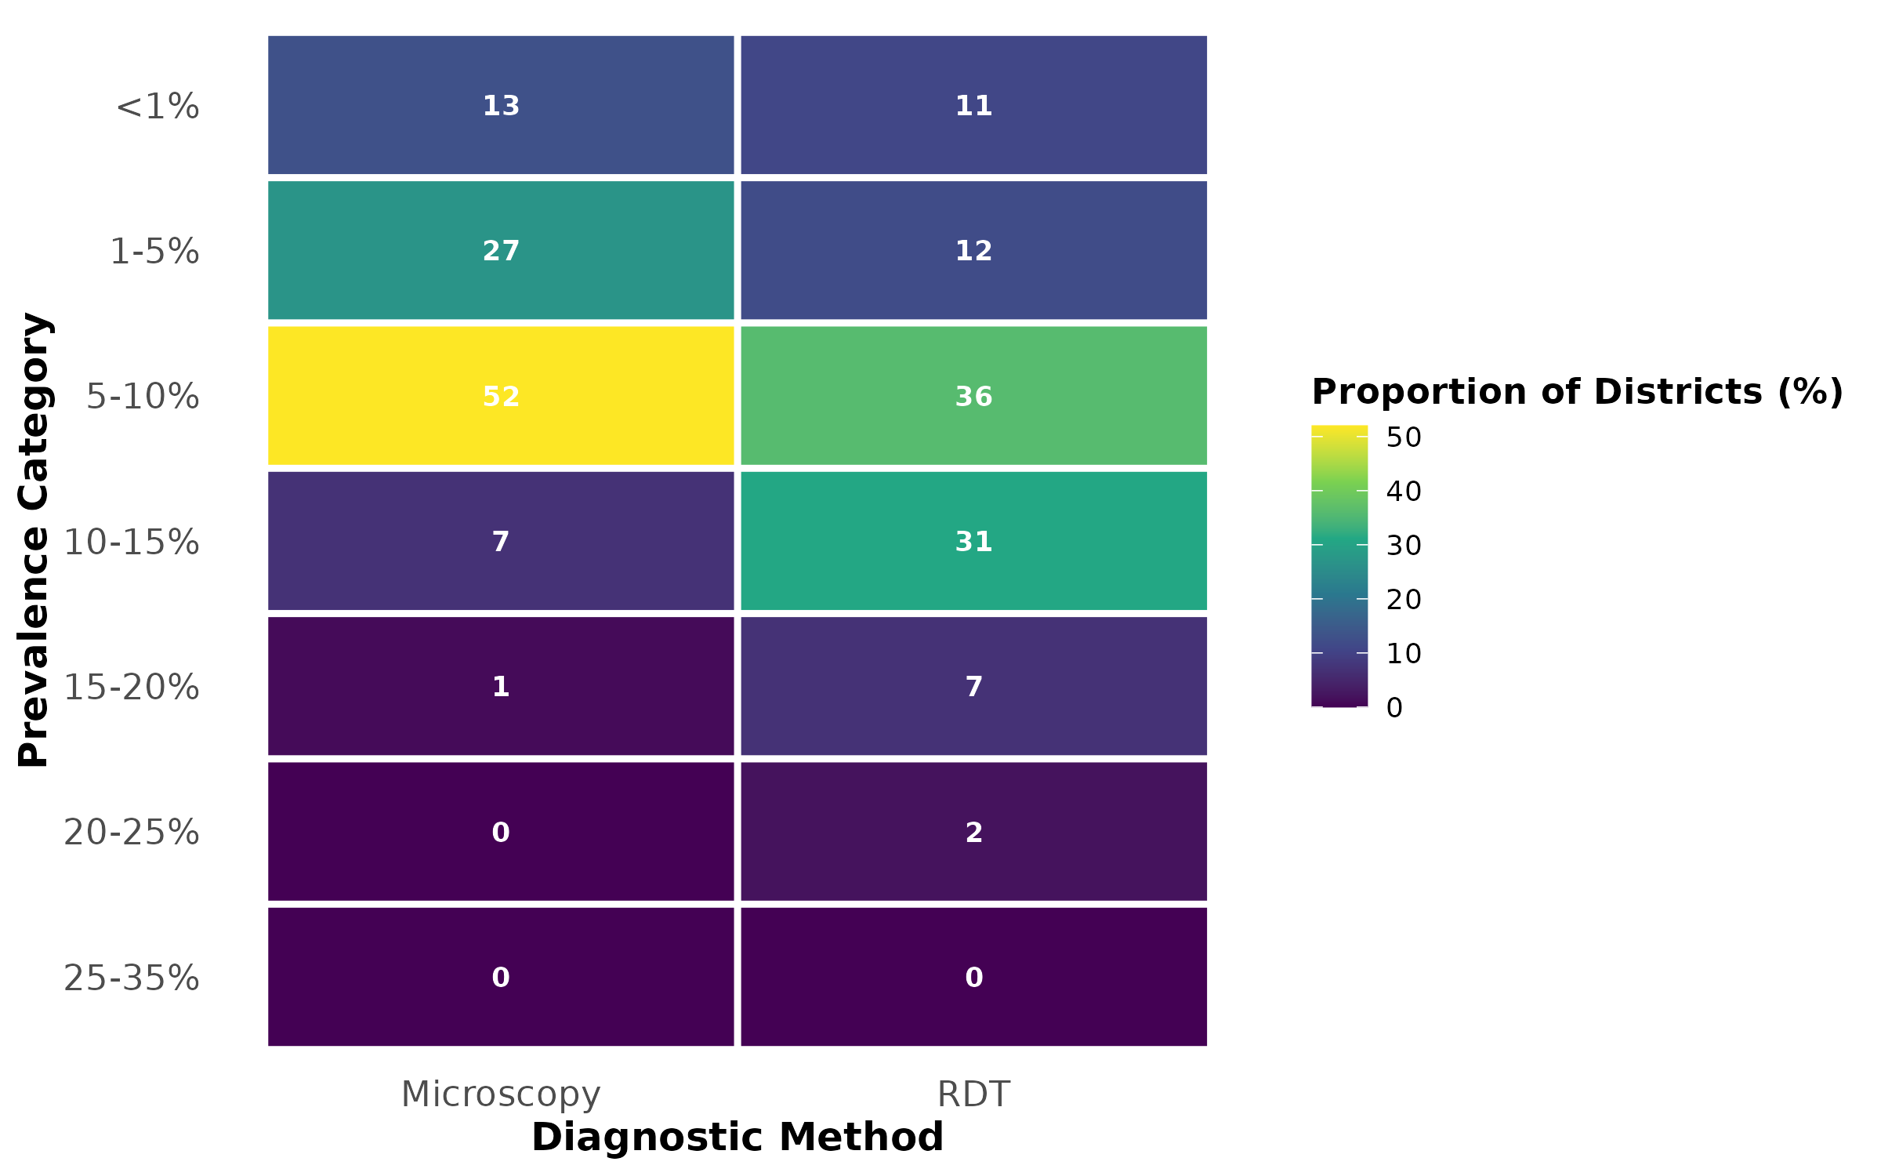
Supplementary figure 13: Proportion of districts in different prevalence categories for each method in 2025 in Ghana

References
1. R Core Team (2024)., _R. R: The R Project for Statistical Computing. https://www.r-project.org/.
2. Nelson, A. Travel Time to Major Cities: A Global Map of Accessibility. (2008).
3. Farr, T. G. et al. The Shuttle Radar Topography Mission. Rev. Geophys. 45, (2007).
4. VIIRS Nighttime Light. https://eogdata.mines.edu/products/vnl/.
5. Schiavina, M. Global Human Settlement - GHS-POP_GLOBE_R2023A - European Commission. https://human-settlement.emergency.copernicus.eu/ghs_pop2023.php.
6. WorldPop :: Population Counts. https://hub.worldpop.org/project/categories?id=3.
7. L, J. Enhanced Vegetation Index (EVI): A Modern Approach to Vegetation Health Monitoring. Geospatial Artificial Intelligence | GeoAI https://geoai.au/enhanced-vegetation-index-evi-a-modern-approach-to-vegetation-health-monitoring/ (2024).
8. Wan, Z., Hook, S. & Hulley, G. MODIS/Terra Land Surface Temperature/Emissivity 8-Day L3 Global 1km SIN Grid V061. NASA EOSDIS Land Processes Distributed Active Archive Center https://doi.org/10.5067/MODIS/MOD11A2.061 (2021).
9. Baig, M. H. A., Zhang, L., Shuai, T. & Tong, Q. Derivation of a tasselled cap transformation based on Landsat 8 at-satellite reflectance. Remote Sens. Lett. 5, 423–431 (2014).
10. Weiss, D. J. et al. Air temperature suitability for Plasmodium falciparum malaria transmission in Africa 2000-2012: a high-resolution spatiotemporal prediction. Malar. J. 13, 171 (2014).
11. Funk, C. C. et al. A Quasi-Global Precipitation Time Series for Drought Monitoring. Data Series https://pubs.usgs.gov/publication/ds832 (2014) doi:10.3133/ds832.

