Supplementary Information

Comparative formation of disinfection byproducts and human health risk under different chlorinated disinfectant types and water matrices

Yeonjeong Ha

ICT Environment Convergence, Department of ICT Convergence, Pyeongtaek University, Pyeongtaek 17869, Republic of Korea

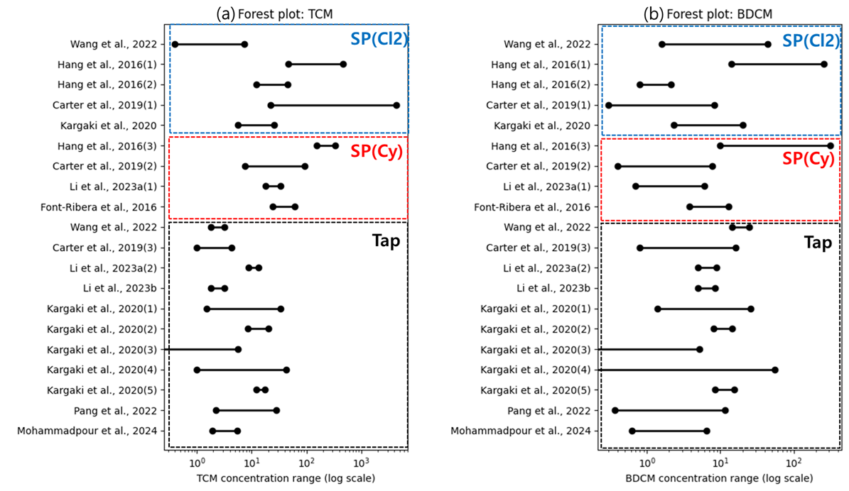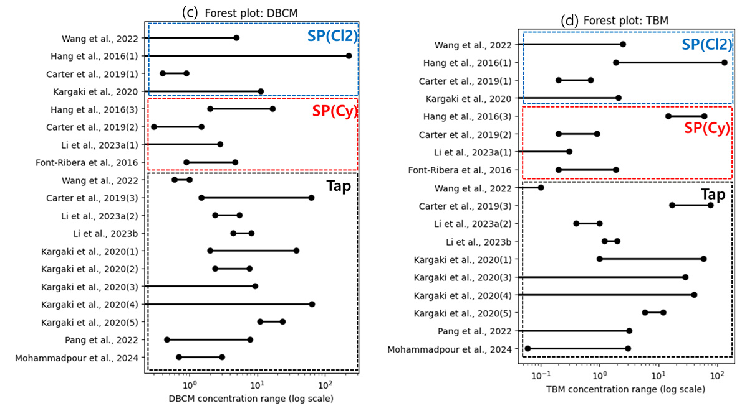
Figure S1. Forest plots showing reported concentration ranges (µg/L) of THMs: (a) TCM, (b) BDCM, (c) DBCM, and (d) TBM in swimming pools and tap water from previous studies. Horizontal lines represent the minimum–maximum concentration range reported in each study, and solid circles indicate the corresponding mean values when available. Studies are grouped by water matrix and disinfectant type: swimming pools treated with chlorine and sodium hypochlorite (SP (Cl₂), blue dashed box), swimming pools treated with cyanuric acid–stabilized chlorine (SP (Cy), red dashed box), and tap water (black dashed box).
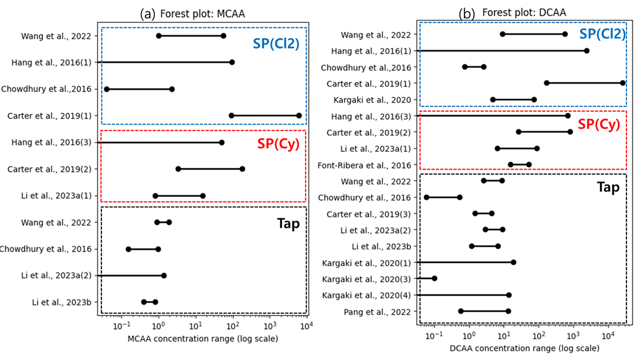

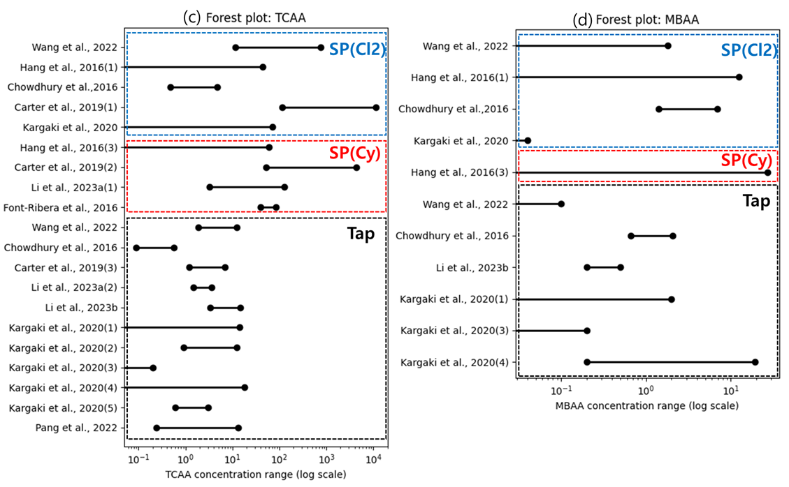
(continued)

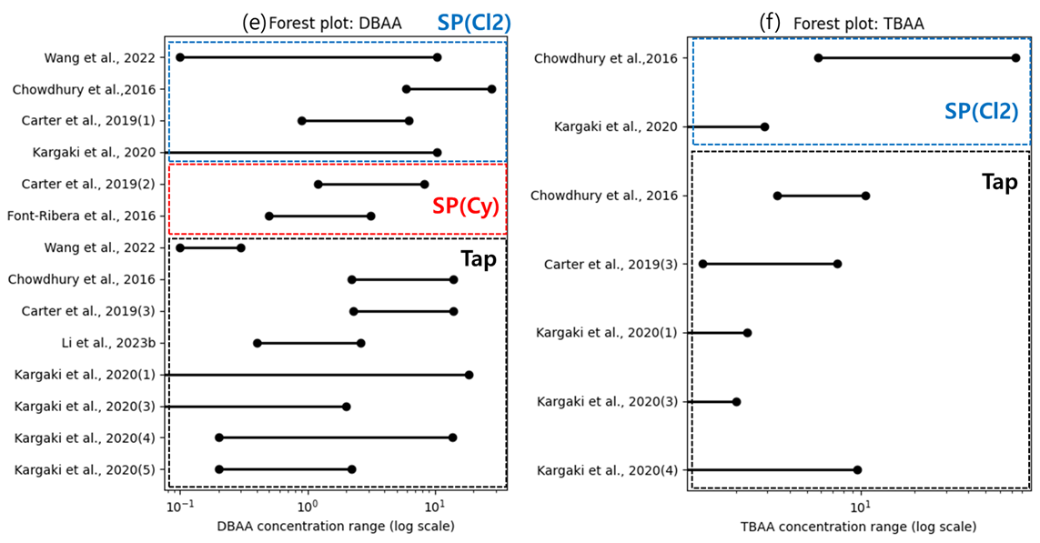
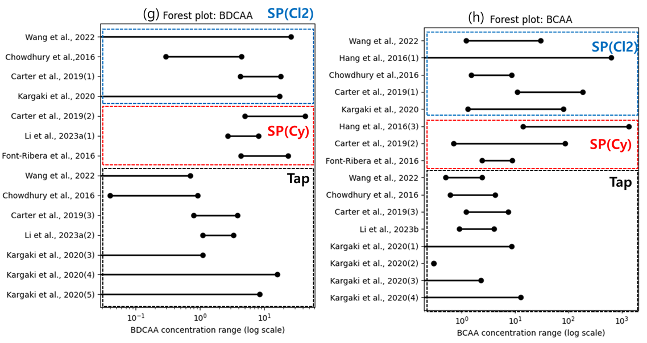
Figure S2. Forest plots showing reported concentration ranges (µg/L) of HAAs: (a) MCAA, (b) DCAA, (c) TCAA, (d) MBAA, (e) DBAA, (f) TBAA, (g) BDCAA, and (h) BCAA in swimming pools and tap water from previous studies. Horizontal lines represent the minimum–maximum concentration range reported in each study, and solid circles indicate the corresponding mean values when available. Studies are grouped by water matrix and disinfectant type: swimming pools treated with chlorine and sodium hypochlorite (SP (Cl₂), blue dashed box), swimming pools treated with cyanuric acid–stabilized chlorine (SP (Cy), red dashed box), and tap water (black dashed box).

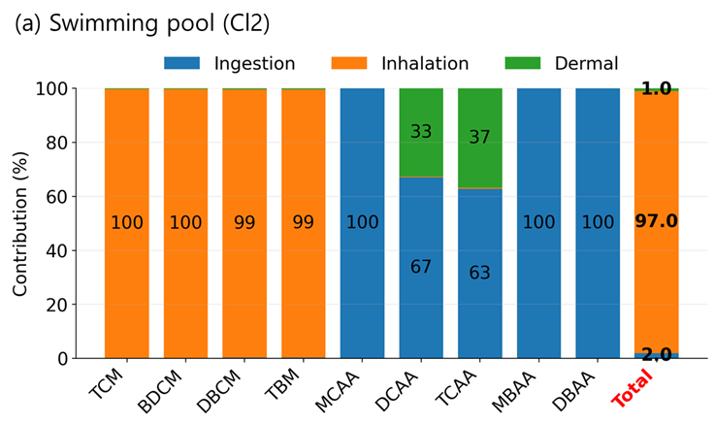
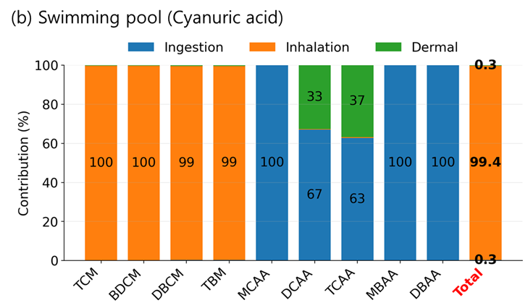
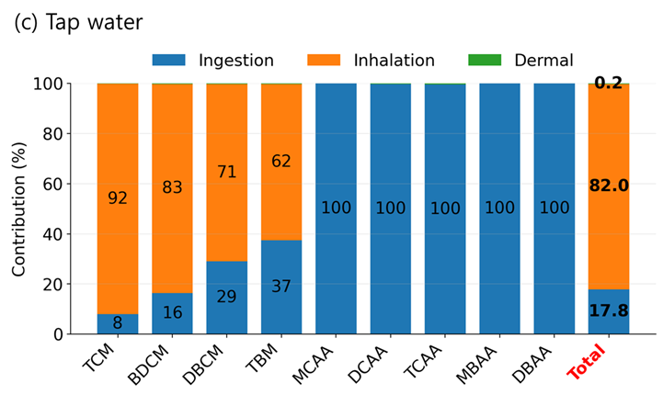
Figure S3 Pathway-specific contributions of ingestion, inhalation, and dermal exposure to the total chronic daily intake (CDI) of disinfection by-products (DBPs) grouped by water matrix and disinfectant type: (a) swimming pools treated with chlorine and sodium hypochlorite (Swimming pool (Cl₂)), (b) swimming pools treated with cyanuric acid–stabilized chlorine (Swimming pool (Cyanuric acid)), and (c) tap water.
For each compound, contributions were normalized to 100% of total CDI. The red-labeled “Total” bar denotes the cumulative exposure across all DBPs within each scenario.

Table S1. Exposure parameter values and their references

Parameter | Explanation | Unit | Swimming pool | Tap water (Shower) | Tap water (Drinking)
EF | Exposure Frequency | event/yr | 34.8ª | 384.8ª | 365(days/yr)
ED | Exposure Duration | yr | 53^{b} | 70 | -
ET | Exposure Time | h/event | 0.887ª | 0.237ª | -
AT | Average Life Time | yr | 70 | 70 | -
SA | Body Surface Area | cm² | 17352ª | 17352ª | -
BW | Body Weight | kg | 64.5ª | 64.5ª | 64.5ª
IR | Inhalation Rate | m³/day | 14.62ª | 14.62ª | -
IT_{SP} | Oral Intake rate (Swimming pool) | L/h | 0.05^{b} | 0.05^{b} | -
IT_{DW} | Oral Intake Rate  (Tap water drinking) | L/day | - | - | 2

ª National Institute of Environmental Resesarch, 2019, Korean Exposure Factors Handbook
^{b} Li et al., (2023a)
Table S2 Summary of calculated human health risks associated with chlorinated disinfectants evaluated in this study. (a) Annual daily uptake (ADD), (b) Excess cancer risk (ECR), and (c) Harzardous quotient (HQ)

(a) Annual daily uptake (ADD)
 | ADD_Inhalation (μg/m³) |  |  |  |  |  | ADD_Dermal (mg/kg/dy) |  |  |  |  |  | ADD_Ingestion (mg/kg/day)
 | SP(Cl2) |  | SP(Cy) |  | Tap |  | SP(Cl2) |  | SP(Cy) |  | Tap |  | SP(Cl2) |  | SP(Cy) |  | Tap
 | Min | Max | Min | Max | Min | Max | Min | Max | Min | Max | Min | Max | Min | Max | Min | Max | Min | Max
TCM | 3.1E-02 | 4.1 | 9.3E-03 | 2.2 | 3.1E-02 | 2.4 | 4.8E-07 | 6.4E-05 | 1.4E-07 | 3.4E-05 | 4.9E-07 | 3.7E-05 | 1.5E-07 | 2.1E-05 | 4.7E-08 | 1.1E-05 | 2.5E-05 | 1.9E-03
BDCM | 7.3E-03 | 7.4E-01 | 1.8E-02 | 1.1 | 1.7E-02 | 5.3E-01 | 1.3E-07 | 1.3E-05 | 3.2E-07 | 2.0E-05 | 3.1E-07 | 9.4E-06 | 6.5E-08 | 6.6E-06 | 1.6E-07 | 1.0E-05 | 2.4E-05 | 7.5E-04
DBCM | 1.2E-03 | 6.3E-02 | 1.5E-03 | 2.0E-02 | 4.1E-03 | 2.1E-01 | 4.0E-08 | 2.0E-06 | 4.7E-08 | 6.5E-07 | 1.3E-07 | 6.8E-06 | 3.0E-08 | 1.5E-06 | 3.5E-08 | 4.8E-07 | 1.6E-05 | 8.1E-04
TBM | 7.2E-04 | 8.6E-02 | 2.9E-04 | 4.1E-02 | 3.9E-03 | 1.9E-01 | 2.2E-08 | 2.7E-06 | 9.0E-09 | 1.3E-06 | 1.2E-07 | 5.8E-06 | 2.5E-08 | 3.0E-06 | 9.9E-09 | 1.4E-06 | 2.2E-05 | 1.0E-03
MCAA | - | - | - | - | - | - | - | - | - | - | - | - | - | 1.2E-04 | 4.5E-07 | 2.4E-06 | 1.6E-05 | 3.7E-05
DCAA | 3.7E-08 | 2.9E-04 | 6.6E-07 | 6.6E-06 | 1.8E-09 | 2.1E-06 | 4.0E-08 | 3.1E-04 | 7.1E-07 | 7.1E-06 | 1.9E-09 | 2.3E-06 | 8.3E-08 | 6.4E-04 | 1.5E-06 | 1.5E-05 | 6.2E-07 | 7.5E-04
TCAA | 9.6E-07 | 9.6E-04 | 8.0E-06 | 2.6E-04 | 1.5E-08 | 3.3E-05 | 7.4E-08 | 7.5E-05 | 6.2E-07 | 2.0E-05 | 1.1E-09 | 2.5E-06 | 1.3E-07 | 1.3E-04 | 1.1E-06 | 3.4E-05 | 3.1E-07 | 6.9E-04
MBAA | - | - | - | - | - | - | - | - | - | - | - | - | 0.0E+00 | 1.3E-06 | 1.1E-07 | 1.1E-07 | 6.2E-07 | 2.1E-04
DBAA | - | - | - | - | - | - | - | - | - | - | - | - | 1.7E-09 | 4.0E-06 | 5.0E-08 | 1.4E-07 | 9.3E-07 | 2.4E-04
TBAA | - | - | - | - | - | - | - | - | - | - | - | - | 8.3E-10 | 1.8E-06 | - | - | 3.1E-06 | 2.1E-04
BDCAA | - | - | - | - | - | - | - | - | - | - | - | - | 9.3E-08 | 1.3E-06 | 7.4E-08 | 5.9E-07 | 6.2E-07 | 2.3E-04
BCAA | - | - | - | - | - | - | 1.2E-08 | 4.0E-06 | 1.3E-07 | 2.4E-05 | 1.1E-08 | 5.6E-07 | 2.2E-08 | 7.2E-06 | 2.4E-07 | 4.3E-05 | 3.1E-06 | 1.6E-04
CDBAA | - | - | - | - | - | - | - | - | - | - | - | - | 3.5E-08 | 1.2E-06 | - | - | 3.1E-06 | 1.5E-04

(b) Excess cancer risk (ECR)
 | ECR_Inhalation |  |  |  |  |  | ECR_Dermal |  |  |  |  |  | ECR_Ingestion
 | SP(Cl2) |  | SP(Cy) |  | Tap |  | SP(Cl2) |  | SP(Cy) |  | Tap |  | SP(Cl2) |  | SP(Cy) |  | Tap
 | Min | Max | Min | Max | Min | Max | Min | Max | Min | Max | Min | Max | Min | Max | Min | Max | Min | Max
TCM | 7.0E-07 | 9.5E-05 | 2.1E-07 | 5.0E-05 | 7.3E-07 | 5.5E-05 | 1.5E-08 | 2.0E-06 | 4.5E-09 | 1.0E-06 | 1.5E-08 | 1.2E-06 | 4.8E-09 | 6.4E-07 | 1.4E-09 | 3.4E-07 | 7.9E-07 | 6.0E-05
BDCM | 2.7E-07 | 2.7E-05 | 6.6E-07 | 4.2E-05 | 6.4E-07 | 1.9E-05 | 8.2E-09 | 8.3E-07 | 2.0E-08 | 1.3E-06 | 1.9E-08 | 5.9E-07 | 4.0E-09 | 4.1E-07 | 9.8E-09 | 6.2E-07 | 1.5E-06 | 4.6E-05
DBCM | 3.4E-08 | 1.7E-06 | 3.9E-08 | 5.4E-07 | 1.1E-07 | 5.7E-06 | 3.4E-09 | 1.7E-07 | 3.9E-09 | 5.5E-08 | 1.1E-08 | 5.7E-07 | 2.5E-09 | 1.3E-07 | 2.9E-09 | 4.0E-08 | 1.3E-06 | 6.8E-05
TBM | 7.9E-10 | 9.4E-08 | 3.2E-10 | 4.5E-08 | 4.3E-09 | 2.0E-07 | 2.9E-10 | 3.5E-08 | 1.2E-10 | 1.7E-08 | 1.6E-09 | 7.5E-08 | 2.0E-10 | 2.3E-08 | 7.8E-11 | 1.1E-08 | 1.7E-07 | 8.1E-06
MCAA | - | - | - | - | - | - | - | - | - | - | - | - | - | - | - | - | - | -
DCAA | - | - | - | - | - | - | 2.0E-09 | 1.5E-05 | 3.5E-08 | 3.6E-07 | 9.4E-11 | 1.1E-07 | 4.1E-09 | 3.2E-05 | 7.3E-08 | 7.3E-07 | 3.1E-08 | 3.8E-05
TCAA | - | - | - | - | - | - | 7.4E-08 | 7.5E-05 | 6.2E-07 | 2.0E-05 | 1.1E-09 | 2.5E-06 | 8.9E-09 | 8.9E-06 | 7.4E-08 | 2.4E-06 | 2.2E-08 | 4.8E-05
MBAA | - | - | - | - | - | - | - | - | - | - | - | - | - | - | - | - | - | -
DBAA | - | - | - | - | - | - | - | - | - | - | - | - | 4.1E-10 | 1.0E-06 | 1.2E-08 | 3.4E-08 | 2.3E-07 | 5.9E-05
TBAA | - | - | - | - | - | - | - | - | - | - | - | - | - | - | - | - | - | -
BDCAA | - | - | - | - | - | - | - | - | - | - | - | - | - | - | - | - | - | -
BCAA | - | - | - | - | - | - | - | - | - | - | - | - | - | - | - | - | - | -
CDBAA | - | - | - | - | - | - | - | - | - | - | - | -

(c) Harzardous Quotient (HQ)
 | HQ_Ingestion
 | SP(Cl2) |  | SP(Cy) |  | Tap
 | Min | Max | Min | Max | Min | Max
TCM | 1.5E-05 | 2.1E-03 | 4.7E-06 | 1.1E-03 | 2.5E-03 | 1.9E-01
BDCM | 8.1E-06 | 8.2E-04 | 2.0E-05 | 1.3E-03 | 3.1E-03 | 9.3E-02
DBCM | 1.5E-06 | 7.5E-05 | 1.7E-06 | 2.4E-05 | 7.8E-04 | 4.0E-02
TBM | 1.2E-06 | 1.5E-04 | 5.0E-07 | 7.0E-05 | 1.1E-03 | 5.1E-02
MCAA | 0.0E+00 | 3.5E-02 | 1.3E-04 | 6.9E-04 | 4.6E-03 | 1.1E-02
DCAA | 2.1E-05 | 1.6E-01 | 3.6E-04 | 3.7E-03 | 1.6E-04 | 1.9E-01
TCAA | 6.4E-06 | 6.4E-03 | 5.3E-05 | 1.7E-03 | 1.6E-05 | 3.5E-02
MBAA | 0.0E+00 | 7.6E-04 | 6.7E-05 | 6.7E-05 | 3.6E-04 | 1.2E-01
DBAA | 5.5E-06 | 1.3E-02 | 1.7E-04 | 4.6E-04 | 3.1E-03 | 7.9E-01
TBAA | - | - | - | - | - | -
BDCAA | - | - | - | - | - | -
BCAA | - | - | - | - | - | -
CDBAA | - | - | - | - | - | -

References
Carter RAA, Allard S, Croué JP, Joll CA (2019) 500 days of swimmers: The chemical water quality of swimming pool waters from the beginning. Environ Sci Pollut Res 26:29110–29126. https://doi.org/10.1007/s11356-019-05861-0

Chen Z, Su Y, Chen J, Li Z, Wang T (2024) Study on the health risk of cyanuric acid in swimming pool water and its prevention and control measures. Front Public Health 11:1294842. https://doi.org/10.3389/fpubh.2023.1294842

Chowdhury S, Mazumder AJ, Husain T (2016) Predicting bromide incorporation in a chlorinated indoor swimming pool. Environ Sci Pollut Res 23:12174–12184. https://doi.org/10.1007/s11356-016-6339-4

Couto M, Bernard A, Delgado L, Drobnic F, Kurowski M, Moreira A, Rodrigues-Alves R, Rukhadze M, Seys S, Wiszniewska M, Quirce S (2021) Health effects of exposure to chlorination by-products in swimming pools. Allergy 76:3257–3275. https://doi.org/10.1111/all.15014

Daiber EJ, DeMarini DM, Ravuri SA, Liberatore HK, Cuthbertson AA, Thompson-Klemish A, Byer JD, Schmid JE, Afifi MZ, Blatchley ER III, Richardson SD (2016) Progressive increase in disinfection byproducts and mutagenicity from source to tap to swimming pool and spa water: Impact of human inputs. Environ Sci Technol 50:6652–6662. https://doi.org/10.1021/acs.est.6b00808

Dehghani M, Shahsavani S, Mohammadpour A, Jafarian A, Arjmand S, Rasekhi MA, Dehghani S, Zaravar F, Derakhshan Z, Ferrante M, Oliveri Conti G (2022) Determination of chloroform concentration and human exposure assessment in the swimming pool. Environ Res 203:111883. https://doi.org/10.1016/j.envres.2021.111883

Dufour AP, Behymer TD, Cantú R, Magnuson M, Wymer LJ (2017) Ingestion of swimming pool water by recreational swimmers. J Water Health 15:429–437. https://doi.org/10.2166/wh.2017.255

Font-Ribera L, Kogevinas M, Schmalz C, Zwiener C, Marco E, Grimalt JO, Liu J, Zhang X, Mitch W, Critelli R, Naccarati A, Heederik D, Spithoven J, Arjona L, de Bont J, Gracia-Lavedan E, Villanueva CM (2016) Environmental and personal determinants of the uptake of disinfection by-products during swimming. Environ Res 149:206–215. https://doi.org/10.1016/j.envres.2016.05.013

Genisoglu M, Minaz M, Tanacan E, Sofuoglu SC, Kaplan-Bekaroglu SS, Kanan A, Ates N, Sardohan-Koseoglu T, Özgü Yigit N, Harman BI (2023) Halogenated by-products in chlorinated indoor swimming pools: A long-term monitoring and empirical modeling study. ACS Omega 8:11364–11372. https://doi.org/10.1021/acsomega.3c00091

Gouveia P, Felgueiras F, Mourão Z, Fernandes EDO, Moreira A, Gabriel MF (2019) Predicting health risk from exposure to trihalomethanes in an Olympic-size indoor swimming pool among elite swimmers and coaches. J Toxicol Environ Health A 82:577–590. https://doi.org/10.1080/15287394.2019.1634383

Hang C, Zhang B, Gong T, Xian Q (2016) Occurrence and health risk assessment of halogenated disinfection byproducts in indoor swimming pool water. Sci Total Environ 543:425–431. https://doi.org/10.1016/j.scitotenv.2015.11.055

Hernández B, Duque-Sarango P, Tonón MD, Abril-González M, Pinos-Vélez V, García-Sánchez CR, Rodríguez MJ (2025) Determination of the occurrence of trihalomethanes in the drinking water supply of the city of Cuenca, Ecuador. Water 17:591. https://doi.org/10.3390/w17040591

Ilyas H, Masih I, van der Hoek JP (2018) An exploration of disinfection by-products formation and governing factors in chlorinated swimming pool water. J Water Health 16:861–878. https://doi.org/10.2166/wh.2018.067

Kargaki S, Iakovides M, Stephanou EG (2020) Study of the occurrence and multi-pathway health risk assessment of regulated and unregulated disinfection by-products in drinking and swimming pool waters of Mediterranean cities. Sci Total Environ 739:139890. https://doi.org/10.1016/j.scitotenv.2020.139890

Legay C, Leduc S, Dubé P, Levallois P, Rodriguez MJ (2019) Chlorination by-product levels in hot tap water: Significance and variability. Sci Total Environ 651:1735–1741. https://doi.org/10.1016/j.scitotenv.2018.10.075

Li J, Chen J, Hu Z, Li X, Li M, Wang Y, Zhang Z, Liang X (2023a) Overlooked inorganic DBPs in trichloroisocyanuric acid (TCCA) disinfected indoor swimming pool: Evidences from concentration, cytotoxicity, and human health risk. Chemosphere 335:139061. https://doi.org/10.1016/j.chemosphere.2023.139061

Li J, Zhang Z, Aziz MT, Granger CO, Qiang Z, Richardson SD, Dong H (2023b) Simple and sensitive method for synchronous quantification of regulated and unregulated priority disinfection byproducts in drinking water. Anal Chem 95:10975–10983. https://doi.org/10.1021/acs.analchem.3c01013

Liberatore HK, Daiber EJ, Ravuri SA, Schmid JE, Richardson SD, DeMarini DM (2022) Disinfection byproducts in chlorinated or brominated swimming pools and spas: Role of brominated DBPs and association with mutagenicity. J Environ Sci 117:253–263. https://doi.org/10.1016/j.jes.2022.04.049

Mao Y, Zhang L, Dong H (2018) Formation of trihalomethanes in swimming pool waters using sodium dichloroisocyanurate as an alternative disinfectant. J Water Health 16:770–781.

Maréchal M, Correc O, Demelas C, Couzinet A, Cimetière N, Vassalo L, Gérardin F, Boudenne JL (2023) Characterization and chlorine reactivity of particulate matter released by bathers in indoor swimming pools. Chemosphere 313:137589. https://doi.org/10.1016/j.chemosphere.2022.137589

Mohammadpour A, Emadi Z, Berizi E, Kazemi A (2024) Trihalomethanes in chlorinated drinking water: Seasonal variations and health risk assessment in southern Iran. Groundw Sustain Dev 27:101342. https://doi.org/10.1016/j.gsd.2024.101342

Pang Z, Zhang P, Chen X, Dong F, Deng J, Li C, Liu J, Ma X, Dietrich AM (2022) Occurrence and modeling of disinfection byproducts in distributed water of a megacity in China: Implications for human health. Sci Total Environ 848:157674. https://doi.org/10.1016/j.scitotenv.2022.157674

Peng D, Saravia F, Abbt-Braun G, Horn H (2016) Occurrence and simulation of trihalomethanes in swimming pool water: A simple prediction method based on DOC and mass balance. Water Res 88:634–642. https://doi.org/10.1016/j.watres.2015.10.061

Peng F, Wang Y, Lu Y, Yang Z, Li H (2024) Formation and control of disinfection by-products during the trichloroisocyanuric acid disinfection in swimming pool water. Environ Pollut 346:123536. https://doi.org/10.1016/j.envpol.2024.123536

Sdougkou A, Kapsalaki K, Kozari A, Pantelaki I, Voutsa D (2021) Occurrence of disinfection by-products in swimming pools in the area of Thessaloniki, Northern Greece: Assessment of multi-pathway exposure and risk. Molecules 26:7639. https://doi.org/10.3390/molecules26247639

Usman M, Hüben M, Kato T, Zwiener C, Wintgens T, Linnemann V (2022) Occurrence of brominated disinfection by-products in thermal spas. Sci Total Environ 845:157338. https://doi.org/10.1016/j.scitotenv.2022.157338

Wang J, Zhang M, Hu S, Xian Q, Chen H, Gong T (2022) Occurrence and cytotoxicity of aliphatic and aromatic halogenated disinfection byproducts in indoor swimming pool water and their incoming tap water. Environ Sci Technol 56:17763–17775. https://doi.org/10.1021/acs.est.2c07175

Wang L, Fang Z, Zhou X, Cheng K, Ren Y, Li C, Gao B, Lv Y, Xu S, Xu H (2025) Health risk assessment via ingestion of disinfection by-products in drinking water. Sci Rep 15:1793. https://doi.org/10.1038/s41598-024-84094-9

Zhang D, Chen L, Dong S, Luo J, Xu Z, Chu W (2022) Dramatically increased disinfection byproducts in swimming pool water caused by commonly used urea degradants. Water Res 223:118987. https://doi.org/10.1016/j.watres.2022.118987

Zheng X, Xu J, Gao Y, Li W, Chen Y, Geng H, Yue J, Xu M (2023) Within-day variation and health risk assessment of trihalomethanes (THMs) in a chlorinated indoor swimming pool in China. Environ Sci Pollut Res 30:18354–18363. https://doi.org/10.1007/s11356-022-23498-4

