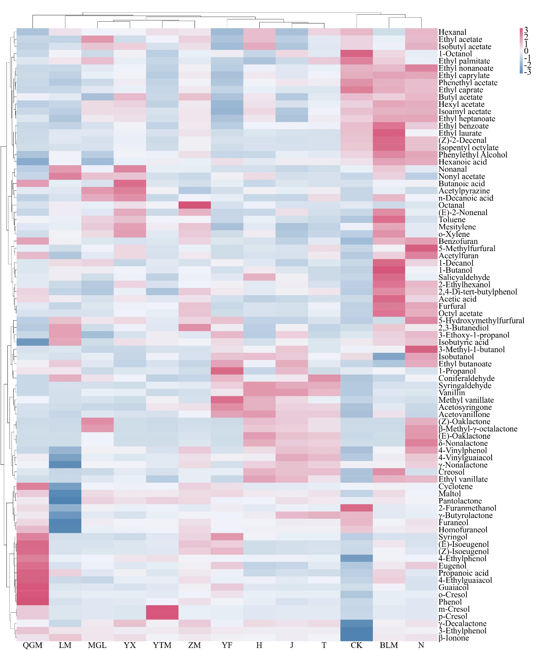
Figure S1. Clustered heatmap based on the concentrations of 85 compounds.

