Extended Data Figure Legends

Extended Data Figure 1: TIGAR is dispensable for immune homeostasis but supports CD4⁺ T-cell activation.
(a) Immunophenotyping of female and male WT and TIGAR-null mice (n = 5 biologically independent mice per genotype). Heat maps showing the frequencies of CD4⁺ T cells, CD8⁺ T cells, B220⁺ B cells and neutrophils in the spleen, peripheral lymph nodes (pLN) and mesenteric lymph nodes (mLN). (b) Experimental design of the homeostatic proliferation assay. CFSE, carboxyfluorescein succinimidyl ester. (c) Homeostatic proliferation of WT and TIGAR-null donor CD4⁺ T cells following adoptive transfer into Rag2^{-/-} recipient mice (n = 4 biologically independent mice per genotype). (d) Representative flow cytometry plots of Annexin V and propidium iodide (PI) staining in WT and TIGAR-null CD4⁺ T cells 24 h after anti-CD3/CD28 stimulation. (e) Expression of CD62L, CD69 and CD44 on WT and TIGAR-null CD4⁺ T cells 24 h after anti-CD3/CD28 stimulation. (f) Quantification of glucose uptake, measured by 2-NBDG mean fluorescence intensity (MFI), in WT and TIGAR-null CD4⁺ T cells after 24 h of activation. Data are presented as mean ± s.e.m. (a) or mean ± s.d. (e,f). Statistical significance was determined using two-way ANOVA (a) or two-tailed unpaired Student's t-tests (e,f).
Extended Data Figure 2: Putative TIGAR enzymatic functions and its role in amino acid metabolism and CD4 T cell differentiation.
(a) Structural superposition of the predicted/experimental structure of TIGAR with listed identified proteins. (b) LC–MS analysis of ¹³C₃-alanine tracing in WT and TIGAR-null CD4⁺ T cells 24 h after TCR stimulation. Isotopomer distribution of citrate, α-ketoglutarate (αKG) and malate. (c) Abundance of intracellular ¹³C₅-glutamine in WT and TIGAR-null CD4⁺ T cells following anti-CD3/28 activation. (d) Immunoblot analysis of glutaminase (GLS1) expression in naïve and activated WT and TIGAR-null mouse CD4⁺ T cells. Vinculin served as a loading control. (e–g) Quantification of CD4⁺ T-cell differentiation. (e)Frequencies of IFNγ⁺T-bet⁺ Th1 cells. (f) Frequencies of IL-17A⁺RORγt⁺ Th17 cells. (g) Frequencies of Foxp3⁺ iTreg cells after 3 days of differentiation. (g) Representative flow cytometry plots corresponding to g. Data are presented as mean ± s.d. Statistical significance was determined using two-tailed unpaired Student's t-tests (e–g). n = 4 technical replicates per condition (e,g) and n = 3 technical replicates per condition (f). Immunoblots are representative of three independent experiments (d).
Extended Data Figure 3: Identification of a TIGAR-polyol pathway axis driving CD4 T cell fate
(a,b) Quantification of WT CD4⁺ T cells differentiated in the presence of increasing concentrations of sorbitol (1.25, 2.5 and 5 mM). (a) Frequencies of IFNγ⁺T-bet⁺ Th1 cells. (b) Frequencies of IL-17A⁺RORγt⁺ Th17 cells. (c) Representative flow cytometry plots and quantification (d) of FOXP3⁺ induced regulatory T (iTreg) cells differentiated in the presence of sorbitol (2.5 or 5 mM). (e,f) Quantification of WT CD4⁺ T cells differentiated in the presence of the aldose reductase inhibitor epalrestat (1 or 5 μM). (e) Frequencies of IFNγ⁺T-bet⁺ Th1 cells. (f)Frequencies of IL-17A⁺RORγt⁺ Th17 cells. (g) Representative flow cytometry plots and (h) quantification of FOXP3⁺ iTreg cells differentiated in the presence or absence of epalrestat (1 μM). Data are presented as mean ± s.d. Statistical significance was determined using two-way ANOVA with Šídák's multiple-comparisons test (a,b), one-way ANOVA with Tukey's multiple-comparisons test (d–f), or two-tailed unpaired Student's t-test (h). Data are representative of two independent experiments (a,b) or three independent experiments (c–h).
Extended Data Figure 4: The polyol pathway remodels mitochondrial metabolism and contributes to mitochondrial flexibility.
a. Total NAD(P)H autofluorescence measured by spectral flow cytometry (UV-5 channel). b. CellROX levels in TIGAR WT and KO CD4+ T cells after 24 h of activation were measured by flow cytometry (mean fluorescence intensity, MFI), with a representative histogram (right). c. MitoSOX levels measured by flow cytometry (MFI) in WT-T and KO-T cells at 24 h of activation. d. Diagram of the TCA cycle and FAO. e. Stable isotope tracing analysis of ¹³C₆-glucose and isotopomer distribution in TCA cycle metabolites: α-ketoglutarate (αKG) and citrate, measured by LC-MS. (f-i) Comparison of metabolic profiles measured by a Seahorse MitoStress test of WT-T CD4⁺ T cells under 2.5, 5 mM sorbitol exposure or 1 μM Epalresat treatment. (f,g) Plot of oxygen consumption rate (OCR) versus extracellular acidification rate (ECAR) profiled using the Seahorse Analyzer during a mitochondrial stress test. (h,i) Spare respiratory capacity measured as a percentage of baseline. Significance was tested using unpaired Student's t-tests (a-c, e, i) and one-way ANOVA with Tukey's multiple-comparisons test (f,h). Data are presented as mean ± s.d. for technical replicates. Data are representative of two independent experiments (e) or three independent experiments (a-c, f-i).

Extended Data Figure 5: Exogenous sorbitol does not affect CD4-T cell movement behaviour
Comparison between migration characteristics (a. average speed, b. meandering index, c. outreach ratio and d. φ - phi: relative turning angle) of WT-T CD4⁺ T cells in the presence or absence of sorbitol (2mM and 5 mM). WT-T CD4⁺ cells without sorbitol were stained with VPD450, and those with sorbitol (2 mM and 5 mM) were stained with CTFR. Data are normalised to the WT-T average per well. Each point represents the average parameter for all cells in an FOV. Significance was tested using a one-way ANOVA with Tukey's multiple comparisons test. Data are presented as mean ± s.d for technical replicates (a-d).

Extended Data Figure 6: TIGAR deficiency in T cells does not impact all cytokine and inflammatory fecal biomarkers during Citrobacter infection
a. Frequency of RORγT⁺ cells within the CD4⁺ T cell population in the colonic lamina propria (cLP) and the mesenteric lymph nodes (mLN) of WT-T and KO-T mice at day 13 post-infection. (b) Faecal lipocalin quantified by ELISA and normalised to faecal weight from TIGAR WT-T and KO-T at day 12 post-infection. (c) Cytokine abundance (pg/mg of faeces) between WT (n=5) and KO-T cells (n=4) at day 12 post-infection measured by multi-bead-based immunoassay. Significance was tested using unpaired Student's t-tests (a-c). Data are presented as mean ± s.e.m for biological replicates (a-d).

Extended Data Figure 7: TIGAR regulates inflammatory de novo generation of Th1 cells in colitis, but does not affect pTreg suppressive activity.
a. CD4⁺ T cell frequencies of donor WT-T or KO-T cells in Rag2-null recipients at day 21 in the colonic lamina propria (cLP), spleen and peripheral lymph nodes (pLN) b. Representative flow cytometry plot of IFNγ-producing CD4⁺ Th1 pathogenic cells in the spleen of the in vivo inducible colitis model. c. Plasma IFNγ levels were measured by ELISA on day 21 post-transfer. d. Representative flow cytometry plot of Tregs (CD4⁺FOXP3⁺) in the cLP at day 21. e. Schematic of in vivo pTreg suppression assay of co-transfer of pTregs and Tconv (1:4 ratio). f. Overall survival of WT-T versus KO-T pTreg recipients, as well as WT-T and KO-T CD4⁺CD25⁻ recipients (Tconv). g. IFNγ production of CD4⁺ Th1 pathogenic cells in the mLN, spleen and pLN of WT-T and KO-T Treg recipients at day 50 post-transfer. h. Quantification of TCRβ⁺CD4⁺ T cells in the spleen and pLN of WT-T and KO-T pTreg recipients. i. Treg frequency (FOXP3⁺), measured by flow cytometry, in the spleen, mLN, and pLN of WT-T and KO-T Treg recipients. Significance was tested using unpaired Student’s t-tests (a,c,g-i). n=5 (WT-T), n=6 (KO-T) biological replicates (a,b) and n=3 biological replicates (g-i). Data are presented as mean ± s.e.m (a,c,g-i).

Supplementary Information Figure 1- Representative Flow Cytometry Gating Strategy

Representative gating strategy followed for flow cytometry experiments. Data from the immune cell profiling used (Extended Data Figure 1.a.).
Dead cells were stained with the Fixable Viability Dye eFluoroTM 780 and excluded. Doublets were excluded using side scatter (SSC) area versus height. Gating strategy for all flow cytometry experiments for surface markers (CD4, CD8, B220, CD11b, Ly6G) and intracellular markers (FOXP3) from different tissues a. spleen, b. peripheral lymph nodes (pLN), c. mesenteric lymph nodes (mLN). Gating strategy for: Figure 1c, Extended Data Figure 1c-f, Figure 2i,g,j,k, Extended Data Figure 2g, Figure 3d-I, Extended Data Figure c,j, Figure 5d-f, Figure 6c,d, Extended Data Figure 6a-c, Extended Data Figure 7a,b,d,g-i,

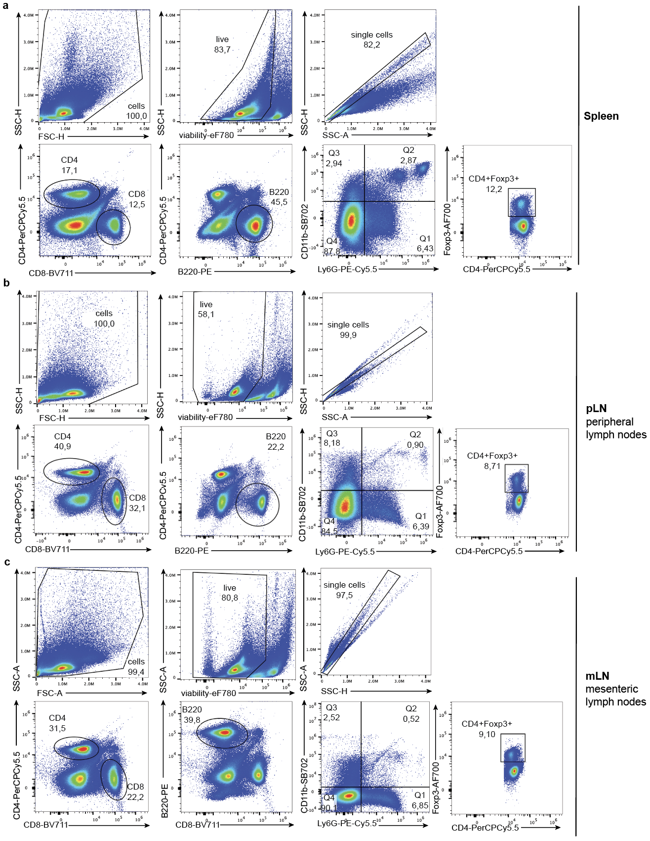

Supplementary Information Figure 2- Table with ligand pubchem files used for molecular docking
Ligand | Estimated free energy of binding of the best pose  (Kcal/mol) | Pubchem sdf file links
Fructose-2,6-biphosphate | -7.728 | https://pubchem.ncbi.nlm.nih.gov/compound/168318456
Alpha ribazole phosphate | -7.643 | https://pubchem.ncbi.nlm.nih.gov/compound/alpha-Ribazole-5_-phosphate
2,3 Diphosphoglycerate | -6.167 | https://pubchem.ncbi.nlm.nih.gov/compound/61
2-phosphoglycerate | -5.623 | https://pubchem.ncbi.nlm.nih.gov/compound/59
3-Phosphoglycerate | -5.374 | https://pubchem.ncbi.nlm.nih.gov/compound/724
Phosphoenol pyruvate | -5.245 | https://pubchem.ncbi.nlm.nih.gov/compound/2724421
2-phosphoglycolate | -4.894 | https://pubchem.ncbi.nlm.nih.gov/compound/529

Supplementary Information List-1: List of Antibodies

Abcam
β-actin (Abcam ab317794; 1:1000)

Thermofisher Scientific

IFNγ-FITC (clone XMG1.2, Cat# 11-7311-82)
RORγT-APC (clone B2D, Cat#17-6981-82)
Phalloidin (Cat#A12380)
CD11b – Superbright 702 (Cat#67-0112-82)
B220-BV785 (Cat# 417-0452-82)
CD11b-Superbright 702 (clone M1/70, Cat# 67-0112-82)
CD44-eFluor450 (clone: IM7, Cat# 48-0441-82)

Invitrogen (eBioscience)
CD4-FITC (clone RM4-5, Lot 2057560, Cat#11-0042-85)
Fixable viability Dye eFluo780 (Cat#65-0865-14)
IFNγ-PerCPCy5.5 (clone XMG1.2, Cat# 45-7311-80)
Ly6G-PeCy5.5 (clone GR-1, Cat# 35-5931-82)
CD11c-eFluor 450 (clone N418, Cat# 48-0114-80)
B220-PE (clone: RA3-6B2, Cat# 12-0452-83)

BioLegend
anti-IFNγ (clone XMG1.2, Cat#505802)
Anti-CD28 (clone 37.51, Cat#14-0281-85)
FOXP3-PE (clone MF-14, Cat#505031)
CD25-APC, (clone PC61, Cat#102012)
Anti-CD3(clone 145-2C11, Cat#100302)
CD8-APC (Cat# 100712)
T-bet-PeCy7 (Cat# 644824)
Anti-IL-4 (clone 11B11, Cat# 57430)
FITC-CD62L (Cat# 104406)
CD69-BV650 (Cat# 104541)
CD44-APC (Cat# 103012)
TCRβ-APC (Cat# 109212)
B220-BV605 (Cat# 103243)
CD8-PerCP (Cat# 100731)
GM-CSF-APC (Cat# 505413)
TNFα-BV421 (Cat#506327)
CD4-eF450 (clone RM4-5, Cat#100531)
IL-10-BV605 (Cat#505031)
CD25-BV421 (Cat# 101923)

BD-Pharmigen
IL17A-PerCPCy5.5 (clone 4B10, Cat#560666)
DAPI solution (Cat#564907; 1 :10 000)
Annexin-V APC (Cat# 550474)
CD8-BV711 (clone 53-6.7, Cat# 566410)

Santa Cruz (SC)
TIGAR (G-2) (sc-74577; lot:L0211 1:10000)
Vinculin (7F9) (sc-73614, lot:C1815; 1:10000)

Tonbo Biosciences

CD4-PerCPCy5.5 (GK1.5, Cat# 65-0041-U100)

