Supplemental Materials

Table 1. Demographic and Clinical Characteristics of the Study Cohort
bpm = breaths per minute; CPAP = continuous positive airway pressure; SIMV = synchronized intermittent mandatory ventilation; IQR = interquartile range.
Data are presented as median [range] or n (%), as appropriate.
Figure Legends

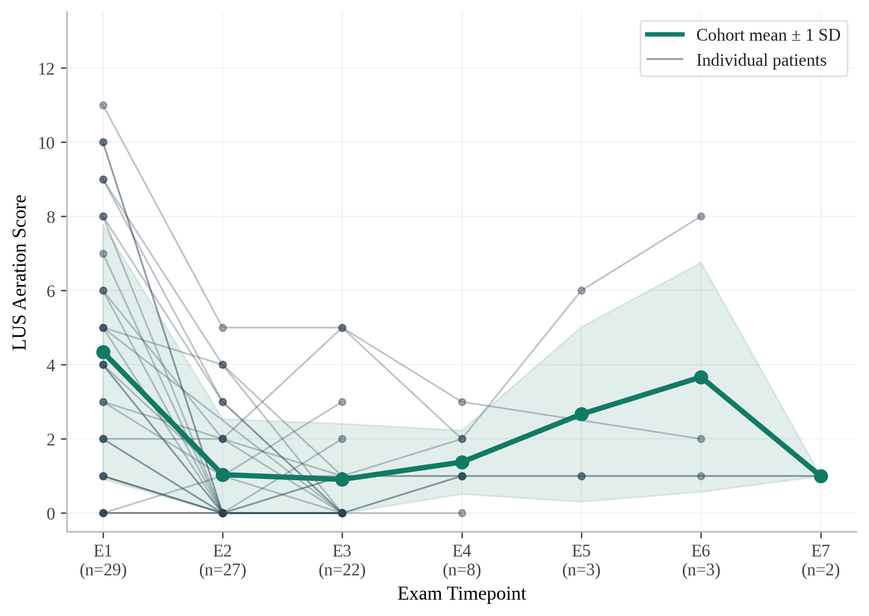
Figure 1. Serial Lung Ultrasound Scores by Patient Over Time. Line plot depicting individual patient LUS trajectories across serial examinations (E1 through E7). Bold line represents cohort mean ± 1 SD. Lines are colored by total respiratory support duration. Patient numbers are labeled at E1. The sharpest improvement is observed between E1 and E2, with 93% of patients demonstrating score reduction at the 24-hour examination. E1, within 6 hours of life; E2, approximately 24 hours of life; E3+, subsequent daily assessments.

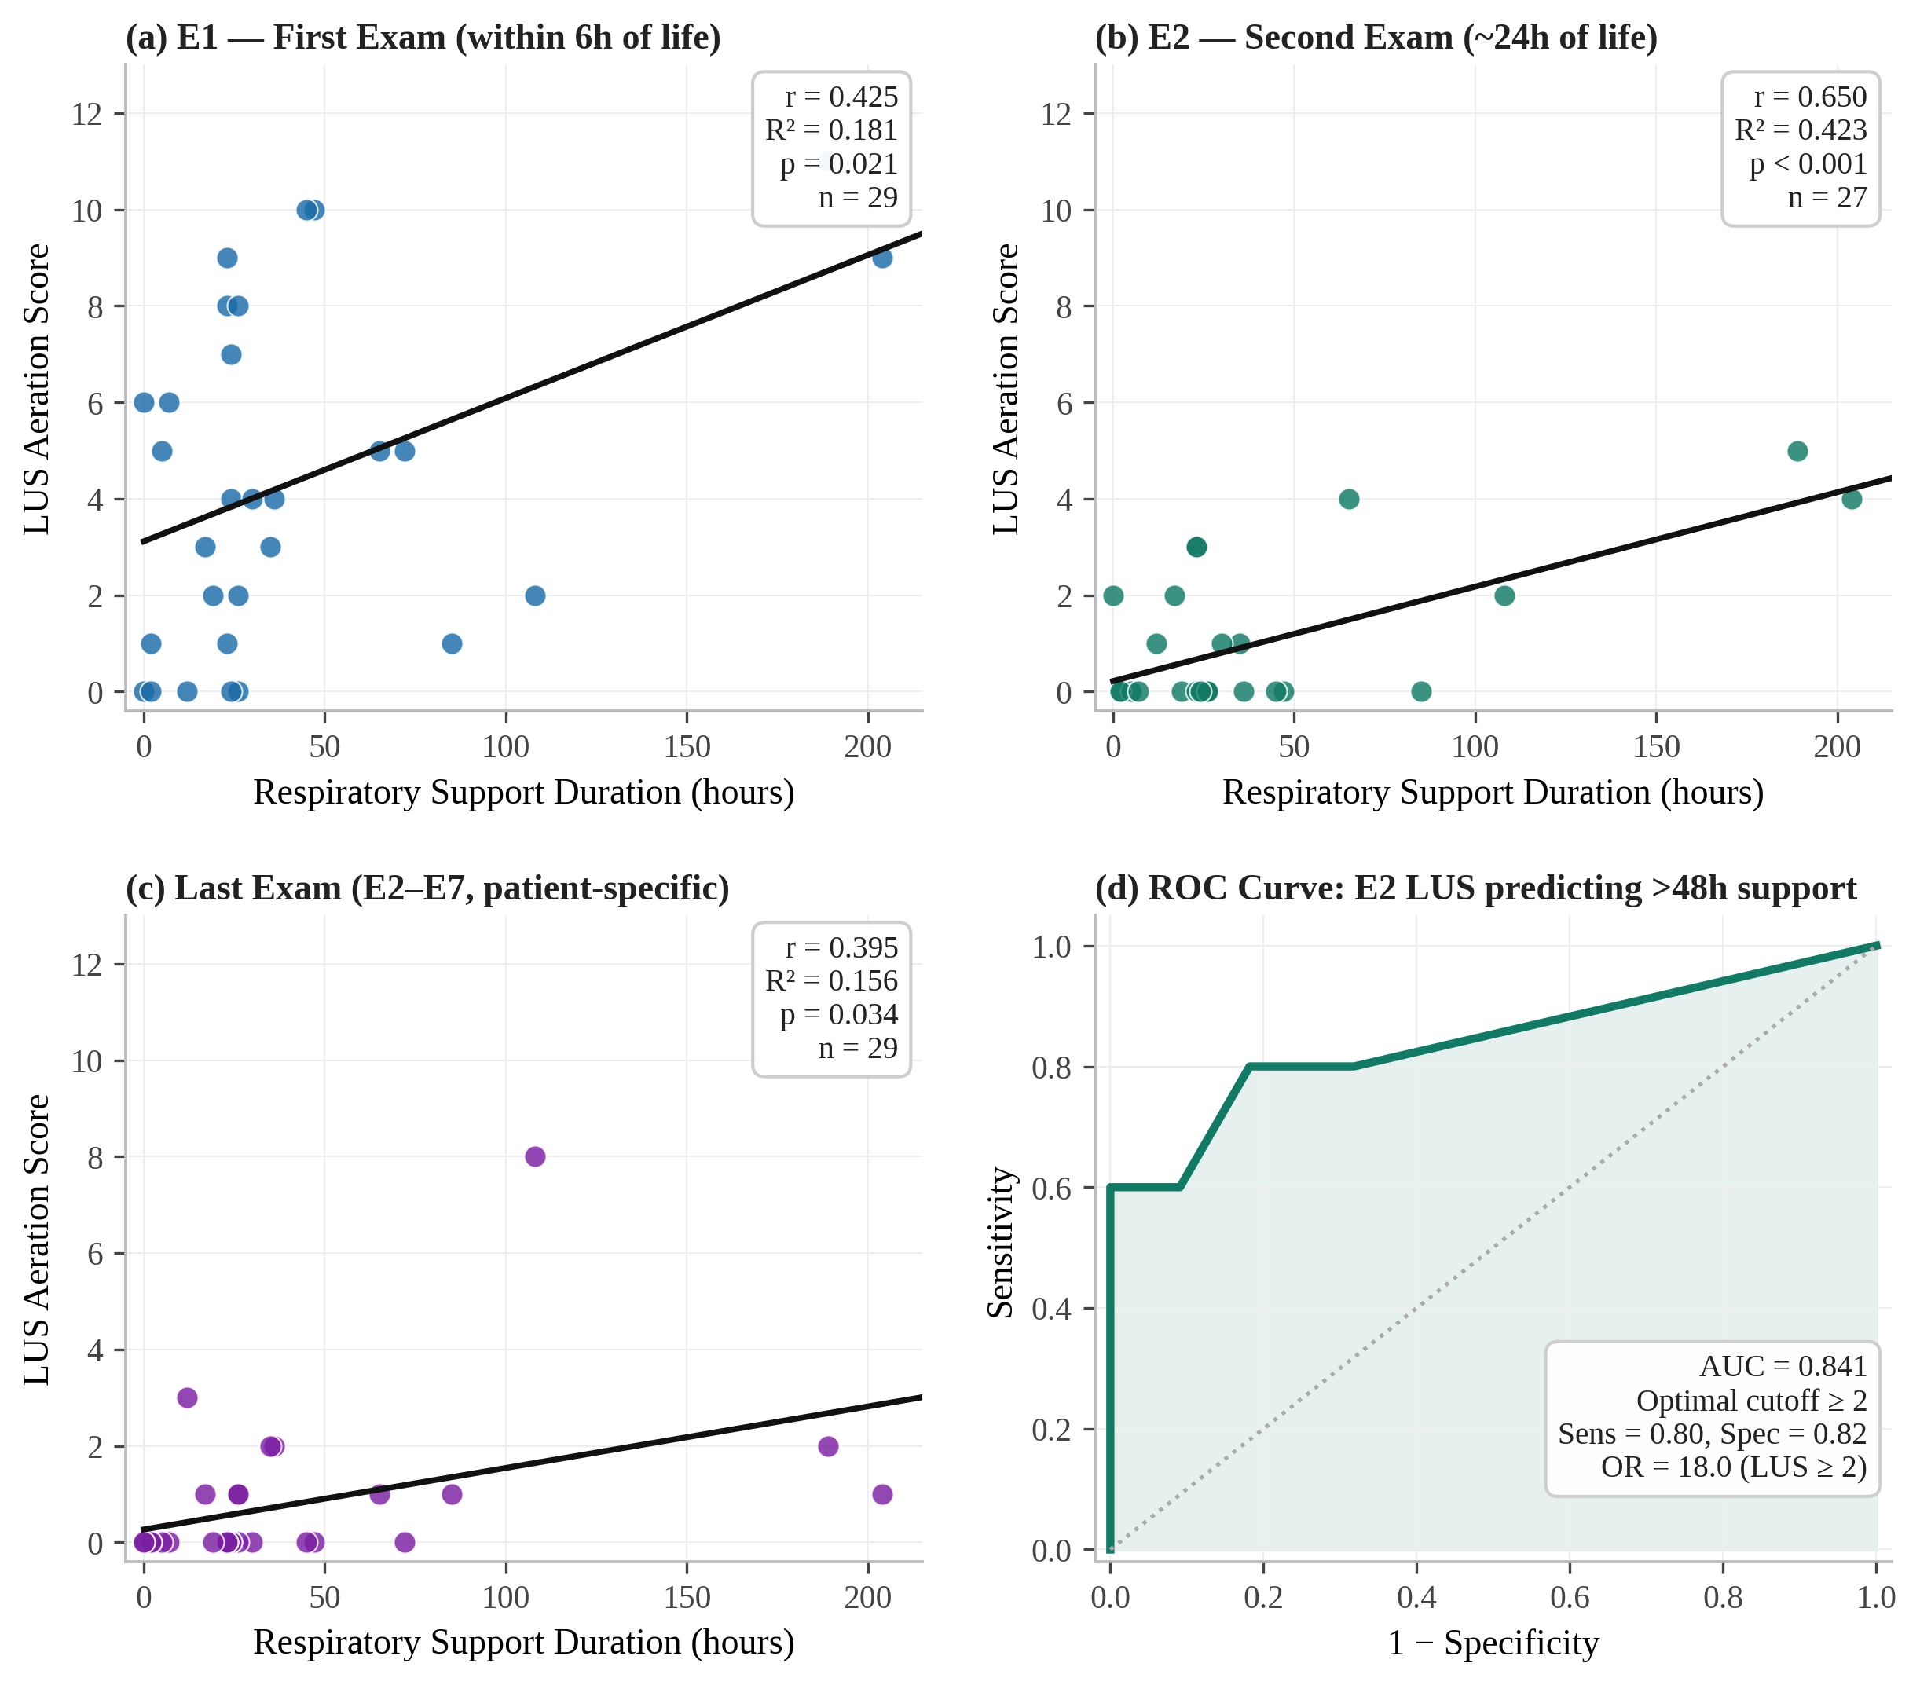
Figure 2. Association Between Lung Ultrasound Score and Duration of Respiratory Support. (a) Scatter plot at E1 (Pearson r = 0.425, R² = 0.181, p = 0.021). (b) Scatter plot at E2 (Pearson r = 0.650, R² = 0.423, p < 0.001). (c) Scatter plot at last available examination (Pearson r = 0.395, R² = 0.156, p = 0.034). (d) Logistic regression: E2 average LUS ≥2 vs. prolonged respiratory support (≥48 hours); OR = 18.0.

Figure 3. CONSORT Enrollment Flow Diagram. Screening and enrollment flow from 72 assessed neonates to the final analytic cohort of 29 participants completing 96 examination sessions.

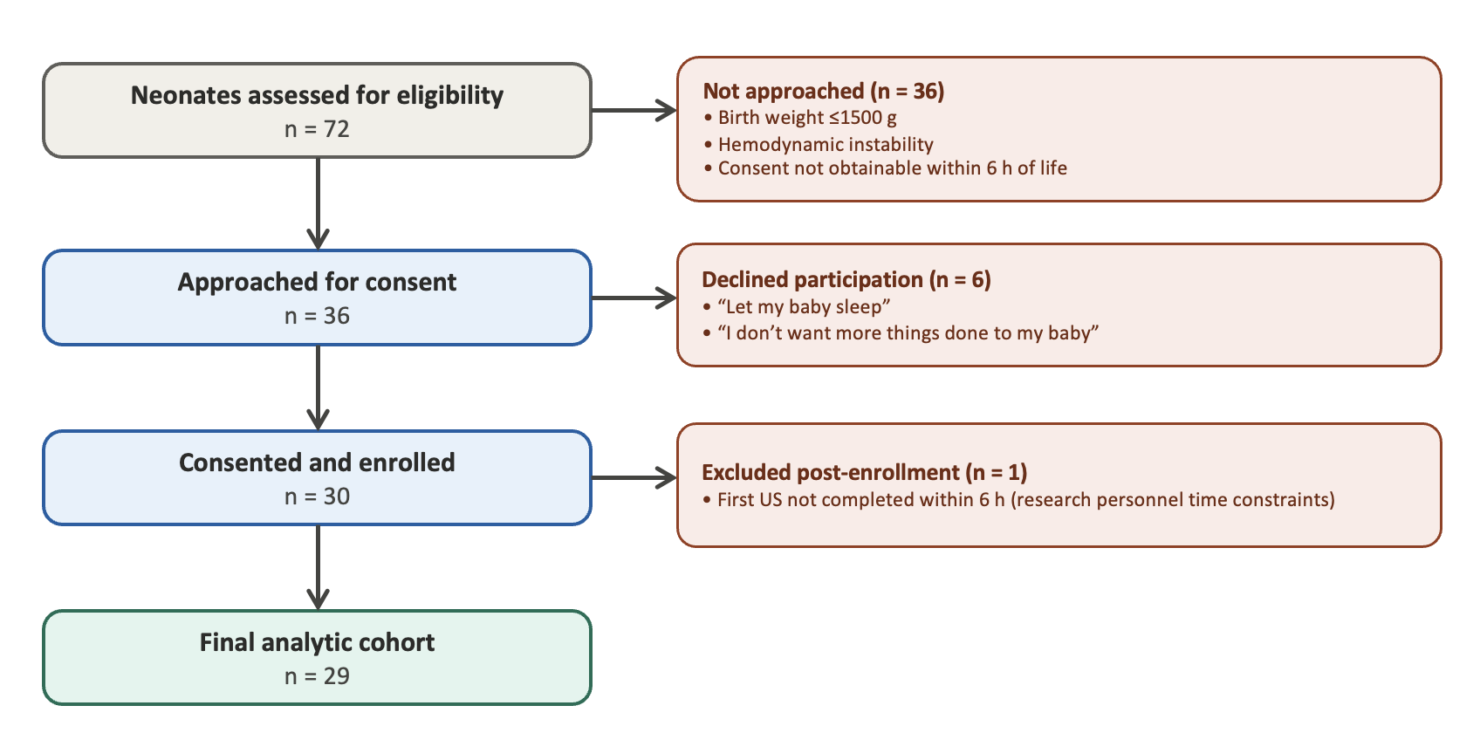

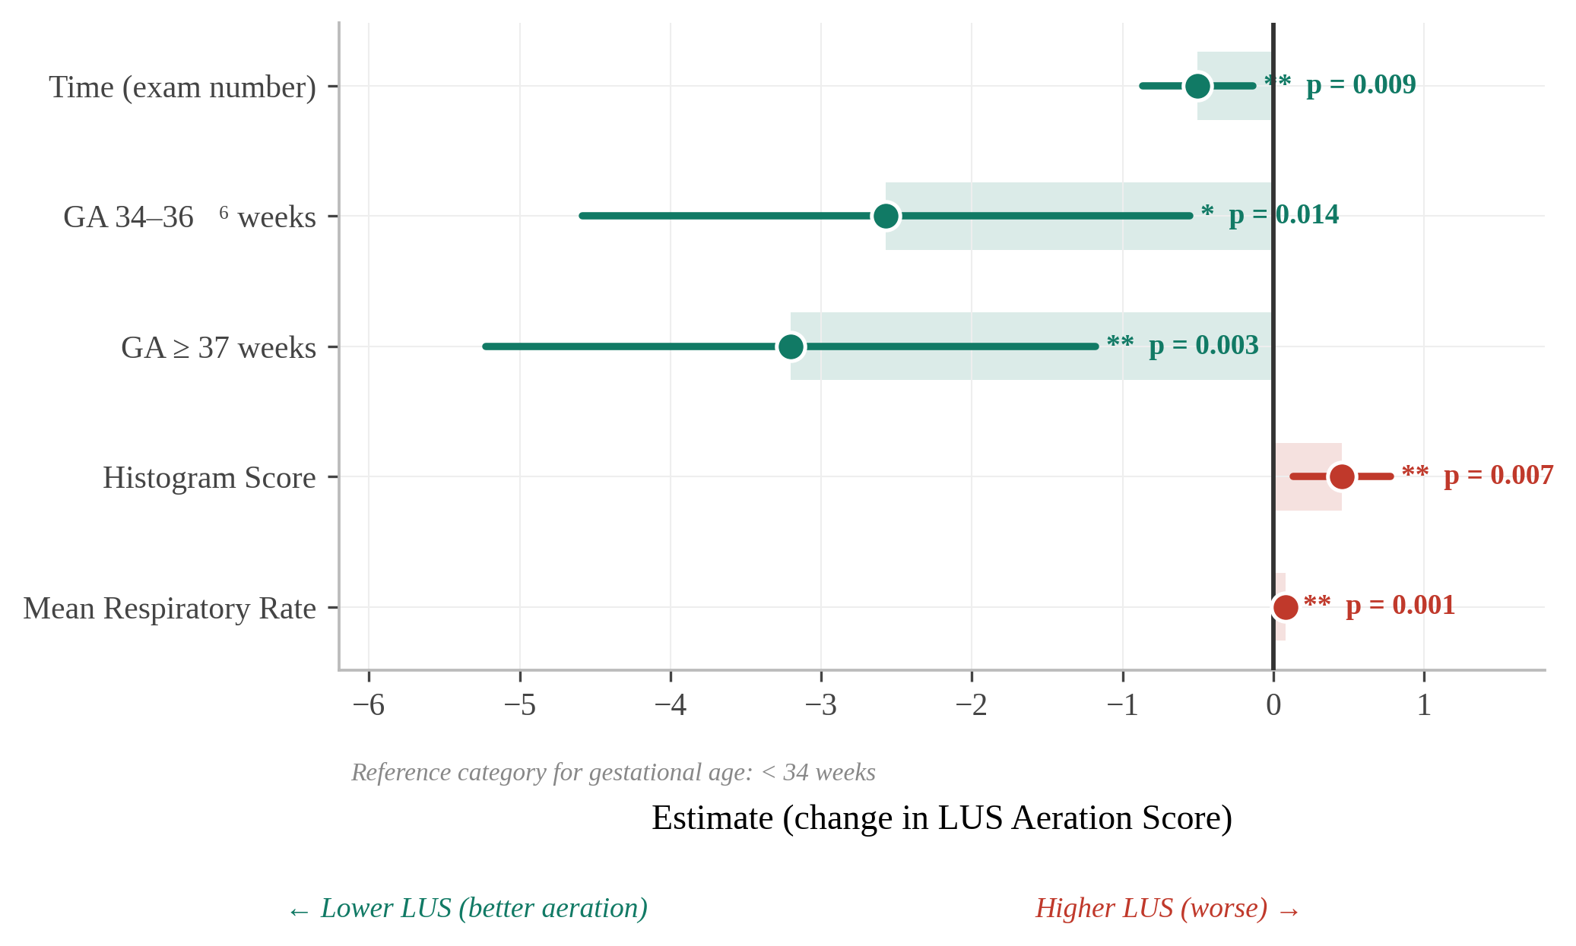
Figure 4. Linear Mixed-Effects Model: Fixed Effects on Respiratory Support Duration. Fixed-effects estimates from a linear mixed model with gestational age, respiratory rate, and LUS histogram pattern as covariates, showing the independent association between LUS and duration of respiratory support across repeated measures.

