SUPPLEMENTARY INFORMATION

ARTICLE TITLE
PSR Framework for Identifying Eutrophication Drivers in a Tropical Hydroelectric Reservoir
JOURNAL NAME
Environmental Management
AUTHOR NAMES
M.Sc. Valquíria Flávia Lima Viana.¹ ORCID: 0000-0002-4136-9723
Ph.D. Juliana da Silva Martins Pimentel.¹ ORCID: 0000-0002-6318-464X
Ph.D. Cristiano Christófaro.³ ORCID: 0000-0002-9957-202X
Arthur Lanna Neves.¹ ORCID: 0000-0002-1287-3445
Ph.D. Lenora Nunes Ludolf Gomes.² ORCID: 0000-0002-5165-6603
Ph.D. Maria Clara Vieira Martins Starling¹ ORCID: 0000-0002-1942-7173
Ph.D. Camila Costa de Amorim.¹ (corresponding author): ORCID 0000-0001-6132-0866
camila@desa.ufmg.br

AUTHORS AFFILIATION
¹ Intelligent Systems for Environmental Monitoring - SIMOA,
Department of Sanitary and Environmental Engineering,
Universidade Federal de Minas Gerais – UFMG. Belo Horizonte/MG, Brazil
² Center for Environmental Studies - NEA,
Center for Advanced Multidisciplinary Studies - CEAM
Universidade de Brasília - UnB. Brasília/DF, Brazil
³ Department of Forestry Engineering,
Universidade Federal dos Vales do Jequitinhonha e Mucuri – UFVJM. Diamantina/MG, Brazil

- Table S1: Summary of the indicator selection process for constructing the causal network.
- Table S2: Description of the sampling stations of the Nova Ponte HPP reservoir, located in the Araguari River Basin PN2.
- Table S3: Area (km2) of land use and land cover classes in the Araguari River sub-basin (surrounding the Nova Ponte reservoir).
- Figure S1: Land use and land cover maps 2005 (a) and 2015 (b)
- Figure S2 Boxplots: Electrical conductivity (a), Orthophosphate (b), Temperature (c), Ammoniacal N (d), Total suspended solids (e) and Total dissolved solids (f)
- Figure S3 Heatmap: Heatmap of Euclidean distances among sampling stations based on standardized environmental variables. Values represent pairwise dissimilarities between stations.
Table S1: Summary of the indicator selection process for constructing the causal network.
 | Indicators |  | Detailed Description
PRESSURE | Changes in land use and land cover  Percentage of impacted area in the surrounding area over time |  | - Land use and land cover maps, with classes and developments according to the databases (IDE SISEMA, Mapbiomas, and PNLA);  - Graphs of activities in the surrounding areas and by municipality;  - Maps produced from satellite images (Landsat 5 and 8) for the study period, i.e., 1995, 2005, 2015, and 2020, using IDE SISEMA, Mapbiomas, and ANA databases;  - Maps produced from satellite images of the study period, including center pivots if applicable.
PRESSURE | Increase in irrigation and number of center pivots |  | - Calculation of the area covered by center pivots based on ANA database information.
PRESSURE | Discharge of untreated or inadequately treated sewage into water bodies |  | - Graphs showing the percentage of compliance with sanitation conditions in the municipalities surrounding the study area.
PRESSURE | Soil erosion
PRESSURE | Others |  | - Maps produced from satellite images (Landsat 5 and 8) for the study period, i.e., 1995, 2005, 2015, and 2020, using IDE SISEMA, Mapbiomas, and ANA databases.
STATE | Deterioration of water quality  Temporal variation of water quality parameters |  | - Statistical analysis of the available database for the three reservoirs from 1995 to 2020
STATE | Presence of excess nutrients and organic matter and sedimentation of water bodies; |  | - Calculation of the Trophic State Index (TSI) for each station in each reservoir and throughout the time series to determine the trophic level and assess significant differences among stations within each reservoir
STATE | Correlation of chlorophyll-a with relevant parameters (total N and P, ammonia N, nitrite, nitrate); Nitrogen-to-phosphorus ratio (N/P) |  | - Conducted for all stations in each study area (Pearson correlation and linear regression)  - Identification of the correlation between land use and occupation impact and water quality degradation.
STATE | Others
RESPONSE | Periodic monitoring of the parameters of interest  Improving the management and handling of impact sources that cause pressures | - Public policies for management and monitoring that ensure the sustainability of the environment and water resources
RESPONSE | Others

Table S2: Description of the sampling stations of the Nova Ponte HPP reservoir, located in the Araguari River Basin PN2
Sampling station | Municipality | River | Environment type | Geographic Coordinates
 |  |  |  | Latitude | Longitude
NP110 | Perdizes | Capivara River | Lotic/Lentic (transition) | 19° 21’36” S | 47º 02’49” O
NP120 | Patrocínio | Reservoir | Lentic | 19° 12’ 50” S | 47° 02’ 11” O
NP130 | Patrocínio | Reservoir | Lentic | 19° 12’ 50” S | 47° 20’ 00” O
NP140 | Pedrinópolis | Reservoir | Lentic | 19° 06’ 21” S | 47º 31’ 51” O
NP160 | Santa Juliana | Araguari River | Lotic/Lentic (transition) | 19° 29’ 00” S | 47° 32’ 37” O
NP170 | Pedrinópolis | Reservoir | Lentic | 19° 10’ 28” S | 47° 38’ 40” O
NP180 | Nova Ponte | Reservoir | Lentic | 19° 07’ 43” S | 47° 41’ 32” O
NP190 | Nova Ponte | Araguari River | Lotic/Lentic (transition) | 19° 07’ 54” S | 47° 41’ 57” O

Table S3: Area (km²) of land use and land cover classes in the Araguari River sub-basin (surrounding the Nova Ponte reservoir).
HPP Nova Ponte | Areas (km²)  Years
Class | 1995 | 2005 | 2015 | 2020
Mineral area | 379.14 | 1031.66 | 2534.19 | 3120.35
Mined area | 6.712 | 18.82 | 253.34 | 364.63
Turbid water | 0.44 | 9.32 | 22.31 | 59.09
Deep water | 385.89 | 429.15 | 214.47 | 210.49
Typical Cerrado | 8272.59 | 6241.82 | 4368.73 | 2749.35
Forestry | 2425.61 | 2543.09 | 3644.39 | 3059.11
Exposed Fields/erosion | 1121.01 | 1649.00 | 1797,46 | 1758.49
Grassland | 4245.57 | 4717.04 | 7037.52 | 7491.89
Thin Cerrado | 2889.23 | 1217.16 | 2833.66 | 3446.08
Urban area | 157 | 157 | 242.73 | 312
Center Pivot* | 233 | 334 | 610 | 754
*sum of the central pivot areas

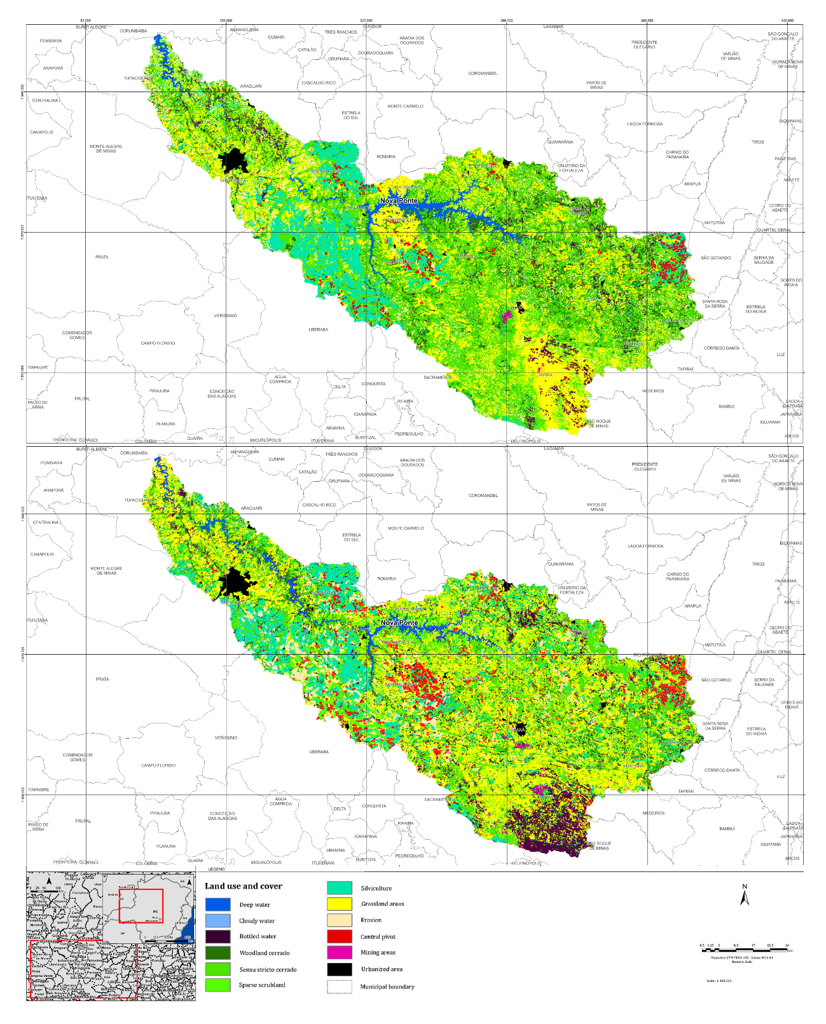
a)
b)
Figure S1: Use and occupation maps 2005 (a) and 2015 (b)

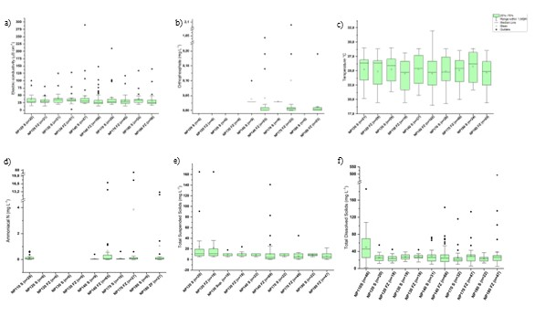
Figure S2: Box whisker Electrical conductivity (a), Orthophosphate (b), Temperature(c), Ammoniacal N (d), Total suspended solids (e) and Total dissolved solids (f) in the sampled stations of the reservoir at Fotic Zone (FZ) and Surface (S)

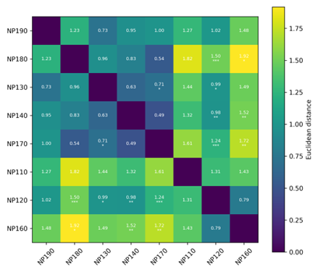
Figure S3: Heatmap of Euclidean distances among sampling stations based on standardized environmental variables. Values represent pairwise dissimilarities between stations. Asterisks indicate statistically significant differences based on Mann–Whitney tests with Benjamini–Hochberg correction ( p < 0.05, ** p < 0.01, *** p < 0.001*).

