Supplemental materials

Table S1. Associations between the aggregated life-impact score and measures of psychological functioning in an independent sample
Table S2. Descriptive statistics for experience frequency, perceived life impact, and spiritual or religious interpretation across the 12 psychotic-like nonordinary experiences

Figure S1. Distribution of experience frequency across experience types
Figure S2. Distribution of perceived life impact across experience types
Figure S3. Distribution of spiritual or religious interpretation across experience types

Table S3. Experience-specific regression models

Figure S4. Experience-specific associations between interpreting nonordinary experiences as spiritual or religious and their perceived life impact across all INOE experiences.

Table S1. Associations between the aggregated life-impact score and measures of psychological functioning in an independent sample
 | N | Rho
Life Satisfaction | 1615 | .179
Loneliness (reverse score) | 1615 | .179
PHQ-9 | 1615 | -.208
GAD-7 | 1615 | -.185

Table S2. Descriptive statistics for experience frequency, perceived life impact, and spiritual or religious interpretation across the 12 psychotic-like nonordinary experiences
Experience | Observations | Frequency |  | Life Impact |  | Spiritual/religious  interpretation (%)
Experience | Observations | Mean | SD | Mean | SD | Spiritual/religious  interpretation (%)
Diminished sense of self | 1098 | 3.88 | 1.58 | 3.25 | 1.43 | 37.10
Auditory experience | 1,27 | 3.71 | 1.39 | 2.71 | 1.04 | 28.80
Olfactory experience | 977 | 3.49 | 1.33 | 3.29 | 1.05 | 29.80
Sensed presence | 866 | 3.61 | 1.45 | 3.46 | 1.29 | 58.10
Perception of animated places | 802 | 3.34 | 1.43 | 3.88 | 1.18 | 59.20
Tactile experience | 699 | 3.29 | 1.33 | 2.76 | 1.19 | 40.60
Visual experience | 392 | 3.14 | 1.30 | 2.85 | 1.16 | 37.00
Out-of-body experience | 345 | 2.96 | 1.25 | 3.11 | 1.24 | 40.60
Sensed presence or communication with the deceased | 339 | 3.28 | 1.43 | 3.72 | 1.16 | 64.90
Experience of another self within the body | 306 | 3.47 | 1.44 | 2.96 | 1.40 | 50.70
Perception of animated objects | 285 | 2.97 | 1.23 | 3.56 | 1.21 | 53.70
Perception of auras | 232 | 2.96 | 1.27 | 3.79 | 1.05 | 55.60
Note. Frequency ranged from 1 (never) to 6 (more than 10 times), and perceived life impact ranged from 1 (very negative) to 5 (very positive).
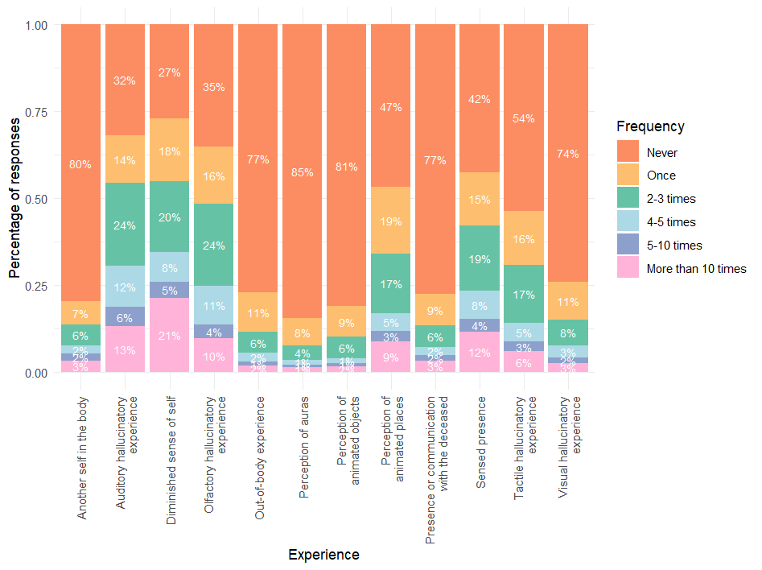
Figure S1. Distribution of experience frequency across experience types
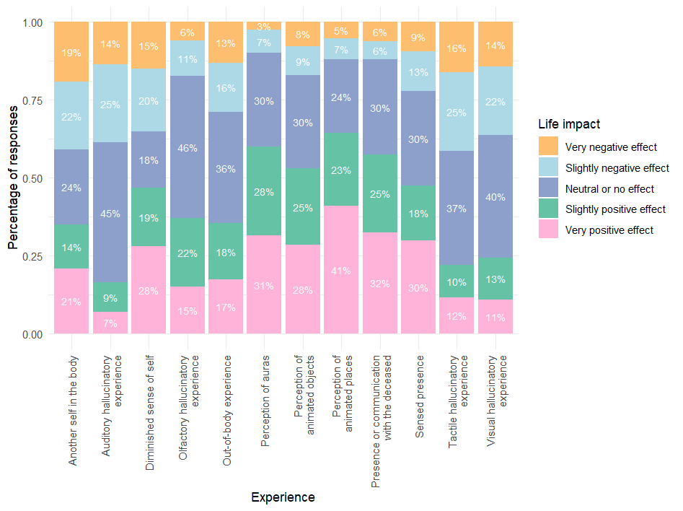
Figure S2. Distribution of perceived life impact across experience types

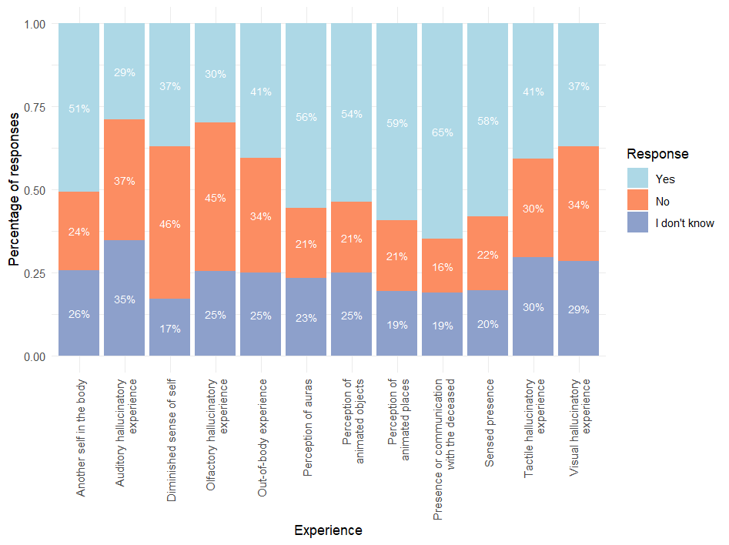
Figure S3. Distribution of spiritual or religious interpretation across experience types

Table S3. Experience-specific regression models
Experience | Observations | b | 95% CI | SE | t | p | p_adjusted
Diminished sense of self | 1,098 | 1.18 | [1.014, 1.354] | 0.09 | 13.69 | < .001 | < .001
Experience of another  self within the body | 306 | 1.05 | [0.693, 1.401] | 0.18 | 5.82 | < .001 | < .001
Perception of animated objects | 285 | 0.91 | [0.572, 1.240] | 0.17 | 5.34 | < .001 | < .001
Sensed presence | 866 | 0.84 | [0.639, 1.045] | 0.10 | 8.14 | < .001 | < .001
Perception of animated places | 802 | 0.79 | [0.600, 0.980] | 0.10 | 8.17 | < .001 | < .001
Perception of auras | 232 | 0.63 | [0.297, 0.955] | 0.17 | 3.75 | < .001 | .002
Sensed presence or communication  with the deceased | 339 | 0.59 | [0.262, 0.925] | 0.17 | 3.52 | < .001 | .003
Out-of-body experience | 345 | 0.38 | [0.079, 0.677] | 0.15 | 2.49 | .013 | .033
Visual hallucinatory experience | 392 | 0.35 | [0.081, 0.624] | 0.14 | 2.55 | .011 | .026
Tactile hallucinatory experience | 699 | 0.31 | [0.097, 0.520] | 0.11 | 2.86 | .004 | .021
Olfactory hallucinatory experience | 977 | 0.23 | [0.072, 0.381] | 0.08 | 2.88 | .004 | .021
Auditory hallucinatory experience | 1,027 | 0.12 | [-0.036, 0.281] | 0.08 | 1.52 | .130 | .130
Note. Separate linear regression models were estimated for each experience type, with perceived life impact as the outcome and spiritual or religious interpretation and experience frequency as predictors. Estimates represent the adjusted contrast between experiences interpreted as spiritual or religious (“Yes”) and those not interpreted as spiritual or religious (“No”). p values were adjusted across the 12 experience-specific tests using the Holm procedure. b = unstandardized regression coefficient; SE = standard error; CI = confidence interval.

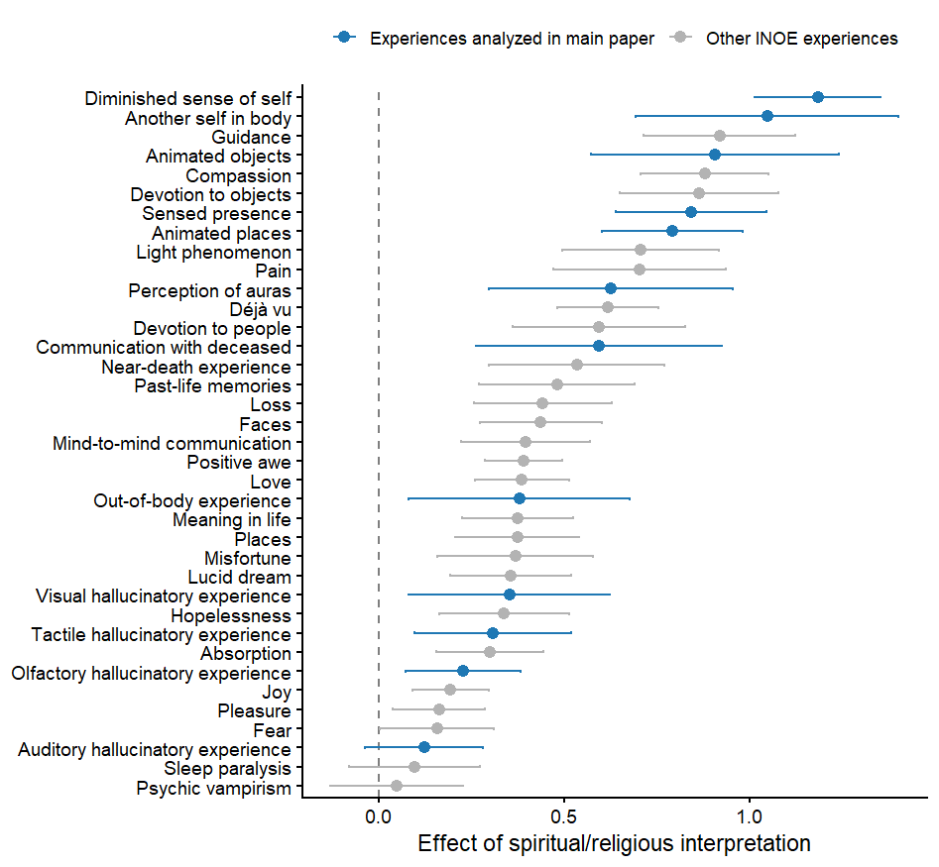
Figure S4. Experience-specific associations between interpreting nonordinary experiences as spiritual or religious and their perceived life impact across all INOE experiences.
Note. Point estimates and 95% confidence intervals are shown for the adjusted association between interpreting an experience as spiritual or religious ("Yes") versus not ("No") and its perceived life impact. Estimates were obtained from separate linear regression models for each experience, adjusting for experience frequency. Experiences included in the primary analyses are highlighted in blue.

