SUPPLEMENTARY FIGURES

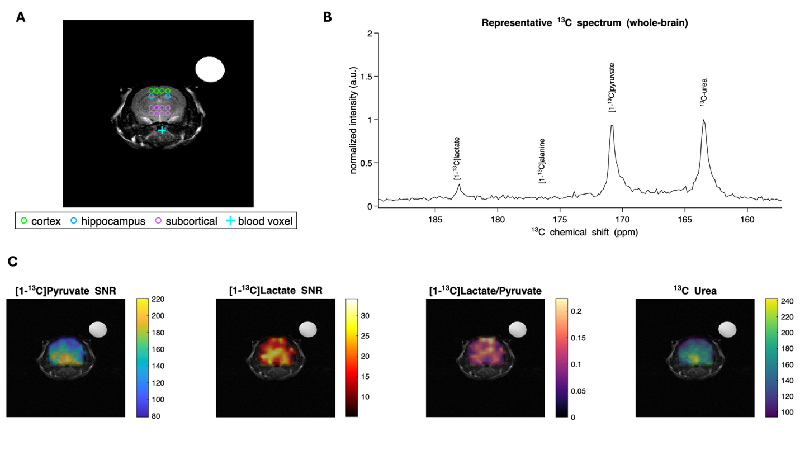
Figure S1. Representative HP ¹³C Spectra and metabolite maps. (A) Anatomical image with marker overlay for ROI voxels from which HP 13C metabolite data are extracted; (B) Representative ¹³C Spectra from the whole brain; (C) HP ¹³C metabolite maps of [1-¹³C]Pyruvate, [1-¹³C]Lactate, [1-¹³C]Lactate/Pyruvate and ¹³C Urea.

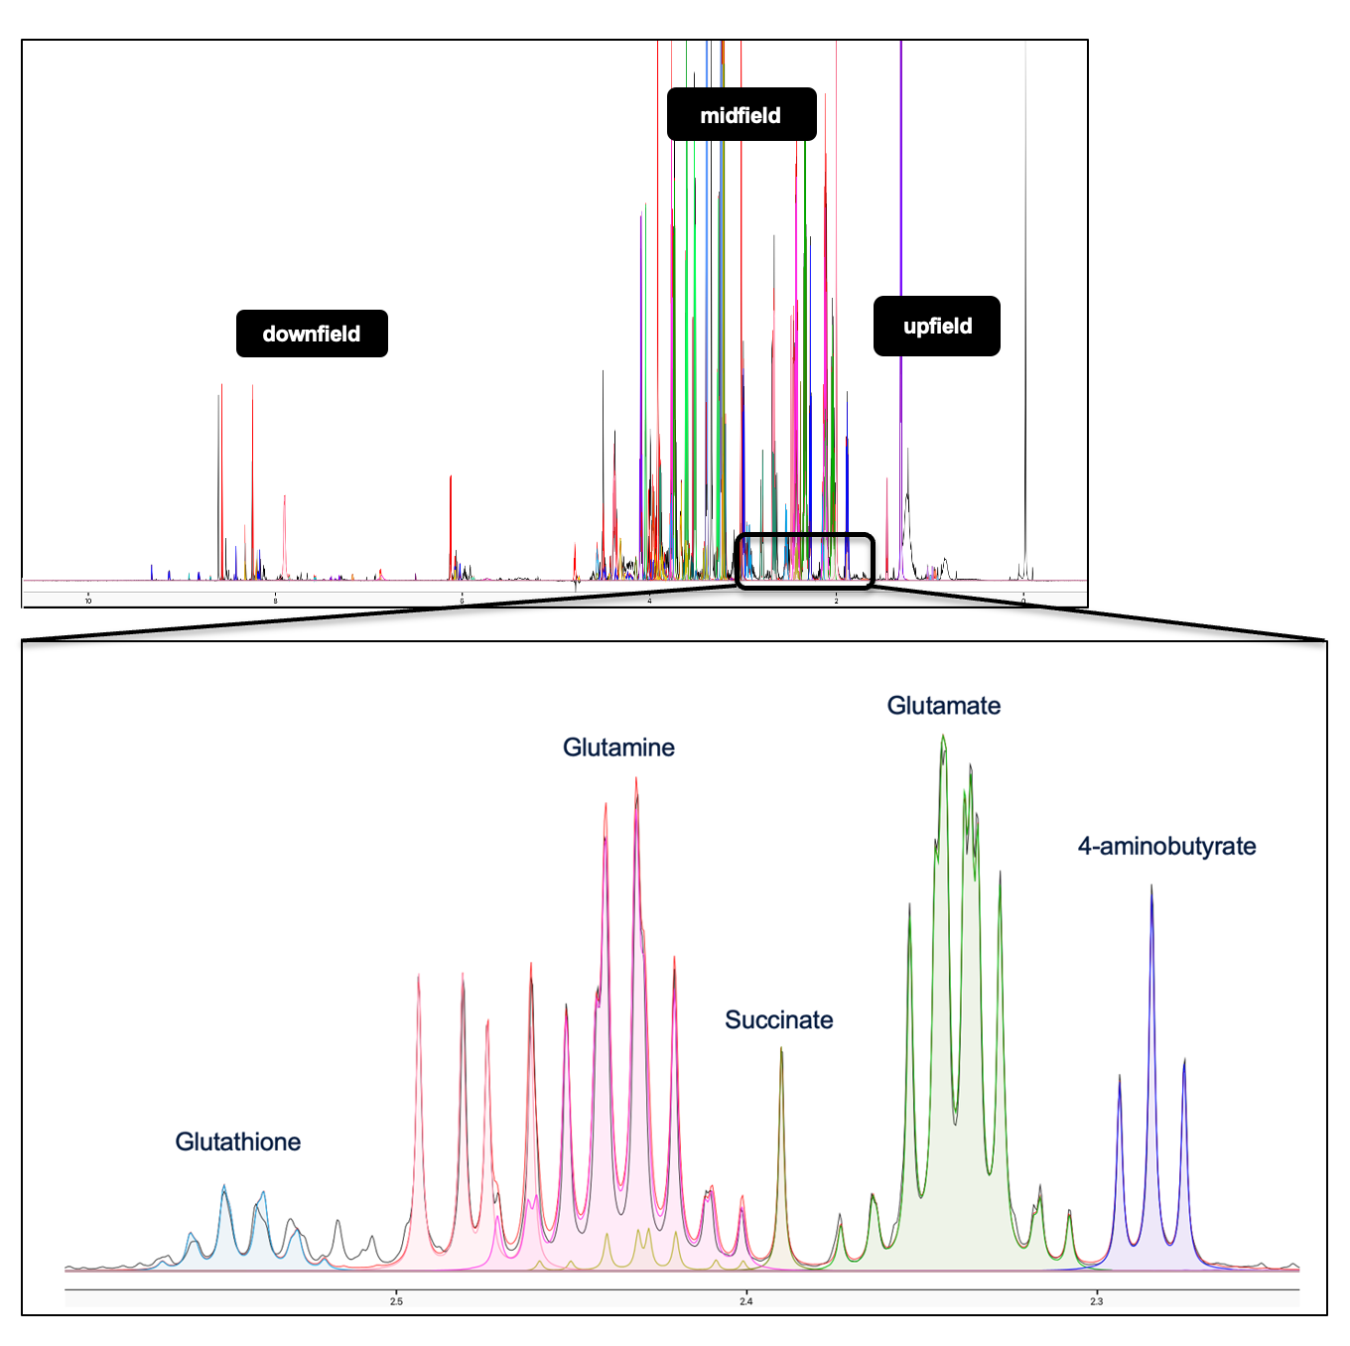
Figure S2. Representative ¹H-NMR spectrum of brain tissue extracts with metabolite peak assignments. (Top) Full ¹H-NMR spectrum spanning the downfield, midfield, and upfield regions, with overlaid traces from individual samples. (Bottom) Expanded view of the boxed midfield region (~2.3–2.5 ppm), showing resolved resonances for representative metabolites including glutathione, glutamine, succinate, glutamate, and 4-aminobutyrate (GABA). Peaks are color-coded by metabolite, and spectral fits are overlaid on the acquired spectra.

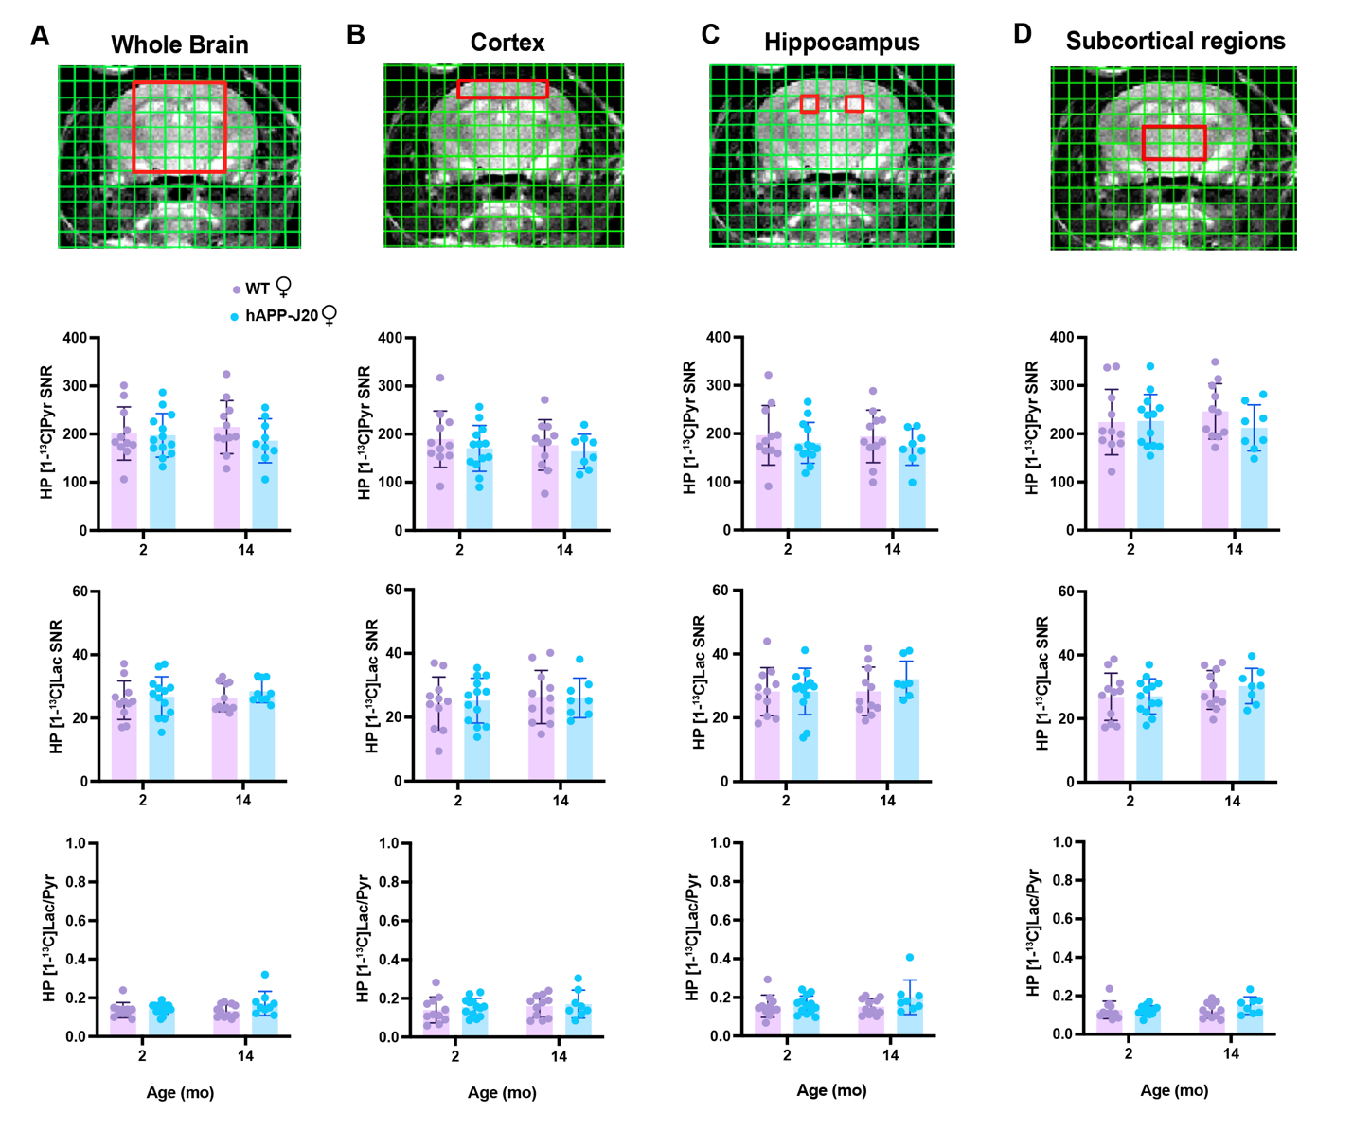

Figure S3. Unadjusted HP [1-¹³C] metabolite signals across age in hAPP-J20 and WT female mice. Each column represents the anatomical image with an overlay ROI, whereas inter-genotypic differences in SNR of HP [1-¹³C]Pyruvate, HP [1-¹³C]Lactate and HP [1-¹³C]Lactate/Pyruvate conversion, for (A) whole brain, (B) Cortex, (C) Hippocampus, and (D) Subcortical regions. Graph representation of bar graphs with subject values with SD per group; linear mixed model with Šidák post-hoc correction: dotted line - main age effect, full line - post-hoc comparisons; *p ≤ .05, **p ≤ 0.01, ***p ≤ 0.001, ****p ≤ 0.0001

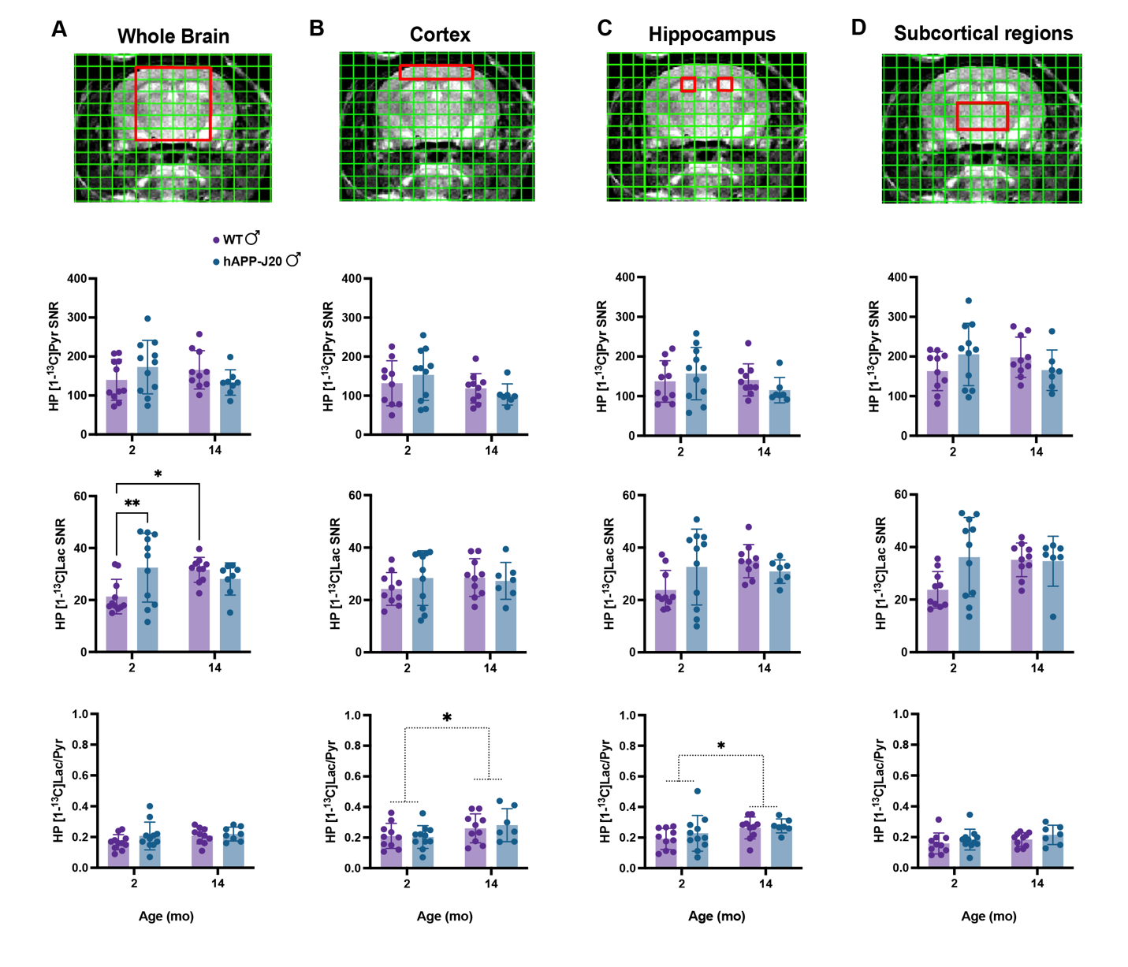
Figure S4. Unadjusted HP [1-¹³C] metabolite signals across age in hAPP-J20 and WT male mice. Each column represents the anatomical image with an overlay ROI, whereas inter-genotypic differences in SNR of HP [1-¹³C]Pyruvate, HP [1-¹³C]Lactate and HP [1-¹³C]Lactate/Pyruvate conversion, for (A) whole brain, (B) Cortex, (C) Hippocampus, and (D) Subcortical regions. Graph representation of bar graphs with subject values with SD per group; linear mixed model with Šidák post-hoc correction: dotted line - main age effect, full line - post-hoc comparisons; *p ≤ .05, **p ≤ 0.01, ***p ≤ 0.001, ****p ≤ 0.0001

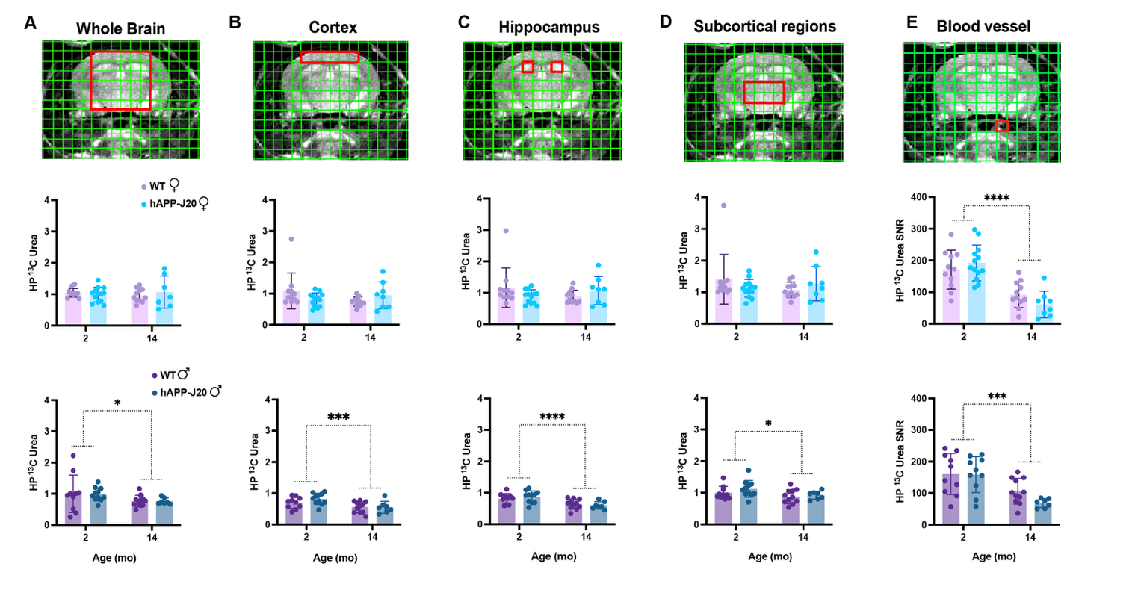
Figure S5. Normalized HP ¹³C Urea across age in hAPP-J20 and WT mice. Each column represents the anatomical image with an overlay ROI, with inter-genotypic differences for (A) whole brain, (B) Cortex, (C) Hippocampus, and (D) Subcortical regions (E) Blood voxel (unadjusted HP ¹³C Urea SNR). Top row is females and bottom row is males. Graph representation of bar graphs with subject values with SD per group; linear mixed model with Šidák post-hoc correction: dotted line - main age effect, full line - post-hoc comparisons; *p ≤ .05, **p ≤ 0.01, ***p ≤ 0.001, ****p ≤ 0.0001

