Table S1. The composition and volume of materials required for the cDNA synthesis reaction (volumes in microliters)
(OD ≥ 600) Group3 | Group 2 (OD 300-600) | Group 1 (OD 100-300) | Components
2.5 | 1.5 | 1 | nuclease-free H2O
14 | 14 | 12 | cDNA Master mix
1 | 1 | 1 | Primer pool
1 | 1 | 1 | Random Hexamer
2 | 3 | 6 | RNA
20 | 20 | 20 | Total

Table S2. Temperature protocol for the cDNA synthesis
Cycle | Temperature (°C) | Time
1 | 50 | 30 minutes
2 | 90 | 5 seconds
3 | 4 | ∞

Table S4. Temperature program of Real-Time PCR steps
Time | Temperature(°C) | No of cycles | Steps
15 min | 95 | 1 | Pre-Incubation
20 sec | 95 | 45 | Amplification
30 sec | 60 | 45 | Amplification
60 min | 60-95 | 1 | Melting curve

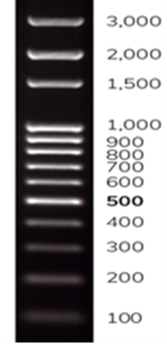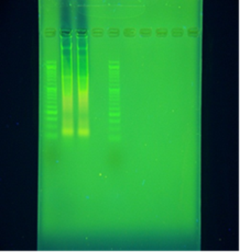
Fig S1. Agarose Gel electrophoresis of total RNA samples

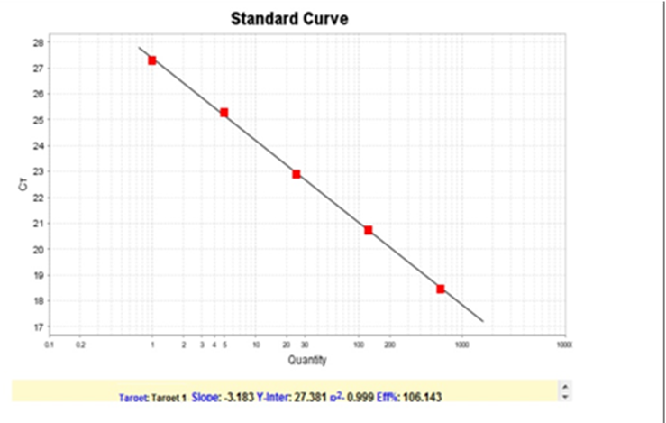
Fig S2. Standard curve of lncRNA Morrbid gene primer

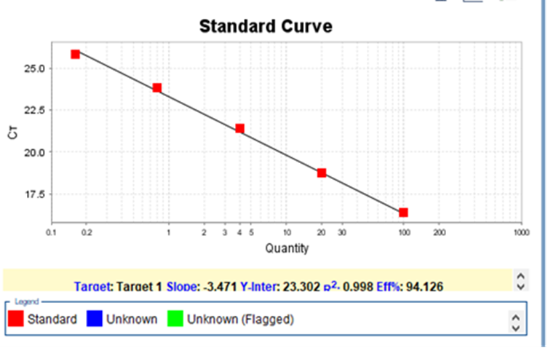
Fig S3. Standard curve of lncRNA NeST gene primer
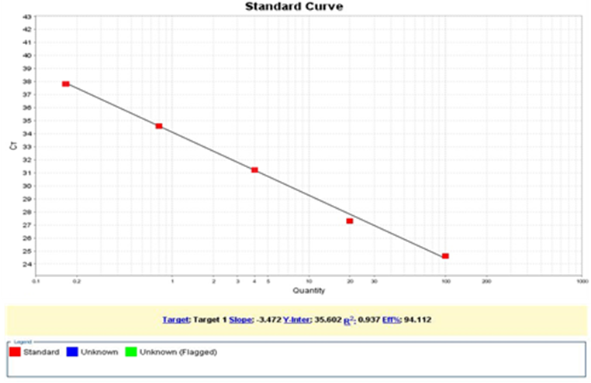
Fig S4. Standard curve of the ACTB gene primer
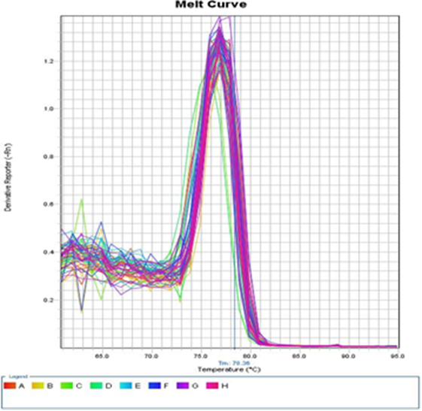
Fig S5. Melt curve of Morrbid lncRNA
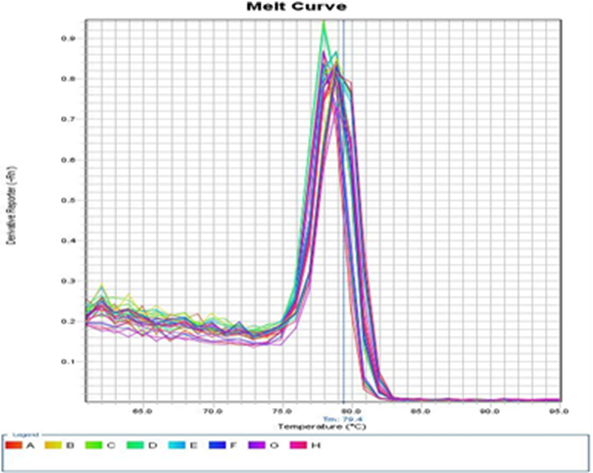
Fig S6. Melt curve of NeST lncRNA
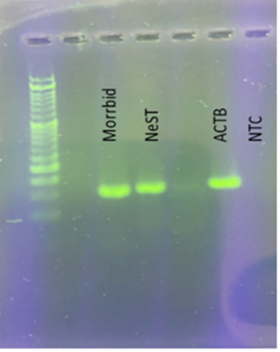
Fig S7. Agarose gel electrophoresis of Real-time PCR (lncRNA Morrbid, lncRNA NeST, ACTB)

