Metastatic Cancers Exploit Vagal Sensory Neurons and Neural Repair Programs to Colonize New Tissues
Tiago H Zaninelli,^{1,2,*} Telma Saraiva-Santos,^{1,2} Gustavo Gastão Davanzo,^{2,3} Alliny CS Bastos,^{1,4} Ruben Silva,^{2,3} Jose C de Lima-Junior,⁵ Amanda Martins Dionisio,^{1,2,7} Soraia Mendes-Pierotti,^{1,2,6} Kennedy K Reed,^{1,2} Yuriy Kirichok,⁵ Rubia Casagrande,⁶ Waldiceu A Verri Jr.,⁷ Igor Smirnov,^{2,3} Jason Weber,^{1,4} David Y Chen,¹ Jonathan Kipnis,^{2,3} and Felipe A Pinho-Ribeiro^{1,2, **}
¹Department of Medicine, School of Medicine, Washington University in St. Louis, Saint Louis, MO, USA
²Brain Immunology and Glia (BIG) Center, Washington University in St. Louis, Saint Louis, MO, USA
³Department of Pathology and Immunology, School of Medicine, Washington University in St. Louis, Saint Louis, MO, USA
⁴Division of Medical Oncology, Washington University in St. Louis, Saint Louis, MO, USA
⁵Department of Biochemistry & Molecular Biophysics, Washington University in St. Louis, St. Louis, MO, USA
⁶Department of Pharmaceutical Sciences, Center of Health Sciences, Londrina State University, Londrina, Paraná, Brazil
⁷Department of Immunology, Parasitology, and Pathology, Center of Biological Sciences, Londrina State University, Londrina, Paraná, Brazil
*Correspondence: tiago@wustl.edu
**Correspondence: dfelipe@wustl.edu

Supplementary Information (SI)

- Supplementary Tables

Supplementary Table 1 – Summary of predicted protein–protein interactions between vagal sensory neurons and tumor cells.
Ligand | Receptor | Source | Target | Mean source expression | Mean target expression | Source Detection fraction | Target detection fraction
NINJ1 | NINJ1 | Vagal neurons | Tumor | 0.688312 | 0.574695 | 0.806363 | 0.770411
NINJ1 | NINJ1 | Tumor | Vagal Neurons | 0.574695 | 0.688312 | 0.770411 | 0.806363

Supplementary Table 2 – CRISPR–Cas9-induced mutations in the murine Ninj1 locus identified by next-generation sequencing.
Original sequencing |  | CAGCCACCCCGCTGGGGTTTGCGGAACCGGCCC
B16F10^{ΔNinj1} | Allele I | CAGCCACCCCGCTGGGGTTTGCGGAACCGGCCC
B16F10^{ΔNinj1} | Allele II | CAGCCACCCCGCTGGGGTTTGCGGAACCGGCCC
EO771^{ΔNinj1} | Allele I | CAGCCACCCCGCTGGGGTTTGCGGAACCGGCCC
EO771^{ΔNinj1} | Allele II | CAGCCACCCCGCTGGGGGTTGCGGAACCGGCCC
EO771^{ΔNinj1} | Allele III | CAGCCACCCCGCTGGGGTTTGCGGAACCGGCCC
4T1^{ΔNinj1} | Allele I | CAGCCACCCCGCTGGGGTTTGCGGAACCGGCCC
4T1^{ΔNinj1} | Allele II | CAGCCACCCCGCTGGGGTTTGCGGAACCGGCCC
4T1^{ΔNinj1} | Allele III | CAGCCACCCCGCTGGGGTTTGCGGAACCGGCCC
Red strikethrough base pairs, deletion; green underlined base pairs, substitution.

Supplementary Table 3 – STR profile from WT and NINJ1 KO cells.
Loci | B16F10^{WT} | B16F10^{ΔNinj1} | EO771^{WT} | EO771^{ΔNinj1} | 4T1^{WT} | 4T1^{ΔNinj1}
1-1 |  | 17, 18 | 17, 18, 19 | 17, 18, 19 | 15, 16 | 16
1-2 |  | 18.3, 19.3 | 18.3, 19.3, 21.3 | 19.3, 21.3 | 16.3 | 16.3
2-1 |  | 16 | 16, 18 | 16, 18 | 16, 17 | 16, 17
3-2 |  | 14, 15 | 14, 15 | 14, 15 | 14, 15 | 14, 15
4-2 | 20.3, 21.3 | 20.3, 21.3 | 21.3, 22.3, 24.3 | 21.3, 22.3, 24.3 | 21.3 | 21.3
5-5 |  |  |  | 17, 21, 22 | 14 | 14
6-7 | 15 | 15 | 15, 16 | 15, 17 | 12 | 12
8-1 |  | 15, 16, 17, 18 | 16 | 16 | 13 | 13
9-2 | 18, 19 | 18, 19 | 17, 19 | 17, 19 | 15 | 15
12-1 | 18,17 | 18, 17 | 17,18 | 17, 18 | 16 | 16
15-3 | 22.3, 23.3 | 22.3, 23.3 | 22.3, 23.3 | 22.3, 23.3 | 22.3 | 22.3, 23.3
18-3 | 15, 16 | 15,16 | 16, 18 | 16, 18 | 18, 19 | 18, 19
19-2 |  | 13, 14 | 13 | 13 | 13 | 13
X-1 |  | 28 | 27, 29 | 27, 29 | 25 | 25

Supplementary Table 4 – Sequence of primers used for quantitative gene expression (qRT-PCR)
 | Forward (5’ to 3’) | Reverse (5’ to 3’)
Gapdh | TGG CCT TCC GTG TTC CTA C | GAG TTG CTG TTG AAG TCG CA
Actb | GGC TGT ATT CCC CTC CAT CG | CCA GTT GGT AAC AAT GCC ATG T
Ninj1 | CCA CCC CGC TGG GGT TTG CG | TGG CCG GGT TGT TGA GGT CA
Wnt5a | CAA CTG GAC GGA CTT TCT CAA | CAT CTC CGA TGC CGG AAC T
Nes | CCC CTT GCC TAA TAC CCT TGA | GCC TCA GAC ATA GGT GGG ATG
Prom1 | GAC CAG GAC TCG GAT CAA AGG | TGT ACT GCT CCA CTA CAT AGT CA
Igf1r | TGA CAT CCG CAA CGA CTA TCA | CCA GTG CGT AGT TGT AGA AGA GT
Igf2r | TGC CAG CCT TCA GAT TCA CAG | CAG ATA GCC ACC ATT TAG CTT GA
Trpm1 | AGG TGG TCC TAA CGT GGT TTC | TCC TTC GTC GCA GTA TTT GTG

- Supplementary Video
Supplementary Video 1. Sensory neuron innervation of melanoma lung metastases. Three-dimensional confocal z-stack rendering of B16F10-eGFP⁺ melanoma cells in a 200-µm lung slice from Nav1.8^{tdTomato} mice, showing the spatial association between metastatic tumor cells and sensory fibers. B16F10-eGFP⁺ tumor cells are shown in green, and Nav1.8⁺ sensory neurons are shown in magenta.
- Supplementary Data
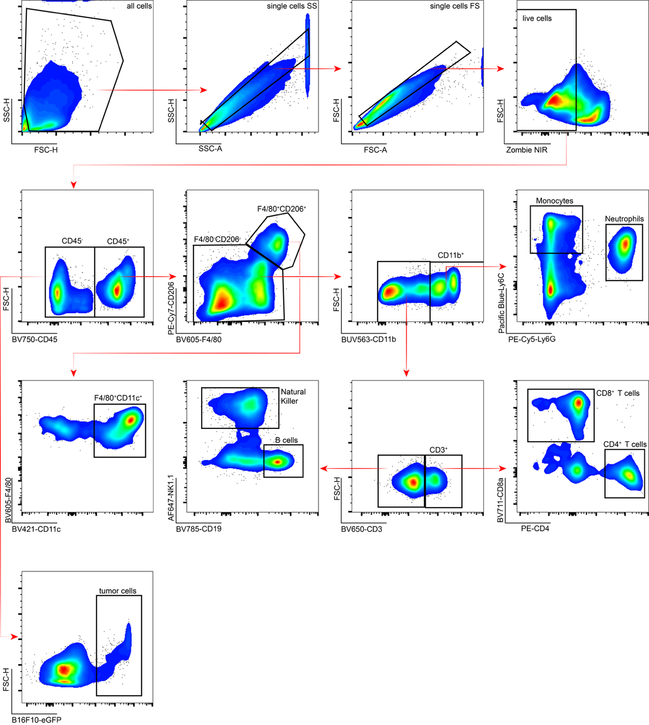
Supplementary Data Figure 1. Gating strategy for flow cytometry of lung tissue.

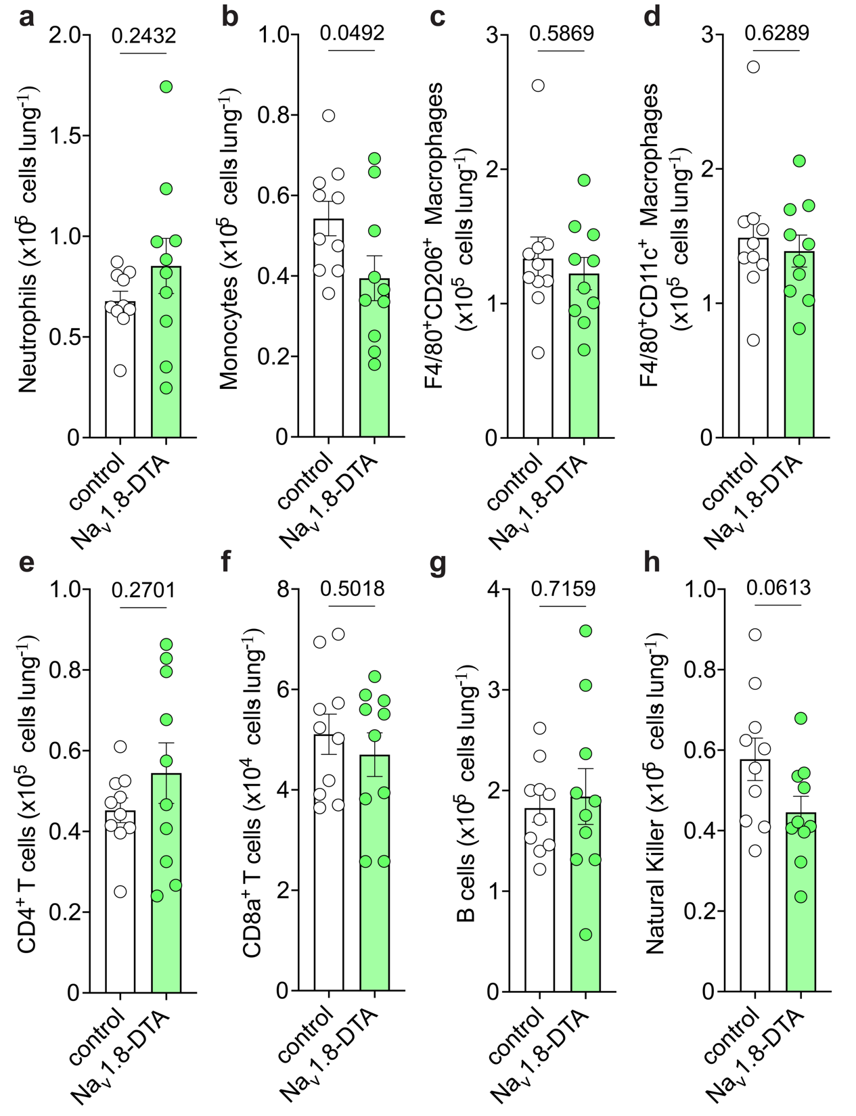
Supplementary Data Figure 2. Baseline lung immune landscape in control and Na_{v}1.8-DTA mice. Flow cytometry quantification of a, neutrophils; b, monocytes; c, F4/80⁺CD206⁺ macrophages; d, F4/80⁺CD11c⁺ macrophages; e, CD4⁺ T cells; f, CD8⁺ T cells; g, B cells; and h, natural killer cells in lung tissue. n = 10 mice per group. Data are shown as mean ± SEM of cell number per lung. Statistical significance was determined by unpaired two-tailed Student’s t-test in a–h.
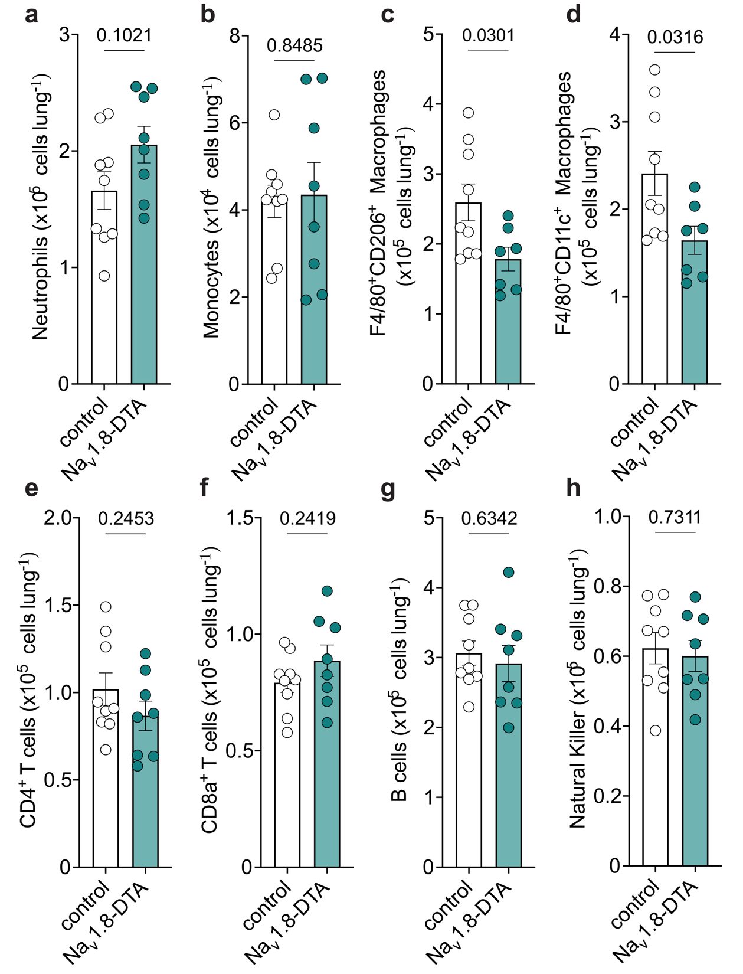
Supplementary Data Figure 3. Comparative lung immune landscape in control and Na_{v}1.8-DTA mice during B16F10 metastasis. Flow cytometry quantification of a, neutrophils; b, monocytes; c, F4/80⁺CD206⁺ macrophages; d, F4/80⁺CD11c⁺ macrophages; e, CD4⁺ T cells; f, CD8⁺ T cells; g, B cells; and h, natural killer cells in lung tissue. n = 8–9 mice per group. Data are shown as mean ± SEM of cell number per lung. Statistical significance was determined by unpaired two-tailed Student’s t-test in a–h.
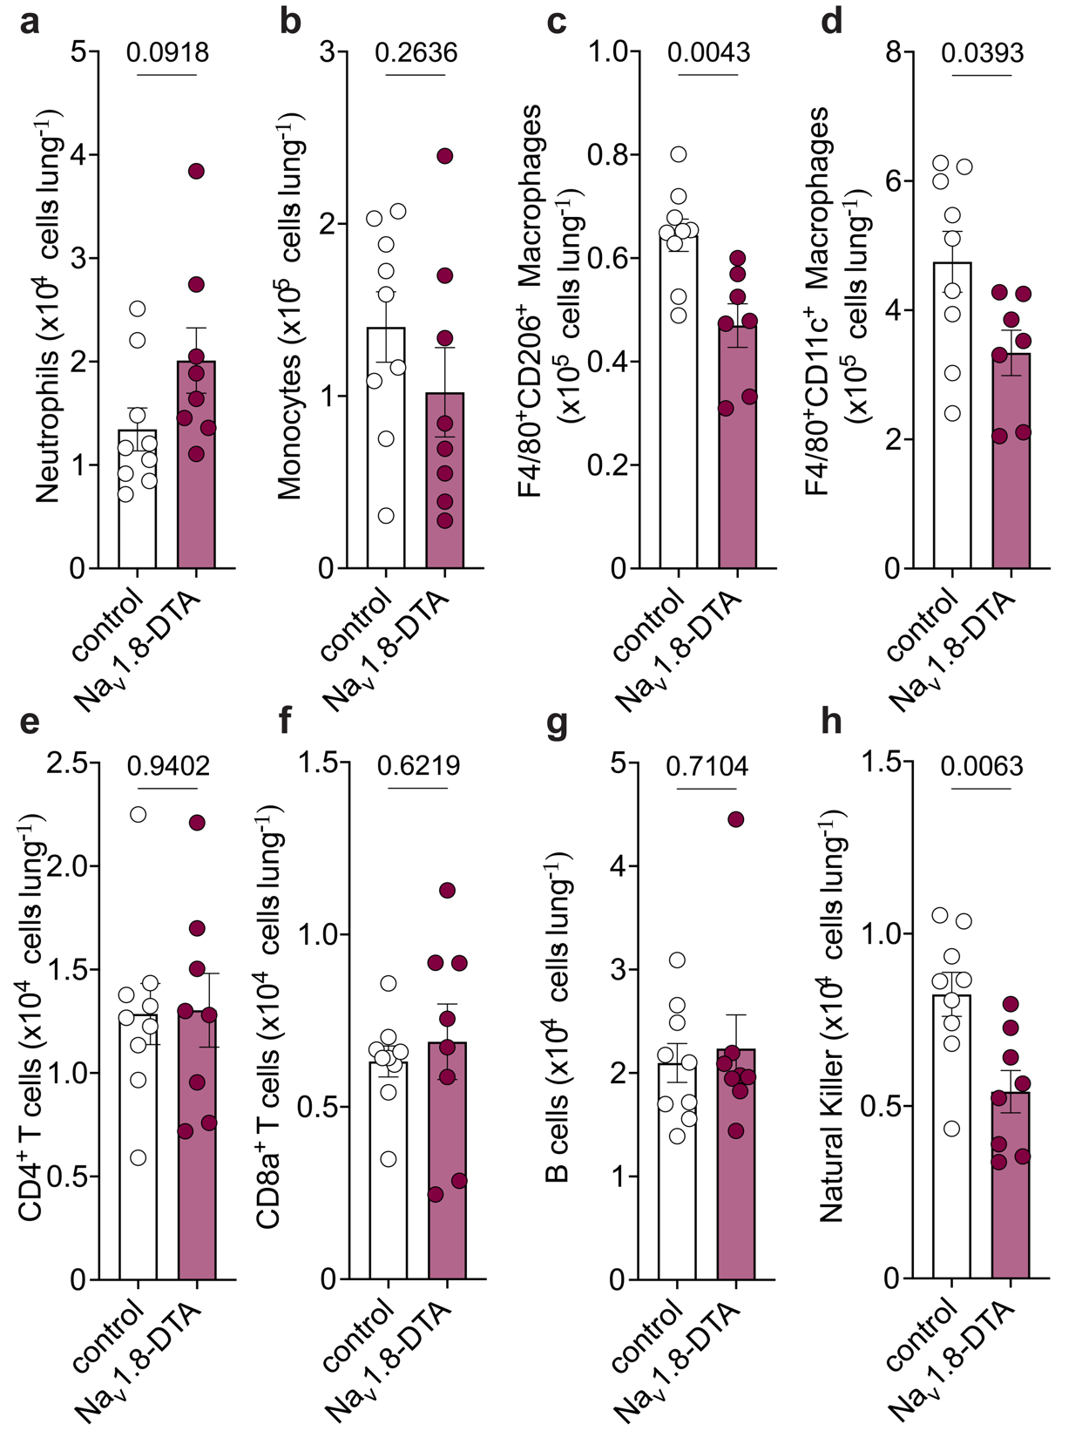
Supplementary Data Figure 4. Comparative lung immune landscape in control and Na_{v}1.8-DTA mice during EO771 metastasis. Flow cytometry quantification of a, neutrophils; b, monocytes; c, F4/80⁺CD206⁺ macrophages; d, F4/80⁺CD11c⁺ macrophages; e, CD4⁺ T cells; f, CD8⁺ T cells; g, B cells; and h, natural killer cells in lung tissue. n = 9–10 mice per group. Data are shown as mean ± SEM of cell number per lung. Statistical significance was determined by unpaired two-tailed Student’s t-test in a–h.
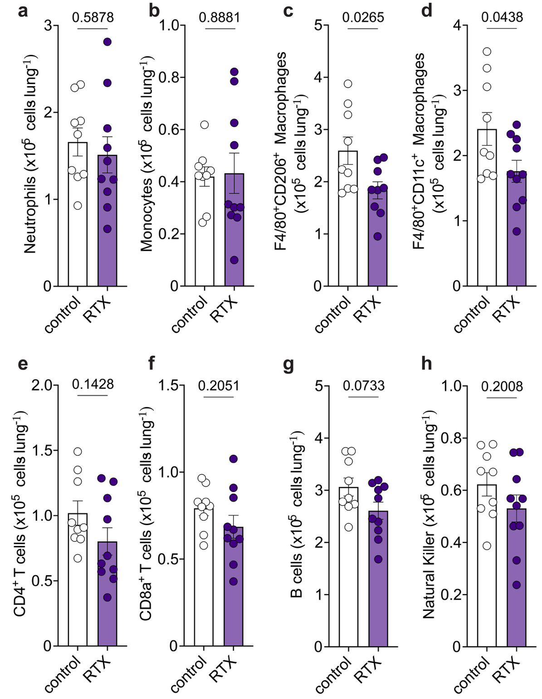
Supplementary Data Figure 5. Comparative lung immune landscape in vehicle- and RTX-treated mice during B16F10 metastasis. Flow cytometry quantification of a, neutrophils; b, monocytes; c, F4/80⁺CD206⁺ macrophages; d, F4/80⁺CD11c⁺ macrophages; e, CD4⁺ T cells; f, CD8⁺ T cells; g, B cells; and h, natural killer cells in lung tissue. n = 9–10 mice per group. Data are shown as mean ± SEM of cell number per lung. Statistical significance was determined by unpaired two-tailed Student’s t-test in a–h.
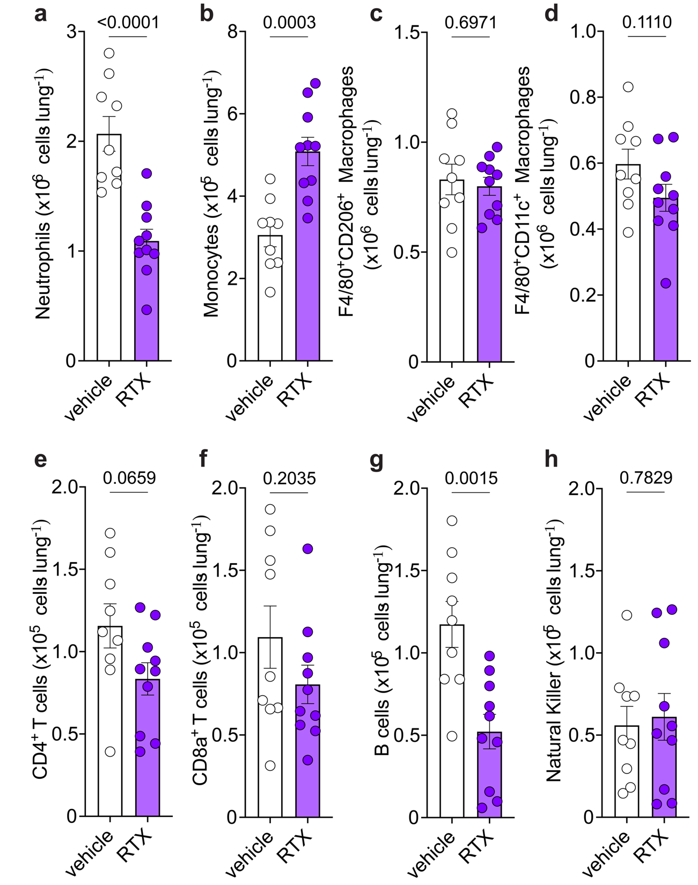
Supplementary Data Figure 6. Comparative lung immune landscape in vehicle- and RTX-treated mice during 4T1 metastasis. Flow cytometry quantification of a, neutrophils; b, monocytes; c, F4/80⁺CD206⁺ macrophages; d, F4/80⁺CD11c⁺ macrophages; e, CD4⁺ T cells; f, CD8⁺ T cells; g, B cells; and h, natural killer cells in lung tissue. n = 9–10 mice per group. Data are shown as mean ± SEM of cell number per lung. Statistical significance was determined by unpaired two-tailed Student’s t-test in a–h.
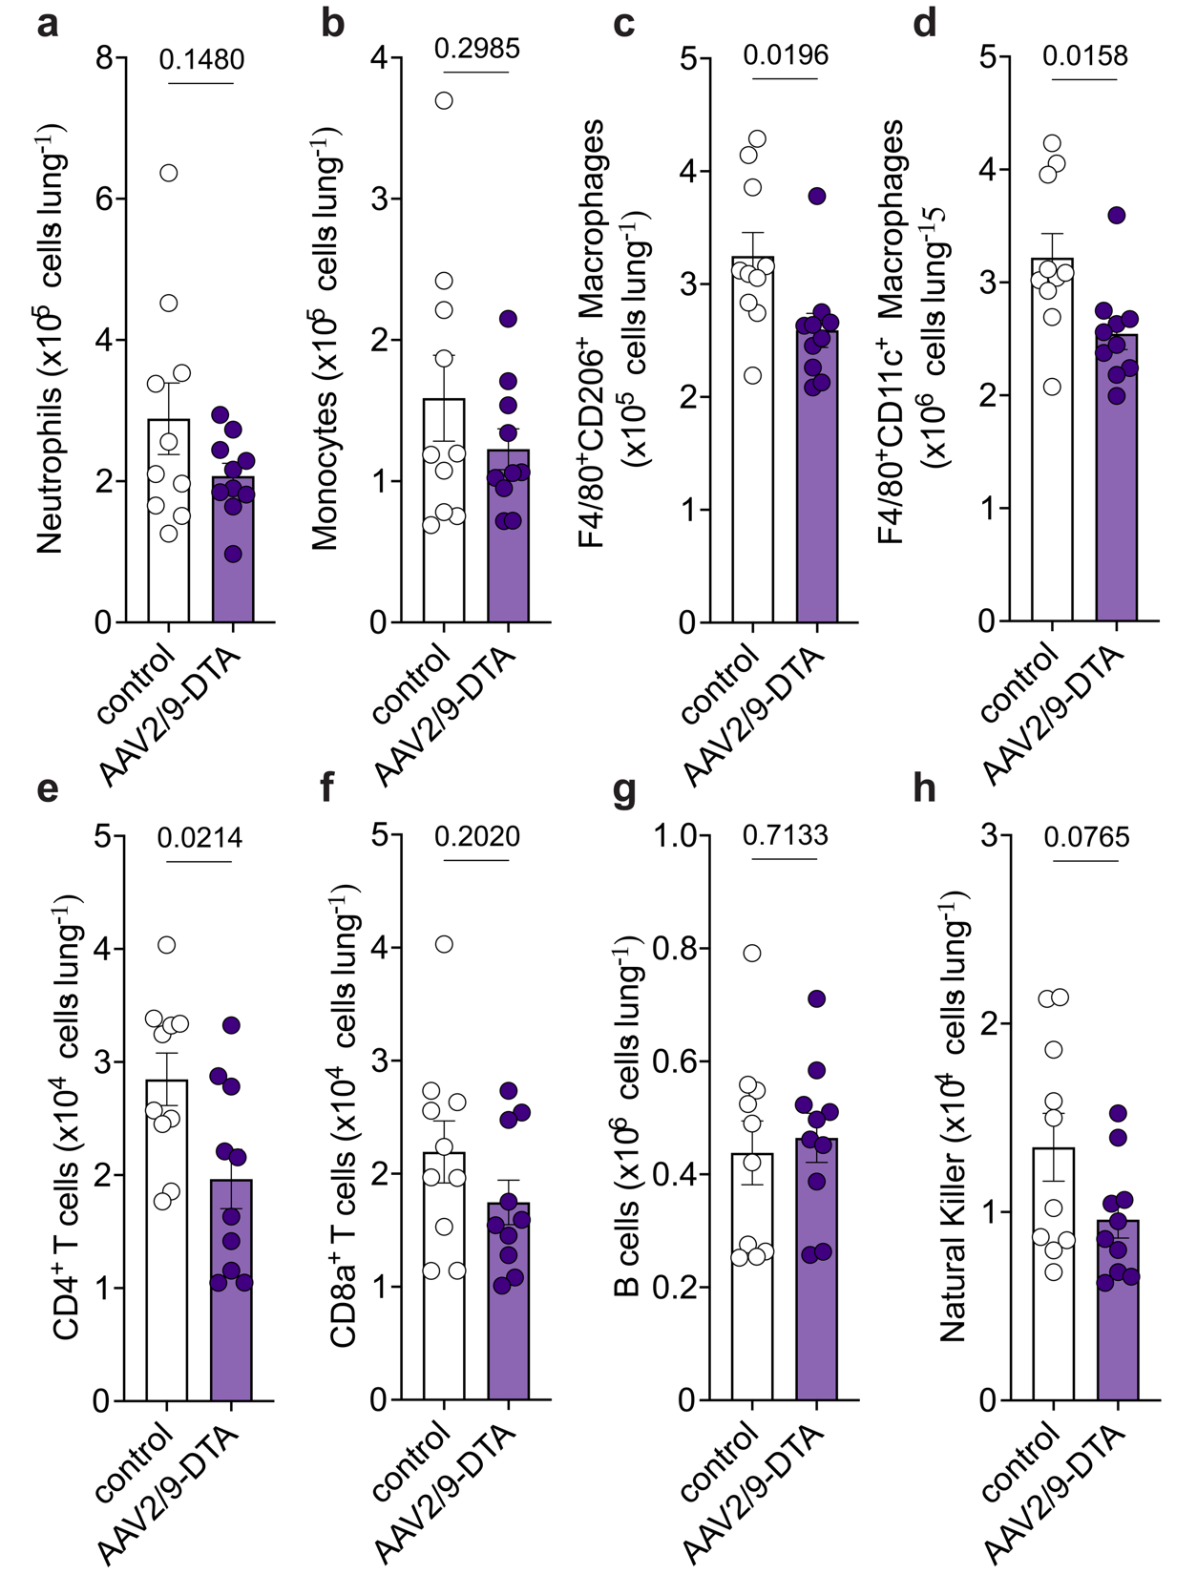
Supplementary Data Figure 7. Comparative lung immune landscape in control and AAV2/9-TRPV1-DTA intratracheally instilled mice during B16F10 metastasis. Flow cytometry quantification of a, neutrophils; b, monocytes; c, F4/80⁺CD206⁺ macrophages; d, F4/80⁺CD11c⁺ macrophages; e, CD4⁺ T cells; f, CD8⁺ T cells; g, B cells; and h, natural killer cells in lung tissue. n = 9–10 mice per group. Data are shown as mean ± SEM of cell number per lung. Statistical significance was determined by unpaired two-tailed Student’s t-test in a–h.
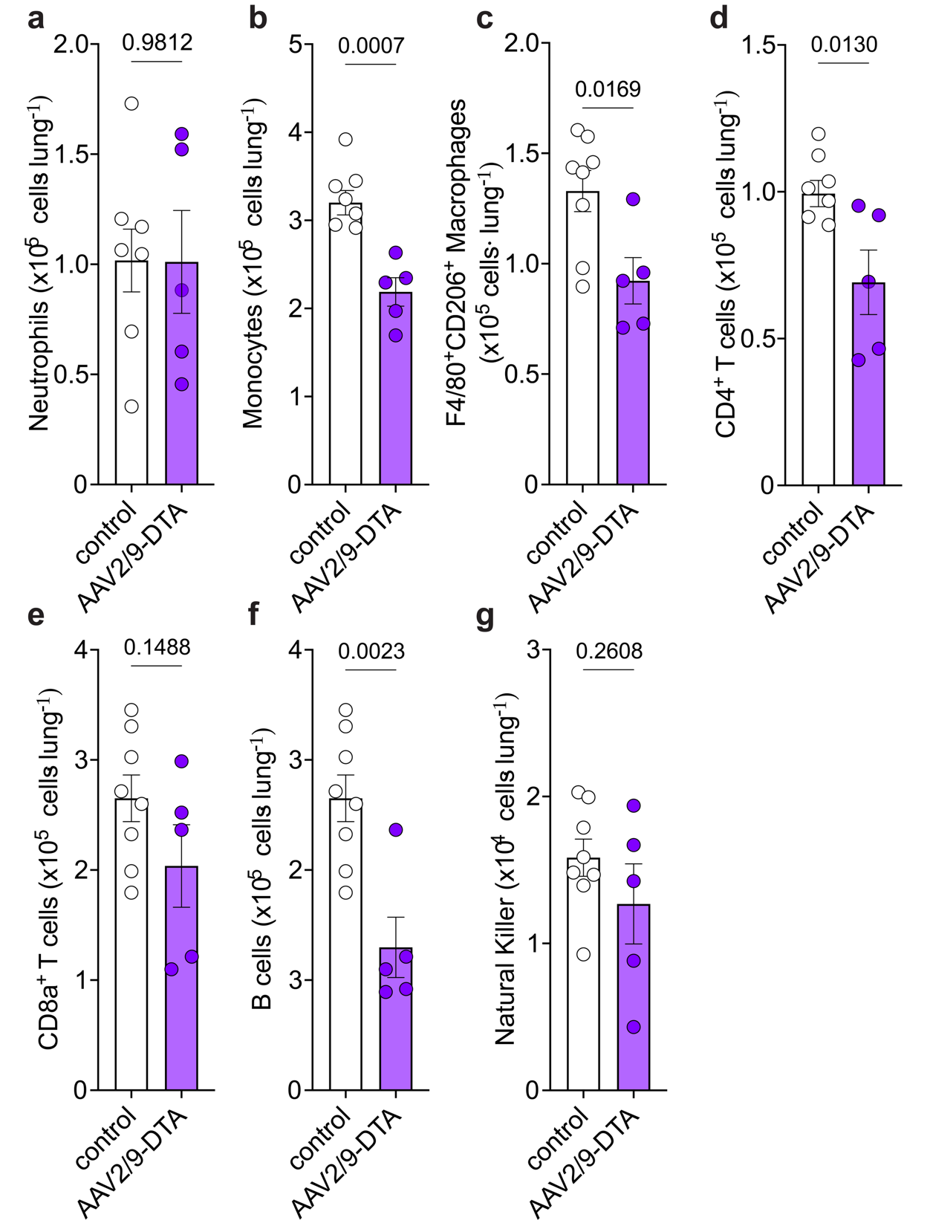
Supplementary Data Figure 8. Comparative lung immune landscape in control and AAV2/9-TRPV1-DTA intraganglionic injected mice during B16F10 metastasis. Flow cytometry quantification of a, neutrophils; b, monocytes; c, F4/80⁺CD206⁺ macrophages; d, CD4⁺ T cells; e, CD8⁺ T cells; f, B cells; and g, natural killer cells in lung tissue. n = 9–10 mice per group. Data are shown as mean ± SEM of cell number per lung. Statistical significance was determined by unpaired two-tailed Student’s t-test in a–g.
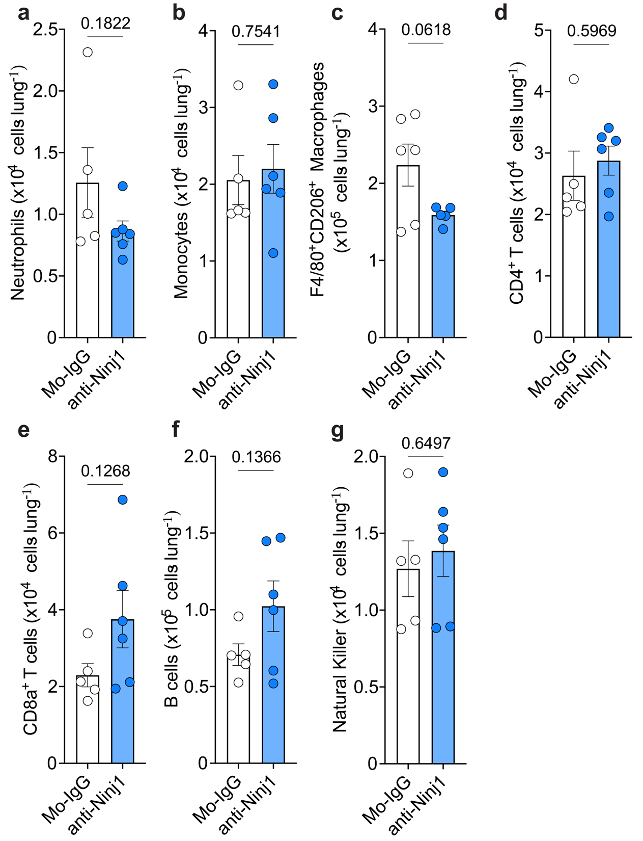
Supplementary Data Figure 9. Comparative lung immune landscape in Mo-IgG control- and anti-NINJ1-treated mice during B16F10 metastasis. Flow cytometry quantification of a, neutrophils; b, monocytes; c, F4/80⁺CD206⁺ macrophages; d, CD4⁺ T cells; e, CD8⁺ T cells; f, B cells; and g, natural killer cells in lung tissue. n = 9–10 mice per group. Data are shown as mean ± SEM of cell number per lung. Statistical significance was determined by unpaired two-tailed Student’s t-test in a–g.
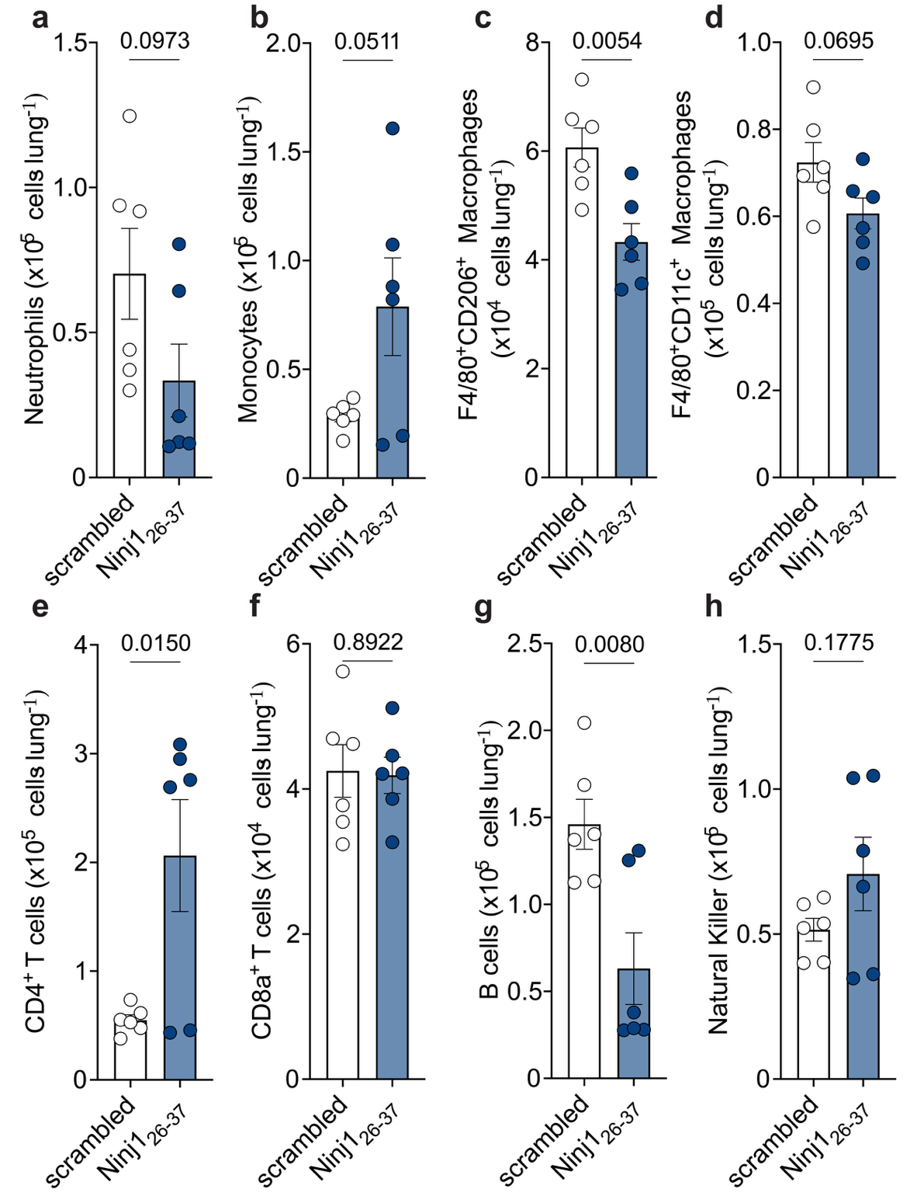

Supplementary Data Figure 10. Comparative lung immune landscape in scrambled- and NINJ1₂₆₋₃₇-treated mice during B16F10 metastasis. Flow cytometry quantification of a, neutrophils; b, monocytes; c, F4/80⁺CD206⁺ macrophages; d, F4/80⁺CD11c⁺ macrophages; e, CD4⁺ T cells; f, CD8⁺ T cells; g, B cells; and h, natural killer cells in lung tissue. n = 9–10 mice per group. Data are shown as mean ± SEM of cell number per lung. Statistical significance was determined by unpaired two-tailed Student’s t-test in a–h.
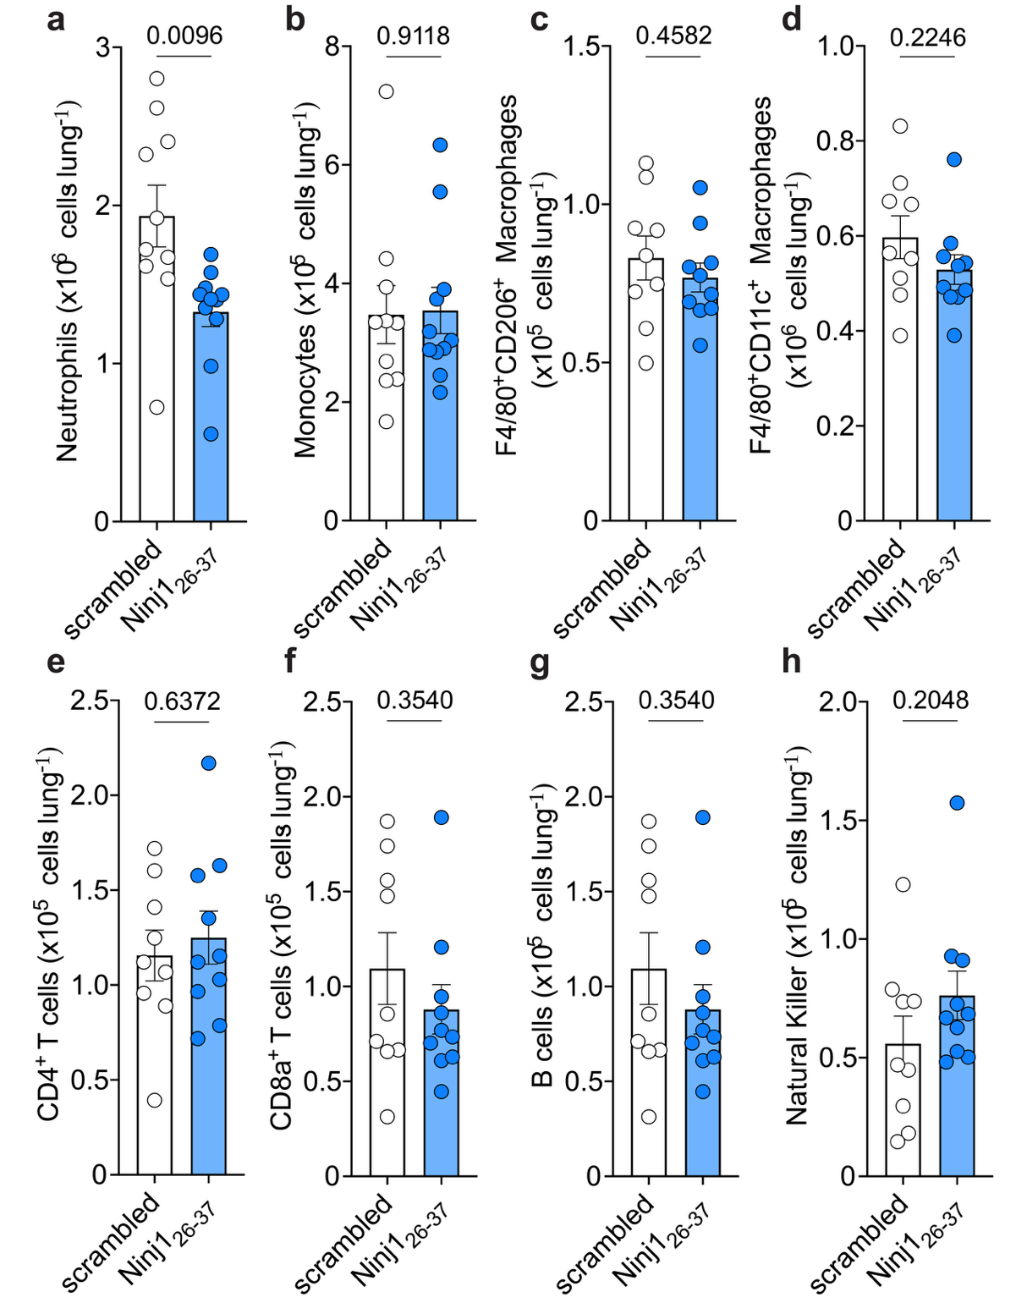

Supplementary Data Figure 11. Comparative lung immune landscape in scrambled- and NINJ1₂₆₋₃₇-treated mice during 4T1 metastasis. Flow cytometry quantification of a, neutrophils; b, monocytes; c, F4/80⁺CD206⁺ macrophages; d, F4/80⁺CD11c⁺ macrophages; e, CD4⁺ T cells; f, CD8⁺ T cells; g, B cells; and h, natural killer cells in lung tissue. n = 9–10 mice per group. Data are shown as mean ± SEM of cell number per lung. Statistical significance was determined by unpaired two-tailed Student’s t-test in a–h.
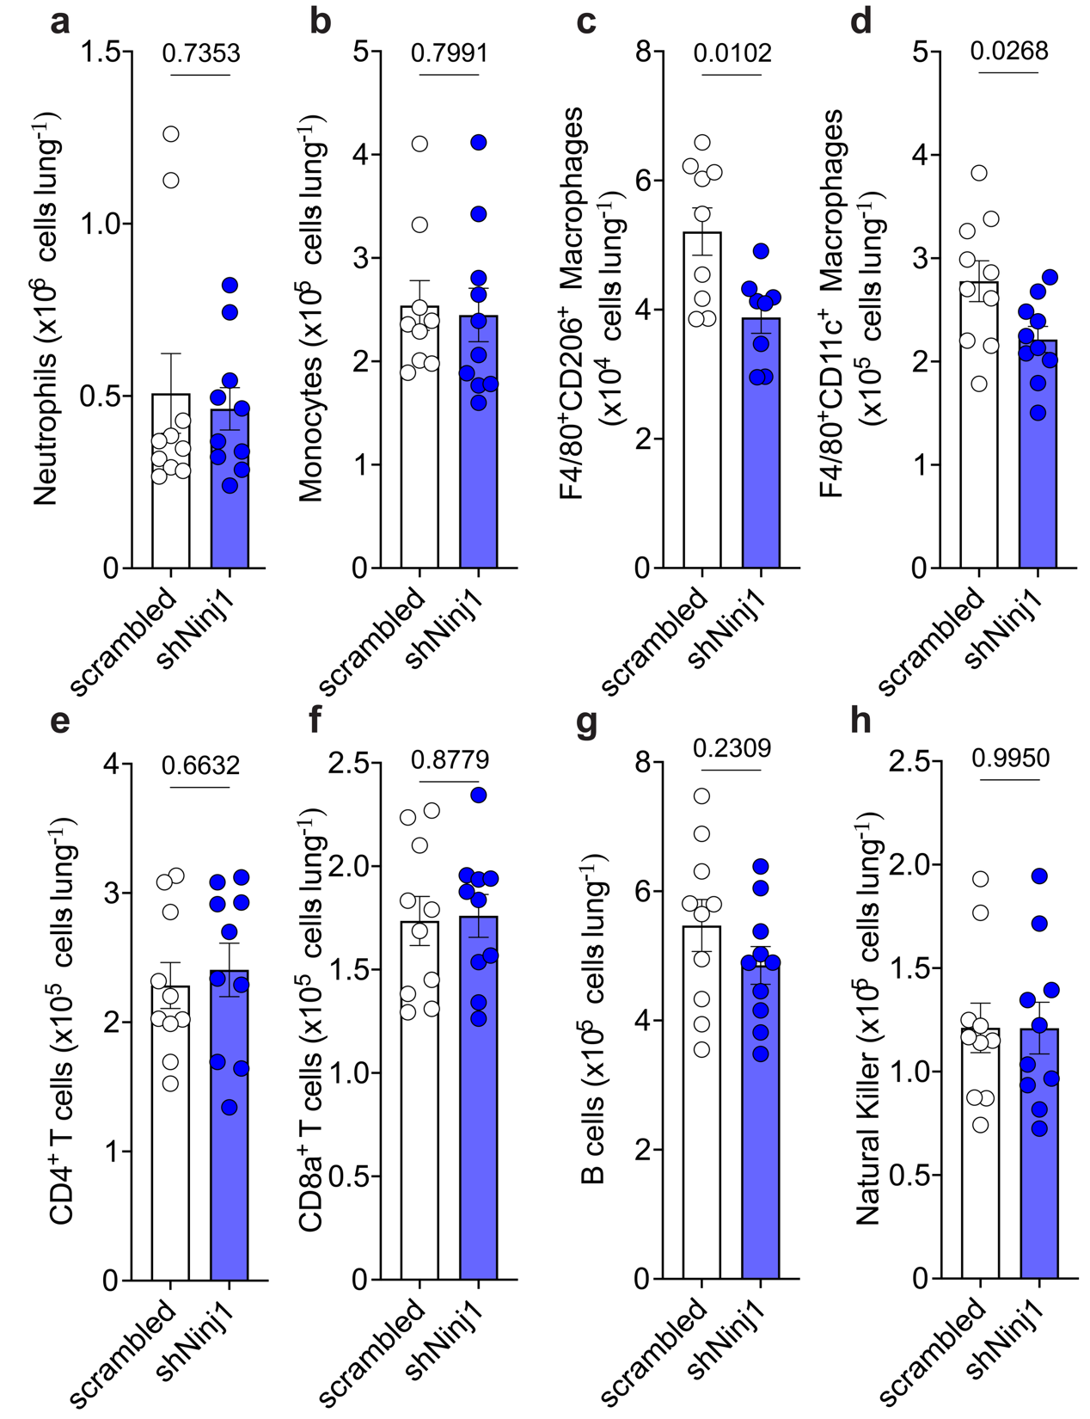
Supplementary Data Figure 12. Comparative lung immune landscape in scrambled control and shNinj1-treated mice during B16F10 metastasis. Flow cytometry quantification of a, neutrophils; b, monocytes; c, F4/80⁺CD206⁺ macrophages; d, F4/80⁺CD11c⁺ macrophages; e, CD4⁺ T cells; f, CD8⁺ T cells; g, B cells; and h, natural killer cells in lung tissue. n = 9–10 mice per group. Data are shown as mean ± SEM of cell number per lung. Statistical significance was determined by unpaired two-tailed Student’s t-test in a–h.
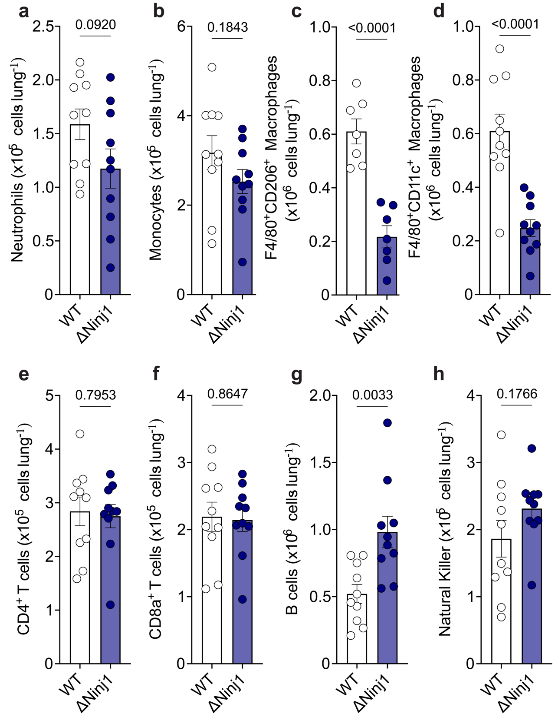
Supplementary Data Figure 13. Comparative lung immune landscape during B16F10^{WT} and B16F10^{ΔNinj1} metastasis. Flow cytometry quantification of a, neutrophils; b, monocytes; c, F4/80⁺CD206⁺ macrophages; d, F4/80⁺CD11c⁺ macrophages; e, CD4⁺ T cells; f, CD8⁺ T cells; g, B cells; and h, natural killer cells in lung tissue. n = 9–10 mice per group. Data are shown as mean ± SEM of cell number per lung. Statistical significance was determined by unpaired two-tailed Student’s t-test in a–h.
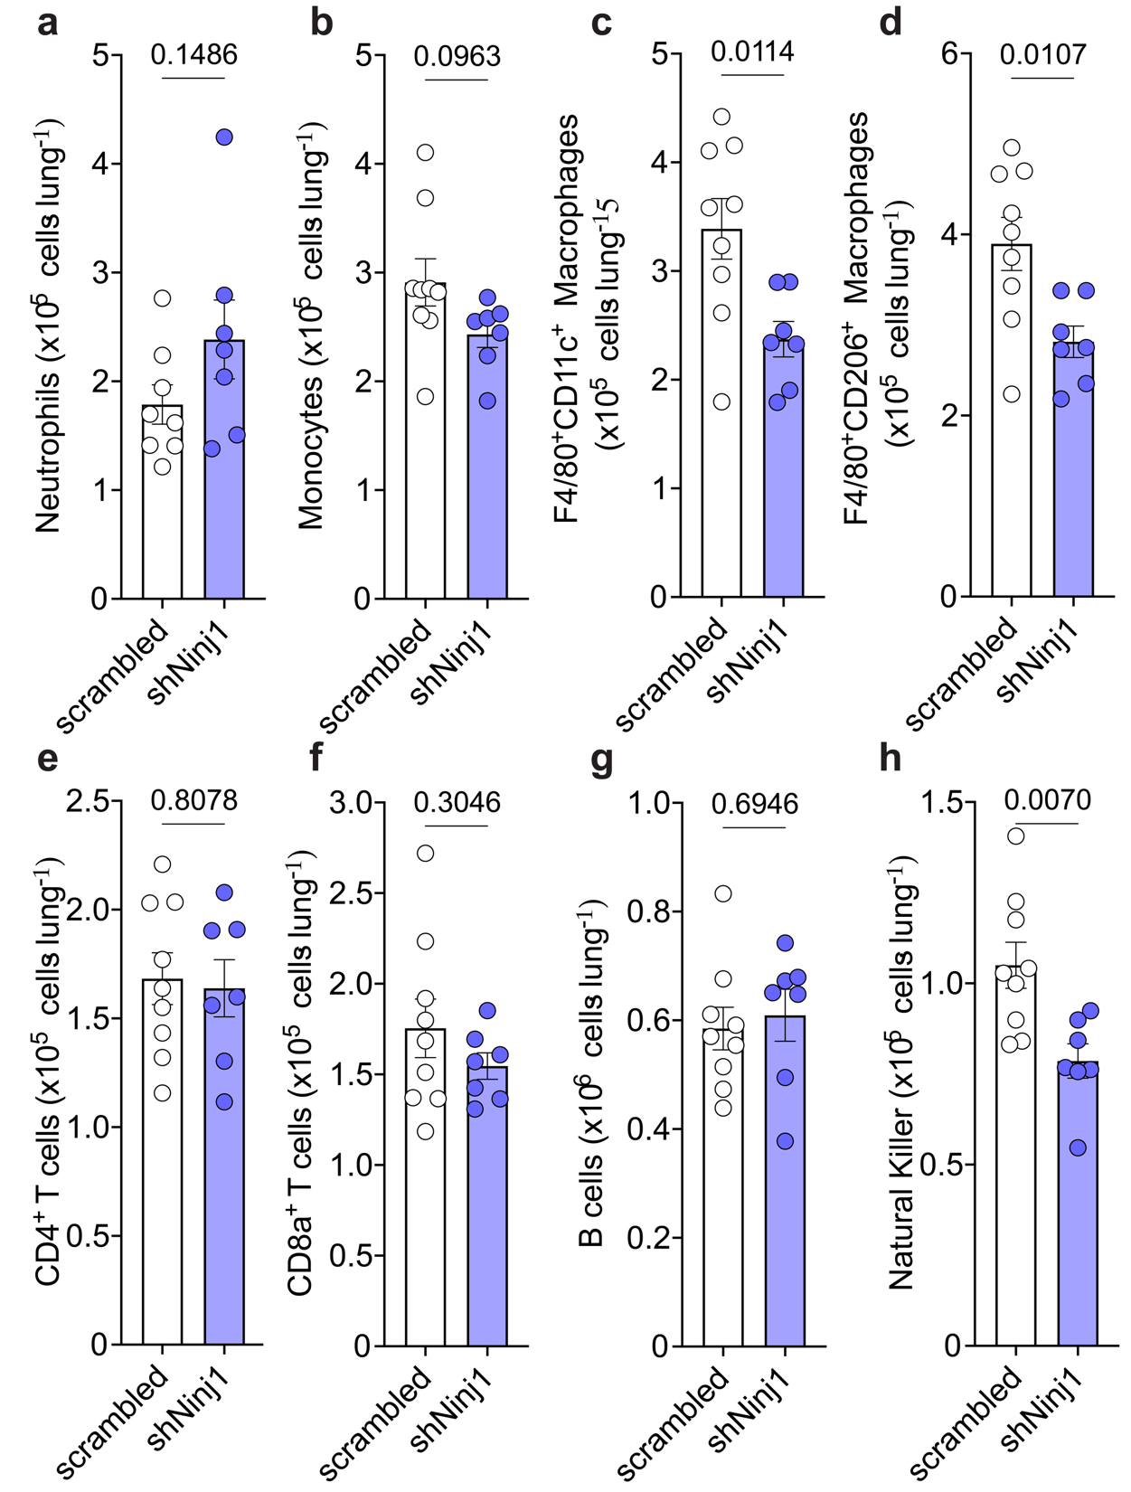
Supplementary Data Figure 14. Comparative lung immune landscape in scrambled control and shNinj1-treated mice during EO771 metastasis. Flow cytometry quantification of a, neutrophils; b, monocytes; c, F4/80⁺CD11c⁺ macrophages; d, F4/80⁺CD206⁺ macrophages; e, CD4⁺ T cells; f, CD8⁺ T cells; g, B cells; and h, natural killer cells in lung tissue. n = 9–10 mice per group. Data are shown as mean ± SEM of cell number per lung. Statistical significance was determined by unpaired two-tailed Student’s t-test in a–h.

