Heterogeneous 30-Day Readmission Risk in Diabetic Kidney Disease: A Nationwide Analysis Stratified by Phenotype, Age, and Socioeconomic Status

Authors: Qimeng Zhu^{2,3,4}, Yang Ge^{2,3,4}, Tongxin Wang^{2,3,4}, Hang Dong^{1,2,3,4}, Menghan Liu^{2,3,4}, Zihan Xu^{2,3,4}, Panpan Yin^{2,3,4,5,6}*, Jia Liu^{2,3,4,5,6}*.
Author Affiliations:
- Key Laboratory of Endocrine Glucose & Lipids Metabolism and Brain Aging, Ministry of Education; Department of Endocrinology, Shandong Provincial Hospital Affiliated to Shandong First Medical University, Jinan, Shandong, 250021, China.
- Shandong Clinical Research Center of Diabetes and Metabolic Diseases, Jinan, Shandong, 250021, China.
- Shandong Institute of Endocrine and Metabolic Diseases, Jinan, Shandong, 250021, China.
- “Chuangxin China” Innovation Base of stem cell and Gene Therapy for endocrine Metabolic diseases.
- Shandong Engineering Laboratory of Prevention and Control for Endocrine and Metabolic Diseases, Jinan, Shandong, 250021, China.
- Shandong Engineering Research Center of Stem Cell and Gene Therapy for Endocrine and Metabolic Diseases, Jinan, Shandong, 250021, China.
*Corresponding Author:
Jia Liu, Shandong Provincial Hospital Affiliated to Shandong First Medical University, Jinan, Shandong Province.
Email: liujia_625@163.com
Panpan Yin, Shandong Provincial Hospital Affiliated to Shandong First Medical University, Jinan, Shandong Province.
Email: jyfyusypp_0827@163.com
Table of Contents

Table S1. Flowchart of Study Population Selection and 30-Day Readmission Classificatio……3
Table S2. ICD-10 Codes for comorbidities and procedures…………......................................…..4
Table S3. Distributions of age among type 1 and type 2 diabetic kidney disease patients………6
Table S4. Readmission patterns by age…………………………………………………............….8
Table S5. Readmission patterns by socioeconomic status………………………………………...10
Table S6. Model Discrimination and Calibration Statistics……………………………………....12
Figure S1. Covariate balance plot…………………………………………………………………..16
Figure S2. E-value analysis……..……………………………………………………………...……17
Figure S3. Receiver operating characteristic curves and calibration plots…………………18

Table S1. Flowchart of Study Population Selection and 30-Day Readmission Classification Among Patients with Diabetic Kidney Disease in the 2018 National Readmissions Database.
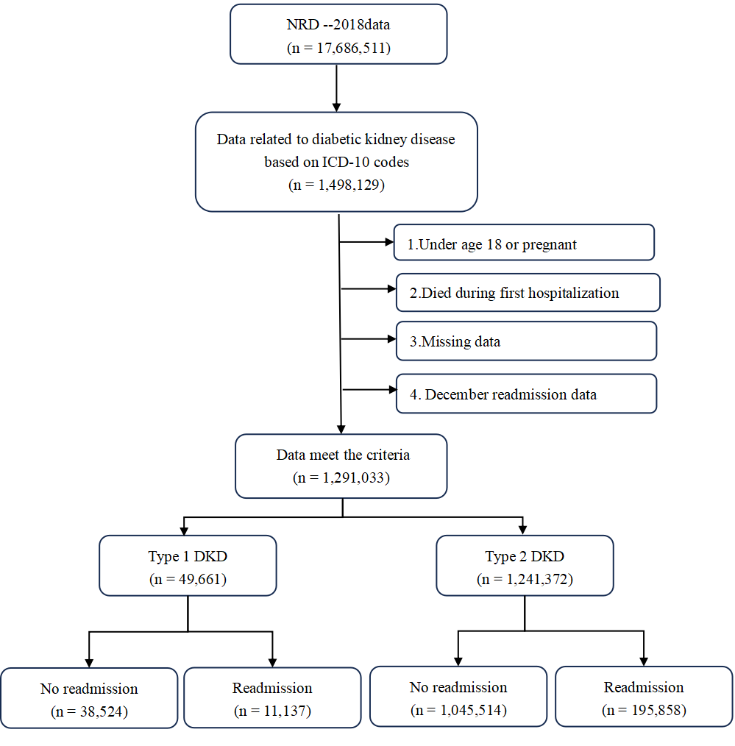
Table S2. ICD-10 Codes for comorbidities and procedures.

Condition/Procedure | Codes ICD10 / OPCS 4
Type 1 Diabetes Mellitus | E10.x
Type 2 Diabetes Mellitus | E11.x
Diabetic Kidney Disease (DKD) | E10.21, E10.22, E11.21, E11.22
Diabetic Ketoacidosis (DKA) | E10.10, E11.10
Hyperosmolar Hyperglycemic State (HHS) | E11.00, E11.01
Diabetes Mellitus with Hypoglycemia | E10.649, E11.649
Diabetes Mellitus with Hyperglycemia | E10.65, E11.65
Diabetic Peripheral Angiopathy | E10.51, E11.51
Diabetic Foot Ulcer | E10.621, E11.621
Diabetic Neuropathy | E10.40-E10.49, E11.40-E11.49
Diabetic Retinopathy | E10.3xx, E11.3xx
Diabetes with Other Specified Complications | E10.69, E11.69
Unspecified Diabetes Complications | E10.8, E11.8
End-Stage Renal Disease (ESRD) | N18.6
Urinary Tract Infection (UTI) | N39.0
Coronary artery disease | I20-I25
Cerebrovascular Accident (CVA)/Stroke | I60-I69
Secondary Hypertension | I15.x
Heart Failure | I50.x
Chronic Obstructive Pulmonary Disease (COPD) | J44.x
Pneumonia | J12-J18
Hyperlipidemia | E78.0-E78.5
Non-Alcoholic Fatty Liver Disease (NAFLD) | K76.0
Metabolic Syndrome | E88.81
Sleep Apnea Syndrome | G47.3x
Electrolyte Disturbances | E87.x
Anemia | D50-D64
Depression/Anxiety | F32.x, F33.x, F41.x
Non-ST Elevation Myocardial Infarction (NSTEMI) | I21.4
Hypertensive Heart and Kidney Disease | I13.x
Kidney Failure (Acute or Chronic) | N17.x, N18.x
Hepatic Failure | K72.x
Sepsis | A41.x
Cancer (Malignant Neoplasms) | C00-C97
Respiratory Failure | J96.x
Alcohol Abuse or Dependence | F10.x
Tobacco Use | F17.x

Table S3. Distribution of principal diagnoses at 30-day hospital readmission among patients with Type 1 and Type 2 diabetic kidney disease.
Variable | All-cause aOR  (95% CI) | DKD-specific aOR  (95% CI) | Other DM aOR  (95% CI) | Non-DM aOR  (95% CI)
Primary exposure
Type 1 DKD | 1.284 (1.245, 1.324) | 0.832 (0.350, 1.973)* | 2.588 (2.395, 2.796) | 1.045 (1.011, 1.079)
Age group
<40 years | Ref | Ref | Ref | Ref
40–49 years | 0.796 (0.759, 0.836) | 0.776 (0.329, 1.830)* | 0.756 (0.688, 0.831) | 0.887 (0.846, 0.930)
50–59 years | 0.766 (0.734, 0.799) | 0.792 (0.380, 1.651)* | 0.577 (0.526, 0.633) | 0.897 (0.858, 0.937)
60–69 years | 0.707 (0.676, 0.739) | 0.717 (0.352, 1.460)* | 0.419 (0.382, 0.460) | 0.849 (0.812, 0.889)
70–79 years | 0.655 (0.626, 0.685) | 0.605 (0.304, 1.203)* | 0.291 (0.263, 0.323) | 0.801 (0.766, 0.838)
>79 years | 0.593 (0.566, 0.622) | 0.780 (0.329, 1.851)* | 0.209 (0.188, 0.232) | 0.734 (0.701, 0.768)
Female | 1.001 (0.989, 1.013) | 0.973 (0.709, 1.335)* | 0.932 (0.894, 0.972) | 1.009 (0.997, 1.021)
Insurance
Medicare | Ref | Ref | Ref | Ref
Medicaid | 1.044 (1.013, 1.076) | 1.370 (0.766, 2.450)* | 1.063 (0.995, 1.136) | 1.038 (1.007, 1.070)
Private | 0.769 (0.753, 0.785) | 0.784 (0.422, 1.458)* | 0.691 (0.644, 0.742) | 0.787 (0.770, 0.803)
Self-pay/Other | 0.827 (0.776, 0.880) | 1.502 (0.311, 7.261)* | 0.970 (0.838, 1.122) | 0.809 (0.759, 0.864)
Income (ref: Q1)
<$45,999 | Ref | Ref | Ref | Ref
$46k-$59k | 1.013 (0.992, 1.033) | 1.426 (0.910, 2.234)* | 0.925 (0.875, 0.977) | 1.021 (1.000, 1.042)
$59k-$79k | 0.998 (0.976, 1.020) | 1.001 (0.642, 1.561)* | 0.919 (0.863, 0.978) | 1.006 (0.984, 1.029)
≥$79k | 1.017 (0.991, 1.044) | 0.944 (0.526, 1.693)* | 0.921 (0.862, 0.985) | 1.027 (1.000, 1.054)
Elective admission | 0.697 (0.679, 0.716) | 0.804 (0.412, 1.572)* | 0.699 (0.645, 0.758) | 0.703 (0.684, 0.723)
Comorbidities
ESRD | 1.597 (1.567, 1.628) | 7.711 (4.982, 11.935) | 1.720 (1.641, 1.803) | 1.555 (1.525, 1.587)
Heart failure | 1.348 (1.330, 1.367) | 1.126 (0.810, 1.566)* | 0.910 (0.870, 0.952) | 1.383 (1.364, 1.403)
Anemia | 1.209 (1.193, 1.226) | 1.534 (1.048, 2.246) | 1.144 (1.097, 1.192) | 1.208 (1.192, 1.225)
Malignancy | 1.266 (1.236, 1.296) | 2.135 (1.186, 3.840) | 0.644 (0.580, 0.716) | 1.307 (1.276, 1.339)
COPD | 1.192 (1.174, 1.210) | 1.760 (1.128, 2.747) | 0.843 (0.795, 0.894) | 1.212 (1.194, 1.231)
DKA | 1.061 (1.018, 1.106) | 1.552 (0.220, 10.967)* | 2.889 (2.672, 3.124) | 0.704 (0.670, 0.741)
CAD | 1.106 (1.089, 1.122) | 1.060 (0.726, 1.548)* | 0.915 (0.866, 0.968) | 1.120 (1.103, 1.138)
PVD | 1.070 (1.040, 1.100) | 1.031 (0.543, 1.960)* | 1.234 (1.138, 1.337) | 1.055 (1.025, 1.086)
Hyperlipidemia | 0.939 (0.926, 0.951) | 0.847 (0.612, 1.173)* | 0.963 (0.925, 1.003) | 0.939 (0.926, 0.952)
NAFLD/NASH | 1.190 (1.142, 1.240) | 1.910 (0.809, 4.505)* | 0.664 (0.568, 0.777) | 1.234 (1.183, 1.288)
Sepsis | 0.811 (0.796, 0.826) | 0.786 (0.455, 1.358)* | 0.733 (0.691, 0.776) | 0.826 (0.810, 0.842)
Stroke | 0.683 (0.652, 0.715) | 2.107 (0.406, 10.929)* | 0.474 (0.395, 0.568) | 0.706 (0.673, 0.741)
Sleep apnea | 0.970 (0.954, 0.986) | 0.989 (0.645, 1.517)* | 0.739 (0.695, 0.786) | 0.989 (0.973, 1.006)
Tobacco use | 1.038 (1.017, 1.060) | 1.064 (0.614, 1.842)* | 1.072 (1.009, 1.139) | 1.032 (1.010, 1.054)
Depression/Anxiety | 1.013 (0.993, 1.034) | 1.217 (0.752, 1.971)* | 0.936 (0.882, 0.994) | 1.020 (0.999, 1.042)

Table S4. Readmission patterns by age.

Age groups | Type 1 DKD n (%) | Type 2 DKD n (%) | p | Adjusted p | aOR (95% CI)
All-cause readmissions
<40 years | 4484 (28.87%) | 3519 (19.88%) | <0.001 | <0.001 | 1.593 (1.481, 1.713)
40–49 years | 2130 (22.47%) | 10421 (18.21%) | <0.001 | <0.001 | 1.226 (1.142, 1.316)
50–59 years | 1872 (20.31%) | 29178 (17.73%) | <0.001 | <0.001 | 1.187 (1.111, 1.268)
60–69 years | 1397 (17.57%) | 51523 (16.58%) | 0.002 | 0.002 | 1.121 (1.045, 1.204)
70–79 years | 863 (17.27%) | 57684 (15.36%) | <0.001 | <0.001 | 1.198 (1.084, 1.323)
>79 years | 391 (15.74%) | 43533 (13.79%) | 0.035 | 0.035 | 1.147 (1.010, 1.303)
DKD-specific readmissions
<40 years | 115 (59.90%) | 38 (18.18%) | — | — | Not estimated
40–49 years | 37 (19.27%) | 96 (15.38%) | — | — | Not estimated
50–59 years | 21 (10.94%) | 209 (17.05%) | — | — | Not estimated
60–69 years | 16 (8.33%) | 258 (15.52%) | — | — | Not estimated
70–79 years | 2 (1.04%) | 168 (17.27%) | — | — | Not estimated
>79 years | 1 (0.52%) | 66 (15.94%) | — | — | Not estimated
Other diabetes-related comorbidities readmissions
<40 years | 1720 (11.08%) | 587 (3.32%) | <0.001 | <0.001 | 2.841 (2.486, 3.246)
40–49 years | 703 (7.42%) | 1310 (2.29%) | <0.001 | <0.001 | 2.449 (2.112, 2.840)
50–59 years | 466 (5.06%) | 2531 (1.54%) | <0.001 | <0.001 | 2.361 (2.036, 2.738)
60–69 years | 277 (3.48%) | 3229 (1.04%) | <0.001 | <0.001 | 2.400 (2.030, 2.837)
70–79 years | 96 (1.92%) | 2595 (0.69%) | <0.001 | <0.001 | 2.540 (1.792, 3.601)
>79 years | 54 (2.17%) | 1518 (0.48%) | <0.001 | <0.001 | 3.372 (2.458, 4.625)
Non-diabetes-related comorbidities readmissions
<40 years | 2757 (17.75%) | 2929 (16.55%) | <0.001 | <0.001 | 1.175 (1.086, 1.272)
40–49 years | 1425 (15.03%) | 9098 (15.90%) | 0.361 | 0.722 | 0.965 (0.894, 1.042)
50–59 years | 1405 (15.25%) | 26606 (16.17%) | 0.921 | 0.921 | 0.996 (0.928, 1.070)
60–69 years | 1120 (14.08%) | 48242 (15.53%) | 0.567 | 0.850 | 0.979 (0.909, 1.054)
70–79 years | 767 (15.35%) | 55048 (14.66%) | 0.050 | 0.150 | 1.102 (1.000, 1.214)
>79 years | 337 (13.57%) | 41988 (13.30%) | 0.739 | 0.887 | 1.023 (0.894, 1.172)

Table S5. Readmission patterns by socioeconomic status.
Subgroup | Type 1 DKD n (rate) | Type 2 DKD n (rate) | p | Adjusted p | aOR (95% CI)
All-cause readmissions
Insurance type
Medicare | 6,567 (22.93%) | 155,301 (15.96%) | <0.001 | <0.001 | 1.217 (1.172, 1.265)
Medicaid | 2,715 (26.78%) | 19,173 (18.27%) | <0.001 | <0.001 | 1.473 (1.373, 1.580)
Private | 1,445 (16.43%) | 16,407 (12.92%) | <0.001 | <0.001 | 1.318 (1.224, 1.419)
Self-pay/Other | 247 (20.10%) | 1,834 (14.05%) | <0.001 | <0.001 | 1.565 (1.264, 1.938)
Income quartile
<$45,999 | 3,754 (24.75%) | 63,012 (16.34%) | <0.001 | <0.001 | 1.339 (1.266, 1.415)
$46k-$59k | 3,117 (21.91%) | 55,663 (15.87%) | <0.001 | <0.001 | 1.214 (1.145, 1.286)
$59k-$79k | 2,552 (21.24%) | 45,025 (15.34%) | <0.001 | <0.001 | 1.288 (1.210, 1.370)
≥$79k | 1,714 (20.78%) | 32,158 (15.20%) | <0.001 | <0.001 | 1.313 (1.224, 1.409)
DKD-specific readmissions were not estimated
Other diabetes-related comorbidities readmissions
Medicare | 1,748 (6.10%) | 8,542 (0.88%) | <0.001 | <0.001 | 2.463 (2.223, 2.730)
Medicaid | 1,013 (9.99%) | 1,714 (1.63%) | <0.001 | <0.001 | 2.875 (2.491, 3.318)
Private | 382 (4.34%) | 1,113 (0.88%) | <0.001 | <0.001 | 2.498 (2.102, 2.967)
Self-pay/Other | 119 (9.69%) | 196 (1.50%) | <0.001 | <0.001 | 3.323 (2.263, 4.880)
Income quartile
<$45,999 | 1,217 (8.02%) | 4,375 (1.13%) | <0.001 | <0.001 | 2.454 (2.169, 2.776)
$46k-$59k | 925 (6.50%) | 3,245 (0.93%) | <0.001 | <0.001 | 2.524 (2.211–2.882)
$59k-$79k | 724 (6.02%) | 2,511 (0.86%) | <0.001 | <0.001 | 2.857 (2.439, 3.345)
≥$79k | 450 (5.45%) | 1,639 (0.78%) | <0.001 | <0.001 | 2.736 (2.267, 3.302)
Non-diabetes-related comorbidities readmissions
Insurance type
Medicare | 4,814 (16.82%) | 146,621 (15.06%) | 0.486 | 0.648 | 1.014 (0.975, 1.055)
Medicaid | 1,697 (16.74%) | 17,438 (16.61%) | 0.019 | 0.038 | 1.097 (1.016, 1.184)
Private | 1,063 (12.08%) | 15,281 (12.04%) | 0.007 | 0.028 | 1.122 (1.032, 1.220)
Self-pay/Other | 128 (10.41%) | 1,636 (12.52%) | 0.710 | 0.710 | 1.049 (0.815, 1.351)
Income quartile
<$45,999 | 2,534 (16.70%) | 58,579 (15.19%) | 0.028 | 0.056 | 1.071 (1.007, 1.138)
$46k-$59k | 2,189 (15.38%) | 52,359 (14.94%) | 0.671 | 0.671 | 0.987 (0.929, 1.049)
$59k-$79k | 1,825 (15.18%) | 42,478 (14.47%) | 0.157 | 0.209 | 1.047 (0.982, 1.115)
≥$79k | 1,263 (15.31%) | 30,495 (14.41%) | 0.005 | 0.020 | 1.108 (1.032, 1.191)

Table S6. Model Discrimination and Calibration Statistics.

Outcome | N events | Event rate | C-statistic (95% CI) | Calibration slope (95% CI)
All-cause readmissions | 206,995 | 16.03% | 0.612 (0.608–0.616) | 1.001 (0.987–1.015)
DM-related comorbidity readmissions | 15,588 | 1.21% | 0.772 (0.768–0.776) | 1.005 (0.990–1.018)
Non-DM comorbidity readmissions | 190,380 | 14.75% | 0.611 (0.607–0.613) | 1.003 (0.988–1.015)

Table footnotes
Table S1. Flowchart of Study Population Selection and 30-Day Readmission Classification Among Patients with Diabetic Kidney Disease in the 2018 National Readmissions Database.
Hospitalizations with diabetic kidney disease were identified using ICD-10 diagnostic codes from the 2018 NRD. Records were excluded if patients were aged <18 years or pregnant, died during the index hospitalization, had missing data, or lacked complete 30-day follow-up (December admissions). The final analytic cohort included 1,291,033 hospitalizations and was categorized into type 1 DKD and type 2 DKD. Patients were subsequently classified according to 30-day readmission status.
Abbreviations: DKD, diabetic kidney disease; NRD, Nationwide Readmissions Database; ICD-10, International Classification of Diseases, Tenth Revision.

Table S2. ICD-10 Codes for comorbidities and procedures.
Diagnostic conditions, exposures, outcomes, and comorbidities were identified using International Classification of Diseases, Tenth Revision, Clinical Modification (ICD-10-CM) codes from hospitalization records in the Nationwide Readmissions Database (NRD). Code ranges include all corresponding subcategories unless otherwise specified (e.g., x or xx indicates all descendant codes).
Abbreviations: ICD-10-CM, International Classification of Diseases, Tenth Revision, Clinical Modification; DKD, diabetic kidney disease; DKA, diabetic ketoacidosis; HHS, hyperosmolar hyperglycemic state; ESRD, end-stage renal disease; UTI, urinary tract infection; CVD, cardiovascular disease; CVA, cerebrovascular accident; COPD, chronic obstructive pulmonary disease; NAFLD, non-alcoholic fatty

Table S3. Distribution of principal diagnoses at 30-day hospital readmission among patients with Type 1 and Type 2 diabetic kidney disease.
Adjusted ORs were estimated using survey-weighted logistic regression accounting for NRD complex survey design. Models adjusted for demographic, socioeconomic, admission, and comorbidity variables. Values marked with * indicate unstable estimates due to wide confidence intervals and should be interpreted cautiously.
Abbreviations: DKD, diabetic kidney disease; ESRD, end-stage renal disease; DKA, diabetic ketoacidosis; CAD, coronary artery disease; COPD, chronic obstructive pulmonary disease; NAFLD, non-alcoholic fatty liver disease; SNF, skilled nursing facility; ICF, intermediate care facility; IQR, interquartile range; SMD, standardized mean difference; NRD, Nationwide Readmissions Database.

Table S4. Readmission patterns by age.
Thirty-day readmission rates and adjusted odds ratios by age group, stratified by readmission cause. n = unweighted event count; rate (%) = unweighted crude event rate calculated as n events divided by total patients within the age group. Adjusted odds ratios (aOR) for type 1 versus type 2 DKD within each age stratum were estimated by separate survey-weighted logistic regression (svyglm, quasibinomial; DISCWT, HOSP_NRD, NRD_STRATUM), with age excluded from the covariate set. Adjusted p = Benjamini–Hochberg FDR correction within each readmission cause. DKD-specific readmissions: aOR not estimated in all age strata due to type 1 DKD event count <10; crude unweighted rates displayed for descriptive purposes. — indicates not estimated.
Abbreviations: DKD, diabetic kidney disease; DM, diabetes mellitus; aOR, adjusted odds ratio; CI, confidence interval; FDR, false discovery rate.

Table S5. Readmission patterns by socioeconomic status.
n = unweighted event count; rate (%) = unweighted crude event rate. Adjusted odds ratios (aOR) for type 1 versus type 2 DKD within each socioeconomic subgroup were estimated by separate survey-weighted logistic regression (svyglm, quasibinomial; DISCWT, HOSP_NRD, NRD_STRATUM), with the stratifying variable (insurance type or income quartile) excluded from the covariate set. Adjusted p = Benjamini–Hochberg FDR correction within each readmission cause. DKD-specific readmissions: aOR not estimated in any socioeconomic subgroup due to insufficient type 1 DKD event counts (n<10 in all strata); actual event counts and rates are presented for transparency. — indicates not estimated.
Abbreviations: DKD, diabetic kidney disease; DM, diabetes mellitus; aOR, adjusted odds ratio; CI, confidence interval; FDR, false discovery rate.
Table S6. Model Discrimination and Calibration Statistics.
The C-statistic (equivalent to the area under the receiver operating characteristic curve, AUROC) quantifies model discrimination, with 0.5 indicating no discrimination and 1.0 indicating perfect discrimination; 95% CIs were derived by bootstrap resampling (1,000 iterations) with survey weights. The calibration slope was estimated by regressing observed outcomes on log-odds predicted by each model; a slope of 1.0 indicates perfect calibration, with values >1.0 suggesting underfitting and values <1.0 suggesting overfitting. All models incorporated NRD complex survey design (hospital-level clusters, strata, and discharge weights [DISCWT]) using the svyglm function (quasibinomial family) in the R survey package.
Abbreviations: DKD, diabetic kidney disease; DM, diabetes mellitus

Figure S1. Covariate balance plot depicting standardized mean differences (SMDs) of baseline covariates between patients with type 1 and type 2 diabetic kidney disease (DKD).

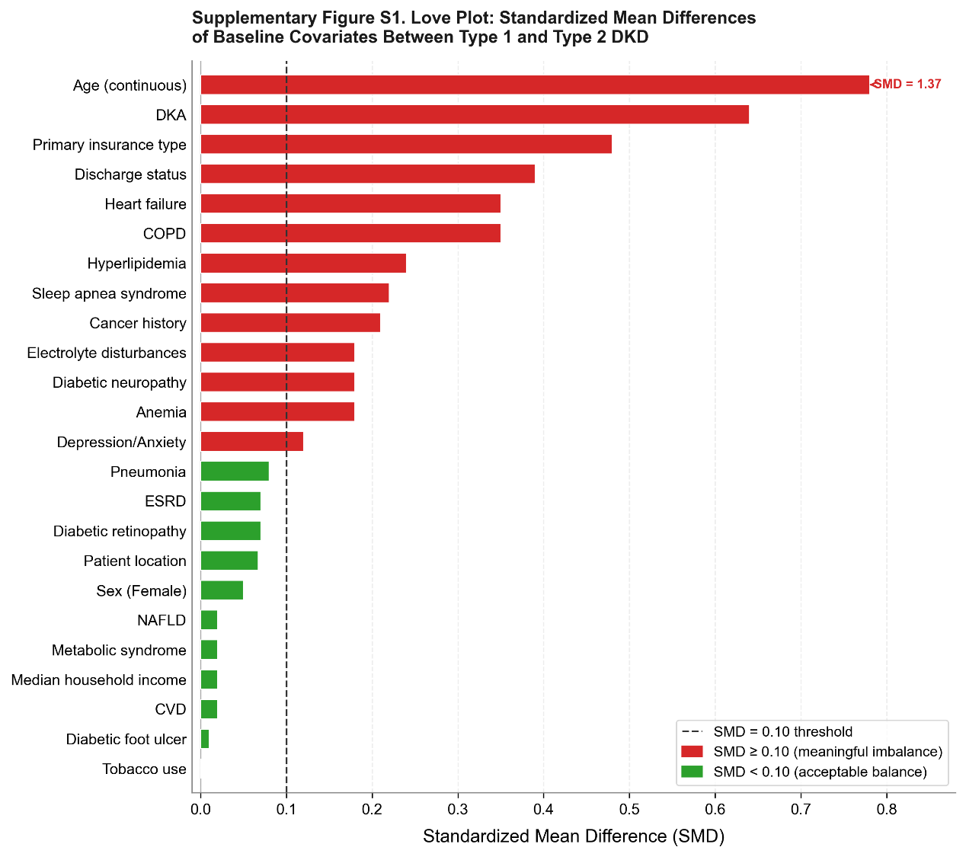

Figure S2. E-value analysis quantifying the robustness of primary multivariable associations to potential unmeasured confounding.

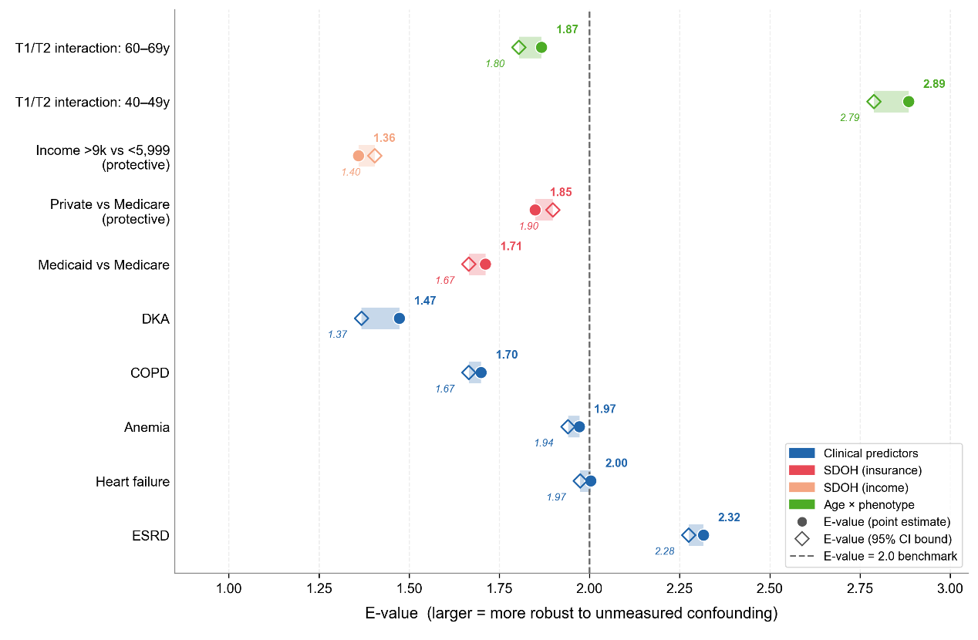

Figure S3. Discrimination and Calibration of Survey-Weighted Logistic Models for 30-Day Readmission Outcomes in Patients with Diabetic Kidney Disease.

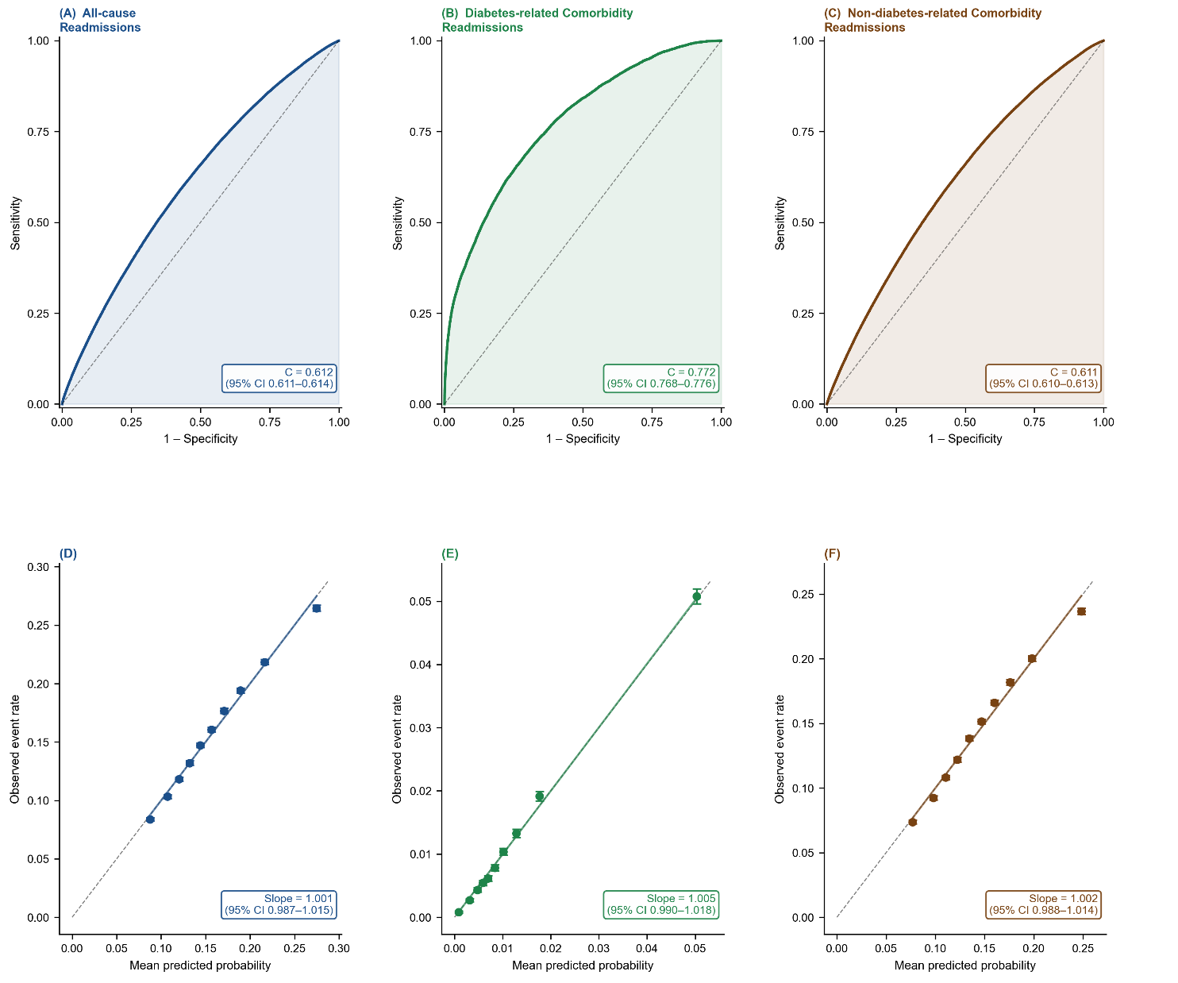

Figure legends:
Figure S1. Covariate balance plot depicting standardized mean differences (SMDs) of baseline covariates between patients with type 1 and type 2 diabetic kidney disease (DKD).
Each horizontal bar represents the SMD for a single covariate, with bar length reflecting the magnitude of imbalance between the two DKD phenotypes. Variables are ordered from smallest to largest SMD. The dashed vertical reference line denotes the conventional SMD threshold of 0.10, above which imbalance is considered clinically meaningful. Bars in red indicate covariates with SMD ≥ 0.10 that were prioritized for inclusion in multivariable adjustment; bars in green indicate covariates with SMD < 0.10 reflecting acceptable between-group balance. Notably, diabetic ketoacidosis (SMD = 0.64), age (SMD = 1.37, truncated for display), primary insurance type (SMD = 0.48), and discharge status (SMD = 0.39) demonstrated the greatest imbalance, consistent with the well-established phenotypic divergence between type 1 and type 2 DKD. All covariates with SMD > 0.10 were incorporated as adjustment variables in the primary multivariable logistic regression models.
Abbreviations: DKA, diabetic ketoacidosis; ESRD, end-stage renal disease; CVD, cardiovascular disease; COPD, chronic obstructive pulmonary disease; NAFLD, non-alcoholic fatty liver disease; SMD, standardized mean difference.

Figure S2. E-value analysis quantifying the robustness of primary multivariable associations to potential unmeasured confounding.
E-values were calculated for key adjusted odds ratios (ORs) from the multivariable logistic regression models and stratified analyses, following the method of VanderWeele and Ding (2017). The E-value represents the minimum strength of association that an unmeasured confounder would need to have with both the exposure and the outcome—on the risk ratio scale—to fully explain away an observed association; higher E-values indicate greater robustness. Filled circles denote E-values corresponding to the point estimates of the adjusted OR; open diamonds denote E-values corresponding to the 95% confidence interval bound closest to the null. Shaded horizontal bars span the range between the two. The dashed vertical reference line marks an E-value of 2.0, a commonly applied benchmark for moderate robustness in observational epidemiology. Associations with E-values exceeding 2.0 for both the point estimate and its confidence interval bound are considered robust to moderate unmeasured confounding. E-values are presented separately for clinical predictors (blue), insurance-based social determinants of health (red), income-based social determinants of health (orange), and age-by-phenotype interaction effects (green).
Reference: VanderWeele TJ, Ding P. Sensitivity analysis in observational research: introducing the E-value. Ann Intern Med. 2017;167(4):268–274.
Abbreviations: ESRD, end-stage renal disease; COPD, chronic obstructive pulmonary disease; DKA, diabetic ketoacidosis; OR, odds ratio; CI, confidence interval; SDOH, social determinants of health.

Figure S3. Discrimination and Calibration of Survey-Weighted Logistic Models for 30-Day Readmission Outcomes in Patients with Diabetic Kidney Disease.
Receiver operating characteristic (ROC) curves (panels A–C) and calibration plots (panels D–F) for three mutually exclusive 30-day readmission outcomes among patients hospitalised with a primary diagnosis of diabetic kidney disease (DKD) in the 2018 Nationwide Readmissions Database (NRD; n = 1,291,033 weighted discharges). Outcomes are defined as: (A, D) all-cause readmission; (B, E) diabetes-related comorbidity readmission (principal readmission diagnosis ICD-10-CM E08–E13); and (C, F) non-diabetes-related comorbidity readmission (all other principal diagnoses). Models included DKD type (Type 1 vs. Type 2), sex, age group, insurance type, income quartile, elective admission status, urbanicity, and 40 comorbidity flags derived from secondary diagnosis codes. Survey weights (DISCWT) and the complex sampling design (stratum: NRD_STRATUM; cluster: HOSP_NRD) were applied using generalised linear models with a logit link. C-statistics (area under the ROC curve) with 95% bootstrap confidence intervals (1,000 iterations) are displayed within each ROC panel. Calibration plots show decile-grouped mean predicted probability (x-axis) against observed event rate (y-axis); the calibration slope and its 95% CI are annotated. The diagonal dashed line represents perfect calibration (slope = 1.0). Error bars denote 95% Wilson confidence intervals for observed proportions within each decile.
Abbreviations: CI, confidence interval.

